Login:
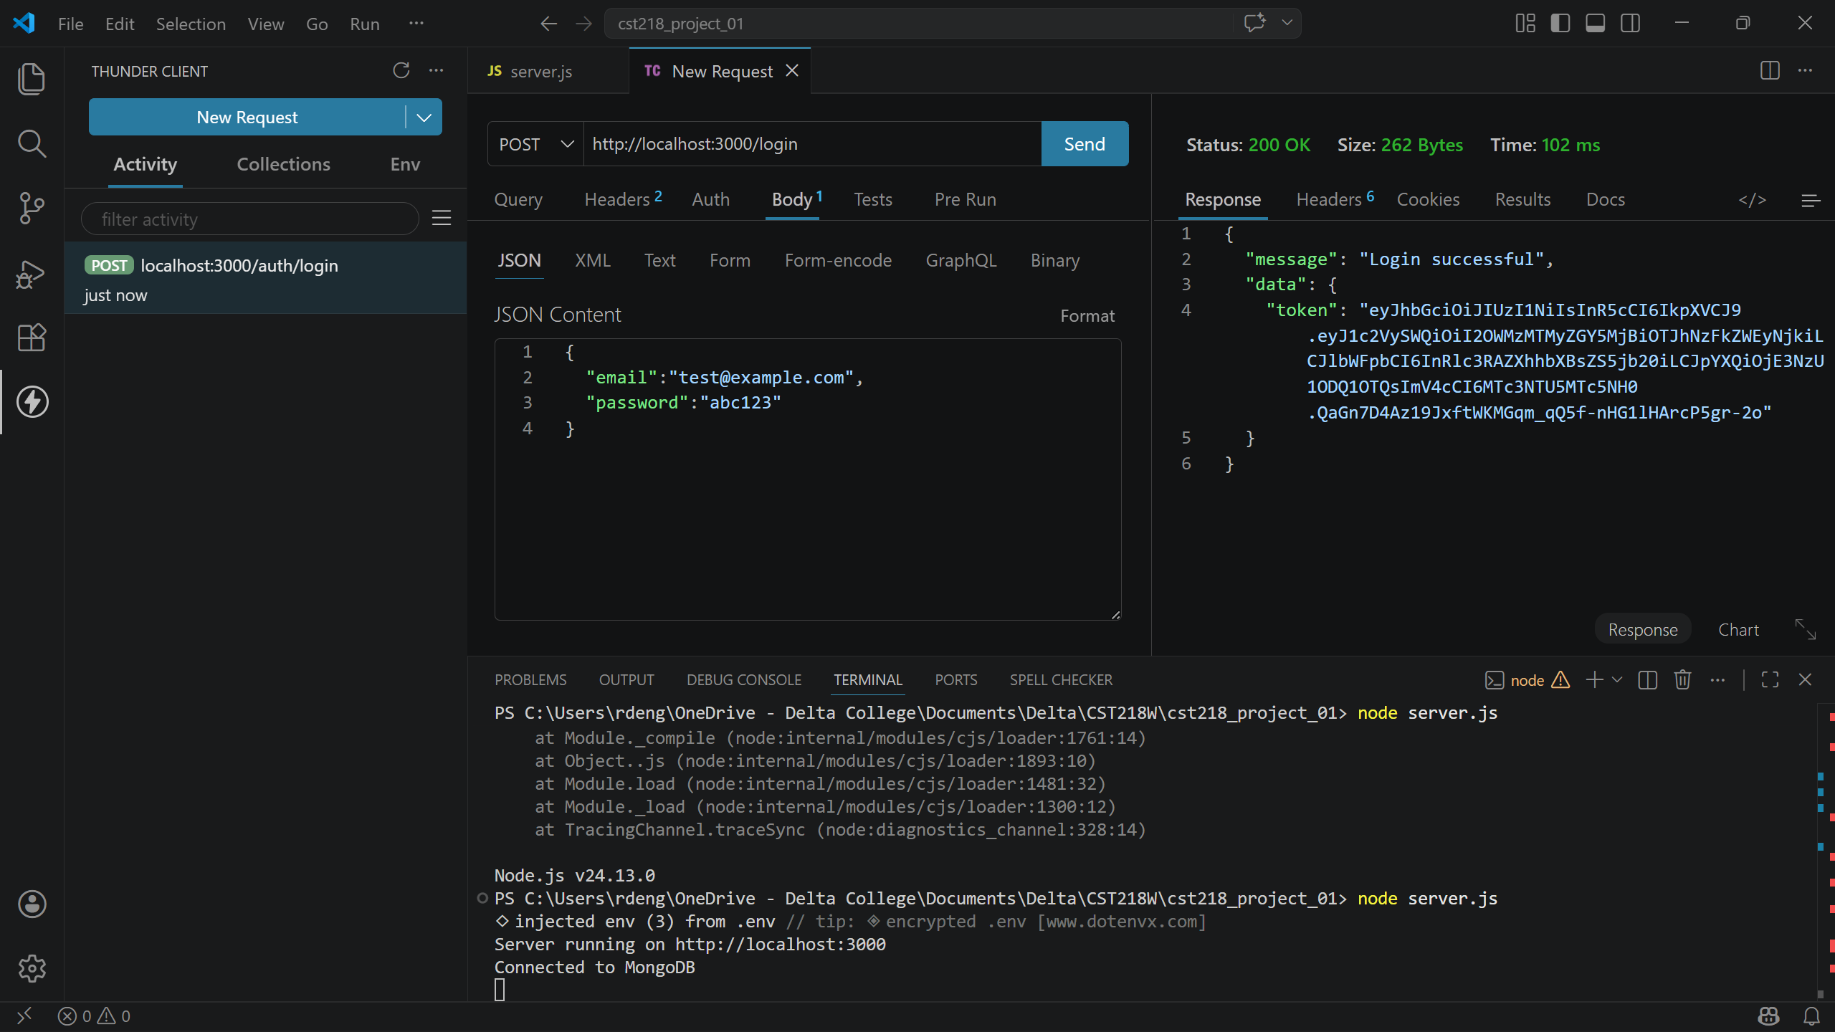
Protected route w/ token:
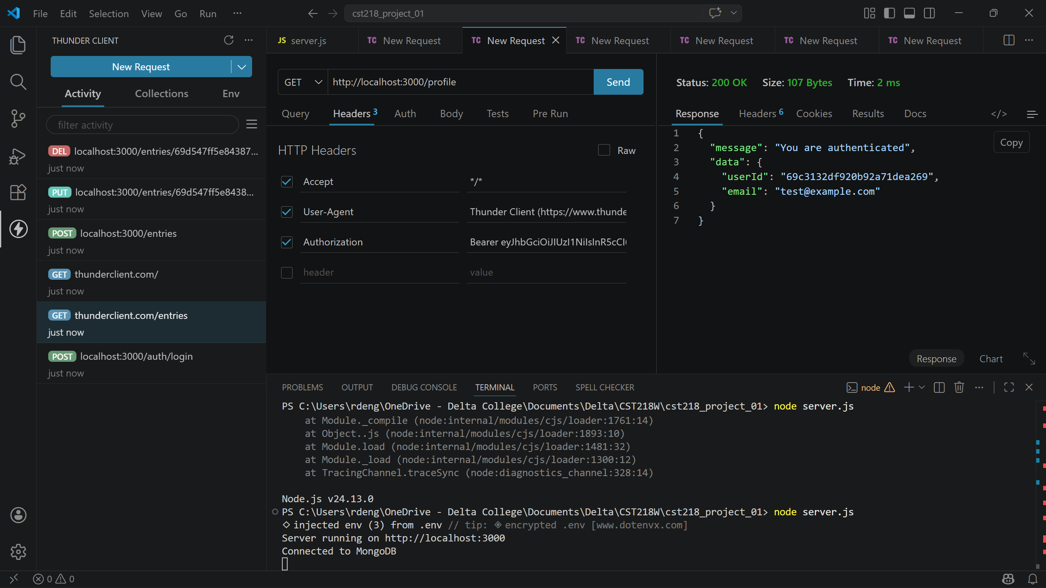
Get all:
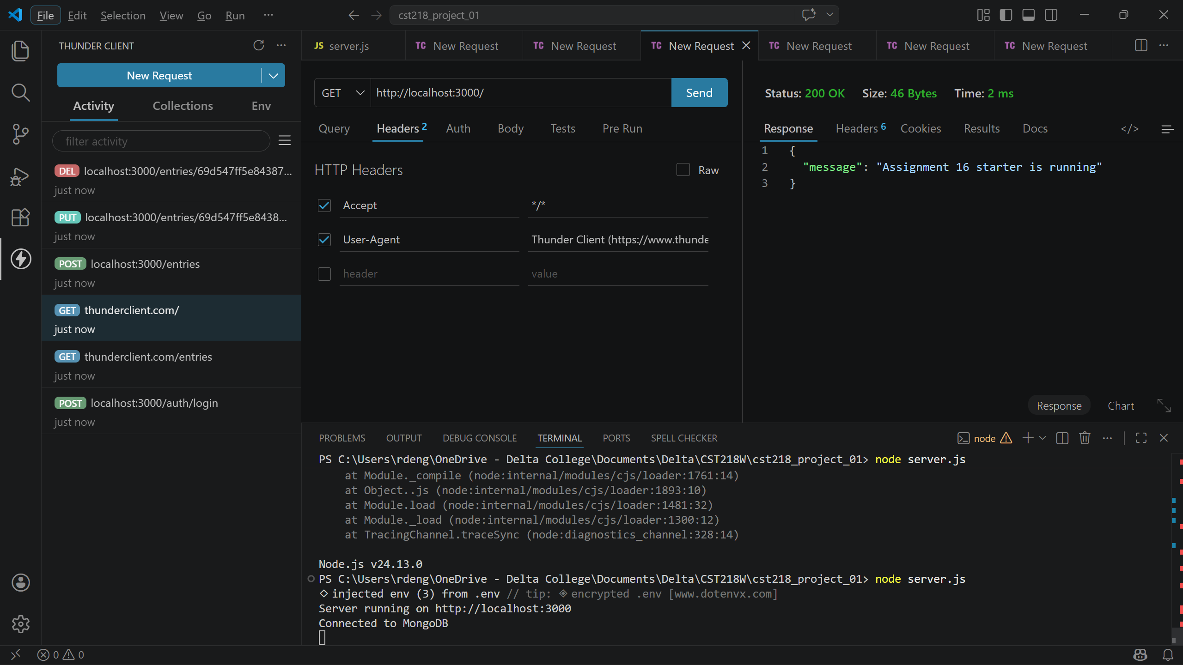
Post:
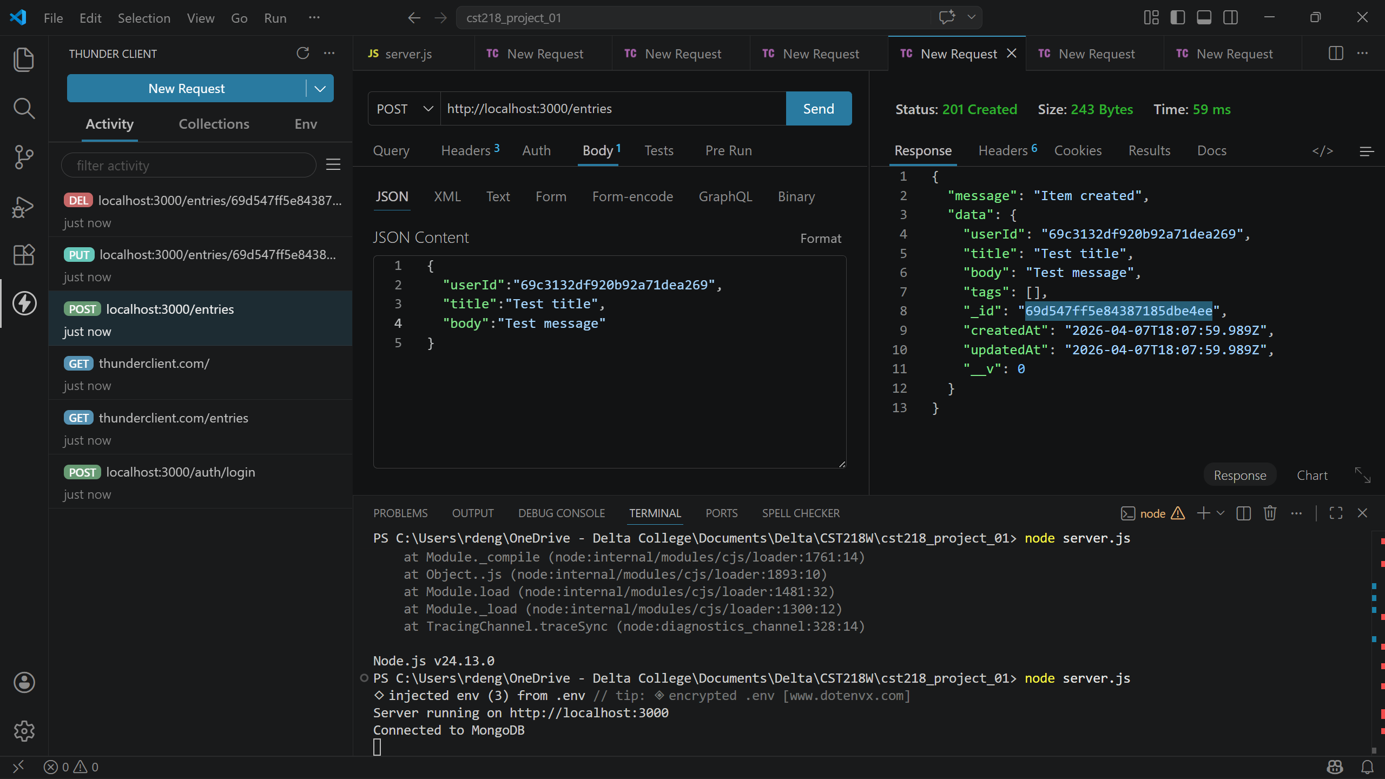
Put:
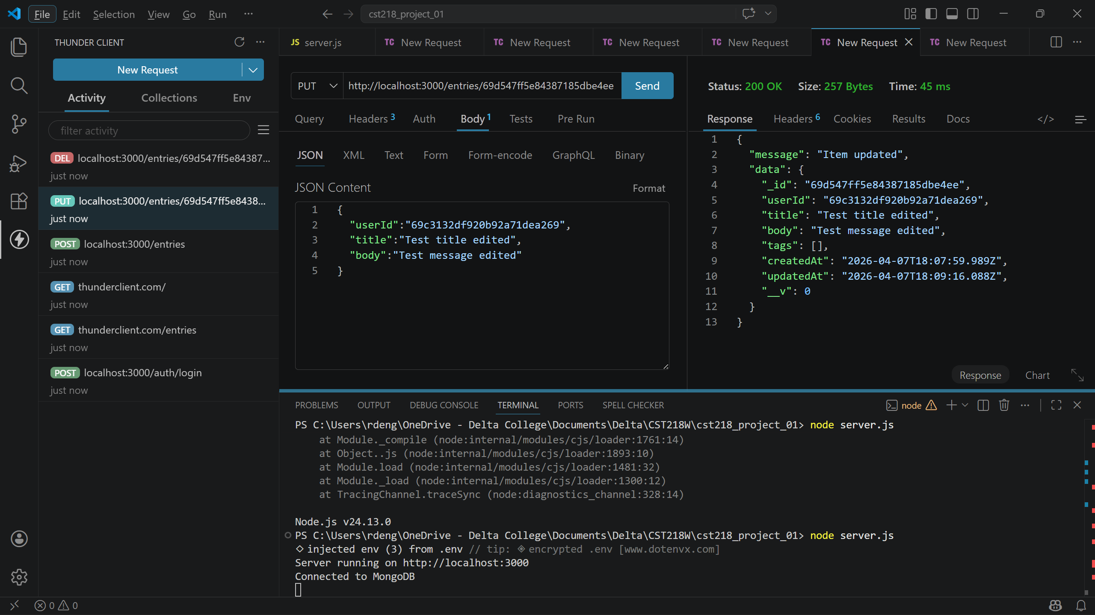
Del:
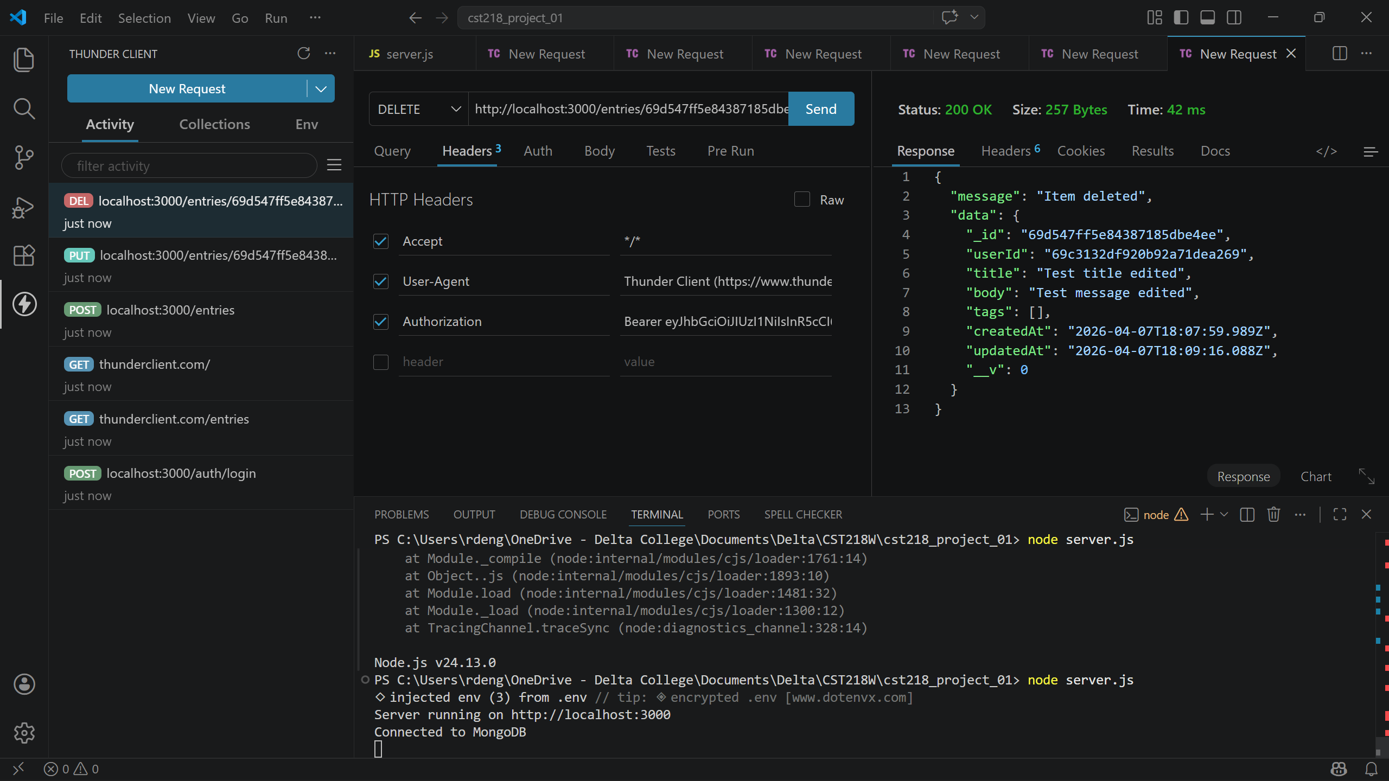

The routes portion of the codebase is much cleaner and easier to understand after refactoring. The most confusing part of the refactor had to do with ensuring I was importing various modules and files in order for everything to stay functional. The additional layers or organization will help greatly as this project expands to prevent it from becoming one giant, unorganized file.

