Login success + request logs:
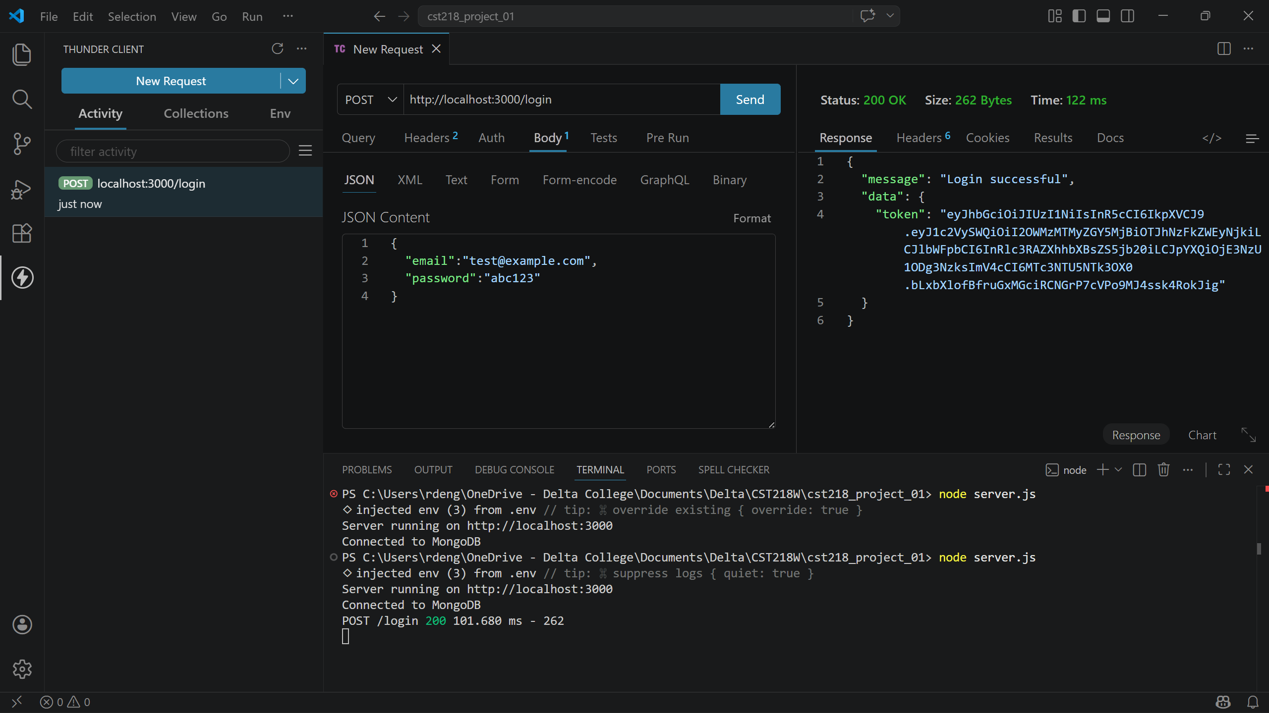
400 Bad Input:
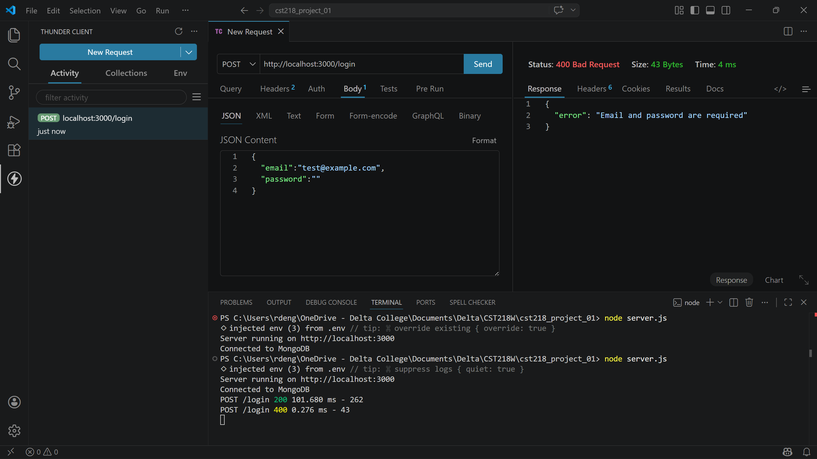
Get all success:
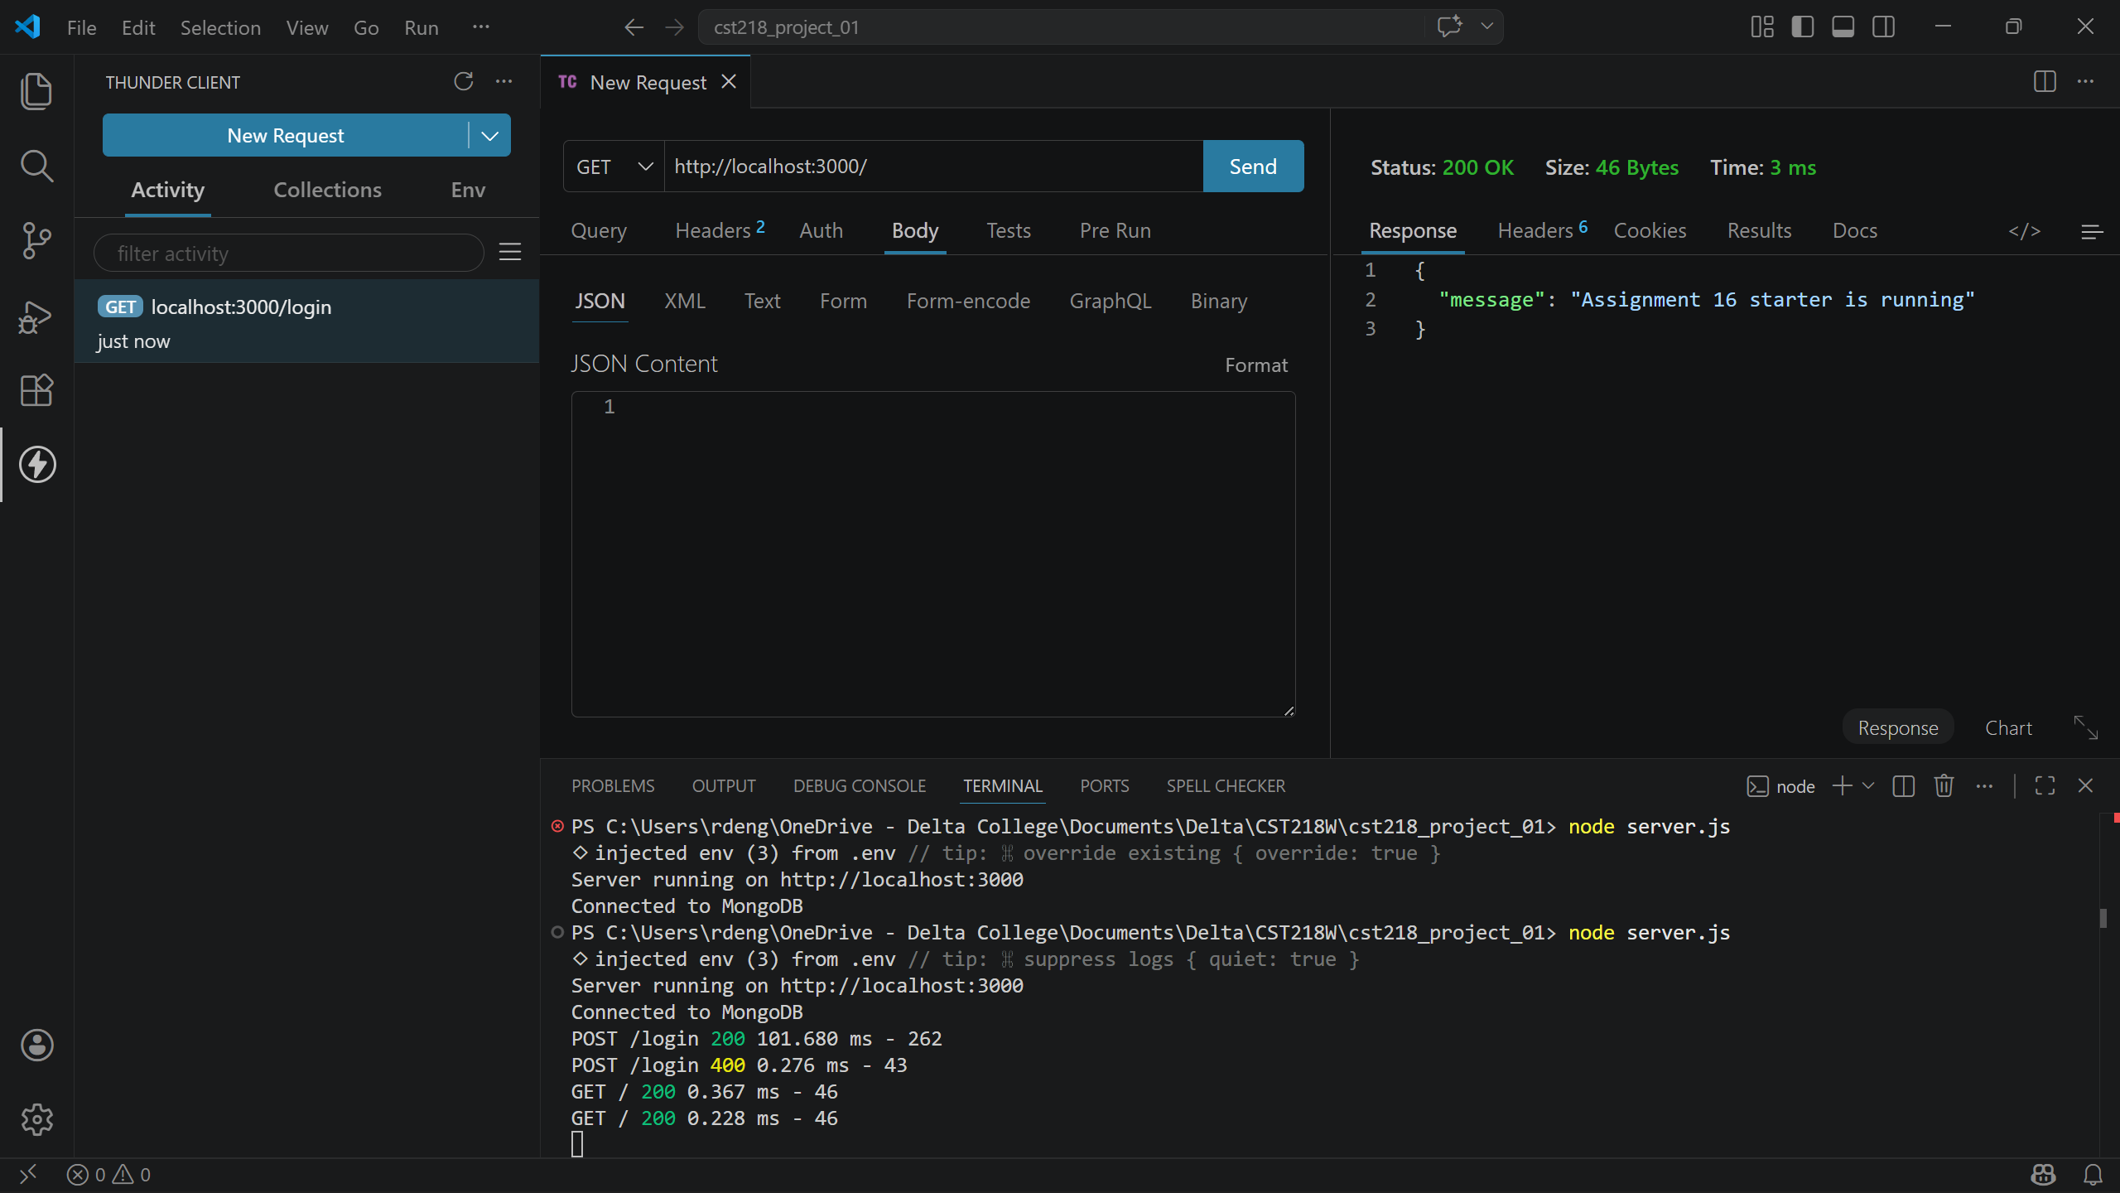
Post create:
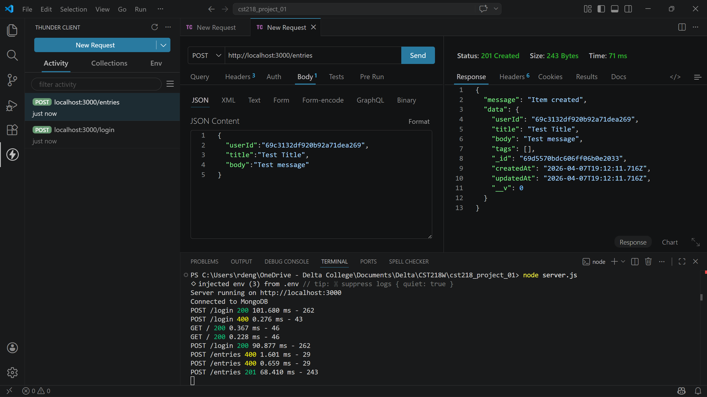
Delete:
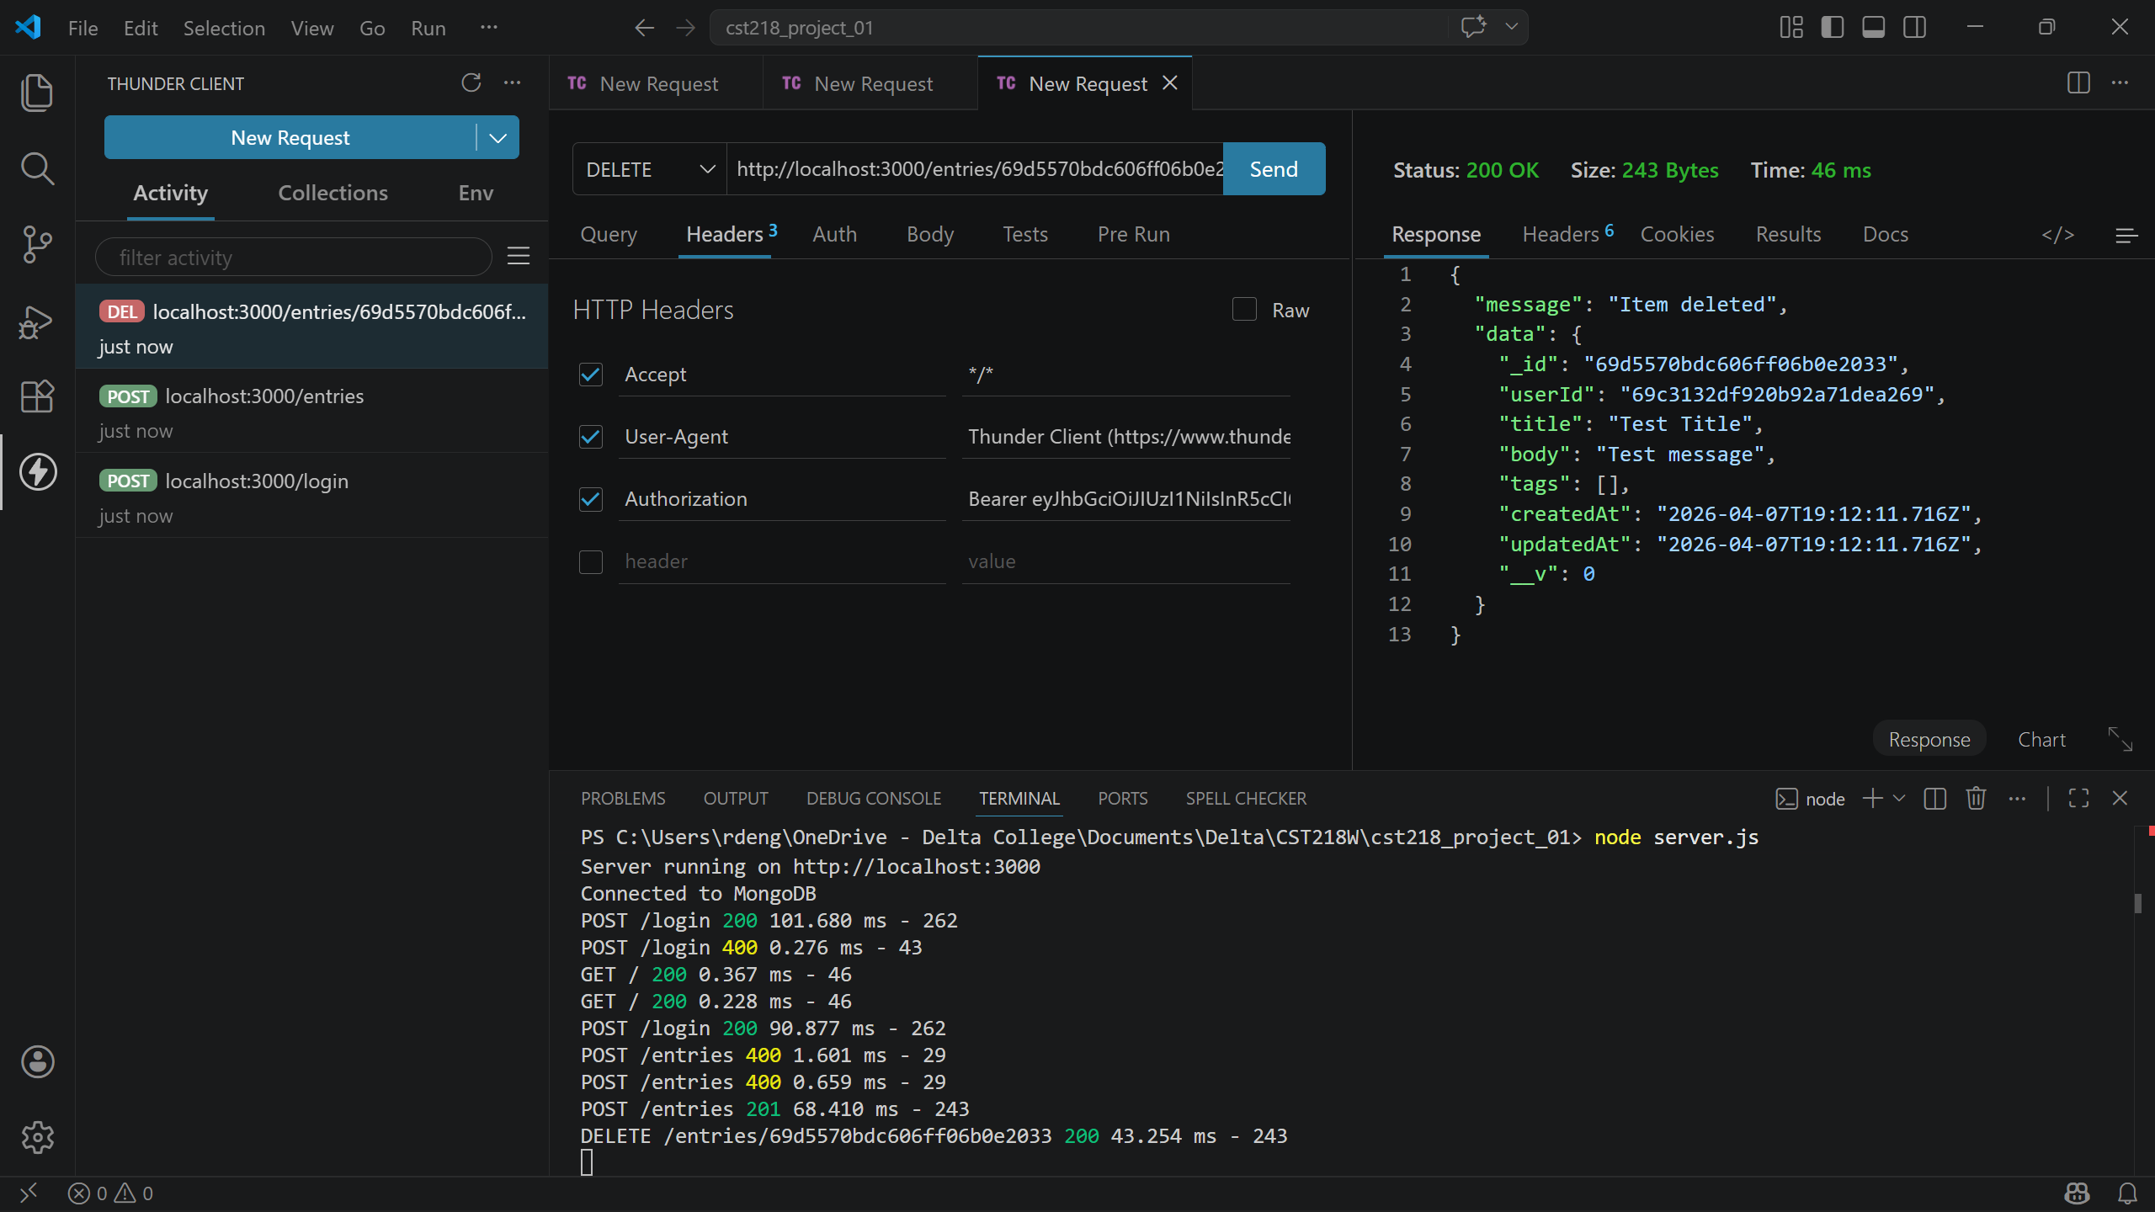

Middleware allowed me to greatly simplify data validation, error handling, and error logging. The trickiest thing about the middleware order was ensuring they were called in the correct order. Next I’m looking forward to improving the user interactivity through GUI elements.

