**Atlanta Regional Commission – MSAA System Design Document**   
**09/30/2017**

**Document Number**: 10.0   
**Federal Award ID Number**: GA-26-0008-01

|  |  |
| --- | --- |
| System Design Document | Table of Contents |

**Table of Contents**

**1.Introduction .............................................................................................................. 6**

1.1 Purpose of the SDD .......................................................................................... 7

1.2 Audience ........................................................................................................... 8

1.3 Executive Summary .......................................................................................... 8

1.3.1 System Overview Summary ....................................................................... 8

1.3.2 Design Constraints ................................................................................... 10

1.3.3 Future Contingencies ................................................................................ 10

1.3.4 Document Organization ............................................................................ 11

**2.General Overview and Design Guidelines/Approach ......................................... 12**

2.1 General Overview ........................................................................................... 12

2.2 Current ............................................................................................................ 12

2.2.1 Proposed Solution - Statement of Need ................................................... 13

2.3 Stakeholder Roles/Responsibilities/Concerns ................................................ 13

2.3.1 Roles ........................................................................................................ 14

2.3.2 Responsibilities ......................................................................................... 15

2.3.3 Concerns .................................................................................................. 18

2.4 System Assumptions/Constraints/Dependencies/Risks .................................. 18

2.4.1 Assumptions ............................................................................................. 18

2.4.2 Constraints ............................................................................................... 18

2.4.3 Dependencies ........................................................................................... 18

2.4.4 Risks ......................................................................................................... 18

Alignment with National/Regional ITS Architectures ....................................... 18

**3.Design Considerations .......................................................................................... 18**

|  |  |
| --- | --- |
| 3.1 3.2 3.3 3.4 3.5 | Goals and Guidelines ...................................................................................... 19 Operational Environment ................................................................................ 19 Development Methods & Contingencies ......................................................... 20 Architectural Strategies ................................................................................... 20 Performance Engineering ............................................................................... 23 |

**4.System Architecture and Architecture Design .................................................... 24**

|  |  |  |
| --- | --- | --- |
| 4.1 System Architecture Diagrams........................................................................ 24  4.1.1 External Systems diagram ........................................................................ 24  4.1.2 Functional/Logical diagram ....................................................................... 24  4.2 Hardware Architecture .................................................................................... 25  4.2.1 Security Hardware Architecture ................................................................ 28  4.2.2 Performance Hardware Architecture ......................................................... 28  4.3 Software Architecture ...................................................................................... 29  4.3.1 Software Elements .................................................................................... 30  4.3.2 Security Software Architecture ................................................................. 31  4.3.3 Performance Software Architecture .......................................................... 32  4.4 Information Architecture .................................................................................. 33 | | |
| SDD Version 4.0 | ii | ARC SGT SDD> |

|  |  |
| --- | --- |
| System Design Document | Table of Contents |
| 4.4.1 Records Management .............................................................................. 34  4.5 Internal Communications Architecture ............................................................ 35  4.6 Security Architecture ....................................................................................... 35  4.7 Performance ................................................................................................... 35 | |

**5.System Design ....................................................................................................... 36**

5.1 Business Requirements .................................................................................. 36 5.1.1 Priorities ....................................................... **Error! Bookmark not defined.** 5.2 Database Design ............................................................................................ 37 5.2.1 Data Objects and Resultant Data Structures ............................................ 37 5.2.2 File and Database Structures ................................................................... 45 5.3 Data Conversion ............................................................................................. 47 5.4 User Machine-Readable Interface .................................................................. 47 5.4.1 Inputs ........................................................................................................ 47 5.4.2 Outputs ..................................................................................................... 47 5.5 User Interface Design ..................................................................................... 47 5.5.1 Section 508 Compliance ........................................................................... 48

**6.Operational Scenarios ........................................................................................... 49**

**1.1Major Operational Scenarios ................................................................................ 49**

**1.2Major Use Cases .................................................................................................... 50**

1.2.1Customer Resources ...................................................................................... 50 1.2.2Vehicle Resources .......................................................................................... 55 1.2.3Driver Resource .............................................................................................. 58 1.2.4Reservations ................................................................................................... 60 1.2.5Scheduling ...................................................................................................... 63 1.2.6Dispatch .......................................................................................................... 66 1.2.7Analytics ......................................................................................................... 69

**7.Detailed Design ...................................................................................................... 72**

|  |  |
| --- | --- |
| 7.1 7.2 7.3 7.4 7.5 | Hardware Detailed Design .............................................................................. 72 Software Detailed Design ............................................................................... 72 Security Detailed Design ................................................................................. 73 Performance Detailed Design ......................................................................... 74 Internal Communications Detailed Design ...................................................... 74 |

**8.System Integrity Controls ..................................................................................... 75**

**9.External Interfaces ................................................................................................. 76**

|  |  |  |  |
| --- | --- | --- | --- |
| 9.1  9.2  9.3  9.4  9.5  9.6 | ATL Transit ..................................................................................................... 76 Google Maps .................................................................................................. 76 OpenTripPlanner............................................................................................. 76 Rideshare ....................................................................................................... 76 Taxi Fare Finder.............................................................................................. 76 Transportation Network Companies (TNC) ..................................................... 77 | | |
| SDD Version 4.0 | | iii | ARC SGT SDD> |

|  |  |
| --- | --- |
| System Design Document | List of Figures |
| 9.7 GTFS Real Time ............................................................................................. 77 9.8 GTFS Flex ...................................................................................................... 77 9.9 Emerging Business Models ............................................................................ 77 9.10 Third Party Commercial Application Integration .............................................. 77 9.11 Transportation Clearinghouse ......................................................................... 78 9.11.1Adapter API .............................................................................................. 78 9.12 Points of Interest ............................................................................................. 78 9.13 Public Transit .................................................................................................. 78 9.14   GTFS .............................................................................................................. 79 9.15 Agencies ......................................................................................................... 79 9.16 Specialized Service Providers ........................................................................ 79 9.17 Providers ......................................................................................................... 79 9.18   Services .......................................................................................................... 80 9.18.1Geocoding ................................................................................................ 80 9.18.2Maps ......................................................................................................... 81 9.18.3Google Street View ................................................................................... 82 9.19 Interface Architecture ...................................................................................... 82 9.20 Interface Detailed Design ................................................................................ 82 | |

**10.Appendix A: Record of Changes .......................................................................... 85**

**List of Figures**

Figure 1: SGT Roles ...................................................................................................... 15 Figure 3: Amazon Web Services model ........................................................................ 21 Figure 4: External systems diagram .............................................................................. 24 Figure 5: Hardware architecture .................................................................................... 25 Figure 6: Security architecture ...................................................................................... 28 Figure 7: Software architecture tiers.............................................................................. 29 Figure 8: SGT high level architecture ............................................................................ 30 Figure 9: Security authentication ................................................................................... 32 Figure 9: Performance architecture scalability .............................................................. 33 Figure 11: Example of a database design ..................................................................... 37 Figure 12: Example of balsamiq mockup ...................................................................... 48 Figure 13: Example of web application hosting ............................................................. 72 Figure 14: Security detail design ................................................................................... 74

|  |  |  |
| --- | --- | --- |
| SDD Version 4.0 | iv | ARC SGT SDD> |

|  |  |
| --- | --- |
| System Design Document | List of Tables |

Figure 14: Sample uber API responses ......................................................................... 77

**List of Tables**

Table 1: Project members contact information .............................................................. 14 Table 2: System design roles ........................................................................................ 15 Table 3: Software descriptions ...................................................................................... 23 Table 4: Systems descriptions ...................................................................................... 25 Table 5: Server requirements ........................................................................................ 27 Table 6: Software elements and descriptions ................................................................ 30 Table 7: SGT future enhancements .............................................................................. 36 Table 8: Data objects and schemas .............................................................................. 37 Table 9: Major operational scenarios ............................................................................ 49 Table 10: Customer use cases ...................................................................................... 50 Table 11: Vehicle use cases ......................................................................................... 55 Table 12: Driver resource use cases ............................................................................. 58 Table 13: Reservation use cases .................................................................................. 60 Table 14: Schedule use cases ...................................................................................... 64 Table 15: Dispatch use cases ....................................................................................... 67 Table 16: Report use cases .......................................................................................... 70 Table 17: 1-Click Points of Interest File Format ............................................................ 78 Table 18: Public Transit Agency Attributes .................................................................... 79 Table 19 - Specialized Services Provider Attributes ...................................................... 79 Table 20: Provider Services attributes........................................................................... 80 Table 21: Map API pros & cons ..................................................................................... 81 Table 22: Record of changes ........................................................................................ 85

|  |  |  |
| --- | --- | --- |
| SDD Version 4.0 | v | ARC SGT SDD> |

|  |  |  |
| --- | --- | --- |
| Page 6 |  | System Design Document |
| **1.** | **Introduction** |  |

ARC serves as the Metropolitan Planning Organization (MPO), the Area Agency on Aging (AAA) serving as the Aging and Disability Resource Center (ADRC), the Workforce Board (for a 7-county area) and the Regional Transit Committee (RTC). This structure facilitated collaboration between the AAA and the MPO regarding the need to increase transportation access for older adults and persons with disabilities and the development of the region’s first Human Services Transportation (HST) Plan. In 2008, ARC successfully

administered the Federal Transit Administration’s (FTA) Mobility Services for All Americans (MSAA) grant for a feasibility study for the Atlanta Regional Transportation Management Coordination Center (TMCC). Findings from the 2008 TMCC study supported the development of an HST Advisory Committee and an update of the HST Plan to facilitate greater coordination of HST transportation services throughout the region.

Many Americans have difficulty accessing some of their basic needs, particularly seniors, persons with disabilities and the economically disadvantaged, because they must rely on human service transportation systems which are often fragmented, unreliable, and inefficiently operated. Lack of coordination is the leading obstacle to meeting the mobility needs of the people who need the services most.

In 2015, the MSAA Initiative funded additional deployment planning projects to further improve HST coordination and delivery. The purpose of this deployment planning effort is to replicate and advance the success of TMCC phased-implementation by providing “seed” funding to leverage other federal, state and

local resources to build up coordinated community transportation services. MSAA’s focus on enhanced coordination supports the realization of USDOT’s strategic focus on developing Mobility on Demand (MOD).

Goals are to use service coordination and technology integration to:

|  |  |
| --- | --- |
| • • | Increase mobility and transportation accessibility for the transportation disadvantaged and the general public.  Achieve more efficient use of federal transportation funding resources (i.e., do more with less). |

**Simply Get There Overview**

Simply Get There.org is a trip-planning resource for anyone and everyone who lives in or visits metro Atlanta. Users can compare different travel options and costs especially if they needspecialized transportation services. It is a relatively new service developed and hosted by the ARC and its Atlanta Area Agency on Aging (AAA). The web-based application uses a comprehensive listing of public and private sector transportation providers in the Atlanta region to help individuals, especially older adults and persons with disabilities, identify available transportation options. It also provides regional fixed route trip planning options as well as biking and for hire options.

SGT Summary:

|  |  |  |  |
| --- | --- | --- | --- |
| • | VTCLI one-call, one-click award | | |
| • | “Trip discovery” tool for public, private, specialized and volunteer transportation services | | |
| o | | Similar to kayak.com | |
| • | Software application developed with Cambridge Systematics | | |
| o | | Pulls from two ARC-developed databases, ESP and atltransit.org | |
| • | Responsive design for use on computers, tablets, and smartphones | | |
| • | Unique to the Atlanta region | | |
| • | Includes specialized transportation | | |
| • | Does not have scheduling capabilities | | |
| SDD Version 4.0 | | 6 | ARC SGT SDD> |

|  |  |
| --- | --- |
| Page 7 | System Design Document |

The project was funded through a Veterans Transportation and Community Living Initiative (VTCLI) grant of the Federal Transportation Administration (FTA) as part of their “One-Click/One-Call” initiative. Launched on March 2015, Simply Get There became the first comprehensive online trip planner for HST populations in the Atlanta region.

**1.1**  **Purpose of the System Design Document (SDD)**

The SDD documents and tracks the necessary information required to effectively define architecture and system design in order to give the development team guidance on the architecture of the system to be developed. Design documents are incrementally and iteratively produced during the system development life cycle, based on the particular circumstances of the information technology (IT) project and the system development methodology used for developing the system.

Cambridge Systematics is the original developer of the current solution.

The intent of the solution was to provide a “one call one click” solution. This was not achieved in the initial implementation. The initial vision of the Regional Mobility One-click software application was to link multiple existing call centers to one centralized database with a multi-functional web interface. This concept would maximize staff resources and make transportation information accessible to a wider range of consumers. Transportation resources would be available to the general public and to participating call center operators. Call center staff would have access to a secure client component of the application to register consumers and assist them in accessing/scheduling services. The system would provide an interface for existing client and transportation resource databases from ESP and atltransit.org.

The proposed solution will simply add additional features and functionality to the existing solution to meet the original scope and vision of the Regional Mobility One Click Software application. These features will extend SFT to be a real and integrated one call – one click mobility management solution.

Key points that relate to the design and architecture of the proposed system.

1) No major changes to existing architecture

2) No major changes to system design

3) Major positive impact to the user community

4) Major feature extensions to automate operational functions

5) Major feature extensions to coordinate multiple call centers and transportation providers

6) Regional Coordination API Middleware development

Based on extensive user interviews conducted during the concept of operations phase, it was revealed that the current solution is lacking in key features. It provides strong multi-modal trip planning functions but is limited in back office operational features and lacks one call one click functionality for the consumer. Simply Get There will be expanded to include to create a true one call one click center. The following additional major functionality that users requested to be added or improved include:

|  |  |  |  |
| --- | --- | --- | --- |
| • | Web-Based Reservations |  |  |
| • | Automated Scheduling |
| • | Provider Management |
| • | Trip – Provider Assignment |
| • | Automated Dispatching |
| • | Regional Transportation Coordination |
| • | Regional Cost Allocation |
| SDD Version 4.0 | | 7 | ARC SGT SDD> |

|  |  |  |
| --- | --- | --- |
| Page 8 |  | System Design Document |
| • | Automated Fare Payment |  |
| • |
| Mobility on Demand Mobile App for consumers and operators |
| **1.2** |
| **Audience** |

The intended audience for the SDD is the project manager, project team, and the future development team. The audience or users for this system design document include the following:

|  |  |
| --- | --- |
| • • • • •  **1.3**  **1.3.1** | ARC Project Management Team  ARC Information Technology Team  Future application development team  FTA Project Managers and Oversight Team Internal Consulting Team  **Executive Summary**  **System Overview Summary** |

ARC has entered a cooperative agreement with FTA to create system specifications for a web-based application that will bring the system forward from “trip discovery” (pinpointing options) to “trip transaction" (centralized booking, scheduling, and dispatching). ARC staff will work with Ride Connection and the third party consultants to design this application. ARC plans to issue an RFP for competitive procurement.

As with websites like kayak.com that aggregate airline data, the long-range vision is for residents to book trips through one online web application, ideally supplemented with phone services. This concept and application design will include the entire process of establishing eligibility, scheduling a trip, finding the right transportation mode and provider, executing the trip, and invoicing the client and paying the provider, as applicable. The application must be designed to be intuitive, supportable, scalable, cost effective, and have the foundation to support future growth. It should also be user-friendly for the general public, transportation and service providers, and ARC staff. ARC has developed an extensive network of external partners and may want to grow or extend the network over time. These partners may wish to access the information directly through a user interface or through an API into their own client system.

ARC must have a hierarchy of access points within the application’s administrative functions so that ARC may select the level of access for various external partners.

Project goals include:

1) Integration with Simply Get There trip discovery web application   
2) Ability to create client profiles with permissions to use multiple providers, records of current

eligibility, trip accommodations needed, and indication of other programs they might join 3) "Trip triaging” capabilities to find ideal cost/accommodations match   
4) Ability to schedule a trip

5) Ability to pay for a trip   
6) Ability for ARC or a provider to charge a user and for ARC to pay a provider

7) Information on and ability to schedule travel coaching/training assistance   
8) Cross-modal trip booking and connections to manifest creation and scheduling systems as well as

route optimization across modes   
9) Payment and billing - Cost sharing calculated on back-end   
10) Data analysis/monitoring to find efficiencies and influence planning/future implementation in a system-wide feedback loop   
11) Modular system (“plug and play” system that users could adapt to local needs)   
12) Integration with third party systems, including Computer- Aided Dispatched /Automatic Vehicle CAD AVL software, Google, Google Maps, RouteMatch, and Trapeze   
13) Ability to track trips by the funding source   
14) Ability to generate invoices

|  |  |  |
| --- | --- | --- |
| SDD Version 4.0 | 8 | ARC SGT SDD> |

|  |  |
| --- | --- |
| Page 9 | System Design Document |

15) Web-based application that can be hosted or deployed locally on ARC servers or a location of

ARC’s choosing   
16) A robust API to map data from other ARC and partner systems   
17) Ability to house some transportation provider information on this application, rather than pulling all information from two external databases   
18) Ability to be 508 compliant

The major new functional modules and extensions to support the goals above may include:

|  |  |
| --- | --- |
| ▪ ▪ ▪ ▪ ▪ ▪ ▪ ▪ ▪ ▪ ▪ ▪ ▪ | Coordinated Eligibility Determination  Coordinated Resource Management  Automated Web Reservations  Electronic Payment  Automated Scheduling and Provider Assignment Route Planning and Optimization  Multi Modal Transportation Coordination  Real Time Vehicle Tracking and Dispatching Transportation Verification  Transportation Data Analytics  Customer Mobile App  Driver Mobile App  Regional Coordination API Middleware |

ARC requires a design with specific functionality to model internal business processes, workflows, partner needs, and integration requirements. ARC requires a design that allows ARC to own the application but may become open source that can be available for use in other parts of the U.S.

**User Types**

SGT is designed to serve the needs of many different types of users, with features and functions appropriate for each one:

|  |  |
| --- | --- |
| ▪  ▪ ▪ ▪ ▪ ▪ | Travelers are individuals in need of transportation services. Registered Travelers have a user account and travel profile, while anonymous Travelers do not have an account and can use the system without logging in.  Buddies are friends, family members, or other caregivers who assist Travelers in creating trip plans and managing account settings.  Agents are customer service representatives who assist Travelers in creating trip plans and managing account settings.  Agency Administrators are the managers of Agents, who perform maintenance functions related to their Agency.  Provider Administrators are representatives of organizations that provide transportation services, who need to manage and maintain information on the services they provide.  System Administrators are the “super-users” who manage the SGT software. |

**Modes Currently Supported in SGT**

|  |  |  |  |
| --- | --- | --- | --- |
| ▪ ▪ | Bicycle;  Drive; | |  |
| ▪ | Paratransit from local providers; | |
| ▪ ▪ | Taxi;  Transit (Bus, Rail) based on General Transit Feed Specification; and, | |
| ▪ | Walk; | |
| ▪ | UberX | |
| SDD Version 4.0 | | 9 | ARC SGT SDD> |

|  |  |  |
| --- | --- | --- |
| Page 10 |  | System Design Document |
| **1.3.2** | **Design Constraints** |  |

The proposed solution will utilize the current architecture and system design of the current solution. The current solution is hosted in an industry leading application hosting and data center. Performance, storage, security, and access can be easily scaled using to meet the minimal amount of additional resources the proposed solution will require. This will be a financial constraint that must be considered.

**Financial**

The largest design constraint for the implementation of the project is financial. The full implementation of the project could be financially significant. ARC intends to implement a phased approach to manage this constraint.

**Technical**

The development and integration of the new software components into the existing open source software application is a major constraint. Specifc skills and technical understanding of mobility management and demand response management and optimization will be required. This knowledge and skillset is very specific and narrow. Detailed business requirements and use cases will assist in minimizing this challenge.

Transportation coordination and trip sharing will be a major technical consideration. The proposed system must support regional coordination features and provide the ability to integrate trip data into other scheduling and dispatching systems. The coordination function must allow for easy integration and

provide open published API’s.

Due to the fact that the application is currently hosted and managed by ARC staff, we do not envision any technical computer hardware, network, internet, or database maintenance challenges.

**Institutional**

The proposed system will be utilized by multiple third party agencies and organizations. This will require coordination and collaboration across the region. Stakeholders that currently have automated

scheduling systems may have to integrate into the proposed system via a “reginonal trip coordination” API or comparable solution.

**1.3.3**  **Future Contingencies**

The current application has multiple third party dependencies. These third party dependencies are mission critical to the application. Failures or service stoppage severely impacts the applications capabilities.

SGT utilizes existing third party dependencies. These are currently availalble and published. The dependencies include:

|  |  |
| --- | --- |
| • •  • | Google Maps API – Utilized as mapping and geocoding engine for the application. Enhanced Services Program (ESP) Database Connector – Serves as data source for HHS and demand response service providers.  OpenTrip Planner API – Utilized to calculate fixed route trip itinerary. |

**Fixed Route Trip Planning API**

The fixed route trip planning functionality utilizes Open Trip Planner (OTP). If OTP becomes unavailable or the service stops, SGT will fail. Google Maps would be a viable alternative for trip planning   
functionality. OTP is open source which would allow ARC to maintain the service themselves. This would require a minimal level of effort to maintain and manage.

**Demand Response Options API**

|  |  |  |
| --- | --- | --- |
| SDD Version 4.0 | 10 | ARC SGT SDD> |

|  |  |
| --- | --- |
| Page 11 | System Design Document |

The current application incorporates demand response data from an in-house custom application – ESP. ESP is maintained and managed by the Aging Resources staff and utilize the system for information and referral. SGT is dependent on the transportation provider database. If not available, an alternative source would need to be developed, purchased, or integrated. This would be a major effort and not a good alternative. The risk of ESP becoming unavailable is minimized. ARC owns and manages this application directly.

Due to the lack of major architectural and system design changes associated with the proposed solution, contingency risks are very minimal.

**1.3.4**  **Document Organization**

This document completely describes the system at the architecture level, including subsystems and their services, hardware mapping, data management, access control, global software control structure, and boundary conditions. The document is organized into nine major sections. Each section provides detailed sub-sections relevant to the major section. Charts, tables, and graphics have been inserted to explain or clarify content.

|  |  |  |
| --- | --- | --- |
| SDD Version 4.0 | 11 | ARC SGT SDD> |

|  |  |
| --- | --- |
| Page 12 | System Design Document |
| **2.** | **General Overview and Design Guidelines/Approach** |
| **2.1** | **General Overview** |

The current solution was built by Cambridge Systematics through funding from the Federal Transit Administration’s Veterans Transportation and Community Living Initiative grant program. ARC has privately labeled this application Simply Get There (SGT). SGT is an open source mobility management and cross-modal trip planning software that connects people who need transportation to education, work, health care, and other vital services in their communities.

SGT is built on an open source framework. Source code is available using standard open source management tools such as Git. All source code is stored in a Github repository. Any developer can contribute to the application.

SGT utilizes an open-source web server, Nginx. Nginx is a free open source web server. Nginx is focused on high performance, high concurrency and low memory usage. Additional features on top of the web server functionality, like load balancing, caching, access and bandwidth control, and the ability to integrate efficiently with a variety of applications, have helped to make Nginx a good choice for modern website architectures. Currently Nginx is the second most popular open source web server on the Internet.

SGT is hosted on Heroku. Heroku is a cloud Platform-as-a-Service (PaaS) supporting several programming languages that is used as a web application deployment model. Heroku, one of the first cloud platforms, has been in development since June 2007, when it supported only the Ruby programming language, but now supports multiple other languages.

SGT’s development language is Ruby. Ruby is commonly integrated with Rails, a software library that

extends Ruby’s capabilities. This framework is commonly referred to as “Ruby on Rails”. Software developers must be familiar with this framework in order to maintain or build additional functionality into the application.

SGT’s database is Postgres. Postgres is also open source and it is very popular and utilized across many open source applications. Postgres is an object-relational database (ORDBMS). It has an emphasis on extensibility and standards compliance.

Github is used as the software development platform. Github provides version control and source code management. Github is the largest host of soure code in the world.

In summary, the existing system design includes the following sub-systems:

• SGT Web Application

• Postgres Database

• Ngenx Web Server

• Heroku Development Platform

• Heroku

• Github Version and Source Code Control

There is no expectation that any of these systems will be changed or modified with the proposed system.

**2.2**  **Current**

A Statement of Need explains why the system is being developed, what purpose it serves, and why it is necessary.

|  |  |  |
| --- | --- | --- |
| SDD Version 4.0 | 12 | ARC SGT SDD> |

|  |  |
| --- | --- |
| Page 13 | System Design Document |

SGT was designed to meet the transportation needs of human service transportation clients such as Veterans, military families, elderly, disabled, other transportation disadvantaged.

SGT is a trip planning system designed to meet the transportation needs of human service clients including veterans, military families, elderly, disabled and other transportation disadvantaged groups. It:

|  |  |
| --- | --- |
| ▪ ▪ ▪ ▪ | Provides unified trip planning for public, private and volunteer services; Works on computers, tablets, and smartphones;  Is tailored to an individuals’ trip planning needs; and  Empowers call center staff to deliver improved services. |

Veterans and their families are often in need of transportation services to enable them to attend medical appointments, receive physical therapy or mental health counseling, seek jobs or education, and access various veterans and related community services. Some veterans and family members have disabilities – mental, physical, or developmental – that exacerbate the challenge of obtaining these services.

Numerous other populations experience similar challenges, including the elderly, transit-dependent populations, and other nonveterans with disabilities.

SGT enables these target populations to quickly and easily identify the most appropriate options for making a particular trip, evaluating and identifying options that include fixed-route transit, demand-responsive transit (DRT), taxi and other private transportation services, paratransit, volunteer   
transportation service networks, carpools, and vanpools. 1-Click also provides call center or social service agency staff with a single, centralized source of this information to use on behalf of their clients.

SGT tailors trip plan options to the needs, preferences, and schedules of each individual, based on

factors such as Medicaid eligibility, veterans’ transportation eligibility (which depends on Veteran status and trip purpose), age, physical mobility limitations, and other preferences regarding tradeoffs of time, cost, and convenience.

SGT also stores data that can be used to generate a variety of reports on system usage, mobility impacts, trips planned and made, and unmet transportation needs.

**2.2.1**  **Proposed Solution - Statement of Need**

The current solution does not provide call center operational support nor does it provide the ability to coordinate other regional call centers and transportation resources. The solution must be extended to support these functional needs. The proposed system will dramatically improve call center operations, regional coordination, and, most importantly, the customer experience. Customers will be able to plan and reserve transportation online. Transportation providers will be able to connect to the one click system in real time to schedule the trip. Operations will have the ability to assign trips and to monitor performance in real time. Automated scheduling and routing will be available to optimize transportation resources. Automate dispatching tools will be available to the call center and to providers. This will create a single coordinated system for HST and demand response transportation. Transportation Network Companies (TNC) will also be integrated into the solution for a true multi-modal application. Transportation data analytics will be available at a regional level. Ultimately, the proposed system will

execute the intended vision and requirements of a “one click” mobility management solution.

**2.3**  **Stakeholder Roles/Responsibilities/Concerns**

System design can cross many different groups within an organization to ensure requirements are gathered and met for all stakeholders. As such, the roles and responsibilities section may be necessary to provide the team with clarification on who performs various roles. This section also serves as a list of points of contact for the team and stakeholders should issues and concerns arise which need to be addressed.

**Regional Stakeholders**

1. ARC Aging and Disability Resource Connection (ADRC) 2. ARC Transportation Access and Mobility Services Division

|  |  |  |
| --- | --- | --- |
| SDD Version 4.0 | 13 | ARC SGT SDD> |

|  |  |
| --- | --- |
| Page 14 | System Design Document |

3. ARC Area Agency on Aging   
4. Center for Visually Impaired (CVI)   
5. City of Atlanta, Vehicles for Hire/Taxi Management   
6. Cobb Community Transit (CCT)   
7. DeKalb Office of Senior Affairs   
8. Disability Link, the Center for Independent Living (CIL)   
9. Goodwill Industries   
10. Georgia Commute Options (GCO)   
11. Georgia Department of Community Health (DCH)   
12. Georgia Department of Human Services (DHS)   
13. Georgia Department of Transportation (GDOT)   
14. Georgia Governor’s Development Council (GDC), Rural and Human Services Transportation (RHST)   
15. Georgia Transit Association (GTA)   
16. Gwinnett County Senior Services   
17. Lifespan Resources (volunteer driver program)   
18. Metropolitan Atlanta Rapid Transit Authority (MARTA)   
19. Ride Connection of Portland, Oregon   
20. Atlanta United Way 211   
21. Veterans Affairs (VA), Veterans Transportation Program (VTP)

Additional support is provided by Kevin Chambers, IT Director of Ride Connection in Portland, OR.

**Technical / Project Stakeholders**

The following table provides the role and contact information for the key technical and project stakeholders associated with the system design.

**Table 1: Project members contact information**

|  |  |  |  |
| --- | --- | --- | --- |
| Name | | Role | Email |
| Mary Blumberg | | Executive Sponsor | mblumberg@atlantaregional .com |
| Cynthia Burke | | Project Manager | [Cburke2@atlantaregional.com](mailto:Cburke2@atlantaregional.com) |
| Leslie Caceda | | Application Owner | lcaceda@atlantaregional.com |
| Ray Randolph | | IT Director | rrandolph@atlantaregional.com |
| Tim Quinn | | Technical Lead | [Tim.quinn@thingtech.com](mailto:Tim.quinn@thingtech.com) |
| Carly Harper | | Business Consultant | Carly.harper@thingtech.com |
| **2.3.1** | **Roles** |

SGT is designed to serve the needs of many different types of users, with features and functions appropriate for each one:

|  |  |  |  |
| --- | --- | --- | --- |
| ▪ | Travelers are individuals in need of transportation services. Registered Travelers have a user | | |
| account and travel profile, while anonymous Travelers do not have an account and can use the system without logging in. | | | |
| ▪ | Buddies are friends, family members, or other caregivers who assist Travelers in creating trip plans | | |
| and managing account settings. | | | |
| ▪ | Agents are customer service representatives who assist Travelers in creating trip plans and | | |
| managing account settings. | | | |
| SDD Version 4.0 | | 14 | ARC SGT SDD> |

|  |  |
| --- | --- |
| Page 15 | System Design Document |
| ▪ ▪ ▪ | Agency Administrators are the managers of Agents, who perform maintenance functions related to their Agency.  Provider Administrators are representatives of organizations that provide transportation services, who need to manage and maintain information on the services they provide.  System Administrators are the “super-users” who manage the SGT software. |

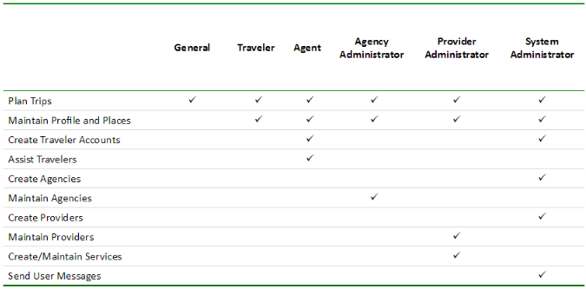

**Figure 1: SGT Roles**

The following table identifies the system design roles. This matrix also serves as the list of points of contact for issues and concerns relating to the system design.

**Table 2: System design roles**

|  |  |  |  |
| --- | --- | --- | --- |
| **Name** | **Role** | **Phone** | **Email** |
| Not Identified | Project Manager |  |  |
| Not Identified | Lead Designer – User Interface |  |  |
| Not Identified | System Architect |  |  |
| Not Identified | Software Developer |  |  |
| Not Identified | Quality Assurance Lead |  |  |

|  |  |
| --- | --- |
| **2.3.2** | **Responsibilities** |

Development team has not been selected to design and build the extended functionality to the current system. However, the items below define the roles for the project.

**Project Manager**

|  |  |  |
| --- | --- | --- |
| SDD Version 4.0 | 15 | ARC SGT SDD> |

|  |  |
| --- | --- |
| Page 16 | System Design Document |

Project management responsibilities include delivering every project on time within budget and scope. Project managers should have a background in business skills, management, budgeting and analysis.

Responsibilities:

|  |  |
| --- | --- |
| • • •  • • • • • • • • • | Coordinate internal resources and third parties/vendors for the flawless execution of projects Ensure that all projects are delivered on-time, within scope and within budget  Developing project scopes and objectives, involving all relevant stakeholders and ensuring technical feasibility  Ensure resource availability and allocation  Develop a detailed project plan to track progress  Use appropriate verification techniques to manage changes in project scope, schedule and costs Measure project performance using appropriate systems, tools and techniques  Report and escalate to management as needed  Manage the relationship with the client and all stakeholders  Perform risk management to minimize project risks  Establish and maintain relationships with third parties/vendors  Create and maintain comprehensive project documentation |

**Lead Designer – User Interface**

UI designer is responsible for creating intuitive user experiences. The ideal candidate should have an eye for clean and artful design, possess superior UI skills and be able to translate high-level requirements into interaction flows and artifacts, and transform them into beautiful, intuitive, and functional user interfaces.

Responsibilities

|  |  |
| --- | --- |
| • • • • • • • | Collaborate with product management and engineering to define and implement innovative solutions for the product direction, visuals and experience  Execute all visual design stages from concept to final hand-off to engineering  Conceptualize original ideas that bring simplicity and user friendliness to complex design roadblocks  Create wireframes, storyboards, user flows, process flows and site maps to effectively communicate interaction and design ideas  Present and defend designs and key milestone deliverables to peers and executive level stakeholders  Conduct user research and evaluate user feedback  Establish and promote design guidelines, best practices and standards |

**Software Architect**

Responsible for initial design and development of new software or extensive software revisions; products may be for use internally or for resale. Defines product requirements and creates high-level architectural specifications, ensuring feasibility, functionality, and integration with existing systems/platforms. Requires a bachelor's degree and may be expected to have an advanced degree in area of specialty and at least 7 years of experience in the field or in a related area.

|  |  |  |  |
| --- | --- | --- | --- |
| • | Demonstrates expertise in a variety of the field's concepts, practices, and procedures. | | |
| SDD Version 4.0 | | 16 | ARC SGT SDD> |

|  |  |
| --- | --- |
| Page 17 | System Design Document |
| • • •  • | Relies on extensive experience and judgment to plan and accomplish goals.  Performs a variety of complicated tasks.  May provide consultation on complex projects and is considered to be the top level contributor/specialist.  May guide a team of developers through the project to completion. Typically reports to a head of a unit/department or top management. |

**Software Engineer**

The software engineer builds high-quality, innovative and fully performing software in compliance with

coding standards and technical design. Software engineer responsibilities will include development,

writing code, and documenting functionality.

• Execute full lifecycle software development

• Write well designed, testable, efficient code

• Produce specifications and determine operational feasibility

• Integrate software components into a fully functional software system

• Develop software verification plans and quality assurance procedures

• Document and maintain software functionality

• Tailor and deploy software tools, processes and metrics

• Serve as a subject matter expert

• Comply with project plans and industry standards

**Quality Assurance Lead**

QA engineer responsibilities include designing and implementing tests, debugging and defining corrective

actions. You will also review system requirements and track quality assurance metrics (e.g. defect

densities and open defect counts.)

Responsibilities

|  |  |  |  |
| --- | --- | --- | --- |
| • | Review requirements, specifications and technical design documents to provide timely and meaningful feedback | | |
| • | Create detailed, comprehensive and well-structured test plans and test cases | | |
| • | Estimate, prioritize, plan and coordinate testing activities | | |
| • | Design, develop and execute automation scripts using open source tools | | |
| • | Identify, record, document thoroughly and track bugs | | |
| • | Perform thorough regression testing when bugs are resolved | | |
| • | Develop and apply testing processes for new and existing products to meet client needs | | |
| • | Liaise with internal teams (e.g. developers and product managers) to identify system requirements | | |
| • | Monitor debugging process results | | |
| • | Investigate the causes of non-conforming software and train users to implement solutions | | |
| • | Track quality assurance metrics, like defect densities and open defect counts | | |
| • | Stay up-to-date with new testing tools and test strategies | | |
| SDD Version 4.0 | | 17 | ARC SGT SDD> |

|  |  |  |
| --- | --- | --- |
| Page 18 |  | System Design Document |
| **2.3.3** | **Concerns** |  |

Due to the fact that the proposed system is simply additional features and will not require any design or architectural changes, there are no technical concerns.

**2.4**  **System Assumptions/Constraints/Dependencies/Risks**

**2.4.1**  **Assumptions**

The largest assumption is that the existing SGT trip planning application will be extended to support the proposed new features. The existing architecture and system design will be used including all existing components and sub-systems. It is certain that additional functionality will be added to the proposed solution.

**2.4.2**  **Constraints**

There are no hardware, software, or software technical constraints identified with this project. Financial constraints are a potential constraint since funding has not been identified to build the proposed solution. Institutional constraints mays exist due to the systems need for regional coordination, participation, and interoperability.

**2.4.3**  **Dependencies**

The current application is dependent on many third party systems. These include:

• Open Trip Planner

• Google Maps

• ESP

• Uber (if shared ride mode is enabled)

The current application is also dependent on accurate GTFS data. ARC is currently responsible for maintaining the GTFS data for the regional fixed route providers.

**2.4.4**  **Risks**

Minimal risk is associated with the system design. This is primarily due to the fact that the existing system design and architecture will not be modified to meet the needs of the proposed solution. Financial risks are a concern. Funds have not been identified to fund the proposed project. Ongoing maintenance of the system will also be a concern.

Alignment with National/Regional ITS ArchitecturesThe current and proposed solution aligns with the National and Regional ITS architecture. The proposed solution, if implemented, will adhere to all appropriate federal ITS architecture mandates.

Design Considerations

SGT is a trip planning system designed to meet the transportation needs of human service clients including veterans, military families, elderly, disabled and other transportation disadvantaged groups. It:

|  |  |  |  |
| --- | --- | --- | --- |
| ▪ ▪ | Provides unified trip planning for public, private and volunteer services; Works on computers, tablets, and smartphones; | |  |
| ▪ | Is tailored to an individuals’ trip planning needs; and | |
| ▪ | Empowers call center staff to deliver improved services. | |
| SDD Version 4.0 | | 18 | ARC SGT SDD> |

|  |  |
| --- | --- |
| Page 19 | System Design Document |

The major design considerations for the proposed extended features are related to system performance and scalability of the solution. Data center is hosted in AWS which provides a tremendous amount of flexibility in terms of scaling the performance. Processor speed, memory, peripherals, and stakeholder support will be factored in the design.

**2.5**  **Goals and Guidelines**   
The following goals must be addressed in the execution of the proposed solution.

**Leverage Existing Architecture**   
The proposed solution must leverage the current architecture and system design used by current solution. This minimizes negative impacts on usability, user experience, and financials. The proposed solution will simply extend the current application to support additional features, functionality, and use cases.

**Development Environment**   
The application development environment must remain consistent. This minimizes negative impacts to interoperability and quality. ARC does not wish to re-write or re-engineer the existing application unless absolutely necessary.

**Ease of Use**   
The new features must be easy to use and provide a strong user experience. New features cannot impact existing functionality from a user perspective.

**Extensibility**   
The proposed features must be extensible. Features can be enabled as needed or required by the users.

**API Enabled**   
Regional coordination support is a key driver of the project. The application must be API centric and support an open and published API architecture.

**RESTful Framework**   
The application and underlying architecture must be a REST framework.

|  |  |
| --- | --- |
| **2.6**  ▪ ▪ ▪ ▪ ▪ ▪ | **Operational Environment**  Ruby on Rails Development  Git Version Control  Github Repository  PostgreSQL Database  Apache Web Server  NGINX Server |

Functional goals of the proposed system includes:

|  |  |  |  |
| --- | --- | --- | --- |
| • | Extending functionality of the existing web application | |  |
| • | Improving application performance | |
| • | Sharing and coordinating data via a distributed model | |
| • | Completing the one-call one click deployment model | |
| SDD Version 4.0 | | 19 | ARC SGT SDD> |

|  |  |  |
| --- | --- | --- |
| Page 20 |  | System Design Document |
| **2.7** | **Development Methods & Contingencies** |  |

The basics of a good architecture is to layer the application into multiple autocratic and autonomous applications that can be replaced individually and allow us to keep the application running while we are working on a specific layer. The communication between each layer should be a RESTful API call with JSON content.

Scalability

Ensure that the architecture can be scaled horizontally, across multiple servers and across multiple regions. That means that once your traffic goes up, you should be able to add and remove new servers as the solution requires.

Availability

The architecture should support a high availability environment. Infrastructure redundancy is required. This ensures the solution is available if multiple servers or an entire data center fail. The current availaibility of the solution per the hosting providers service level agreement is 99.999% availability.

Security

Solution architecture should expose only the minimal amount of code possible. Most of the back-end pieces should be hidden away. In addition to that, security of each system should be multi-layered.

Extensibility

Architecture must be able to swap out modules, change layers, and add pieces to the application without having to worry about the underlying data contracts in place.

Separation of responsibility

System should be modular enough that each piece of code has a set of responsibilities and not more. The back-end should not create front end code nor should the front-end code include business logic.

RESTful Framework

The reason for a RESTful API is plain and simple flexibility. Framework does not want to be tied or dependent on a specific programming language and architecture (Java or C#). Architecture needs to be able to replace each layer independently and even use different languages that might be better suited for a certain layer.

**2.8**  **Architectural Strategies**

The Cloud trend is one of the most disruptive and challenging forces impacting customers’ applications and infrastructure, requiring new business models and new architecture decisions, which impact how organizations deploy, manage, maintain, and protect and manage their data.

Amazon Web Services offers multiple options for provisioning IT infrastructure and the deployment of web-based applications. The deployment model varies from customer to customer. Below are the key strategies associated with this model.

**Infrastructure On Demand**

In a non-cloud environment: (i) infrastructure assets require manually configured, (ii) capacity requires manual tracking, (iii) capacity predictions are based on the guess of a theoretical maximum peak, and (iv) deployment can take weeks. Within the cloud, these building blocks that represent the Infrastructure are not only provisioned as required, following actual demand and allowing pay-as-you-go, but can also be programmed and addressed by code. This greatly enhances flexibility for both Production/Dev/Test environments as well as Disaster Recovery scenarios. Resources can be provisioned as temporary, disposable units, freeing users from the inflexibility and constraints of a fixed and finite IT infrastructure.

|  |  |  |
| --- | --- | --- |
| SDD Version 4.0 | 20 | ARC SGT SDD> |

|  |  |
| --- | --- |
| Page 21 | System Design Document |

Infrastructure can be automated through code, allowing for greater self-service and more automated delivery of desired business and technical outcomes. Consumption is measured by what you consume, not what you could consume, drastically changing the DR cost modelling challenges experienced today. This represents a major, disruptive reset for the way in which you approach Disaster Recovery, testing, reliability and capacity planning.

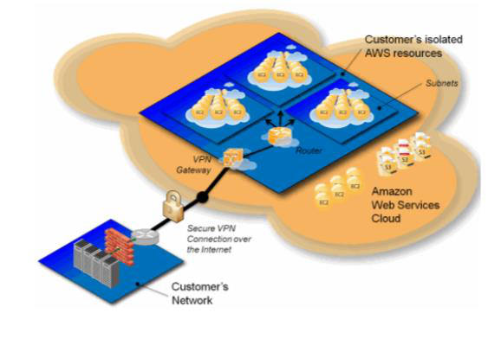

**Figure 2: Amazon Web Services model**

**Cloud Computing**

Cloud computing is a model for enabling ubiquitous, convenient, on-demand network access to a shared pool of configurable computing resources (e.g., networks, servers, storage, applications, and services) that can be rapidly provisioned and released with minimal management effort or service provider interaction. Cloud computing has become the primary engine driving IT as a service. With cloud

computing, you don’t need to make large upfront investments in hardware and spend a lot of time managing that hardware. Instead, you can provision exactly the right type and size of computing resources you need to power your newest bright idea or operate your IT department. As the cloud has become mainstream and adoption has garnered momentum, you have access to state-of-the-art technology at a fraction of the cost and with greater speed than ever before.

AWS offers global infrastructure available to Customers on a pay-as-you-go model, allowing for more flexibility in meeting requirements for Data Protection and Disaster Recovery. Resources, bandwidth and their availability can now be localized to your corporate assets and human resources, allowing for a more distributed footprint that reduces backup windows and simplifies data protection that otherwise would be cost prohibitive with a physical datacenter or co-located approach, all while maintaining a simplified, unified pay-as-you-go billing approach.

**Disaster Recovery**

|  |  |  |
| --- | --- | --- |
| SDD Version 4.0 | 21 | ARC SGT SDD> |

|  |  |
| --- | --- |
| Page 22 | System Design Document |

Physical DR environments have less capacity than their Production, or Dev/Test counterparts, resulting in degraded service in the event of a failover. Even more so, hardware is often re-purposed to fulfill the DR environment’s requirements, resulting in higher than expected maintenance costs. With the Public Cloud model, this hardware availability and refresh aspect is disrupted by removing the need to maintain a hardware fleet that can meet both your DR requirements and sustain your service level agreements. You can provision instances to meet your needs, when you need them, and for specific DR events – both real and test – and the underpinning hardware is maintained and upgraded by the Cloud provider without any need for technical input, and no upgrade costs are incurred by the organization. This dynamic shift allows you to begin costing per DR event, instead of paying for availability, improving your level of Disaster Recovery Preparedness through the application of flexible, unlimited resources to stage both DR tests and execute actual DR events.

**Mobility**

Mobility has fundamentally changed the way businesses operate. Information is available in multiple devices, in real time, and with greater accuracy than ever before. Mobility and the cloud together make it easier for workers to be productive from anywhere—not just the office. The mobile tools they use must be secured to meet tough industry standards.

**Social**

Social media has had a significant impact on the way people work. Employees can share information in real time, with multiple inputs and transparency.

In a non-cloud environment you would have to provision capacity based on a guess of a theoretical maximum peak. This can result in periods where expensive resources are idle or occasions of insufficient capacity.

**Scalability**

Applications grow over time, and a Data Management solution needs to adapt with the change rate to protect the dataset quickly and efficiently, while maintaining an economy of scale that continues to generate business value out of that system.

**Backup/Archive to the Cloud**

Protecting data at the primary on-premise location by writing directly to an external cloud provider’s storage solution, or retaining a local copy and replicating the backup/archive data (either in full, or only selective portions of that data) into an external cloud provider’s storage service

**Platform**

Platform as a Service (PaaS) is the next step down from Software as a Service (SaaS) in the Cloud Computing Stack.

PaaS provides the platform for developing SaaS applications and services.

Includes software development tools, network connectivity, application servers, database management, enterprise service buses, analytics, etc…

|  |  |
| --- | --- |
| • • • | OpenShift  Heroku  Amazon |

The current application utilizes a platform as a service (PaaS). Below is the summary of this service.

|  |  |  |  |
| --- | --- | --- | --- |
| • • | Heroku Platform as a Service (PaaS): Cedar -14 Stack using Ubuntu 14.04 Linux as a basis  Polyglot Platform – native support for development with :  o Ruby or Rails  o Node.js, Angular  o Java, Spring or Play  o Python or Django  o Clojure | | |
| SDD Version 4.0 | | 22 | ARC SGT SDD> |

|  |  |  |
| --- | --- | --- |
| Page 23 |  | System Design Document |
| • | o Scala  Process Model with OS Kernel, Web Server Configured on Dyno Spin-Up |  |

**Development Environment**

**Table 3: Software descriptions**

|  |  |
| --- | --- |
| **Software** | **Description** |
| Github | Version control repository |
| Heroku / Amazon Web Services | Cloud computing platform |
| Force.com | Cloud computing platform |
| Postgres SQL | Database |
| Bootstrap | UI Framework / Theme |
| Node / Node.js | Programing Language |
| ReactJS | Programming Framework for Web UI |
| React Native | Programming Framework for Mobile |
| APEX | Force.com Programming Language |

**Open API Centric**

APIs allow for the creation of a minimal interface that is relatively stable that can be used by other software systems to access or manipulate the underlying systems or data. This allows for enhancements to the underlying systems or data without disturbing the software systems that use the API Usually implemented using REST, SOAP, or JSON. Third party application and database integration is simplified as long as all parties support the published API.

**2.9**  **Performance Engineering**

AWS provides multiple options to configure and procure related services to eliminate potential performance issues.

|  |  |  |
| --- | --- | --- |
| SDD Version 4.0 | 23 | ARC SGT SDD> |

|  |  |  |
| --- | --- | --- |
| Page 24 |  | System Design Document |
| **3.** | **System Architecture and Architecture Design** |  |

This section outlines the system and hardware architecture design of the system.

**3.1**  **System Architecture Diagrams**

This section provides the conceptual view of the system and its functionality.

Simply Get There currently provides the following major components.

|  |  |
| --- | --- |
| • • • •  **3.1.1** | Trip Discovery  Eligibility  Trip Review  Trip Plans  **External Systems diagram** |

*Instructions: Provide an external systems diagram model of the interaction of the system with other*

*external systems in the relevant contexts, thus providing a definition of the system’s boundary in terms of the system’s inputs and outputs.*

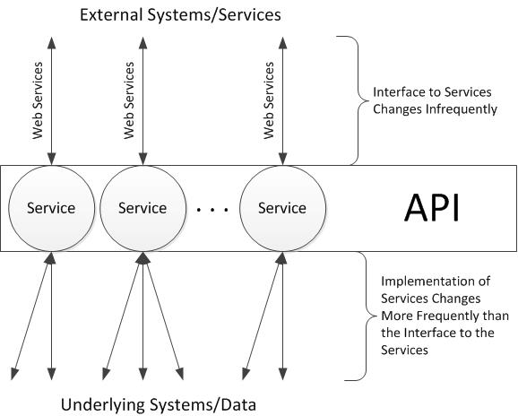

**Figure 3: External systems diagram**

**3.1.2**  **Functional/Logical diagram**

*Instructions: Insert any related functional/logical views or provide a reference to where they are stored. A functional architecture is a logical model of the functional decomposition. The logic model provides a depiction of the flow of inputs and outputs and it provides a tracing of inputs and output to specific functions and items representing the system.*

|  |  |  |
| --- | --- | --- |
| SDD Version 4.0 | 24 | ARC SGT SDD> |

|  |  |  |
| --- | --- | --- |
| Page 25 |  | System Design Document |
| **3.2** | **Hardware Architecture** |  |

Different deployments can use different server configurations, but SGT is typically deployed on four servers:

1.A web server running Apache to host the web application;   
2.Storage for various application configuration files (e.g., CSS, images, etc.); 3.An OpenTripPlanner server to respond to trip planning requests; and 4.A PostgreSQL database server to host the 1-Click database.

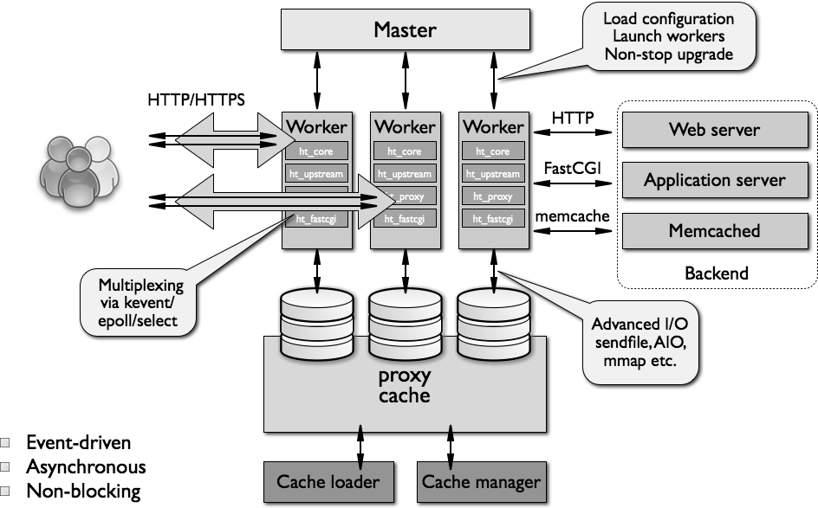

**Figure 4: Hardware architecture**   
**Table 4: Systems descriptions**

|  |  |
| --- | --- |
| **SYSTEM** | **NOTE** |

|  |  |  |
| --- | --- | --- |
| SDD Version 4.0 | 25 | ARC SGT SDD> |

|  |  |  |
| --- | --- | --- |
| Page 26 |  | System Design Document |
| **APPLICATION FRAMEWORK** | Rails | Rails is a software library that extends the Ruby programming language. Rails  combines the Ruby programming language with HTML, CSS, and JavaScript to create a web application that runs on a web server. When Rails is plugged into Ruby, it is often |
| referred to as “Ruby on Rails”. |
| **DEVELOPMENT AND VERSION CONTROL ENVIRONMENT** | Git | Git is a version control system that is used for software development and other version control tasks. As a distributed revision  control system. Git is free software  distributed under the terms of the GNU  General Public License version 2. |
| **HOSTING SERVICE** | GitHub | GitHub is a web-based Git repository hosting service. It offers all of the distributed revision control and source code management (SCM) functionality of Git as well as adding its own features. Unlike Git, which is strictly a  command-line tool, GitHub provides a Web-based graphical interface and desktop as well as mobile integration. It also provides access control and several collaboration  features such as bug tracking, feature  requests, task management, and wikis for every project. |

GitHub offers both plans for private   
repositories and free accounts, which are   
usually used to host open-source software   
projects

|  |  |  |  |
| --- | --- | --- | --- |
| **DATABASE** | PostgreSQL |  | PostgreSQL is an object-relational database management system (ORDBMS) with an emphasis on extensibility and standards- compliance. As a database server, its  primary function is to store data securely, and to allow for retrieval at the request of other software applications. It can handle workloads ranging from small single-machine applications to large Internet-facing  applications with many concurrent users. |
| **WEB SERVER** | NGINX |  | NGINX is a free, open-source, high-performance HTTP server and reverse proxy, as well as an IMAP/POP3 proxy server. NGINX is known for its high |
| SDD Version 4.0 |  | 26 | ARC SGT SDD> |

|  |  |
| --- | --- |
| Page 27 | System Design Document |

performance, stability, rich feature set,   
simple configuration, and low resource   
consumption

|  |  |  |
| --- | --- | --- |
| **WEB SERVER SOFTWARE** | Apache | Apache HTTP Server is the world’s most used web server software. Apache is an open-source project. Runs on all major server operating systems. |

Due to the variation in size between different deployments of 1-Click, load testing on specific configurations is required to give accurate assessments of hardware requirement. However, for comparison purposes, the 1-Click demonstration and quality assurance deployments are hosted at Heroku.com and Amazon Web Services with the following specifications:

**Table 5: Server requirements**

|  |  |  |  |  |
| --- | --- | --- | --- | --- |
| **Device** | **Web Server** | **Storage** | **OTP Server** | **Database Server** |
| Type | Heroku 2X Dyno | AWS S3 | AWS m3.xlarge | Heroku 2X Dyno |
| CPU | 8-core Intel Xeon E5-2680 v2 (Ivy Bridge) | 2 virtual cores | 13 virtual cores | 8-core Intel Xeon E5-2680 v2 (Ivy Bridge) |
| Memory | 2 GB | 4 GB | 15 GB | 2 GB |
| Storage | 100 GB+ | 100 GB | 80 GB | 512 GB |
| OS | Ubuntu v12.04 LTS (or later) | Ubuntu v12.04 LTS (or later) | Ubuntu v12.04 LTS (or later) | Ubuntu v12.04 LTS (or later) |
| Software | Apache | - | OpenTripPlanner | PostgreSQL 9.x (or later) |

AWS Best Practice

1) Failover - Elastic IPs: Elastic IP is a static IP that is dynamically re-mappable. You can quickly remap and failover to another set of servers so that your traffic is routed to the new servers. It works great when you want to upgrade from old to new versions or in case of hardware failures.

2) Utilize multiple Availability Zones: Availability Zones are conceptually like logical datacenters. By deploying your architecture to multiple availability zones, you can ensure highly availability. Utilize Amazon RDS Multi-AZ] deployment functionality to automatically replicate database updates across multiple Availability Zones.

3) Maintain an Amazon Machine Image so that you can restore and clone environments very easily in a different Availability Zone; Maintain multiple Database slaves across Availability Zones and setup hot replication.

4) Utilize Amazon CloudWatch (or various real-time open source monitoring tools) to get more visibility and take appropriate actions in case of hardware failure or performance degradation. Setup an Auto scaling group to maintain a fixed fleet size so that it replaces unhealthy Amazon EC2 instances by new ones.

5) Utilize Amazon EBS and set up cron jobs so that incremental snapshots are automatically uploaded to Amazon S3 and data is persisted independent of your instances.

|  |  |  |
| --- | --- | --- |
| SDD Version 4.0 | 27 | ARC SGT SDD> |

|  |  |
| --- | --- |
| Page 28 | System Design Document |

6) Utilize Amazon RDS and set the retention period for backups, so that it can perform automated backups.

**3.2.1**  **Security Hardware Architecture**

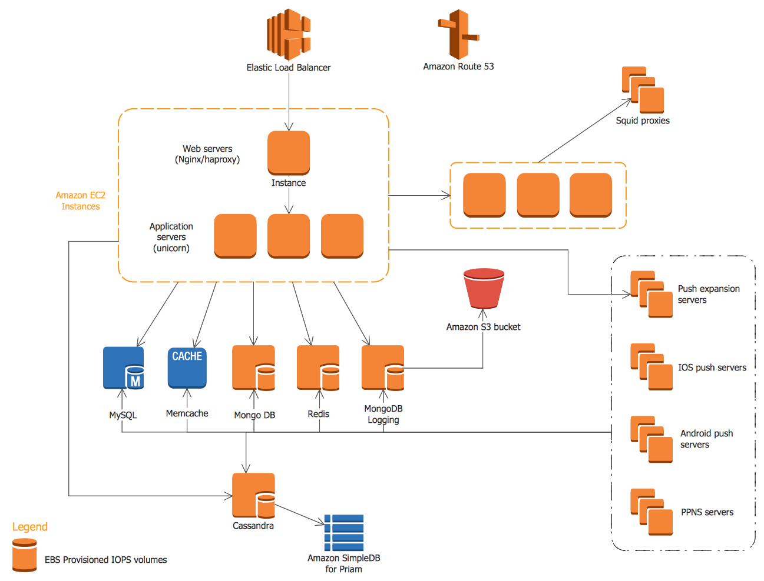

**Figure 5: Security architecture**

**3.2.2**  **Performance Hardware Architecture**

The current and proposed solution utilizes AWS S3 for hardware performance and reliability. Amazon S3 is storage for the Internet. It’s a simple storage service that offers software developers a highly-scalable, reliable, and low-latency data storage infrastructure at very low costs.

Amazon S3 provides a simple web service interface that you can use to store and retrieve any amount of data, at any time, from anywhere on the web. Using this web service, developers can easily build applications that make use of Internet storage. Since Amazon S3 is highly scalable and you only pay for what you use, developers can start small and grow their application as they wish, with no compromise on performance or reliability.

Amazon S3 is also designed to be highly flexible. Store any type and amount of data that you want; read the same piece of data a million times or only for emergency disaster recovery; build a simple FTP application, or a sophisticated web application such as the Amazon.com retail web site. Amazon S3 frees developers to focus on innovation, not figuring out how to store their data.

|  |  |  |
| --- | --- | --- |
| SDD Version 4.0 | 28 | ARC SGT SDD> |

|  |  |
| --- | --- |
| Page 29 | System Design Document |

Amazon S3 gives any developer access to the same highly scalable, reliable, fast, inexpensive data storage infrastructure that Amazon uses to run its own global network of web sites. S3 Standard is designed for 99.99% availability and Standard - IA is designed for 99.9% availability. Both are backed by the Amazon S3 Service Level Agreement.

**3.3**  **Software Architecture**

The three-tier architecture is a popular pattern for user-facing applications. The tiers that comprise this architecture include the presentation tier, the logic tier, and the data tier. The presentation tier represents the component that users directly interact with (such as a web page, mobile app UI, etc.). The logic tier contains the code required to translate user actions at the presentation tier to the functionality that drives

the application’s behavior. The data tier consists of storage media (databases, object stores, caches, file systems, etc.) that hold the data relevant to the application.

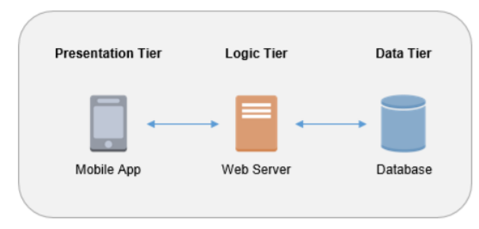

**Figure 6: Software architecture tiers**

**The Serverless Logic Tier**

The logic tier of the three-tier architecture represents the brains of the architecture. The features of the two services allow you to build a serverless production application that is highly available, scalable, and secure.

|  |  |  |
| --- | --- | --- |
| SDD Version 4.0 | 29 | ARC SGT SDD> |

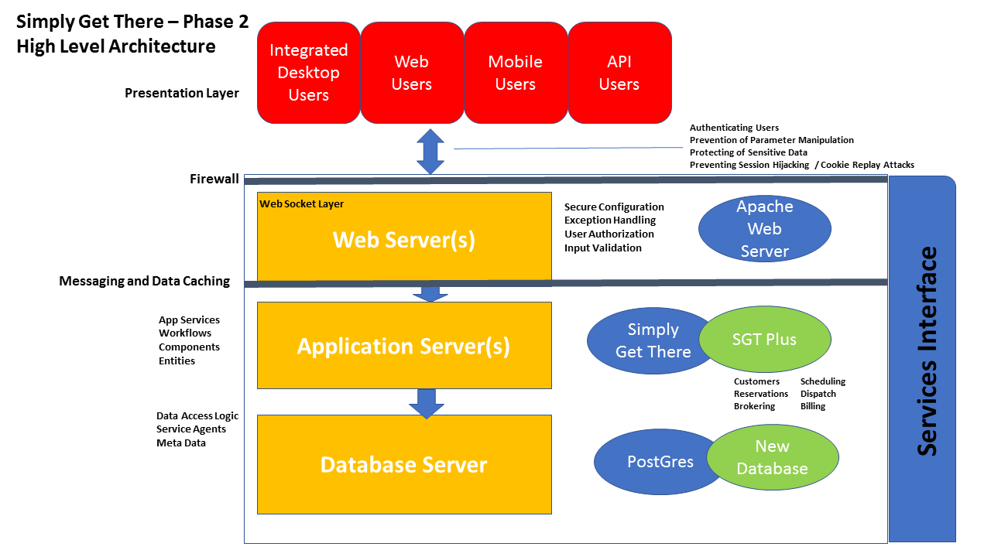

|  |  |
| --- | --- |
| Page 30 | System Design Document |

**App Services**

**Workflows**

|  |  |  |
| --- | --- | --- |
| **Figure 7: SGT high level solution architecture** | | **Components**  **Entities** |
| **3.3.1** | **Software Elements** |

**Table 6: Software elements and descriptions**

|  |  |
| --- | --- |
| **FUNCTION** | **DESCRIPTION** |

|  |  |  |
| --- | --- | --- |
| SDD Version 4.0 | 30 | ARC SGT SDD> |

|  |  |  |
| --- | --- | --- |
| Page 31 | | System Design Document |
| |  | | --- | | **TRIP DETAILS** | | | Based on trip plan review and selected trip plan, the system will display the trip plan detail. If specialized transportation plan was selected, the system will display the origin and destination and the selected specialized transportation provider. |
| **TRIP PLAN PRINT** | | User can choose to print the trip plan |
| **TRIP PLAN EMAIL** | | User can choose to email the trip plan |
| **TRAVEL PROFILE** | | If registered, user can maintain and manage their user profile. |
| **TRIP PROFILE** | | User can view selected trip plans. Users can delete edit or remove the trip from the profile. User can get details of the planned trip. |
| **PLACES** | | User can save common origins or destinations in the Places function to customize the planning process to their common travel plans. |
| **PROVIDERS** | | Users can obtain a list of all transportation providers in the system with hyperlink to provider detailed information. |
|  | |
| **3.3.2** | **Security Software Architecture** | |

There are a number of principles applied to current and proposed system security.

|  |  |  |  |
| --- | --- | --- | --- |
| • | Apply security at all layers: | | |
| o | | Rather than running security appliances (e.g., firewalls) only at the edge of your infrastructure, use firewalls and other security controls on all of your resources (e.g., every virtual server, load balancer, and network subnet). | |
| • | Enable traceability: | | |
| o | | Log and audit all actions and changes to your environment. | |
| • | Implement a principle of least privilege: | | |
| o | | Ensure that authorization is appropriate for each interaction with your AWS resources and implement strong logical access controls directly on resources. | |
| SDD Version 4.0 | | 31 | ARC SGT SDD> |

|  |  |
| --- | --- |
| Page 32 | System Design Document |

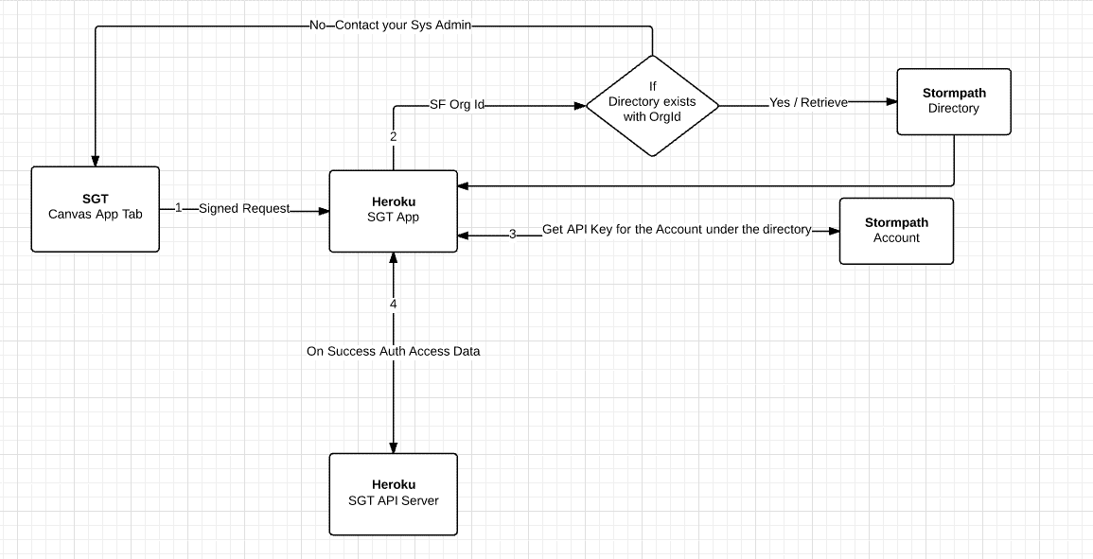

**Figure 8: Security authentication**

**3.3.3**  **Performance Software Architecture**

The most fundamental reason for performance concerns is that the tasks we set our systems to perform have become much more complex over time. The performance of the system depends on much more than the raw processing power of its hardware. The way that hardware is configured, the way resources are allocated and managed, and the way the software is written can have significant impacts on the system’s ability to meet its performance goals.

The scalability property of a system is closely related to performance, but rather than considering how

quickly the system performs its current workload, scalability focuses on the predictability of the system’s performance as the workload increases.

|  |  |  |
| --- | --- | --- |
| SDD Version 4.0 | 32 | ARC SGT SDD> |

|  |  |
| --- | --- |
| Page 33 | System Design Document |

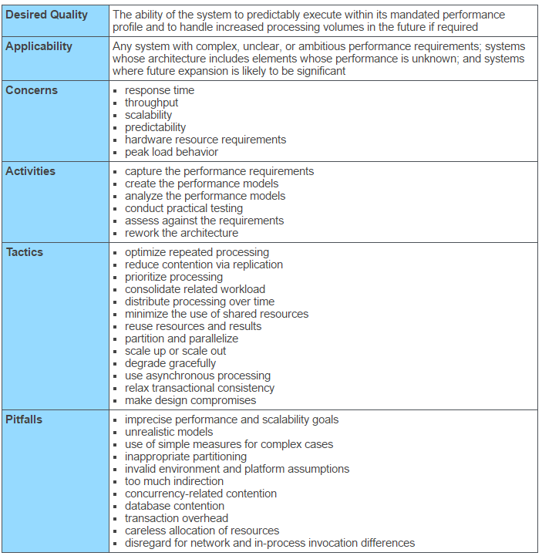

**Figure 9: Performance architecture scalability**

|  |  |
| --- | --- |
| **3.4** | **Information Architecture** |

There are minimal additional personal data elements that will be stored in the new functionality. SGT currently stores customer and transportation related data of the consumer. This data is classified as personally identifiable information. Minor health related records are stored with this information. Health information can be derived based on location information.

The proposed new features and functions of the system will include additional PII data for the trip reservation function. This data includes:

|  |  |  |  |
| --- | --- | --- | --- |
| • | Trip Purpose |  |  |
| SDD Version 4.0 | | 33 | ARC SGT SDD> |

|  |  |  |
| --- | --- | --- |
| Page 34 |  | System Design Document |
| • | Trip Type |  |
| **3.4.1** |
| **Records Management** |

HIPAA is a major federal records management regulation that must be considered and adhered to

**3.4.1.1**  **Data**

Data is supplied by end user or the consumer of the system. Data is entered into the system via the web application. Call center users will also enter data into the system via a graphical user interface. Third

party provider data may also be inserted into the data via API’s. API middleware for trip and coordination transactions will manage the exporting and importing of any third party data elements.

**3.4.1.2**  **Manual/Electronic Inputs**

All inserts or upserts into database shall be managed using industry standard data validation tools and triggers. Data validation is intended to provide certain well-defined guarantees for fitness, accuracy, and consistency for any of various kinds of user input into an application or automated system. Data validation rules can be defined and designed using any of various methodologies, and be deployed in any of various contexts.

Types:

• Data type validation;

• Range and constraint validation;

• Code and Cross-reference validation; and

• Structured validation

**Data-type validation**

Data type validation is customarily carried out on one or more simple data fields. The simplest kind of data type validation verifies that the individual characters provided through user input are consistent with the expected characters of one or more known primitive data types; as defined in a programming language or data storage and retrieval mechanism. As an example, telephone numbers are routinely expected to include the digits and possibly the characters +, -, ( ) (plus, minus, and parentheses).

**Simple range and constraint validation**

Simple range and constraint validation may examine user input for consistency with a minimum/maximum range, or consistency with a test for evaluating a sequence of characters, such as one or more tests against regular expressions.

**Code and cross-reference validation**

Code and cross-reference validation includes tests for data type validation, combined with one or more operations to verify that the user-supplied data is consistent with one or more external rules,   
requirements, or validity constraints relevant to a particular organization, context or set of underlying assumptions. These additional validity constraints may involve cross-referencing supplied data with a known look-up table or directory information service such as LDAP.

**Structured validation**

Structured validation allows for the combination of any of various basic data type validation steps, along with more complex processing. Such complex processing may include the testing of conditional constraints for an entire complex data object or set of process operations within a system.

**3.4.1.3**  **Master Files**

The following tables define the data maintained in the proposed system.

|  |  |  |
| --- | --- | --- |
| SDD Version 4.0 | 34 | ARC SGT SDD> |

|  |  |  |
| --- | --- | --- |
| Page 35 |  | System Design Document |
| **3.5** | **Internal Communications Architecture** |  |

Current and proposed solution is managed in AWS. Specific network architecture is not provided due to security issues.

**3.6**  **Security Architecture**   
Not available   
**3.7**  **Performance**   
Not available

|  |  |  |
| --- | --- | --- |
| SDD Version 4.0 | 35 | ARC SGT SDD> |

|  |  |  |
| --- | --- | --- |
| Page 36 |  | System Design Document |
| **4.** | **System Design** |  |

The proposed system may extend the current system via the existing SGT framework or by the

development of a modular component that “plugs” into the SGT application. Proposed solution may be commercially available or custom developed to fully meet the requirements of the project. ARC will host the application internally but may also choose to host the solution in a third party environment. Technical support and maintenance will be required for the transactional and mission critical components of the system. The system must provide strong security and credentialing methods to ensure privacy and system security.

**4.1**  **Business Requirements**

System could provide substantial functionality to the existing SGT application. ARC intends to understand the functional requirements necessary for each component and its applicable capital and ongoing support costs to layout a short to mid-range implementation plan.

**Table 7: SGT future enhancements**

|  |  |
| --- | --- |
| **WEB BASED RESERVATIONS** | **1** |

|  |  |  |
| --- | --- | --- |
| SDD Version 4.0 | 36 | ARC SGT SDD> |

|  |  |  |
| --- | --- | --- |
| Page 37 |  | System Design Document |
| **MOBILE DRIVER APP** | 12 |  |

|  |  |  |
| --- | --- | --- |
| **CUSTOMER INFORMATION APP** | | 13 |
| **4.2** | **Database Design** |

Data dictionary is provided as an attachment to this document.

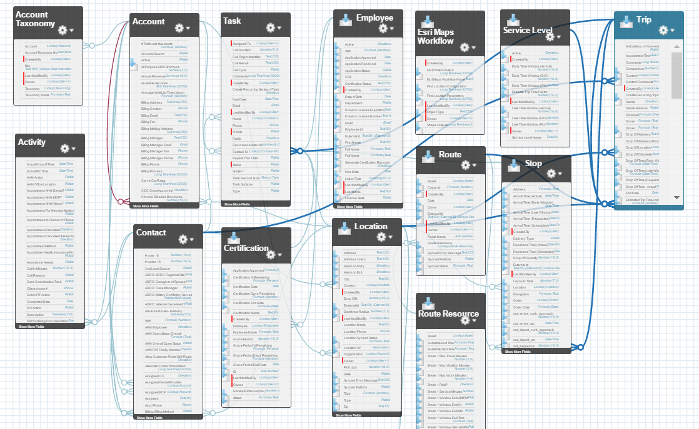

**Figure 10: Example of a database design**

**4.2.1**  **Data Objects and Resultant Data Structures**

The following table defines the data objects and schema for the proposed solution.

**Table 8: Data objects and schemas**

ActiveRecord::Schema.define(version:20170419145226) do

# These are extensions that must be enabled in order to support this database

|  |  |  |
| --- | --- | --- |
| SDD Version 4.0 | 37 | ARC SGT SDD> |

|  |  |
| --- | --- |
| Page 38 | System Design Document |

enable_extension "plpgsql"  
 enable_extension "postgis"

create_table "accommodations", force::cascadedo |t|   
 t.string "code", null:false  
 t.datetime "created_at", null:false  
 t.datetime "updated_at", null:false  
 t.index ["code"], name:"index_accommodations_on_code", unique:true, using::btree end

create_table "accommodations_services", id:false, force::cascadedo |t|   
 t.integer "service_id", null:false  
 t.integer "accommodation_id", null:false  
 t.index ["accommodation_id"], name:"index_accommodations_services_on_accommodation_id", using: :btree  
 t.index ["service_id"], name:"index_accommodations_services_on_service_id", using::btree end

create_table "accommodations_users", id:false, force::cascadedo |t|   
 t.integer "user_id", null:false  
 t.integer "accommodation_id", null:false  
 t.index ["accommodation_id"], name:"index_accommodations_users_on_accommodation_id", using: :btree  
 t.index ["user_id"], name:"index_accommodations_users_on_user_id", using::btree   
end

create_table "cities", force::cascadedo |t|   
 t.string "name"  
 t.string "state"  
 t.geometry "geom", limit: {:srid=>0, :type=>"geometry"}   
 t.datetime "created_at", null:false t.datetime "updated_at", null:false t.index ["geom"], name:"index_cities_on_geom", using::gist  
 t.index ["name", "state"], name:"index_cities_on_name_and_state", using::btree end

create_table "comments", force::cascadedo |t|   
 t.text "comment"

|  |  |  |
| --- | --- | --- |
| SDD Version 4.0 | 38 | ARC SGT SDD> |

|  |  |
| --- | --- |
| Page 39 | System Design Document |

t.string "locale"  
 t.string "commentable_type"  
 t.integer "commentable_id"  
 t.datetime "created_at", null:false  
 t.datetime "updated_at", null:false  
 t.index ["commentable_type", "commentable_id"], name:   
 "index_comments_on_commentable_type_and_commentable_id", using::btree end

create_table "configs", force::cascadedo |t|   
 t.datetime "created_at", null:false  
 t.datetime "updated_at", null:false  
 t.string "key"  
 t.text "value"   
end

create_table "counties", force::cascadedo |t|   
 t.string "name"  
 t.string "state"  
 t.geometry "geom", limit: {:srid=>0, :type=>"geometry"}   
 t.datetime "created_at", null:false t.datetime "updated_at", null:false t.index ["geom"], name:"index_counties_on_geom", using::gist  
 t.index ["name", "state"], name:"index_counties_on_name_and_state", using::btree end

create_table "custom_geographies", force::cascadedo |t|   
 t.string "name"  
 t.geometry "geom", limit: {:srid=>0, :type=>"geometry"}   
 t.datetime "created_at", null:false t.datetime "updated_at", null:false t.index ["geom"], name:"index_custom_geographies_on_geom", using::gist t.index ["name"], name:"index_custom_geographies_on_name", using::btree end

create_table "eligibilities", force::cascadedo |t| t.string "code", null:false  
 t.datetime "created_at", null:false  
 t.datetime "updated_at", null:false

|  |  |  |
| --- | --- | --- |
| SDD Version 4.0 | 39 | ARC SGT SDD> |

|  |  |
| --- | --- |
| Page 40 | System Design Document |

t.index ["code"], name:"index_eligibilities_on_code", unique:true, using::btree end

create_table "eligibilities_services", id:false, force::cascadedo |t|   
 t.integer "service_id", null:false  
 t.integer "eligibility_id", null:false  
 t.index ["eligibility_id"], name:"index_eligibilities_services_on_eligibility_id", using: :btree  
 t.index ["service_id"], name:"index_eligibilities_services_on_service_id", using::btree end

create_table "fare_zones", force::cascadedo |t|   
 t.integer "service_id"  
 t.integer "region_id"  
 t.string "code"  
 t.datetime "created_at", null:false  
 t.datetime "updated_at", null:false  
 t.index ["service_id", "region_id"], name:"index_fare_zones_on_service_id_and_region_id", using::btree   
end

create_table "itineraries", force::cascadedo |t|   
 t.datetime "created_at", null:false  
 t.datetime "updated_at", null:false  
 t.integer "trip_id"  
 t.datetime "start_time"  
 t.datetime "end_time"  
 t.text "legs"  
 t.integer "walk_time"  
 t.integer "transit_time"  
 t.float "cost"  
 t.integer "service_id"  
 t.string "trip_type"  
 t.index ["service_id"], name:"index_itineraries_on_service_id", using::btree t.index ["trip_id"], name:"index_itineraries_on_trip_id", using::btree end

create_table "landmarks", force::cascadedo |t|   
 t.datetime "created_at", null:false

|  |  |  |
| --- | --- | --- |
| SDD Version 4.0 | 40 | ARC SGT SDD> |

|  |  |
| --- | --- |
| Page 41 | System Design Document |

t.datetime "updated_at", null:false t.string "name"  
 t.string "street_number"  
 t.string "route"  
 t.string "city"  
 t.string "state"  
 t.string "zip"  
 t.boolean "old"  
 t.decimal "lat", precision:10, scale:6  
 t.decimal "lng", precision:10, scale:6   
end

create_table "locales", force::cascadedo |t|   
 t.string "name"  
 t.datetime "created_at", null:false  
 t.datetime "updated_at", null:false   
end

create_table "purposes", force::cascadedo |t|   
 t.string "code", null:false  
 t.datetime "created_at", null:false  
 t.datetime "updated_at", null:false   
end

create_table "purposes_services", id:false, force::cascadedo |t|   
 t.integer "service_id", null:false  
 t.integer "purpose_id", null:false  
 t.index ["purpose_id"], name:"index_purposes_services_on_purpose_id", using::btree t.index ["service_id"], name:"index_purposes_services_on_service_id", using::btree end

create_table "regions", force::cascadedo |t|   
 t.text "recipe"  
 t.geometry "geom", limit: {:srid=>0, :type=>"multi_polygon"}   
 t.datetime "created_at", null:false t.datetime "updated_at", null:false t.index ["geom"], name:"index_regions_on_geom", using::gist   
end

|  |  |  |
| --- | --- | --- |
| SDD Version 4.0 | 41 | ARC SGT SDD> |

|  |  |
| --- | --- |
| Page 42 | System Design Document |

create_table "roles", force::cascadedo |t|   
 t.string "name"  
 t.string "resource_type"  
 t.integer "resource_id"  
 t.datetime "created_at"  
 t.datetime "updated_at"  
 t.index ["name", "resource_type", "resource_id"], name:   
 "index_roles_on_name_and_resource_type_and_resource_id", using::btree t.index ["name"], name:"index_roles_on_name", using::btree   
end

create_table "schedules", force::cascadedo |t|   
 t.integer "service_id"  
 t.integer "day"  
 t.integer "start_time"  
 t.integer "end_time"  
 t.datetime "created_at", null:false  
 t.datetime "updated_at", null:false  
 t.index ["day"], name:"index_schedules_on_day", using::btree  
 t.index ["service_id"], name:"index_schedules_on_service_id", using::btree end

create_table "services", force::cascadedo |t|   
 t.datetime "created_at", null:false  
 t.datetime "updated_at", null:false  
 t.string "type"  
 t.string "name"  
 t.string "gtfs_agency_id"  
 t.string "logo"  
 t.string "email"  
 t.string "url"  
 t.string "phone"  
 t.integer "start_or_end_area_id"  
 t.integer "trip_within_area_id"  
 t.string "fare_structure"  
 t.text "fare_details"  
 t.boolean "archived", default:false  
 t.index ["archived"], name:"index_services_on_archived", using::btree  
 t.index ["gtfs_agency_id"], name:"index_services_on_gtfs_agency_id", using::btree t.index ["name"], name:"index_services_on_name", using::btree

|  |  |  |
| --- | --- | --- |
| SDD Version 4.0 | 42 | ARC SGT SDD> |

|  |  |
| --- | --- |
| Page 43 | System Design Document |

t.index ["start_or_end_area_id"], name:"index_services_on_start_or_end_area_id", using::btree t.index ["trip_within_area_id"], name:"index_services_on_trip_within_area_id", using::btree end

create_table "translation_keys", force::cascadedo |t| t.string "name"  
 t.datetime "created_at", null:false  
 t.datetime "updated_at", null:false   
end

create_table "translations", force::cascadedo |t| t.integer "locale_id"  
 t.integer "translation_key_id"  
 t.text "value"  
 t.datetime "created_at", null:false  
 t.datetime "updated_at", null:false   
end

create_table "trips", force::cascadedo |t|   
 t.datetime "created_at", null:false  
 t.datetime "updated_at", null:false  
 t.integer "user_id"  
 t.integer "origin_id"  
 t.integer "destination_id"  
 t.datetime "trip_time"  
 t.boolean "arrive_by"  
 t.integer "selected_itinerary_id"  
 t.integer "purpose_id"  
 t.index ["destination_id"], name:"index_trips_on_destination_id", using::btree  
 t.index ["origin_id"], name:"index_trips_on_origin_id", using::btree  
 t.index ["purpose_id"], name:"index_trips_on_purpose_id", using::btree  
 t.index ["selected_itinerary_id"], name:"index_trips_on_selected_itinerary_id", using::btree t.index ["user_id"], name:"index_trips_on_user_id", using::btree   
end

create_table "user_eligibilities", force::cascadedo |t| t.integer "user_id"  
 t.integer "eligibility_id"  
 t.boolean "value", default:true

|  |  |  |
| --- | --- | --- |
| SDD Version 4.0 | 43 | ARC SGT SDD> |

|  |  |
| --- | --- |
| Page 44 | System Design Document |

t.datetime "created_at", null:false  
 t.datetime "updated_at", null:false  
 t.index ["eligibility_id"], name:"index_user_eligibilities_on_eligibility_id", using::btree t.index ["user_id"], name:"index_user_eligibilities_on_user_id", using::btree   
end

create_table "users", force::cascadedo |t|   
 t.datetime "created_at", null:false  
 t.datetime "updated_at", null:false  
 t.string "email", default:"", null:false  
 t.string "encrypted_password", default:"", null:false  
 t.string "reset_password_token"  
 t.datetime "reset_password_sent_at"  
 t.datetime "remember_created_at"  
 t.integer "sign_in_count", default:0, null:false  
 t.datetime "current_sign_in_at"  
 t.datetime "last_sign_in_at"  
 t.inet "current_sign_in_ip"  
 t.inet "last_sign_in_ip"  
 t.string "authentication_token", limit:30  
 t.string "first_name"  
 t.string "last_name"  
 t.integer "preferred_locale_id"  
 t.text "preferred_trip_types"  
 t.index ["authentication_token"], name:"index_users_on_authentication_token", unique:true, using::btree  
 t.index ["email"], name:"index_users_on_email", unique:true, using::btree  
 t.index ["last_name", "first_name"], name:"index_users_on_last_name_and_first_name", using: :btree  
 t.index ["preferred_locale_id"], name:"index_users_on_preferred_locale_id", using::btree t.index ["reset_password_token"], name:"index_users_on_reset_password_token", unique:true, using::btree   
end

create_table "users_roles", id:false, force::cascadedo |t|   
 t.integer "user_id"  
 t.integer "role_id"  
 t.index ["user_id", "role_id"], name:"index_users_roles_on_user_id_and_role_id", using::btree end

|  |  |  |
| --- | --- | --- |
| SDD Version 4.0 | 44 | ARC SGT SDD> |

|  |  |
| --- | --- |
| Page 45 | System Design Document |

create_table "waypoints", force::cascadedo |t|   
 t.datetime "created_at", null:false t.datetime "updated_at", null:false t.string "name"  
 t.string "street_number"  
 t.string "route"  
 t.string "city"  
 t.string "state"  
 t.string "zip"  
 t.decimal "lat", precision:10, scale:6  
 t.decimal "lng", precision:10, scale:6   
end

create_table "zipcodes", force::cascadedo |t|   
 t.string "name"  
 t.geometry "geom", limit: {:srid=>0, :type=>"geometry"}   
 t.datetime "created_at", null:false t.datetime "updated_at", null:false t.index ["geom"], name:"index_zipcodes_on_geom", using::gist  
 t.index ["name"], name:"index_zipcodes_on_name", using::btree   
end

add_foreign_key "itineraries", "services"  
 add_foreign_key "itineraries", "trips"  
 add_foreign_key "schedules", "services"  
 add_foreign_key "services", "regions", column:"start_or_end_area_id" add_foreign_key "services", "regions", column:"trip_within_area_id" add_foreign_key "trips", "itineraries", column:"selected_itinerary_id" add_foreign_key "trips", "purposes"  
 add_foreign_key "trips", "users"  
 add_foreign_key "trips", "waypoints", column:"destination_id"  
 add_foreign_key "trips", "waypoints", column:"origin_id"  
 add_foreign_key "user_eligibilities", "eligibilities"  
 add_foreign_key "user_eligibilities", "users"  
 add_foreign_key "users", "locales", column:"preferred_locale_id"

**4.2.2**  **File and Database Structures**   
The following data model represents the current solution with the proposed solution highlighted.

|  |  |  |
| --- | --- | --- |
| SDD Version 4.0 | 45 | ARC SGT SDD> |

|  |  |  |
| --- | --- | --- |
| Page 46 |  | System Design Document |
| **4.2.2.1** | **Database Management System Files** |  |

The image below represents the high level ER diagram and object model for the current system.

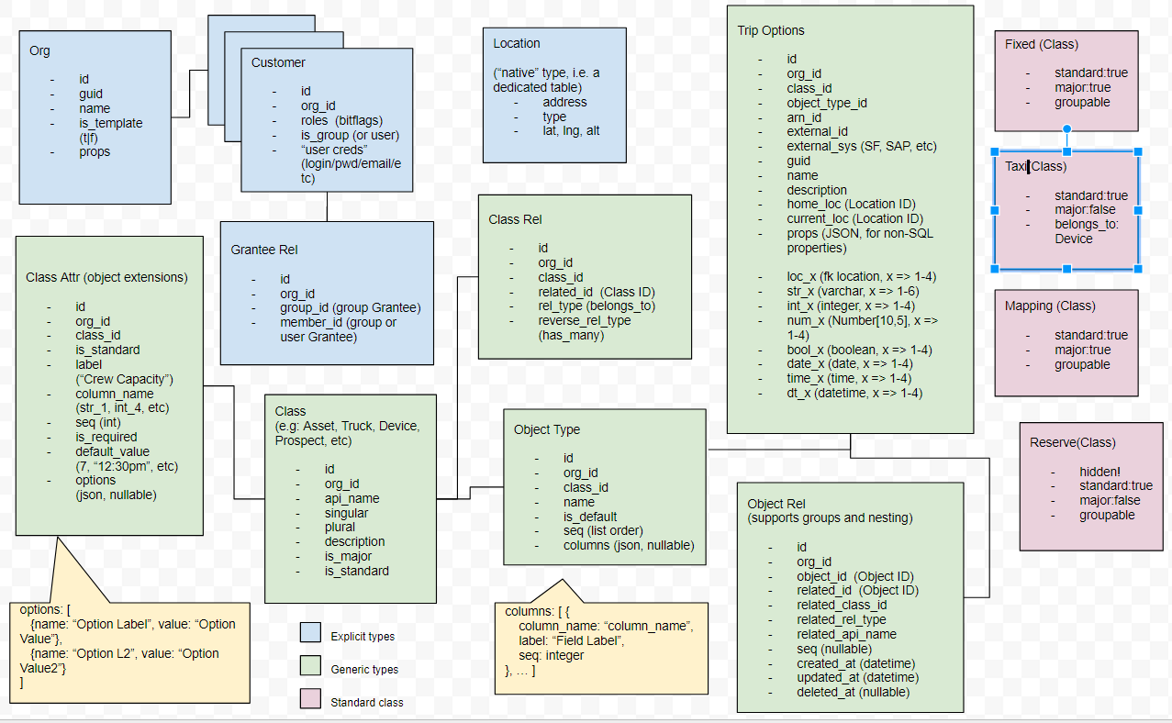

**4.2.2.2**  **Non-Database Management System Files**

None

|  |  |  |
| --- | --- | --- |
| SDD Version 4.0 | 46 | ARC SGT SDD> |

|  |  |  |
| --- | --- | --- |
| Page 47 |  | System Design Document |
| **4.3** | **Data Conversion** |  |

None

**4.4**  **User Machine-Readable Interface**

**4.4.1**  **Inputs**

See Concept of Operations for user inputs, forms, and user roles and permissions.

**4.4.2**  **Outputs**

*Instructions: Describe the system output design relative to the user/operator. Show a mapping to the high-level data flows. System outputs include reports, data display screens and GUIs, query results, etc.*

*The output files described in the section for Data Design may be referenced. The following should be provided, if appropriate:*

|  |  |
| --- | --- |
| • •  • • • | *Identification of codes and names for reports and data display screens*  *Description of report and screen contents (provide a graphical representation of each layout and define all data elements associated with the layout or reference the data dictionary)*  *Description of the purpose of the output, including identification of the primary users*  *Report distribution requirements, if any (include frequency for periodic reports)*  *Description of any access restrictions or security considerations* |

Users did not specifiy specific outputs. They requested that an ad hoc report and dashboard design tool . This would allow them to define and build their own reports and queries. The current application provides standard reports that are unusable and unchangeable. This is a big area of frustration.

The report designer will expose all available objects and fields including extensions and allow admin users to sort, group, filter, and bucket datasets. Basic and advanced statistics and data aggregration functions will be available. Reports can be defined as tabular, summary, matrix, and joined. The report tool will allow a basic user to build simple and/or very advanced reports. This method provides the flexibility and scalability ARC requires.

**4.5**  **User Interface Design**

User interface designs have not been completed for this document. It is anticipated that the development team will develop mockups based on final procurement specifications. The image below represents and example mockup.

|  |  |  |
| --- | --- | --- |
| SDD Version 4.0 | 47 | ARC SGT SDD> |

|  |  |
| --- | --- |
| Page 48 | System Design Document |

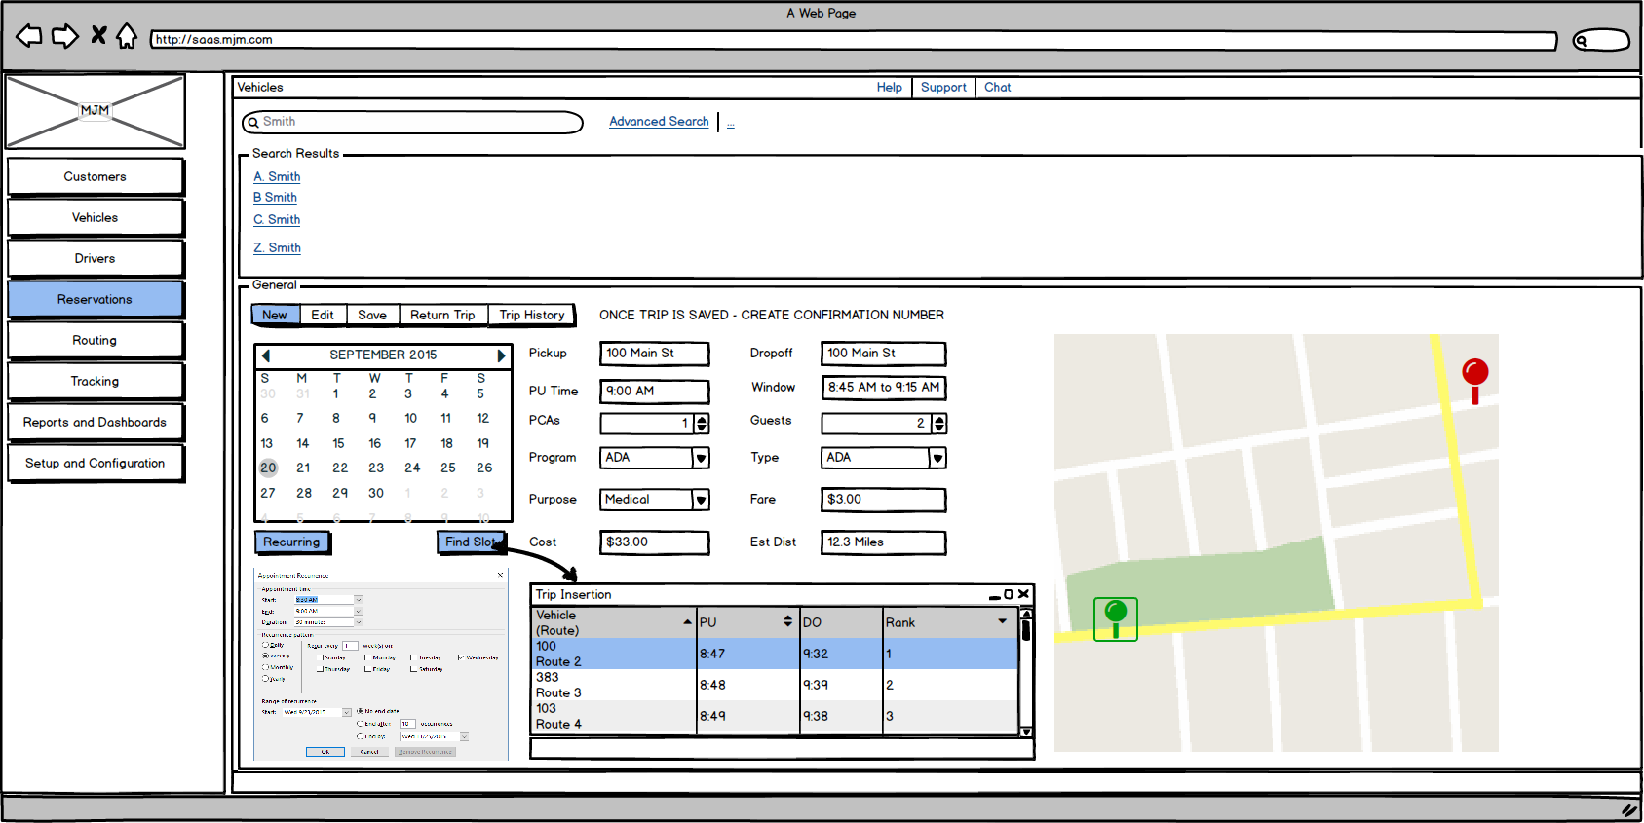

**Figure 11: Example of balsamiq mockup**

**4.5.1**  **Section 508 Compliance**

The current application is Section 508 Compliant. The proposed application will be designed and

developed to support Section 508 compliance.

|  |  |  |
| --- | --- | --- |
| SDD Version 4.0 | 48 | ARC SGT SDD> |

|  |  |  |
| --- | --- | --- |
| Page 49 |  | System Design Document |
| **5.** | **Operational Scenarios** |  |

Section 5 describes scenarios that show how the system will be used to perform its objectives and meet the user’s requirements. Each scenario can be illustrated by a use case. Develop sample usage scenarios (as realistic as possible) for each user class that show what inputs, outputs, and user interaction will be required.

**1.1Major Operational Scenarios**

**Table 9: Major operational scenarios**

|  |  |  |  |  |
| --- | --- | --- | --- | --- |
| **Process** | **Purpose** | **Description** | **Priority** | **Frequency** |

|  |  |
| --- | --- |
| Reservations | Web based trip booking |
| Centralized  Resource  Management | Central  repository for customer,  vehicle, and provider data |
| Provider  Assignment | Trip Assignment and Brokering |
| Scheduling | Schedule and route planning |
| Dispatching | Real time  dispatching and tracking |
| Electronic Payment | Web or mobile payment |
| Cost  Allocation | Transportation cost sharing |
| Reporting | Reporting and Analytics |

|  |  |  |
| --- | --- | --- |
| Users can book transportation  directly from trip planning function. Users may choose to book directly without going through planning  process. | High | Daily |
| System can leverage regional resources more effectively.  Foundation for regional coordination and provider assignment. | High | Daily |
| Functions to support automated trip assignment based on least cost most appropriate logic. | High | Daily |
| Functions to support automated,  computer assisted, and manual  scheduling and route optimization to coordinate trips and improve  capacity. | High | Daily |
| Users can view real time location, status, and ETA of transportation to improve service delivery and  customer service. | High | Daily |
| Users can pay for transportation  online via credit card or, potentially, a pre-paid transportation account. | High | Daily |
| System can allocate costs to proper funding source. | High | Daily |
| Users can run canned reports and dashboards. Users can create custom ad hoc reports. | High | Daily /  Weekly / Monthly |

|  |  |  |
| --- | --- | --- |
| SDD Version 4.0 | 49 | ARC SGT SDD> |

|  |  |
| --- | --- |
| Page 50 | System Design Document |

|  |  |
| --- | --- |
| Coordination | Trip  Coordination |

**1.2Major Use Cases**

|  |  |  |
| --- | --- | --- |
| Trip data can be exchanged  electronically via published and open  API’s for the facilitation of  coordination of resources and trips. | High | Daily |

**1.2.1Customer Resources**   
Creating and editing customer demographics including default address information (geocoded), eligibility information, capacity and constraint related parameters (mobility needs, PCA’s, guests, etc.…), trip related data (trip purpose, trip type), and billing information. Information below defines the core data management requirements for customers.

Major Functions:

|  |  |
| --- | --- |
| • • • • | SEARCH - Searching for Customers NEW - Creating New Customers  EDIT - Editing Customers  DELETE - Deleting Customers |

**Table 10: Customer use cases**

|  |  |  |  |  |  |  |
| --- | --- | --- | --- | --- | --- | --- |
| |  |  | | --- | --- | | • | **Them e** | | **I want to…** | **so that…** | **Use Case** | **Notes** |
| User Interface | Access the customer  module | I can add,  edit, or  review  customer  related  information | **<given>**a user with rights to  customer module needs to  launch customer  module**<when>**the user selects a customer  tab/button/section**<then>**custo mer module is displayed | UI design for  module  accessibility will be important |
| User Interface | Search for customer | Edit an  existing  customer | **<given>**a user needs to quickly search for a single or multiple customers **<when>**the user  provides full or partial name  **<then>**the application provides a single or multiple customers for user to select | Search UI must be simple and fast. Wildcard searches  required.  Advanced search criteria required |
| User Interface | Create New Customer | I can add a new  customer to the  database | **<given>**a user has rights to  create new  customer**<when>**the user  selects NEW function**<then>**the application provides new form to enter required data |  |

|  |  |  |
| --- | --- | --- |
| SDD Version 4.0 | 50 | ARC SGT SDD> |

|  |  |
| --- | --- |
| Page 51 | System Design Document |

|  |  |  |  |  |
| --- | --- | --- | --- | --- |
| General Data | Edit or enter  basic customer demographic  data | I can store customer  data for  future use | **<given>** user has rights to  create and edit customer data **<when>**the user creates new or edits a customer **<then>** the application allows user to input data in form: First Name, Last Name, Default Pickup Address, Mailing Address, Phone, Email, and Birthday |  |
| User Interface | Delete  customer | I can purge customer  from  system | **<given>** user has rights to  delete customer **<when>**the user creates selects a customer **<then>** the application allows user to delete customer | All associated  data, including  trips, must be  purged. Warning message should be displayed prior to submitting  request |
| General Data | Add Language to customer  record | I can assign default  language to customer | **<given>** user has rights to  create and edit customer data **<when>**the user creates new or edits a customer **<then>** allow user to select default  LANGUAGE from picklist  values |  |
| General Data | Add RACE to customer  record | I can assign default race to customer | **<given>** user has rights to  create and edit customer data **<when>**the user creates new or edits a customer <**then>** allow user to select default RACE  from picklist values |  |
| General Data | Add GENDER to customer  record | I can assign default  gender to  customer | **<given>** user has rights to  create and edit customer data **<when>**the user creates new or edits a customer <**then>** allow user to select default GENDER from picklist values |  |
| General Data | Add  emergency contact | I can assign a default  emergency contact to  customer | **<given>** user has rights to  create and edit customer data **<when>**the user creates new or edits a customer <**then>** allow user to assign an emergency contact with phone number to record |  |

|  |  |  |
| --- | --- | --- |
| SDD Version 4.0 | 51 | ARC SGT SDD> |

|  |  |
| --- | --- |
| Page 52 | System Design Document |

|  |  |  |  |  |
| --- | --- | --- | --- | --- |
| Function | Geocode a  customer  address  (address, city, state, zip) | I can locate default  customer  pickup  address on map | **<given>**user has rights to  create new customer <**when>** user enters a valid pickup  address **<then>** locate the customer on the map and  provide user with options to select appropriate address | Design  consideration:  Address  geocoding must be very simple and  straightforward.  Reducing  address  redundancy is important (i.e.  Address  duplication) |
| Function | Calculate  customer age | I can easily determine  the age of  the  customer  as a  function of AGE field | **<given>**user has rights to  create or edit customers  **<when>**user enters AGE data <**then>** then application  calculates age of customer | Used in reporting especially in  senior and social services  transportation.  Often used to  determine eligible programs |
| Function | Make customer active | I can easily make a  customer  active or  inactive | **<given>**the user has rights to create or edit customer  <**when>**user creates new  customer **<then>** automatically make customer active | Upon NEW make customer active.  Allow user to  change to  inactive in future.  If changed to INACTIVE, all future trip  reservations  should be  cancelled |
| General Data | Add a  customer picture to customer record | I can view image of  customer | **<given>**the user has rights to create or edit customer  **<when>**the user creates or edits customer**<then>** provide method to upload customer image to record | Customer image may also be  utilized for future mobile data app to identify  customer upon  boarding |
| Mobility | Add customer mobility type | I can assign mobility  type to  customer | **<given>**the user has rights to create or edit customer  **<when>**the user creates or  edits a customer **<then>** allow user to select MOBILITY TYPE from picklist values | Default picklist  values:  Ambulatory,  Wheelchair, Extra Large Wheelchair |

|  |  |  |
| --- | --- | --- |
| SDD Version 4.0 | 52 | ARC SGT SDD> |

|  |  |
| --- | --- |
| Page 53 | System Design Document |

|  |  |  |  |  |
| --- | --- | --- | --- | --- |
| Mobility | Add load and unload type as a function of  mobility type | I can assign automaticall y assign  load and  unload time to a  customer  profile for  use in  reservation and  scheduling  module | **<given>**the user has rights to create or edit customer  **<when>**the user selects  MOBILITY Type**<then>** assign default load and unload times as function of MOBILITY TYPE as default, but editable, values | Mobility type and load and unload time will populate automatically in RESERVATION module upon  creating NEW  RESERVATION |
| Mobility | Add additional passengers | I can add a Personal  Care  Attendant  (PCA),  Guest, or  other  passengers travelling  with me | **<given>**the user has rights to create or edit customer  **<when>**the user selects ADD PASSENGERS**<then>** allow user to enter additional  passenger name, type (PCA, Guest) | Vehicle Capacity Constraint |
| Mobility | Add additional passenger’s  mobility type | I can add  MOBILITY TYPES to any  additional  passenger travelling  with me as a default | **<given>**the user has rights to create or edit customer  **<when>**the user selects ADD PASSENGERS **<then>** allow user to enter mobility types for each passenger. | Vehicle Capacity Constraint |
| General Data | Add a  customer type to customer  record | I can add a customer  type from a PICKLIST | **<given>**the user has rights to create or edit customer  **<when>**the user selects TYPE picklist **<then>** allow user to enter a customer type from  default picklist values | Placeholder to  put customers in generic "buckets" - Elderly, Child,  etc.… |
| General Data | Add assistance needs to  customer  record | I can add  multiple  assistance needs to  customer  record | **<given>**the user has rights to create or edit customer  **<when>**the user selects ADD ASSISTANCE **<then>** allow user to add multiple  ASSISTANCE NEED items to record | Assistance needs will be used for  driver instructions and will be  available on  paper manifest or mobile device |
| General Data | Add  COMMENTS to customer  record | I can add  general  comments  to customer record | **<given>**the user has rights to create or edit customer  **<when>**the user selects  COMMENTS field **<then>** allow user to enter text in  COMMENTS field |  |

|  |  |  |
| --- | --- | --- |
| SDD Version 4.0 | 53 | ARC SGT SDD> |

|  |  |
| --- | --- |
| Page 54 | System Design Document |

|  |  |  |  |  |
| --- | --- | --- | --- | --- |
| Function | Upload  ATTACHMENT S to customer record | I can easily add or  delete one or multiple documents to the  customer  record | **<given>**the user has rights to create or edit customer  **<when>**the user **<then>** allow |  |
| Eligibility | Add  PROGRAM  ELIGIBILITY to customer  record | I can track  which  programs  the  customer is eligible for  and to  associate  relevant  eligibility  information to future trip reservation  s | **<given>**the user has rights to add eligibility info to  customers**<when>**the user selects ADD ELIGIBILITY  **<then>** allow user to add  multiple ELIGIBILITY records |  |
| Eligibility | Add  PROGRAM ELIGIBILITY details to  ELIGIBILITY record | I can track various  data  elements  relating to ELIGIBILIT Y include: Program  (picklist),  Start, End, Fare | **<given>**the user has rights to add eligibility info to  customers**<when>**the user  selects ELIGIBILITY record  **<then>** allow user to enter  relevant program eligibility data | Design  consideration:  Provide flexibility to allow admins to configure  different eligibility criteria for each program. ADA  has different  criteria than  Medicaid. Based on program  selected, form is displayed based on configured  layout / fields. |
| Function | Implement Audit Trail  functions at field level | I can track  and report  on who  created,  updated, or deleted  customer  related data | **<given>**any user with Read Only rights**<when>**the user selects a customer  record**<then>**display AUDIT TRAIL information | Audit trail should display both the user and the  date/time of edit as well as data  changed from -> to |
| User Interface | Implement inline and  online help | I can obtain help at the form and  field level | **<given>**any user with Read Only rights**<when>**the user selects HELP **<then>**display help at form or field level  depending on what user  requests | Online, Inline,  and CBT will be very important in scaling and  streamlining  implementation |

|  |  |  |
| --- | --- | --- |
| SDD Version 4.0 | 54 | ARC SGT SDD> |

|  |  |
| --- | --- |
| Page 55 | System Design Document |

|  |  |  |  |  |
| --- | --- | --- | --- | --- |
| User Interface | Create or  Cancel Trip Reservation | I can select a BUTTON to create or cancel a  reservation directly  from  customer  module | **<given>**the user has rights to create or edit customer  **<when>**the user **<then>** allow | See  RESERVATION Module. |
| User Interface | Add custom fields to the customer  module | I can track data  elements  that are  specific to my  organizatio n | **<given>**the user is an admin **<when>**the user accesses  ADMIN MODULE**<then>** allow user to define custom data  elements to customer module | See  ADMINISTRATIO N Module |
| User Interface | Configure  picklist values | I can  configure  picklist  values  specific to my  organizatio n | **<given>**the user has rights to create or edit customer  **<when>**the user **<then>** allow | See  ADMINISTRATIO N Module |

**1.2.2Vehicle Resources**

Vehicle module simply provides users the ability to define the type of vehicles operated and their relevant

characteristics. This data is very important for the route and schedule optimization problem. Vehicle data

will be passed into scheduling tools. Much of the data below is required by FTA for National Transit

Database (NTD) annual reporting. Automated NTD reports will be critical and strong value add.

Key considerations:

|  |  |  |
| --- | --- | --- |
| •  •  •  • | Vehicle Capacity | |
| o  o | Ambulatory Seats  Wheelchair Slots |
| Vehicle Availability  Vehicle Requirements | |
| o | Drivers must have this capability in order to be assigned to it |
| Vehicle Pull In / Pullout (Garage Location) | |

**Table 11: Vehicle use cases**

|  |  |  |  |  |
| --- | --- | --- | --- | --- |
| **Theme** | **I want to…** | **so that…** | **Use Case** | **Notes** |
| User  Interface | Access the vehicle  module | I can add, edit, or  review  vehicle | <given>a user with rights to vehicle module needs to launch vehicle  module<when>the user selects a vehicle | UI design for module accessibility will be important |

|  |  |  |
| --- | --- | --- |
| SDD Version 4.0 | 55 | ARC SGT SDD> |

|  |  |
| --- | --- |
| Page 56 | System Design Document |

|  |  |  |  |  |
| --- | --- | --- | --- | --- |
|  |  | related  information | tab/button/section<then>vehicle module is displayed |  |
| User  Interface | Search for vehicle | Edit an  existing vehicle | <given>a user needs to quickly search for a single or multiple  vehicles <when>the user provides full or partial name <then>the  application provides a single or multiple vehicles for user to select | Search UI must be simple and fast.  Wildcard searches  required. Advanced  search criteria required |
| User  Interface | Create New vehicle | I can add a new vehicle to the  database | <given>a user has rights to create new vehicle<when>the user selects NEW function<then>the application provides new form to enter required data |  |
| General Data | Edit or enter basic  vehicle data | I can store  vehicle data for future use | <given> user has rights to create  and edit vehicle data <when>the  user creates new or edits a vehicle <then> the application allows user to input data in form: Vehicle Number, Type, Fleet, VIN, Plate, Status,  Make, Model, Fuel Type, Year,  Color, Length, Ownership,  Operating cost | Multiple Generic Vehicle fields |
| User  Interface | Delete  vehicle | I can purge vehicle from system | <given> user has rights to delete vehicle <when>the user creates selects a vehicle <then> the  application allows user to delete vehicle | All associated data,  including trips, must be unscheduled. Warning message should be  displayed prior to  submitting request |
| Function | Geocode a vehicle  garage  (address,  city, state, zip) | I can locate default  garage  address on map | <given>user has rights to create new vehicle <when> user enters a valid pickup address <then> locate the vehicle on the map and provide user with options to select  appropriate address | Design consideration:  Address geocoding  must be very simple and straightforward.  Reducing address  redundancy is important (i.e. Address  duplication) |
| Function | Make  vehicle active | I can easily  make a  vehicle active or inactive | <given>the user has rights to create or edit vehicle <when>user creates new vehicle <then> automatically make vehicle active | Upon NEW make  vehicle active. Allow user to change to  inactive in future. If  changed to INACTIVE, all future trip  reservations should be cancelled |

|  |  |  |
| --- | --- | --- |
| SDD Version 4.0 | 56 | ARC SGT SDD> |

|  |  |
| --- | --- |
| Page 57 | System Design Document |

|  |  |  |  |  |
| --- | --- | --- | --- | --- |
| General Data | Add a  vehicle  picture to vehicle  record | I can view image of  vehicle | <given>the user has rights to create or edit vehicle <when>the user  creates or edits vehicle<then>  provide method to upload vehicle image to record | vehicle image may also be utilized for future  mobile data app to  identify vehicle upon  boarding |
| General Data | Add vehicle capacity | I can enter  the number  of ambulatory and  wheelchair  seats the  vehicle has | <given>the user has rights to edit vehicle <when>the user creates or edits vehicle<then> allow user to enter capacity information - 1) AMB 2) WC |  |
| General Data | Add  equipment types the  vehicle  supports | I can assign  multiple types of equipment to the vehicle | <given> user has rights to edit  vehicle data <when>the user  creates new or edits a vehicle  <then> allow user to select one or multiple equipment types | Multi Picklist. o  Constraints used in  optimization to ensure vehicle has proper  equipment to perform trips assigned. For  example, a wheelchair trip can only be  assigned to a vehicle that has both a wheel chair lift (equipment) and a slot / seat  (capacity) at that given time. |
| General Data | Add vehicle restrictions | I can assign restrictions to the vehicle.  This tells the system what the vehicle is not allowed  to do. | <given> user has rights to edit  vehicle data <when>the user selects vehicle and vehicle schedule tab  <then> allow user to select one or multiple vehicle restrictions | Multi Picklist. Values could equal - No U- Turns, Toll Roads, Out of State Trips, etc.… |
| General Data | Assign  vehicle to a route or run | I can assign a vehicle to a route for a  single day or multiple days | <given> user has rights to edit  vehicle data <when>the user selects vehicle and vehicle schedule tab  <then>allow user to assign the  vehicle to a defined route | NOTE: Need to define a route object |
| General Data | Assign a  pull out cost to vehicle | I can assign a "cost" that weights the vehicles pull out  assignment | <given> user has rights to edit  vehicle data <when>the user selects vehicle and vehicle schedule tab  <then>allow user to assign a  numeric cost to the vehicle | Cost will be used to  determine least costly vehicles to utilize when assigning schedules |

|  |  |  |
| --- | --- | --- |
| SDD Version 4.0 | 57 | ARC SGT SDD> |

|  |  |
| --- | --- |
| Page 58 | System Design Document |

**1.2.3Driver Resource**

Driver module allows users to maintain a list of drivers and related information.

**COMMON ACTIONS**

|  |  |  |  |
| --- | --- | --- | --- |
| • • | NEW  SEARCH | | |
| o  o | Easy and flexible search functions.  Once driver is identified, user can edit record | |
| ▪ | EDIT |
| ▪ | | DELETE |
| ▪ | | VIEW SCHEDULE |

**Table 12: Driver resource use cases**

|  |  |  |  |  |
| --- | --- | --- | --- | --- |
| **Theme** | **I want to…** | **so that…** | **Use Case** | **Notes** |
| User  Interface | Access the driver  module | I can add, edit, or review driver related  information | <given>a user with rights to driver module needs to launch driver module<when>the user selects a driver  tab/button/section<then>driver module is displayed | UI design for  module accessibility will be important |
| User  Interface | Search for driver | Edit an existing driver | <given>a user needs to quickly search for a single or multiple drivers <when>the user provides full or partial name <then>the  application provides a single or multiple drivers for user to select | Search UI must be simple and fast.  Wildcard searches required. Advanced search criteria  required |
| User  Interface | Create New driver | I can add a new driver to the  database | <given>a user has rights to  create new driver<when>the user selects NEW function<then>the application provides new form to enter required data |  |
| General Data | Edit or enter basic driver data | I can store  driver data for future use | <given> user has rights to create and edit driver data <when>the user creates new or edits a driver <then> the application allows  user to input data in form:  Name, Address, Phone, Email, License, Date Hired, Date  Terminated, Training /  Certification, Schedule, Type,  Comments | Multiple Generic driver fields |
| User  Interface | Delete  driver | I can purge driver from system | <given> user has rights to delete driver <when>the user creates selects a driver <then> the  application allows user to delete driver | All associated data, including trips, must be unscheduled.  Warning message should be displayed |

|  |  |  |
| --- | --- | --- |
| SDD Version 4.0 | 58 | ARC SGT SDD> |

|  |  |
| --- | --- |
| Page 59 | System Design Document |

|  |  |  |  |  |
| --- | --- | --- | --- | --- |
|  |  |  |  | prior to submitting request |
| Function | Make driver active | I can easily  make a driver active or  inactive | <given>the user has rights to  create or edit driver <when>user creates new driver <then>  automatically make driver active | Upon NEW make  driver active. Allow user to change to  inactive in future. If changed to  INACTIVE, all future trip reservations  should be cancelled |
| General Data | Add a driver picture to  driver  record | I can view  image of driver | <given>the user has rights to create or edit driver <when>the user creates or edits  driver<then> provide method to upload driver image to record | driver image may  also be utilized for  future mobile data  app to identify driver upon boarding |
| General Data | Add driver capacity | I can enter the number of  ambulatory and wheelchair  seats the driver has | <given>the user has rights to edit driver <when>the user creates or edits driver<then> allow user to enter capacity information - 1)  AMB 2) WC |  |
| General Data | Add driver  capabilities | I can assign  capabilities to  the driver. This tells the system what the driver is capable of  operating | <given> user has rights to edit driver data <when>the user  selects driver and vehicle  schedule tab <then> allow user to select one or multiple driver capabilities | Multi Picklist.  Values could equal - Operate Wheelchair Lift, CPR Trained,  Operate Large Bus, etc.… |
| General Data | Assign  driver to a  route or run | I can assign a  driver to a route for a single day or multiple days | <given> user has rights to edit driver data <when>the user  selects driver and vehicle  schedule tab <then>allow user to assign the driver to a defined  route | NOTE: Need to  define a route object |
| General Data | Create a driver  schedule | I can create,  update, or  deleate a driver schedule for a defined period | <given> user has rights to edit driver data <when>the user  selects driver and vehicle  schedule tab <then>allow user to assign the driver schedule for a period. Days of Week, Start  Time, End Time, |  |

|  |  |  |
| --- | --- | --- |
| SDD Version 4.0 | 59 | ARC SGT SDD> |

|  |  |
| --- | --- |
| Page 60 | System Design Document |

**1.2.4Reservations**

Reservation module allows web users or customer service representatives (CSR) to quickly and easily

book trips. There are two types of trips:

|  |  |
| --- | --- |
| • • | Demand Response (single trip)  Standing Order (recurrence pattern) |

**COMMON ACTIONS**

|  |  |  |
| --- | --- | --- |
| • •  • | NEW  SEARCH  o Easy and flexible search functions.  o Once customer with trips is identified, user can edit record  ▪ EDIT | |
| ▪ | DELETE |
| ▪ | COPY |
| SCHEDULE / ASSIGN | |

**Table 13: Reservation use cases**

|  |  |  |  |  |
| --- | --- | --- | --- | --- |
| **Theme** | **I want to…** | **so that…** | **Use Case** | **Notes** |
| User  Interface | Access the reservation module | I can add, edit, or review  reservations  related  information | <given>a user with rights to  reservation module needs to launch reservation  module<when>the user selects a reservation tab/button/section <then>reservation module is displayed | UI design for module accessibility will be important |
| User  Interface | Search for  reservation | Edit an existing reservation | <given>a user needs to quickly search for a single or multiple reservations <when>the user provides driver ID, phone  number, name, or wildcards  <then>the application provides a single or multiple customers for user to select | Search UI must be simple and fast.  Wildcard searches required. Advanced search criteria  required |
| General Data | Create New reservation | I can add a new reservation to the database | <given>a user has rights to  create new  reservation<when>the user  selects NEW function<then>the application provides new form to enter required data |  |
|  |  |  |  |  |
|  |  |  | Trip Date | Calendar to select reservation date |
|  |  |  | Pickup Address | Pickup Location |

|  |  |  |
| --- | --- | --- |
| SDD Version 4.0 | 60 | ARC SGT SDD> |

|  |  |
| --- | --- |
| Page 61 | System Design Document |

|  |  |  |  |  |
| --- | --- | --- | --- | --- |
|  |  |  | Drop-off Address | Drop-off Location |
|  |  |  | Program | Eligible Program Picklist |
|  |  |  | Type | Pickup or Drop-off |
|  |  |  | Time Window | Range to PU / DO customer |
|  |  |  | Mobility Type | Defaults from  customer profile |
|  |  |  | Guests | Defaults from  customer profile |
|  |  |  | Attendants | Defaults from  customer profile |
|  |  |  | Recurrence Pattern | Recurring trip pattern. If trip has a pattern, it is considered a  standing order or  subscription trip |
|  |  |  | Trip Type | Picklist of trip type |
|  |  |  | Trip Purpose | Picklist of trip purpose |
| Function | Geocode  addresses | I can easily  geocode PU / DO addresses | <given>a user has rights to  create or edit new  reservation<when>the user  selects address location  function<then>the user can  enter address details in form to find address geocode |  |
| Function | Create a  return trip | I can select a button to  automatically create a return trip | <given>a user has rights to create or edit a  reservation<when>the user selects RETURN TRIP  function<then>the PU / DO addresses are toggled and user is asked to enter return time |  |
| Function | Delete  reservation | I can purge  reservations from system | <given> user has rights to  delete reservation <when>the user creates selects a  reservation <then> the  application allows user to  delete reservation | All associated trips deleted. Warning message should be displayed prior to  submitting request |

|  |  |  |
| --- | --- | --- |
| SDD Version 4.0 | 61 | ARC SGT SDD> |

|  |  |
| --- | --- |
| Page 62 | System Design Document |

|  |  |  |  |  |
| --- | --- | --- | --- | --- |
| General Data | Make  reservation active | I can easily make a reservations  active or inactive | <given>the user has rights to create or edit reservation  <when>user creates new  reservation <then>  automatically make reservation active or inactive | Upon NEW make reservation active.  Allow user to change to inactive in future. If changed to  INACTIVE, all future trip reservations  should be cancelled |
|  | View trip on Map | I can easily see the pickup and drop-off on Map | <given>the user has rights to create or edit reservation  <when>user selects MAP  function <then> display origin destination on map | If fixed routes  available, display fixed routes |
|  | Fare  Calculation | I can view  estimated fare  and let customer know how much to have upon  pickup | <given>the user has rights to create or edit reservation  <when>user selects  PROGRAM associated with  reservation<then> calculate the estimated fare based on the  programs fare rules | Billing rules can be  complicated especially for NEMT. Customer Fare and total trip cost is not necessarily the same |
|  | Trip  Comments | I can enter  comments about trip that will be  displayed on  manifest | <given>the user has rights to create or edit reservation  <when>user selects TRIP  COMMENTS text box<then> allow user to enter  alphanumeric text into box | Make sure you  provide enough size to enter text. 264  characters’ minimum. |
|  | Confirmation Number | I can view a  unique  confirmation  number and  provide to  customer on the phone | <given>the user has rights to create or edit reservation  <when>user SAVES  reservation <then>  automatically generate a  unique reservation confirmation number |  |
|  | Capacity  Estimation | I can ensure that there is enough capacity to  perform trip on  that requested | <given>the user has rights to create or edit reservation  <when>user enters required reservation data<then>  automatically confirm there is capacity for the PU / DO | UI NOTE: Visual representation of capacity at time of request. |
|  | Pickup Time Windows  Estimation | I can provide the customer an  estimated PU  window | <given>the user has rights to create or edit reservation  <when>user enters required reservation data<then>  automatically display the  estimated time windows | These are also called "promise" windows.  On Time performance is normally calculated based on these  windows |

|  |  |  |
| --- | --- | --- |
| SDD Version 4.0 | 62 | ARC SGT SDD> |

|  |  |
| --- | --- |
| Page 63 | System Design Document |

|  |  |  |  |  |
| --- | --- | --- | --- | --- |
|  | Schedule  Reservation | I can assign the reservation to an available vehicle / route | <given>the user has rights to create or edit reservation  <when>user selects ASSIGN function <then> determine  most efficient vehicle/route to assign to trip | Computer Assisted  Scheduling. Function to bring back trip  options listed from  most efficient to least efficient. |
|  | Assign to Provider | I can assign a  trip to my fleet or a provider’s fleet | <given>the user has rights to create or edit reservation  <when>user selects ASSIGN function <then> determine  most efficient provider to  assign to trip | Assignment rules are a function of cost |

**1.2.5Scheduling**

The most complex problem associated with this application is the scheduling and routing problem. Trips must be automatically assigned to a route/vehicle pair that meets the customer requirements and does not violate system constraints.

Solves a vehicle routing problem (VRP) to find the best routes for a fleet of vehicles. A scheduler or dispatcher managing a fleet of vehicles is often required to make decisions about vehicle routing. One such decision involves how to best assign a group of customers to a fleet of vehicles and to sequence and schedule their visits. The objectives in solving such vehicle routing problems (VRP) are to provide a high level of customer service by honoring any time windows while keeping the overall operating and investment costs for each route as low as possible. The constraints are to complete the routes with available resources and within the time limits imposed by driver work shifts, driving speeds, and customer commitments. This service can be used to determine solutions for such complex fleet management tasks.

The goal is to come up with an itinerary for each driver (or route) such that the deliveries can be made while honoring all the service requirements and minimizing the total time spent on a particular route by the driver.

**COMMON ACTIONS**

|  |  |  |  |
| --- | --- | --- | --- |
| • •  • • | NEW SCHEDULE  SCHEDULE / ASSIGN OPTIMIZATION METHODS  o Automated  o Assisted  o Manual  EDIT EXISTING SCHEDULE  CREATE ROUTE | | |
| o | CREATE RUN | |
| ▪ | Multiple runs can be assigned to a route |
| o  o | ASSIGN DRIVER  ASSIGN VEHICLE | |

**SCHEDULE VIEWER**

Scheduler requires a graphical interface to create, edit, and view:

|  |  |  |  |
| --- | --- | --- | --- |
| • | Schedule |  |  |
| • | Route |
| • | Runs |
| • | Unscheduled Trips |
| SDD Version 4.0 | | 63 | ARC SGT SDD> |

|  |  |  |
| --- | --- | --- |
| Page 64 |  | System Design Document |
| • | Unscheduled Runs |  |
| • | Map View for route and unscheduled trip display |

Scheduler requires ability to search for single routes / runs or view the entire day’s schedule.

|  |  |
| --- | --- |
| • | Simple and easy to use scheduling solution that incorporates drag and drop and map based editing is recommended. |

Scheduler requires ability to view daily schedules – current and in the future. **Table 14: Schedule use cases**

|  |  |  |  |  |
| --- | --- | --- | --- | --- |
| **Theme** | **I want to…** | **so that…** | **Use Case** | **Notes** |
| User  Interface | Access the scheduling and routing module | I can create, edit, or review  schedule and  route related  information | <given>a user with rights to  scheduling module needs to launch scheduling  module<when>the user selects a scheduling tab/button/section <then>scheduling module is displayed | UI design for module accessibility will be important |
| User  Interface | Search for scheduling | Edit an existing scheduling or  route | <given>a user needs to quickly search for a single or multiple vehicle/routes<when>the user provides route or vehicle  information <then>the  application finds route,  highlights results, and zooms to extents on map | Search UI must be simple and fast.  Wildcard searches  required. Advanced  search criteria required |
| General Data | Create New Schedule in Automated Mode | I can  automatically  insert  unscheduled trips into existing  schedule | <given>a user has rights to edit and create new  schedules<when>the user selects SCHEDULE  function<then>the system automatically inserts all or subset of trips into existing schedule | UI Note: User should be able to easily select ALL trips or filter out a subset of trips.  Minimum constraints below:  • Time windows  • On Board Travel Time  • Vehicle capacity (i.e.  does vehicle have  capacity at the given request time)  • Vehicle capabilities (i.e. wheel chair lift) |
|  | Optimize Routes | I can  automatically  route the trips in most effective  and efficient  manner that  meets my  business rules | <given>a user has rights to  edit and create  routes<when>the user selects SCHEDULE function<then>the system automatically creates optimized route | NOTE: This happens in conjunction with the schedule optimization function. Point to Point least cost minimum  path solutions are used to generate the actual route line. |

|  |  |  |
| --- | --- | --- |
| SDD Version 4.0 | 64 | ARC SGT SDD> |

|  |  |
| --- | --- |
| Page 65 | System Design Document |

|  |  |  |  |  |
| --- | --- | --- | --- | --- |
|  | Find Best Insertion | I can insert a  single trip into an existing schedule | <given>a user has rights to edit and create  schedules<when>the user  selects INSERT  function<then>the system  automatically identifies  potential insertion candidates and presents them logically to the user | Multiple options could be available and must be presented to the  user |
|  | Create route | I can create or edit an existing route | <given>a user has rights to edit and create  routes<when>the user selects ROUTE EDITOR  function<then>the system  presents a form to create or edit a route |  |
|  | Route  Name | Route Name |  | ROUTE EDITOR FORM |
|  | Route  Number | Number of Route |  | ROUTE EDITOR FORM |
|  | *Route*  *Description* | *Description of Route* |  | ROUTE EDITOR FORM |
|  | *Start Time* | *Route Start Time* |  | ROUTE EDITOR FORM |
|  | *End Time* | *Route End Time* |  | ROUTE EDITOR FORM |
|  | *Operating Days* | *Days that the route operates* |  | ROUTE EDITOR FORM |
|  | *Assigned Vehicle* | *Picklist of*  *unassigned vehicles* |  | ROUTE EDITOR FORM |
|  | *Assigned Driver* | *Picklist of*  *unassigned drivers* |  | ROUTE EDITOR FORM |
|  | *Garage* | *Picklist of Garage Locations* |  | ROUTE EDITOR FORM |
|  | Create Breaks | I can insert  breaks into  existing route | <given>a user has rights to  edit and create  breaks<when>the user selects INSERT BREAK  function<then>the system  presents a form to create or edit new breaks for route | BREAK EDITOR FORM |
|  |  | *Break Name* |  | BREAK EDITOR FORM |
|  |  | *Break Duration* |  | BREAK EDITOR FORM |

|  |  |  |
| --- | --- | --- |
| SDD Version 4.0 | 65 | ARC SGT SDD> |

|  |  |
| --- | --- |
| Page 66 | System Design Document |

|  |  |  |  |  |
| --- | --- | --- | --- | --- |
|  |  | *Break Time Window* |  | BREAK EDITOR FORM |
|  |  | *Break Location* |  | BREAK EDITOR FORM |
|  | Create  schedule viewer | I can edit and  modify schedules and routes | <given>a user has rights to edit and create  schedules<when>the user  selects SCHEDULE  MANAGER function<then>the system presents a form where the user can select a date to create or edit a schedules that have been generated | Routes are listed with assigned vehicle and driver - Below routes are assigned trips  sorted in time order  (ascending). Uses will want to edit times and move trips around  based on local  knowledge. Grid may be considered for this or a hierarchical  structure. |
|  | Route  Viewer | I can graphically view routes that have been  generated on a map with route lines and stop  points | <given>a user has rights to edit and create  routes<when>the user selects a single or multiple routes on SCHEDULE VIEWER <then> routes and stops are  graphically displayed on the MAP | UX: Simple and easy to use scheduling solution that incorporates drag and drop and map  based editing is  recommended. Users may want to edit or  move trips on map  component and quickly see impact of map.  Statistics of the route should be presented (time and distance) |
|  | Statistics Viewer | I can easily see  relevant transport statistics  associated with  entire schedule, subset of  schedule, or a  single route | <given>a user has rights to  open SCHEDULE  MODULE<when>the user  selects the daily schedule,  single schedule, or multiple  schedules <then> statistics are displayed on the map broken down by route | Miles  Hours  Trips  Productivity  Costs  Revenue |

**1.2.6Dispatch**

Dispatching is the process of monitoring the performance of service delivery. Dispatchers need

easy and fast access to schedule and trip information. Views or lists of routes, trips, and

related performance data are required. Mapping of routes and trips is also important. Map /

GIS will be used in later versions to support vehicle tracking.

**DISPATCH DATA ELEMENTS**

|  |  |  |  |
| --- | --- | --- | --- |
| • | Name |  |  |
| • | Route |
| • | Run |
| SDD Version 4.0 | | 66 | ARC SGT SDD> |

|  |  |  |  |
| --- | --- | --- | --- |
| Page 67 | Vehicle | | System Design Document |
| • |  |
| • | Stop Time | |
| • | Stop Type | |
| • | Stop Address | |
| • | Scheduled Time | |
| • | Time Window | |
| • | Trip Status  o Completed  o No Show  o Late Cancelled  o Cancelled with x minutes of scheduled time  ▪ User defined setting | |
| • | o | Missed Trip |
| Other Trip, Route, run data fields should be available to add to grid / layout | |

**Calculated Fields**

|  |  |
| --- | --- |
| • • • | Estimated Time of Arrival (ETA)  User Interface should visually depict project late trips  Users must be able to sort and group data in a grid or similar component |

**MAP**

|  |  |
| --- | --- |
| • • | Display scheduled routes  Display trip origin and destination |

**Table 15: Dispatch use cases**

|  |  |  |  |  |
| --- | --- | --- | --- | --- |
| **Theme** | **I want to…** | **so that…** | **Use Case** | **Notes** |
| User  Interface | Access the dispatch  module | I can add, edit, or review dispatch  related  information | <given>a user with rights to dispatch module needs to launch dispatch module<when>the user selects a dispatch tab/button/section  <then>dispatch module is displayed | UI design for module  accessibility will be  important. Accessing information very quickly is very important |
| User  Interface | Select a date to  dispatch | I can monitor and manage the  status of routes, trips,  performance,  schedule for the day | <given>a user needs view dispatch screen <when>the user selects a calendar function <then>the user selects the date that they wish to perform dispatch functions | Dispatch should default to current date |
| User  Interface | Search for data | I can easily find  customers, trips, and routes to view status | <given>a user needs to quickly  search for a single or multiple data elements <when>the user provides name, confirmation number, route, vehicle, or wild card <then>the  system filters all data elements that meet criteria | Fast and easy search functions are important |

|  |  |  |
| --- | --- | --- |
| SDD Version 4.0 | 67 | ARC SGT SDD> |

|  |  |
| --- | --- |
| Page 68 | System Design Document |

|  |  |  |  |  |
| --- | --- | --- | --- | --- |
| User  Interface | View  schedules and trips in grid | I can easily view a grid with related  schedule  information | <given>a user has permission to view dispatch <when>the user open  dispatch form<then>the application provides easy to view grid (or similar component) to view scheduled data elements | Grid or similar  component can be used for dispatch list view |
|  | Edit  schedule and trip  data | I can edit  scheduled data elements to  reflect actual  performance | <given>a user has permission to view and edit dispatch <when>the user  selects a record<then>the application allows user to update record | Need to maintain  scheduled information and actual information separately for  comparisons (i.e. He was scheduled to be picked up at 11:30;  Actual pickup was  12:15. |
|  | View  dispatch data  elements | I can view  relevant schedule information in  dispatch view | <given>a user has permission to view and edit dispatch <when>the user  open dispatch form<then>the  application displays following data  elements (minimum… there are probably more) | UX: Allow users to  select and organize columns to include in dispatch view |
|  |  |  |  |  |
|  |  | Customer Name |  |  |
|  |  | Route |  |  |
|  |  | Driver |  |  |
|  |  | Vehicle |  |  |
|  |  | Scheduled Stop Time |  |  |
|  |  | Actual Stop Time |  |  |
|  |  | Mobility Type |  |  |
|  |  | Trip Type |  |  |
|  |  | Trip Purpose |  |  |
|  |  | Program |  |  |
|  |  | Type (PU / DO) |  |  |
|  |  | Stop Address |  |  |
|  |  | Stop City |  |  |

|  |  |  |
| --- | --- | --- |
| SDD Version 4.0 | 68 | ARC SGT SDD> |

|  |  |
| --- | --- |
| Page 69 | System Design Document |

|  |  |  |  |  |
| --- | --- | --- | --- | --- |
|  |  | Early Time Window |  |  |
|  |  | Late Time Window |  |  |
|  |  | Trip Status | Cancel, Late Cancel, No Show, Completed |  |
|  |  | Route Pullout Time |  |  |
|  |  | Route Pulling Time |  |  |
|  |  |  |  |  |
|  |  | Trip ETA | Calculated field |  |
|  |  | Route ETA | Calculated field |  |
|  | See routes on Map | I can determine status and  location of trips | <given>a user has permission to view dispatch <when>the user selects a MAP function<then>a map with  scheduled routes and stops is  displayed on map | Map control must have common map tools  such as: Zoom in,  Zoom Out, Pan, Find Address |
|  | Sort and Group | I can sort and  group schedule by multiple  methods | <given>a user has permission to view dispatch <when>user selects  dispatch data element  header<then>column can be sorted and grouped by multiple methods and levels | UX Note: Provide  ability to save grid  layouts for future use (i.e. Late Trips, OTP) |

**1.2.7Analytics**

Reporting and data analytics is an extremely important component of the system. In fact, it could be the biggest. Systems and users must be able to access all of the data in the system via standard and ad hoc reports.

**STANDARD REPORT THEMES**

|  |  |  |  |  |
| --- | --- | --- | --- | --- |
| • | Major Object Reports | |  |  |
| o  o  o  o  o | | Customers  Drivers  Reservations Schedule  Dispatch |
| • | Operations | |
| • | On Time Performance | |
| • | Productivity | |
| • | Financial | |
| SDD Version 4.0 | | | 69 | ARC SGT SDD> |

|  |  |  |
| --- | --- | --- |
| Page 70 |  | System Design Document |
| • | Exception |  |

Samples:

|  |  |  |
| --- | --- | --- |
| • • •  • • • • | Driver Manifest  Route Summary  Schedule Productivity | |
| o  o  o | Route  Run  Driver |
| Cancellation and No Shows  Operating Statistics  Exception Reports  Financial Invoices | |
| o | Cost Allocation by Program |

**Table 16: Report use cases**

|  |  |  |  |  |
| --- | --- | --- | --- | --- |
| **Theme** | **I want to…** | **so that…** | **Acceptance Criteria** | **Notes** |
| User  Interface | Access the report  module | I can add, edit, or review  dispatch related information | <given>a user with rights to  dispatch module needs to launch dispatch module<when>the user selects a dispatch  tab/button/section <then>dispatch module is displayed | UI design for module  accessibility will be  important. Accessing  information very quickly is very important |
| User  Interface | Search for reports | I can easily find reports | <given>a user needs to quickly  search for a single or multiple data elements <when>the user provides name, confirmation number, route, vehicle, or wild card <then>the  system filters all data elements that meet criteria | Fast and easy search functions are important |
| User  Interface | Access reports | I can easily run reports that I  have  permissions to access | <given>a user needs to run a  report<when> the user searches or selects a report <then> the report is run and displayed | Administration must provide ability to set permissions at the report level: CRUD |
| User  Interface | Run reports with  parameters | I can easily  select different parameters for the report | <given> the user wants to run a  report with valid  permissions<when> user selects report <then>a parameter form is presented that allows user to enter various report parameters and pass into report | Common Parameters:  Date Range, Group By, Sort By, Filter By, Sum, Average |

|  |  |  |
| --- | --- | --- |
| SDD Version 4.0 | 70 | ARC SGT SDD> |

|  |  |
| --- | --- |
| Page 71 | System Design Document |

|  |  |  |  |  |
| --- | --- | --- | --- | --- |
| User  Interface | View  Reports in Folders | I can easily  organize reports by functional  area | <given>user has permissions to access report module <when> user selects NEW FOLDER function  <then> system allows user to  create a folder under PERSONAL REPORTS | Standard Report Objects: Customers, Drivers,  Operations, Productivity, Financial, Exceptions,  Dashboards |
| User  Interface | Create  custom reports | I can easily  create my own reports and  save them to  public or private folders | <given>user has permissions to create ad hoc reports <when> user selects NEW REPORT  <then>NEW REPORT FORM is displayed that allows user to create custom report with desired fields, grouping, sorting, filters, graphs, pivots, and logic | UX: Major differentiator opportunity. |
| User  Interface | Export  reports | I can easily  email or export to other formats | <given> user has permission to run reports<when>user runs selected report<then>user has options to export or email to standard file  formats | CSV, PDF are two most common |
| User  Interface | Standard Reports | I can easily view common and  industry  standard reports | <given> user has permission to run reports<when>user can easily find and select reports<then>user can run desired standard reports with various parameters | Users cannot SAVE  standard reports. Only SAVE AS to Personal Workspace |

|  |  |  |
| --- | --- | --- |
| SDD Version 4.0 | 71 | ARC SGT SDD> |

|  |  |  |
| --- | --- | --- |
| Page 72 |  | System Design Document |
| **6.** | **Detailed Design** |  |

*Instructions: Provide the information needed for a system development team to actually build and integrate the hardware components, code and integrate the software components, and interconnect the hardware and software segments into a functional product. Additionally, address the detailed procedures for combining separate COTS packages into a single system.*

ARC will continue to utilize third party virtualization services for its physical hardware, internet provisioning, security, and platform hosting. ARC currently utilizes both Heroku and AWS to fill this requirement.

The current is an open source application. The proposed solution may be open source, proprietary or a combination of both. Integration between the current solution and a COTS solution, if available and selected, will occur at the API level using a RESTful framework.

**6.1**  **Hardware Detailed Design**

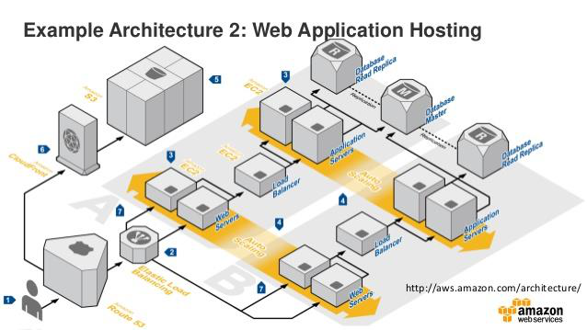

**Figure 12: Example of web application hosting**

**6.2**  **Software Detailed Design**

*Provide a detailed description for each system software service that addresses the following software service attributes. Much of the information that appears in this section should be contained in the headers/prologues and comment sections of the source code for each component, subsystem, module, and subroutine. If so, this section may largely consist of references to or excerpts of annotated diagrams and source code. Any referenced diagrams or source code excerpts should be provided at any design reviews.*

|  |  |  |  |
| --- | --- | --- | --- |
| • | *Service Identifier - The unique identifier and/or name of the software service* | | |
| • | *Classification - The kind of service (e.g., application, data service, etc.)* | | |
| SDD Version 4.0 | | 72 | ARC SGT SDD> |

|  |  |
| --- | --- |
| Page 73 | System Design Document |
| • • • •  •  •  •  •  •  **6.3** | *Definition - The specific purpose and semantic meaning of the service*  *Requirements - The specific functional or nonfunctional requirements that the service satisfies Internal Data Structures - The internal data structures for the service*  *Constraints - Any relevant, assumptions, limitations, or constraints for the service (this should include constraints on timing, storage, or service state, and might include rules for interacting with the service (encompassing pre-conditions, post-conditions, invariants, other constraints on input or output values and local or global values, data formats and data access, synchronization, exceptions, etc.))*  *Composition - A description of the use and meaning of the subservices that are a part of the service*  *Users/Interactions - A description of the service’s collaborations with other services (what other services use this this entity? what other services does this entity use (including any side-effects this service might have on other parts of the system)? this includes the method of interaction, as well as the interaction itself. Object-oriented designs should include a description of any known or anticipated sub-classes, super-classes, and meta-classes)*  *Processing - A description of precisely how the service goes about performing the duties necessary to fulfill its responsibilities (this should encompass a description of any algorithms used; changes or state; relevant time or space complexity; concurrency; methods of creation, initialization, and cleanup; and handling of exceptional conditions)*  *Interfaces/Exports - The set of services (resources, data types, constants, subroutines, and exceptions) that the service provides (the precise definition or declaration of each such element should be present, along with comments or annotations describing the meanings of values, parameters, etc.; for each service element described, include or provide a reference in its discussion to a description of its important software service attributes (Component Identifier, Classification, Language, Source Lines of Code (SLOC) Estimate, Definition, Responsibilities, Requirements, Internal Data Structures, Constraints, Composition, Uses/Interactions, Resources, Processing, and Interfaces/Exports))*  *Reporting Design and Integration - If built in, provide details on data traffic and volumes*  **Security Detailed Design** |

*Instructions: Provide a graphical representation with detailed information for each of the individual security hardware components. Specify the design for the below items as required.*

|  |  |
| --- | --- |
| • • • • • • | *Authentication*  *Authorization*  *Logging and Auditing*  *Encryption*  *Network ports usage*  *Intrusion Detection and Prevention* |

*The design should be based on the designated system security level and provide adequate protection against threats and vulnerabilities.*

Current and proposed application utilizes AWS IAM for security and authentication.

AWS Identity and Access Management (IAM) is a web service that helps you securely control access to AWS resources for your users. You use IAM to control who can use your AWS resources (*authentication*) and what resources they can use and in what ways (*authorization*).

The "identity" aspect of AWS Identity and Access Management (IAM) helps you with the question "Who is that user?", often referred to as authentication. Instead of sharing your root account credentials with others, you can create individual IAM users within your account that correspond to users in your organization. IAM users are not separate accounts; they are users within your account. Each user can

|  |  |  |
| --- | --- | --- |
| SDD Version 4.0 | 73 | ARC SGT SDD> |

|  |  |
| --- | --- |
| Page 74 | System Design Document |

have its own password for access to the AWS Management Console. You can also create an individual access key for each user so that the user can make programmatic requests to work with resources in your account. In the following figure, the users Brad, Jim, DevApp1, DevApp2, TestApp1, and TestApp2 have been added to a single AWS account. Each user has its own credentials.

If you are creating a mobile app or web-based app that can let users identify themselves through an Internet identity provider like Login with Amazon, Facebook, Google, or any OpenID Connect (OIDC) compatible identity provider, the app can use federation to access AWS.

Amazon Cognito should be used for proposed solution security improvements. Amazon Cognito lets you easily add user sign-up and sign-in and manage permissions for your mobile and web apps. You can create your own user directory within Amazon Cognito, or you can authenticate users through social identity providers such as Facebook, Twitter, or Amazon; with SAML identity solutions; or by using your own identity system. In addition, Amazon Cognito enables you to save data locally on users' devices, allowing your applications to work even when the devices are offline. You can then synchronize data across users' devices so that their app experience remains consistent regardless of the device they use.

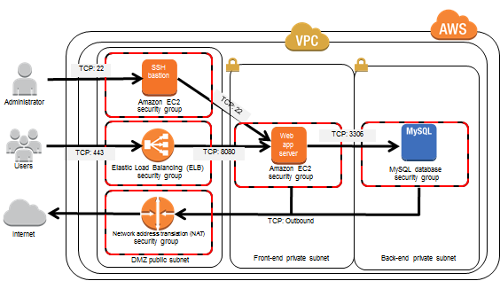

**Figure 13: Security detail design**

**6.4**  **Performance Detailed Design**

The AWS platform used by the current solution provides elastic and on demand capacity and availability. Performance management and monitoring is integrated into solution. Hardware architecture scales as needed based on demand. There are no single points of failure in current and proposed data center architecture.

**6.5**  **Internal Communications Detailed Design**

The proposed solution utilize existing communication protocols and methods. There are no additional components, servers, or applications to communicate with. The proposed solution will simply extend the current capabilities.

|  |  |  |
| --- | --- | --- |
| SDD Version 4.0 | 74 | ARC SGT SDD> |

|  |  |  |
| --- | --- | --- |
| Page 75 |  | System Design Document |
| **7.** | **System Integrity Controls** |  |

The following section documents security integrity controls.

|  |  |  |  |
| --- | --- | --- | --- |
| •  •  •  •  •  • | Internal security to restrict access of critical data items to only those access types required by  users/operators  o The current system is roles and permission based. Form and field level security will be  available in the proposed system. Based on user roles and permissions, system  administrators can control data access by user and provider.  Audit procedures to meet control, reporting, and retention period requirements for operational and  management reports  o Audit logs and audit trail is proposed in the current use cases. All changes to data must  be recorded by date, time, and user. Data will be managed indefinitely or until a system  admin purges the data.  Application audit trails to dynamically audit retrieval access to designated critical data  o See above.  Standard tables to be used or requested for validating data fields  o Industry standard data validation rules, triggers, and process have been identified in this  document.  Verification processes for additions, deletions, or updates of critical data  o Verification of additions, deletion, updates, etc… are controlled in the data validation  functions described in another section.  Ability to identify all audit information by user identification, network terminal identification, date,  time, and data accessed or changed.  o Data audit trails and logging will provide detailed audit of all data. Network and  application logs identify network terminations, user terminations, bugs, and catastrophic  failures. These allow system admin to improve the application and hosting environment. | | |
| SDD Version 4.0 | | 75 | ARC SGT SDD> |

|  |  |  |
| --- | --- | --- |
| Page 76 |  | System Design Document |
| **8.** | **External Interfaces** |  |

A number of services external to the 1-Click software can be used to provide additional fixed-route, taxi, or ride share information to travelers.

**8.1**  **ATL Transit**

ARC has created and maintains ATLTransit, a regional transit information hub web application for transportation options not currently offered by existing trip planning applications. ATLTransit contains route information from all of the transit agencies in the region. ATL Transit is a regional fixed route trip planner that leverages both Google Maps and Open Trip Planner. SGT connects to this system for fixed route planning information. It is integrated to SGT via API.

**8.2**  **Google Maps**

Services from Google are used to display the background of the maps within 1-Click, and to geocode street addresses to determine full addresses and the latitude/longitude location.

As such, a unique Google Maps API Key is needed for each 1-Click instance.

**8.3**  **OpenTripPlanner**

OpenTripPlanner provides fixed-route transit, walking, bicycling, and driving itineraries for the SGT system. OpenTripPlanner requires GTFS data from each public transit agency. OpenTripPlanner also requires a graph of the street network derived from OpenStreetMap.

An instance of OpenTripPlanner will be setup and maintained as part of the proposes system.

**8.4**  **Rideshare**

Rideshare integration is not available due to the propriety nature of these services, no standard integration method can be implemented. If a public API is available, the proposed system may be able to integrate this mode into system.

**8.5**  **Taxi Fare Finder**

SGT uses a taxi fare estimator known as Taxi Fare Finder to estimate taxi fares for trips. Taxi Fare Finder does not require any additional hardware or services to be setup. Taxi Fare Finder provides a public API that the system will query as part of the trip planning process.

|  |  |  |
| --- | --- | --- |
| SDD Version 4.0 | 76 | ARC SGT SDD> |

|  |  |
| --- | --- |
| Page 77 | System Design Document |
| **8.6**  **Transportation Network**  Regional transit systems may publish real time GTFS feeds. This allows third party systems to consume the real time location data for fixed route buses and rail.  MARTA currently publishes this information on their developer website. Other regional transit systems may choose to do this in the future. If so, this dramatically improves the same day trip planning and multi-modal coordination capabilities of these types of systems.  Sample MARTA Real Time GTFS Feed Response:  [ { "ADHERENCE": "4", "BLOCKID": "31", "BLOCK_ABBR": "110-4", "DIRECTION": "Northbound", "LATITUDE": "33.8346347",  **Companies (TNC)**  TNC’s may be implemented in the proposed system.  Uber and Lyft both provide well published open API’s for integration into third party systems. The system would be able to take advantage of these business models to complement or supplement transportation services.  **8.7**  **GTFS Real Time**  "LONGITUDE": "-84.3824637", "MSGTIME":  "5\/14\/2013 11:14:04 AM", "ROUTE": "110", **Figure 14: Sample uber API responses** "STOPID": "900456", "TIMEPOINT": "Peachtree Hills &  Peachtree", "TRIPID": "3719918", "VEHICLE": "2853" }, ... ] | |
| **8.8** | **GTFS Flex** |

GTFS flex is the newest emerging transit standard that models mobility on demand, demand response, and flex-deviation services. As an example, CCT has recently implemented a flex service that could be integrated into this system.

**8.9**  **Emerging Business Models**

Integration and connectivity to emerging business models must be envisioned in the TCMP. Car sharing,

bike sharing, and other emerging models should be supported via published and open API’s.

**8.10Third Party Commercial Application Integration**

Many providers have implemented third party applications for customer management, eligibility, reservations, scheduling and dispatching. Integration and connectivity support may be required to coordinate and exchange data across multiple platforms. It is anticipated that an open and published set

of API’s will facilitate this effort. Current research projects in Portland, Oregon, are exploring the concept of open sourced transportation clearinghouses to support this.

Major commercial providers include:

|  |  |  |  |
| --- | --- | --- | --- |
| ▪ | Trapeze |  |  |
| ▪ | RouteMatch |
| ▪ ▪ | SimpliTransport Ecolane |
| SDD Version 4.0 | | 77 | ARC SGT SDD> |

|  |  |  |
| --- | --- | --- |
| Page 78 |  | System Design Document |
| ▪ | Mobilitat  Stratagen |  |
| ▪ |

**8.11Transportation Clearinghouse**

The Ride Connection Clearinghouse (“Clearinghouse”) is a web site that allows ride services to share trips that cannot be fulfilled and claim trips shared by other services. The Clearinghouse API is an Internet-accessible programming interface that allows services and third parties to integrate other software with the Clearinghouse to automate the sharing and claiming of trips. One such system has already been developed: the Ride Connection Clearinghouse Adapter. This reference is intended to assist with further work on the Adapter as well as the development of new adapter software.

**8.11.1Adapter API**

The Ride Clearinghouse Adapter is a software system that simplifies back office integration with the Ride Clearinghouse web site. The Adapter runs as a Windows Service in the background, periodically triggering a worker process that synchronizes data with the Clearinghouse API, then imports new data

from a user’s system to send to the Clearinghouse. The Ride Clearinghouse web site supports manual import and export (upload and download) of trip tickets via the Bulk Upload menu. Imported trip tickets must be formatted as text files in the CSV format.

**8.12Points of Interest**

Trip origins and destinations can be located interactively on a map, using the GPS of a mobile device, via the Google geocoder that will convert a street address into a X-Y coordinate, and by selecting from a pre-defined list of Points of Interest (POIs). These POIs often include hospitals, schools, offices of Veterans Affairs, and other popular locations.

In order to include points of interest in the 1-Click database, a comma separated value (CSV) file is required containing the list of POIs. For each point of interest, the following fields are needed.

**Table 17: 1-Click Points of Interest File Format**

|  |  |  |
| --- | --- | --- |
| **Field** | **Type** | **Description** |
| LONGITUDE | Double | Longitude (X) coordinate of the location |
| LATITUDE | Double | Latitude (Y) coordinate of the location |
| NAME | String | Name |
| ADDRESS_1 | String | Address (line 1) |
| ADDRESS_2 | String | Address (line 2) |
| CITY | String | City name |
| STATE | String(2) | State abbreviation |
| ZIP | String(5) | 5-digit zipcode |
| COUNTY | String | County name |

TYPE (Optional)

**8.13Public Transit**

Multiple public transit agencies may be operating within the 1-Click area. Each one needs to exist within the 1-Click database, together with the defined fixed service routes.

|  |  |  |
| --- | --- | --- |
| SDD Version 4.0 | 78 | ARC SGT SDD> |

|  |  |
| --- | --- |
| Page 79 | System Design Document |

**8.14GTFS**   
The General Transit Feed Services1 (GTFS) defines a common format for public transportation schedules and associated geographic information. These GTFS files are loaded into 1-Click and are consumed by the OpenTripPlanner server to generate public transit trip itineraries.

**8.15Agencies**

**Table 18: Public Transit Agency Attributes**

|  |  |
| --- | --- |
| **Attribute** | **Description** |
| Name | Name of the Public Transit Agency |

Street

|  |  |
| --- | --- |
| City |  |
| State | Contact Address |

Zipcode

|  |  |
| --- | --- |
| Phone | General phone number for Public Transit Agency |
| Email | General information email address for Public Transit Agency |
| Website | URL of the Public Transit Agency website |
| Logo | Image of the Public Transit Agency logo suitable for display within 1-Click |
| Administrator | Name of the person who will be the 1-Click Public Transit Agency |

Administrator. Administrator needs a 1-Click user account prior to being assigned.

|  |  |
| --- | --- |
| Note: | Some of these attributes can be extracted from the GTFS file. |

**8.16Specialized Service Providers**   
Demand-Response Services are provided by a number of Providers.

**8.17Providers**   
The following data is required about each Provider.

**Table 19 - Specialized Services Provider Attributes**

|  |  |
| --- | --- |
| **Attribute** | **Description** |
| Name | Name of the Provider |

Street

|  |  |
| --- | --- |
| City |  |
| State | Provider Address |

Zipcode

|  |  |  |
| --- | --- | --- |
| Phone | General phone number for Provider |  |
| Email | General information email address for Provider |  |
| Website | URL of the Provider website |  |
| SDD Version 4.0 | 79 | ARC SGT SDD> |

|  |  |
| --- | --- |
| Page 80 | System Design Document |
| Logo | Image of the Provider logo suitable for display within 1-Click |
| Administrator | Name of the person who will be the 1-Click Provider Administrator. |

Administrator needs a 1-Click user account prior to being assigned.

**8.18Services**

The following data is required about each Service offered by a Provider.

**Table 20: Provider Services attributes**

|  |  |
| --- | --- |
| **Attribute** | **Description** |
| Provider Name | Name of the Provider |
| Service Name | Name of the Service |

Contact Name

|  |  |
| --- | --- |
| Contact Phone | Contact details of the person responsible for this service |

Contact Email

|  |  |
| --- | --- |
| Schedule | Daily start and end times of the services |
| Advanced Booking | How much advanced notice is required to book a trip with this service? |
| Accommodations | What traveler accommodations are provided for this service? |
| Eligibility Requirements | What are the eligibility requirements to use this service? |
| Trip Purposed Served | Is this service only for specific trip purposes? If so, what trip purposes? |
| Service Area | The geographic area covered by this service – can be split into Origin, |

Destination and Resides areas.

|  |  |
| --- | --- |
| Fare Information | Fare structure for this service |

As part of the 1-Click trip planning workflow, users need to define the start and end of the trips and display information (e.g., start/end locations, sidewalk obstructions, trip routes, etc.) on a map. To accomplish this, 1-Click uses a number of third party application programming interfaces (API):

• Google Geocoding API2 for geocoding addresses, and reverse geocoding point locations. • Leaflet Map API3 for rendering maps.

• Google Street View Image API 4for displaying a street view of a given location.

The pros and cons regarding the use of these APIs is discussed below with potential alternatives.

**8.18.1Geocoding**

1-Click allows users to define the start and end locations of a trip by:   
1. Entering a street address which is then geocoded to determine a longitude/latitude.

2. Selecting a predefined Point of Interest that has an associated longitude/latitude.

3. Clicking on the map that returns a longitude/latitude that is reverse geocoded to determine the street address at that location.

|  |  |  |
| --- | --- | --- |
| SDD Version 4.0 | 80 | ARC SGT SDD> |

|  |  |
| --- | --- |
| Page 81 | System Design Document |

To implement methods 1 and 3, the Geocoding API must allow both forward and reverse geocoding, and be available as a web service that can be called directly from 1-Click.

There are many Geocoding APIs that could potential be used within 1-Click (e.g., Gisgraphy, Google, Here, MapQuest, Nominatim, Yahoo!). While any of these Geocoding APIs could potentially be used within 1-Click, the strength of the geocoder is based on the quality of the returned geocodes. Based on research, third-party review and comparison testing, the Google Geocoder was selected due to the quality of the returned geocodes in comparison to the competitors.

CS will be updating the geocoding implementation within 1-Click v1.2 to use client-side geocoding instead of server-side geocoding to increase the number of daily free geocodes.

**8.18.2Maps**

1-Click displays maps when defining the start and end points of a trip; displaying the trip itinerary routes; defining Traveler Places; and displaying Provider Service coverage areas. To do this, the select Map API must be able to:

|  |  |
| --- | --- |
| •  • • • | Zoom to a specific map extent (e.g., area around start/end of the trip, current location, extent of the route, etc.).  Display a map background, known as a basemap, that provides context.  Render various graphics (e.g., start/end trip locations, trip itinerary routes, other spatial data).  Allow users to interact with the map (e.g., zoom/pan, identify graphics, determine clicked locations, etc.). |

Based on these requirements, there are a number of Map APIs that could potential be used within the proposed solution. The pros and cons of these different Map APIs are listed below.

**Table 21: Map API pros & cons**

|  |  |  |
| --- | --- | --- |
| **Map API** | **Pros** | **Cons** |
| Google | •Widely used | •Proprietary |

•Extensive set of graphic controls

•Detailed license language •HTML4

|  |  |
| --- | --- |
| Leaflet | •Open-source  •Light-weight (i.e., small download |

size that improves performance)   
•Fully HTML5 compatible   
•Seamless integration with multiple   
 formats of basemap (e.g., Esri,   
 Google, OpenStreetMap)   
•Seamless integration with multiple   
 formats of feature map service (e.g.,   
 Open Geospatial Consortium (OGC)   
 WFS and WMS, Esri)   
•Extensive set of graphic controls

|  |  |  |
| --- | --- | --- |
| OpenLayers | •Open-source | •HTML4 |

•Seamless integration with multiple   
formats of basemap (e.g.,   
OpenStreetMap, Bing, MapQuest)

The Leaflet API was selected for displaying maps in 1-Click due to its high level of functionality, compatibility with a modern open source HTML5 application, and flexibility to show different basemaps.

|  |  |  |
| --- | --- | --- |
| SDD Version 4.0 | 81 | ARC SGT SDD> |

|  |  |
| --- | --- |
| Page 82 | System Design Document |

The Google Maps API license that states that Google Geocodes must be displayed on a Google basemap. As such, the Leaflet implementation within 1-Click uses a plugin5 that uses the Google Maps API v3 to display the Google basemap. CS believes that 1-Click complies with the Google Maps license, and will take responsibility as part of Maintenance and Support services for resolving any claims by Google to the contrary.

**8.18.3Google Street View**

Google Street View pages are displayed by passing the longitude/latitude coordinates as URL parameters to the Google Street View Image API.

Use of Google Street View is considered separate from the use of other Google Map APIs, with the license stating “As another example, you must not display Street View imagery alongside a non-Google map, but you may display Street View imagery without a corresponding Google map because the Maps APIs Documentation explicitly permits you to do so.”

**8.19Interface Architecture**

The current and proposed solutions utilize a services oriented architecture. The proposed system will utilize the existing interface architecture by implementing a REST framework.

**Representational State Tranfser (REST)**

This is a style or framework for designing integrated applications or services over HTTP. The proposed solution will implement a true RESTful API for interapplication integration and regional coordination. This achieves the following results from an interface architecture perspective:

• Uniform interface

• Client–server

• Stateless

• Cacheable

• Layered system

• Code on demand

**Data Exchange**

JSON (JavaScript Object Notation) is a lightweight data-interchange format. It is easy for developers to read and write. It is easy for machines to parse and generate. It is based on a subset of the JavaScript Programming Language. JSON is a text format that is completely language independent but uses conventions that are familiar to programmers of the C-family of languages, including C, C++, C#, Java, JavaScript, Perl, Python, and many others. These properties make JSON an ideal data-interchange language.

**8.20Interface Detailed Design**

All third party applications and integrations will utilize a RESTful API that will be designed in the application development phase. The API will be open and published. This means that any developer or

|  |  |  |
| --- | --- | --- |
| SDD Version 4.0 | 82 | ARC SGT SDD> |

|  |  |
| --- | --- |
| Page 83 | System Design Document |

third party, if provide the proper security credentials, can access application, database, and published functions.

REST Model Clients make standard HTTP requests over an SSL channel and should always validate the certificate of the endpoint with which the client is communicating.

**Resources**   
Clients make requests against enStratus resources, either in aggregate or a specific resource.

The format of the URL is:

|  |  |
| --- | --- |
| • | endpoint/version/namespace/resource[?query_parameters] • endpoint/version/namespace/resource/resource_id |

**Operations**   
API requests are standard HTTP requests against SGT published resources. GET queries for a list of a class of resources or the details of a specific resource. POST creates a new resource instance and will provide either a job or a resource tance in the response body. PUT updates an existing resource with the specified parameters. DELETE removes or terminates or deactivates a resource. In general, there is no such thing as permanent deletion of anything in enStratus. Resources are instead “deactivated” via the DELETE call. HEAD provides response headers, including a count of matching resources.

**Request Headers**   
When making a request, there are three authentication headers the third party must specify plus an optional authentication header for preventing replay attacks.

In addition, the API must support the following optional request headers:

• Accept

• x-es-details

• x-es-with-perms

Third parties may specify an “Accept” header to define whether you wish to receive responses as XML or JSON. The default response is XML. The values you may specify for “Accept” are:

• application/xml

• application/json   
**Response Codes**   
API will respond with standard HTTP response codes appropriate to the result of the request. While the exact meaning of the code varies depending on the request, the general rules are:   
200   
A response code of 200 means the request was successful and details about the response can be found in the body of the response.

201   
The requested POST operation was successful and an object was created in the system.

202   
The requested operation has been accepted and the body contains information about an asynchronous job you can query to check on the progress of the request.

204

|  |  |  |
| --- | --- | --- |
| SDD Version 4.0 | 83 | ARC SGT SDD> |

|  |  |
| --- | --- |
| Page 84 | System Design Document |

The requested operation was successful and there is no response body.

307   
Please repeat the request using the provided URI. Subsequent requests can use the old URI.

400   
Your request was improperly formatted. You should verify that your request conforms to this specification and re-issue the request in a properly formatted manner.

404   
The requested resource does not exist.

409   
An operational error occurred. The most common reason is an error with the cloud provider itself, but it can also result from any number of cloud state issues.

418   
A request was made to create a resource, but the resource was not created and no job was returned.

500   
API failed to process the request because of an error inside the system.

501   
You requested an action against a resource in a cloud that does not support that action.

503   
API undergoing maintenance or is otherwise temporarily unavailable for API queries.

**Response Entities**   
All GET methods respond with the JSON or XML of the resource(s) being requested. HEAD methods have no response entity.

POST methods may respond with a 201 CREATED or 202 ACCEPTED response code depending on whether the creation completed immediately or is an asynchronous operation. If the resource was created immediately, API should provide a JSON or XML entity that includes the new resource’s unique ID. If the creation operation takes time, however, the response body will include a Job resource that can be tracked to completion.

PUT and DELETE methods generally respond with 204 NO CONTENT unless the operation is a long-lived operation. In those scenarios, the PUT will respond with a 202 ACCEPTED response code and include a Job resource in the response entity

|  |  |  |
| --- | --- | --- |
| SDD Version 4.0 | 84 | ARC SGT SDD> |

|  |  |  |
| --- | --- | --- |
| Page 85 |  | System Design Document |
| **9.** | **Appendix A: Record of Changes** |  |

**Table 22: Record of changes**

|  |  |  |  |  |
| --- | --- | --- | --- | --- |
| |  | | --- | | **Version Number** | | **Date** | **Author/Owner** | **Description of Change** |
| *1.0* | *02/26/2017* | *Tim Quinn* | *Draft document* |
| *2.0* | *03/12/2017* | *Carly Harper* | *Revisions* |
| *3.0* | *04/26/2017* | *Cyndi Burke* | *Feedback / Process* |
| *4.0* | *5/02/2017* | *Tim Quinn* | *Final Draft* |
| *5.0* | *05/05/2017* | *Cyndi Burke* | *Review* |
| *6.0* | *05/05/2017* | *Carly Harper* | *Modifications* |
| *7.0* | *05/08/2017* | *Tim Quinn* | *Final Draft (v1)* |
| *8.0* | *06/22/2017* | *Tim Quinn / Carly Harper* | *Comments from FTA / Modifications* |
| SDD Version 4.0 |  | 85 | ARC SGT SDD> |