Final Project Requirements:

Team B

ECT 330 Advanced Internet Application Development

February 23, 2016

Karen Cardenas | Roberto Despoiu | Alex Alvarez

Company Profile

**Company Name:** Above Treeline

**Type of Business:** Mountaineering, hiking, climbing, and outdoor gear store

**Tagline: “**In mountaineering terms, the treeline is the “line” past which trees can no longer grow because of high altitude. Most difficult mountaineering ascents occur above the treeline.”

**Social Media:**

Twitter: Above Treeline [@TreelineAbove](https://twitter.com/TreelineAbove)

Email: [weareabovetreeline@gmail.com](mailto:weareabovetreeline@gmail.com)

**Additional Information:**

The main purpose of Above Treeline is to reach out to the outdoors community and provide them with whatever type of tools or accessories they may need to continue on the path. In making a website, it makes them and their products more accessible and available to everyone looking for these kinds of equipment.

Site Profile

**Media Assets:**

All media assets will be in the form of images, and most will fall under the Creative Commons licenses found on the web and under public domains. The other provided images will be from self-owned images, i.e. photographs, owned by us, the developers.

The company has a logo, created by Roberto via Photoshop/Illustrator.

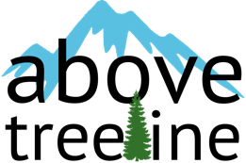

**Site Layout:**

An initial site layout mockup has been worked up. This is the initial design moving forward:

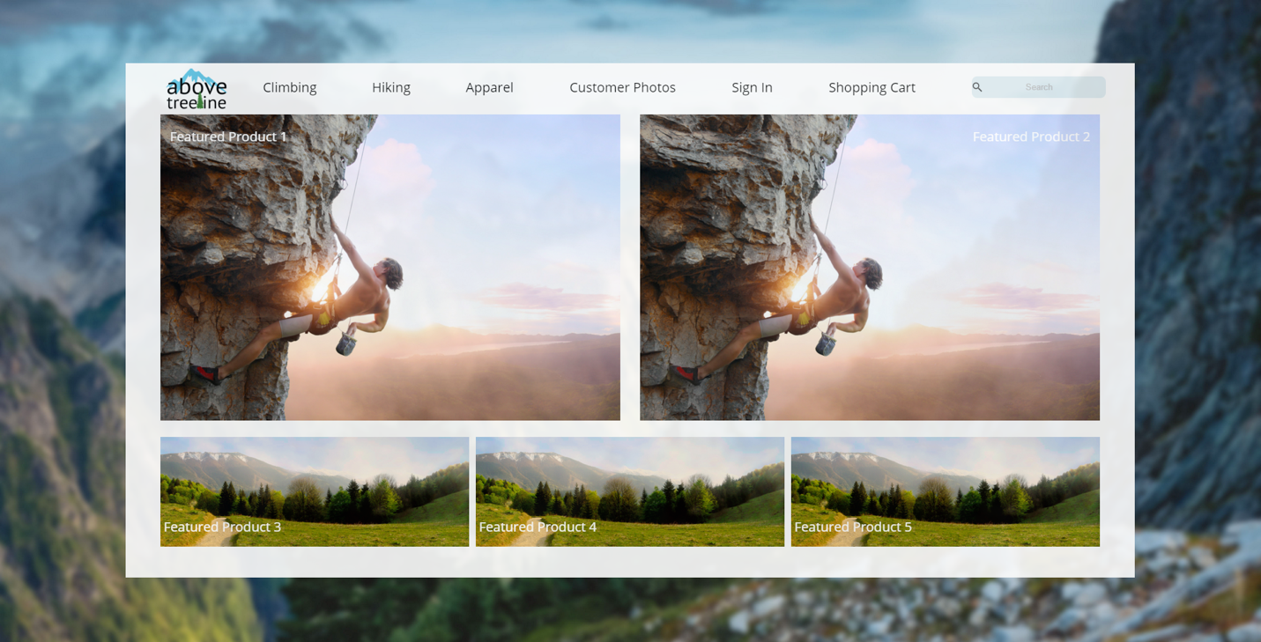

**Page Layout/Content:**

There will be a multitude of varying pages for the website. Provided is a comprehensive list of pages being implemented, as well as content information shells.

1. Splash Page
   1. Includes a select few items to highlight (POSSIBLE VIDEO?)
2. Login Page
   1. Standard login page that acts as login portal for the site
3. Products List
   1. Lists products and allows filters by different categories
4. Product Detail Page
   1. Gives more exact information about a specific product
5. Shopping Cart
   1. Allows the customer to view what is in their current cart
6. Checkout Page
   1. Allows customer to buy the products in their cart and do a credit card transaction
7. Summary Page
   1. This is what the customer is redirected to after the checkout page, and has summary information about the checkout to confirm the purchase
8. About Page
   1. This will include the mission statement, as well as a bit of background information about the company

Pages will be implementing the use of Master Pages, and those pages will have header and footer sections. The header will highlight the company logo (clickable), as well as global navigational links, a search bar, a message to users if logged in, and a clickable button to the cart. The footer will have standard contact information along with terms and conditions.

**Database Information:**

Tables:

1. Customers(ID:int, FirstName:String, LastName:String, BillingAddress:String, ShippingAddress:String, City:String, State:String, Zipcode:String, Email:String, Username:String, Password:String)
   1. Primary Key: ID
2. Products(ID:int, Stock:int, UnitPrice:double, ProductName:String, Description:String, Image:String, CategoryID:int, Featured:Boolean)
   1. Primary Key: ID
   2. Foreign Key: CategoryID -> Categories
3. Categories(ID:int, Description:String)
   1. Primary Key: ID
4. Orders(ID:int, CustomerID:int, Subtotal:double, ShippingAddress:String, OrderDate:String?Date?, OrderStatus:String)
   1. Primary Key: ID
   2. Foreign Key: CustomerID -> Customers
5. OrderItem(ID:int, OrderID:int, ProductID:int, Quantity:int)
   1. Primary Key: ID
   2. Foreign Key: OrderID -> Orders, CustomerID -> Customers

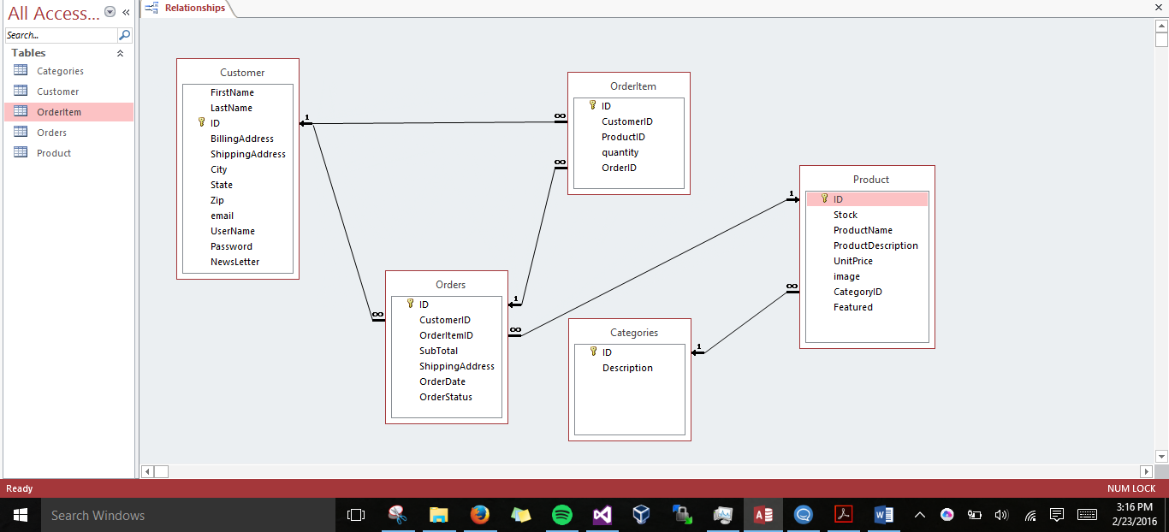

Team/Work Breakdown

**Team Member Responsibilities:**

With there being three team members, everyone will be contributing as much as they can in as many roles as possible. However, as a guide, there have been specific tasks given to each member to be ultimately responsible for. Karen is leading the database work along with Twitter API and social media functionality. Roberto will be handling backend classes, functions, as well as handling Master Page design and CSS manipulation. Alex will be in charge of the login, checkout, summary page, and the search functionality. As a team we will work on all fronts and will be cross-collaborating to get the website built as sound as possible.

**Build Timeline:**

The Master Pages and database implementation is the first main goal that needs to be addressed as they are the foundation to the project. Those should be constructed and at least close to finalized by 2/26. The login authentication system being actualized will be the next phase, and should be finished promptly by 3/1. The Twitter API implementation and final database finalization should be done by 3/11. After that milestone, there should be a working prototype close to the final deliverable by 3/14. The reason for this is to have time for final adjustments and have a buffer going in to the final presentation.