Sales Data Cleaning, SQL Analysis & Power BI Dashboard
End-to-End Sales Data Analytics Project
Dataset: sales_data.csv
Tools Used:
Microsoft Excel 2019 • MySQL 8.0 • Power BI
Data Cleaning → SQL Analysis → Power BI Dashboard
Date: August 8, 2026

Introduction
This document records the full, end-to-end workflow followed to clean, analyse, and visualise the sales_data.csv dataset. The dataset originally contained 113,036 rows covering bike and accessory sales across multiple countries, including fields for customer demographics, product details, order quantities, and financial figures (cost, profit, revenue). The project was carried out in three phases: (1) data cleaning and preparation in Microsoft Excel, (2) importing the cleaned data into MySQL and running analytical SQL queries, and (3) building an interactive Power BI dashboard to visualise the results.

Part 1: Data Cleaning in Microsoft Excel

Step 1: Correcting the Age Group Column
The dataset included a pre-existing Age_Group column, but it contained inconsistent or incorrect labels for some rows. To resolve this, a new helper column, age_grp, was added using a nested IFS/AND formula to correctly re-bucket each customer based on their Customer_Age value:
=IFS(E2<25,"Youth", AND(E2>=25,E2<=34),"Young Adult", AND(E2>=35,E2<=64),"Adult", E2>64,"Senior")
This ensured every row was assigned to the correct age bracket -- Youth, Young Adult, Adult, or Senior -- based strictly on numeric age, independent of any errors in the original column.
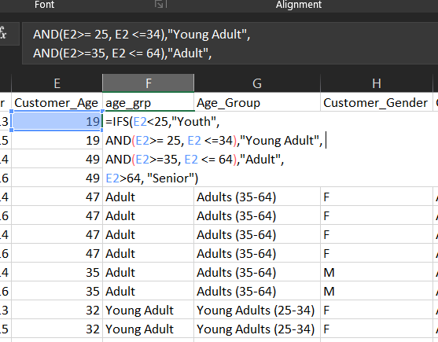
Figure 1: age_grp formula correcting the existing Age_Group column

Step 2: Removing Duplicate Rows
The dataset was checked for fully duplicated rows using Excel's built-in Remove Duplicates tool (Data tab > Data Tools > Remove Duplicates), with all columns selected to ensure only exact, full-row duplicates were removed.
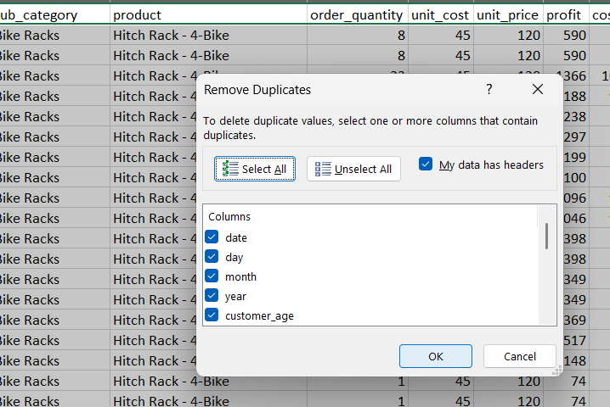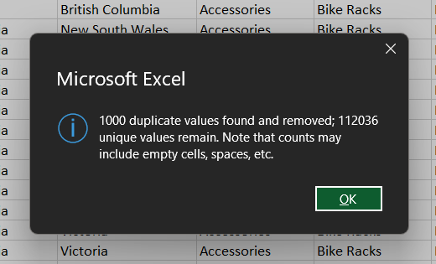
Figure 2a: Remove Duplicates dialog with all columns selected | Figure 2b: Confirmation of duplicates found and removed
Result: 1,000 duplicate values were found and removed, leaving 112,036 unique records in the dataset.

Step 3: Removing Redundant Date Columns
The original dataset stored the date as four separate fields: date, day, month, and year. Since the date column already contained the full date value, the separate day, month, and year columns were deleted to avoid redundancy and simplify the dataset structure.
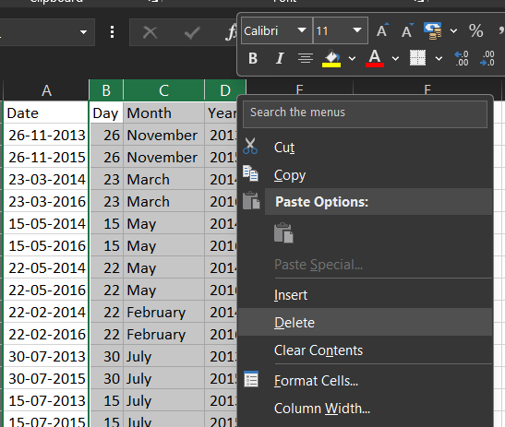
Figure 3: Deleting the redundant Day, Month, and Year columns

Step 4: Checking for Blank Cells
The dataset was checked for missing (blank) values using the COUNTBLANK function applied across the full data range:
=COUNTBLANK(A2:A112037)
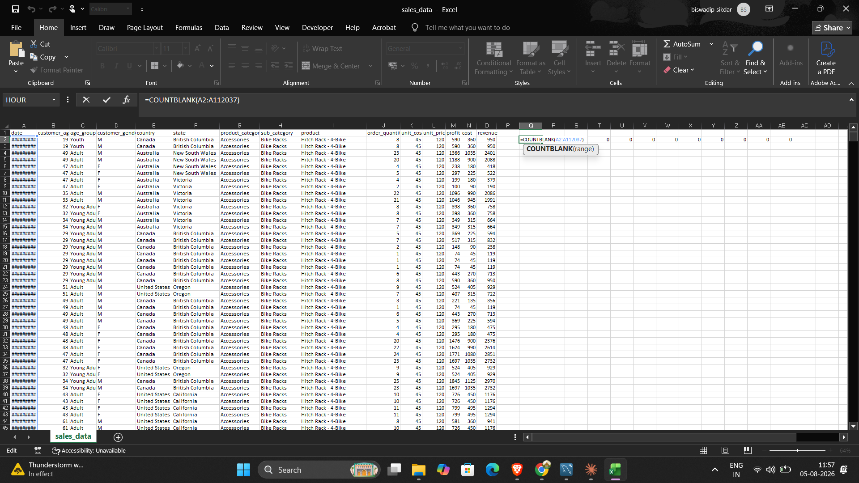
Figure 4: COUNTBLANK formula applied to check for missing values
Result: No blank cells were found in the dataset after the duplicate-removal step.

Step 5: Sorting the Data by Date
The full dataset was sorted in chronological order using Data > Sort, with the date column selected and the order set to Oldest to Newest. This made the dataset easier to review and prepared it for any time-based analysis.
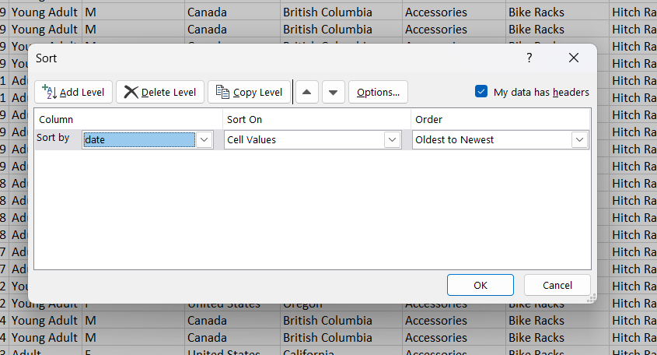
Figure 5: Sort dialog configured to order records by date, oldest to newest

Step 6: Data Consistency Validation Checks
A series of formula-based checks were carried out to confirm that the financial figures in the dataset were internally consistent. Each check was implemented as a helper column that returned “OK” or a flag when a row failed the test.
a. Revenue = Cost + Profit
=IF(O4=N4+M4,"OK","Mismatched")
Confirms that revenue equals the sum of cost and profit for every row.
b. Cost = Unit Cost x Order Quantity
Confirms that the recorded cost matches unit cost multiplied by order quantity for every row.
c. Unit Price Never Less Than Unit Cost
Confirms no product was sold at a per-unit loss (i.e. unit_price is never lower than unit_cost).
d. No Zero or Negative Order Quantity
Confirms every order has a valid, positive quantity.
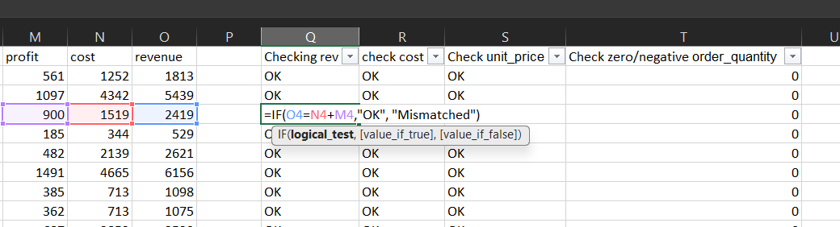
Figure 6: Validation formulas and results for checks (a)-(d), all returning "OK" / 0
All four checks passed across the dataset: revenue consistently equalled cost + profit, cost consistently equalled unit_cost x order_quantity, no unit price was below unit cost, and no order quantity was zero or negative.

Step 7: Adding Calculated Columns
a. Profit Margin
A profit_margin column was added to express profit as a percentage of revenue:
=M2/O2
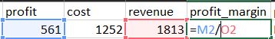
Figure 7a: profit_margin formula (profit / revenue)
b. Profit / Loss Flag
A profit_loss column was added to classify each transaction as a "Profit" or a "Loss" based on the sign of the profit value:
=IF(M2>=0,"Profit","Loss")
Figure 7b: profit_loss formula flagging each row as Profit or Loss

Excel Phase Summary
- Corrected inconsistent Age_Group labels using a new age_grp formula column
- Removed 1,000 duplicate rows (112,036 unique records remain)
- Removed redundant Day, Month, and Year columns in favour of the single Date column
- Confirmed no blank cells remain in the dataset
- Sorted the dataset chronologically by date
- Validated that revenue, cost, and unit price relationships are internally consistent, with no invalid order quantities
- Added profit_margin and profit_loss calculated columns to support further analysis

Part 2: SQL Analysis in MySQL
With the dataset cleaned in Excel, the cleaned CSV file was imported into a MySQL 8.0 database for structured, query-based analysis. A table was created to match the cleaned column structure, the data was bulk-loaded from the CSV file, and a series of analytical queries were run to explore revenue, profit, product performance, customer segments, and regional trends.

Step 1: Importing the Data
A. Creating the table
A sales_data table was created in MySQL with columns matching the cleaned dataset, including the calculated profit_margin and profit_loss fields added during the Excel phase.
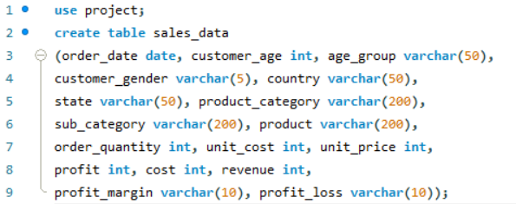
Figure 8: CREATE TABLE statement defining the sales_data schema
B. Loading the data
The cleaned CSV file was bulk-loaded into the table using LOAD DATA INFILE.
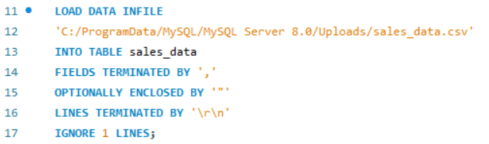
Figure 9: LOAD DATA INFILE statement importing sales_data.csv
Because the product column contains commas inside some values, OPTIONALLY ENCLOSED BY '"' was added to the statement. This tells MySQL that a field wrapped in double quotes should be read as a single value, even if it contains commas inside — preventing those product names from being incorrectly split across columns during the import.

Step 2: Analytical Queries
The following queries were run against the sales_data table to answer specific business questions about the dataset.
A. Total revenue, profit, and order count by year and month
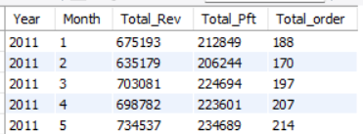
Figure 10: Revenue, profit, and order count grouped by year and month
B. Revenue vs. profit by product category
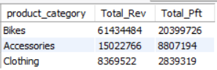
Figure 11: Revenue and profit grouped by product category
C. Profit margin trend over time
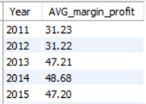
Figure 12: Average profit margin by year
D. Top 10 products by revenue and units sold
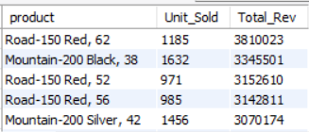
Figure 13: Top 10 products ranked by total revenue
E. Gender split in purchases by product category
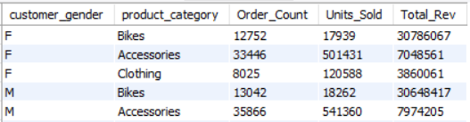
Figure 14: Order count, units sold, and revenue by gender and product category
F. Ranking states within each country by total sales
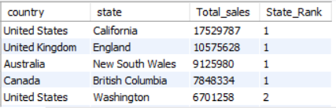
Figure 15: States ranked within each country using RANK() OVER (PARTITION BY country)
G. Products most often sold at a loss
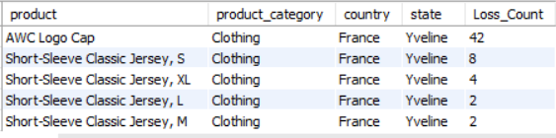
Figure 16: Products, categories, and locations with the highest loss-transaction counts
H. Year-over-year growth in revenue and margin
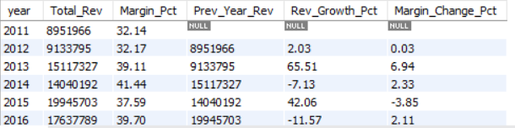
I. Highest-margin country + category + age_group combination
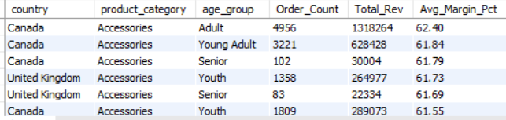

SQL Phase Summary
- Created a sales_data table in MySQL matching the cleaned Excel column structure
- Bulk-loaded the cleaned CSV using LOAD DATA INFILE, with OPTIONALLY ENCLOSED BY '"' to correctly handle commas inside the product field
- Analysed revenue, profit, and order volume trends by year and month
- Compared revenue-leading vs. profit-leading product categories
- Tracked the profit margin trend over time
- Identified the top 10 products by revenue and units sold
- Examined gender-based purchasing patterns across product categories
- Ranked states within each country by total sales using a window function
- Identified products, categories, and regions most frequently sold at a loss
- Calculated year-over-year revenue and margin growth
- Found the country + category + age_group combination with the highest average profit margin

Part 3: Power BI Dashboard
The results of the SQL analysis were brought into Power BI to build an interactive Sales Dashboard, allowing the results to be explored visually and filtered by year, country, age group, and gender.
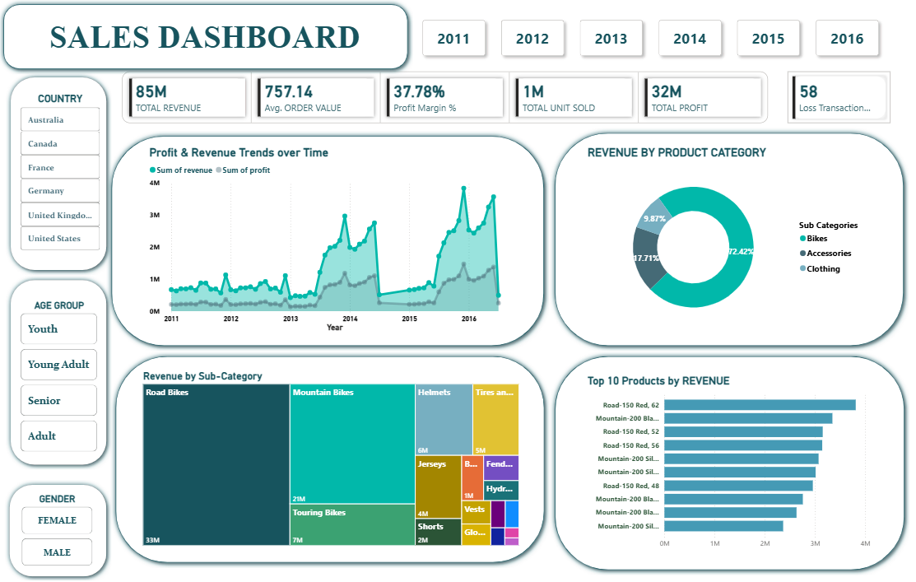
Figure 17: Interactive Power BI Sales Dashboard
The dashboard includes:
- Year selector (2011–2016) and slicers for Country, Age Group, and Gender
- KPI cards for Total Revenue, Average Order Value, Profit Margin %, Total Units Sold, Total Profit, and Loss Transaction count
- A Profit & Revenue Trends line/area chart showing revenue and profit over time
- A donut chart showing Revenue by Product Category / Sub-Category split (Bikes, Accessories, Clothing)
- A treemap showing Revenue by Sub-Category, broken down to individual products
- A bar chart showing the Top 10 Products by Revenue
Together, the KPI cards and visuals let a viewer quickly see overall performance (85M total revenue, ~37.8% profit margin, 1M units sold across the filtered period) and drill down into which years, countries, categories, and products are driving that performance.

Overall Project Summary
This project took the sales_data.csv dataset through a complete analytics workflow, from raw data to an interactive dashboard:
- Excel: cleaned and validated 113,036 raw rows down to 112,036 unique, consistent records, and added profit_margin / profit_loss calculated fields
- MySQL: imported the cleaned data and ran 9 analytical queries covering time trends, product and category performance, customer segmentation, regional ranking, and loss analysis
- Power BI: visualised the results in an interactive dashboard with year, country, age group, and gender filters
Tools used throughout the project: Microsoft Excel 2019, MySQL 8.0, and Power BI.

