introduction: this page introduces how use environmental science approaches to determine the source and extend of microplastics pollutions.

Source:

When determining the source of microplastics pollution in a water body such as a river, a transect can be set along the water body to effectively determine the spatial variation of the concentration of microplastics. Multiple samples of water collected in each quadrants in the transect will undergo chemical analysis to find the place where the concentration of microplastics starts to increase and hence find the source of the pollution.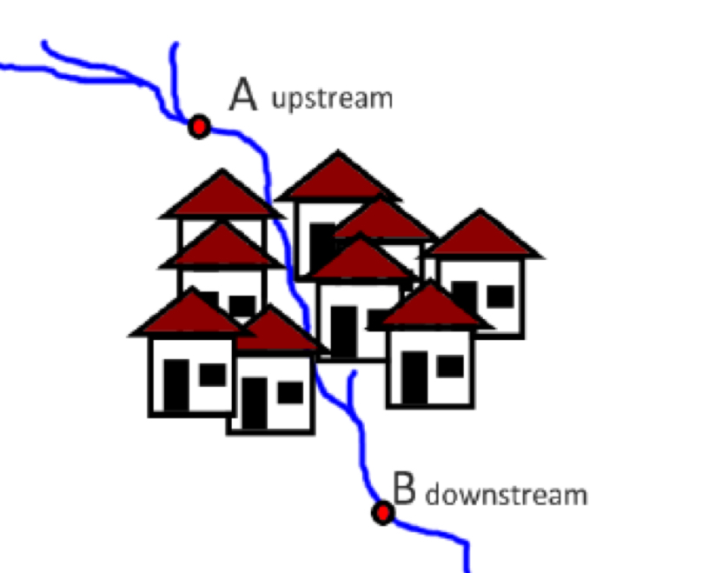

Extend:

Environmental impact assessment (EIA) should be carried out over time to compare the water body before and after microplastics enter it. Various environmental indicators such as biotic index and biodiversity index can be used to assess the impact of the pollution.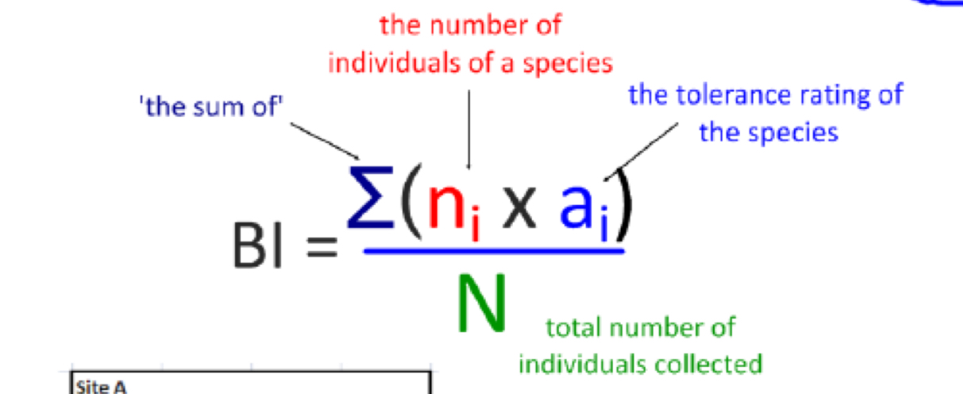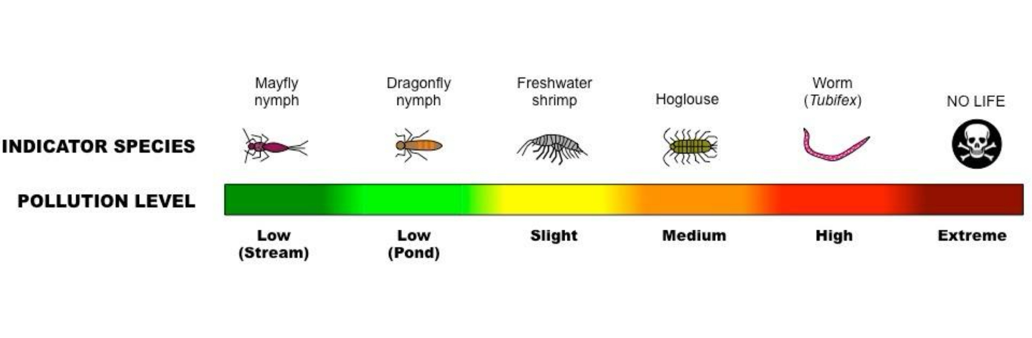

Source:(MLA)

Davis, Andrew, and Garrett Nagle. Environmental Systems and Societies. Oxford, Oxford University Press, 2019.

Friedland, Andrew J, and Rick Relyea. Friedland and Relyea Environmental Science for AP. New York, W.H. Freeman And Company, 2015.