Introduction

Microplastics with a size of less than 5mm are increasingly ubiquitously reported in water, land and even air. Over the past few years, microplastics pollution has attracted a lot of interest since they are dangerous to the environment and human health (Auta et al., 2017; Hale et al., 2020; Zhang et al., 2020). There is currently insufficient evidence that connects microplastic consumption with negative human health impacts, but experiments on animals suggest possible dangers. The consequences of microplastic filtration are inflammation, oxidative stress, and cytotoxicity because of the abrasive properties of microplastics. Chemical effects stem from the toxic additives in plastics and pollutants that get adsorbed on microplastics which can lead to reproductive and developmental toxicities or immune reactions. Biological effects include the release of pathogens that can cause diseases or have impact on the normal functioning of the intestinal microflora (Blackburn & Green, 2021).

To understand the microplastic pollution in natural water bodies and urban water bodies, we chose to collect and compare water samples from the Changbai Mountain region and Beijing. The results show that Beijing's water bodies are more seriously polluted by microplastics than Changbai Mountain.

Method

Combine water samples from the same location and filter through a 5mm sieve to remove large particles (the volume of water sample from each area is 1L).

Add 30ml of freshly prepared 0.05M ferrous sulfate solution and 30% hydrogen peroxide solution to the sample, mix thoroughly, and let it stand for 24 hours to fully digest organic matter.

After standing, pass the sample through a 2μm microporous membrane, collect the particles on the membrane, place them on a slide, and observe the contents on the membrane under a microscope at 100x magnification, recording the findings (Hu et al., 2021).

Result and discussion

The pictures below show the fields of the microscope from different areas:

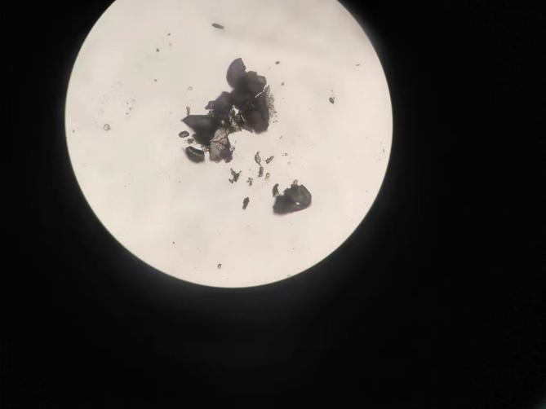

Figure 1 Residue from water sample of Beijing

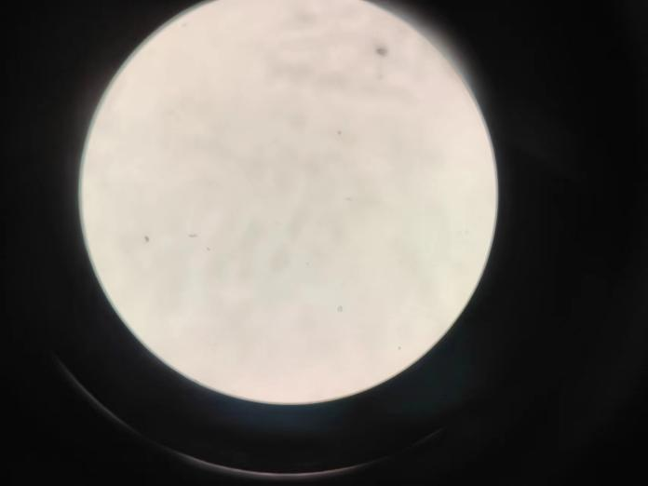

Figure 2 Residue A from water body of Changbai mountain

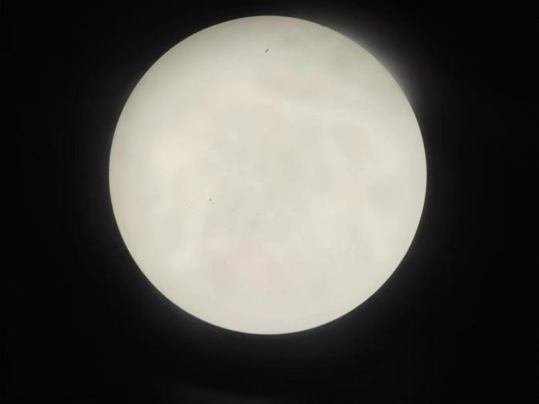

Figure 3 Residue B from water body of Changbai mountain

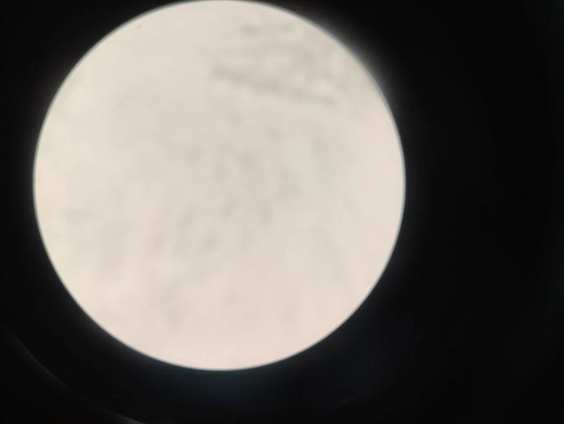

Figure 4 Residue C from waterbody of Changbai mountain

Using microscope, we found that only the residue from Beijing is polluted by microplastics. Due to the small sample size, it is challenging to conduct precise quantitative analysis for the experiment. Through rough estimates, there are 4 pieces of microplastics in the residue from the river in Beijing (Due to the use of a scraper that may damage the structure of microplastics during the transfer from the membrane, fragments are considered to originate from the same particle as the larger pieces of microplastic). The previous research shows that the average abundance of microplastics is 4160 n·m-3(where n is the number of particles), or 4.160 n·L. This implies that our research findings are consistent with previous studies (Hu et al., 2021).

However, there are also other research studies conducted in the same region that show significant discrepancies with our findings. For instance, a research suggest that the abundance of microplastics in a river in Beijing is 0.35±0.22 n/L. This difference may caused by multiple reasons: 1. the different filtering methods; 2. The reduction in microplastic abundance due to differences in rainfall (Wang et al., 2020).

Conclusion

In conclusion, this study aimed to contrast levels of microplastic pollution in natural and urban aquatic systems by sampling water from Changbai Mountain and Beijing, respectively. The finding of this study indicates that water microplastics levels in Beijing are much higher than in the clean water of Changbai Mountain. Through a method that included sieving, chemical digestion, and microporous membrane filtration, we discovered four microplastics in the Beijing samples and no microplastics in the Changbai Mountain samples.  
  
The results obtained in this study are consistent with other researches that revealed a large concentration of microplastics in urban areas. The differences with other studies could be due to differences in the filtration technique and variability in rainfall which influences the movement of microplastics.

References

Auta, H.S., Emenike, C.U., Fauziah, S.H., 2017. Distribution and importance of microplastics

in the marine environment: a review of the sources, fate, effects, and potential solu

tions. Environ. Int. 102, 165–176.

Blackburn, K, & Green, D (2022). The potential effects of microplastics on human health: What is known and what is unknown. Ambio, Springer, <https://doi.org/10.1007/S13280-021-01589-9>

Hale, R.C., Seeley, M.E., La Guardia, M.J., Mai, L., Zeng, E.Y., 2020. A global perspective on

microplastics. J. Geophys. Res. Oceans. 125 (1). https://doi.org/10.1029/

2018JC014719 e2018JC014719.

HU Jia-min, ZUO Jian-e, LI Di, XIE Zhen-wen, CHEN Lei. Composition and Distribution of Microplastics in the Water and Sediments of Urban Rivers in Beijing[J]. Environmental Science, 2021, 42(11): 5275-5283.

Wang, C, Xing, R, Sun, M, Ling, W, Shi, W, Cui, S, & ... (2020). Microplastics profile in a typical urban river in Beijing. Science of the Total …, Elsevier, <https://www.sciencedirect.com/science/article/pii/S0048969720342303>

Zhang, Q., Xu, E.G., Li, J., Chen, Q., Ma, L., Zeng, E.Y., Shi, H., 2020b. A review of

microplastics in table salt, drinking water, and air: direct human exposure. Environ.

Sci. Technol. 54 (7), 3740–3751.