

Table of Contents
Chapter 1 — Claude vs Other AI Tools
Chapter 2 — Getting Around Claude (The Basics)
Chapter 3 — How to Talk to Claude So It Actually Understands You
Chapter 4 — Make Claude Remember You (Projects)
Chapter 5 — Build Your Own Mini Tools
Chapter 6 — How to Fix a Bad Answer Instead of Starting Over
Chapter 7 — Get More Done With Your Documents
Chapter 8 — Claude for Indian Business Needs
Chapter 9 — Claude for WhatsApp Business
Chapter 10 — A Simple Start to AI Automation
Chapter 11 — For Students
Chapter 12 — For Freelancers
Chapter 13 — Earn Extra Income Using Claude
Chapter 14 — For Small Business Owners
Chapter 15 — For Teachers
Chapter 16 — For Job Seekers
Chapter 17 — Ready-to-Use Prompt List
Chapter 18 — What Claude Can Get Wrong
Chapter 19 — See It Working: Real Examples
Appendix — Tools That Work Well With Claude (India Context)
Back Matter — Cheat Sheet, FAQ & Bonus

Claude Unlocked: The SPICE Method

For Real Work, Real Income, and Everyday Life — Built for India
Who this book is for:
Freelancers, small business owners, students, and job seekers in India who want to use Claude for real, everyday problems — not just generic AI hype.
What you'll be able to do after reading this:
- Talk to Claude in a way that actually gets you useful answers (the SPICE method)
- Set up Claude to remember your business or work, so you stop repeating yourself
- Build small tools, handle documents, and automate repeat tasks — no coding needed
- Use Claude for real Indian business needs: GST invoices, WhatsApp content, festival marketing
- Apply everything to your specific situation — student, freelancer, shop owner, teacher, or job seeker
- Know exactly where Claude can go wrong, so you use it responsibly

Chapter 1

Claude vs Other AI Tools — Which One Should You Use?
If you've searched "best AI tool" even once, you've probably felt overwhelmed. ChatGPT, Claude, Gemini, Perplexity, Copilot — everyone claims to be the best. So which one should you actually use?
Here's the simple answer: you don't need to pick just one forever. But if you're starting today, and you want a tool that's genuinely great at writing, thinking through problems, and handling long documents — Claude is one of the strongest choices available.
Let's break down why, in plain terms.

What Makes Claude Different
Claude is made by a company called Anthropic. Unlike a search engine, Claude doesn't just look things up — it reads what you write, thinks through it, and responds like a very well-read person having a conversation with you.
Three things Claude is genuinely strong at:
1. Long, careful writing
Claude is good at writing that needs to sound natural — emails, articles, descriptions, explanations. It doesn't sound robotic or repetitive the way some AI writing can.
2. Understanding long documents
You can paste in a long PDF, a contract, or pages of notes, and Claude can work with all of it at once — not just the last few lines you typed.
3. Careful, step-by-step thinking
When you give Claude a complicated problem, it tends to think it through properly instead of jumping to a quick, shallow answer.

What Claude Isn't Built For
To use any tool well, you need to know what it's *not* good at too. Claude has some real limits:
- It doesn't know today's news. Claude's knowledge has a cutoff date. For live news, current prices, or "what happened today" — you'll want to double-check with a search engine.
- It can't generate images. If you want AI-generated pictures, you'll need a different tool for that part.
- It doesn't remember you between separate, unrelated chats unless you set up something called a Project (we'll cover this in Chapter 4).
None of these are dealbreakers — they just mean Claude is one part of your toolkit, not the only tool you'll ever need.

A Simple Way to Decide
Here's a plain comparison to help you choose the right tool for the right job:
What you need | Best choice
Writing an email, article, or long explanation | Claude
Reading and understanding a long document | Claude
Latest news or today's information | A search engine, or an AI tool with live search
Generating a picture or image | An image-generation tool
Quick, casual chit-chat or brainstorming | Any AI tool works — pick what's fastest for you

The honest truth: most people don't need five different AI tools. They need one they actually know how to use well. That's what the rest of this book is about — not just knowing Claude exists, but knowing exactly how to talk to it so it gives you real, usable results.

Which Plan Should You Use?
Claude has a free version and a paid version (called Pro). Here's a simple way to think about it:
- Free plan: Good for trying things out, occasional use, light tasks.
- Paid plan: Worth it once you're using Claude regularly for work, business, or study — you get more usage and access to more capable models.
You don't need to pay anything to follow along with this book. Everything we cover works on the free plan too — the paid plan just means you can do more of it, more often, without hitting limits.

Chapter 1 Key Takeaways
- Claude is one of the strongest tools available for writing, long documents, and careful thinking.
- It's not built for live news, images, or remembering separate old chats — know these limits so you're not caught off guard.
- You don't need every AI tool. You need to know one tool well. That's the goal of this book.

Chapter 2

Getting Around Claude (The Basics)
Before we get into the powerful stuff, let's make sure you're comfortable with the basics. If you've already used Claude a few times, feel free to skim this chapter — but it's worth reading once, since a few small things here save a lot of confusion later.

Starting a Conversation
When you open Claude, you'll see a simple text box. Just type what you need and press enter. That's it — there's no special code or command required.
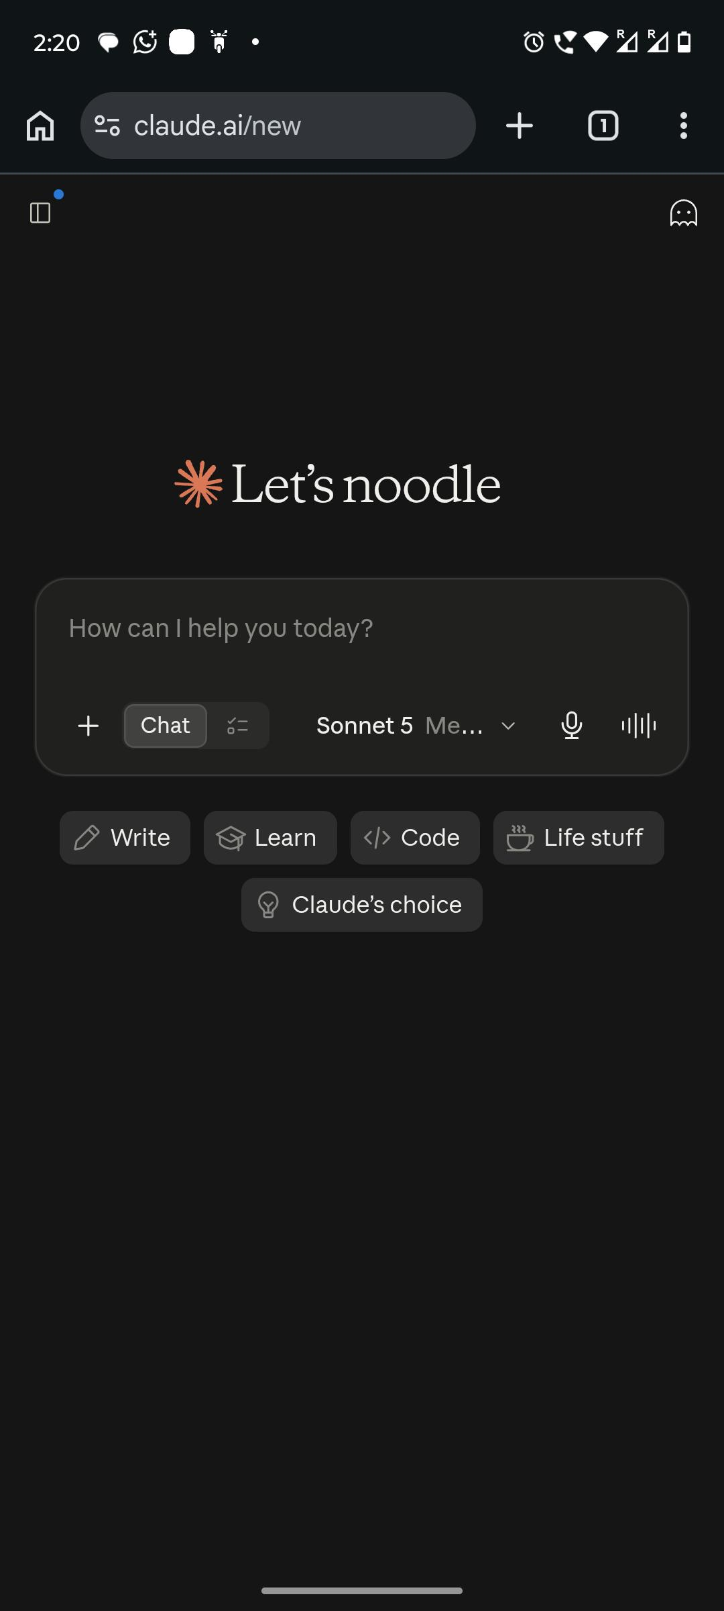
Claude replies in the same window, and you can keep talking back and forth. Everything you've said earlier in that same conversation stays "in memory" for that chat — Claude can refer back to something you mentioned five messages ago, without you repeating it.

Starting Fresh vs Continuing
Every new conversation starts with a blank slate. Claude won't remember what you discussed in a *different* chat unless you're using a Project (covered in Chapter 4).
A simple rule of thumb:
- Same topic, related task? Stay in the same conversation.
- Completely different topic? Start a new one. It keeps things clean and avoids confusing outputs.

Uploading Files
You can upload files directly into a conversation — PDFs, Word documents, spreadsheets, and images all work. This is genuinely useful: instead of copy-pasting a long document, just upload it and ask your question.
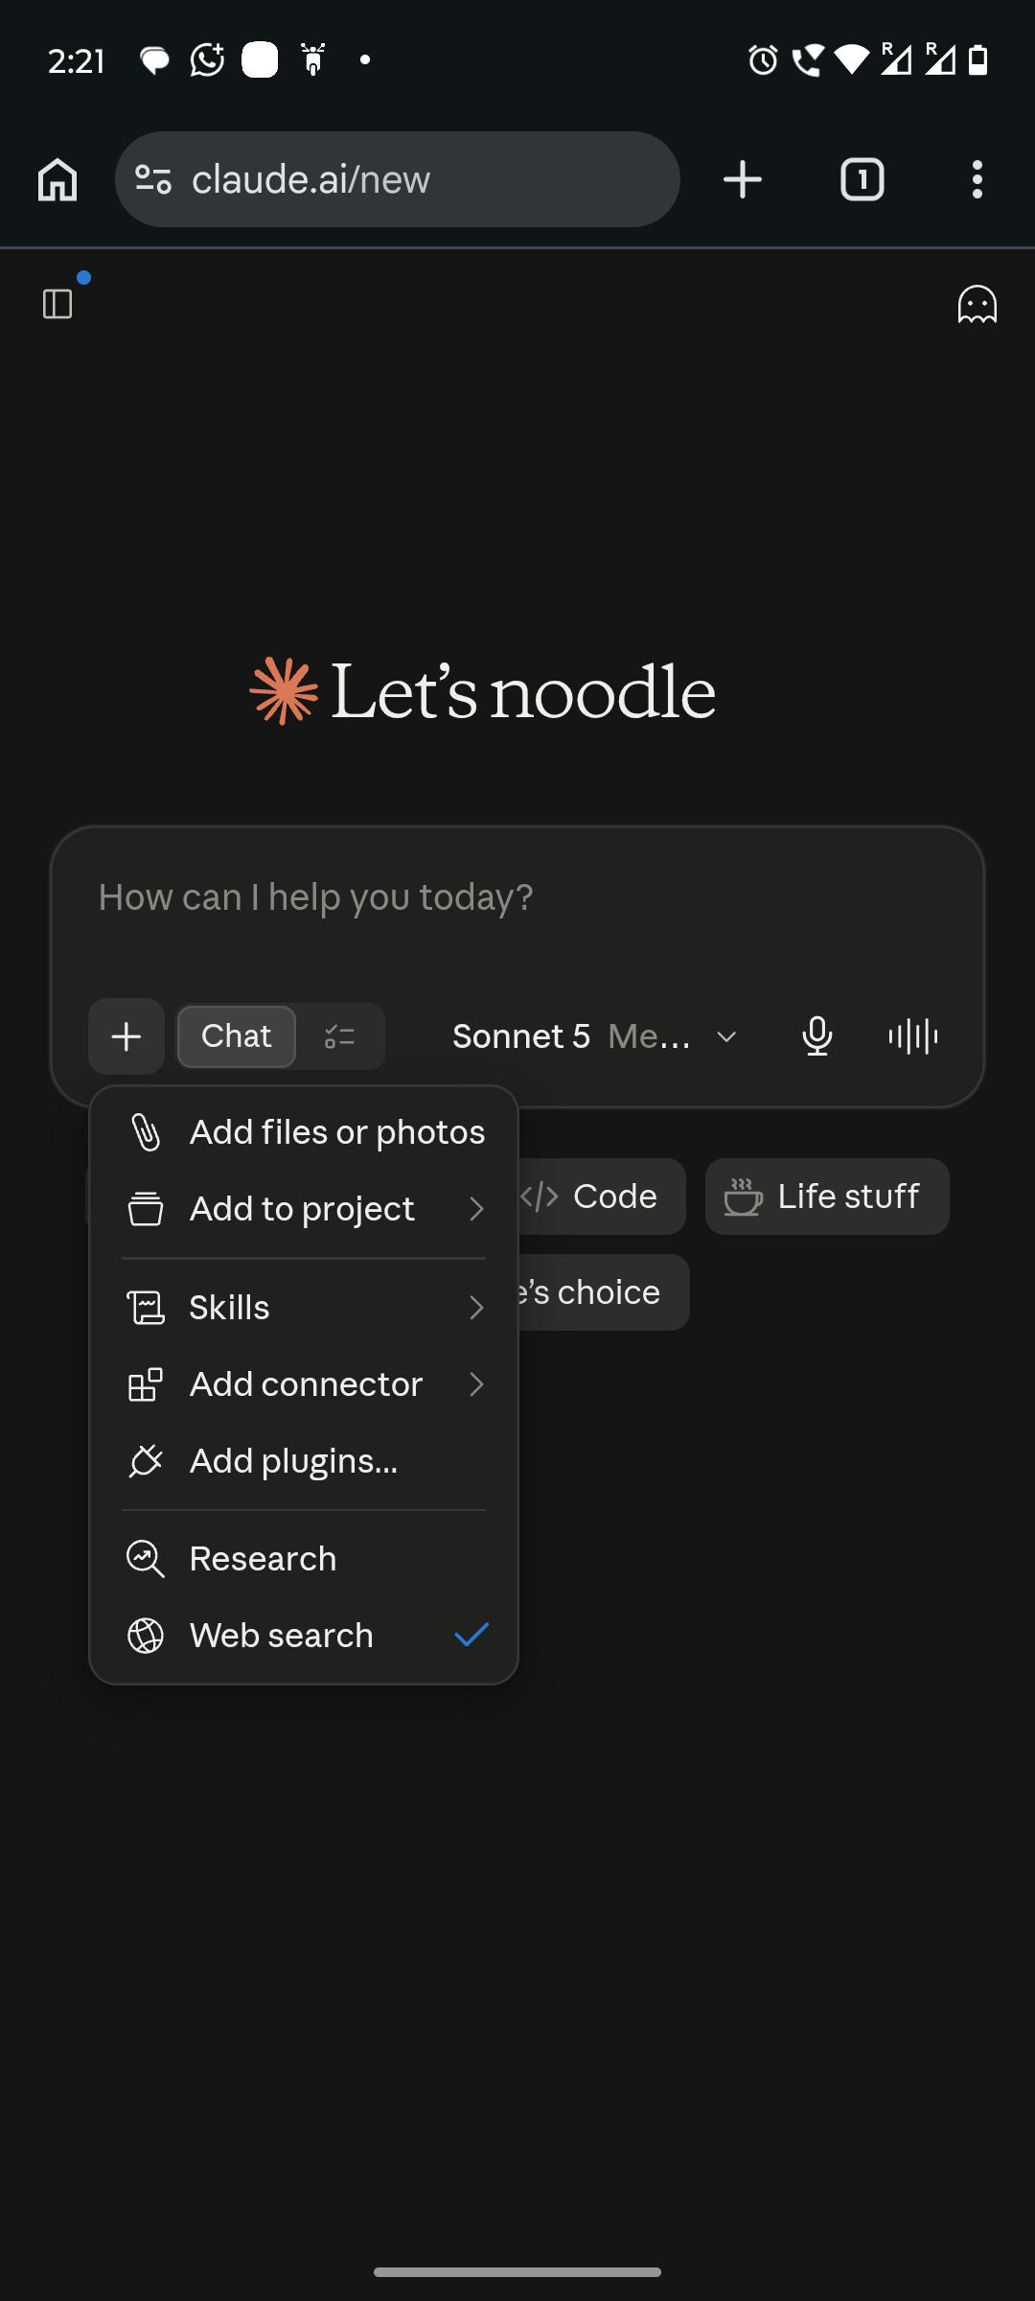
A few things worth knowing:
- Large files may take a moment to process — that's normal.
- If you're uploading something sensitive (client data, personal information), always check whether that's appropriate to share, the same way you would before emailing it to anyone.

Switching Models
You might notice Claude offers more than one "model" to choose from. Think of these like different versions of the same assistant — some are faster and better for quick tasks, others are more powerful and better for deep, complex work.
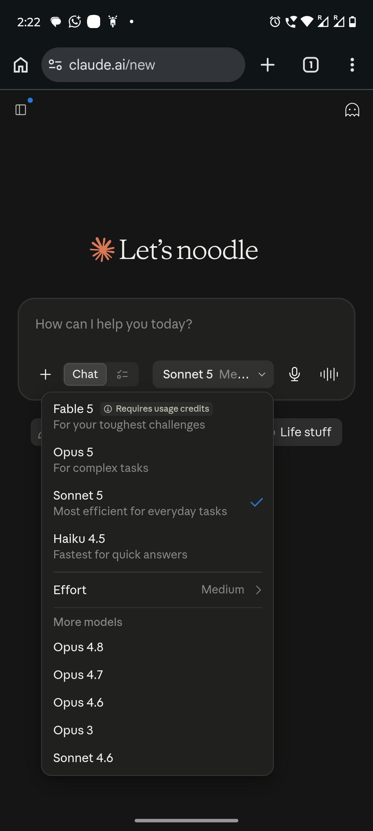
You don't need to memorize the technical differences. A simple approach:
- Quick task, simple question? Use the faster, everyday model.
- Complex task — a long document, a detailed business plan, tricky reasoning? Switch to the more powerful option.
If you're ever unsure, the default option works well for most day-to-day tasks.

Editing and Regenerating
Didn't get the answer you wanted? You have two simple options:
- Reply and correct it — just tell Claude what to change, like we covered in Chapter 3 with SPICE.
- Edit your original message — if you want to start that particular question over completely with a cleaner prompt, you can edit what you typed and resend it.
Both are fine. Use whichever feels more natural for the situation.

A Note on Mobile vs Desktop
Claude works on both your phone and your computer. For quick tasks — replying to a customer, drafting a short caption — the phone app is perfectly fine. For longer work — writing a document, uploading files, working through something detailed — you'll likely find it easier on a laptop or desktop, simply because typing and reading longer text is more comfortable there.

Chapter 2 Key Takeaways
- A conversation remembers everything said within it — but not across separate, unrelated chats.
- You can upload documents, spreadsheets, and images directly instead of retyping them.
- Use the faster model for quick tasks, the more powerful one for complex work.
- If an answer isn't right, just say so and ask for a fix — don't feel like you have to start over.

Chapter 3

How to Talk to Claude So It Actually Understands You
Most people talk to Claude the way they talk to Google. They type a few words and hope for the best.
"Write a caption for my shop."
"Help me with my resume."
"Give me marketing ideas."
Then they look at the answer, feel disappointed, and think — *"AI isn't that smart after all."*
Here's the truth: Claude isn't the problem. The message you sent it is.
Claude cannot read your mind. It cannot see your shop, your resume, or your business. It only knows what you tell it. So if you give it three vague words, you get a vague answer back. This is not a Claude problem. It's a "how you're asking" problem — and it's the easiest thing in this whole book to fix.

A Quick Example
Let's look at two people asking for the exact same thing.
Person A types:
Write an Instagram caption for my shop.
Person B types:
I sell handmade candles from my home in Chennai. Write an Instagram caption for a new lavender candle. The tone should be warm and simple, not too salesy. Keep it under 40 words and end with a soft call to action like "DM to order."
Person A will get something generic — it could be a caption for literally any shop in the world. Person B will get something that sounds like it was written *for* their candle, *for* their audience, in *their* tone.
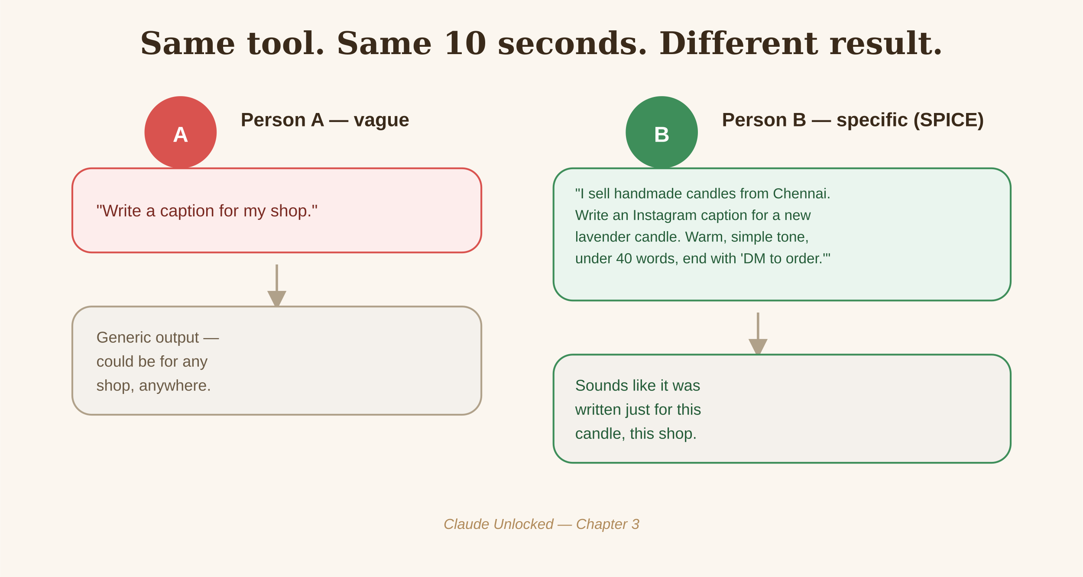
Same tool. Same 10 seconds of extra typing. Completely different result.
This is the entire secret of using Claude well. Once you get comfortable with this one skill, everything else in this book becomes ten times more useful.

Introducing the SPICE Method
To make this easy to remember, we're going to use a simple method called SPICE. Think of it like a recipe — leave out an ingredient, and the dish just doesn't taste right. Add all five, and Claude gives you something that actually works.
Add the right SPICE to your prompt, and Claude cooks better results.
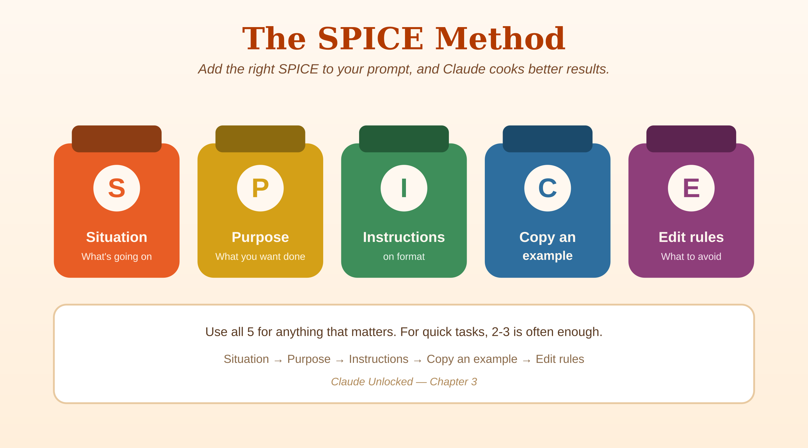
Here's what each letter stands for:
S — Situation
What's going on? Give Claude the background. Who are you, what are you working on, what's the setting?
P — Purpose
What exactly do you want Claude to do? Be specific. Not "help me," but "write," "fix," "explain," "compare," "shorten."
I — Instructions on format
How should the answer look? A list? A short paragraph? A table? A message you can copy-paste and send immediately?
C — Copy an example
If you have any example of what "good" looks like — a caption you liked, an email you admired — show it. Even one example makes a big difference.
E — Edit rules
What should Claude avoid? Length limits, words to avoid, things to leave out, a tone you don't want.
You don't always need all five for every single message. For small tasks, 2-3 is often enough. But for anything that actually matters — a client email, a product description, a resume — running through all five will save you from a weak first answer and a lot of back-and-forth.

SPICE in Action: Three Real Examples

Example 1: A Weak Prompt vs a SPICE Prompt
Weak:
Write a WhatsApp message for my customers about a sale.
With SPICE:
Situation: I run a small clothing store in Chennai. I'm having a 20% off sale this weekend only.
Purpose: Write a WhatsApp broadcast message announcing the sale to my customer list.
Format: Keep it to 3-4 short lines, easy to read on a phone.
Example: Here's a message I sent before that customers liked: "New stock alert! Fresh kurtis just arrived, starting ₹499. Reply to book yours before they're gone."
Edit rules: No emojis overload — max 2-3. Don't sound like a big brand, sound like a local shop owner talking to regulars.
Notice how much more specific and usable the second version's output would be — it's basically ready to copy and send.

Example 2: A Weak Prompt vs a SPICE Prompt
Weak:
Help me with my resume.
With SPICE:
Situation: I'm applying for a customer support role at a fintech company. I currently work in a call center handling billing complaints.
Purpose: Rewrite my "Experience" section to sound stronger and more relevant to this job.
Format: 4 bullet points, each starting with an action word.
Example: [paste your current resume bullet points here]
Edit rules: No exaggeration — only describe what I actually did. Keep each bullet under 20 words.

Example 3: A Weak Prompt vs a SPICE Prompt
Weak:
Explain GST to me.
With SPICE:
Situation: I just started a small online business selling handmade jewelry. I've never dealt with GST before.
Purpose: Explain what GST registration means for someone at my stage, and whether I need it yet.
Format: Simple explanation, no legal jargon, use an example with real numbers.
Edit rules: Keep it under 200 words. Tell me clearly if I should double check this with a CA (chartered accountant).

The Follow-Up Trick
Here's something most people miss: you don't have to get it perfect in one message. Claude remembers everything you've said earlier in the same conversation. So if the first answer is close but not quite right, just say so:
"Make it shorter."
"Make it sound less formal."
"Add one more example."
"This is good, but remove the last line."
This back-and-forth is normal and expected — even people who are excellent at this go through 2-3 rounds before landing on the final version. Don't treat the first answer as the only chance you get.

A Simple Practice Exercise
Before moving to the next chapter, try this: think of one message you need to write this week — an email, a WhatsApp reply, a social post, anything. Write it out using all five parts of SPICE. Even if it feels slow the first time, you'll notice the output is dramatically better than what you're used to getting.
Once you do this a few times, SPICE stops being something you think about consciously — it becomes how you naturally talk to Claude every time.

Chapter 3 Key Takeaways
- Claude gives weak answers to weak messages. This is fixable, not a limitation of the tool.
- Use SPICE — Situation, Purpose, Instructions on format, Copy an example, Edit rules — for anything that matters.
- You don't need all five every time, but the more that's missing, the more generic the answer will be.
- Don't stop at the first answer — refine it with quick follow-ups.

Chapter 4

Make Claude Remember You (Projects)
If you've been using Claude for a while, you've probably felt this: you explain your business, your writing style, or your situation — and then the next day, in a new chat, you have to explain it all over again. It gets tiring fast.
There's a feature that fixes this completely, and most people never turn it on. It's called Projects.

What a Project Actually Is
A Project is a separate workspace inside Claude. Anything you set up inside it — instructions, documents, past conversations — stays there and applies every single time you open a new chat within that Project.
Think of it like this: a normal chat is like meeting a stranger and explaining your situation from scratch. A Project is like working with someone who's read your notes before every meeting — you just pick up where you left off.
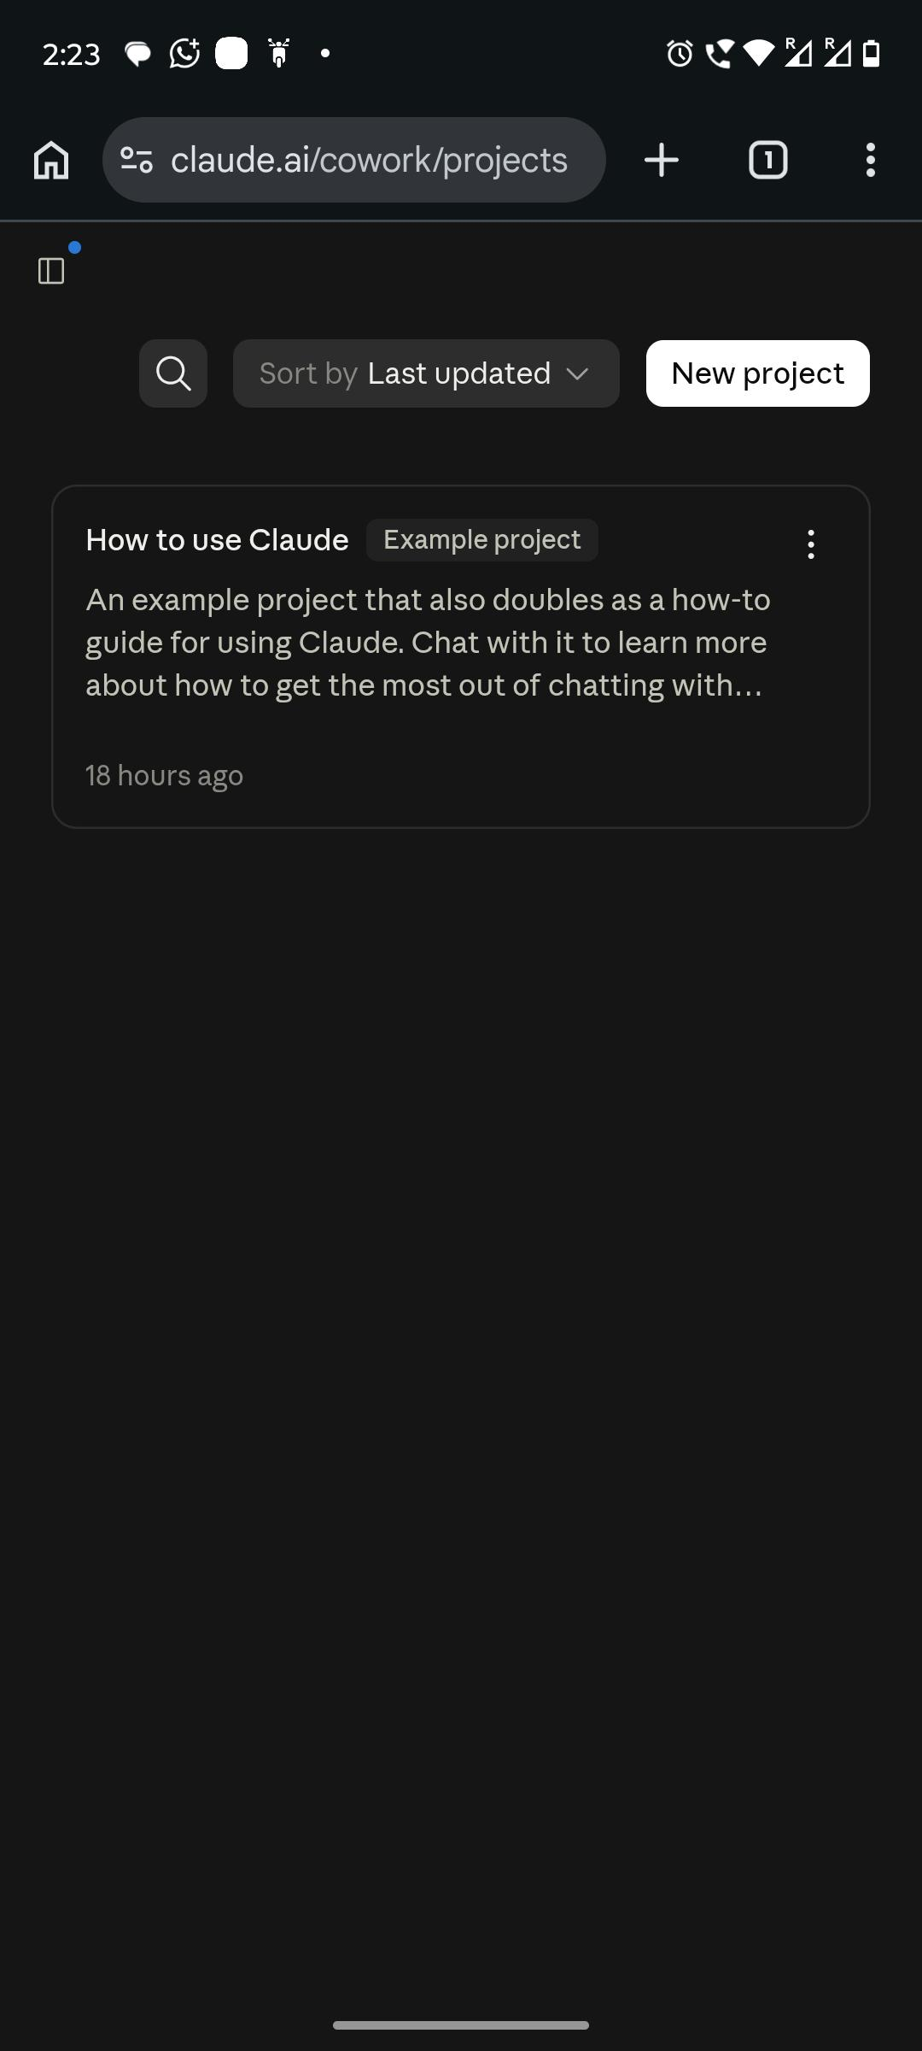
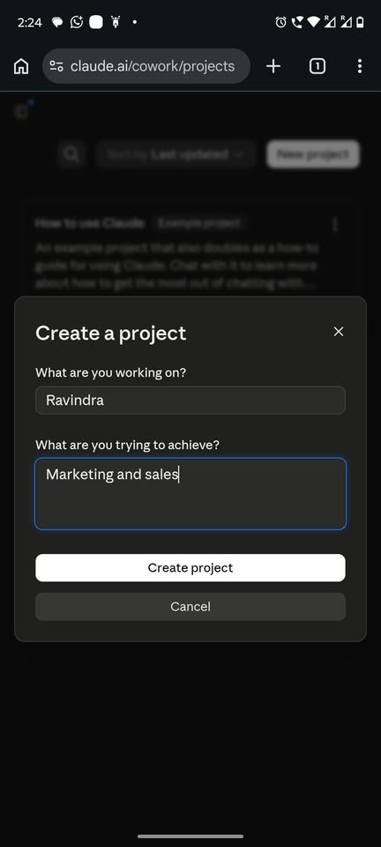

Setting Up Your First Project
Here's a simple setup you can follow, whether you run a shop, freelance, or study.
Step 1: Give it a name
Something clear, like "My Candle Shop" or "Freelance Writing Work."
Step 2: Write simple instructions
This is the most important part. In plain sentences, tell Claude:
- Who you are and what you do
- Who your audience or customers are
- The tone you want (friendly? formal? simple?)
- Anything Claude should always remember about your situation
Example, for a small business:
"I run a small home bakery in Chennai selling cakes and cookies. My customers are mostly local families ordering for birthdays and small celebrations. Keep my writing warm and simple, not too formal. Always mention that orders need 2 days notice."
Step 3: Add a few documents (optional but powerful)
If you have a price list, a sample of writing you liked, or notes about your customers — upload them. Claude will refer to them automatically in every chat inside this Project.
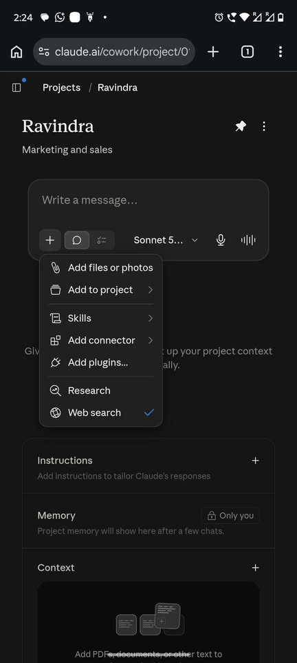
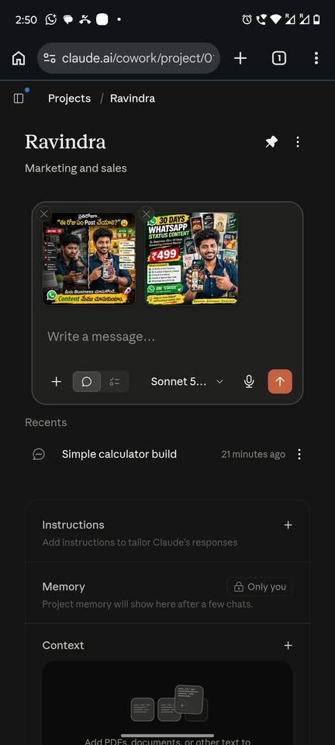

A Simple Before and After
Without a Project, every new chat looks like this:
"I run a home bakery in Chennai... [explain everything again] ...now write me a caption for a new chocolate cake."
With a Project set up, every new chat looks like this:
"Write me a caption for a new chocolate cake."
Same result, but you save the setup explanation every single time. Over weeks and months, this adds up to real time saved.

Which Projects Should You Actually Create?
You don't need a Project for everything. Create one wherever you find yourself repeating the same background information often. A few common examples:
- Your business or shop — for product descriptions, customer replies, marketing posts
- Your freelance work — one Project per major client, so Claude knows their brand and preferences instantly
- Your studies — upload your syllabus or notes, and use it for all your learning-related chats
- Your job search — upload your resume once, and reuse it every time you tailor an application

Chapter 4 Key Takeaways
- A Project lets Claude remember your context across every new chat inside it — no more repeating yourself.
- Set it up once with simple instructions and a few key documents.
- Create separate Projects for separate parts of your life — business, freelance clients, studies, job search.

Chapter 5

Build Your Own Mini Tools — No Coding Needed
Here's something that surprises most people: Claude can build small, working tools for you — a bill generator, a price calculator, a simple tracker — without you writing a single line of code. You just describe what you want.
This chapter is a build-along. Follow the steps, and you'll have real, usable tools by the end.

What This Feature Is
When you ask Claude to build something like a calculator or a small form, it can create a working version that appears right inside your chat — you can use it immediately, and even ask for changes.
You don't need to understand how it works technically. You just need to describe what you want clearly, the same way you learned in Chapter 3 with SPICE.
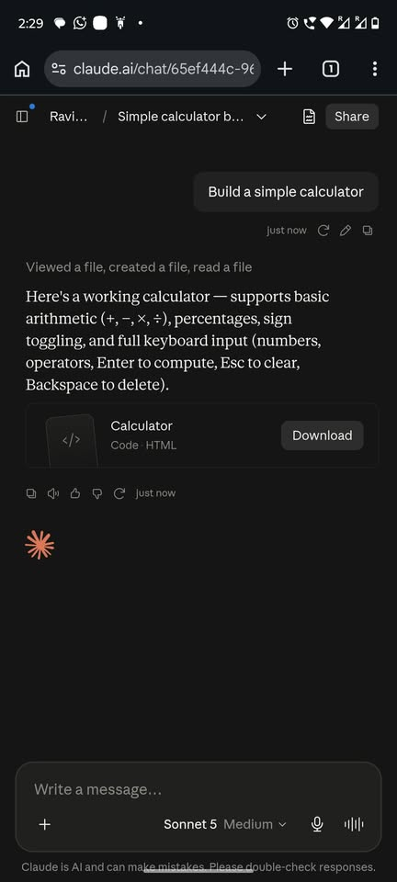
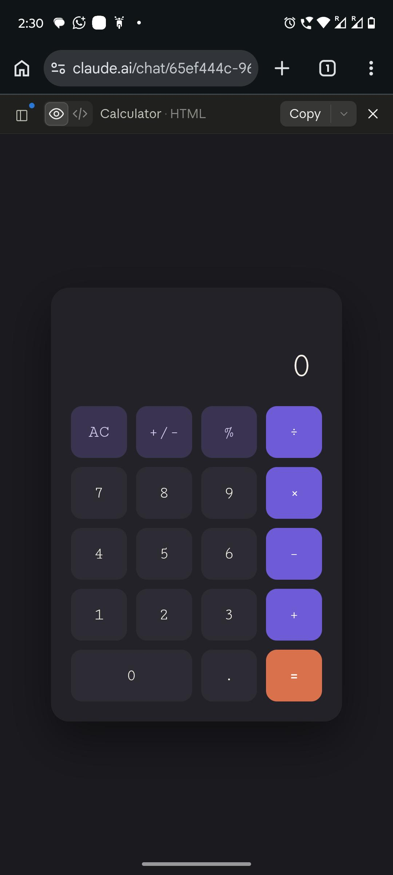

Build-Along 1: A Simple Bill Generator
Let's say you run a small shop and want an easy way to create bills for customers.
What to type (using SPICE):
Situation: I run a small clothing shop and need to give customers a simple bill after each purchase.
Purpose: Build a simple bill generator where I can enter the customer name, items, quantity, price, and it calculates the total.
Format: Make it something I can actually use — enter details and see the total update automatically.
Edit rules: Keep it simple, no unnecessary extra fields.
Claude will build this for you as a working tool. Try it, then ask for small changes — "add a discount field," "add my shop name at the top" — the same way you'd ask a person to adjust something.

Build-Along 2: A Price/Quote Calculator
If you offer any kind of service — tutoring, freelance work, consulting — a quote calculator helps you (and your customers) see pricing instantly.
What to type:
Situation: I'm a freelance graphic designer. My pricing depends on the type of work and how many revisions the client wants.
Purpose: Build a simple calculator where I select the type of project and number of revisions, and it shows an estimated price.
Format: Simple dropdown or input fields, clear final price shown.

Build-Along 3: A Study or Habit Tracker
For students or anyone building a routine, a simple tracker keeps you accountable.
What to type:
Situation: I'm a student trying to track my daily study hours across 4 subjects.
Purpose: Build a simple tracker where I can log hours per subject each day and see a weekly total.
Format: Something visual and easy to update daily.

What's Realistic to Expect
These tools are genuinely useful for personal or small business use — quick calculators, simple trackers, basic generators. They're not meant to replace a full business website or a professional app. Think of this chapter as "solve a real daily annoyance," not "build the next big startup."
If your first attempt isn't quite right, don't restart from scratch — just describe what to change, the same way you'd give feedback on any draft.

Chapter 5 Key Takeaways
- Claude can build small working tools directly inside your chat — no coding required.
- Describe what you want clearly using SPICE, then refine with follow-up requests.
- These tools are great for solving everyday problems — bills, calculators, trackers — not for building large applications.

Chapter 6

How to Fix a Bad Answer Instead of Starting Over
Here's a mistake almost everyone makes when they start using Claude: the first answer isn't quite right, so they delete everything and try a whole new prompt from scratch. This wastes time and often gets you a *different* kind of wrong answer instead of a better one.
There's a much faster way.

The "Keep, Cut, Change" Method
When an answer is close but not perfect, don't restart. Just tell Claude exactly what to keep, cut, or change.
Example:
"Keep the opening line, but cut the second paragraph — it's too long. Change the ending to include a call to action."
This is faster than rewriting your original prompt, and Claude already has the full context of what it wrote — so the fix is usually much closer to what you wanted on the very next try.
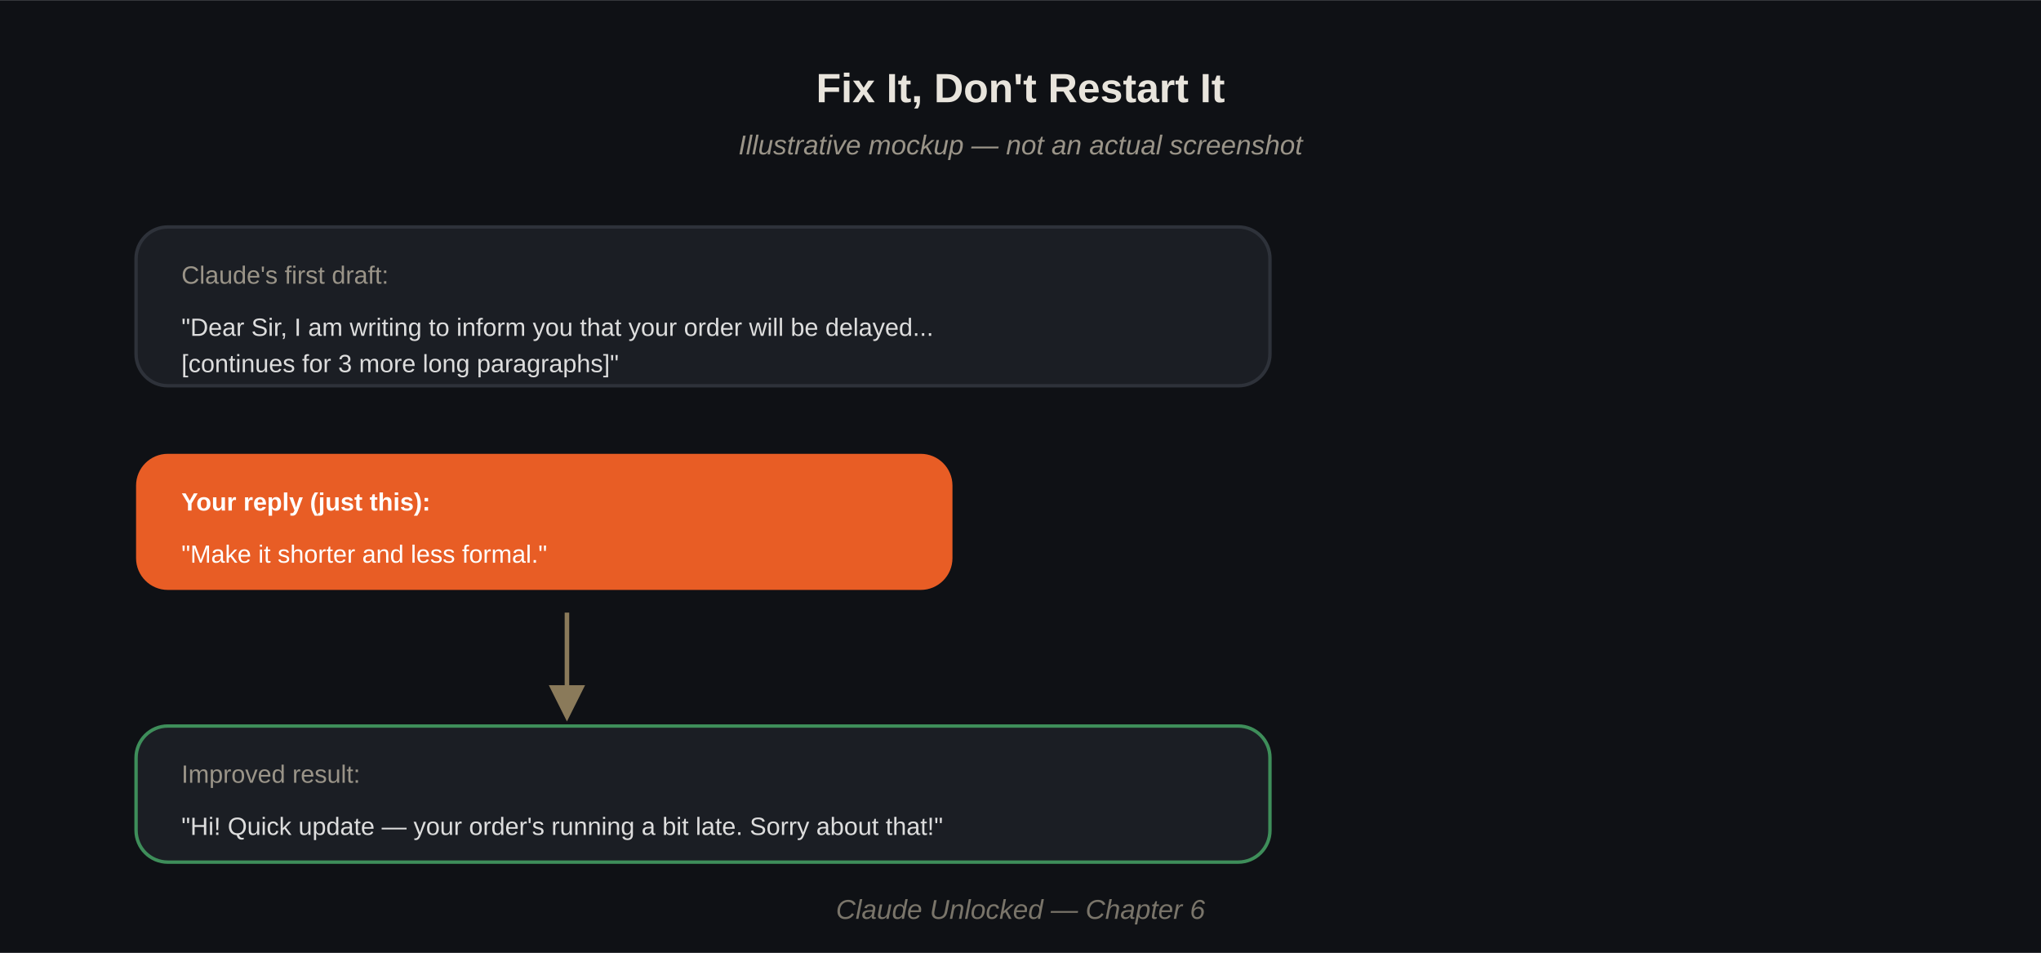

The Ask, Check, Fix Loop
For anything that really matters — a client email, a resume, an important post — there's a simple 3-step method that noticeably improves quality.
Step 1 — Ask
Get Claude's first attempt at the task.
Step 2 — Check
Ask Claude to honestly review its own work:
"Look at this again. What are the 2-3 weakest parts of this response?"
Step 3 — Fix
Ask Claude to improve it based on what it just pointed out:
"Now fix those weak points and give me the improved version."
This works because Claude is genuinely good at spotting problems in writing when asked directly — even its own. Running this loop once or twice usually produces a noticeably stronger final result than the first attempt alone.

A Real Example
Ask:
Write a message to a client explaining their project will be delayed by one week.
Check:
"What are the 2-3 weakest parts of this message?"
Claude might point out: it sounds too apologetic, doesn't give a clear new date, doesn't offer anything to make up for the delay.
Fix:
"Fix those three things and give me the improved version."
You'll usually notice the second version is more confident, more specific, and more professional — without you having to know what was wrong yourself.

When to Use Which Method
- Small tweaks (wrong tone, too long, missing one detail) → use "Keep, Cut, Change"
- Something important where quality really matters → use the full "Ask, Check, Fix" loop
You don't need to run the full loop on every message — that would slow you down for simple tasks. Save it for the messages where getting it right actually matters.

Chapter 6 Key Takeaways
- Don't restart from scratch when an answer is close — just tell Claude what to keep, cut, or change.
- For important work, use the Ask, Check, Fix loop: get an answer, ask Claude to critique it, then ask for the fix.
- Save the full loop for messages that really matter — quick fixes are enough for everyday tasks.

Chapter 7

Get More Done With Your Documents
A lot of everyday work isn't glamorous — it's dealing with paperwork. Scanned bills, messy spreadsheets, long PDFs nobody wants to read fully. This chapter shows you how Claude can take real time off these tasks.

Reading a Scanned Bill or Receipt
If you have a photo or scan of a bill, you can upload it directly and ask Claude to pull out the details.
What to type:
"Here's a photo of a supplier bill. Pull out the item names, quantities, prices, and the total amount, and put it in a simple table."
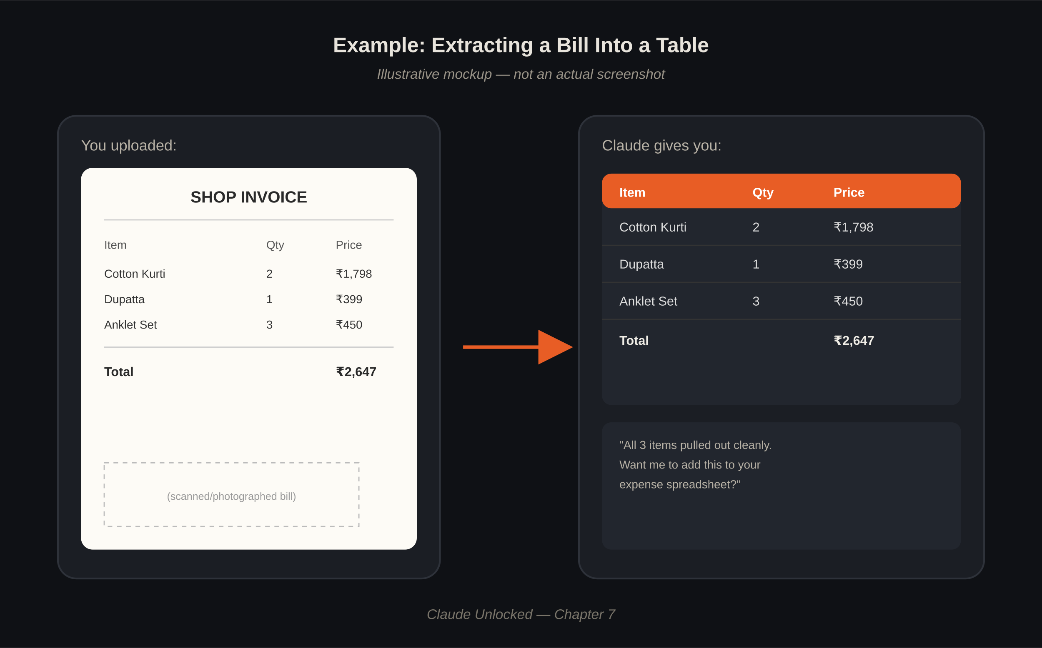
This is especially useful if you're tracking expenses for a small business and don't want to manually type every bill into a spreadsheet.

Cleaning Up a Messy Spreadsheet
Spreadsheets that have been edited by multiple people, or built over time, often turn messy — inconsistent formatting, missing values, duplicate rows.
What to type:
"Here's my spreadsheet. Some rows have missing prices and the date format is inconsistent. Clean it up and point out anything that looks wrong so I can double check it."
Claude can spot obvious errors — like a price of ₹0 that's probably missing data, or a date that doesn't match the format of the rest of the sheet — and flag them for you rather than silently guessing.

Summarizing a Long Document
Contracts, research papers, and policy documents are often long and dense. Instead of reading the whole thing, you can get a clear summary — and still ask specific questions afterward.
What to type:
"Summarize this contract in plain language. What are the key obligations for each side? Point out anything unusual or that I should get clarified before signing."
A word of caution: for anything legally binding, treat Claude's summary as a helpful first read — not a replacement for having an actual lawyer review anything important.

Filling In Forms
If you regularly fill the same type of form — an invoice template, an application, a report — you can ask Claude to fill it in based on details you give, saving you from retyping the same structure every time.
What to type:
"Here's my invoice template. Fill it in with these details: [customer name, items, amounts]. Keep the same format as the template."

A Word on Accuracy
Claude is genuinely helpful with documents, but it can occasionally misread something — especially in blurry photos or unusual formats. For anything with real consequences (money, contracts, official forms), always give it a quick check yourself before using it. Think of Claude as doing the first 90% of the tedious work — you're still the final check.

Chapter 7 Key Takeaways
- Upload scanned bills or receipts and have Claude extract the details into a clean table.
- Ask Claude to clean and flag issues in a messy spreadsheet, rather than manually fixing it row by row.
- Get plain-language summaries of long documents — but double-check anything legally or financially important yourself.

Chapter 8

Claude for Indian Business Needs
Most AI guides are written for a US or global audience — Etsy shops, dollar pricing, English-only content. This chapter is different. It's built around problems Indian shop owners, freelancers, and small business owners actually deal with every week.

Writing GST-Friendly Invoices
If you're running a small business, invoices need to include specific details — your GSTIN (if registered), item details, tax breakdown. Claude can't file your taxes, but it can help you draft a clean, correctly structured invoice template.
What to type:
"I run a small business and need a simple GST invoice template. I sell handmade soaps. Include fields for GSTIN, item, quantity, price, GST rate, and total. Keep the layout simple and professional."
A clear boundary worth stating here: Claude can help you draft the format and wording — it cannot replace a Chartered Accountant for actual tax filing or compliance questions. Always confirm anything tax-related with a CA.

Payment Reminder Messages
Chasing late payments is awkward for most small business owners. Claude can help you write reminders that are firm but polite.
What to type:
"Write a payment reminder message for a client whose invoice is 10 days overdue. Keep it polite but clear that payment is expected soon."
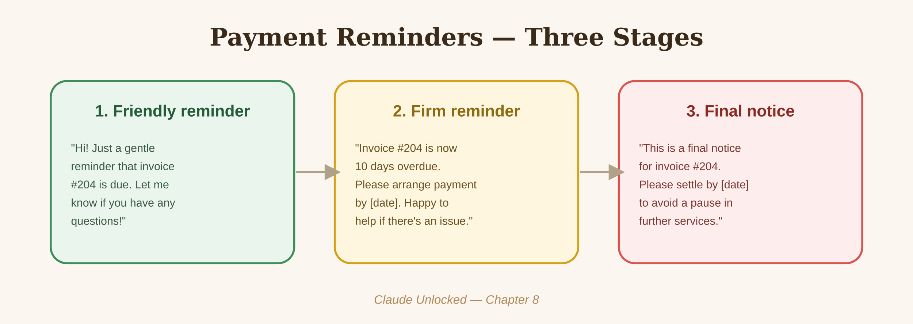

Mixing Hindi/Regional Language With English
A lot of everyday communication in India naturally mixes languages — and Claude can write in that same natural mix, if you ask for it directly.
What to type:
"Write a WhatsApp message for my customers announcing a festival sale. Mix Hindi and English naturally, the way people actually text — not too formal, not fully in one language."
You can do this for Tamil, Telugu, Bengali, or any other regional language mixed with English too — just tell Claude which language and ask it to keep the mix natural rather than textbook-formal.

Festival and Seasonal Marketing Content
Indian businesses have a unique advantage: a calendar full of festivals that naturally create marketing moments — Diwali, Pongal, Eid, Christmas, New Year, regional festivals. Claude can help you plan content around these without starting from a blank page every time.
What to type:
"I run a small jewelry shop. Give me 5 post ideas for Diwali — a mix of offer announcements and simple, warm festival wishes. Keep the tone personal, not like a big brand."

A Simple Yearly Content Calendar Prompt
You can even plan several months ahead in one sitting:
"Give me a list of major Indian festivals and shopping occasions over the next 3 months relevant to a [your business type]. For each one, suggest one content idea."

Simple Legal-Adjacent Drafting — With a Clear Line
Claude can help draft things like basic payment notices or simple service agreements between you and a client. But for anything with real legal weight — contracts involving significant money, disputes, or anything you'd need to enforce in court — treat Claude's draft as a starting point only, and have an actual lawyer review it before it's final.

Chapter 8 Key Takeaways
- Claude can draft GST-style invoice formats and payment reminders, but always confirm tax details with a CA.
- Ask for natural Hindi/regional-English mixing when writing for Indian customers — it sounds much more real than one language alone.
- Use India's festival calendar as a built-in content strategy — Claude can help you plan around it easily.
- For anything with real legal weight, use Claude's draft as a starting point, not a final document.

Chapter 9

Claude for WhatsApp Business
For a huge number of small businesses in India, WhatsApp isn't a side channel — it's the main way customers find out about products, ask questions, and place orders. This chapter is about using Claude to make that channel work harder for you.

Writing Catalog Descriptions
If you sell through WhatsApp Business's catalog feature, each product needs a short, clear description that makes someone want to ask about it.
What to type:
"Write a short WhatsApp catalog description for a cotton kurti, ₹899. Mention fabric, fit, and available sizes. Keep it under 30 words, simple and appealing."
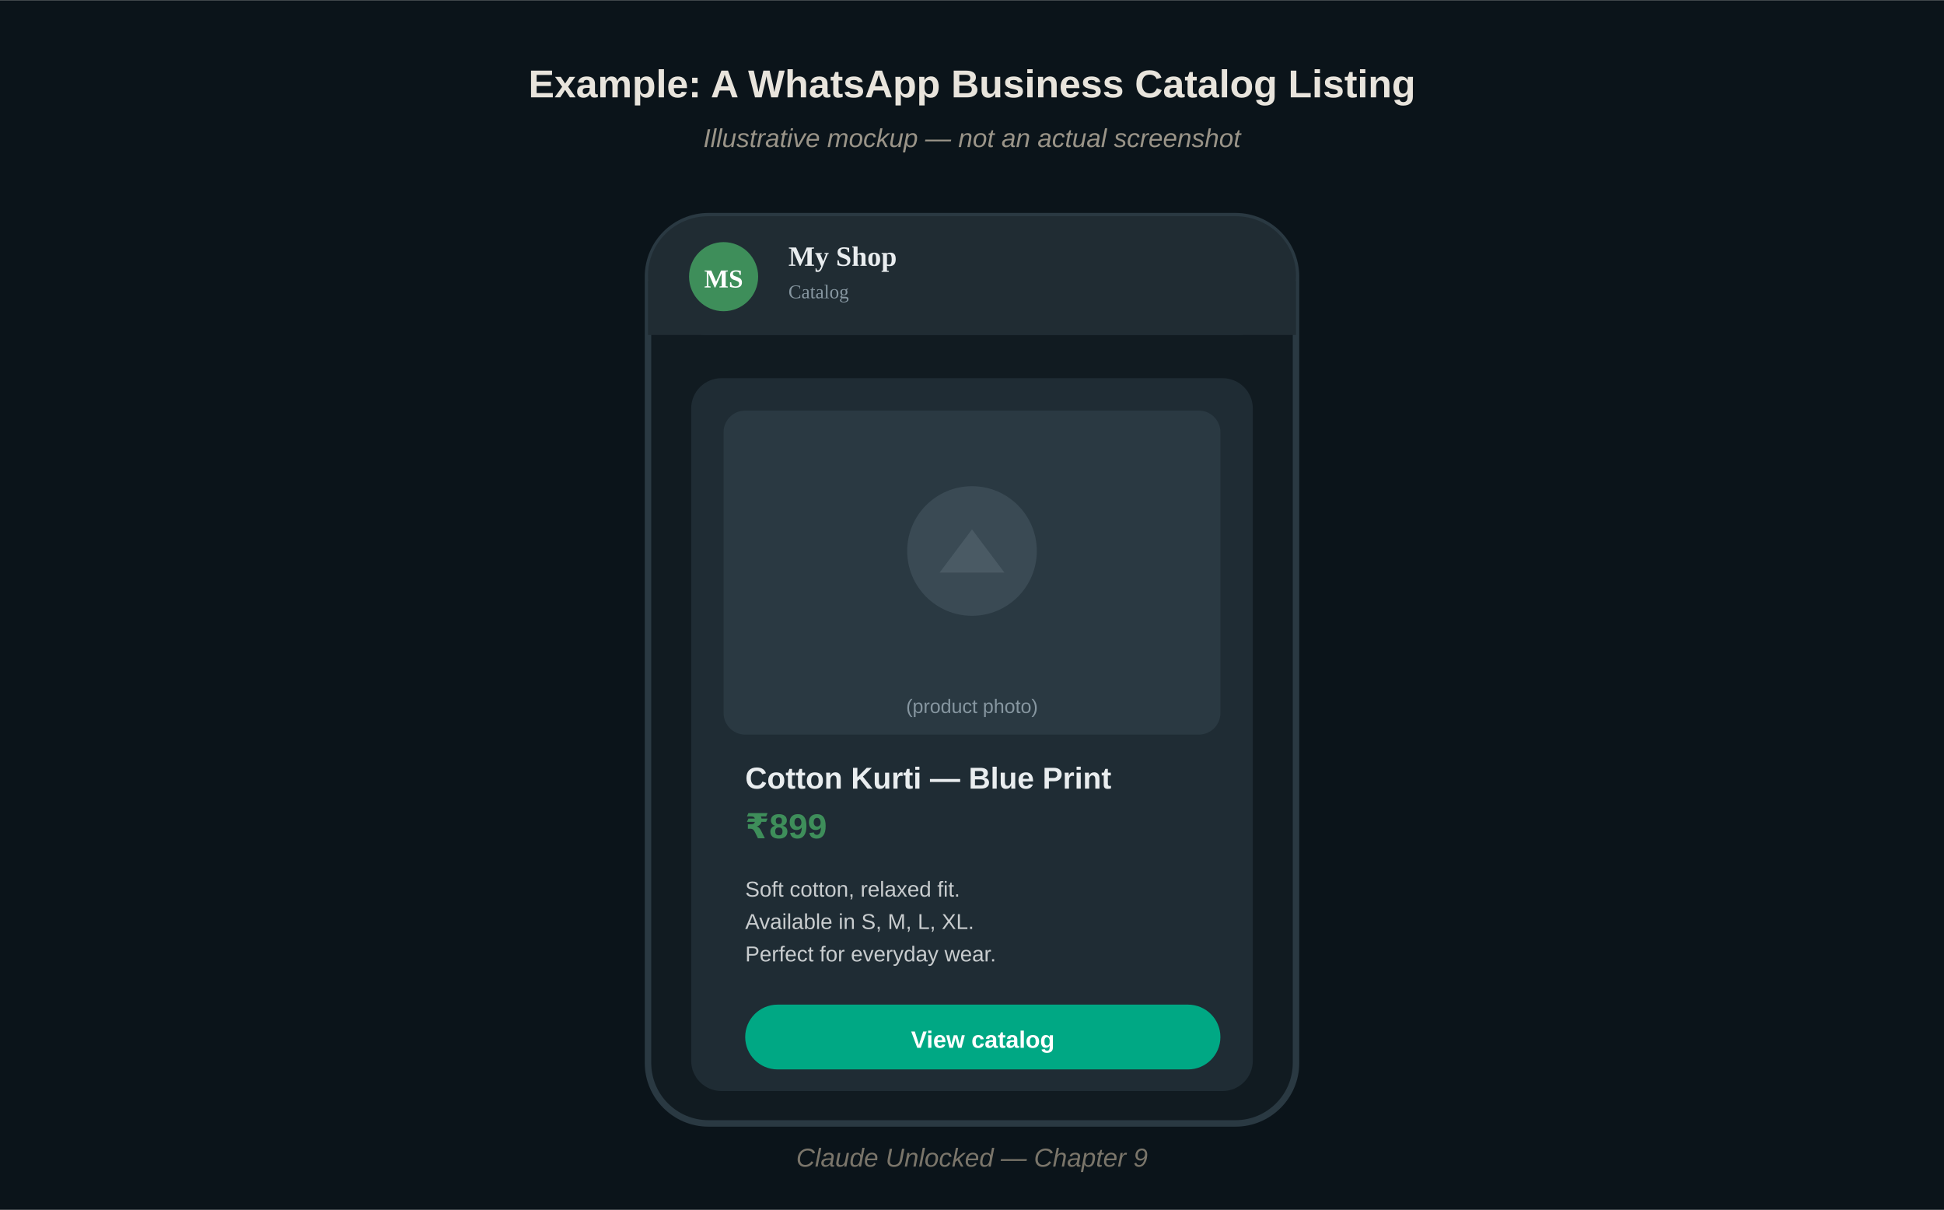

Broadcast Messages That Don't Feel Spammy
Broadcast messages are powerful, but they can easily feel like spam if they're too pushy. A good broadcast feels like a message from someone you know, not an ad blast.
What to type:
"Write a WhatsApp broadcast message announcing 15% off this weekend only. Keep it short, warm, and not overly salesy — like a shop owner texting regular customers, not a big brand."
A simple rule worth remembering: the more your message sounds like a real person typed it, the better it tends to land on WhatsApp specifically — this is a personal channel, and customers notice when it doesn't feel personal.

Customer Reply Templates
Certain questions come up again and again — "is this available," "what sizes do you have," "can I get a discount." Instead of typing fresh replies every time, build a small set of templates with Claude's help, then adjust them slightly per customer.
What to type:
"Write 5 short WhatsApp reply templates for common customer questions I get: availability, sizing, delivery time, discount requests, and return policy. Keep each one under 3 lines, friendly tone."

Handling a Complaint Well
How you respond to an unhappy customer often matters more than the mistake itself. Claude can help you find calm, professional wording when you're frustrated or unsure what to say.
What to type:
"A customer is upset because their order arrived a day late. Write a WhatsApp reply that acknowledges the delay, apologizes without over-apologizing, and offers a small gesture of goodwill."

Building Your Own Reply Library
Once you've generated a few good templates, save them somewhere easy to access — a Notes app, a Google Doc, or even a simple list in your Claude Project (from Chapter 4). Over time, this becomes a ready-made library you can copy from instead of starting fresh every time a similar question comes in.

Chapter 9 Key Takeaways
- Use Claude to write short, clear WhatsApp catalog descriptions that make customers want to ask more.
- Keep broadcast messages personal and short — they should feel like a real message, not an ad.
- Build a small library of reply templates for common questions, so you're not retyping the same answers daily.
- For complaints, let Claude help you find calm, professional wording when you're not sure what to say.

Chapter 10

A Simple Start to AI Automation (Agents, Explained Plainly)
You may have heard the word "agents" thrown around a lot — often with big, vague promises attached. This chapter explains what it actually means, in plain words, with one real example you can try yourself.

What "Agent" Actually Means
Strip away the buzzword, and it's simple: an agent is when Claude doesn't just answer one question, but works through a small series of steps toward a goal — checking its own work along the way, instead of you doing every step manually.
A regular chat: you ask, Claude answers, done.
An agent-style workflow: you give a goal, Claude works through multiple steps toward it, sometimes checking its own progress in between.
You don't need any special technical setup to benefit from this idea — you can apply the *thinking* behind it in a normal chat.

A Real Example: Automating a Weekly Report
Let's say every week, you need to summarize your business numbers into a short update for yourself or your team.
Instead of one prompt, break it into a simple sequence:
Step 1:
"Here are my numbers for this week: [sales, orders, expenses]. Summarize the key changes compared to a typical week."
Step 2:
"Based on that summary, what are the top 2 things I should focus on next week?"
Step 3:
"Turn all of this into a short weekly report I can send to my team — under 150 words."
Once you've run this sequence once, you can reuse the same structure every week — just swap in new numbers. That's the core idea behind automation: build the steps once, reuse them repeatedly.
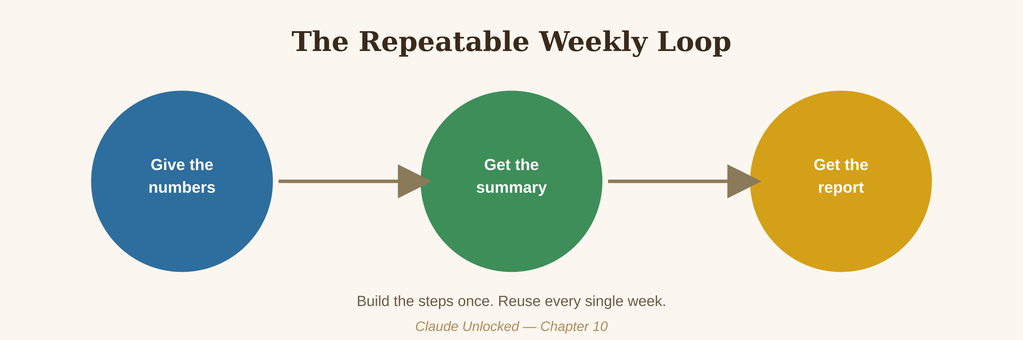

Where This Genuinely Helps
- Weekly or monthly reports you write from the same kind of data each time
- Repeated research tasks — checking a topic, summarizing it the same way each time
- Any task where you find yourself typing a very similar prompt over and over

Where to Be Careful
Automation works well for tasks with a clear, repeatable structure. It works less well for anything requiring real judgment about a unique situation — a sensitive client conversation, a one-off legal question, a decision with real consequences. Use automation to handle the repetitive parts, and keep your own judgment in the loop for anything that genuinely needs it.

Chapter 10 Key Takeaways
- "Agent" simply means Claude working through multiple steps toward a goal, instead of answering just one question.
- You can apply this idea in a normal chat — just break a repeated task into a reusable sequence of prompts.
- Save time by reusing the same sequence for tasks you do weekly or monthly — but keep your own judgment for anything sensitive or one-off.

Chapter 11

For Students
The Problem: Studying takes time, and a lot of it goes into things that aren't actually learning — reformatting notes, rereading long chapters, guessing what might be on the exam.
How Claude Helps: It can compress hours of prep work into minutes, while keeping you honestly in control of the actual learning.

Summarizing Study Material Without Losing the Important Parts
What to type:
"Here are my notes on [topic]. Summarize the key points in simple language, and highlight anything that seems important enough to be tested."
A tip: paste your *own* notes rather than asking Claude to explain a topic from scratch. This keeps the summary aligned with what you were actually taught, not a generic overview.

Planning an Assignment
What to type:
"I have to write a 1500-word assignment on [topic]. Help me build a simple outline — introduction, 3-4 main sections, and a conclusion. Just the structure, I'll write the actual content myself."
A word on originality: use Claude to help you *structure and understand* your work, not to write and submit your assignment as-is. Many colleges have clear rules against submitting AI-written work as your own — always check your institution's policy, and use Claude as a study partner, not a ghostwriter.

Making Your Own Practice Questions
What to type:
"Based on these notes, create 10 practice questions that test my understanding of the key concepts. Don't give me the answers yet — I'll try first."
Once you've attempted them:
"Here are my answers: [paste]. Check them and tell me what I got wrong or missed."
This turns Claude into a genuinely useful study partner — testing you, not just handing you answers.

Explaining a Topic You're Stuck On
What to type:
"Explain [concept] like I'm hearing it for the first time. Use a simple, everyday example, not textbook language."
If the first explanation doesn't click, just say so:
"I still don't get it — try a different example."

Chapter 11 Key Takeaways
- Paste your own notes for summaries rather than asking Claude to explain topics generically — it keeps things aligned with what you were taught.
- Use Claude to structure assignments, not to write and submit them as your own — check your institution's AI policy.
- Turn Claude into a practice partner — have it quiz you, then check your answers.

Chapter 12

For Freelancers
The Problem: Freelancing means constantly writing proposals, contracts, and pitches — often from scratch, often under time pressure, often for clients who won't reply anyway.
How Claude Helps: It can take the blank-page problem off your plate, so you spend your energy on the work that actually pays.

Writing Proposals That Don't Sound Copy-Pasted
What to type:
"I'm a freelance [your skill] pitching for a project: [brief description]. Write a short proposal that shows I understand their specific problem, not a generic pitch. Keep it under 200 words."
The key detail clients notice: does the proposal mention *their* specific situation, or could it be sent to anyone? Always include a real detail from their brief in your prompt so the output reflects it.

Simple Contracts and Scope of Work
What to type:
"Write a simple scope-of-work document for a [type of project]. Include: what's included, number of revisions, timeline, and payment terms. Keep the language simple, not overly legal."
As with Chapter 8, treat this as a solid starting draft — for larger projects or higher-value contracts, it's worth having someone review the terms before you send it.

Pitch Content
What to type:
"I'm pitching a [type of project] to a potential client. Help me write 3 talking points that show my experience is a strong fit for their specific need: [describe their need]."

Following Up Without Sounding Desperate
A common freelancer struggle — you sent a proposal, heard nothing, and don't know how to follow up without seeming pushy.
What to type:
"Write a short, polite follow-up message for a proposal I sent 5 days ago with no reply. Keep it low-pressure, not pushy."

Handling a Difficult Client Conversation
What to type:
"A client wants unlimited free revisions beyond what we agreed. Help me write a firm but polite message that holds my boundary without damaging the relationship."

Chapter 12 Key Takeaways
- Always include a real detail from the client's brief in your prompt — it's what separates a proposal that feels personal from one that feels generic.
- Use Claude for a strong first draft of contracts, but have important ones reviewed before sending.
- Claude is especially useful for the uncomfortable messages — follow-ups, boundary-setting, difficult replies — where the right tone matters most.

Chapter 13

Earn Extra Income Using Claude
This chapter is about turning what you've learned so far into real, practical extra income — not hype, just concrete options and realistic numbers for the Indian market.

A Simple Rate Guide
These are realistic starting ranges for beginners in the Indian market. As you build a track record, rates go up — but this gives you a grounded starting point, not an inflated promise.
Service | Typical starting rate (India)
Content/blog writing (Claude-assisted) | ₹500 – ₹2,000 per article
Resume/cover letter writing | ₹300 – ₹1,000 per resume
WhatsApp catalog writing for shops | ₹1,000 – ₹5,000 per project
Social media captions (monthly package) | ₹2,000 – ₹8,000 per month
Virtual assistant / admin support | ₹8,000 – ₹20,000 per month (part-time)

These are starting points, not guarantees — your actual rate depends on your skill, portfolio, and niche. Use them to set a realistic first price, not a ceiling.

Option 1: Freelance Writing Services
Using Claude, you can produce a strong first draft quickly, then spend your time editing and adding your own voice — which is exactly what separates a professional from someone just copy-pasting AI output.
Getting your first client:
"Help me write a short pitch message for offering blog-writing services to small business owners on Instagram. Keep it friendly and specific about what I offer."

Option 2: Resume and Cover Letter Writing
Many people struggle to write about themselves. If you're comfortable with Claude and the SPICE method from Chapter 3, you can offer this as a simple, low-cost service to job seekers in your network.

Option 3: WhatsApp Content for Local Shop Owners
Most small shop owners don't have time to write good catalog descriptions or broadcast messages (Chapter 9). Offering this as a simple monthly service — write 10-15 messages a month — is a realistic, low-barrier way to start.
Getting your first client:
"Help me write a simple offer message I can send to local shop owners, offering to write their WhatsApp catalog and broadcast messages for a monthly fee."

Option 4: Social Media Captions
If you're comfortable with a niche (fashion, food, fitness, etc.), offering a monthly caption-writing package is a common, low-barrier freelance service — and Claude makes the actual writing far faster.

A Grounded Starting Plan
- Pick one service from this chapter — don't try all four at once.
- Practice on your own content or a friend's business first, to build a small sample.
- Set a realistic starting rate using the table above.
- Reach out to 3-5 people this week using a Claude-written pitch message.
Consistency matters more than speed here — a steady, realistic start beats an ambitious plan you abandon after a week.

Chapter 13 Key Takeaways
- Use the rate table as a realistic starting point, not a promise — actual rates depend on skill and track record.
- Pick one service to start with, rather than spreading yourself across all of them.
- Build a small sample of work before pitching, and reach out consistently rather than waiting for the "perfect" offer.

Chapter 14

For Small Business Owners
The Problem: Running a small business means wearing every hat — marketing, customer service, competitor research — usually with no time or budget for a full team.
How Claude Helps: It becomes a fast, always-available assistant for the tasks that would otherwise eat your whole day.

A Month of Marketing Post Ideas in One Sitting
What to type:
"I run a [type of business]. My audience is [describe them]. Give me 20 social media post ideas for this month — mix of product posts, tips, and engagement posts. Just the ideas and hooks, not the full captions yet."
Once you like a batch of ideas, ask Claude to write the full captions one at a time, matching your usual tone.

Understanding What Competitors Are Doing
What to type:
"Here's what 3 competitor businesses are posting/offering: [describe or paste examples]. What patterns do you notice? What gap could I fill that they're not covering?"
Claude can't browse live social media on its own in every case, so the most useful approach is: you gather a few real examples (screenshots, descriptions), and ask Claude to analyze what you've collected.

Ready-Made Customer Reply Scripts
What to type:
"Write 5 reply templates for common questions my customers ask: pricing, availability, delivery time, refunds, and custom orders. Keep each short and in a warm, approachable tone."

Planning Ahead for Slow Seasons
What to type:
"My business usually slows down during [time period]. Give me 3 ideas for keeping customers engaged or generating sales during this slower period."

A Simple Weekly Routine
Most small business owners don't need daily AI use — a consistent weekly habit is enough:
- Monday: Plan the week's content ideas
- Midweek: Draft any customer replies or messages needed
- End of week: Review what worked, ask Claude to summarize the week's numbers if you're tracking them

Chapter 14 Key Takeaways
- Batch a month of content ideas in one sitting, then write full captions one at a time as needed.
- Feed Claude real examples of what competitors are doing rather than expecting it to browse for you.
- Build a small library of reply templates for the questions you get most often.

Chapter 15

For Teachers
The Problem: Lesson planning, quiz-making, and giving personalized feedback all take real time — time that often comes out of evenings and weekends.
How Claude Helps: It can take the first, time-consuming draft off your plate, so you spend your energy on actually teaching.

Lesson Plans Aligned to Your Syllabus
What to type:
"I teach [subject] to [grade/level]. Here's the topic for this week: [topic]. Create a simple lesson plan with an introduction activity, main teaching points, and a short wrap-up exercise."
If you have a specific syllabus or textbook, mention it directly so the plan stays aligned:
"This should align with [textbook/syllabus name], chapter [X]."

Generating Quizzes With Answer Keys
What to type:
"Create a 10-question quiz on [topic] for [grade level]. Mix multiple choice and short answer. Include an answer key at the end."

Personalized Feedback Templates
Writing individual feedback for every student is one of the most time-consuming parts of teaching. Claude can help you build a starting template you then personalize quickly.
What to type:
"Write a feedback template for a student who did well on content but needs to work on structure and clarity. Keep it encouraging, specific, and easy to personalize with the student's name and details."

Explaining a Tricky Concept Differently
If some students aren't getting a concept the usual way, ask Claude for a different angle:
What to type:
"Give me 3 different ways to explain [concept] to students who are struggling with the standard explanation. Include a simple analogy for each."

Chapter 15 Key Takeaways
- Mention your specific syllabus or textbook so lesson plans and quizzes stay aligned with what you're actually teaching.
- Use Claude to draft the time-consuming first version of feedback, then personalize it quickly per student.
- When a concept isn't landing, ask for multiple different explanations rather than repeating the same one.

Chapter 16

For Job Seekers
The Problem: Job hunting means writing the same story about yourself over and over — resumes, cover letters, interview answers — often while stressed and short on time.
How Claude Helps: It can help you say what you actually mean, tailored to each specific job, instead of sending the same generic resume everywhere.

Tailoring Your Resume to a Specific Job
What to type:
"Here's my resume: [paste]. Here's the job description I'm applying for: [paste]. Rewrite my experience section to highlight the parts most relevant to this specific job. Don't invent anything — only reword what's already true."
That last line matters — always tell Claude to work only with what's genuinely true about your experience. A resume that's rewritten to sound stronger is fine; one that exaggerates or invents things can seriously backfire in an interview.

Writing a Cover Letter That Sounds Like You
What to type:
"Write a cover letter for this job: [paste description]. Here's a bit about my background: [describe]. Keep it sounding natural and personal, not like a template — mention one specific thing about the company that shows I actually researched them."

Practicing for Interviews
What to type:
"I have an interview for a [role] position. Ask me 5 common interview questions for this role, one at a time. After each answer, give me honest feedback on how to improve it."
This turns Claude into a low-pressure practice partner — you can run through tough questions as many times as you need, without the anxiety of a real interview.

Preparing for Tricky Questions
What to type:
"What are 3 tricky or unexpected questions someone might ask in an interview for [role]? Help me think through how to answer them honestly and confidently."

A Simple Weekly Job Search Routine
- Tailor your resume and cover letter for 2-3 specific roles
- Run one practice interview session
- Review and refine your answers based on the feedback

Chapter 16 Key Takeaways
- Always tell Claude to only reword what's true about your experience — never to invent or exaggerate.
- Mention something specific about the company in your cover letter so it doesn't read like a generic template.
- Use Claude as a low-pressure interview practice partner, with honest feedback after each answer.

Chapter 17

Ready-to-Use Prompt List
This is your quick-reference swipe file — copy, paste, and swap in your own details wherever you see [brackets]. Organized by the kind of task, so you can find what you need fast.

Business & Marketing
- Write a short WhatsApp broadcast for [offer], keeping it under 4 lines and not too salesy.
- Give me 10 social media post ideas for [business type] this month — mix of product, tips, and engagement posts.
- Write a payment reminder message for a client whose invoice is [X] days overdue.
- Write a festival greeting + soft offer post for [festival] for my [business type].
- Write a customer reply template for the question: "[common customer question]."

Freelancing & Income
- Write a short proposal pitching [service] to a client with this brief: [paste brief].
- Write a polite follow-up message for a proposal I sent [X] days ago with no reply.
- Write a simple scope-of-work document for [type of project], including timeline and payment terms.
- Write a firm but polite message setting a boundary about [issue] with a client.

Students
- Summarize these notes in simple language, highlighting anything important: [paste notes].
- Create 10 practice questions based on this material: [paste notes]. Don't give answers yet.
- Build a simple outline for a [word count] assignment on [topic] — structure only.
- Explain [concept] like I'm hearing it for the first time, using a simple everyday example.

Job Search
- Rewrite my experience section to match this job description, without inventing anything: [paste resume + job description].
- Write a cover letter for this role, mentioning one specific thing about the company: [paste job description].
- Ask me 5 interview questions for a [role] position, one at a time, with feedback after each.

Documents & Data
- Pull the item names, quantities, prices, and total from this bill into a table: [upload/paste].
- Clean up this spreadsheet and flag anything that looks wrong: [paste/upload].
- Summarize this document in plain language and point out anything unusual: [upload].

Fixing & Improving Answers
- Keep [X], but cut [Y], and change [Z] in your last response.
- What are the 2-3 weakest parts of that response? Now fix them.

A Note on Using This List
These are starting points, not final answers. The real skill — from Chapter 3 — is filling in the SPICE details (Situation, Purpose, Instructions, Copy an example, Edit rules) rather than sending these exactly as written. Use this list to save time getting started, then customize each one to your specific situation.

Chapter 18

What Claude Can Get Wrong (Read This Before You Rely on It)
Claude is genuinely useful, but it's not perfect — and knowing where it can go wrong is just as important as knowing what it does well. This chapter is your honest checklist.

Numbers and Calculations
For simple math, Claude is usually fine. But for anything involving large or precise numbers — financial calculations, exact tax figures — always double-check with a calculator or a professional before relying on it, especially for anything involving real money.

Current Events and Live Information
Claude's knowledge has a cutoff date, so it may not know about very recent news, current prices, or things that changed after that point. For anything time-sensitive, verify with a live source.

Legal and Medical Topics
Claude can help you understand a topic or draft something in plain language, but it should never be your final word on anything legal or medical. For contracts, disputes, or health decisions — always involve an actual professional.

Facts It States Confidently but Gets Wrong
One of the trickiest things about AI tools in general — Claude included — is that a wrong answer can sound just as confident as a correct one. If something matters, especially a specific fact, name, date, or statistic, verify it independently before using it publicly or professionally.

What Not to Type Into Any AI Tool
A simple rule of thumb: don't paste anything into any AI tool that you wouldn't be comfortable being seen by someone else. This includes:
- Passwords or login details
- Other people's personal information without their permission
- Sensitive financial account details
- Confidential client or business data you don't have permission to share

A Simple Trust Checklist
Before using Claude's output for anything important, ask yourself:
- Does this involve money, health, or legal matters? → Double-check with a professional.
- Does this involve a specific fact, date, or statistic? → Verify it independently.
- Does this involve someone else's private information? → Don't paste it in the first place.
- Is this going out publicly under my name? → Read it fully yourself before sending.

Chapter 18 Key Takeaways
- Treat Claude as a fast, capable first draft — not a final authority on money, law, or health.
- A confident-sounding answer isn't always a correct one. Verify anything specific and important.
- Never paste sensitive personal, financial, or confidential data into any AI tool.

Chapter 19

See It Working — Real Examples
*Note: The scenarios below are illustrative examples meant to show realistic, modest outcomes — not verified case studies or testimonials. If you collect real customer stories after launching, replace these with their actual results.*

Example: A Tuition Teacher Saves Time on Lesson Planning
A tuition teacher handling multiple grade levels used to spend 1-2 hours every evening preparing the next day's lessons. Using the lesson plan prompts from Chapter 15, that dropped to about 30-40 minutes — mostly spent reviewing and personalizing what Claude drafted, rather than starting from a blank page each time.

Example: A Shop Owner Plans a Month of WhatsApp Offers in One Sitting
A small clothing shop owner used to write WhatsApp broadcast messages the same day they wanted to send them — often rushed, and inconsistent in tone. Using the batching approach from Chapter 9, she planned a full month of offer messages and festival greetings in about an hour on a Sunday, then just sent the ready drafts through the week as needed.

Example: A Freelancer Speeds Up Proposal Writing
A freelance content writer used to spend 30-45 minutes on each new client proposal, often feeling stuck on the opening line. Using the SPICE method and proposal prompt from Chapter 12, a solid first draft now takes about 10 minutes — leaving more time to personalize the details that actually make a client say yes.

The Pattern Across All Three
Notice what's similar in each example: nobody handed the work entirely over to Claude. They used it to remove the slow, repetitive part of the task, then spent their own time on the part that actually needed a human's judgment — personalizing, reviewing, deciding. That's the realistic way this tool helps, not a magic replacement for doing the work.

Chapter 19 Key Takeaways
- The biggest time savings usually come from repetitive, first-draft tasks — not from skipping judgment entirely.
- Batching similar tasks together (like a month of messages at once) saves more time than doing them one at a time under pressure.
- Realistic, modest results are more trustworthy than big promises — and they're usually what people actually experience.

Appendix

Tools That Work Well With Claude (India Context)
Claude works even better paired with a few everyday tools most Indian users already have. Here's a simple, practical pairing guide — no need to learn a dozen new platforms, just know when to use what.

Tool | What it's for | How it pairs with Claude
Canva | Turning text into visuals | Take a caption or product description Claude wrote and design it into a post using Canva's templates
Google Sheets | Organizing data | Paste Claude's cleaned-up data or analysis directly into a sheet to track over time
WhatsApp Business | Sending messages to customers | Copy the catalog descriptions, broadcasts, and reply templates Claude writes (Chapter 9) directly into your WhatsApp Business app
Notion or Google Docs | Saving your prompt list | Keep your growing swipe file (Chapter 17) and your best custom prompts in one place you can copy from anytime
Instamojo / Gumroad | Selling digital products | If you build something like a template or guide with Claude's help, these platforms let you sell it directly to Indian customers
Razorpay / UPI links | Accepting payments | Pair with any of the above for simple, India-friendly payment collection from customers or clients

A Simple Way to Think About This
You don't need to master every tool on this list. Pick the 2-3 that match what you're actually doing — a shop owner might only need WhatsApp Business and Canva; a freelancer might only need Google Docs and a payment link. Add more only when you actually need them.

Back Matter

Quick Reference Cheat Sheet
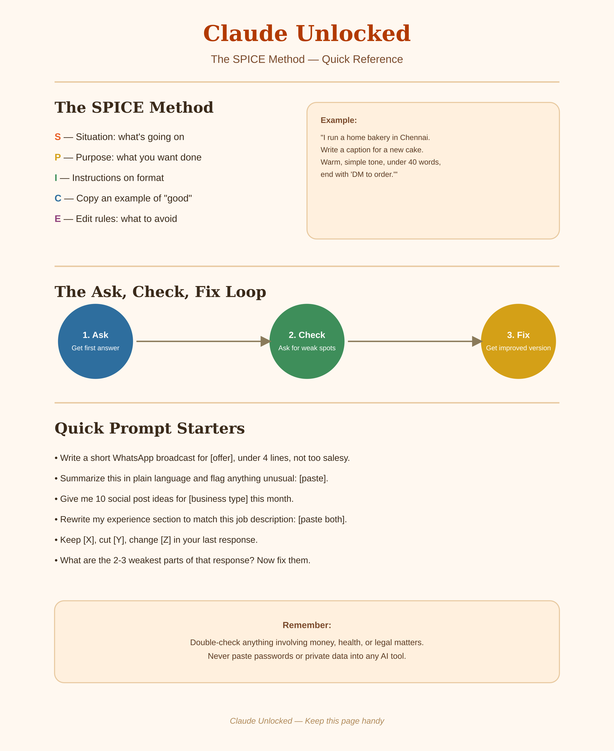
The SPICE Method, in short:
- Situation — what's going on
- Purpose — what you want done
- Instructions on format — how it should look
- Copy an example — show what "good" looks like
- Edit rules — what to avoid
The Ask, Check, Fix Loop, in short:
- Ask — get a first answer
- Check — ask Claude to point out its own weak spots
- Fix — ask it to improve based on that

Frequently Asked Questions
Do I need the paid version of Claude to follow this book?
No. Everything in this book works on the free plan. The paid plan just gives you more usage and access to more powerful models if you're using Claude very frequently.
I'm not good with technology — will I be able to follow this?
Yes. Every chapter is written in plain language, with clear examples. If you can type a WhatsApp message, you can follow this book.
Does this cover coding or building real apps?
This book focuses on using Claude for everyday writing, business, and productivity tasks — not software development. Chapter 5 covers building small, simple tools (calculators, trackers) without needing to code.
Is the income advice in Chapter 13 guaranteed?
No — the numbers given are realistic starting ranges based on the Indian market, not guarantees. Actual results depend on your effort, skill, and consistency.
Can I use this for my business in any language?
Yes — Chapter 8 covers writing in a natural mix of English and Hindi or other regional languages. The same approach works for any language Claude supports.

Bonus
The full Ready-to-Use Prompt List (Chapter 17) is also available as a separate downloadable file — useful if you want to offer it as a bonus or a smaller standalone product later.

Terms of Use & Copyright
© 2026 Vihaanflowai.com. All rights reserved. Written by Ravindra.
This product, including its text, examples, and the SPICE framework, is licensed for single-user personal or business use only upon purchase. You may use it for your own work, print a personal copy, and apply what you learn to your own business or clients.
You may not:
- Resell, rent, or redistribute this product or any part of it
- Share or upload it to shared drives, groups, channels, or file-sharing sites
- Repackage or claim this content as your own original work
- Use the "SPICE Method" name or framework to build a competing product without written permission
This is intended for educational purposes only and is not financial, legal, or professional advice. Income examples and rate ranges are illustrative starting points, not guarantees.
Claude, Claude.ai, and Anthropic are trademarks of Anthropic PBC. This is an independent, unofficial guide, not created, endorsed, or affiliated with Anthropic.
Questions or permissions: ravindra.mom96@gmail.com

