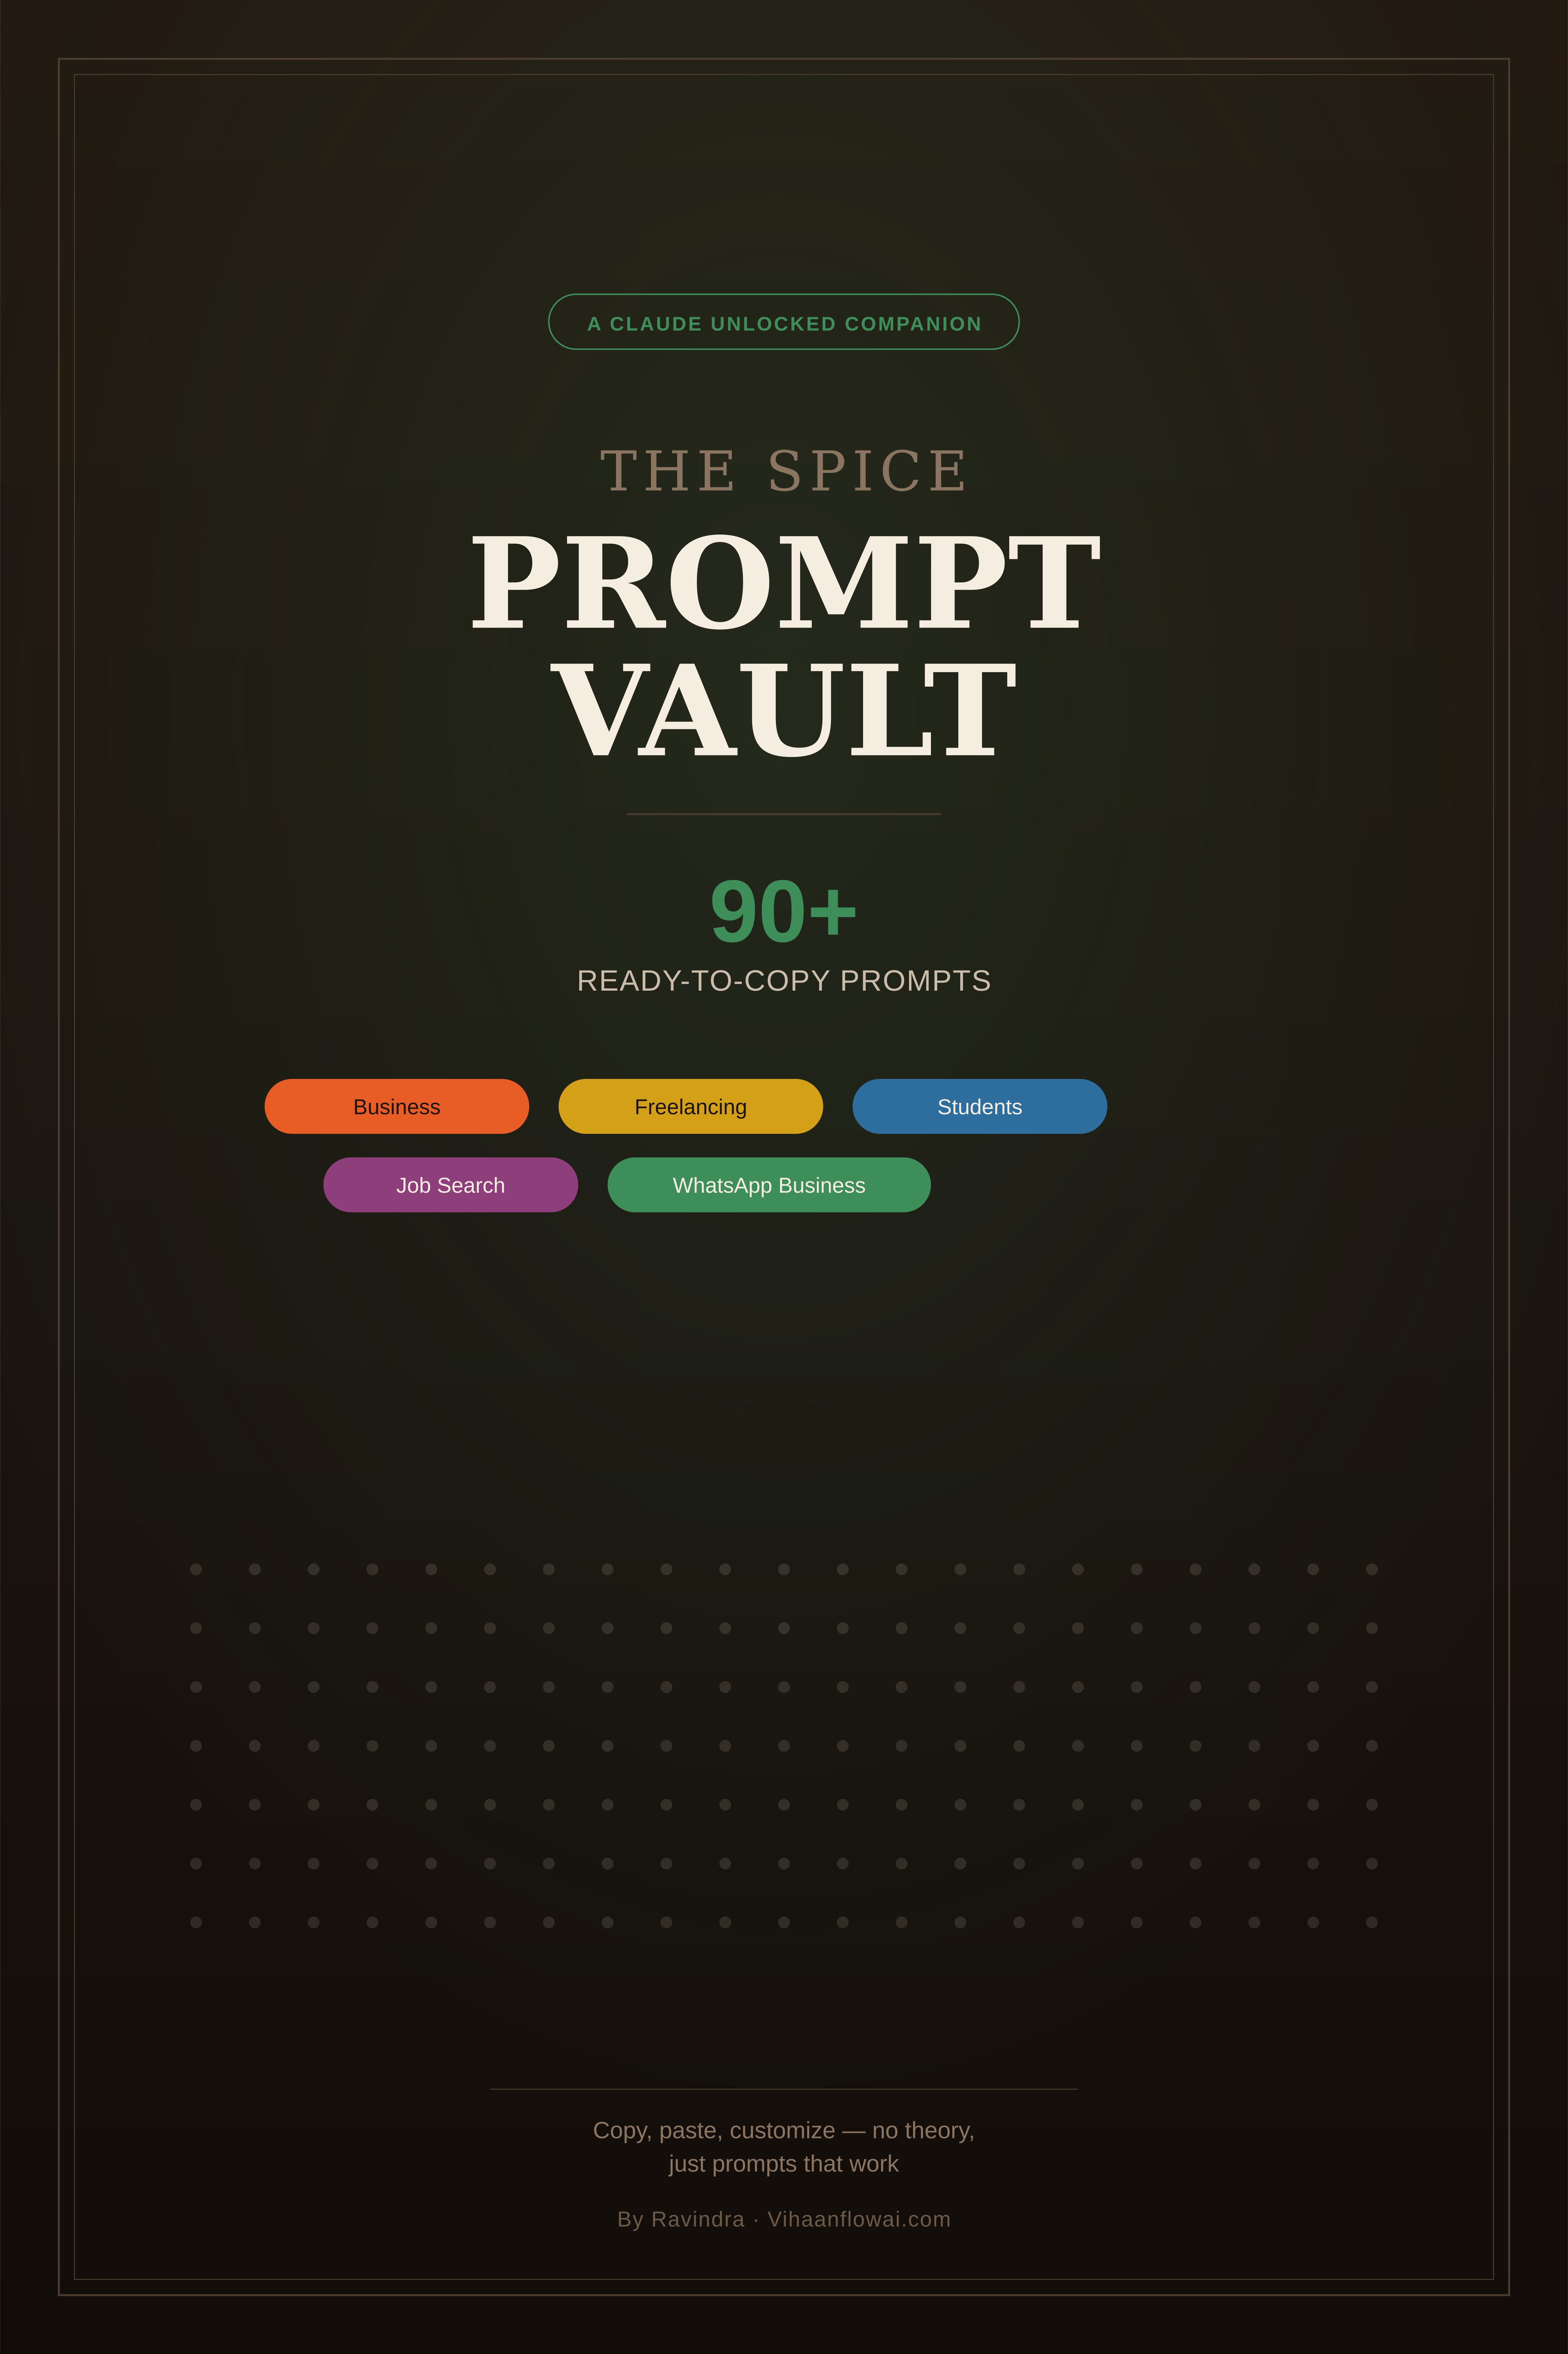

The SPICE Prompt Vault

90+ Ready-to-Copy Claude Prompts for Work, Business & Everyday Life

How to Use This Vault
Every prompt below is ready to copy and paste into Claude. Just swap out anything in [brackets] with your own details. No teaching, no theory — just prompts that work, organized so you can find what you need fast.
A quick tip: the more specific you make the [bracketed] parts, the better your result will be. A filled-in prompt always beats a generic one.

1. Business & Marketing
- Write a short WhatsApp broadcast for [offer], under 4 lines, not too salesy.
- Give me 10 social media post ideas for [business type] this month — mix of product, tips, and engagement posts.
- Write a payment reminder message for a client whose invoice is [X] days overdue.
- Write a festival greeting + soft offer post for [festival] for my [business type].
- Write a customer reply template for the question: "[common customer question]."
- Create a 30-day content calendar for [business type] targeting [audience]. Just topics and hooks, not full posts.
- Write an "About My Shop" section for my [business type] page, warm and personal, under 80 words.
- Give me 5 ideas for a customer loyalty or referral offer for [business type].
- Write a short thank-you message to send after a customer's first purchase.
- Turn this list of features into simple, benefit-focused bullet points: [paste features].

2. Freelancing & Client Work
- Write a short proposal pitching [service] to a client with this brief: [paste brief].
- Write a polite follow-up message for a proposal I sent [X] days ago with no reply.
- Write a simple scope-of-work document for [type of project], including timeline and payment terms.
- Write a firm but polite message setting a boundary about [issue] with a client.
- Write a message asking a client for a testimonial after finishing [project].
- Rewrite this client email to sound more confident and professional: [paste email].
- Write a short message explaining a project delay to a client, without over-apologizing.
- Draft a simple freelance contract summary in plain language for [type of work].

3. Negotiation & Pricing Conversations
- A client says my price is too high. Help me write a confident reply that doesn't immediately discount.
- Write a message proposing a price increase to an existing client, keeping the relationship warm.
- Help me think through how to respond when a client asks for unlimited free revisions.
- Write a polite message declining a project that doesn't fit my budget or timeline.
- Draft a message offering a client two package options instead of one, to make the higher one feel reasonable.

4. Students
- Summarize these notes in simple language, highlighting anything important: [paste notes].
- Create 10 practice questions based on this material: [paste notes]. Don't give answers yet.
- Build a simple outline for a [word count] assignment on [topic] — structure only.
- Explain [concept] like I'm hearing it for the first time, using a simple everyday example.
- Give me a study plan for [subject] with [X] days before my exam.
- Turn these messy notes into a clean, organized summary with headers: [paste notes].
- Quiz me on [topic] with 5 questions, one at a time, and check my answers as I go.

5. Job Search
- Rewrite my experience section to match this job description, without inventing anything: [paste resume + job description].
- Write a cover letter for this role, mentioning one specific thing about the company: [paste job description].
- Ask me 5 interview questions for a [role] position, one at a time, with feedback after each.
- Write a short thank-you email to send after a job interview.
- Help me turn this achievement into a strong resume bullet point: [describe what you did].
- Write a LinkedIn message reaching out to someone for a referral at [company].

6. Documents & Data
- Pull the item names, quantities, prices, and total from this bill into a table: [upload/paste].
- Clean up this spreadsheet and flag anything that looks wrong: [paste/upload].
- Summarize this document in plain language and point out anything unusual: [upload].
- Turn this long report into a 5-bullet summary for someone who has no time to read it fully.
- Fill in this invoice template with these details: [paste details + template].

7. Fixing & Improving Answers
- Keep [X], but cut [Y], and change [Z] in your last response.
- What are the 2-3 weakest parts of that response? Now fix them.
- Make this shorter and less formal: [paste text].
- Rewrite this to sound more confident, without changing the meaning: [paste text].
- Give me 3 different versions of this message, each with a slightly different tone: [paste text].

8. Festival & Seasonal Content
- Write a Diwali greeting + soft offer post for my [business type], warm and personal tone.
- Give me 5 content ideas for [festival] relevant to a [business type].
- Write a New Year message to send to customers, thanking them for the past year.
- Suggest 3 ways to run a small festival-season offer without discounting too heavily.
- Write a short caption mixing Hindi and English for a festival sale post.

9. WhatsApp Business
- Write a short WhatsApp catalog description for [product], under 30 words.
- Write 5 reply templates for common customer questions: availability, sizing, delivery, discounts, and returns.
- Write a WhatsApp reply for a customer upset about a delayed order.
- Write a broadcast message announcing [offer], sounding like a real person, not an ad.
- Draft a WhatsApp message following up with a customer who asked about a product but didn't order.

10. Small Business Operations
- Generate my weekly business report. Here are my numbers: [paste numbers]. Summarize performance and 2-3 priorities for next week.
- Write a simple SOP for [task] that I could hand to someone else to follow.
- Help me prepare 5 smart questions to ask before a meeting with [person/client] about [topic].
- Give me a pros/cons analysis for deciding between [option A] and [option B], based on these factors: [list].
- Write a simple job description for hiring a [role] for my business.

11. Teachers & Educators
- Create a simple lesson plan for [topic] for [grade level], with an intro activity and wrap-up.
- Create a 10-question quiz on [topic] with an answer key.
- Write encouraging, specific feedback for a student who did well on content but needs to improve structure.
- Give me 3 different ways to explain [concept] for students who are struggling with the standard explanation.

12. Personal & Everyday Life
- Help me write a polite message declining an invitation without over-explaining.
- Draft a message asking a friend to repay money I lent them, keeping it light but clear.
- Write a short, sincere apology message for [situation].
- Help me plan a simple weekly routine that balances work, health, and rest.
- Write a message to reschedule an appointment politely.

13. Learning & Explaining Things Simply
- Explain [topic] to me like I'm a complete beginner, using one relatable example.
- Break down [complex idea] into 3 simple steps.
- What are the 3 most common mistakes beginners make with [skill]? How do I avoid them?
- Give me the "80/20" of [topic] — the 20% of knowledge that covers 80% of what I need to know.

14. Quick Everyday Helpers
- Turn this into a clear, polite email: [rough notes or bullet points].
- Summarize this long WhatsApp/email thread into 3 bullet points: [paste thread].
- Help me write a message declining a sales call politely.
- Draft a simple thank-you note for a gift or favor.
- Write a short bio for my [Instagram/LinkedIn] profile, focused on [what you do].

15. Bonus: Multi-Step Prompt Chains
Sometimes one prompt isn't enough — chain a few together for better results.
- Step 1: "Here are my business numbers: [paste]. What are the 3 most important takeaways?"
Step 2: "Based on that, what should I focus on next week?"
Step 3: "Turn this into a short report I can share with my team."
- Step 1: "What are 5 common pain points for [your audience]?"
Step 2: "Based on those, suggest 5 content or product ideas that solve them."
Step 3: "Which of those 5 is easiest to act on this week? Explain why."
- Step 1: "Draft a first version of [message/document]."
Step 2: "Critique this as if you're the toughest reviewer in [field]. What are the 3 weakest parts?"
Step 3: "Now fix those three things."

A Reminder
These prompts are starting points, not magic words. The real skill — from *Claude Unlocked: The SPICE Method* — is filling in the details that make a prompt fit *your* exact situation. Use this vault to save time getting started, then adjust each one as needed.

Terms of Use & Copyright
© 2026 Vihaanflowai.com. All rights reserved. Written by Ravindra.
This product is licensed for single-user personal or business use only upon purchase. You may use it for your own work, print a personal copy, and apply the prompts to your own business or clients.
You may not:
- Resell, rent, or redistribute this product or any part of it
- Share or upload it to shared drives, groups, channels, or file-sharing sites
- Repackage or claim this content as your own original work
This is intended for educational purposes only and is not financial, legal, or professional advice.
Claude, Claude.ai, and Anthropic are trademarks of Anthropic PBC. This is an independent, unofficial product, not created, endorsed, or affiliated with Anthropic.
Questions or permissions: ravindra.mom96@gmail.com

