World Comm.-CT, Koodo Authorized Dealer
Requirements Document
Team 1
Submitted: August, 1, 2015

Created By:
Jung Geon Choi
Ravideep Dhupia
Max Fainshtein
Michael Fainshtein

Contents
1 Project Proposal 4
1.1 Team Skill/Experience Inventory: 4
1.2 Client or Mentor: 4
1.3 Brief description of required system: 4
1.4 Description of any Technological Constraints: 5
1.5 Key System Components: 5
1.6 Context Diagrams: 8
2 The Business Problem 10
2.1 The Business 10
2.2 Problem Statement 10
3 Stakeholders 12
4 Business Rules 13
5 System Use Case Diagrams 14
6 Use Case Specifications 19
6.1 Use Case Name: Process Return 19
6.1.1 Author: Jung Geon Choi 19
6.1.2 Actor(s): Employee 19
6.1.3 Use Case Preconditions 19
6.1.4 Use Case Successful Post Conditions 19
6.1.5 Applicable Business Rules 19
6.1.6 Main Flow: 19
6.1.7 Alternate Flows 20
6.2 Use Case Name: Add Sale 20
6.2.1 Author: Ravideep Dhupia 20
6.2.2 Actor(s): Employee 20
6.2.3 Use Case Preconditions 20
6.2.4 Use Case Successful Post Conditions 20
6.2.5 Applicable Business Rules 20
6.2.6 Main Flow: 21
6.2.7 Alternate Flows 21
6.3 Use Case Name: Request Membership Referral 22
6.3.1 Author: Michael Fainshtein, Max Fainshtein 22
6.3.2 Actor(s): Employee 22
6.3.3 Use Case Preconditions 22
6.3.4 Use Case Successful Post Conditions 22
6.3.5 Applicable Business Rules 22
6.3.6 Main Flow: 22
6.3.7 Alternate Flows 22
6.4 Use Case Name: Check Daily Sales 23
6.4.1 Author: Ravideep Dhupia 23
6.4.2 Actor(s): Employee 23
6.4.3 Use Case Preconditions 23
6.4.4 Use Case Successful Post Conditions 23
6.4.5 Applicable Business Rules 24
6.4.6 Main Flow: 24
6.4.7 Alternate Flows 24
6.5 Use Case Name: Search for a particular member 24
6.5.1 Author: Ravideep Dhupia 24
6.5.2 Actor(s): Employee 24
6.5.3 Use Case Preconditions 24
6.5.4 Use Case Successful Post Conditions 24
6.5.5 Applicable Business Rules 24
6.5.6 Main Flow: 25
6.5.7 Alternate Flows 25
6.6 Use Case Name: View Customer Contact List 26
6.6.1 Author: Michael & Max Fainshtein 26
6.6.2 Actor(s): Manager/Vice president 26
6.6.3 Use Case Preconditions 26
6.6.4 Use Case Successful Post Conditions 26
6.6.5 Applicable Business Rules 26
6.6.6 Main Flow: 26
6.6.7 Alternate Flows 26
6.7 Use Case Name: Change the status of an employee account 28
6.7.1 Author: Jung Geon Choi 28
6.7.2 Actor: Manager 28
6.7.3 Use Case Preconditions 28
6.7.4 Use Case Successful Post Conditions 28
6.7.5 Applicable Business Rules 28
6.7.6 Main Flow: 28
6.7.7 Alternate Flows 28
7 Non-Functional requirements 30

Project Proposal

Team Skill/Experience Inventory:

Student | Skills
Jung Geon Choi | Programming Languages: C, C++, Java, Javascript, C#, PHP, CSS, HTML, MySQL, Windows SQL, Oracle DB express 11g, Objective-C  Platforms: Windows, Mac OSX, iOS, Linux  Environments: Web Service, ASP.NET
Ravideep Dhupia | Programming Languages: C, C++, C#, Java, Javascript, HTML5, PHP  Database systems: MySQL, SQL Server  Platforms: Windows, Linux operating systems  Environments: Unix and Windows based web development, ASP.Net
Max | Programming Languages: C, C++, C#, Java, Javascript, HTML5, PHP  Database systems: MySQL, SQL Server  Platforms: Windows  Environments: Unix and Windows based web development, ASP.Net
Michael | Programming Languages: C, C++, C#, Java, Javascript, HTML5, PHP  Database systems: MySQL, SQL Server  Platforms: Windows  Environments: Unix and Windows based web development, ASP.Net

Client or Mentor:

Client’s Organization | World Comm.-CT, Koodo Authorized Dealer
Client’s name and contact | Kevin Kang  E: kihmin.k@gmail.com
Client position | Vice Président

Brief description of required system:

The proposed system is a “Customer Relation and Sales Management System” to be designed primarily for back-end use by World Comm. -CT employees: Managers and employees.

Through the employee account management module, the system would allow employees from four different outlet locations in the GTA to register and access system functionality, as well as maintain their own user profiles. Managers should be able to review various reports generated by the employees. The system needs to track and manage “strikes” allocated to employees, which the employees can view.

The system must have a sales management component that can be used by the employees to input, update and review daily sales, generate receipt codes and generate sales reports. Managers should be able to set sales targets through the system and manage the sales component. The proposed system should also facilitate handsets management that provides necessary handset details and statuses

The system should have a membership management module where employees can add and manage memberships and request for approval of referrals and credits. The membership management component would be based on the membership policy created by Managers, which the employees should be able to view. Managers should be able to manage customer accounts, VIP status, credits and referrals for memberships.

The customer management module would track customer activities and preferences by creating tracking entries on the basis of their interactions with the customer.

The operations component of the required system would streamline daily operational activities such as managers setting daily tasks for employees. The system should also have components that allow Managers to review database changes; and create and upload files to the system that can be downloaded by employees. An important feature of the system would be a search feature that allows employees to search for Membership IDs, phone numbers, SIM numbers and IMEI numbers, as well as allowing users to report defective or DOA handsets. The proposed system should also facilitate sending email notifications to employees.

Description of any Technological Constraints:
- Web-based system should be accessible from outside the GTA, should be accessible from the U.S.
- System needs to be able to send email notifications
- System needs to support varied mobile devices
- System needs to support access from Google Chrome using Windows XP, 7, 8, and 8.1
- Sales management module need accommodation with barcode reader for SIM and IMEI input

Key System Components:

There are five major components of the proposed system:

- Sales Management Module: This component should be accessed by the users (employees) and by the managers.

- The user should be able to use this module to add new sales, check daily sales count and to view sales.
- When an employee adds new sales, they should be able to add customer information such as Customer name, Id, address, phone number, IMEI number and SIM number. It would be beneficial to have a provision for credit check and address check here.
- The employee should be able to record details of transactions such as type of activity, model of phone, amount charged, sales representative, billing type, billing cycle, price plan, email address, account number, account pin number and comments.
- There should be a facility that indicates if the customer is eligible to receive a Gift Credit. The customer should have the option to allow Koodo to keep certain information for further help, such as email address, account number, account pin.
- When checking daily sales counts, the system should provide a way to allow sales count comparison between stores and their sales or performance.

- After creating a sale, employee should be able to view and review the information. The system should generate a key or receipt number that can be saved by the employees in their daily sales records. If the customer being attended is enrolled in a membership service, ‘View Sales’ should display the membership Id number. The View sales should have basic functionality such as edit, delete (with restrictions to prevent accidents or fraud) and view details.
- A manager should be able to use the sales management module to View Daily Sales, View Model Trend and Manage Target.
- The proposed system should allow Managers to view a summary of sales and select each store location individually to view their daily sales, figures for selected time periods and view detailed data.
- The system should have a search provision that allow the managers to filter for deleted and returned sales.
- The system would also allow Managers to manage targets by selecting month for which the monthly targets are to be set, updated or viewed. The targets tracked can be for activation or accessory sales. The system would show sales progress for all sales employees.

- Membership Management Module: This component of the proposed system would be accessed primarily by employees and Managers. Customers would have limited access to the system through which they would be able to check their balance by using their membership Id.

- Employees will have access to the Membership component to view memberships. They would be able to search for a member’s existence in a global membership database.
- If the membership exists the employee would be able to see details which would include the membership’s transaction history and profile details. Employee should get an option for VIP activation here as well as an option to update profile details.
- This component of the proposed system should also provide tools for the employees to manage credit redemption and addition for members.
- If the member doesn’t already exist, the employee should be able to use this module to create a new membership. The system should generate a new fixed membership number and store all necessary client account details including balance details. The account should be allocated VIP or non-VIP status here.
- This module would also allow the user to request for referrals from either the Koodo store or the Dealer and access existing membership number or attain a new membership number along with the Koodo Account number and phone number. The module would follow the company procedure to attain a referral.
- Managers should be able to access lists of membership users through this component. They should be authorized to deactivate any VIP membership if required and should be able to view daily report of membership activation rate per sales.

- Customer Relation Management Module: This component of the proposed system would primary deal with the customer database and tracking reports.

- Employees should be able to add and view customer information to and from the database. The system should prevent duplicate entries. The customer tracking module of this component would allow employees to add customer visit details for tracking purposes.
- Managers should be able to access customer contacts list through the system and view tracking report. The managers should be able to send promotions to membership customers who have agreed to receive promo emails using this module.

- Employee Account Management Module
- This module will allow unregistered employees to register onto the system and create a user profile. The confirmation of successful registration would be sent to the employee’s email.
- A registered employee would be able to login to the account and select the outlet location that the employee is employed at.
- The system would allow user to update profile information and password details.
- Managers would be able to use this module to add and manage “strikes” for individual employees, this information can be viewed by the employee after logging into their account.
- Managers should be able to change the status of each employee’s account through the proposed system and access related summary reports: Model trend summary, strike summary.
- Managers would be able to view existing users’ list and they’ll receive email notifications when a new user registers.

- Operations Module
- This module would allow Managers to add and update files to the system. Employee users would be able to download these files.
- Managers should be able to set daily tasks and employees from each store should be able to mark completion of tasks
- If a defective phone is found, employees should be able to report it and managers should be able to the check its status and location
- This module should also help in daily handset management. Managers should be able to manage handset information such as name, price, handset code, supporting carrier, type, and description of the handset. Users will have read-only access to the handset list.

Context Diagrams:

Sales Management Module
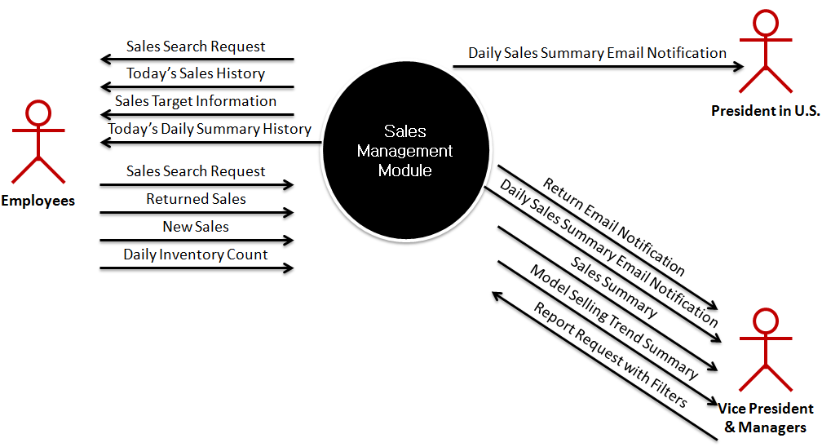

Employee Account Management Module
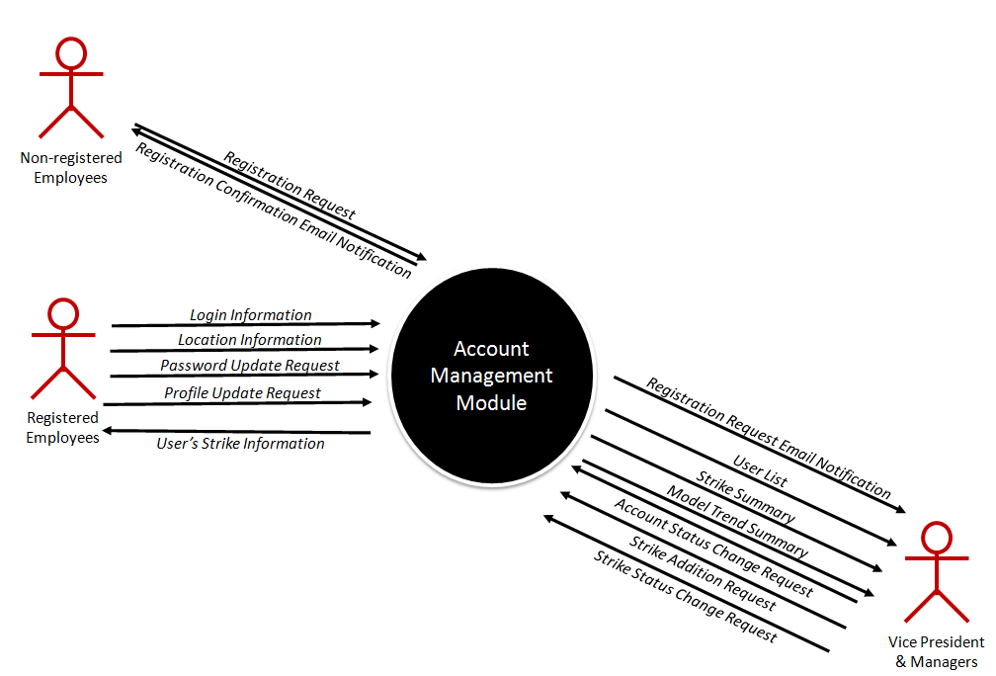
Customer Relation Management Module
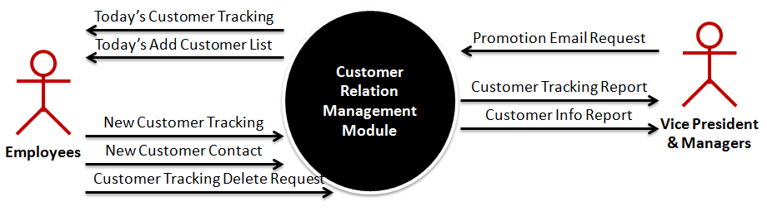

Membership Management Module
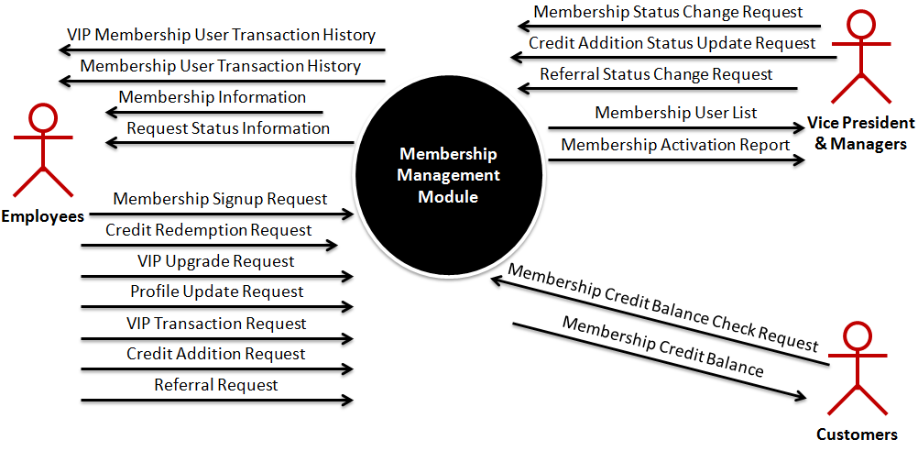

Operations Module
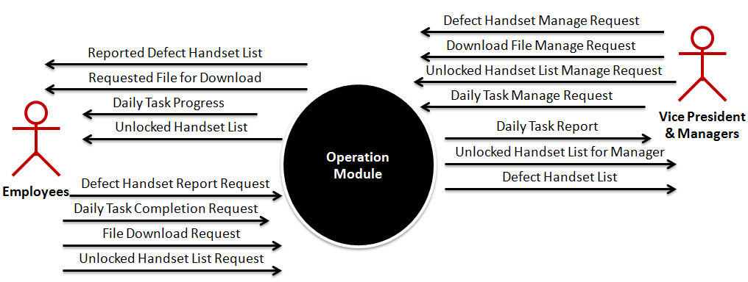

The Business Problem

The Business

World Comm.-CT Koodo Mobile Authorized Dealer
World Comm. –CT is a Koodo Mobile authorized dealer based out of Toronto.
The company is a fast growing competitor in the wireless mobile industry that deals with a wide range of products, accessories and services. They sell a wide variety of wireless plans from Koodo mobile and also provide an array of handsets that a customer can buy as part of a wireless package. Their basic business is similar to that of any other wireless company’s authorized dealership such as Telus, Wind etc. The company offers memberships to customers who wish to register. They currently have 4 stores in the GTA: North York, Scarborough, Toronto and Toronto York.

Areas of business being addressed:
In this project our team will deal with important back-end processes for the company:
Employee accounts management: profile access and management, ‘strike’ management, account status management; Sales management: Sales history and daily sales management including adding sales and customer information, reports generation, receipt code generation, setting and managing sales targets and generating sales comparisons; membership management: adding and managing memberships, communicating policy, membership status management, credits and referrals management, activation reports generation; handsets management; customer tracking and customer relations management; daily operations management: assignment of daily tasks and targets, reviewing database changes, file management, reviewing handsets status; search features; email notification features.

Problem Statement
Issue:
World Comm. –CT Koodo Mobile’s current sales management system is based on Google docs. The access to these documents cannot be controlled, and updates or changes can be made by any employee at any time. Employees have full access to old sales reports and can modify information. Google docs is a slow and inconvenient way to track changes and go through all the entries. It is cumbersome to get daily sales summary and employees need to go through all the uploaded sales reports manually and count them by each type. The information is then sent to the managers using email.

In the current system, there are several inconsistencies found in the entries made by employees. Each employee has a different way of making an entry when processing the return. Due to the complication of the return process employees often make mistakes, but Google doc has no features to provide any guidelines for making an entry.

There is also no system to track “membership” transactions. Currently, membership information and member transactions are entered manually. Employees have to search memberships using Google Doc’s “search” function which is inconvenient and time consuming if there are multiple transactions. There is no check in place currently to prevent duplicate memberships and the system is dependent on the employee for making sure that a similar entry has not already been made.

Since the president of the company is not in Canada, most of the communication has to be done online. However, since all daily operations records are maintained on paper it takes time to convert all the information to an online format. Formats such as customer visit tracking, daily, weekly and monthly tasks completions are maintained on paper and have to be manually transferred to an online form once per week or month. Records regarding handsets have to maintained and transferred in the same way.

Receipts are currently distributed through email. Since all employees do not check their email regularly, some stores end up using out-dated receipts. This often leads to operational issues. Also it’s often difficult to control the version of the company program because employees keep the old version of the receipt in their personal mail.

Vision:
The vision is to create an automated system that can be accessed for anywhere, keeping in mind that the president of the company is based outside Canada. The system should enable creation and maintenance of all records pertaining to sales, employee data, memberships, customer relations, and daily operations through the system itself and thus eliminate the need of paper records and usage of Google docs. The system should be able to send email notifications and alerts to managers and employees and should make communication with the president much easier. The system should help managers set targets and manage sales. The new system should streamline handsets management by making all handset information easily available to users and allowing managers to provide necessary details and statuses. Adding and managing memberships should be facilitated by the proposed system and it should also allow managers to update status, manager member accounts, credits and referrals. Managers should be able to send promotional emails to member through the system. A strong search function would help make operations efficient and allow users to search for membership IDs, phone numbers, SIM numbers and IMEI numbers. The system should play a key role in streamlining daily operations and reporting defective handsets.

Stakeholders

Stakeholder | Role | Power  (L/M/H) | Interest  (L/M/H) | Opposition  (L/M/H/none)
Kun Sung Kim (President) | Authority, Sponsor, End user | H | H | None
Kih Min Kang (Vice President) | Authority, Sponsor, End user | H | H | None
Yina Sin(Regional Manager) | Business Domain Expert & End User | M | H | None
Avery Ava(Store Manager) | Business Domain Expert & End User | L | M | None
Koodo Mobile | Business Domain Expert & Technical | L | L | None
Store front employees | Business Domain Expert & End User | L | M | None
Jung Geon Choi(Systems Administrator) | Business Domain Expert & Technical | M | H | None
Jung Geon Choi, Ravideep Dhupia, Max Fainshtein, Michael Fainshtein (IT Project Team) | Technical & Developer | L | H | None

Business Rules

Description
All Koodo Mobile product sales follows “Koodo Mobile’s Service Terms” (https://secure.koodomobile.com/koodopartners/termsAndConditions.jsp)
It effects return dates calculation, possible return types, DOA handlings
The VIP membership privileges will last for one year and then expire unless renewed.
Only one membership card can be used for one transaction
World Comm.-CT’s membership and its membership credit is not transferrable
A membership card must be presented to invoke membership privileges
Membership services can only be used at the locations specified on the membership card

Membership credit does not have any monetary value
Membership credit cannot be used for handset purchases or Koodo Mobile service payments
Friend referral credit will be applied 8 weeks after the referral request
All products and services purchased with membership credit are final sale
Credit received for Koodo activation must be fully paid if a customer returns or cancels either of their handset or service the awarded credit is void
Membership credit purchases cannot be combined with any other store promotion. All transactions will be record in an instance of a disagreement/dispute over membership credit balances
A customer has 15 days after the start of the service period to cancel the service, 30 days if the customer has a disability
The customer keeps any bonus gifts after being a Koodo customer for 90 days
If a customer returns a phone or ends the service before the 90 day period, the customer must pay Koodo back the value of the gift
The customer to redeem or add credits must provide membership number.
The Membership number must consist of 6 digits. first digit of the Membership number is set by the type of the card:
a) '9' for a VIP card
b) '1' for a regular card
The following 5 digits of the membership number are the same as the last 5 digits from the membership card number

System Use Case Diagrams

Sales Management Module
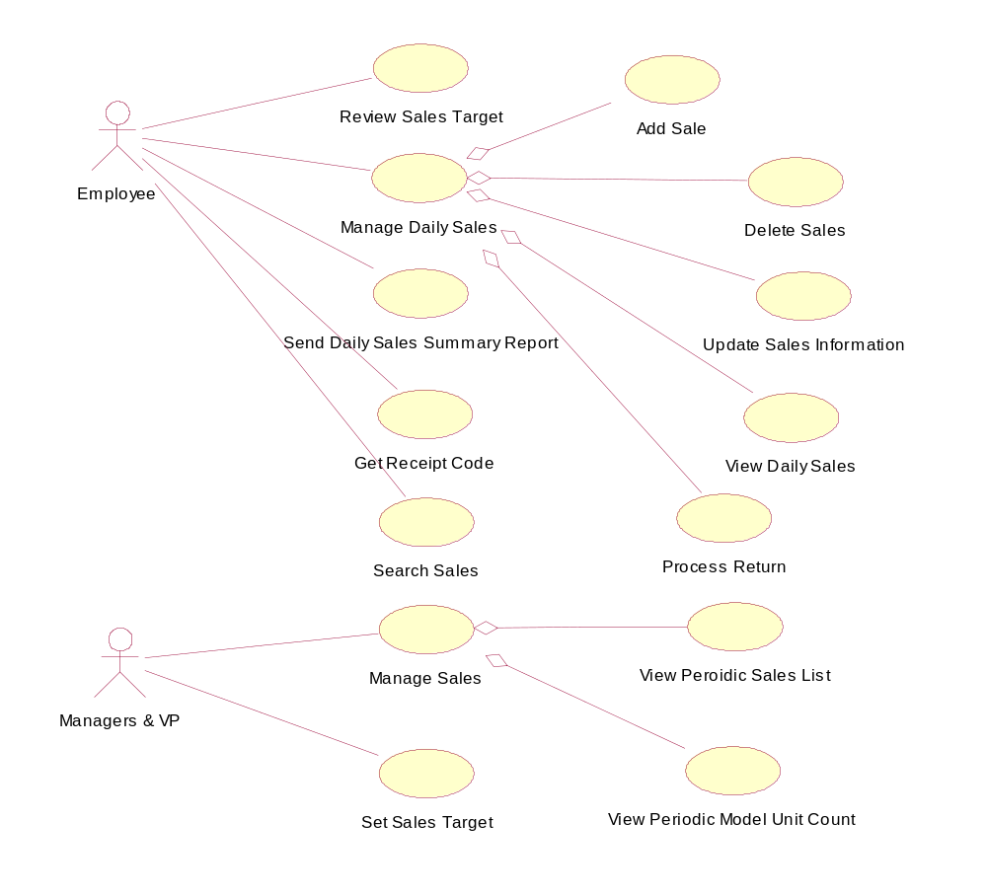

Employee Account Management Module
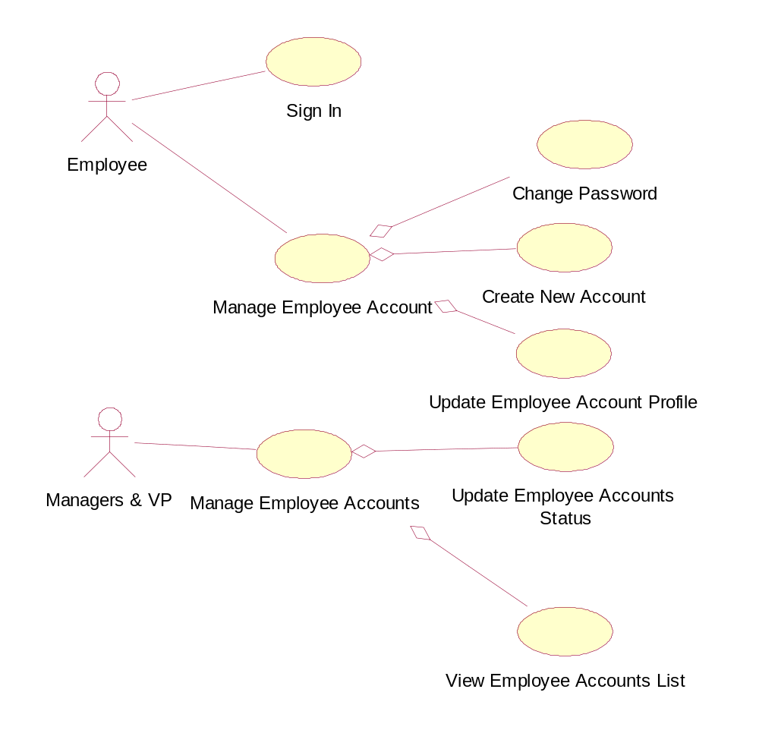

Customer Relation Management Module
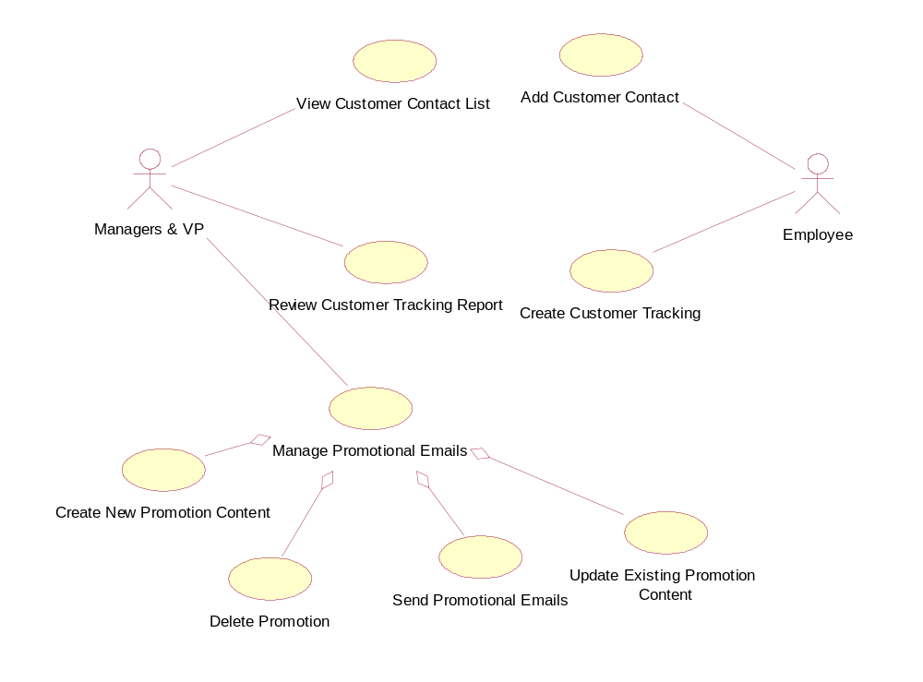

Membership Management Module
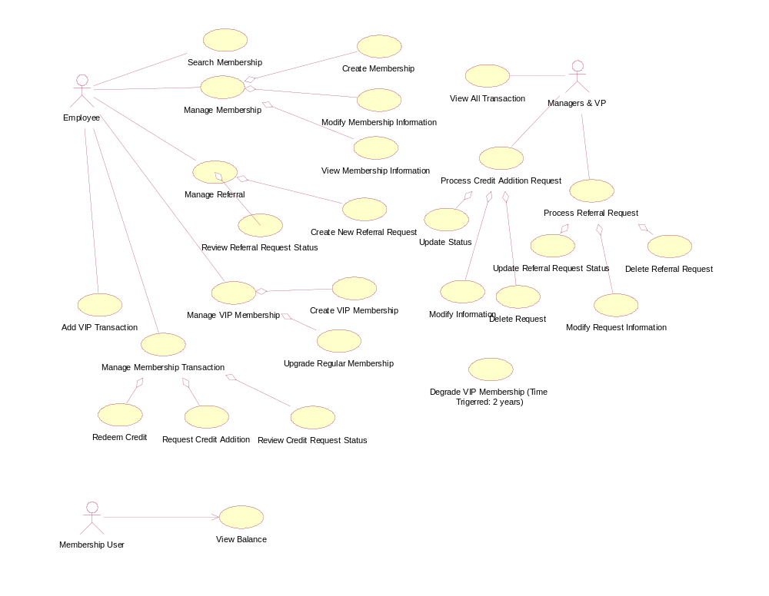

Operations Module
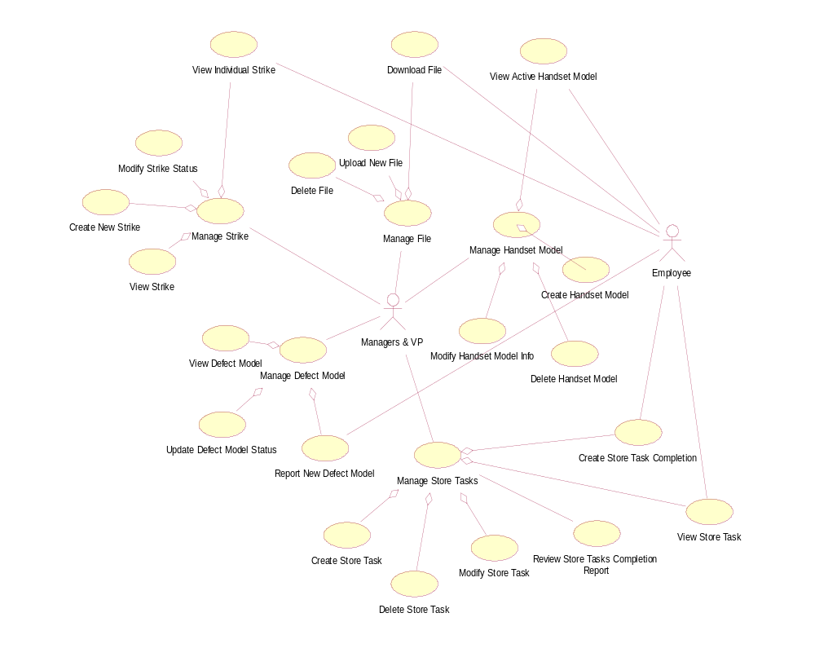

Use Case Specifications

Use Case Name: Process Return
Update the return status of the daily sales entry and add comment for the product return.

Author: Jung Geon Choi

Actor(s): Employee

Use Case Preconditions
- Employee is authenticated
- The handset is in returnable condition
- The customer has provided proof of purchase

Use Case Successful Post Conditions
- The sales entry’s status is updated and saved on the system
- Receipt code for return receipt is generated
- Return notification emails are sent to managers

Applicable Business Rules
- Handset must be returned within 15 days from the original purchase date
- Handset must be returned at the original location of purchase
- Customer need to provide the proof of purchase to return the product

Main Flow:

Additional Precondition (if any; if not then just N/A):
 | Actor: Employee
1 | Employee searches the return product’s phone number from the proof of purchase.
2 | System displays the matched sales entries
3 | Employee starts return procedure with the found sales entry.
4 | System displays input fields for return type and comment with original sales information for the confirmation.
5 | Employee selects return type and adds comment.
6 | Employee submits the update request.
7 | System saves the sales entry’s status, sends notification emails.
8 | System displays the sales entry details with updated information.
9 | Employee requests a receipt code
10 | System generates the receipt code
11 | Employee prints the receipt with the code generates and closes the entry details.

Alternate Flows

 | Alternate Flow
1A | System cannot find the result.  - System displays “No Result Found” message  - Employee searches with IMEI or SIM number from the proof of purchase
1B | System displays wrong sales entries.  - Employee searches with IEMI or SIM number from the proof of purchase.
3A | Return function is disabled for the sales entry due to purchase date being passed more than 15 days or location is not matched  - Employee aborts the return process  - Employee informs the customer
8A | System fails to generate the receipt code that employee requires.  - Employee manually edit the receipt
1-6A | Customer requests to cancel the return process  - Employee aborts the return process

Use Case Name: Add Sale
Add and record a new sale to the system.

Author: Ravideep Dhupia

Actor(s): Employee

Use Case Preconditions
- Employee is authenticated and logged into the system
- Customer has made the purchase which needs to be added to the daily sales

Use Case Successful Post Conditions
- The sales entry is added to daily sales and recorded on the system
- View daily sales page opens which reflects the new addition
- Daily sales count and sales summary are updated

Applicable Business Rules
- Membership credit cannot be used for handset purchases or Koodo Mobile service payments
- Sale must be added on the day of the transaction

Main Flow:

 | Actor: Employee
1 | Employee starts sales module
2 | Employee requests to add a new sale
3 | Employee enters customer identification information
4 | System records the customer identification details
5 | Employee enters required sales information
6 | System saves the sales information and updates the daily sales summary. System also generates a receipt code for the sale and updates the daily sales count.
7 | Employee enters optional customer information if provided and comments (if any) about the sale.
8 | System saves the customer information
9 | System displays the updated sales summary for the day.
9 | Employee repeats steps 1-8 until all transactions have been recorded.
10 | Employee prints the receipts with the codes generated and updates the POS system.

Alternate Flows
 | Alternate Flow
5A | Phone number entered is invalid  1. System requests for a valid phone number  - 2. Employee re-enters a 10 digit phone number
5B | IMEI number entered is invalid  1. System requests for a valid IMEI number  - 2. Employee re-enters a 15 digit IMEI number
5C | SIM number entered is invalid  1. System requests for a valid SIM number  2. Employee re-enters a 19 digit SIM number
5D | Tab amount is more than $504  1. System requests for a tab amount under $504 to be entered  2. Employee checks the customer’s tab amount and ensures that it is under $504 before the transaction can be made
5E | Plan is for more than $100  1. System requests for a plan under $100 to be entered  2. Employee checks the customer’s plan and ensures that it is under $100 before the transaction can be made
7A | Email address entered is invalid  1. System requests for a valid email address  2. Employee confirms the customers email and re-enters a valid address
A1 | Employee decides to cancel the process at any time  1. Employee can return to the previous page.  2. Unless Employee selects “Create New sale”, no information is saved by the system

Use Case Name: Request Membership Referral
Create a referral request for a new account

Author: Michael Fainshtein, Max Fainshtein

Actor(s): Employee

Use Case Preconditions
- Employee is authenticated and logged into the system
- Existing membership customer referred new Koodo Mobile post-paid service customer
- New customer’s daily sale entry is updated, and registered for the membership service

Use Case Successful Post Conditions
- System directs to individual membership view page that shows request(s) list
- The referral request is saved to the database

Applicable Business Rules
- The account that is being referred must be older than the referring account
- An account cannot refer itself
- An account can’t refer a single account multiple times
- Referral takes 8 weeks for approval
- Referred customer’s Koodo account must be active for the request to be approved

Main Flow:

Actor Action |  | System Responsibility
1. | The Employee starts the Membership module | 2. | The system shows possible actions that can be taken in the Membership module
3. | The Employee requests to create a new membership referral | 4. | The system directs the Employee to the Request Membership Referral page.
5. | The employee enters the referring member’s Id and the referred account’s Id, phone Number, and Account Number | 6. | The system checks and readies the referring data for submission
7. | The employee confirms the data entered for the referral | 8. | The system creates a referral using the data and saves it to the database

Alternate Flows
 | Alternate Flow
5A
  1. | The Employee entered an invalid referred membership number | 2. | The System requests for a valid membership number
  3. | The Employee re-enters a 6 digit membership number
5B
  1. | The Employee entered an invalid referring membership number | 2. | The System requests for a valid membership number
  3. | The Employee re-enters a 6 digit membership number
5C
  1. | The Employee entered an invalid Phone number | 2. | The System requests for a valid phone number
  3. | The Employee re-enters a 10 digit phone number
5D
  1. | The Employee entered an invalid account number | 2. | The system requests a valid account number
  3. | The employee re-enters an account number comprised of digits
5E
  1. | The Employee entered a referred membership that matches the referring membership number | 2. | The system requests that either the referred or referring membership number is altered
  3. | The employee re-enters the membership numbers to be different from each other
5F
  1. | The Employee entered a referred account that is newer than the referring account | 2. | The system requests for a different referral set
  3. | The employee re-enters the membership details so that the newest account is the referring account
5G
  1. | The Employee entered a referred account number that was already referred by the referring account | 2. | The system requests for a different referral set
  3. | The employee re-enters a unique referral set

Use Case Name: Check Daily Sales
To check the sales for the day

Author: Ravideep Dhupia

Actor(s): Employee

Use Case Preconditions
- Employee is authenticated and logged into the system.
- Employee is on the home page of the system.

Use Case Successful Post Conditions
- All sales transactions made for the day are displayed by the system.

Applicable Business Rules
- Only the current day’s sales transactions should be visible to the employee.
- Each sales transaction must have a unique identifier

Main Flow:

Actor Action |  | System Responsibility
1. | The Employee starts the Sales module | 2. | The system displays links of possible actions that can be taken in the Sales module
3. | The Employee requests to view sales | 4. | The system retrieves all the transactions for the current business day
 |  | 5. | System displays the view daily sales page which enlists all the transactions for the current business day

Alternate Flows
 | Alternate Flow
A1 | Employee wishes to cancel process at any time
  1. | Employee requests to go back to the previous page | 2. | System displays the home page.

Use Case Name: Search for a particular member
Search for a registered membership

Author: Ravideep Dhupia

Actor(s): Employee

Use Case Preconditions
- Employee is authenticated and logged into the system
- The member has been registered on the system before

Use Case Successful Post Conditions
- System displays the membership info associated with the search parameter
- System displays the customer information and transaction history of the member

Applicable Business Rules
- The member must have a 6 digit membership number with the first digit either ‘1’ or ‘9’ depending on the type of membership card.
- The member must have a valid phone number, an IMEI number and a SIM number associated with the membership.

Main Flow:

Actor Action |  | System Responsibility
1. | Employee accesses the search bar and requests to search for a valid membership number or a phone number or an IMEI number or a SIM number associated with the membership. | 2. | The system searches for the associated membership.
 |  | 3. | System displays the member’s information and transaction history.

Alternate Flows
 | Alternate Flow
1A
  1. | The Employee entered an invalid membership number | 2. | The System requests for a valid membership number
  3. | The Employee re-enters a 6 digit membership number and searches again
1B
  1. | The Employee entered an invalid Phone number | 2. | The System requests for a valid phone number
  3. | The Employee re-enters a 10 digit phone number and searches again
1C
  1. | The Employee entered an invalid IMEI number | 2. | The system requests a valid IMEI number
  3. | The employee re-enters a 15 digit IMEI number and searches again
1D
  1. | The Employee entered an invalid SIM number | 2. | The system requests a valid SIM number
  3. | The employee re-enters a 19 digit SIM number and searches again
1E
  1. | The Employee entered the member’s name for search | 2. | The system requests for any of the acceptable ID types
  3. | The employee searches again using an acceptable ID type
2A
  1. | Employee searches for a membership ID that has not been issued to a member yet | 2. | System displays register new member form for the available ID
  3. | If new member has to be registered: Employee completes registration  If wrong ID was searched: Employee searches again
2B
   |  | 1. | No Member found
  3. | Employee searches again with a different ID number. | 2. | System displays no results found

Use Case Name: View Customer Contact List
View Customer’s Contact list

Author: Michael & Max Fainshtein

Actor(s): Manager/Vice president

Use Case Preconditions
- User is authenticated and logged into the system

Use Case Successful Post Conditions
- System displays a list of the customer’s contacts

Applicable Business Rules
- Customer being searched must have agreed to sharing contact details
- Customer has made at least one complete purchase

Main Flow:

Actor Action |  | System Responsibility
1. | The User starts the Customer Relation Module | 2. | The system shows possible actions that can be taken in the Customer Relation Management Module
3. | The User requests to view a customer’s contacts list | 4. | The system directs the User to a page with a search bar with radio buttons for whether the User entering a name, a phone number, IMEI number, or a SIM number.
5. | The User enters either a name, a phone number, an IMEI number, or a SIM number into the search bar, and then selects radio button for the corresponding radio button, and submits. | 6. | The system shows a customer with a matching name, a phone number, an IMEI number, or a SIM number

Alternate Flows
 | Alternate Flow
5A
  1. | The User entered a name that is not a match | 2. |  | The System requests to re-enter name or to select another option in the radio button array
  3. | The User re-enters customer’s name, or the User selects another option in the radio array, and either keeps the current name or changes the name to match the requirements of the selected option and then submits
5B
  1. | The User entered a number that is not a valid phone number while phone number is selected in the radio button array | 2. | The System requests for a valid phone number or to select another option in the radio button array
  3. | The User re-enters a 10 digit phone number and searches again, or the User selects another option in the radio array, and either keeps the current number or changes the number to matching the match the requirements of the selected option and then submits
5C
  1. | The User entered a number that is not a valid IMEI number while IMEI is selected in the radio button array | 2. | The system requests a valid IMEI number or to select another option in the radio button array
  3. | The User re-enters a 15 digit IMEI number and searches again, or the User selects another option in the radio array, and either keeps the current number or changes the number to matching the match the requirements of the selected option and then submits
5D
  1. | The User entered a number that is not a valid SIM number while IMEI is selected in the radio button array | 2. | The system requests a valid SIM number or to select another option in the radio button array
  3. | The User re-enters a 19 digit SIM number and searches again, or the User selects another option in the radio array, and either keeps the current number or changes the number to matching the match the requirements of the selected option and then submits
5E
  1. | The User enters a valid search parameters that have no match | 2. | System displays no results found
  3. | User searches again using different search parameters.

Use Case Name: Change the status of an employee account
Update the status of an employee account

Author: Jung Geon Choi

Actor: Manager

Use Case Preconditions
- User is authenticated
- User is authorized as “Manager”
- Employee account that need to be update is registered on CRM

Use Case Successful Post Conditions
- Status of selected employee account is successfully updated
- Notification email is sent to the account owner

Applicable Business Rules
- CRM account must be matched with Cello (POS System) account name
- Only currently working employees can access CRM

Main Flow:

 | Actor: Manager |  | System
1 | Starts employee management | 2 | Displays types of management for user to select:  - View  - Status Update  - Strike Management
3 | Selects status update | 4 | Displays all registered non-manager users with Id, full name, and current status
5 | Selects a user | 6 | Displays detailed information about selected user
7 | Select new status (active/inactive) and submit the update request | 8 | Saves changed information on the database and displays the updated detailed user information

Alternate Flows
 | Alternate Flow | System
1-3A | Manager wants to cancel the process:  - Manager abort the process | - System displays new page as requested
2A | Cannot find the user due to mismatching information  - Manager informs employee to update employee’s user account information.  - Once account information is corrected, continue from main flow step 2.
2B | Cannot find the user due to account not existing:  - Manager informs employee to register user account on CRM  - Once account is registered, continue from main flow step 2.
3A | Manager selects wrong user by mistake:  - Manager requests “go back” | - System displays the list of employee
1A | Manager select wrong management option by mistake:  - Manager requests “go back” | - System displays the management options

Non-Functional requirements

In the table below you are asked to specify the type of non-functional requirement you have identified and then describe what the requirement is and how you plan to satisfy it.

 | Requirement Type | Description and Implementation Plan
1. | Look and feel | Professional and clean layout, should be easy to use.  Navigation with minimum clicks, all sections easily reachable from home section.  Simple and approachable.  Minimal use of image files.
2. | Usability and Humanity | Usable by staff employees, middle and higher management.  Will be used by employees with average knowledge and experience of web browsing.
3. | Performance | Has to handle 20-30 concurrent users with no degradation in performance. System should support users for 4 different outlet locations and support system access from outside Canada at the same time  Should be available to users at least 99% of the business hours.  Each webpage should respond within 1 second after click.
4. | Operational | System should support access from Google Chrome on Windows 7, 8, 8.1, 10, Android, and iOS.
5. | Maintainability and Support | The application should be responsive to support access from PC with row resolutions of minimum 1024*768 and mobile devices.
6. | Security | Access: Only registered user with “active” account status can have access daily sales information and their own account information.  Only manager accounts can have access entire sales, customers, membership user information.  Privacy: All customers, sales, membership information must be encrypted when stored in the database. Customer information cannot be printed; customer information is not released to others (e.g. suppliers). PIPEDA standards followed.  Integrity: All sales information is accurate and up-to-date. Membership credit transactions are accurate.  Audit: All sales and membership transaction information logged and stored.
7. | Cultural and Political | The site should be politically neutral and not offensive to any group
8. | Legal | Must adhere to all Canadian business legislations

