# Compare and Contrast Two Cities (Manhattan, NY, and Downtown Toronto)

# To Assist Foreign Travelers

# Christopher Santiago

# 5/16/21

PROBLEM & BACKGROUND

Downtown Toronto Canada and Manhattan New York USA are considered two major tourist spots with lots of multicultural venues. Both are considered financial hubs and with many restaurants, coffee shops, theaters, and other attractions such as CN Tower in Toronto. It will be interesting to compare the different venues such as restaurants, hotel accommodations, tourist attractions such as Broadway shows and many other Tourist spots.

Number of Tourists from various parts of the world (Australia, Europe, Asia) when they visit different cities in different countries, they wanted to see different attractions, different food and so forth. They would not like to spend time and money on two different cities for similar experience. Hence, a comparison of Downtown Toronto and Manhattan New York will be valuable for tourist who are travelling from far away so that they can enjoy best of both and feel happy that their time and money are spent wisely.

# DATA DESCRIPTION

# We have explored Manhattan venues in Week3 module hands on lab using Foursquare API. In addition, through the peer graded assignment for Week3, we analyzed Downtown Toronto using Foursquare API as well. Hence, we have obtained Data frames for both Downtown Toronto and Manhattan New York. From the Jupyter notebook for Toronto and Manhattan. Exported these files to CSV files and named them DT_Toronto.csv and Manhattan_NY.csv.

# METHODOLOGY

# Using the CSV files mentioned in the Data description: DT_Toronto.csv and Manhattan_NY.csv which has the names of the neighborhood (Borough) and location information (latitude and longitude) and used the geolocator library and Folium map to display the neighborhood of Manhattan and Downton Toronto. This is to analyze the number of Boroughs and how far are they to each other.

### Using the function getNearbyVenues and foursquare API to explore the locations of Boroughs and Venues within 1000 meters radius from the location of Manhattan and Downtown Toronto. First, the venues for Manhattan were explored. Using groupby, count, and nlargest functions to display the first 50 venues in descending order (based on total number of venues). Similarly, explored and displayed the first 50 venues in descending order for Downtown Toronto. After that, created a Data Frame to capture the venues and the counts to compare Manhattan and Downtown Toronto. Exported the data to a csv file named: Venu_Comparison.csv. This csv file provided the necessary comparison data between Manhattan and Downton Toronto.

# RESULTS

### Map of the Boroughs for Manhattan:

### 

### Map of the Boroughs for Downtown Toronto:

### Explore the Neighborhoods in Manhattan and Downtown Toronto within 1000m radius

### 

### 

### Explore the Neighborhoods in Manhattan:

### 

### Explore the Neighborhoods in Downtown Toronto:

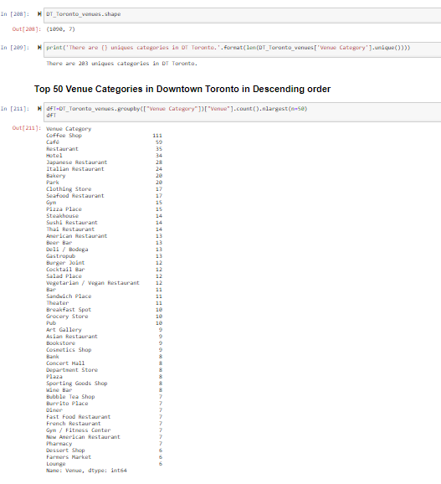

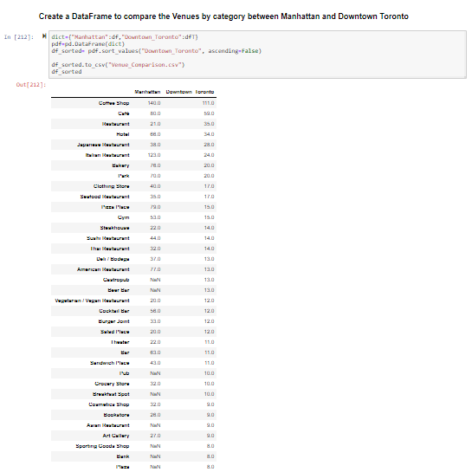**Combine Venue data for both Manhattan and Downton Toronto for comparison**

**Venue_Comparison.csv file was created:**



# KMEANS clustering (Manhattan)

# 

# KMEANS clustering (Downtown Toronto)

# 

# DISCUSSION

# From the maps for Manhattan and Downtown Toronto, number of Boroughs in Manhattan are 40 and situated close to each other whereas Downtown Toronto has only 17 Boroughs and they are spread wider than Manhattan. Although both Manhattan and Downtown Toronto have remarkably similar venues, Manhattan has much higher number of venues except for the number of Coffee shops. For example: Manhattan has 130 Italian restaurant, 109 Pizza places, 111 parks, 65 bars, 73 hotels, and 36 art galleries etc. in comparison Downtown Toronto has only 27 Italian restaurants, 25 Pizza places, 37 hotels, 11 bars, and 19 art galleries, respectively. Also, based on the exploration of venues, there are number of more venues in Manhattan, but appearing in Downtown Toronto, and it may be since the neighborhoods are far apart in Downtown. The number of venues may slightly vary based on the radius of exploration. Smaller radius will result in lower number of venues particularly for Downtown Toronto, since the neighborhoods are spread wider.

# Both places have ample number of Coffee shops. One of the key observations is that Downtown Toronto has an airport whereas Manhattan does not have an airport. It is interesting to notice within 1000 meters radius of Manhattan there are large number of Greek, Indian, Mediterranean, Spanish restaurants whereas Downtown Toronto does not have those restaurants withing 1000 meters but may have those restaurants in the suburbs such Marcom or Scarborough.

# Conclusion

# Based on the above observations, it is recommended to rent a vehicle in Downtown Toronto, since the neighborhoods and venues are more spread. In Manhattan it may be walkable. Also, Downtown Toronto seems to have less hotels. Moreover, no restaurants for Indian, Greek, Spanish etc. Hence, tourists from these countries may consider visiting Manhattan.

# One of the conveniences of Downtown Toronto is that the airport is situated in Downtown. Hence, it will be easier to stay closer to the airport and explore the area. Manhattan may be much crowded due to the large number of venues. People who wanted to shop, Manhattan is the place to be, since there are much more departmental stores.

# Although Manhattan has more Theaters, Downtown Toronto has more concert halls which may be something the music lovers need to consider.

# For families with children, there are plenty of parks in Manhattan than Downtown Toronto.

# In conclusion, both Manhattan and Downtown Toronto have similar venues and hence, tourist could pick and choose different venues in different cities instead of visiting the same venues in both places. Tourists need to book the hotels much earlier in Downtown Toronto than in Manhattan, since Downtown Toronto has only half the number of hotels compared to Manhattan.