**Software Requirements Specification**

**Document**



**Human Resource Management System**

**For**

**Zonal Education Office**

**Mulatiyana**

**Department of Computing & Information Systems**

**Faculty of Computing**

**Sabaragamuwa University of Sri Lanka**

|  |  |  |
| --- | --- | --- |
| Registration Number | Name With Initials | Email |
| 21CIS0029 | T.P.G. Ravindu Dilshan Alwis | dilshanravindu2021@gmail.com |
| 21CIS0206 | E.P. Ashan Hashendra Edirisinghe | ashanedirisingheugc@gmail.com |
| 21CIS0119 | S.W. K. Hansala | hansalawaduge@gmail.com |

**Team 03 Members**

Data Dreamers

Table of Contents

1.0 Introduction 4

1.1 Purpose 4

1.2 Stake Holders 4

1.3 Scope 4

1.4 Overview 5

Features 5

Objective 5

2.0 Identifying requirements 5

2.1 Functional Requirements 5

2.2 Non-functional Requirements 6

3.0 System Analysis 9

3.1 Sequence Diagrams 9

3.2 User Case Diagram 12

3.3 Class Diagram 13

3.4 Relationship Schema Diagram 14

3.5 Entity Relation Diagram 15

# 1.0 Introduction

## 1.1 Purpose

This project is to develop human resource management system for zonal education office. It is intended to make the manual system to automated system. This will make management of the human resource documents more convenient and user friendly. Employees can also use the system for requesting leave of absence forms and refer to their previous and future absence record details. The administrators can use the system for observing attendance and personal files of the employees. The system is intended to make those process in the office rapid and easy to manage through a dynamic graphical interface.

## 1.2 Stake Holders

* System developers
* Branch director of Mulatiyana zonal education office
* Employees of Mulatiyana zonal education office

## 1.3 Scope

* Main component of this system is to store employees’ personal files and inquire unfilled records. Those unfilled attributes will help the employees to keep aware about their future career. The administrator has the authority to create, read, delete and update the personal files. Every Employees should register through the system using their user id and password. The admin panel also have another portal to login to the system using their credentials.
* The next component is for requesting leave of absence. Employees can send their leaving form to managers. Then they can decide whether it should be accepted or not. Employees can be aware about their remaining leaves.
* Managers can view the daily attendance of the employees through their dashboard. The attendance data is receiving from the fingerprint machine that is connected to the database. Admins can filter the attendance of the employees.

## 1.4 Overview

HR management system for zonal education office Mulatiyana.

### Features

* Administrators’ registration
* Employee login
* Administrator dashboard
* Adding personal files of the employees
* Applying for leave of absence by employees
* Approving or rejecting leave of absence
* Showing daily attendance

### Objective

HR management system is to be automated and productive in the zonal education office. It will provide ease of use for employees to keep track on their personal files. Administrators will be able to monitor attendance and personal file resources.

## 2.0 Identifying requirements

### 2.1 Functional Requirements

#### Administrator Registration

Admins need to register using their user ID and password. That should be in a one table where validation can check upon sign up.

#### Employer login

Employees will be given user name and a password by the Human Resource managers. They can use it to logging to system.

#### Administrator dashboard

The daily attendance will be shown on the homepage. It can be filtered by departments or employee names. There is a function to add employees’ personal files. Another function to view and manage leave of absence forms.

On the home page daily attendance of the employees are needed to be shown. And being able to check absence employees status. Whether they are on leave or not.

#### Adding personal files to the system

On the personal file of individuals’ name, ID number, designation, date of birth, salary type, date of commencement ,date of retire, date of promotion, service location. Additional documents of the employees needed to be checked whether those are received or not in manually to the HR office.

#### Applying for leave of absence by employees

In the employees account they will be able to fill the form of leave of absence. Various types of leaving categories and other relevant data such as dates will be required to fill.

In employees account in the system they get the respond from the administrator about their leave of absence .

The remaining leaving details of the year will be shown to the employees on their account. In that method they will get a over view of their requests.

#### Approving or rejecting leave of absence

The request forms from the employees leave of absence needed to be reach to administrators’ leaving form monitoring portal. The history of leaving in a year can be access by entering employee name or ID .Then they can approve or reject the request by clicking a button .

The absences due to illness needed to be inform viva email or call to the HR office in traditional process. They will need to add those kind of absences to relevant employees buy using special form.

The absence information will also need to be collaborate with attendance component.

#### Showing daily attendance

On the administrators dash board home page daily attendance of the employees will be shown. Availability to see absence employees by their names, departments and identifying reason for absence can be seen on that dash board.

### 2.2 Non-functional Requirements

|  |  |
| --- | --- |
| **Requirements** | **Description** |
| Performance Requirements | * All searches should return results within 3-5 seconds. * It should be capable of handling registration forms more than 100. * System should be scalable to accommodate future growth. Adding new features to functional components or adding new functionals should not effect on going functions. |
| Safety Requirements | * Protection of sensitive personal information * Users should have secure login credentials with role-based access control to only access data relevant to their role. * Encrypt sensitive information during transmission and storage. * Employees can log in to the system only after administers add their personal file to the system. Not giving registration form to public interface will provide safe environment. |
| Security Requirements | * Access Control-Implement role-based access control (RBAC) to regulate user permissions. * Data Encryption-Encrypt data in transit and at rest to prevent unauthorized access. * User Authentication and input feels should go through SQL injection striping functions. * Admin log in and form will not be shown on website. that page needed to be access by entering page name manually in URL * Data Backup and Recovery-Conduct regular backups and establish disaster recovery procedures. |
| Reliability Requirements | * The system should be available during core office time with minimal downtime for maintenance * Ensure data integrity for personal records and maintaining personal information. * Plans and procedures should be in place to recover data and functionality in case of major outage or disasters |
| Maintainability Requirements | * Write down clear instructions for how the system works and how to fix any issues that come up. * Follow the same rules when writing the code so that everyone understands it easily. * Use a system to keep track of all the changes made to the code so that if something goes wrong, you can go back to an earlier version. * Use best practices to ensure quality development. |
| Usability Requirements | * The system should feature an intuitive and user-friendly interface, ensuring ease of navigation for all users, regardless of their technical proficiency. * Language is need to be English. * Users should have the ability to customize their interface settings and preferences to suit their individual needs. |
| Compatibility Requirements | * Support mainly on desktop web interface. Responsible for mobile applications      * Ensure supporting on many operating systems by using latest versions of computer languages and frameworks. * Stable connection to the website for broad user capacity. |

# 3.0 System Analysis

## 3.1 Sequence Diagrams

1. Employee Sequence Diagram

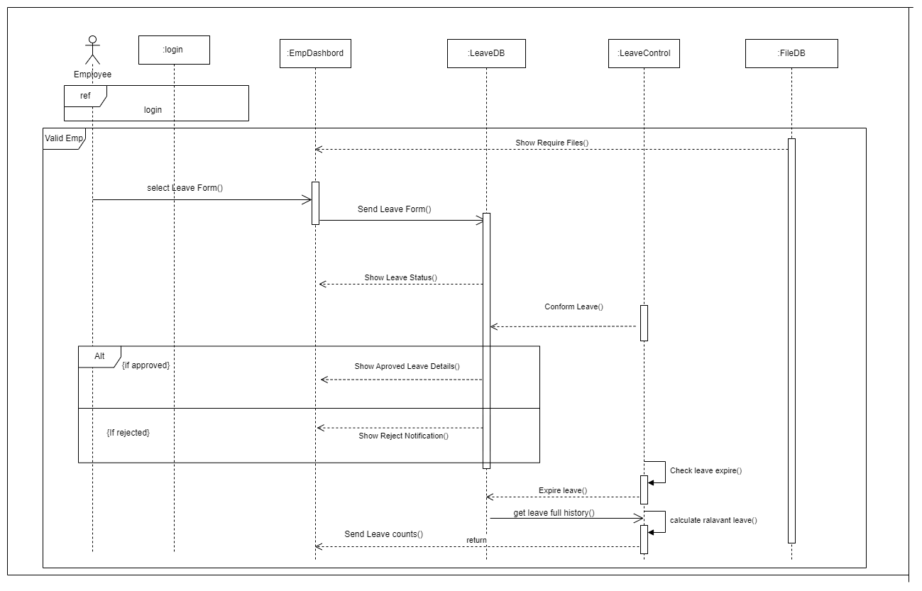

1. Admin Dashboard Sequence Diagram

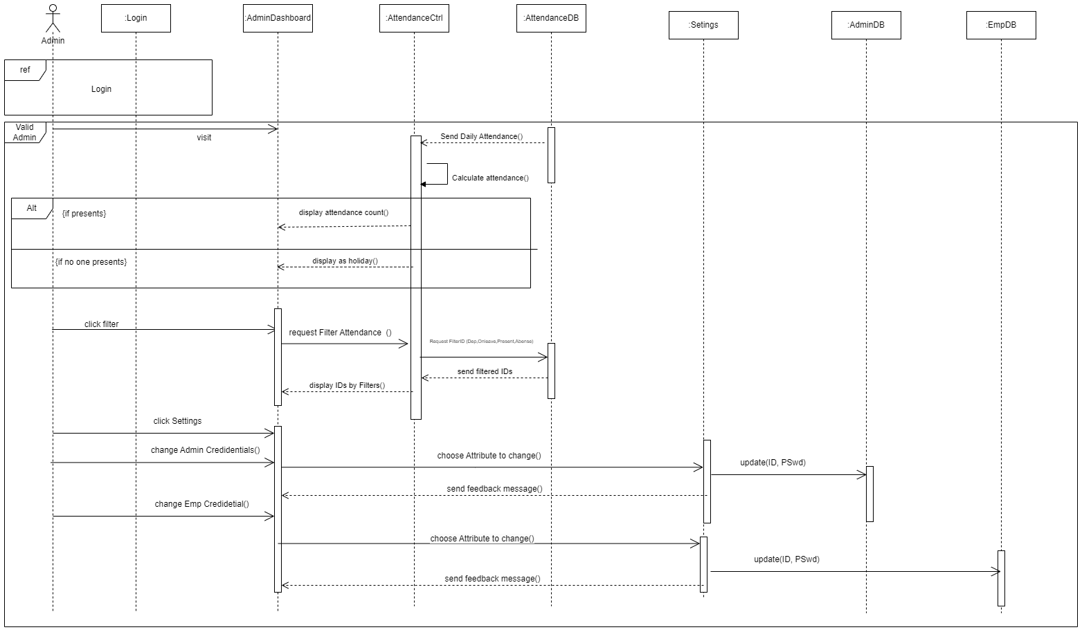

1. Admin Management Sequence Diagram

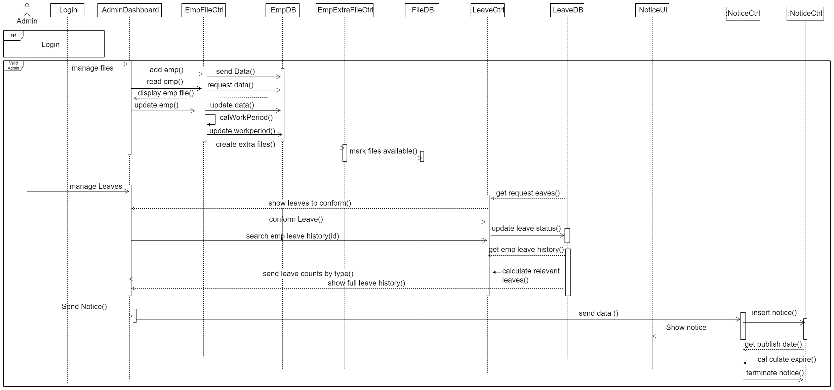

## User Case Diagram

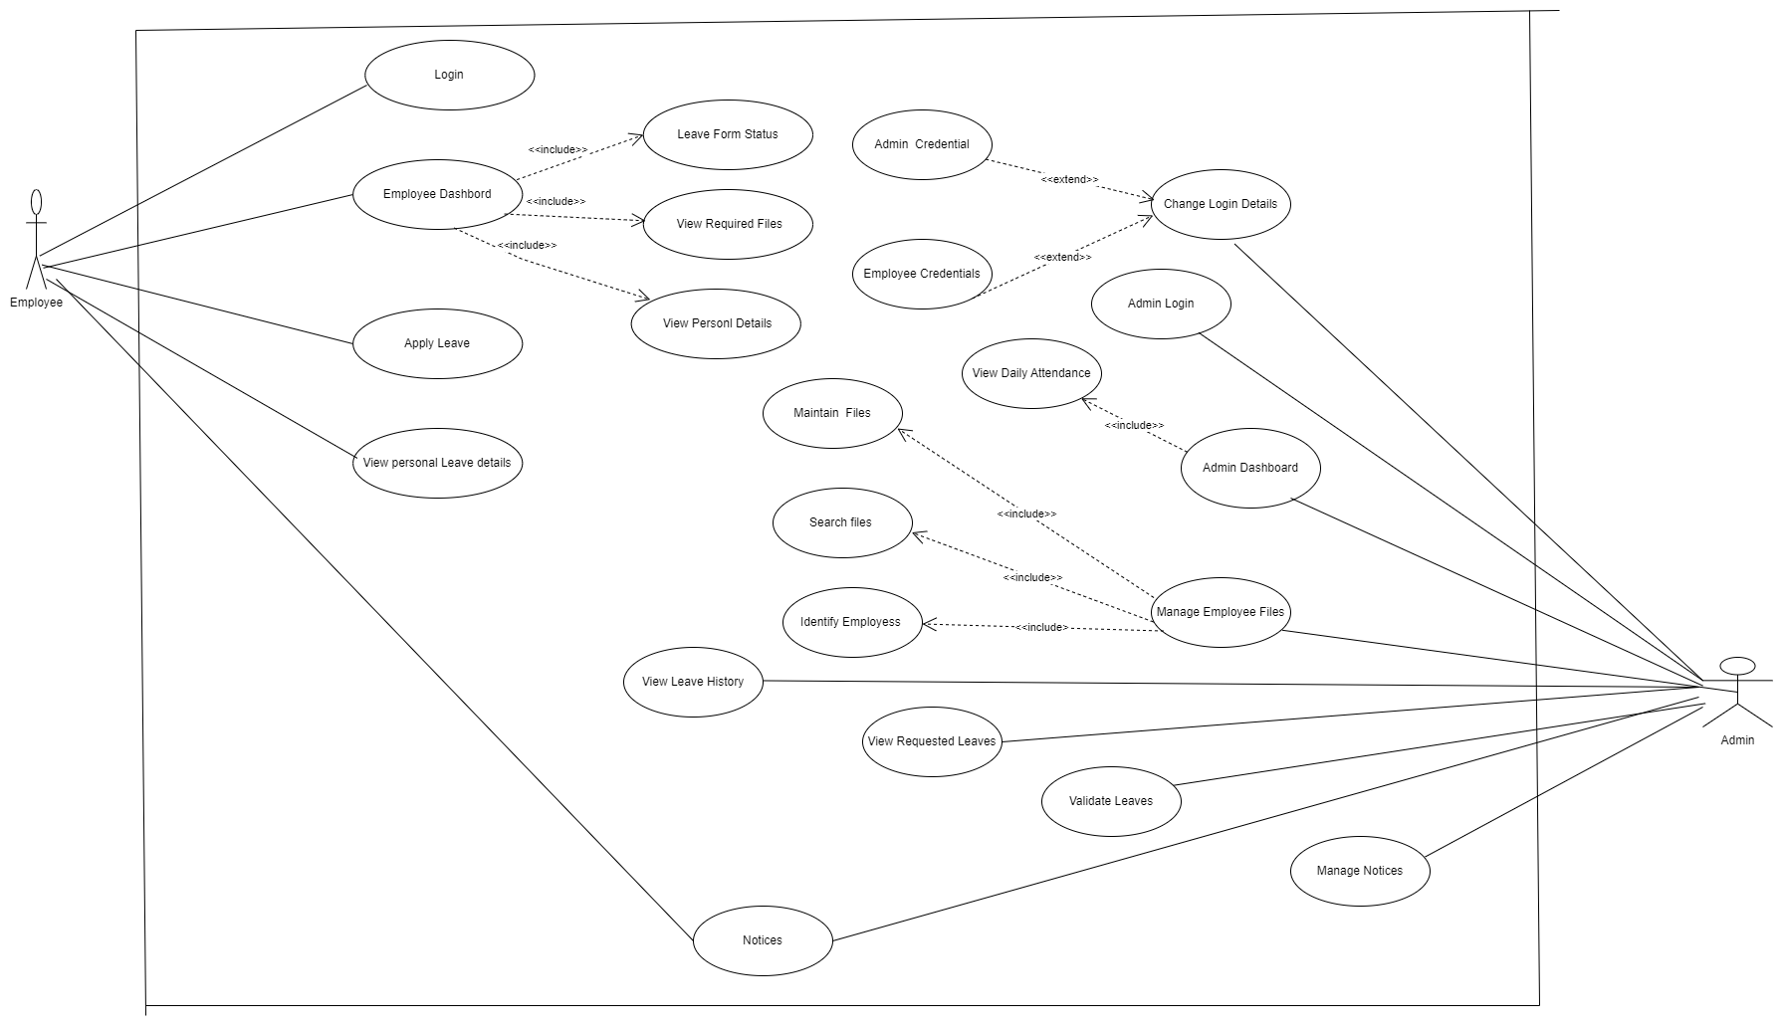

## Class Diagram

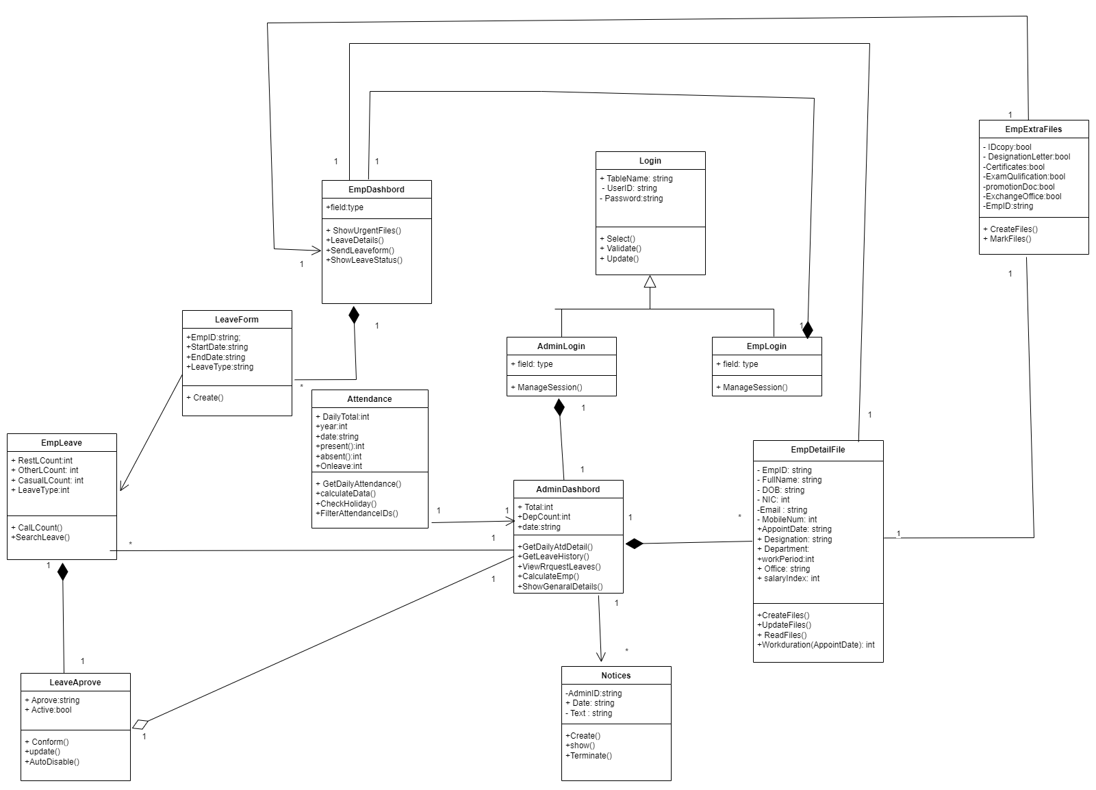

## Relationship Schema Diagram

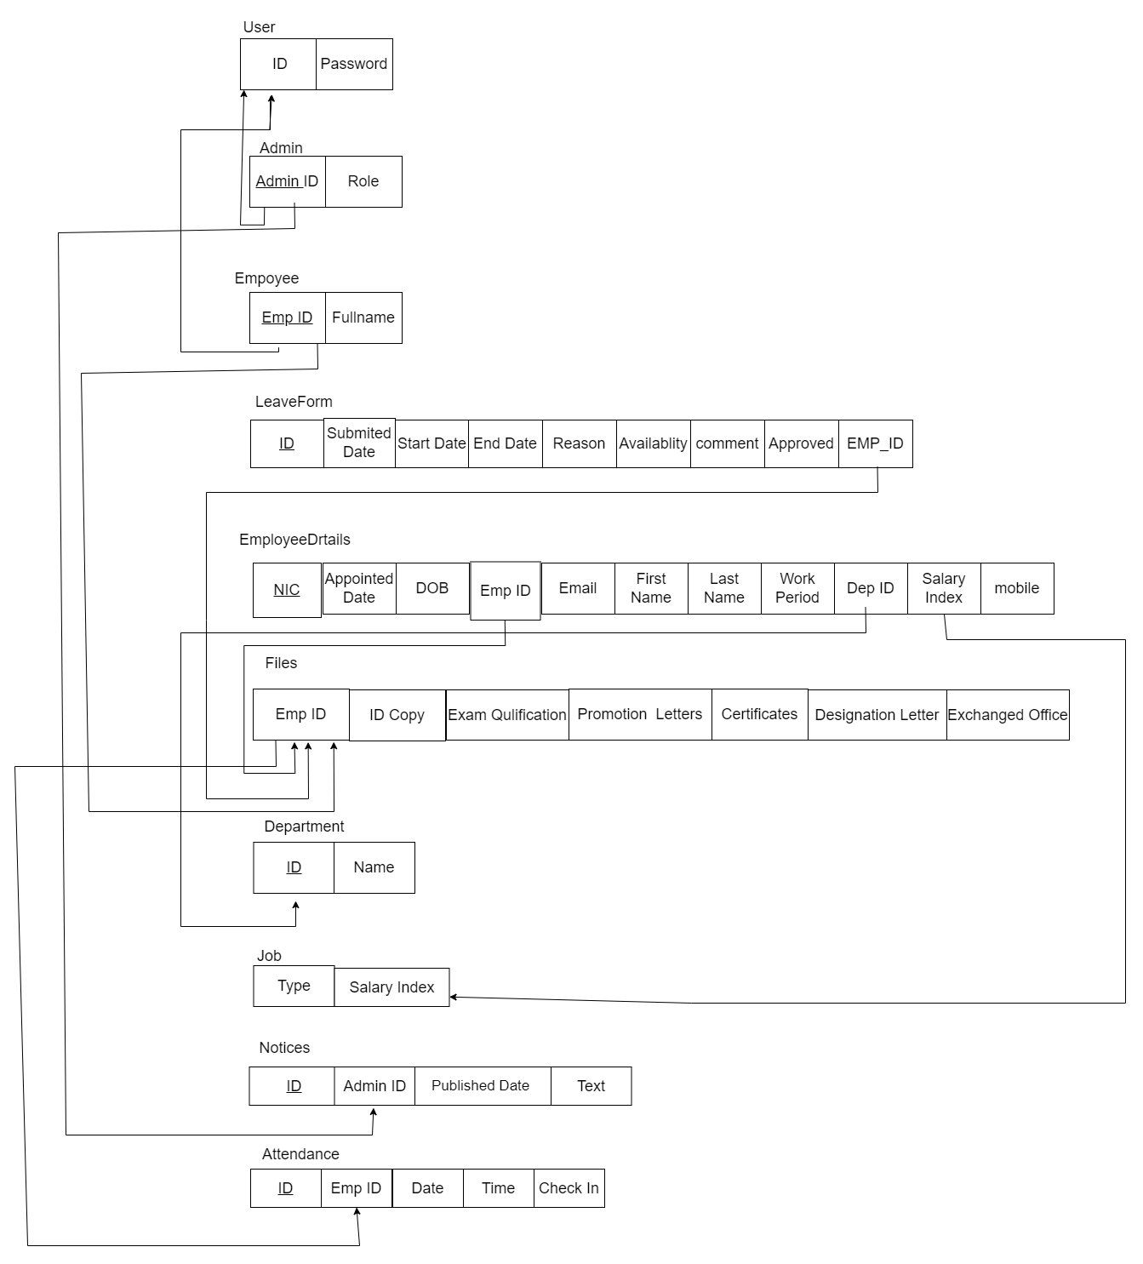

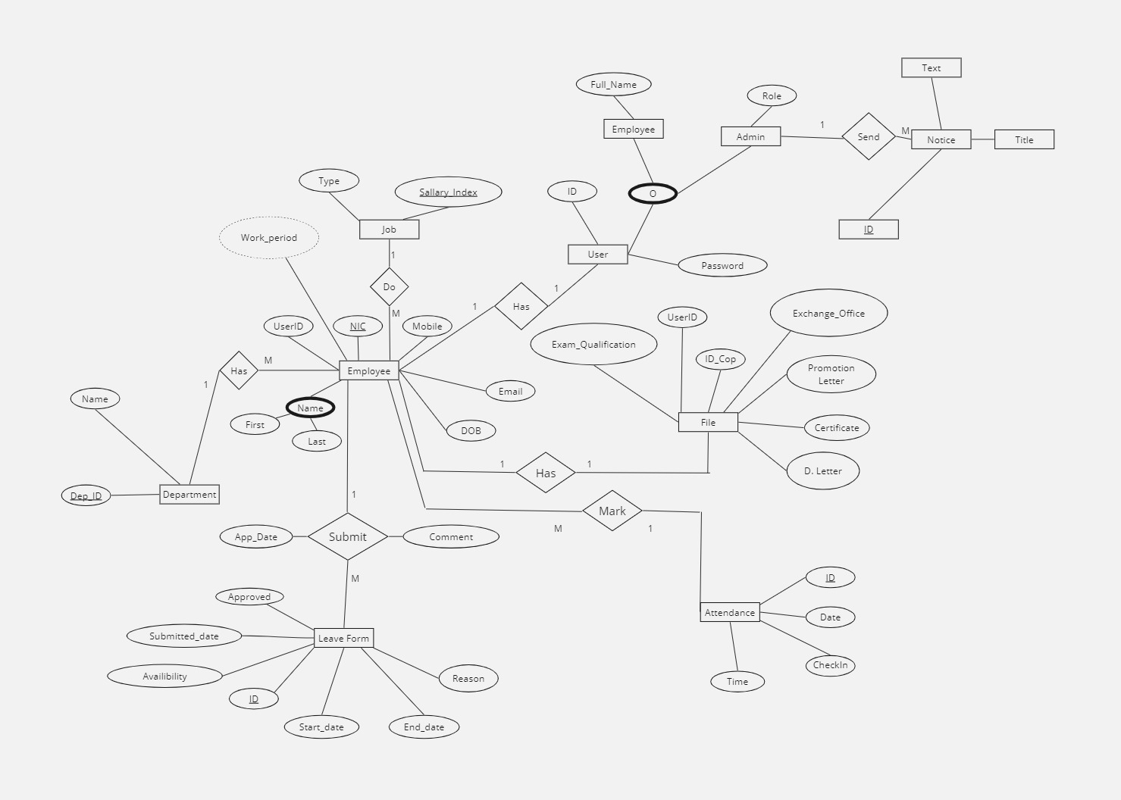

## Entity Relation Diagram

