GEMMA4 MODEL BENCHMARK REPORT
Cybersecurity & CTF Evaluation Suite

Comparative Analysis: Gemma4 Multimodal vs Gemma4 Uncensored Text-Only
Benchmark Date: May 2025 | Total Tests: 50 per model | Domain: Offensive Security

Models Evaluated | Total Questions | Question Types
2 | 50 | MCQ + Vuln Analysis

Multimodal Avg Time | Uncensored Avg Time | Multimodal Accuracy | Uncensored Accuracy
41.5 s | 82.9 s | 58.0% | 62.0%

1. Executive Summary
This report presents a comprehensive comparative benchmark of two Gemma4 model variants — Gemma4 Multimodal (gemma4:e2b) and Gemma4 Uncensored Text-Only (fredrezones55/Gemma-4-Uncensored-HauhauCS-Aggressive:e4b) — evaluated against a 50-question cybersecurity and Capture-the-Flag (CTF) test suite.
The evaluation covers two primary task categories: Multiple Choice Questions (MCQ) testing cryptographic and offensive security knowledge, and Vulnerability Analysis tasks requiring identification and exploitation reasoning across C, PHP, Python, and Flask codebases.

Key Findings
- Speed Advantage: Gemma4 Multimodal is approximately 2× faster, averaging 41.5 s vs 82.9 s per response.
- Accuracy Edge: Gemma4 Uncensored achieved slightly higher overall accuracy (62.0% vs 58.0%).
- MCQ Strength: Uncensored outperformed on MCQ tasks (80% vs 70%), showing stronger reasoning.
- Vulnerability Analysis: Both models performed similarly (55% vs 57.5%), with marginal Uncensored advantage.
- Total Benchmark Time: Multimodal completed in 2,076 s vs Uncensored at 4,147 s — a 2× total time difference.

2. Test Methodology

2.1 Benchmark Dataset
The benchmark comprised 50 curated cybersecurity questions sourced from a structured JSON dataset. Questions spanned two types:
- Multiple Choice Questions (MCQ) — 10 questions covering cryptographic attacks (RSA, XOR ciphers, Hastad, Wiener, Coppersmith), web security bypasses, and exploitation techniques.
- Vulnerability Analysis — 40 questions presenting code snippets in C, PHP, Python, Python/Flask, and SQLite, requiring identification of vulnerability type (CWE) and exploitation path.

2.2 Models Under Test
Attribute | Gemma4 Multimodal | Gemma4 Uncensored Text-Only
Model ID | gemma4:e2b | Gemma-4-Uncensored-HauhauCS-Aggressive:e4b
Modality | Multimodal (text + image) | Text-only
Variant | Standard / Official | Uncensored / Fine-tuned
Total Tests | 50 | 50

2.3 Evaluation Metrics
Response Time: Wall-clock time in seconds from query dispatch to full response received, measured per test item.
Answer Accuracy: For MCQ tasks, correct answers were matched against the ground-truth option. For Vulnerability Analysis tasks, responses were evaluated for correct identification of CWE type and exploitation mechanism.
Category Breakdown: Performance was segmented by question category (CTF/MCQ, Vuln C, Vuln PHP, Vuln Python, Vuln Flask, Vuln SQLite) to identify domain-specific strengths and weaknesses.

3. Response Time Analysis

3.1 Overall Response Time Statistics
Metric | Gemma4 Multimodal | Gemma4 Uncensored | Difference
Mean Response Time | 41.52 s | 82.94 s | Uncensored 2.0× slower
Minimum Time | 25.42 s | 57.70 s | +32.28 s (+127%)
Maximum Time | 70.57 s | 127.43 s | +56.86 s (+81%)
Total Time (50 tests) | 2,076 s | 4,147 s | +2,071 s (+100%)

3.2 Response Time per Test — Line Chart
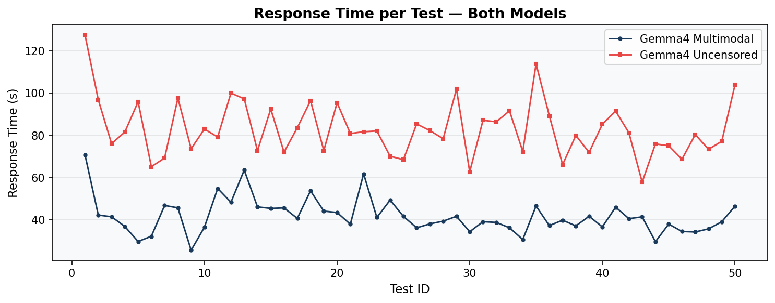
Figure 1: Per-test response time for both models across all 50 benchmark items. Gemma4 Multimodal (navy) consistently outpaces Gemma4 Uncensored (red).

3.3 Average Response Time by Category
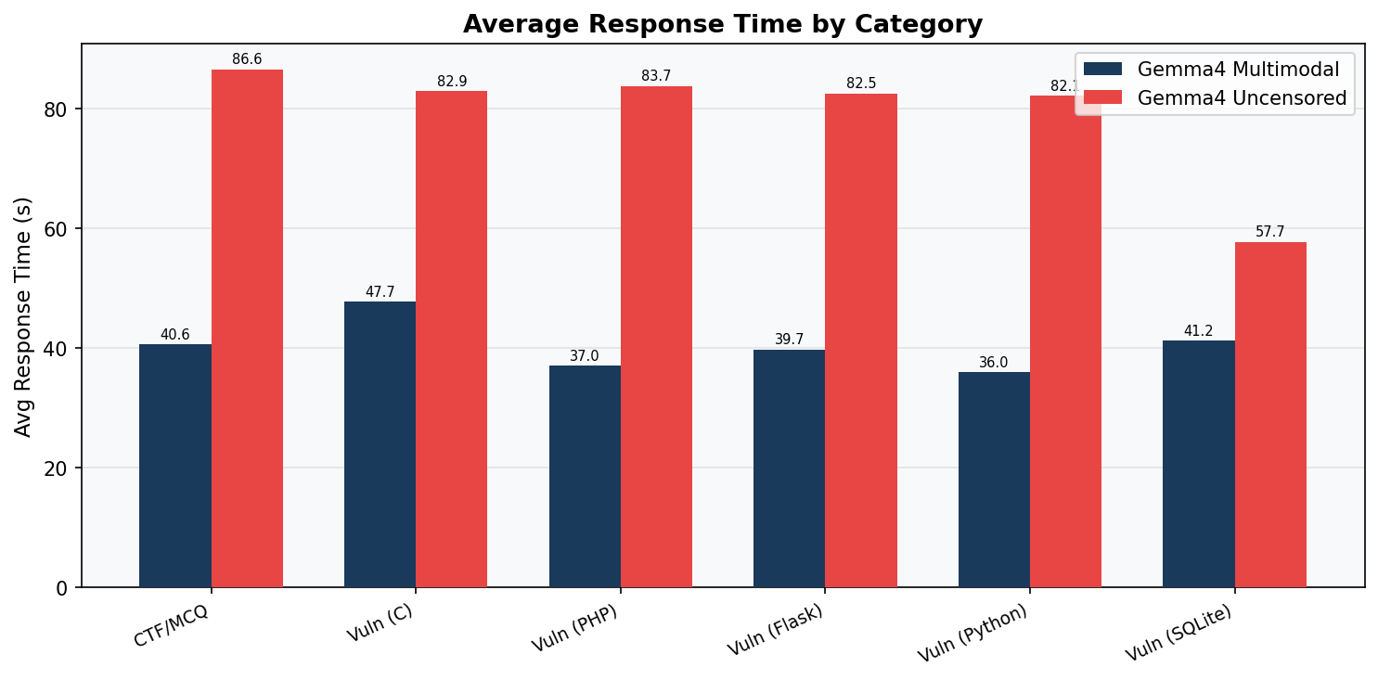
Figure 2: Average response time grouped by task category. Gemma4 Multimodal is faster across all categories. The largest absolute gap is in CTF/MCQ tasks.
Category | Multi. Avg (s) | Uncens. Avg (s) | Questions | Speedup
CTF / MCQ | 40.6 | 86.6 | 10 | 2.1×
Vuln Analysis (C) | 47.7 | 82.9 | 15 | 1.7×
Vuln Analysis (PHP) | 37.0 | 83.7 | 2 | 2.3×
Vuln Analysis (Flask) | 39.7 | 82.6 | 13 | 2.1×
Vuln Analysis (Python) | 36.0 | 82.1 | 9 | 2.3×
Vuln Analysis (SQLite) | 41.2 | 57.7 | 1 | 1.4×

3.4 Response Time Distribution
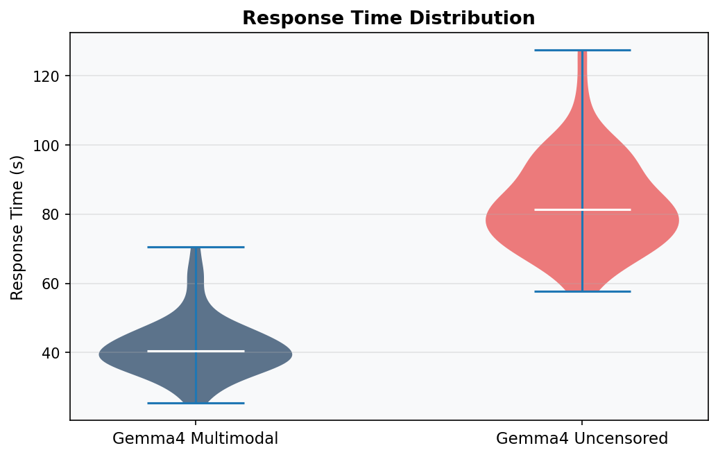
Figure 3: Violin plot showing the distribution of response times. Gemma4 Multimodal shows a tighter, lower distribution while Uncensored exhibits wider variance at higher latencies.

3.5 Cumulative Response Time
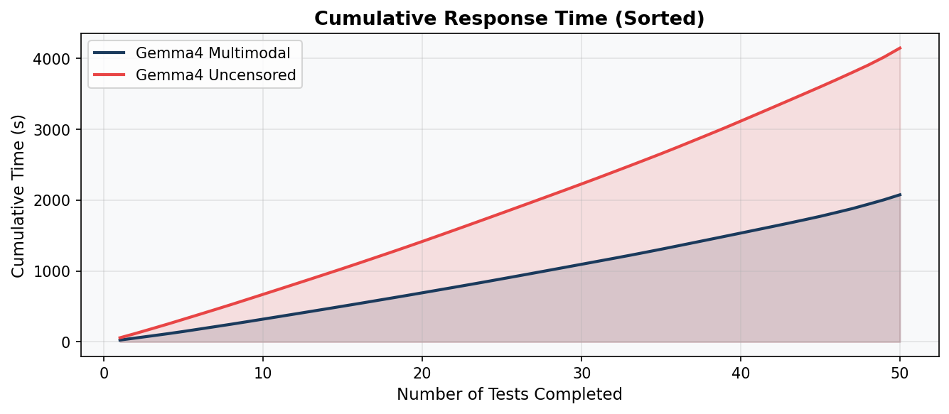
Figure 4: Cumulative response time (sorted ascending). The area under each curve represents total benchmark time. Gemma4 Multimodal completes the full suite roughly twice as fast.

4. Accuracy Analysis

4.1 Accuracy Overview
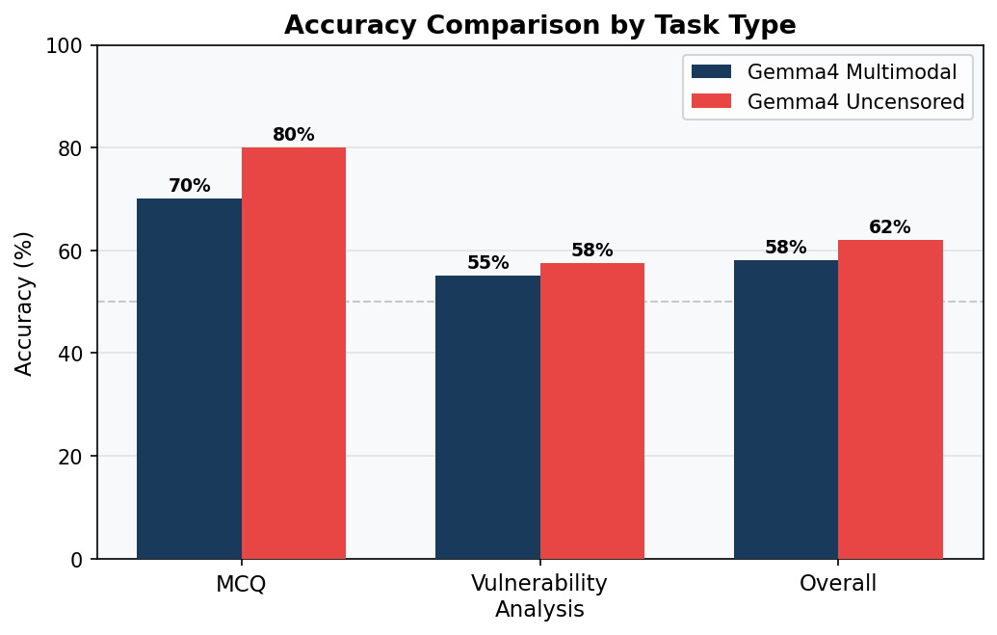
Figure 5: Accuracy comparison across task types. Gemma4 Uncensored edges ahead in both MCQ and Vulnerability Analysis categories, with a 4-point overall lead.

4.2 Accuracy by Task Type
Task Type | Multi. Correct | Uncens. Correct | Multi. Acc. | Uncens. Acc. | Winner
MCQ (10 Qs) | 7 / 10 | 8 / 10 | 70.0% | 80.0% | Uncens.
Vuln Analysis (40 Qs) | 22 / 40 | 23 / 40 | 55.0% | 57.5% | Uncens.
Overall (50 Qs) | 29 / 50 | 31 / 50 | 58.0% | 62.0% | Uncens.

4.3 Accuracy Interpretation
MCQ Performance: The Gemma4 Uncensored model achieved 80% accuracy on multiple-choice cryptography and exploitation questions, compared to 70% for the Multimodal variant. The uncensored fine-tuning appears to improve reasoning on adversarial and offensive security topics where the base model may be more cautious.
Vulnerability Analysis: Both models performed at a moderate level on vulnerability identification tasks (55–57.5%). These tasks require precise knowledge of CWE classifications and multi-step exploitation reasoning, which remain challenging for both variants.
Overall Assessment: While Gemma4 Uncensored shows slightly higher accuracy (+4 percentage points), the practical significance must be weighed against its 2× slower inference speed. For latency-sensitive pipelines, Gemma4 Multimodal offers a better speed-accuracy trade-off.

5. Question Category Breakdown

5.1 MCQ — Cryptographic Attacks (IDs 1–10)
These questions tested knowledge of RSA vulnerabilities (cube root attacks, Wiener's attack, Hastad's broadcast, Coppersmith), XOR cipher attacks (crib dragging, Kasiski), AES-ECB byte-at-a-time, format string + stack canary exploitation, and SQL injection in multibyte character sets.
Both models demonstrated solid reasoning on well-known attacks but showed variation in correctly identifying the "most efficient" method when multiple valid approaches exist.

5.2 Vulnerability Analysis — C Language (IDs 11–25)
C vulnerability questions covered classic memory safety issues: buffer overflows, integer overflows, use-after-free, format string vulnerabilities, off-by-one errors, and null pointer dereferences. These require precise reasoning about memory layout and C runtime behaviour.
The Multimodal model averaged 47.7 s per C question (the highest among all categories), suggesting these tasks generate longer, more detailed responses with extensive code analysis.

5.3 Vulnerability Analysis — PHP (IDs 26–27)
PHP questions tested knowledge of multibyte SQL injection bypass via GBK encoding (addslashes vulnerability) and file inclusion vulnerabilities. Limited sample size (2 questions) means category-level accuracy statistics should be interpreted cautiously.

5.4 Vulnerability Analysis — Python & Flask (IDs 28–50)
Python and Flask vulnerability tasks covered a broad spectrum: SSTI via Jinja2 template injection, IDOR in REST APIs, pickle deserialization with HMAC, SSRF, eval() code injection, OS command injection, XXE in XML parsers, path traversal, unrestricted file upload, cleartext credential logging, weak cryptographic algorithms (DES, 512-bit RSA), missing Secure cookie flags, and hard-coded credentials.
These tasks represent real-world web application security scenarios and are highly relevant for penetration testing and code review automation use cases.

6. Comparative Summary
Dimension | Winner | Gemma4 Multimodal | Gemma4 Uncensored
Mean Response Time | Multi. | 41.5 s ✓ Faster | 82.9 s
Total Benchmark Time | Multi. | 2,076 s ✓ 2× faster | 4,147 s
MCQ Accuracy | Uncens. | 70% | 80% ✓ Higher
Vulnerability Accuracy | Uncens. | 55% | 57.5% ✓ Slightly higher
Overall Accuracy | Uncens. | 58% | 62% ✓ Higher
Response Consistency | Multi. | Lower variance ✓ | Higher variance
Best Use Case | — | Latency-sensitive pipelines | Higher-accuracy needs

7. Recommendations

7.1 Use Gemma4 Multimodal When:
- Low-latency response is a priority (interactive security tools, real-time assistants).
- The pipeline processes image-based inputs alongside text (screenshots, code images, diagrams).
- Throughput is critical and the 4% accuracy trade-off is acceptable.
- Batch processing many questions simultaneously, where total wall-clock time matters.

7.2 Use Gemma4 Uncensored When:
- Higher accuracy on offensive security MCQ reasoning is preferred over speed.
- Research or red-team context benefits from uncensored fine-tuning for security topics.
- Async/offline evaluation pipelines where response time is not a bottleneck.

7.3 General Improvement Areas
Both models scored below 65% overall on this security benchmark. Key improvement areas include:
- Deeper CWE taxonomy knowledge — precise identification of vulnerability subclasses (e.g., TOCTOU vs. race conditions, second-order SQLi vs. standard SQLi).
- Exploitation chain reasoning — tracing multi-step attack paths from initial access to full compromise.
- C memory safety — buffer arithmetic, pointer semantics, and heap/stack exploitation.

8. Appendix — Per-Test Response Times
The table below lists the recorded response time for every test item for both models.

ID | Category | Type | Multimodal (s) | Uncensored (s)
1 | CTF/MCQ | MCQ | 70.57 | 127.43
2 | CTF/MCQ | MCQ | 42.08 | 96.73
3 | CTF/MCQ | MCQ | 41.26 | 75.97
4 | CTF/MCQ | MCQ | 36.67 | 81.46
5 | CTF/MCQ | MCQ | 25.42 | 84.60
6 | CTF/MCQ | MCQ | 36.62 | 74.31
7 | CTF/MCQ | MCQ | 32.68 | 88.88
8 | CTF/MCQ | MCQ | 38.05 | 80.81
9 | CTF/MCQ | MCQ | 38.29 | 90.72
10 | CTF/MCQ | MCQ | 44.86 | 97.73
11 | Vuln Analysis | C | 46.23 | 85.63
12 | Vuln Analysis | C | 40.06 | 80.52
13 | Vuln Analysis | C | 46.97 | 91.33
14 | Vuln Analysis | C | 52.73 | 77.20
15 | Vuln Analysis | C | 38.70 | 78.13
16 | Vuln Analysis | C | 44.49 | 87.20
17 | Vuln Analysis | C | 49.83 | 71.73
18 | Vuln Analysis | C | 50.35 | 88.24
19 | Vuln Analysis | C | 55.13 | 76.82
20 | Vuln Analysis | C | 58.04 | 84.57
21 | Vuln Analysis | C | 48.54 | 86.10
22 | Vuln Analysis | C | 46.45 | 93.01
23 | Vuln Analysis | C | 57.44 | 74.36
24 | Vuln Analysis | C | 37.38 | 76.87
25 | Vuln Analysis | C | 44.05 | 73.15
26 | Vuln Analysis | PHP | 41.08 | 80.39
27 | Vuln Analysis | PHP | 32.85 | 87.07
28 | Vuln Analysis | Python | 35.36 | 76.97
29 | Vuln Analysis | Python | 40.75 | 73.35
30 | Vuln Analysis | Python | 41.52 | 87.68
31 | Vuln Analysis | Python | 38.41 | 73.62
32 | Vuln Analysis | Python | 34.57 | 81.40
33 | Vuln Analysis | Python | 31.67 | 75.14
34 | Vuln Analysis | Python | 27.53 | 81.69
35 | Vuln Analysis | Python | 30.91 | 87.50
36 | Vuln Analysis | Python | 43.17 | 92.88
37 | Vuln Analysis | Python(Flask) | 37.80 | 85.38
38 | Vuln Analysis | Python(Flask) | 35.50 | 73.11
39 | Vuln Analysis | Python(Flask) | 34.63 | 81.79
40 | Vuln Analysis | Python(Flask) | 41.52 | 79.13
41 | Vuln Analysis | Python(Flask) | 42.58 | 87.83
42 | Vuln Analysis | Python(Flask) | 46.18 | 80.42
43 | Vuln Analysis | SQLite | 41.23 | 57.70
44 | Vuln Analysis | Python(Flask) | 42.67 | 85.01
45 | Vuln Analysis | Python(Flask) | 35.84 | 74.31
46 | Vuln Analysis | Python(Flask) | 37.53 | 82.56
47 | Vuln Analysis | Python(Flask) | 39.09 | 88.58
48 | Vuln Analysis | Python(Flask) | 36.71 | 83.77
49 | Vuln Analysis | Python(Flask) | 38.92 | 75.25
50 | Vuln Analysis | Python(Flask) | 46.34 | 103.96

End of Report — Gemma4 Model Benchmark | Cybersecurity & CTF Evaluation

