JavaScript

For Google Search: MDN (developer.mozilla.org)

will understand

string
numbers
boolean

In JavaScript, at the end of each line, I always need to use a ‘;’

Chrome has the best engine to run JavaScript

node = it’s a library from JavaScript, it will run the application

To write a comment on JavaScript:

// comment

ALWAYS WRITE A CLEAN ORGANIZED CODE
– use the comments → always write comments

keep your Github updated – add text to box description to explain what you’re doing

With double quotes = string

if it’s math without the double quotes, it will do the math

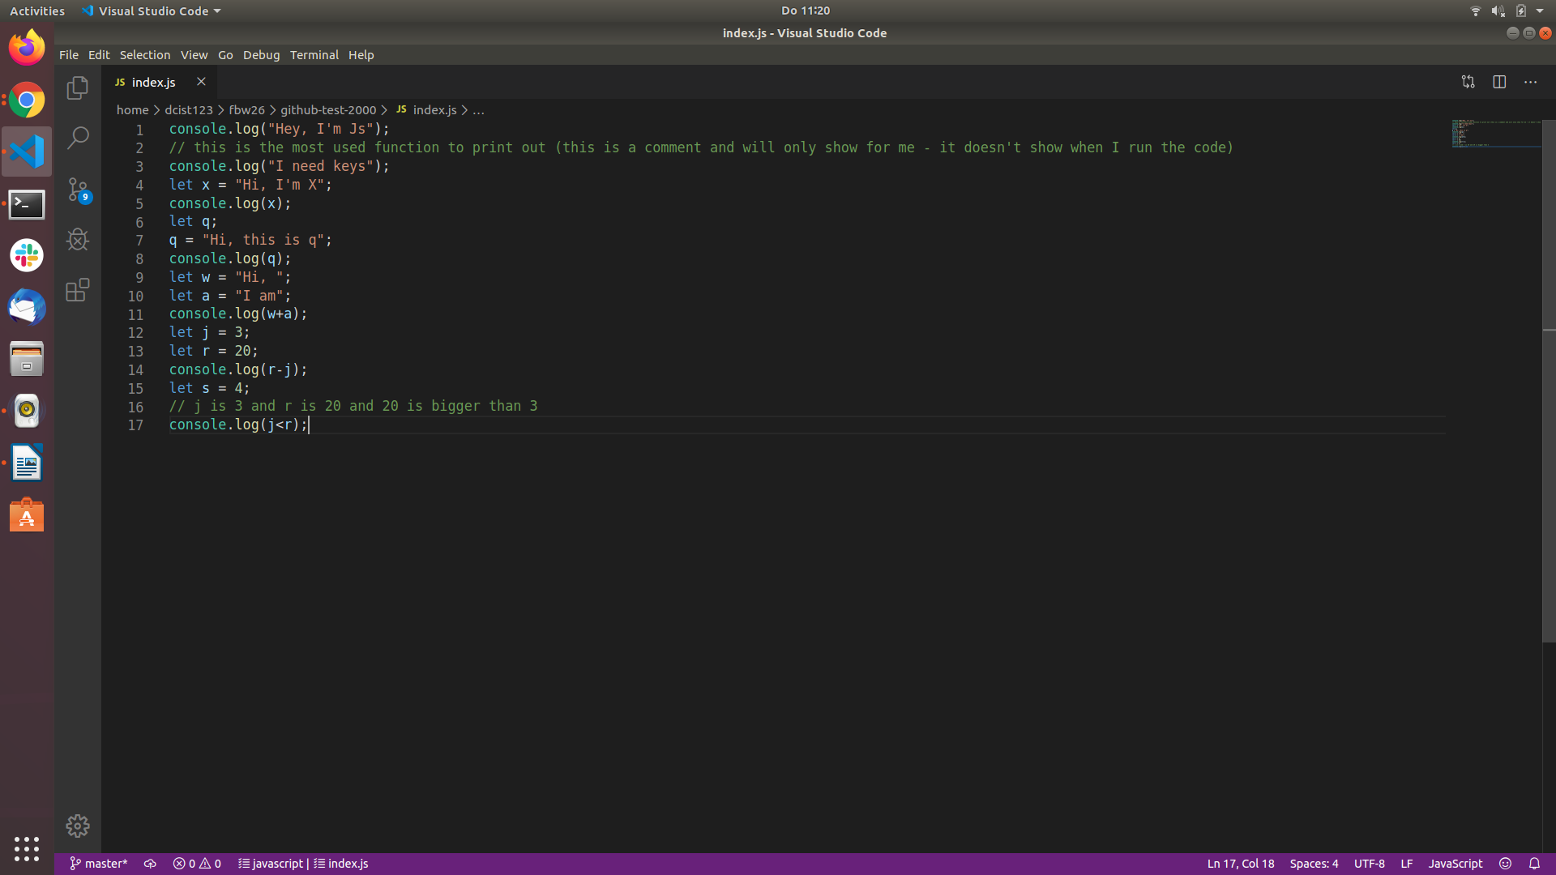
JavaScript – scripting language (not a programming language)

the brain for your front end development

ECMAscript (or ES) is a scripting language specification created by Ecma International to standardise JavaScript to help faster multiple independent implementations

For now, JS and ES are considered the same language/functionality

ES6 – 2015 (it’s the more famous, but every year there’s a new version)

ES.Next – the most recent version

Common Case – JavaScript allows the use of capital letters

3 ways to declare variables in JS:

let – most common we’ll use for now
var
const

JavaScript runs one line at a time

= one equal will assign value to a variable
== to check the same value
=== to check the same coding (all items must be the same)

Substring
is a way to cut off /trim from a certain string and will create a new string

Local Variables

They live only inside their scope

Function
function definition
function call

Method
Trim is a method and it needs the () in the end to be executed

We can create our own methods/functions

Number systems

Odd numbers – whe

Decimal – base is 10
Integer numbers = nrs inteiros
Floats
0
1
2
3
4
5
6
7
8
9

Binary – base is 2
1
0

Hexadecimal – base is 16
0
1
2
3
4
5
6
7
8
9
A
B
C
D
E
F

Octodecimal – base 18
0
1
2
3
4
5
6
7
8
9
A
B
C
D
E
F
G
H

ternary operator (is a short form for “if”

//when you declare the variable but don't assign a value, it will read "undefined"

=== means the type and the value are equal

var is used more for global variables
let is more used for local variables and also variables that don’t need hoisting

const I cannot change; I can access it, I can see it, but I cannot change it

/*THIS WOULDN'T WORK
let x = 10;
let x = 11;

const name = "Raquel";
let name = "Sara";

const name = "Raquel";
name = "Sara";
*/

//BUT THIS WORKS
let x = 10;
x = 11;

We use:

if else/else if – always needs a last else (equivalent to default in switch case
→ to compare numbers in between a range;
→ unpredictable answers (age, for example) – I dont want to list all the possibilities

switch… case – always used with a default clause in the end
→ whenever I have a concrete answer like a building number, countries, an instrument, etc.
→you can only come up with one value at a time

arrays
// we use array when we need to store multiple values in one variable
var firstNameArr = ["Ali", "Olga", "Hadi"];
let funArray = ["😎", "💪🏻", "😊"];

everything in JavaScript is an object

using const in an array, I am not able to change the array, but I am able to change the index of the array
it’s more secure to use const in arrays

never declare a variable inside of a loop

you can have nested anything on javascript

