**STEPS TO DOWNLOAD, COMPILE AND TEST THE SOTEST APPLICATION**

**Author: Ricardo De la Rosa**

**Step 1]** In a computer with operating system Windows 10 or Windows 11 you can open a WSL Command Shell.

Then, it will appear a window like the following:

**Step 2]** It is necessary to install the compiler gcc to compile the project. The command to accomplish this is:

sudo apt install gcc

**Step 3]** Please, change the current directory of this window to the directory where you will download the source code of **sotest project**.

In my environment, I execute this step by executing the following command:

cd /home/rdelarosa/wspacebpc

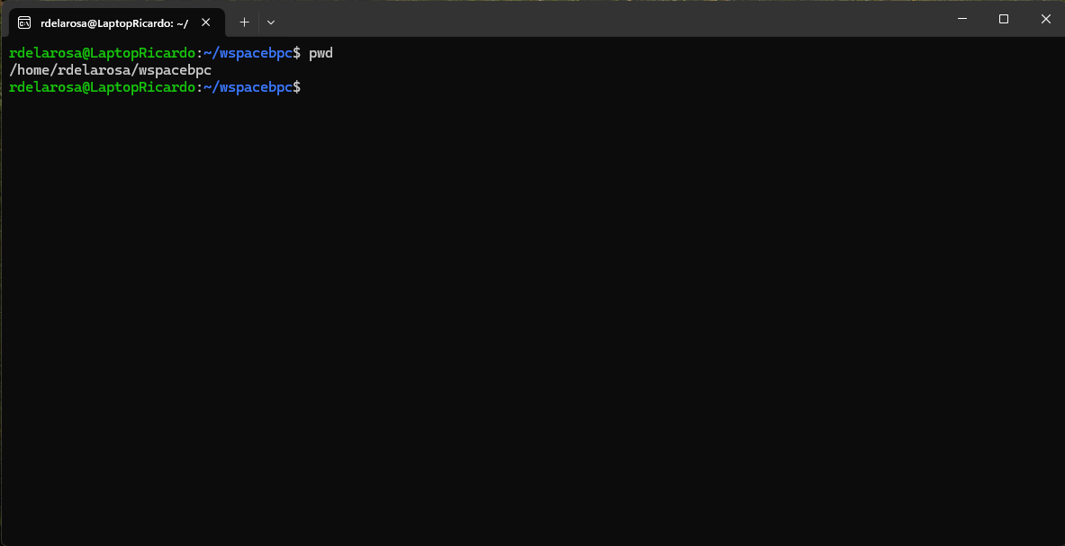

**Step 4]** Download the source code by executing the command:

git clone <https://github.com/rdlarosa2/sotest.git>

**Step 5]** Then the directory **sotest** must be created. Please, change to this directory with the command: **cd sotest**

**Step 6]** If you execute the command: **ls -la**

Then you can see the following files:

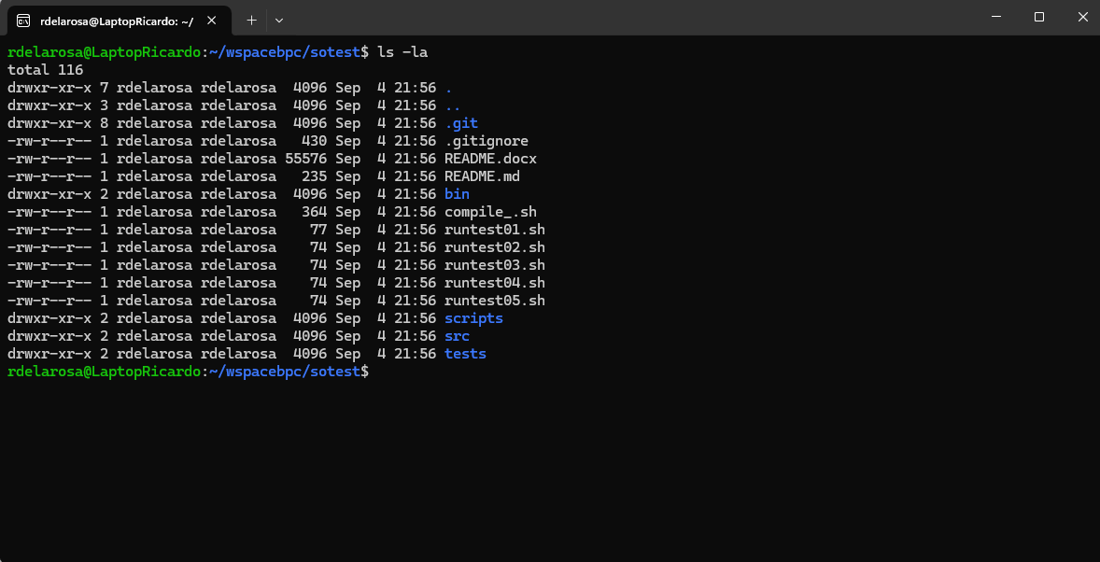

**Step 7]** It’s necessary to give execution permissions to the script **grantpermissions.sh.**

This script grants execution permissions to files compile_.sh, runtest01.sh, runtest02.sh, runtest03.sh, runtest04.sh, runtest05.sh and runtest06.sh**.**

To do this we can execute the command:

chmod goa+x grantpermissions.sh

Then we execute the command:

./grantpermissions.sh

**Step 8]** To generate the executable files, it is necessary to execute the command:

./compile_.sh

To verify that the executable files were generated in the bin directory, it is necessary to execute the command:

**ls bin**

Then the list of files will be:

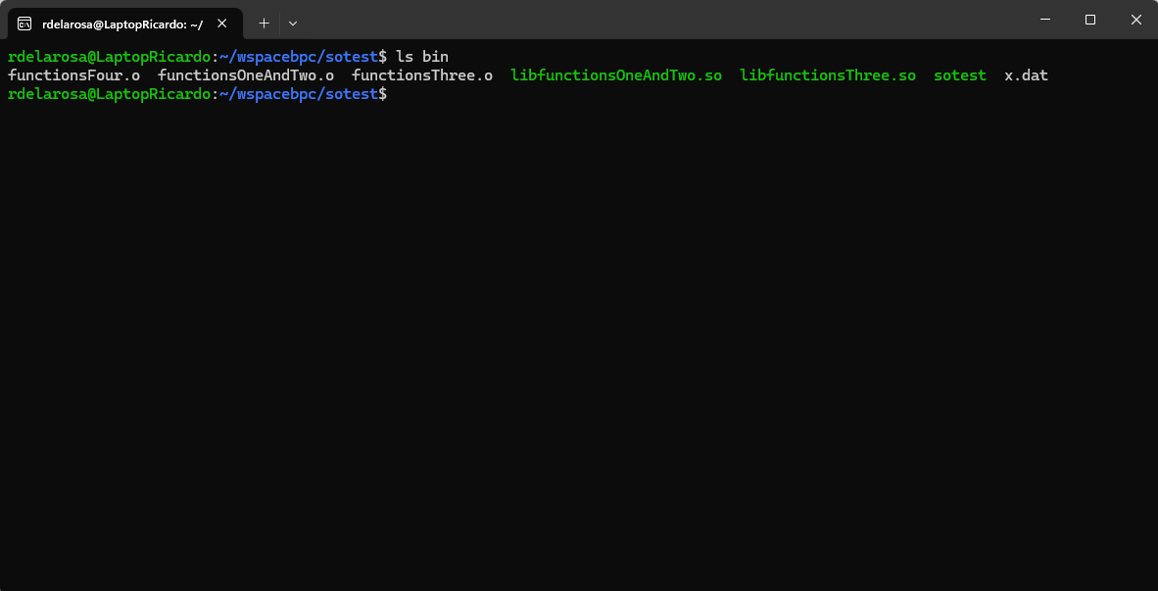

**Step 9]** For the next step it is necessary to define the environment variable called SOTEST_HOME. For this goal, it is necessary to add the line:

export SOTEST_HOME=<Absolute path of the sotest folder>

to the file $HOME/.bashrc

In my case, the line that I need to add is:

**export SOTEST_HOME=/home/rdelarosa/wspacebpc/sotest**

To have a command shell with this variable initiated then you need to close the command shell window. Then open a new command shell window of WSL.

In this window you need to execute the command: **echo $SOTEST_HOME** then it is printed the folder where the sotest folder is located:

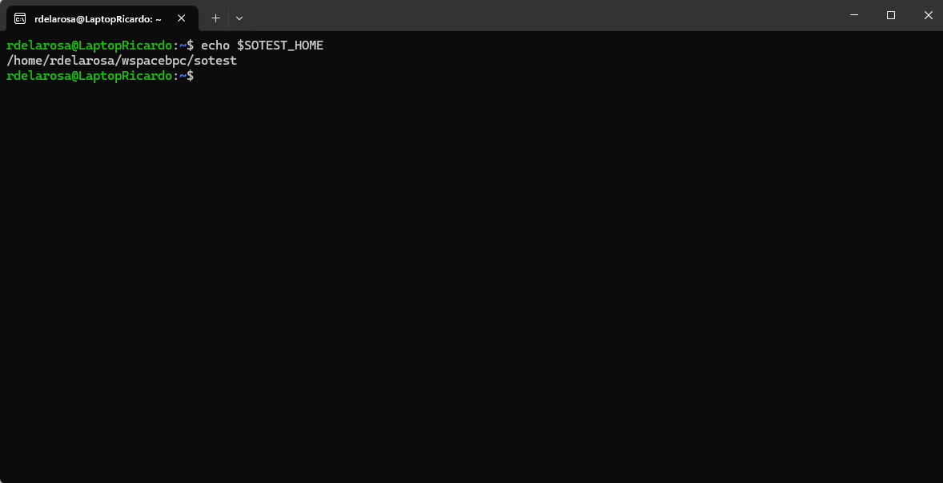

**Step 10]** Then it is necessary to change the current directory to $SOTEST_HOME with command: **cd $SOTEST_HOME**

**STEPS TO TEST THE APPLICATION**

**Step 11] Execution of the First Test**

You need to execute the command:

./runtest01.sh

|  |  |
| --- | --- |
| **Description of test** | Testing that the load of a shared library executes successfully.  Testing that the execution of a function of a loaded shared library executes successfully. |
| **Script name** | commands01.sc |
| **Contents of commands script** | **# Processing the first file**  **use libfunctionsOneAndTwo.so**  **call functionOne**  **call functionTwo**  **; Processing the second file**  **use libfunctionsThree.so**  **call functionThree** |
| **Expected output** | **One**  **Two**  **Three** |
| **Output** |  |
| **Status** | **Test passed** |

**Step 12] Execution of the Second Test**

You need to execute the command: **./runtest02.sh**

|  |  |
| --- | --- |
| **Description of test** | The shared library doesn’t exist.  The execution stopped after trying to load the shared library. |
| **Script name** | commands02.sc |
| **Contents of commands script** | **use libfunctionsFour.so**  **call functionFour** |
| **Expected output** | **File /home/rdelarosa/wspacebpc/sotest/bin/libfunctionsFour.so not found or this file is not a shared library** |
| **Output** |  |
| **Status** | **Test passed** |

**Step 13] Execution of the Third Test**

You need to execute the command: **./runtest03.sh**

|  |  |
| --- | --- |
| **Description of test** | The file is not a shared library. |
| **Script name** | commands03.sc |
| **Contents of commands script** | **use functionsFour.o**  **call functionFour** |
| **Expected output** | **File /home/rdelarosa/wspacebpc/sotest/bin/functionsFour.o not found or this file is not a shared library** |
| **Output** |  |
| **Status** | **Test passed** |

**Step 14] Execution of the Fourth Test**

You need to execute the command: **./runtest04.sh**

|  |  |
| --- | --- |
| **Description of test** | The shared library was loaded successfully.  In the second call the function doesn’t exist. |
| **Script name** | commands04.sc |
| **Contents of commands script** | **use libfunctionsOneAndTwo.so**  **call functionOne**  **call functionFive** |
| **Expected output** | **One**  **Function functionFive doesn't found in the shared library** |
| **Output** |  |
| **Status** | **Test passed** |

**Step 15] Execution of the Fifth Test**

You need to execute the command: **./runtest05.sh**

|  |  |
| --- | --- |
| **Description of test** | The shared library was loaded successfully.  At the end of the first call command there is a line break. |
| **Script name** | commands05.sc |
| **Contents of commands script** | **use libfunctionsOneAndTwo.so**  **call \**  **functionOne** |
| **Expected output** | **One** |
| **Output** |  |
| **Status** | **Test passed** |

**Step 16] Execution of the Sixth Test**

You need to execute the command: **./runtest06.sh**

|  |  |
| --- | --- |
| **Description of test** | It is invoked the command sotest without any argument.  Then this program started in interactive mode. |
| **Script name** | commands06.sc |
| **Contents of commands script** | **There isn’t a script** |
| **Expected output** | Command(use,quit): use libfunctionsOneAndTwo.so  Name of shared library: Command(use,call,quit): call  Function name: functionOne  one  Command(use,call,quit): call  Function name: functionTwo  two  Command(use,call,quit): use  Name of shared library: libfunctionsThree.so  Command(use,call,quit): call  Function name: functionThree  three  Command(use,call,quit): quit |
| **Output** |  |
| **Status** | **Test passed** |

**Step 17] Execution of the Seventh Test**

You need to execute the command: **./runtest07.sh**

|  |  |
| --- | --- |
| **Description of test** | The shared library was loaded successfully.  At the end of the first call command there is a line break. |
| **Script name** | commands07.sc |
| **Contents of commands script** | **use libfunctionsOneAndTwo.so**  **call \**  **functionOne** |
| **Expected output** | One |
| **Output** |  |

**Step 18] Execution of the Eighth Test**

You need to execute the command: **./runtest08.sh**

|  |  |
| --- | --- |
| **Description of test** | In the first line of the script there is a call command. Then the application shows a warning saying that before calling a function is necessary to load a shared library with use command |
| **Script name** | commands08.sc |
| **Contents of commands script** | **call functionOne** |
| **Expected output** | Warning: before calling a function you must load a library with 'use' command |
| **Output** |  |