The construction agreement has three parties:

1. The Developer
2. The Agent
3. The Construction Company

The code is as follows:

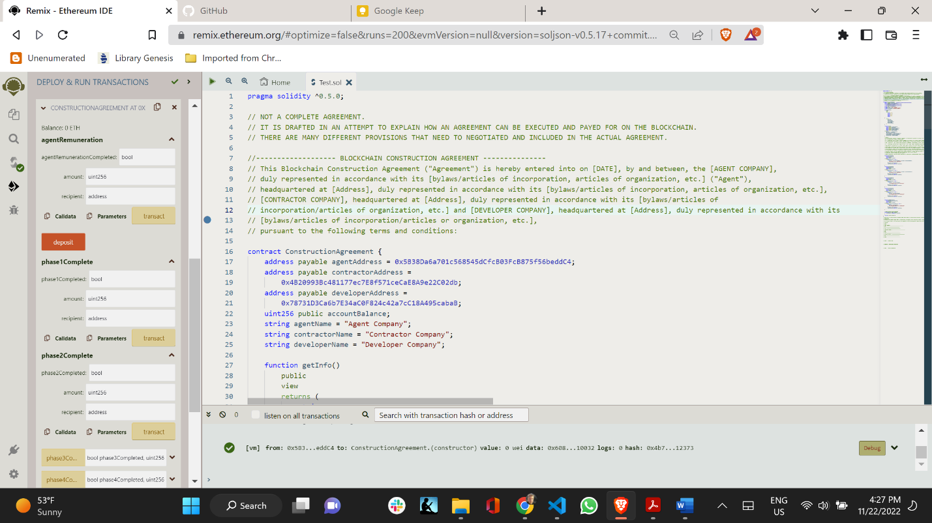

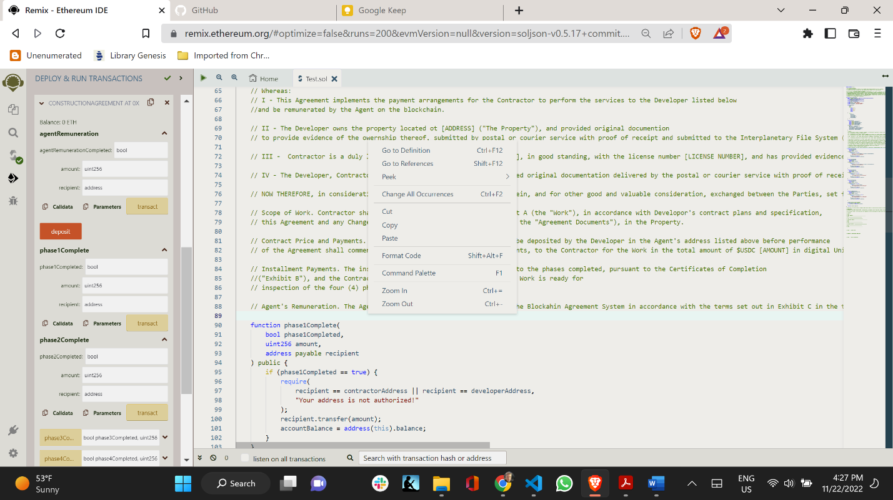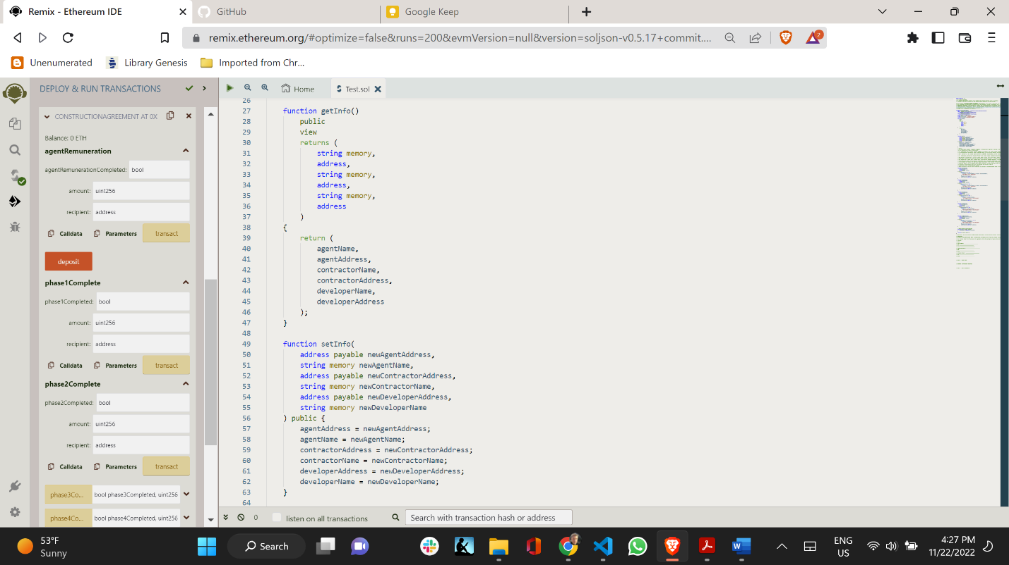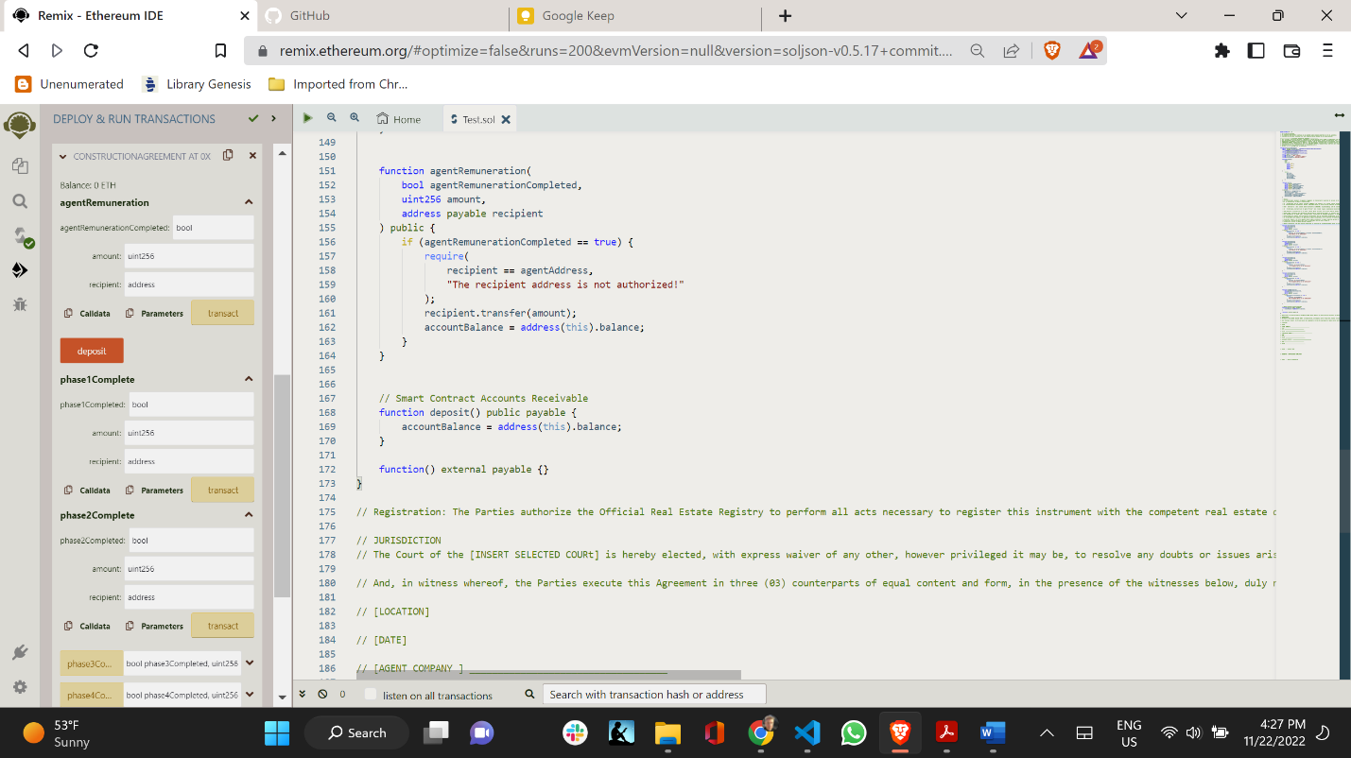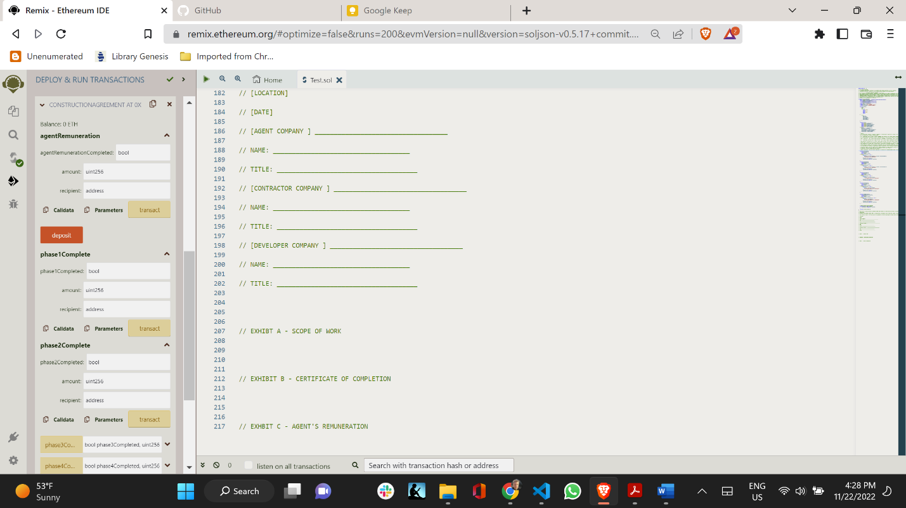

How do we regulate trust placed in a contractual relationship?

The main challenge we are confronted with is how to we regulate the trust that is being placed on the agent to execute the contract properly and pay the contractor when the phases of the agreement are completed?

One option is by creating a Decentralized Autonomous Organization (DAO), but how will we control the behavior of the agent?

When the contractor and the developer agree, the agent will automatically perform in accordance with their wishes, but if they disagree, the action will be to await the conflict resolution provision. This is a that way we will be able to control the payment relationship and the trust imparted on the agent to deal with the money properly, and not escape with the deposit made for in the contract.

How do we create a DAO? Openzeppellin has a wizard application on its website for the creation of DAOs. But do whom do we issue tokens for voting? Other construction companies and developers and how will we control the bad actors attempting to steal the funds in the contract?

