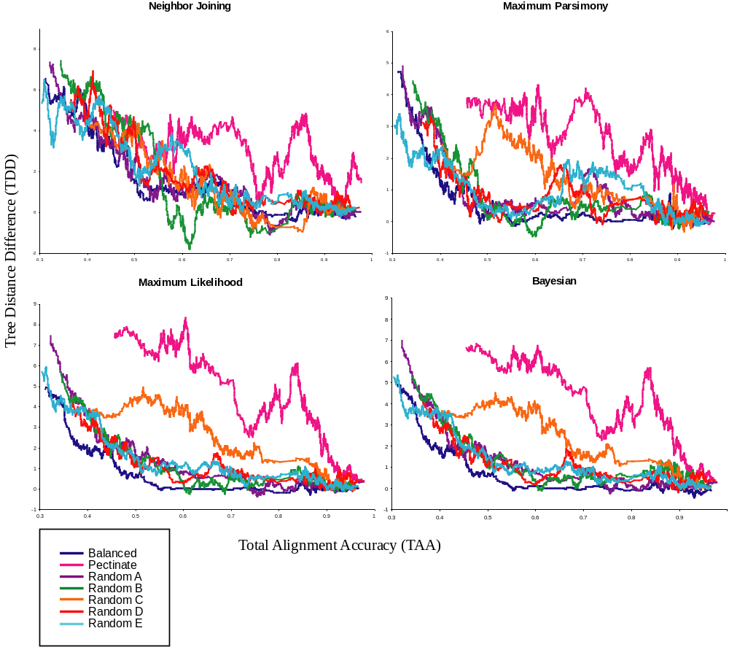

Online Appendix - Figure 1. Hypothesized Alignment (HA) results for neighbor joining, parsimony , likelihood, and Bayesian analyses, separated by the seven tree shapes (see figure 1). The relationship of Total Alignment Accuracy (TAA) and topological accuracy, as measured by the absolute distance to the true tree (number of nodes not correctly recovered) is depicted. The lines are moving averages based on an overlapping sliding window of 50 consecutive points.

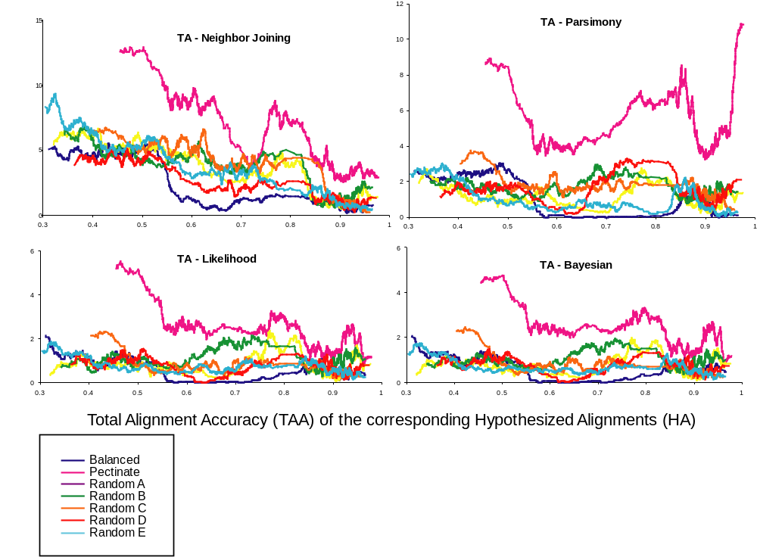

Online Appendix - Figure 2. True Alignment (TA) results for neighbor joining, parsimony , likelihood, and Bayesian analyses, separated by the seven tree shapes (see figure 1), depicting the relationship of topological accuracy, as measured by the distance to the true tree and the corresponding Total Alignment Accuracy (TAA) of the Hypothesized Alignments (HA). Obviously, TA do not have any alignment error, so the TAA scores are the corresponding TAA scores for the HA; they thus represent a measure of potential alignment error if the data were to be algorithmically aligned using ClustalW. The lines are moving averages based on an overlapping sliding window of 50 consecutive points.
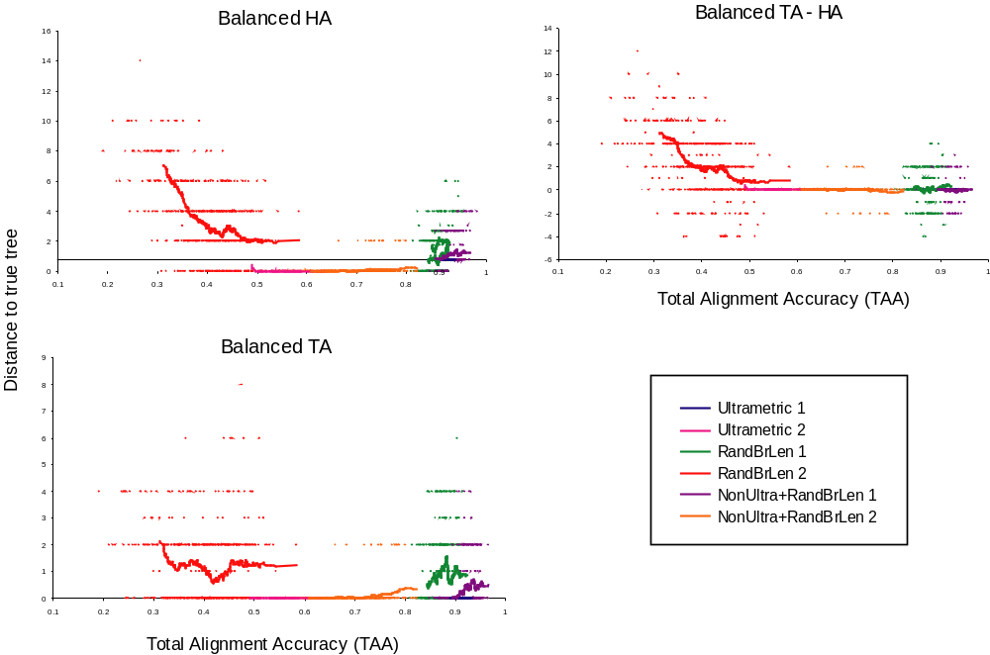

Online Appendix - Figure 3. Likelihood results for the balanced tree shape separated by the six branch treatment types. Ultrametric = ultrametric equal branch length condition; RandBrLen = Ultrametric random branch length condition; NonUltra+RandBrLen = non-clocklike random branch length condition; 1 = maximum evolutionary distance of 1; and 2 = maximum evolutionary distance of 2. For the HA and TA graphs the Y-axis is the absolute difference to the true tree. For the TA – HA graph the Y-axis is the Tree Distance Difference (TDD), i.e., the difference of the other two panels. In all three graphs the X-axis is the Total Alignment Accuracy (TAA) score for the HA. The lines are moving averages based on an overlapping sliding window.
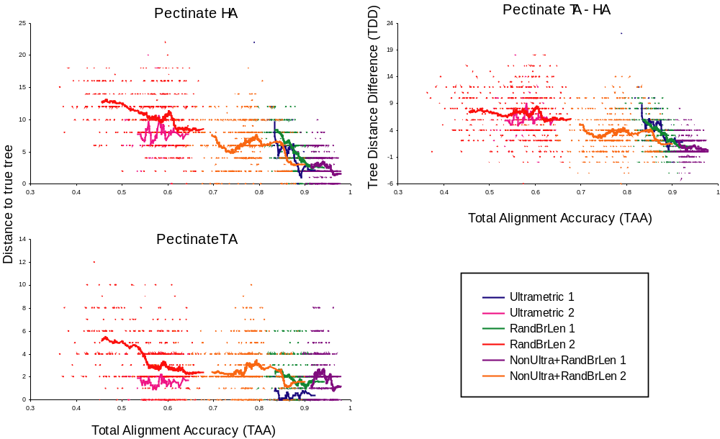

Online Appendix - Figure 4. Likelihood results for the pectinate tree shape separated by the six branch treatment types. Ultrametric = ultrametric equal branch length condition; RandBrLen = Ultrametric random branch length condition; NonUltra+RandBrLen = non-clocklike random branch length condition; 1 = maximum evolutionary distance of 1; and 2 = maximum evolutionary distance of 2. For the HA and TA graphs the Y-axis is the absolute difference to the true tree. For the TA – HA graph the Y-axis is the Tree Distance Difference (TDD), i.e., the difference of the other two panels. In all three graphs the X-axis is the Total Alignment Accuracy (TAA) score for the HA. The lines are moving averages based on an overlapping sliding window.

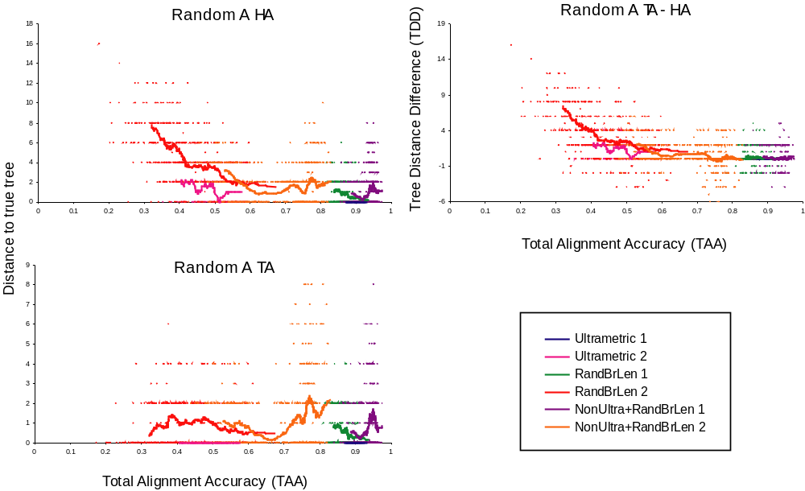

Online Appendix - Figure 5. Likelihood results for the random A tree shape separated by the six branch treatment types. Ultrametric = ultrametric equal branch length condition; RandBrLen = Ultrametric random branch length condition; NonUltra+RandBrLen = non-clocklike random branch length condition; 1 = maximum evolutionary distance of 1; and 2 = maximum evolutionary distance of 2. For the HA and TA graphs the Y-axis is the absolute difference to the true tree. For the TA – HA graph the Y-axis is the Tree Distance Difference (TDD), i.e., the difference of the other two panels. In all three graphs the X-axis is the Total Alignment Accuracy (TAA) score for the HA. The lines are moving averages based on an overlapping sliding window.
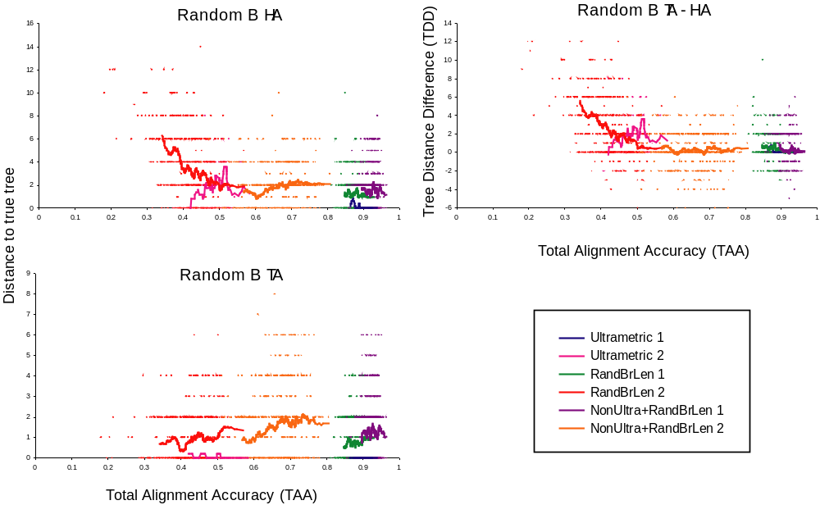

Online Appendix - Figure 6. Likelihood results for the random B tree shape separated by the six branch treatment types. Ultrametric = ultrametric equal branch length condition; RandBrLen = Ultrametric random branch length condition; NonUltra+RandBrLen = non-clocklike random branch length condition; 1 = maximum evolutionary distance of 1; and 2 = maximum evolutionary distance of 2. For the HA and TA graphs the Y-axis is the absolute difference to the true tree. For the TA – HA graph the Y-axis is the Tree Distance Difference (TDD), i.e., the difference of the other two panels. In all three graphs the X-axis is the Total Alignment Accuracy (TAA) score for the HA. The lines are moving averages based on an overlapping sliding window.
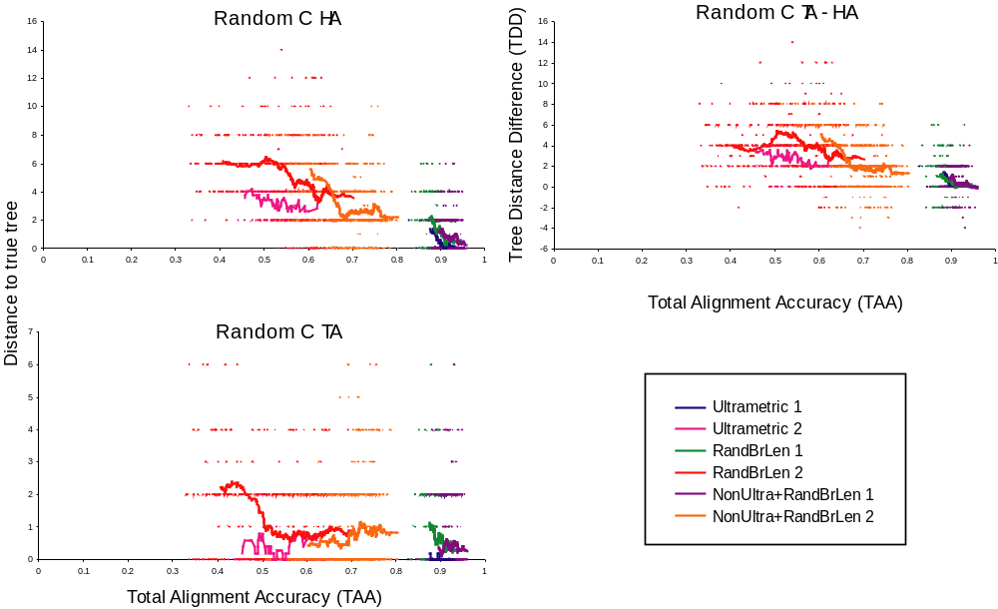

Online Appendix - Figure 7. Likelihood results for the random C tree shape separated by the six branch treatment types. Ultrametric = ultrametric equal branch length condition; RandBrLen = Ultrametric random branch length condition; NonUltra+RandBrLen = non-clocklike random branch length condition; 1 = maximum evolutionary distance of 1; and 2 = maximum evolutionary distance of 2. For the HA and TA graphs the Y-axis is the absolute difference to the true tree. For the TA – HA graph the Y-axis is the Tree Distance Difference (TDD), i.e., the difference of the other two panels. In all three graphs the X-axis is the Total Alignment Accuracy (TAA) score for the HA. The lines are moving averages based on an overlapping sliding window.
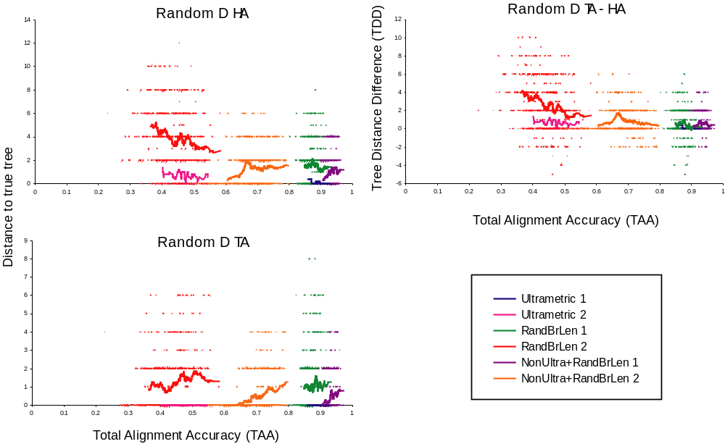

Online Appendix - Figure 8. Likelihood results for the random D tree shape separated by the six branch treatment types. Ultrametric = ultrametric equal branch length condition; RandBrLen = Ultrametric random branch length condition; NonUltra+RandBrLen = non-clocklike random branch length condition; 1 = maximum evolutionary distance of 1; and 2 = maximum evolutionary distance of 2. For the HA and TA graphs the Y-axis is the absolute difference to the true tree. For the TA – HA graph the Y-axis is the Tree Distance Difference (TDD), i.e., the difference of the other two panels. In all three graphs the X-axis is the Total Alignment Accuracy (TAA) score for the HA. The lines are moving averages based on an overlapping sliding window.
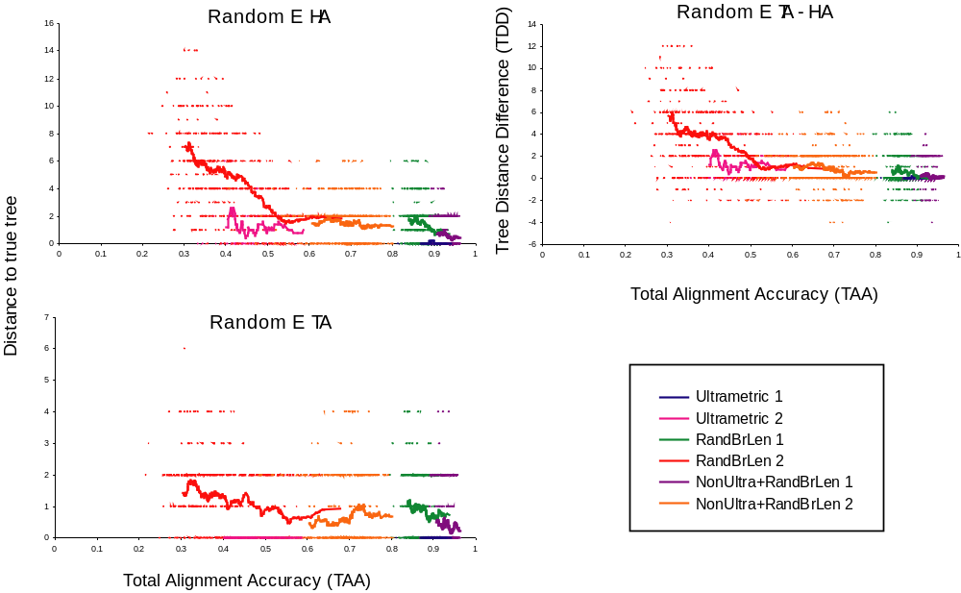

Online Appendix - Figure 9. Likelihood results for the random E tree shape separated by the six branch treatment types. Ultrametric = ultrametric equal branch length condition; RandBrLen = Ultrametric random branch length condition; NonUltra+RandBrLen = non-clocklike random branch length condition; 1 = maximum evolutionary distance of 1; and 2 = maximum evolutionary distance of 2. For the HA and TA graphs the Y-axis is the absolute difference to the true tree. For the TA – HA graph the Y-axis is the Tree Distance Difference (TDD), i.e., the difference of the other two panels. In all three graphs the X-axis is the Total Alignment Accuracy (TAA) score for the HA. The lines are moving averages based on an overlapping sliding window.

