Brief instructions for the AFLP perl script use in Althoff et al. 2007, Syst. Biol.

Feel free to contact me at dmalthof@syr.edu when you run into difficulties.

1) Programs required for performing AFLP analyses:

aflp+3aatcaa
do_blastjobs.sh
do_output.pl

2) In addition to the files provided here you will also need to download a copy of BLAST from NCBI and specify its link in the do_blastjobs.sh file.

3) In the aflp+3aatcaa file you will need to change the following in order to have the program execute successfully:

--You have to specify where the do_blastjobs.sh and do_output.pl files are located

4) You need to have two genome TXT files in GenBank format minus the description lines.

For example you need to have just,

1 aagtttttta atttcttttt tgtcgttttc tgcgtttctg catcagcgac ggttattaat
61 atatcatgca gtaaaatgaa atgcaacacc ttttataaac tttttttaaa ttaactacat
121 ttctttttta ttatcatata cttaaacgaa atatctcttt catttctaaa agattgctac…

We ran the script in Terminal in the MacOSX operating system by typing in

aflp+3aatcaa /put in location of genome1 /put in location of genome 2

E.g. aflp+3aatcaa /Users/Doe/genome1.txt /Users/Doe/genome2.txt

The output will be a set of folders and text files in a folder called work_aflp. I renamed work_aflp to DmDy2Lcaa to designate D. melanogaster vs D. yakuba chromsome 2L.

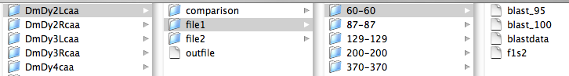

file 1 are the results from genome 1 and file 2 from genome 2. The comparison folder is the combined results. In the above example the program found one sequence 60 bp long. f1s2 is the name it gave the sequence file.

The outfile contains a list of the fragments and their sequences found in both genomes, the blast comparisons of fragments at each size within a genome, and the blast comparisons of fragments at each size between genomes.

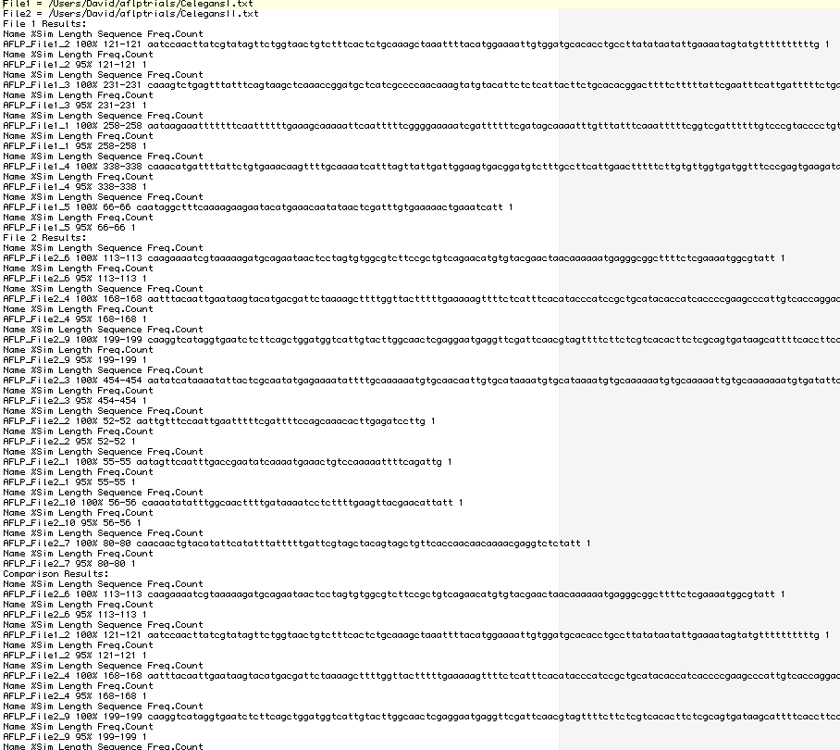

If there were multiple sequences per size the program would list the sequences and you could tell by the frequency if they were similar at the 100% or 95% level. For example if there were two sequences at a given size the frequency count at 100% might 1 for each sequence (meaning there are some differences), but a 2 at 95% meaning they are at least 95% similar.

Good luck and contact me as needed. I am not a programmer, but should be able to help.

