Supplementary Figures

Detecting and overcoming systematic errors in genome-scale phylogenies

Rodríguez-Ezpeleta et al.

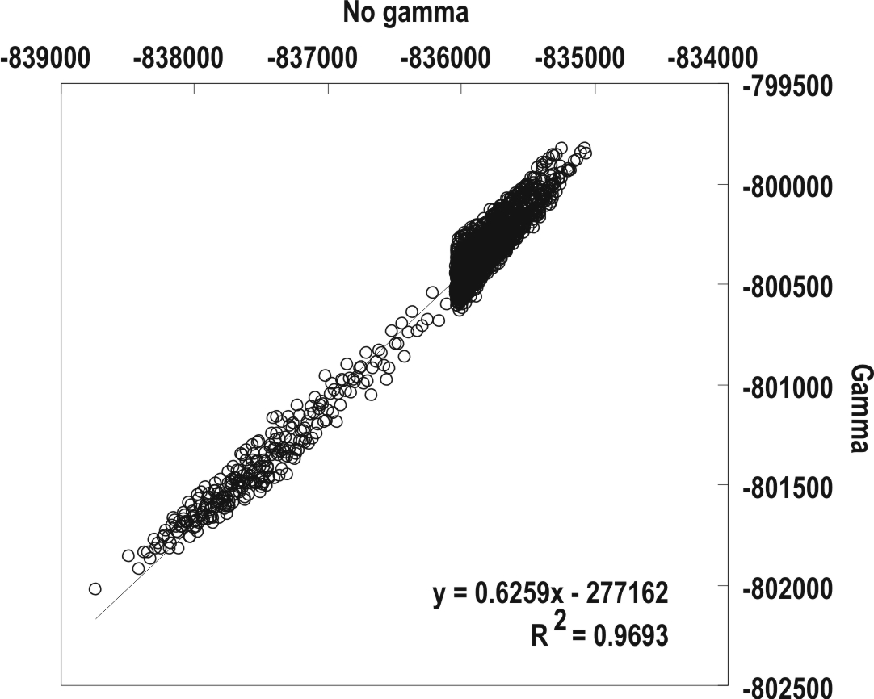

Figure S1:

Correlation between the log likelihood values for the same topologies analyzed with (Y axis) and without (X axis) gamma distributed rates across sites. The trees correspond to the 1,733 best ranking topologies and 267 others sampled with a step of 500 from the analysis without gamma distributed rates across sites.
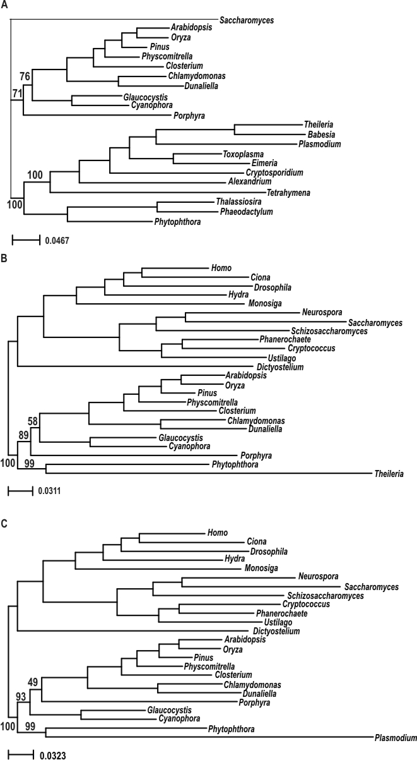

Figure S2:

Same analyses as in Fig. 1, but using different combinations of taxon sampling that are likely to induce an LBA artefact. In all cases, only Porphyra was used to represent the red algae and the kinetoplastids were excluded from the dataset; (A) using Saccharomyces as the only representative of the opisthokonts and Amoebozoa; (B) using Theileria and Phytophthora as the only representatives of alveolates and stramenopiles respectively; and (C) using Plasmodium and Phytophthora as the only representatives of alveolates and stramenopiles respectively.

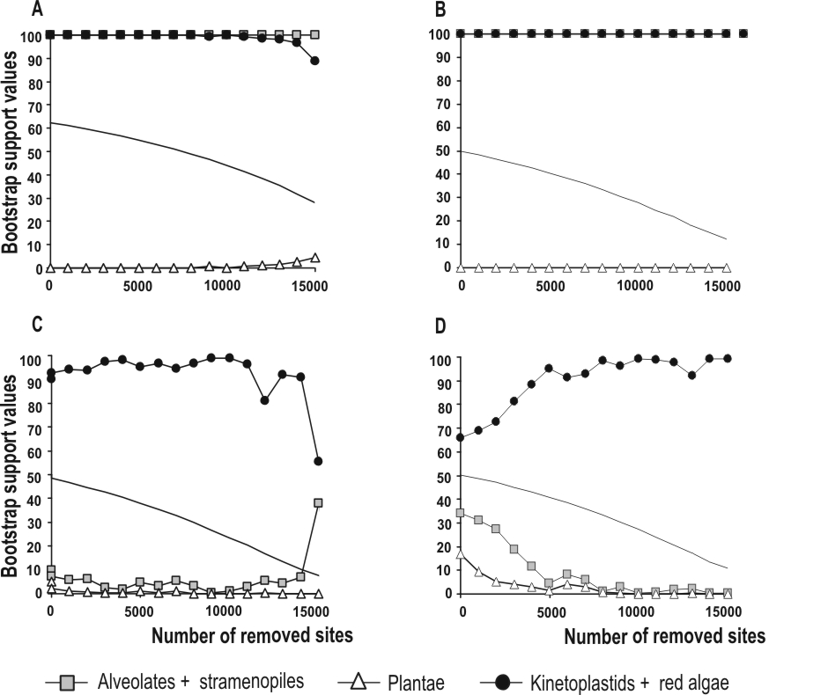

Figure S3:

Progressive removal of the fastest evolving sites from the datasets of Figs. 3B, 4A, 4B and 4C. The rates of each site were calculated on the incorrect topology in which Cyanidioschyzon is attracted to a long branch. Y and X axes refer to bootstrap values (in %) and number of amino acid positions removed, respectively. Plain line represents the number of parsimony informative positions.
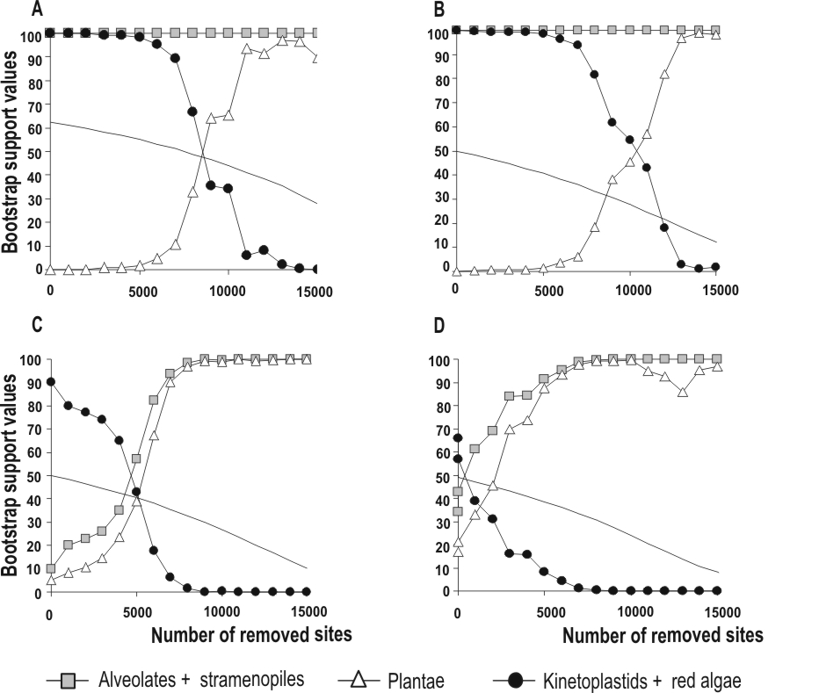

Figure S4:

Progressive removal of the fastest evolving sites from the datasets of Figs. 3B, 4A, 4B and 4C. The rates of each site were calculated on the correct topology in which Cyanidioschyzon branches with the Plantae. Y and X axes refer to bootstrap values (in %) and number of amino acid positions removed, respectively. Plain line represents the number of parsimony informative positions.

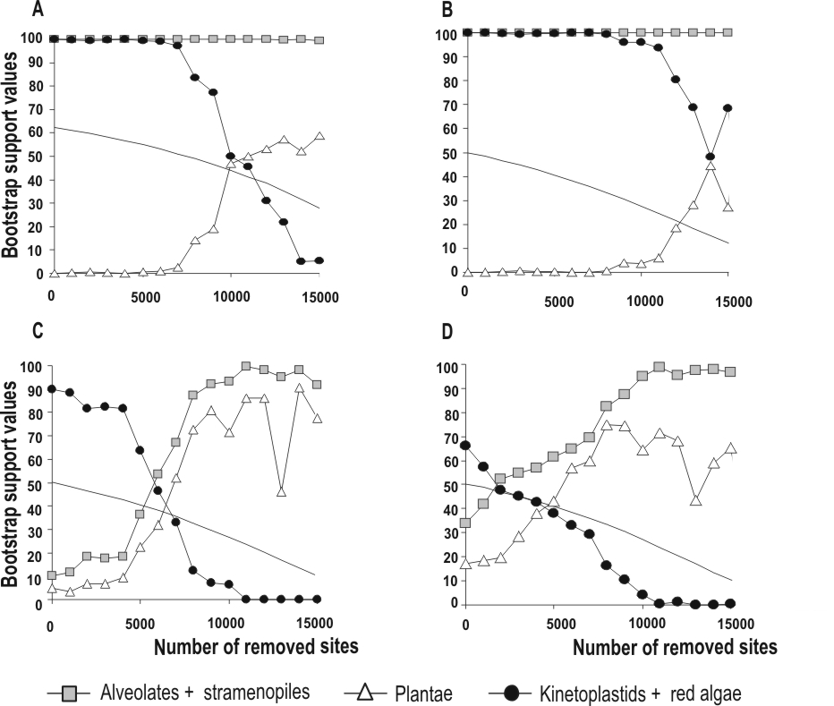

Figure S5:

Progressive removal of the fastest evolving sites from the datasets of Figs. 3B, 4A, 4B and 4C. The rates of each site were calculated on all the 2,000 retained topologies and the mean of the rates for each site was computed. Y and X axes refer to bootstrap values (in %) and number of amino acid positions removed, respectively. Plain line represents the number of parsimony informative positions.

