Determining the type 1 error rate of our coalescence test
Out test of lineage sorting versus hybridization used gene trees inferred from Medicago sequences and then assessed the variation that might arise by lineage sorting using coalescence simulation. We want to know whether the differences among gene trees are too large to be explained by lineage sorting alone and therefore whether another explanation is required. Several key questions arise: Given that we don’t know in advance what the species tree(s) is, is the gene tree an appropriate surrogate to assess this variation? How different do gene trees need to be to reject lineage sorting alone (at a given p value)? How can we incorporate variable levels of lineage sorting in the test when we can’t know the level of sorting in advance?
In our test we took a Medicago gene tree then simulated a pool of trees from this that would arise by lineage sorting alone (using coalescence simulations implemented in Mesquite). In essence, this uses the real gene tree as a surrogate species tree and assesses the variation derived by lineage sorting alone. We then constructed a distribution of tree-to-tree distances (using the symmetric distance) between the pool of simulated trees and the real gene tree. This distribution is then compared to the distance between the two real gene trees derived from Medicago sequences. The real gene trees are different – we know that already – but are they different enough to reject lineage sorting alone? The real gene trees are more different from one another than either is to its pool of simulated trees (trees simulated from both gene trees). This indicates that the variation we might expect from lineage sorting alone is not sufficiently large to explain the difference between the real gene trees. It suggests that the real gene trees are produced by different underlying trees, such as could be caused by hybridization.
But we have not yet addressed whether the gene trees (themselves a sample from an underlying tree(s) influenced by lineage sorting and possibly hybridization) are appropriate surrogates. To address this we made an artificial tree using 15 taxa that had a few short and a few longer branches and was somewhat pectinate (Supp Fig 2). In short, a moderately complex tree that looks similar to many published molecular phylogenies, but not too complex to make the next round of simulations overly time consuming to assess. Although the tree has equal root to tip lengths (i.e., is ultrametric), this corresponds to our use of chronograms rather than phylograms for the simulations above. Chronograms are needed because the simulations use years per generation as a parameter.
This artificial tree was taken as the species tree for an artificial set of 15 species. We then simulated 50 artificial gene trees under a range of Ne. The point of this was to get trees that (1) are derived from a known species tree, (2) were not affected by hybridization and (3) covered a reasonable range of ‘gene tree space’ generated by lineage sorting. The use of several values for Ne generated sets of trees that covered a range of degrees of lineage sorting, as the difference between gene trees and the species tree under simulation clearly rises with increasing Ne (Supp Fig. 3).
We then sampled all pairs of artificial gene trees and performed the test as was done using the real Medicago data. We then assessed what the proportion of tests was that rejected the null of lineage sorting alone. Because we have a single artificial species tree for this assessment, we can therefore know that anytime the null was rejected it was done so incorrectly. This allowed us to find out what the type 1 error rate was for our test. This assessment was done for each value of Ne separately, so that we could see what the influence of differing degrees of lineage sorting is. Furthermore, this assessment was done for different critical values. The critical value for a particular test is the proportion of the distribution of tree-to-tree distances for the simulated pool of trees to their originating gene tree that must not be larger than the tree-to-tree distance between the original pair of gene trees. We assessed whether the distance between the pair of artificial gene trees needed to be greater than 80% - 98% of either pool of simulated gene trees (Supp Fig. 4).
Across the range of Ne (and therefore degree of lineage sorting), most paired artificial gene tree comparisons result in acceptable type 1 error rates when the critical value is 95%. By extrapolation (not shown), the type 1 error rate at the largest Ne is likely to be approximately 5% when the critical value is 100% (no overlap). For our Medicago test, the real gene trees differed from the simulated trees by a critical value of 100%. The Medicago results strongly suggest that lineage sorting alone does not explain the difference between the real gene trees. We therefore invoke hybridzation as a cause for at least some of the incongruence observed between the Medicago gene trees.

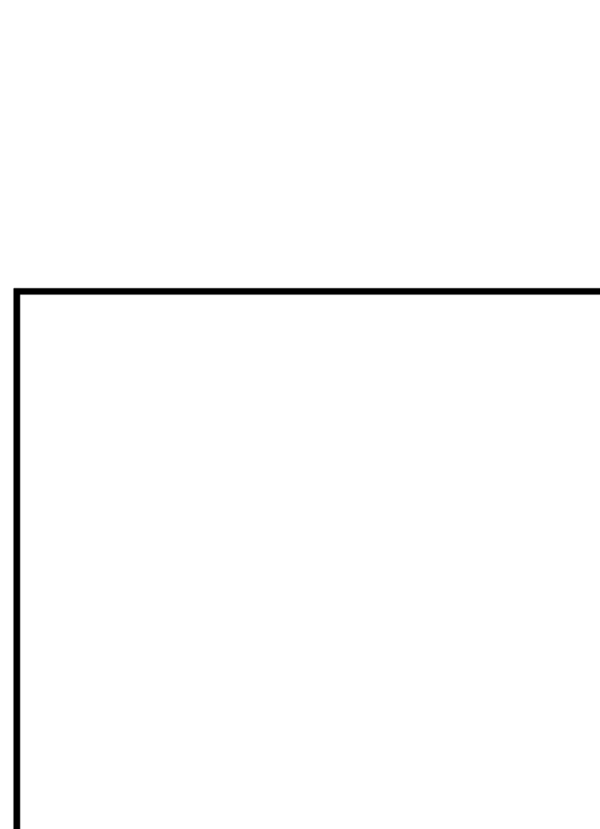

Supp Fig 2: Tree used for simulations to determine the type 1 error rate.
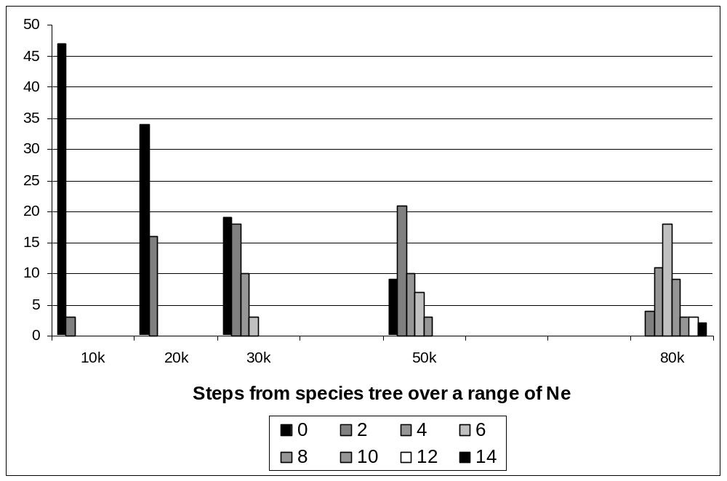
Supp Fig 3: Symmetric distance from the artificial species tree to artificial simulated gene trees under a range of effective population sizes that shows an increased prevalence of lineage sorting.

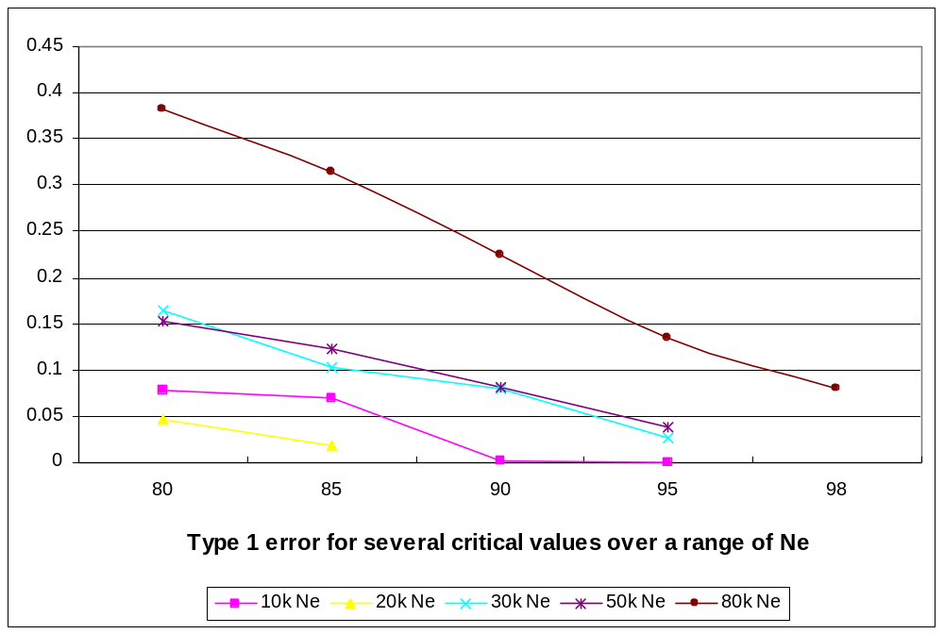
Supp Fig 4: Critical values of tests between a pair of gene trees required (X axis) to produce a given overall p-value (Y axis) under various effective population sizes. For a 5% p-value, critical values of 95% work until lineage sorting increases (shown here by increased Ne). The critical value is the proportion of the distribution of tree-to-tree distances for the simulated pool of trees to their originating gene tree that must not be larger than the tree-to-tree distance between the original pair of gene trees.

The symmetric distance is a topology distance measure (Penny and Hendy, Syst. Zool., 1985). It does not use character information nor branch length differences, only topological distance. The measure counts the number of steps required to convert one tree to another by collapsing nodes and moving a branch to an adjacent branch. This means that two trees identical in all but one terminal placement will differ more if the terminal in question is in distant parts of each tree rather than neighbouring parts of each tree. Lineage sorting is expected to vary trees by having branches placed in very close proximity, thereby limiting the number of steps under this measure. Hybridization has the potential to cause incongruence between less proximal clades and therefore generate larger symmetrical distances. Hybridization that causes only small changes to the symmetrical distance may not necessarily be differentiated from lineage sorting.

