Supplementary material

Branch | GTR1C | GTR16C | GTR1C+RAS
Outgroup –1 | 0.04984 | 0.05102 | 0.05194
1 – 2 | 0.01092 | 0.01128 | 0.01087
1 – 5 | 0.02327 | 0.02401 | 0.02393
2 – 3 | 0.00720 | 0.00743 | 0.00723
2 – Orangutan | 0.01479 | 0.01522 | 0.01495
3 – 4 | 0.00109 | 0.00112 | 0.00106
3 – Gorilla | 0.00714 | 0.00736 | 0.00717
4 – Chimp | 0.00534 | 0.00553 | 0.00536
4 - Human | 0.00495 | 0.00509 | 0.00497
5 - Vervet | 0.01022 | 0.01054 | 0.01034
5 – 6 | 0.00343 | 0.00351 | 0.00337
6 – Baboon | 0.00592 | 0.00608 | 0.00594
6 – Macaque | 0.00546 | 0.00564 | 0.00547
7 – 8 | 0.00050 | 0.00041 | 0.00009
7 – Squirrel Monkey | 0.02957 | 0.03117 | 0.03027
8 – Dusky Titi | 0.03071 | 0.03110 | 0.03140
8 – Marmoset | 0.02962 | 0.03128 | 0.03019

Table 1. Posterior means of the branch lengths for various models for the Ancestral Repeats dataset. Under the assumption of independent evolution, the branches were left undivided for the models with (GTR1C+RAS) and without among-site rate variation (GTR1C). The 16-contexts model however (GTR16C) was estimated with all branches divided in 3 pieces to allow for evolving neighbours as well.

Branch | GTR1C | GTR1C+CpG | GTR1C+RAS
1 – Cyanophora | 0.09867 | 0.09826 | 0.16027
1 – 2 | 0.01168 | 0.01208 | 0.01197
2 – 3 | 0.00840 | 0.00886 | 0.00719
3 – 4 | 0.03049 | 0.03074 | 0.04567
4 – Arabidopsis | 0.03981 | 0.03977 | 0.05393
4 - Taxus | 0.02791 | 0.02806 | 0.03652
3 – 5 | 0.06127 | 0.06132 | 0.09199
5 – 6 | 0.00477 | 0.00455 | 0.00546
6 – 7 | 0.00845 | 0.00850 | 0.01042
7 – Chara | 0.00640 | 0.00637 | 0.00749
7 – Lamprothamnium | 0.00414 | 0.00417 | 0.00508
6 – Nitellopsis | 0.00844 | 0.00840 | 0.01026
5 – Lychnothamnus | 0.00274 | 0.00292 | 0.00339
2 – 8 | 0.00933 | 0.00881 | 0.00960
8 – 9 | 0.00968 | 0.00966 | 0.01261
9 – 10 | 0.00684 | 0.00660 | 0.00902
10 – Coleochaete (2651) | 0.00896 | 0.00887 | 0.01071
10 – Coleochaete (32d1) | 0.00523 | 0.00525 | 0.00625
9 – 11 | 0.00652 | 0.00658 | 0.00747
11 – Coleochaete (3d2) | 0.00245 | 0.00241 | 0.00282
11 – Coleochaete (10d1) | 0.00311 | 0.00320 | 0.00371
8 – 12 | 0.01155 | 0.01204 | 0.01320
12 – 13 | 0.00604 | 0.00615 | 0.00623
13 – 14 | 0.00755 | 0.00785 | 0.00971
14 – 15 | 0.01297 | 0.01302 | 0.01533
15 – Onychonema | 0.00908 | 0.00940 | 0.01186
15 – Cosmocladium | 0.01130 | 0.01095 | 0.01292
14 – Gonatozygon | 0.03737 | 0.03679 | 0.05078
13 – Mougeotia | 0.03936 | 0.03896 | 0.05443
12 – Zygnema | 0.02071 | 0.02048 | 0.02750
1 – 16 | 0.01368 | 0.01355 | 0.01932
16 – 17 | 0.03916 | 0.03964 | 0.06318
17 – 18 | 0.01618 | 0.01606 | 0.01480
18 – Volvox | 0.01732 | 0.01752 | 0.02271
18 – Paulschulzia | 0.00822 | 0.00799 | 0.00883
17 – Chlamydomonas | 0.07150 | 0.07180 | 0.11239
16 – Nephroselmis | 0.03517 | 0.03488 | 0.04971

Table 2. Posterior means of the branch lengths for various models for the Nuclear SSU rRNA dataset. Under the assumption of independent evolution, the branches were left undivided for the models with (GTR1C+RAS) and without among-site rate variation (GTR1C). The CpG (context-dependent) model however (GTR1C+CpG) was estimated with all branches divided in 4 pieces to allow for evolving neighbours as well.

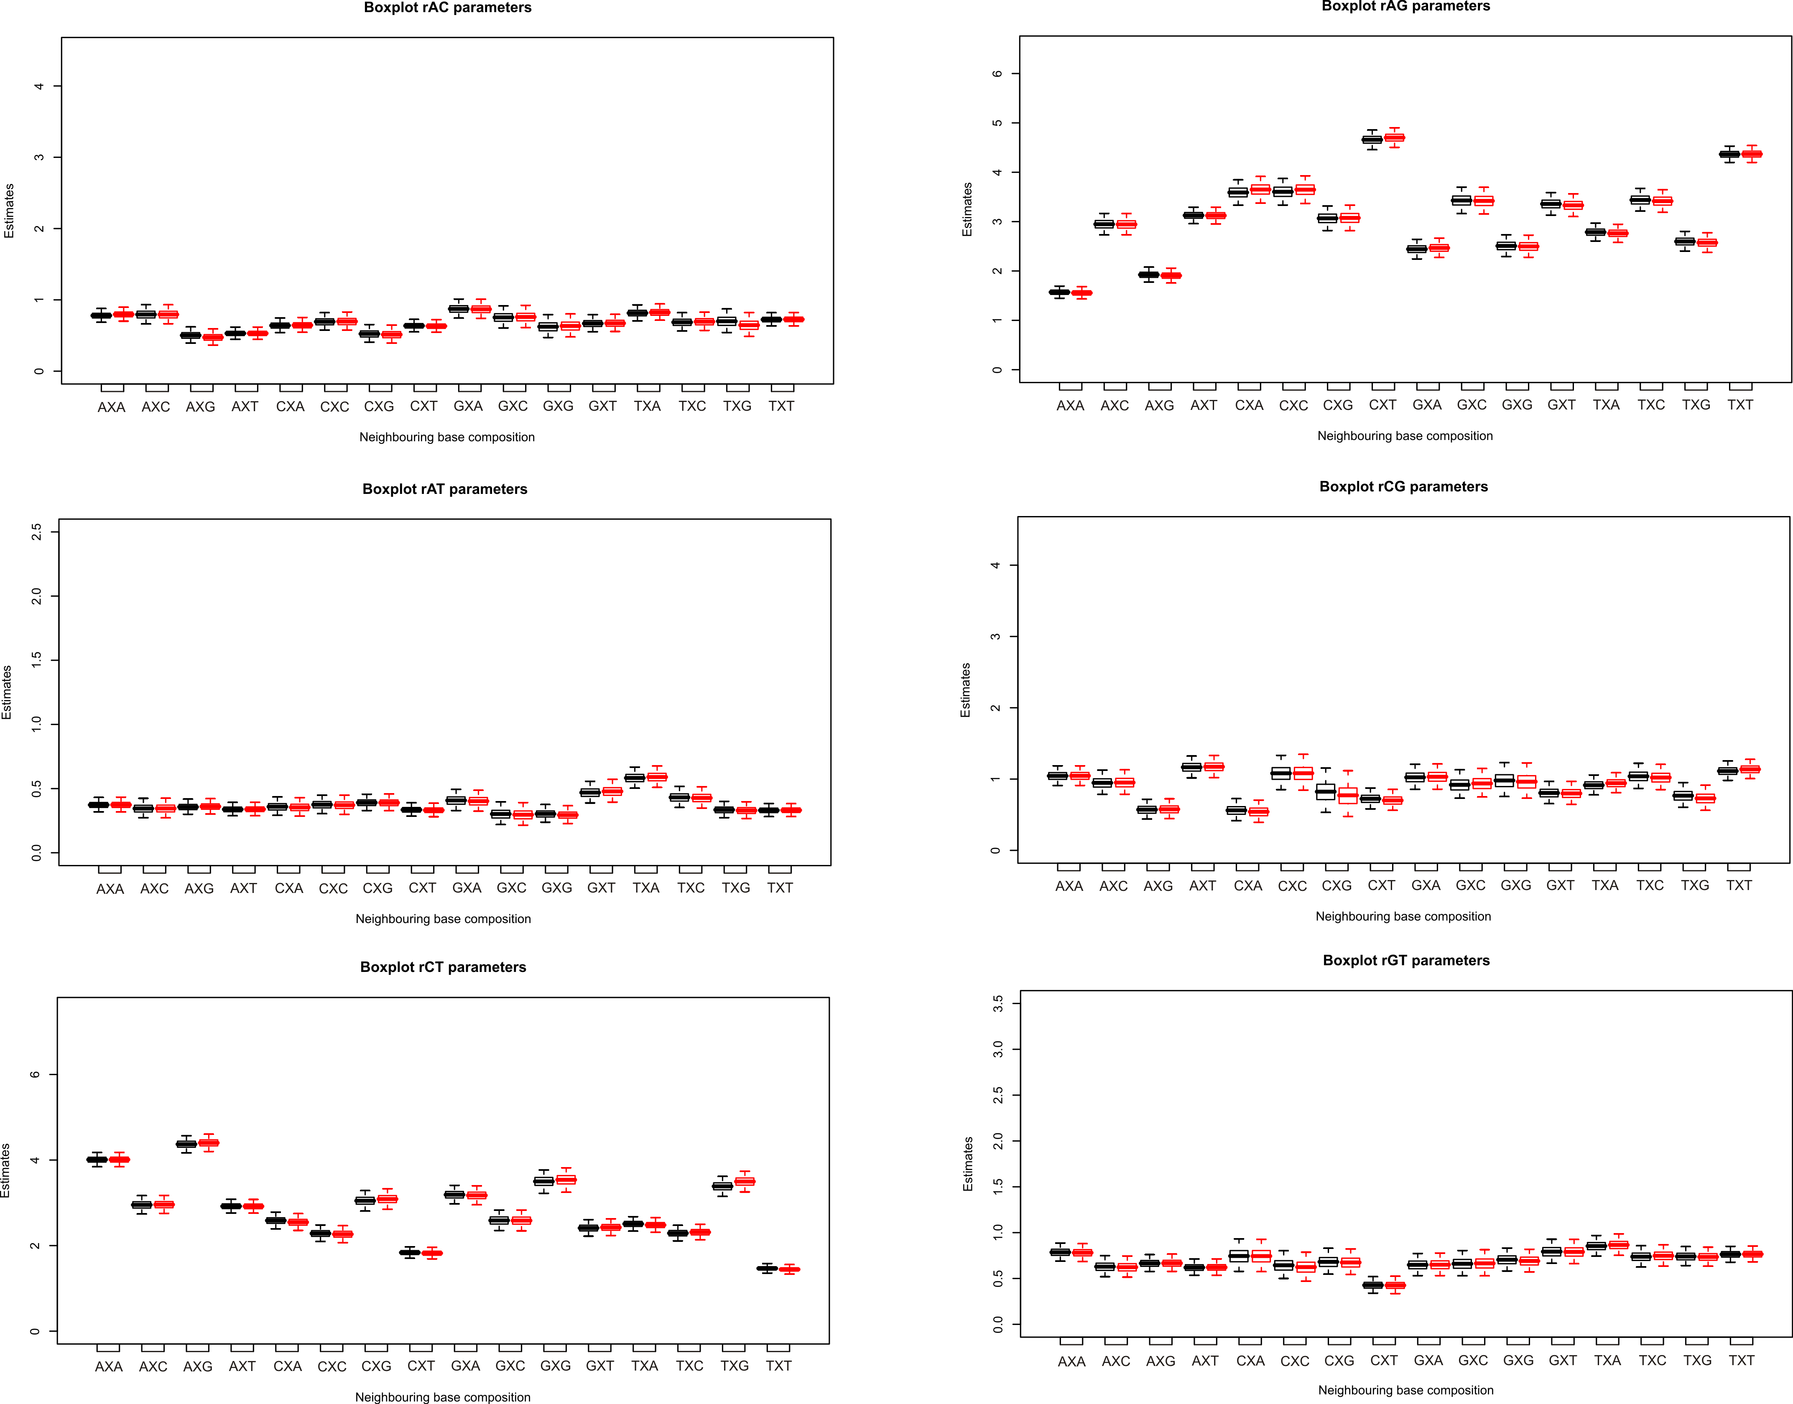
Figure 1. Comparison of the parameter estimates for the Ancestral Repeats dataset between undivided branches (black) and branches divided in 3 pieces (red). The differences are rather small but given the fact that dividing the branches is biologically more realistic, we have used the latter parameter estimations for the discussion of the substitution behaviour.

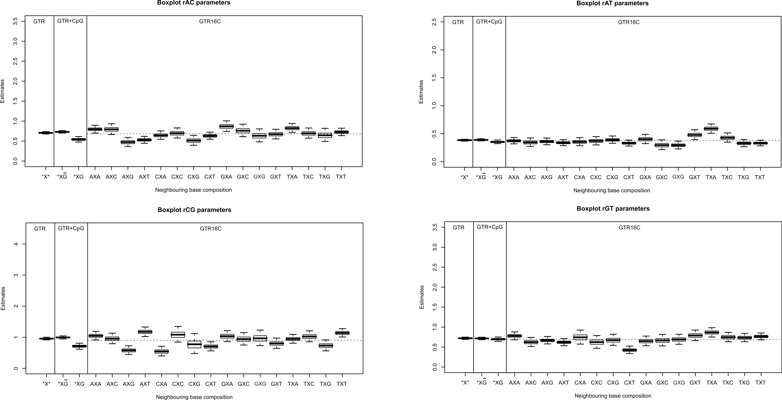
Figure 2. Transversion parameter estimates for the Ancestral Repeats dataset for the different models (the independence model: GTR, the CpG model: GTR+CpG and the 16-context dependent model: GTR16C) with branches divided in 3 pieces. Small differences depending on evolutionary context can be observed for the rAT estimates, with somewhat larger differences for the rCG estimates.

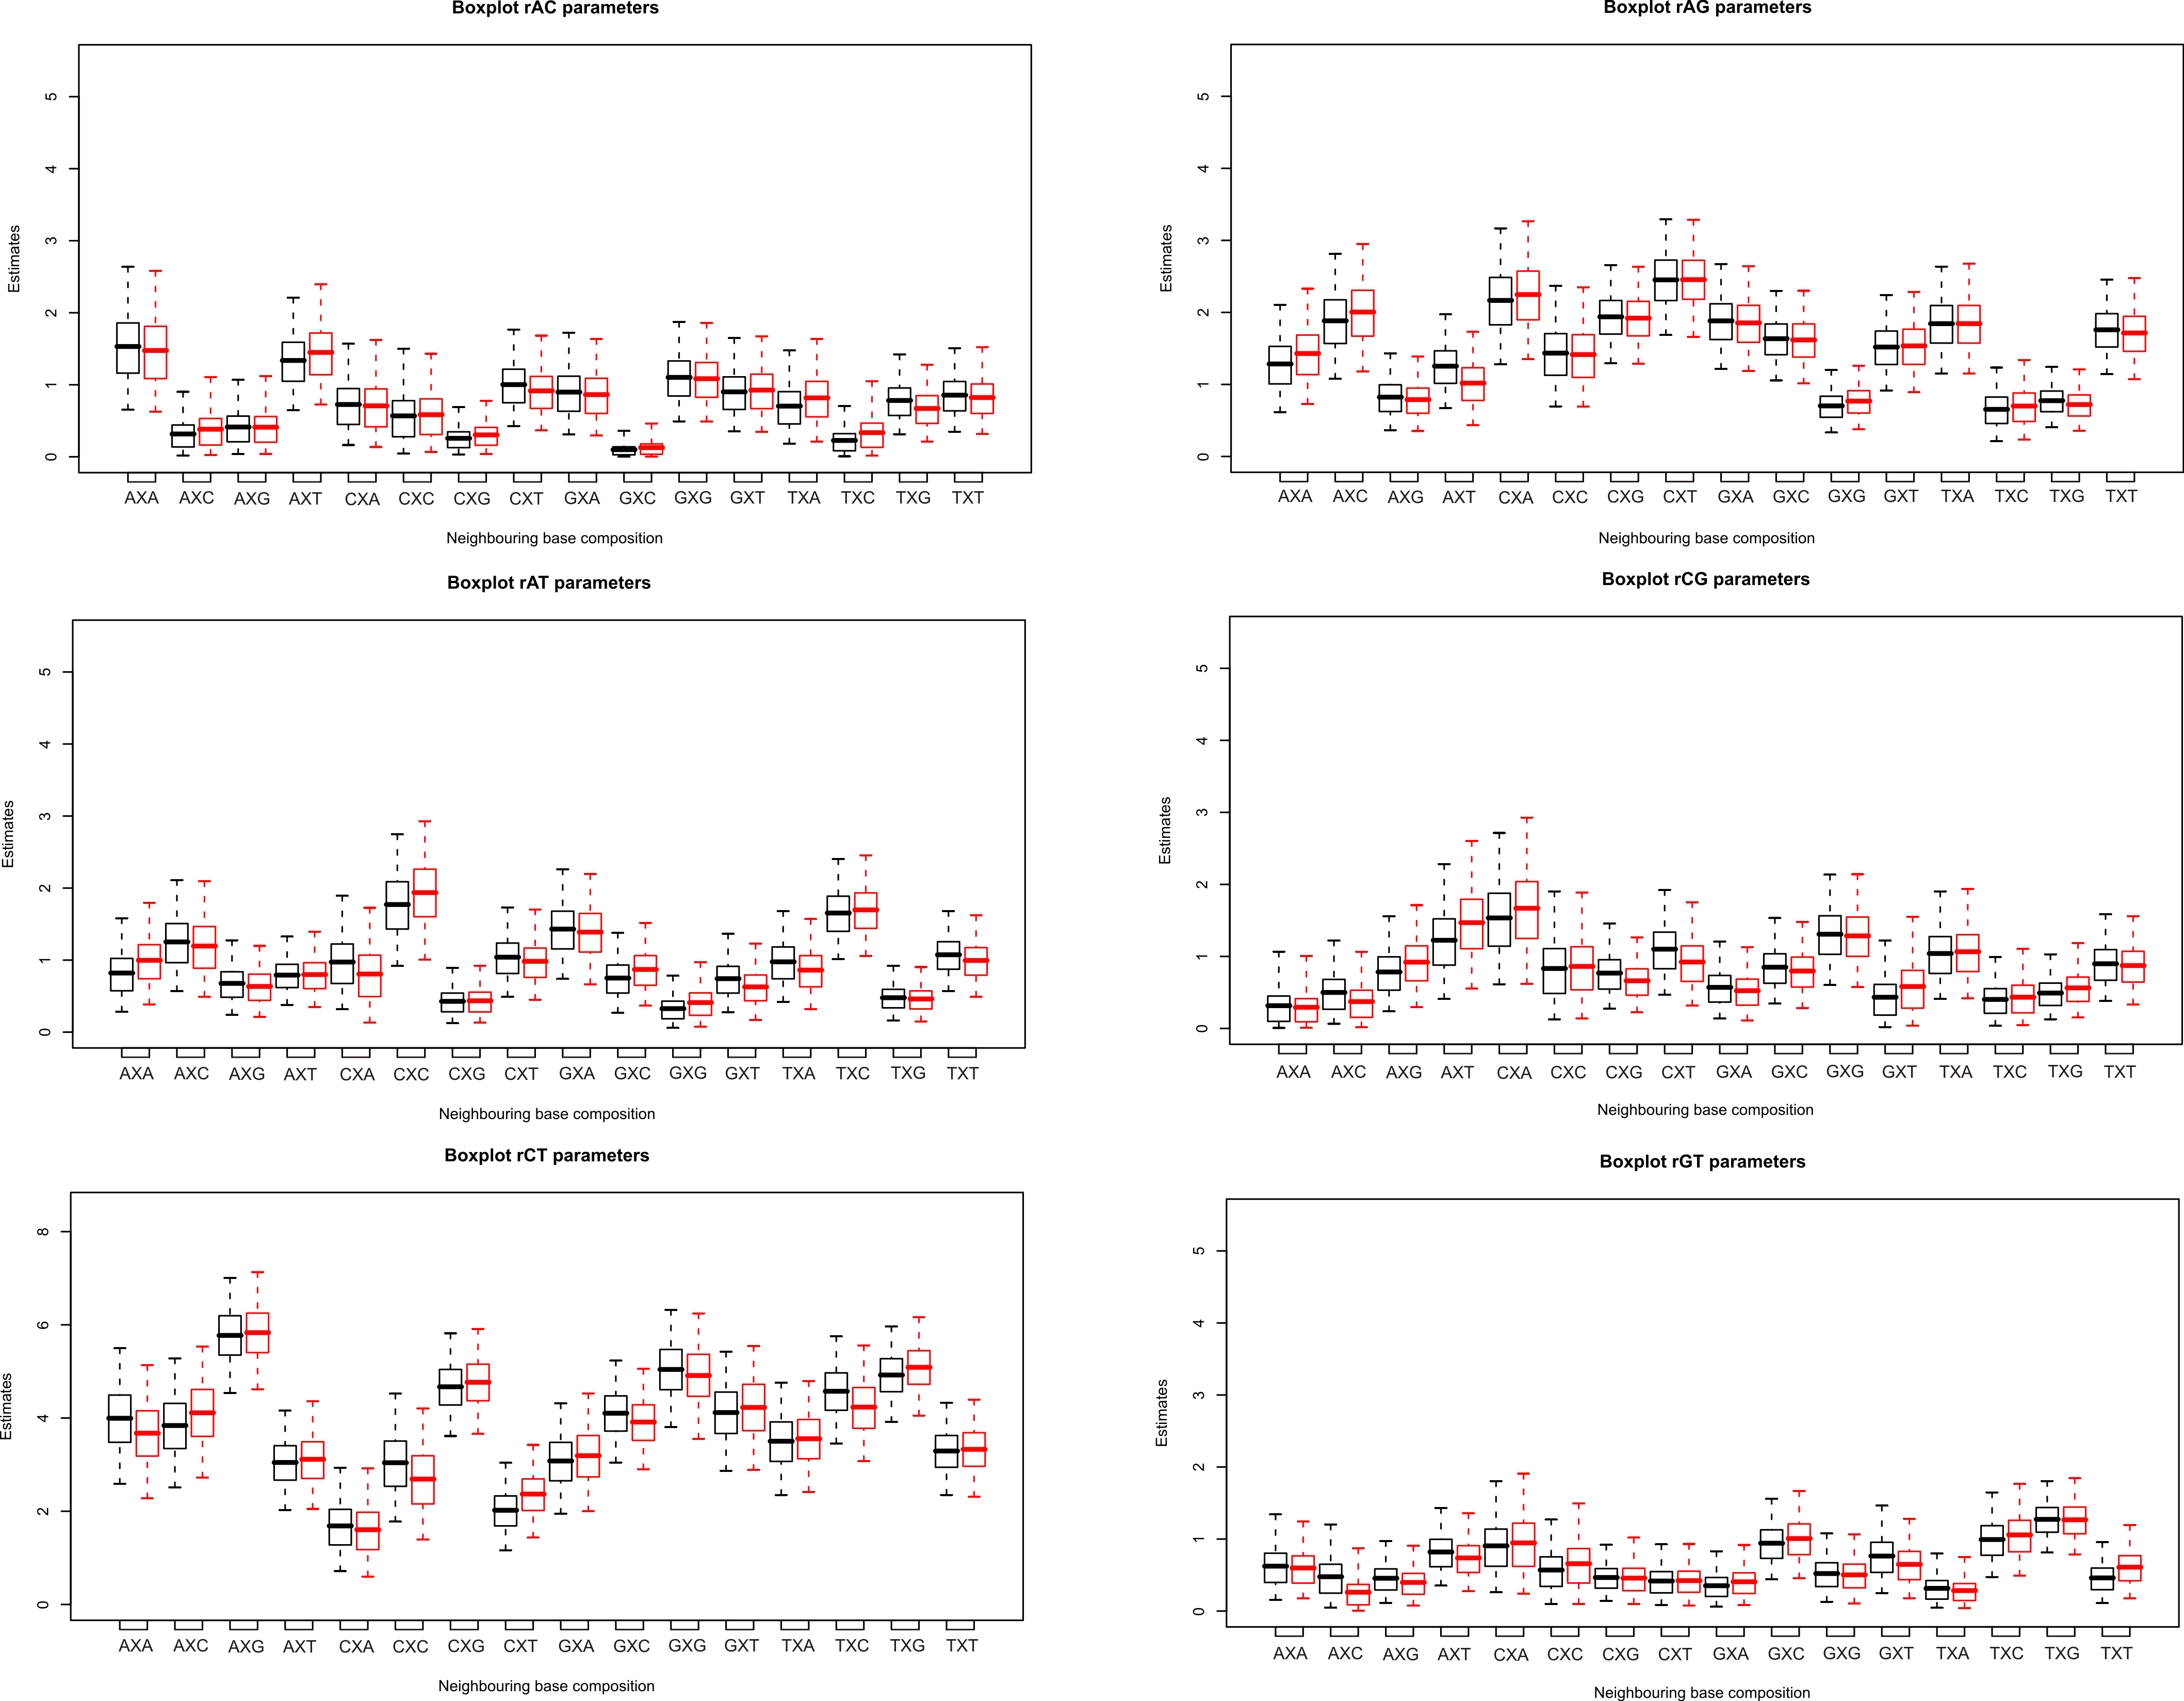
Figure 3. Comparison of the parameter estimates for the Nuclear SSU rRNA dataset between undivided branches (black) and branches divided in 4 pieces (red). Again, the differences are rather small but given the fact that dividing the branches is biologically more realistic, we have used the latter parameter estimations for the discussion of the substitution behaviour.

