SSB Annual Council Meeting Minutes
Friday, June 10, 2:30 pm
IARC 401
University of Alaska, Fairbanks

Call to Order & Welcome, Pam Soltis, President SSB

Attending: Pam Soltis (President), Scott Edwards (President-Elect), David Cannetella (Past-President), Keith Crandall (Executive Vice-President), Vicki Funk (Treasurer/Board of Trustees), Rod Page (Editor), Kelly Zamudio (Awards Director), Chris Simon (Publications Committee Chair), Jeff Boore (Council), David Hibbett (Council), Sydney Cameron (Council), Maureen O’Leary (Council), Scott Steppan (Council), Elizabeth Jockush (Council), Shannon Hackett (Council), Debbie Ciszek (Journal), Andrew Moyer (Taylor-Francis).

Not Attending: Joel Cracraft (Board of Trustees), Terry Yates (Board of Trustees), George Weiblen (Program Director), Priscilla Tucker (Council), Louise Lewis (Council), Bruce Baldwin (Council), Billie Swalla (Council), John Wiens (Council).

Cliff Cunningham, NESCent presentation with associated brochure. Postdocs and sabbatical support available. Proposes to come to annual council meeting to hear feedback on the center. Presentation on Saturday 3:45 pm and town meeting on Sunday at 12-1pm more extensive meeting and discussion.

Joint Council Meeting Report, Pam Soltis. See minutes from Joint Council Meeting for details. Soltis requests suggestions and/or volunteers to serve on a committee representing all three societies to address issues associated with evolution education, etc. Suggestions included Paula Maybee and Kevin Padian.

SSB Symposia for 2006 – Stony Brook, Pam Solits; Discussion of proposal by Althoff and Segraves. Cannetella moves to extend deadline to September 1 for additional proposals and evaluate Althoff and Segraves proposal independently. Seconded by Jockush. Unanimously passed. Councilors will solicit additional proposals from good talks throughout the meeting. Funk moves to accept the Althoff proposal. Second by Cannetella. Approved unanimously.

Financial Report, Vicki Funk. Funk presents profit/loss schedule for 2004 fiscal year and balance sheet for 2004 fiscal year. A discussion was had on the awards for SSB in terms of total award budget ($45,000 was spent in 2004, $42,000 in 2005). We need to consider student travel awards for the 2007 New Zealand meetings.

2004 ANNUAL REPORT RESERVE FUND TRUSTEES
TERRY L. YATES, JOEL CRACRAFT, VICKI FUNK

The past year was a fair one for the market with the Nasdaq ending the year up 8.73%, Standard and Poor’s 500 closed up 9.14% and the DOW gained 3.31% for the year. The SSB reserve fund faired moderately well, experiencing a gain of 6.61% ($ 31,002) over the value on 31 December, 2003. The Trustees are also happy to report that all but one of the society’s accounts which were distributed over 7 accounts in 6 states have been consolidated into one in Albuquerque and the remaining fund will be moved soon. This consolidation will make it much easier for us to manage our portfolio into the future but resulted in an accounting error in our report last year. One of our funds, The Nicholas Fund, did not transfer into the Albuquerque account until 15 December and was double counted by us in the year end report. The adjusted 2003 year end value should have been reported as $468,845 which is still a 22.8% gain over the previous year. Over the past two years our reserve fund has increased in value by $117,935 and did not receive any contributions or other cash transfers. The total value of the reserve fund as of 31 December, 2004 was $499, 847. The Trustees have chosen to maintain a balanced portfolio primarily of mutual funds. Although some consider this a conservative approach, we feel this offers the potential for the greatest amount of growth with the least amount of risk. The status of our investments and the distribution of funds as of 31 December, 2004 is provided below.

STATUS OF ASSETS 31 DECEMBER, 2003 31 DECEMBER, 2004

Market % Market %
Value Value of fund
_______________________________________________________________________
Cash and Money Market $248,259 53.0 $ 74,117 14.8

Common Stocks $220, 586 47.0 $ 425,729 85.2

Value of Reserve Fund $468, 845 $499,847

% Change +22.8 +6.6

Annual Allocation to Operations 0 0

Net Reserve Principal $468, 845 $499, 847

Change in value for year + $86,933 + $31,002

Change in value since 31 December, 2002 + $117,935

Trustees Report, Vicki Funk. All accounts have now been consolidated into a single account in New Mexico. The fund performed reasonably well with a 6.6% increase for 2004 fiscal year. Trustees have phone conference twice a year to discuss investment options. Cannetella moved to accept financial reports, second by Jockush. Unanimously approved.

Membership Contract with Burk, Vicki Funk. Options are presented with Burk running our membership. Page would like integration of website and membership list, including ability to join society online. Also, will Burk handle electronic balloting? Cannetella asks about copying, telephone, etc. charges. Funk will check on those. Cannetalla moves to approve the proposal to use Burk to cover membership issues for SSB. Seconded by Steppan. Unanimously approved.

Award Announcements, Kelly Zamudio. Funded 10 graduate student awards at $1800, 6 international travel awards, for mini-Peet and Ernst Mayr awards. Concerns include advertising. Currently advertising on EvolDir, in the journal, and through website. Funk suggests targeting museums and including advertisement on the bottom of our emails. Second concern is one of membership. Travel awards for international applicants should not have to be members. Memberships will be paid from their awards. Zamudio will not be attending meetings next year and will appoint a member of the Awards Committee to run the Ernst Mayr competition next year.

Council Meeting SSB 2005
Awards Committee Report

Awards Committee:
Kelly Zamudio (Chair)
Elizabeth Jockusch (Grad Awards)
Karl Kjer (Grad Awards)
Louise Lewis (International Travel and Mini-PEETs)
Ken Halanych (International Travel and Mini-PEETs)
Rick Ree (Mayr)
Jack Sullivan (Mayr)

This year, the awards committee handled all four awards. We received 49 Grad Student Research Proposals, 12 International Travel proposals, 18 mini-PEET proposals, and 11 Mayr Award Abstracts for consideration.

This represents a 25% increase in number of applicants relative to last year in
Grad Student Award, but significant decrease in number of applicants in other categories
(up to 50%). Given this imbalance, and at the suggestion of the executive committee, we re-allocated monies among award categories to reflect the number of applications. We funded 10 Grad Awards ($1,800 each, total $18,000), 6 International Travel Awards (range $1800 - $2800, total $12,000), and 4 Mini-PEETs (range $2,000-$3,400, total $12,000).

Payment of awards this year was streamlined. With Vicki Funk’s help, we gathered all tax forms required for disbursement of awards, and created a flow chart with specific instructions on how to claim an award. These materials were posted on the website; I have heard from students that this greatly facilitated the process, especially for International Scholars.

The committee chair discussed three issues and requested feedback from the council on some procedural changes:

- Increasing the applicant pool for International Awards and Mini-PEETs. This year we had a decrease in the number of applicants in the two researcher categories (International Travel and mini-PEETs), even though we advertised these awards on the web site, in the journal, and with two postings on evoldir. International Awards in particular would have benefited from wider advertisement. The council discussed some ways to reach young systematists in under-developed countries, including advertisement with the main molecular evolution and systematics classes our visitors usually attend (Wood’s Hole, North Carolina), and targeting museums in other countries.

- This year we strictly enforced the eligibility requirement of SSB membership for all student applicants. We did not enforce the membership requirement for International Applicants. Not surprisingly, very few of the applicants for Int Travel are members and it was agreed that it might be unfair to ask these applicants to commit limited resources at the time of application. Instead, we evaluated all International Travel Applicants and asked them to pay their dues once they knew they were awarded.

- Budget. The number of grad student research awards has grown substantially in the last few years. This year, with our fund re-allocation and slight decrement in the total award size ($1800 instead of $2000), we were able to fund 10 proposals (20% funding rate). Many meritorious proposals were not funded. This award in particular could benefit from extra funds.

- Travel Awards for New Zealand Meeting. The council discussed the possibility of using part of the award budget in 2007 to defer costs of graduate student travel to the Auckland Meeting in 2007. This meeting support award would be a one-year competition.

2006 Award Winners
Graduate Research Awards
Kyle Dexter Duke University
Michael D. Nowak Duke University
Randall Langerhans Washington University
Maxi Polihronakis University of Connecticut
Catherine Wagner Cornell University
Timothy D. Swain Florida State University
Lucía A. Luna Wong University of Michigan Ann Arbor
Matthew D. Herron University of Arizona
Daniel Rabosky Cornell University
Elen Oneal University of Michigan Ann Arbor

International Travel Awards
Cinthia Brasileiro, Universidade Estadual de Campinas, Brazil
Henry Perdigon, University of the Phillipines
Cecilia Kopuchian, Museo Argentino de Ciencias Naturales, Argentina
Susanna Dipenaar, University of Limpopo, South Africa
Leandro Jones, Instituto de Virología, CICVyA, Argentina
Amit Kumar Singh, Indian Institute of Technology, India

Mini-PEETs
Valérie Reeb Duke University
Carol Dean von Dohlen Utah State University
Micah Saul Dunthorn University of Massachusetts- Amherst
Rebecca L. Belcher Auburn University

Ernst Mayr Award
Heather Maughan University of Arizona
Jonathan Richmond University of Connecticut

Election Results: Keith Crandall reported on the election results for the 2006 positions. Chris Simon was elected President-Elect, Keith Crandall Executive Vice President, Vicki Funk Treasurer, George Weiblen Program Director, and Michael Donoghue, Jack Sullivan, Fredrik Ronquist, Lacey Knowles, and Marshal Hedin as Coucilors through 2008.

Journal, Rod Page, presents report on journal. Some discussion on Open Access. Funk recommends that if authors need open access due to funding agencies that we can put those papers up on the website for open access. O’Leary suggests that Morphobank or other such database be listed as depository for morphological data as the TreeBase requirement suggested by Page for molecular data.

Editor’s Report Evolution meetings 2005

Rod Page & Debbie Ciszek, June 2005

Summary
The journal will introduce two new features that will mean big changes to how the journal is run. The first is the (delayed) introduction of Manuscript Central; the second is eFirst. In general things have been going well, but there are some issues concerning production that have caused problems, namely the cover and the online issue. Future things to think about include whether to have some degree of Open Access (e.g., for specific papers), and finding the next editor.

Changes

This year will likely see two major changes in the way the journal is produced, namely the introduction of Manuscript Central and eFirst.

Manuscript Central

The introduction of Manuscript Central “real soon now” has taken longer than originally planned, I think largely because these things do tend take longer than planned, and also because of the way Manuscript Central works. Essentially, rather than us communicating directly with Scholar One (who run Manuscript Central), we give our requirements to a contact at Taylor and Francis, who then passes these on to Scholar One, who then make the changes (or say they can’t do this), and then this comes back to us via Taylor and Francis. It has been rather frustrating for Debbie because the contact at Taylor and Francis (Vincent Lizzi) has been slow in responding at times. We now have a new contact person at Taylor and Francis (Rachel Rivitsky), so hopefully things will be completed soon.

eFirst

Taylor and Francis are introducing eFirst. Under this system, once a the final version of a manuscript has been through Taylor and Francis’ production system it will go online immediately, rather than waiting for the corresponding printed journal issue to be put together (the online article will have the same page numbers as the printed version). This means that articles will appear sooner than previously. By default, articles will be released in the order Taylor and Francis receives them, and a printed issue will appear at the usual time and will comprise those papers already made available on the eFirst (up to the page limit for the issue). We do have some flexibility, however, and we will retain both the separation between regular articles and Points of View, and we will be able to keep symposium papers together as we currently do.

Problems
In addition to delays with Manuscript Central, there are two areas of production that have been problematic: the cover and the online version.

Cover
The cover artwork has caused problems due to colour matching. Basically, printers and computer screens use two different colour systems (RGB and CKMY, respectively):
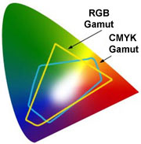
The upshot is that printed cover art may look rather different from the original when viewed on a computer screen. The spectacular cover for the February 2005 issue caused Debbie a lot of grief because of this. This can be gotten around by using CKMY colour matching, which programs like Photoshop and Illustrator support. We are investigating this further, and are hoping to be able to generate cover art that when printed looks exactly like the original. However, it is now clear that some colours are very hard to print (see figure to the right).

One unfortunate mistake made on February’s cover is the use of Times for the Systematic Biology banner, rather than the correct font (LeamingtonEF).

Online edition

The online issue for February 2005 had some problems. The DOIs don’t work, and the Point of Views by Sparks and Smith, and by Smith and Turner both have broken links. The Sparks and Smith paper did not appear in the table of contents, but when the user clicks on the PDF for Smith and Turner they got Sparks and Smith.

Member access to online version

It is now possible to access the journal through the Society’s web site (http://systbiol.org). This is set up so that only users that can log on to the web site can access the journal. Access itself is via a static web page on a server at Glasgow University (T&F requires a static link for authentication). We don’t have a mechanism to use membership numbers to control access. This is unfortunate. If we were to announce to members that they could access the site, at present I would have to manually check each email and user name before granting them access.

Other changes

Staff changes

Melissa James is no longer our contact at T&F (she has left to undertake a Masters degree in education. Andrew Moyer is our new contact until Melissa’s replacement is found.

TreeBASE

One change I’ve made to the author instructions is to now require that data sets be submitted to TreeBASE. In my opinion TreeBASE has a lot of problems, but I’d much rather have data stored somewhere than not at all.

Simulation data

Where possible I’m trying to encourage authors of simulation studies to make their data available on the Syst Biol web site. This can be problematic if a study has generated gigabytes of output, but in some cases we can improve repeatability by storing some of the data or parameters. For example, if we have the topology of the tree used to generate some sequences in Seq-Gen, then others could download that tree and generate data under the same conditions.

LaTeX

We are getting what seems like a growing number of manuscripts in LaTeX, especially from theoreticians. LaTeX by default doesn’t support the reference style used by the journal (typically references are numbered), so I have made a template for use in LaTeX, based on one sent by Ashleigh Smythe.

Figures

In general, vector drawings (e.g., EPS) are preferable to bitmaps (e.g., TIFF, JPEG) in tterms of both file size and final quality. We are encouraging authors to submit artwork in EPS files. At some point I hope to some guides to image file formats on the web.

Future things to think about

Next editor

Like a fool, I’ve spent little or no time thinking about this.

Open Access

To date there hasn’t been much demand for the journal to go Open Access. Probably in the short term the only pressure for this will come from funding agencies. Do we need to explore having an option where authors can pay a fee to make an article Open Access? For example, one potential author informed me that they could not submit an article to Systematic Biology because they can only publish in Open Access journals.

Systematic Biology manuscript statistics

International submissions: In the year 2004, 66% of submissions came from outside the US, from 24 different countries. Once again, this is evidence that Systematic Biology is a very international journal. In 2003, 51% of submissions were from outside the US; in 2002, 45% of submissions were from outside the US and in 2001, 62% of submissions were from outside the US.

Country of residence, corresponding author | 2001 | 2002 | 2003 | 2004
USA | 45 (38%) | 77 (55%) | 79 (49%) | 50 (34%)
Canada | 8 | 14 | 7 | 16
Puerto Rico | 1 | 0 | 0 | 0
Mexico | 0 | 0 | 0 | 1
Columbia | 0 | 1 | 0 | 0
Brazil | 4 | 3 | 0 | 0
Uruguay | 0 | 0 | 0 | 1
Argentina | 2 | 1 | 2 | 1
UK | 15 | 10 | 17 | 16
Ireland | 1 | 0 | 0 | 0
Norway | 1 | 1 | 0 | 0
Sweden | 3 | 6 | 7 | 4
Finland | 1 | 0 | 0 | 0
Denmark | 1 | 0 | 2 | 1
France | 4 | 6 | 8 | 10
Spain | 0 | 2 | 5 | 4
Portugal | 1 | 0 | 0 | 0
Belgium | 1 | 1 | 2 | 7
The Netherlands | 0 | 2 | 1 | 2
Germany | 6 | 1 | 6 | 10
Poland | 0 | 0 | 0 | 2
Austria | 2 | 1 | 1 | 2
Switzerland | 1 | 1 | 2 | 1
Italy | 1 | 0 | 0 | 0
Greece | 0 | 0 | 1 | 0
Turkey | 0 | 0 | 0 | 1
South Africa | 2 | 1 | 3 | 0
Israel | 1 | 1 | 1 | 1
Iran | 0 | 0 | 0 | 2
Pakistan | 1 | 0 | 0 | 0
India | 0 | 1 | 0 | 1
PR China | 0 | 2 | 4 | 3
Japan | 4 | 1 | 1 | 1
Thailand | 0 | 0 | 0 | 1
Australia | 8 | 2 | 7 | 6
New Zealand | 5 | 4 | 4 | 3
Fiji | 0 | 0 | 1 | 0

Current status of manuscripts (as of 31Mar05):
This includes all manuscripts except book reviews. The category “not revised” means the ms was accepted pending revision but the author declined to revise. “Withdrawn” means the author withdrew the paper before the first reviews were completed. The statistics for 2004 are still preliminary because the final status of some papers is not yet known.

Current status of ms’ submitted in 2001
Number of manuscripts submitted | 119
mean # weeks in review (stand. dev.) | 15 (9)
Number currently in review | 0 | 0%
Number returned w/o review | 14 | 12%
Number rejected | 45 | 38%
Number not publishable in present form | 0 | 0%
Number not revised | 3 | 2.5%
Number withdrawn | 1 | 0.8%
Number accepted; not yet published or sent to press | 0 | 0%
Number published | 56 | 47%
Total rejected | 62 | 52%
Total accepted | 56 | 48% acceptance rate
Number Point of View submissions | 30 | 25% of submissions
Number regular paper submissions | 89 | 75% of submissions
Number POVs accepted | 15 | 50% acceptance rate
Number regular papers accepted | 41 | 46% acceptance rate

Current status of ms’ submitted in 2002
Number of manuscripts submitted | 139
mean # weeks in review (stand. dev.) | 13 (9)
Number currently in review | 0 | 0%
Number returned w/o review | 17 | 12%
Number rejected | 36 | 26%
Number not publishable in present form | 0 | 0%
Number not revised | 1 | 0.7%
Number accepted; not yet published or sent to press | 0 | 0%
Number published or sent to press | 85 | 61%
Total rejected | 54 | 39%
Total accepted | 85 | 61% acceptance rate
Number Point of View submissions | 37 | 27% of submissions
Number regular paper submissions | 102 | 73% of submissions
Number POVs accepted | 15 | 40.5% acceptance rate
Number regular papers accepted | 70 | 68.6% acceptance rate

Current status of ms’ submitted in 2003
Number of manuscripts submitted | 160
mean # weeks in review (stand. dev.) | 14 (7.5)
Number currently in review | 0 | 0%
Number returned w/o review | 24 | 15%
Number rejected | 52 | 32.5%
Number not publishable in present form | 0 | 0%
Number not revised | 3 | 2%
Number accepted; not yet published or sent to press | 2 | 1%
Number published or sent to press | 79 | 49.4%
Total rejected | 79 | 49.4%
Total accepted | 81 | 50.6% acceptance rate
Number Point of View submissions | 40 | 25% of submissions
Number regular paper submissions | 120 | 75% of submissions
Number POVs accepted | 17 | 42.5% acceptance rate
Number regular papers accepted | 64 | 53% acceptance rate

Current status of ms’ submitted in 2004
Number of manuscripts submitted | 147
mean # weeks in review (stand. dev.) | 11 (7) | this value is low - some
 |  | ms’ still in review
Number currently in review | 3 | 2%
Number returned w/o review | 36 | 25%
Number rejected | 37 | 25%
Number not publishable in present form | 12 | 8%
Number accepted; not yet published or sent to press | 16 | 11%
Number published or sent to press | 43 | 29%
Total rejected | 85
Total accepted | 59 | *41% acceptance rate
Number Point of View submissions | 34 | 23% of submissions
Number regular paper submissions | 113 | 77% of submissions
Number POVs accepted | 16 | 48% acceptance rate
Number regular papers accepted | 43 | 38% acceptance rate

* current acceptance rate is lower than actual, because some ms’ are still in review and some of those currently “not publishable in present form” will likely eventually be accepted.

Manuscript processing time summary statistics:
Length of time to return first reviews to the author and length of time from submission to publication. “First reviews” are those on the original submission as opposed to a revision. Ms’ are included only if they underwent full review. Symposia and book reviews are not included because their review process is different from that of other papers.

 | Time to return of |  |  | Time from submission
 | first reviews (weeks) |  |  | to publication (months)
Year Submitted | 2001 | 2002 | 2003 | 2001 | 2002 | 2003
Mean | 16.6 | 16.3 | 16.8 | 14.0 | 13.0 | 13.2
Variance | 69 | 55 | 46 | 53 | 42 | 25
Standard Deviation | 8.3 | 7.4 | 6.8 | 7.3 | 6.5 | 5.0

Submission rate:
The number of papers submitted has increased by about 40% from 1998 to 2004. The graph below shows total number of submissions each year, and number of submissions through May of each year (this was included so that 2005 could be compared to previous years). The submission rate continues to increase.
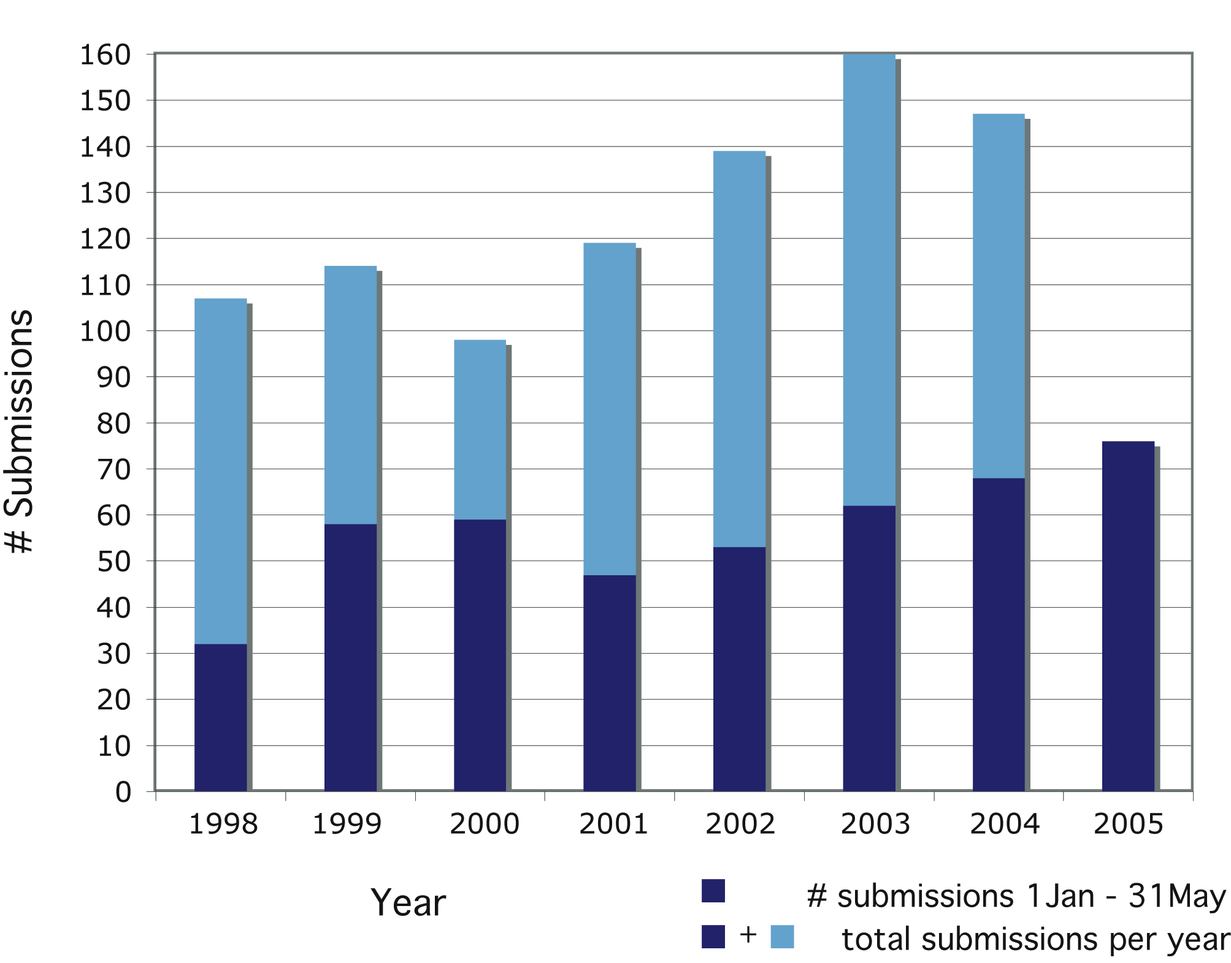

Length of papers:
Of papers submitted in 2004 (not including book reviews) we have received final versions for 46 manuscripts. The average estimated length of regular articles is 15.7 printed pages (stand. dev. 4.5). The average estimated length of POV’s is 7.3 printed pages (stand. dev. 2). These values are estimated because most of these papers have not yet appeared in print.

The graph below shows the lengths of the 71 papers published in 2004 (all were submitted prior to 2004), not including book reviews. The average length of regular articles was 14.4 printed pages (stand. dev. 5.6); the average length of POV’s was 8.6 printed pages (stand. dev. 3).

Publications Committee Report – Chris Simon. Chris is chair of committee with Cannetella, Page, Funk, and Richard Olmstead. Next contract for 20MAY2007 through 2012. Share ideas with SSE who is also working on a new publishing contract. Allen Moore is heading this search for SSE. Approval of new editor at next year’s annual meeting. Publisher’s award chosen by President and Editor.

Proposed Constitutional Amendments, Pam Soltis. Simon suggests addition of a description of the mid-year Executive Council meeting to the ByLaws. After extensive discussion, proposed changes to the constitution (because they were fairly numerous, although not extensive) was postponed for email action. Proposed changes will be sent out via email for Council feedback and then a Council vote will be held via email. EVP Crandall will coordinate these efforts.

Proposed Long-Term Planning Committee, Pam Soltis. Anne Yoder, John Wiens, and Scott Steppan were within the last year or two a long-term committee meeting. Cannetella will send report from this committee to Soltis.

Funk proposes to award Jim Rodman a Society Award for service to the field at next year’s meeting in Stony Brook. Funk also requests a financial report from the joint council meeting. Soltis will get accounting from meeting. Note added: The idea of a Society Award to recognize Jim Rodman of the NSF DEB Systematic Biology Program has been fully supported by the Council via email discussion.

Meeting adjourned 6:10 pm.

