SSB Annual Council Meeting
June 23, 2006
State University of New York, Stony Brook
2:00 pm – 5:30 pm Wang Center 101

Minutes

Call to Order & Welcome – Scott Edwards, President SSB

Attending: Scott Edwards (President), Pam Soltis (Past-President), Chris Simon (President Elect), Keith Crandall (Executive Vice President), Vicki Funk (Treasurer), George Weiblen (Program Director), Jessica Gurevitch (for Kelly Zamudio – Awards Director), Joel Cracraft (Board of Trustees), Rod Page (Editor), Priscilla Tucker (Councilor 06), Marshal Hedin (Councilor 08), Michael Donoghue (Councilor 08), Lacey Knowles (Councilor 08), Jack Sullivan (Councilor 08; Editor Elect), Louise Lewis (Councilor 07), Maureen O’Leary (Councilor 07), Scott Steppan (Councilor 07), Bruce Baldwin (Councilor 07), Debbie Ciszek (Managing editor), Juan Carlos Morales (NSF)

Not Attending: Jeff Boore (Councilor 07; Via Skype), Billie Swalla (Councilor 06), Sydney Cameron (Councilor 07 – represented by Jim Whitfield), Shannon Hackett (Councilor 06), Fredrik Ronquist (Councilor 08), David Hibbett (Councilor 06)

Discussion on role of Council Members – to promote the role of systematics at our own institutions; promote the Society and associated awards opportunities; solicit activities for meetings (symposia etc.); help increase membership to the Society. Please be ambassadors for the Society.

Joint Council Meeting Report - Edwards
Discussion led by Massimo Pigliucci to take on creationism and intelligent design as they try and infiltrate science curricula in public schools. Pigliucci wants to set up a more organized effort across societies. Teacher education activities are already underway through AIBS and NESCENT is hosting evolution education (but NESCENT is not interested in political activities associated with ID). Pigliucci suggests that each society develop a committee to form a joint committee and should liason with the SSE Education Committee. Donoghue suggests that the Pigliucci’s document is very general but with no specific requests or proposals for SSB to consider. Weiblen says that the goal is to have societies embrace the ideas of the document and nominate a representative to sit on a joint committee.

Updates on coming meetings: 2007 Christchurch, New Zealand, 2008 Minnesota, 2009 Brown University, 2010 Portland State University, 2011 University of Costa Rica (in July). Conflicts with ESA first week in August and the international congress of botany in 2011. Jessica Gurevitch suggests the idea of a meeting planner and part-time Executive Director to be hired jointly by the three societies. Would like to know if the SSB has an interest in supporting such a position. A discussion of advantages and disadvantages of having such a person. SSB already contracts out membership and accounting. This would add additional strain on the budget. Difficulties in working with universities for professional meeting planners. Funk suggests that Simon, Weiblen, and Mindell work together to explore the idea relative to our budget.

Update from NSF with discussion about funding rates (10%) and overburden of reviewers. NSF will have an information session on Sunday at noon. New report from the Committee of Visitors which recently evaluated NSF DEB will be available on their website shortly.

Update from NESCENT director Kathleen Smith. They have opportunities for partnerships in data management, catalyst groups, working groups, sabbaticals, etc.

Awards Report – Zamudio (given by Vicki Funk)
Graduate Student awards, mini-PEET awards, Ernst Mayr Award
See report
SSB Awards 2006. An unusually painful and stochastic process…
Grad Awards |  | Institution
Willis | Stuart | University of Nebraska, Lincoln
Allen | Julie | University of Florida
Sperling | Erik | Yale University
Bybee | Seth | University of Florida
Esselstyn | Jacob | University of Kansas
Siler | Cameron | University of Kansas
Tripp | Erin | Duke University
Mini-PEETs |  | Institution
Miller | Donald | California State University Chico
Engel | Roberta | University of Connecticut, Storrs
International |  | Institution
Zaragoitia | Laura | Universidad de Cuba, Havana
Rodriguez-Clark | Kathryn | Instituto Venezolano de Investigaciones Científicas
Flores-Prado | Luis Antonio | Centro de Ecología, Dept. Ecological Sciences

Program Report – Weiblen
Stony Brook program and notes
SSB Symposia for 2007 (New Zealand) – see proposals previously sent
Weiblen presents Symposia agenda for tomorrow’s SSB symposium. There will be an associate editors meeting at noon tomorrow. A joint SSB/SSE/ASN how to get a job symposium also at noon tomorrow. Past-President Soltis gives talk tomorrow night followed by the business meeting. Ernst Mayr Award session is on Sunday. Second symposium is Monday afternoon and conflicts with the second joint council meeting. Awards presentation will be before the banquet.

Call for symposia for the 2007 meeting resulted in four proposals (see report). Meeting to be held in Christchurch, New Zealand June 16-21, 2007. Discussion of relative merits of the proposals. Edwards proposes that the Phylogenetic Diversity and Cultural Phylogenetics symposia be selected. Simon seconds. Further discussion. Tucker suggests getting proposals to the council with more lead time to review them. Donoghue suggests that for a meeting at an international venue like New Zealand, the program should attempt to organize sessions on native biota. Donoghue also recommends that we coordinate with SSE and ASN for overlap in symposia etc. Vote on provisional acceptance of these two symposia under the condition that the organizers improve the proposals in terms of talk titles and diverse representation in the symposia. Unanimously approved by the council.

Update on Evolution 2008 meeting in MN. Dates June 20-24, 2008. Weiblen is working on a contract to have in hand by next June meeting. The contract for the Stony Brook meeting wasn’t signed until two days ago. SSB does not have a copy of the contract. They are signed by SSE. Meeting will be in Minneapolis. 2009 Brown University in Providence, RI at a convention center in Providence. Are we comfortable with SSE deciding on venue and signing contracts on behalf of SSB? Cracraft suggests that at a minimum, SSB should have at least one officer read and sign the contract for future meetings. Weiblen proposes that all three societies are represented for signature on future meeting contracts. Approved unanimously. Crandall suggests that the signature be the Program Director after consultation with the Executive Committee. Donoghue suggests that conceptually the program venue rotates among the three societies. He suggests we go back to that conceptual model.

Election Results – Crandall
David Penny elected as President 2007, David Mindell elected as Treasurer (2007-2009), Class of 2009 Council members (terms 2007-2009): Peter Lockhart, Molly Nepokroeff, Richard Olmstead, Susanne Renner, and Michael Sorenson.

Membership Report – Crandall
SSB Membership as of 6/21/06

Emeritus 51
Emeritus (no Journal) 2
Family 2
Live 11
Regular 862
Student 340
Sustaining 7
Total 1275

Long-Term Planning Committee Report – Soltis
Soltis suggests Past-President chair this committee and a member of the Trustees sit on the committee. Edwards recommends Award Director be on this committee as well.

Financial Report – Funk
Dues Increase Proposal ($10 across categories)
Simplified Budget
 | 2003 | 2004 | 2005 | Projected2006 | Projected2007
Income
Dues | 48,022 | 4,935 | 48,818 | est. 48,000 | est. 48,000
Inst. Sub. & Royalties | 26,250 | 43,004 | 19,778 | 23,462 | est. 20,000
Annual Fee (for Ed) | 25,000 | 26,250 | 27,563 | 28,940 | 30,388
Royalty | 3,211 | 3,840 | 3,000 | 4,968 | est. 3,000
Meeting | 6,631 | 42,895 | 0 | 0 | 0
Misc | 0 | 844 | 3,038 | 0 | 0
Total Income | 109,114 | 121,818 | 102,197 | 105,370
Expenses
Misc | 650 | 4,714 | 1,177 | est. 3,000 | est. 3,000
Ed Office #1 (Page) | 1,067 | *41,160 | 49,067 | 6,000 | ??
Ed Office #2 (Sites) |  |  |  | 0 | 12,000
Managing Ed Office |  |  |  | 28,287 | 30,000
Journal Costs | 0 | 22,230 | 28,293 | est. 22,000
T&F minimum Qty |  |  |  | est. 10,900
CPA | 3,000 | 4,800 | 3,000 | 7,200 | 7,200
Travel Reimb. | 1,948 | 4,274 | 5,702 | est. 6,000 | est. 10,000
Burk (ContractLabor) |  | 2,100 | 16,931 | 23,175 | 23,175
Burk(voting post cards) |  |  |  | 1,313 | 1,400
Supplies |  |  | 565 | est. 500 | est. 500
Symposia & meeting | 4,000 | 8,000 | 10,188 | 8,000 | 8,000
Awards | 31,796 | 45,139 | 43,035 | 23,000
Total Expenses | 42,461 | 132,417 | 157,958 | 139,375
Balance | +66,653 | *(-10,599) | (-55,761) | (-34,005)
*Some of these costs were actually unpaid bills from 2003 so the budget for 2004 actually had a surplus.
Funk suggests we need a membership committee to boost the membership numbers of the society. Baldwin suggests that we raise student dues less – like $5 instead of $10. Page suggests that the difficulty in joining is problematic. We should be able to join on-line. We should strive to get all our web exposure under one roof (membership, journal, society web pages). Cracraft suggests that we shouldn’t depend on meeting revenue in the budget because of its fluctuation and uncertainty. We might be better off taking a rolling 5% from the Reserve Fund to do our budget. We should be able to cover our journal costs with membership. Our current annual cost per journal copy is $21. Soltis and Tucker suggest a paperless copy option for society membership to save on printing costs. Page suggests that we may postpone the membership increase for negotiating with future publisher. Cracraft suggests that BioOne and getting science out to a broader audience is also an important issue for the society to consider. Cracraft suggests that the President send out a cover letter with the dues increase explaining the reasoning behind the decision. Edwards proposes a provisional increase of $5 in student membership and $10 in regular membership to balance the budget, but provisional to allow negotiating with potential publishers. Steppan second. Unanimously approved.

Investment Update – Cracraft
See report
Donoghue asks if funds are invested in green funds. Investments are in various mutual funds and not particularly in green funds. Crandall proposes that Soltis as chair of the long-term strategy committee come to the mid-year executive meeting with proposals for long-term budgeting and initiatives.

Journal Update – Page

Editor’s Report Mid-year meeting 2006

Rod Page

Summary
This report covers a few issues not in Debbie’s extensive report. Some of the issues I’ve listed below have been brought to Taylor and Francis’ attention, others haven’t (such as RSS feeds) – these are here to ensure that I don’t forget them.

Manuscript Central

This is going reasonably well. From my perspective it is great to get a summary of what I need to do in a single screen. This makes it harder for manuscripts to get “lost” (at my end at least). As always there are some annoyances.

Odd characters
Some templates and reviews may odd characters, typically a diamond in a box. I haven’t investigated this in detail, but I suspect that characters such as the double quotes (“”) in Word are not being handled properly. This can render some documents hard to read. This is a programming issue that ScholarOne should be able to address easily.

Dumb templates
For reasons I don’t understand, MC hasn’t been written to make full use of information in the reviews. For example, it generates a line of text saying that a manuscript was reviewed by a named Associate Editor, then simply states “and”. It makes no attempt to list the reviewers, either by name, or if they are anonymous. This would be trivial to do (again an issue for ScholarOne).

Taylor and Francis

I think T&F are doing a reasonable, if unspectacular job. There are a number of things which bug me about their online service.

Journal web site
The T&F site is poorly designed -- you have to hunt to get the current issue (it’s hidden on the right as “Current contents”). It’s clearly not designed with readers in mind (it’s designed by somebody who thinks corporate stuff matters more than speedy access to the content of the journal). Such people need to be taken outside and slapped severely.

Missing issues
This has proved to be a nightmare. The T&F web site is unhelpful. Addresses are hard to find, and the customer service people are often less than helpful. In one case a member sent an email including his postal and email address in his signature, and T&F staff emailed back asking for his name and address(!).

RSS feeds
RSS feeds are becoming a big thing, enabling users to monitor journal issues with feed reading software (or within browsers such as Firefox, safari, and the forthcoming Internet Explorer 7). They can also be used by exciting new tools such as uBio’s RSS service (http://names.mbl.edu/rss/index.php), which displays current contents of journals based on taxonomic name. Journals such as MBE and the Biomednet journals have RSS feeds, T&F doesn’t. This is unsatisfactory.

DOIs
We still get a lag between when the journal goes online and when the DOIs become live. This is bizarre, and is a pain as DOIs are a very convenient way to link to our content.

Membership

I’ve not been involved in this, but I think at some point it would be worthwhile thinking about whether the system we have at present makes sense. The issue of membership arises in several contexts: accessing T&F (online content, dealing with missing issues) and Society membership (dues payment, ballots, etc.). At present access to online content is via a crude hack on the Systematic Biology web site (T&F’s own web site claims to provide access but doesn’t really), and we still don’t have the most obvious way for members to join (credit card online).

Perhaps this relates to publisher negotiations, but what we have at present strikes me as messy (and expensive). Surely there is an all-in-one solution out there?

Debbie Ciszek – Managing Editor’s Report
Managing Editor’s Report June 2006, SUNY

Note to council members: I realize the level of detail in this report is likely to be of more interest to AEs than to the council. Therefore, for anyone who does not have time to read the full report, I’ve placed the symbol “=>” at a summary statement for each section. It should be easy to skip from arrow to arrow and get the gist of this report.

I Submission Statistics:
=> We’ve been experiencing a dramatic increase in submission rate, which appears likely to continue through 2006. We’ve also published many book reviews (thanks to David Morrison), and 69% of submissions came from outside the USA.

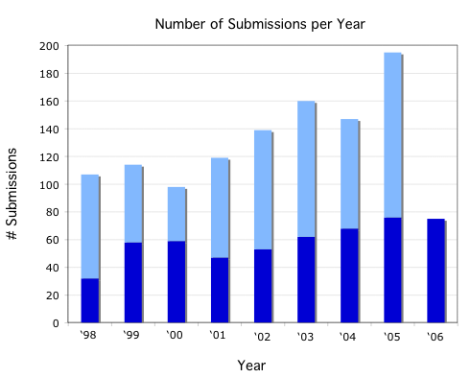
The graph shows total number of submissions each year, with the lower, darker portion of the bar giving the number of submissions through May of each year (this is included so that 2006 can be compared to previous years). It seems likely that our increasing impact factor is at least partly driving the increase in number of submissions.

Book Reviews: David Morrison has been prolific in providing book reviews. He has overseen the publication of 17 reviews (4 so far in 2006, 9 in 2005 and 4 in the December issue of 2004).

Geographic origin of submissions: Of the total number of submissions we’ve received through MC (since we went live 25Aug05), 69% came from a corresponding author outside the United States.
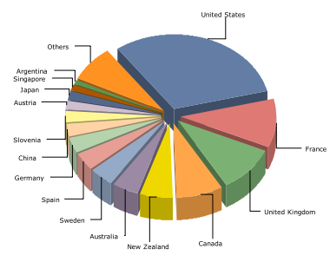

II Submissions categorized by organism, and new AEs:
=> The distribution of submissions we received in 2005 that mentioned an organism in the title, keywords or abstract is shown below (next page). This may be useful in selecting additional associate editors. In terms of organism specialization, it seems that at minimum a new AE with expertise in botany would be particularly welcome.
2005 SB submissions categorized by type of organism
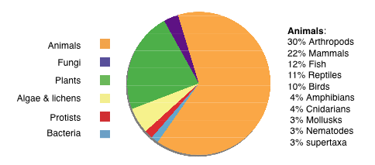

A paper is listed under an organism category if the organism was mentioned in the title, key words, or abstract.
Regular articles and POVs are included, but not book reviews.
Papers may be listed under more than one organism category, if more than one was mentioned.
Number of papers with no organism mentioned: 89 (46% of submissions).

Organism categories |  | # submissions
Bacteria & viruses |  | 2
Protists |  | 2
Algae & lichens |  | 7
Plants |  | 26
Fungi |  | 4
Animals_____________ | _____________ | ____________74
 | Arthropods | 22
 | Mammals | 16
 | Fish | 9
 | Reptiles | 8
 | Birds | 7
 | Amphibians | 3
 | Cnidarians | 3
 | Mollusks | 2
 | Nematodes | 2
 | supertaxa | 2

III Manuscript Processing Statistics:
=> The increased number of submissions is being held at bay by Rod’s 70% rejection rate (a somewhat inflated statistic, see below) and our backlog of papers is decreasing. The average time to return of first reviews is 52 days, but some ms’ are in review for several months. The average published length of regular articles is 15 pages; for POVs it’s half that. We currently have 720 users registered in MC.

Reject/Accept rate:

Breakdown of Decision Categories
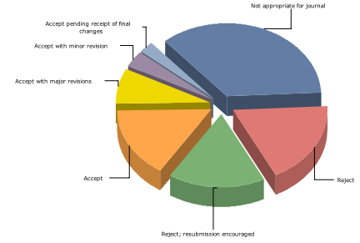
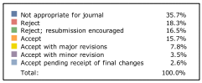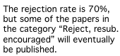

The above graph includes all papers submitted via MC, 25Aug05–13Jun06.

So far in 2006, Rod has returned 21 papers without review (usually “not appropriate for journal,” sometimes “reject”). This helps speed the overall response time statistic. In my estimation we are not simply getting more papers that are clearly inappropriate, it’s just that their numbers are increasing proportionate to the overall submission rate. The 70% rejection rate is a counterbalance to the increased number of submissions, and our backlog of papers for which we’ve received the final version from the author is actually decreasing (finally), which should lead to a shorter lag between acceptance and publication.

Time from submission to decision letter to author:
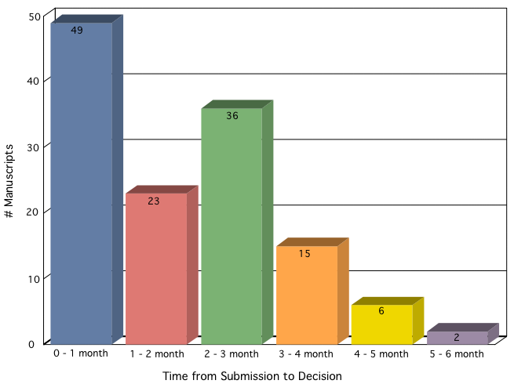

The graph above shows the 131 papers submitted via MC for which a first decision (as opposed to a decision on a revision) has been made. The average time to return a decision to authors is 52 days. The graph includes papers that were returned without review, which account for the majority of the papers in the 0–1 month category. There have been a total of 162 papers submitted via MC, so obviously several do not appear on the graph because they have not yet received a decision. Some of these 31 papers that have not yet received first decisions are still in review after a long period of time, so unfortunately the “2” in the 5–6 month category is a misleadingly small figure. Any suggestions regarding how we can ensure that review periods do not continue beyond a reasonable length of time would be welcome.
Current status of ms’ for which no decision has yet been made: The status on 16Jun06 of all manuscripts submitted via MC which are still in some stage of the initial (i.e. not revision) review process is shown below.
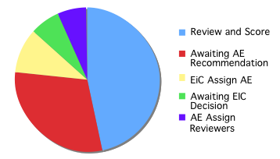

Task to be performed | # papers
Review and Score | 14
Awaiting AE Recommendation | 9
EiC Assign AE | 3
Awaiting EIC Decision | 2
AE Assign Reviewers | 2

Lengths of published papers: For 2004 and 2005 combined, the average number of published pages per regular article was 14.7 (SD 5.5), and for POVs was 7.4 (SD 2.7). There is very little difference between the two years; for reg. articles the ave. in 2004 was14.9 and in 2005 was 14.7, while the 2004 ave. for POVs was 8.6 and in 2005 it was 6.7. In 2004, 61 regular articles and 11 POVs were published; in 2005 53 regular articles and 20 POVs were published. POV’s comprise 17% of submissions.

Number of MC users: We currently have 720 users registered in MC. We’ve been gaining approximately 50 users per month (measured only over the past 3 months). Many of the users have entered keywords, so AEs might want to familiarize themselves with the advanced reviewer search functions (as I’ve heard it called, the “extra stuff” that takes up most of the page on which reviewers are selected). In other words, you don’t necessarily have to think of an appropriate reviewer, you could search on a keyword and see if a name pops up that you recognize.

IV Working with T&F:
=> Rapid turnover in personnel and occasional errors continue to be a problem. Also, the EFirst process does not result in papers being published online as far in advance of print publication as we had hoped.

After working on only two issues, and doing the job well, our previously new Production Editor Jen McCleary left her position suddenly. Our new new Production Editor is Brendan Huffman (that makes three within the past year). Brendan has just started and seems to be doing fine so far with the task of familiarizing himself with our journal and its production. Also on the positive side, I recently asked for a small alteration in our MC setup, and it was done accurately and fairly quickly (a somewhat small change, but it had to be done by ScholarOne rather than myself or T&F).
The following is an example of occasional errors we experience. Recently I caught an mistake on T&F’s part just before the June issue was finalized for print. The June issue has, as its first paper, an invited essay marked as such in a special section. I clearly communicated this to T&F multiple times, which was acknowledged (and which appeared correctly in the proofs), but nevertheless when they published the partial issue online, the invited essay occurred later in the issue as one of the regular articles. Because the pagination had to be changed in order to put the invited essay first, the June issue was pulled offline while this was fixed. We were just lucky that this did not appear in print incorrectly because normally once I approve the proofs I assume there will be no major changes.
There is a significant limitation on how far in advance articles can be published online through EFirst. Apparently papers cannot be posted for upcoming issues until the previous issue is printed, because POVs are not added until nearly print time, and the pagination would be compromised if T&F posted the regular articles for the following issue sooner. Therefore the maximum advance time for an EFirst article posting is just under 2 months, with most manuscripts appearing well below that maximum. (An obvious next question is: why can't they publish an entire issue online, including the POVs with their page numbers, then start the next issue online? I've never received a clear answer to this.) If our backlog of papers continues to decrease, this will become less of a problem. To give an idea of the current size of the backlog, as of 18Jun06 I estimate we currently have authors’ final versions (not proofs) of papers that will take us to just under half way through the October06 issue. Not all of these have been sent to T&F yet, but T&F has enough papers to keep the copy editing process going full speed, so the date we send in our papers is not the limiting factor in processing time.

V Manuscript Central User Conference:
=> My attendance at ScholarOne’s first MC User Conference was funded by T&F. It was very useful, and I learned some tips on using MC . Perhaps more importantly, I gave ScholarOne feedback from Rod, myself, and our AEs regarding suggested improvements for future versions.

The conference was April 24-25 in Charlottesville, VA, where ScholarOne is based. There were a variety of topics covered, such as their planned future product directions, and basic instruction. I estimate I was more advanced with MC than the majority of the attendees, mainly because most journals are struggling with conversion from version 1 to version 3 (no one speaks of a version 2), whereas SB changed to version 3 before we went live, i.e. while I was still learning and testing the system. Some of the most productive conference learning experiences I had were from conversations with other users; comparing notes about how we get around various shortcomings of MC, and exchanging ideas and tips. I won’t go into details about what was discussed, but anyone interested in the finer points of MC is welcome to talk to me about it (I won’t hold my breath – I realize most people want as little to do with MC as possible!).
I took with me a long list of questions, problems, and suggestions from Rod, myself, our AEs, authors and reviewers. One of ScholarOne’s motivations in presenting this conference was to get such feedback. I was able to present every question and suggested change we had, partly because I later cornered the person responsible for recording the feedback and made sure she had all of our items in the record. One item I did not get satisfaction on is that T&F literally will not allow me to directly contact the individual at ScholarOne who is responsible for the configuration of our site. (Even if I looked him up on the web and found an email address, apparently he would send me a form letter asking me not to contact him directly). This is because he’s responsible for so many journals that if he had to deal with each managing editor or etc. personally it would overwhelm his time. So we still have the inefficient system of me asking for changes through T&F and having them pass on the request (although that process seems to be working better now than it has in the past).
One interesting anecdote: One of the items I brought up was the security of emails containing user ID and password information. Although passwords are encrypted when still in the MC system (for example, I can’t see someone’s password even when I send an email telling them what their password is), the email arrives in the person’s inbox with the password in plain text. We received emphatic complaints about this from one reviewer. So I suggested the least ScholarOne could do was send the user ID and the password in separate emails. This suggestion actually received a round of applause, the only comment to receive such a reaction. (ScholarOne hasn’t made the change, but hopefully the applause will have an impact for the next version.)

Web Site Report – Rod Page
Systematic Biology Web site

Rod Page, March 2006
Summary
The Society of Systematic Biologists web site is basically ticking over nicely. Postings are being made by Debbie Ciszek, myself, and some program officers. I’ve signed up for Amazon.com’s Associate program as an experiment in generating revenue. To date a massive $US 47.13 has been made. Traffic is steady at around 1000 visits a week, with a spike corresponding to the DNA barcoding issue of the journal. One major limitation is the clumsy way of providing members of the Society with access to the journal.
Amazon.com
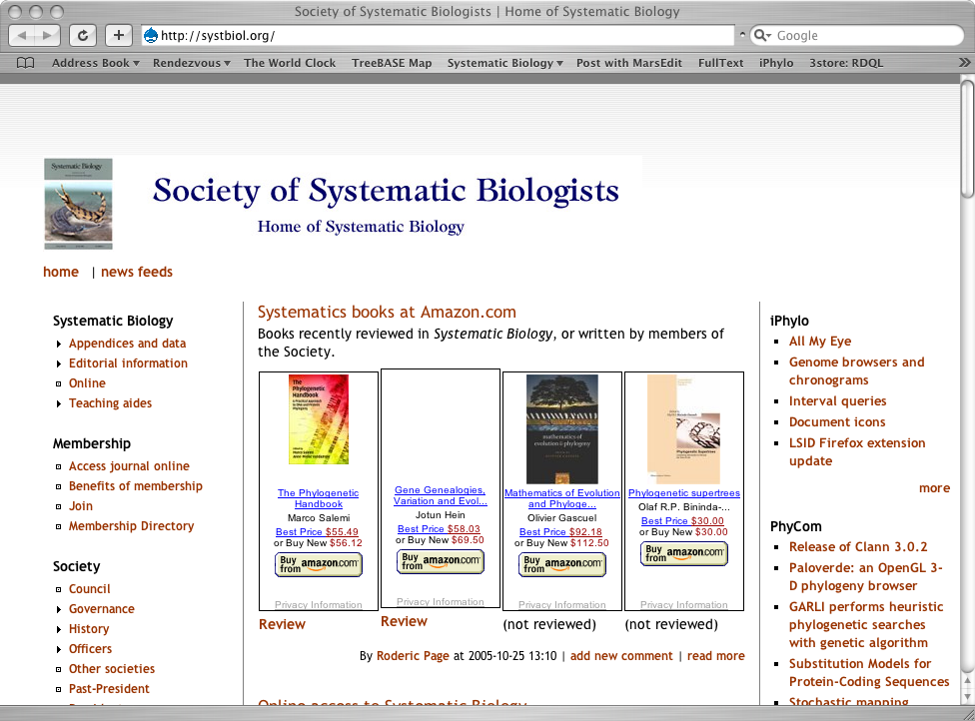
In moments of tedium I’ve experimented with a few ideas. One has been to join Amazon.com’s Associate program, so see whether the web site could generate any money by displaying links to Amazon for books reviewed in the journal. Under Amazon’s Associates program an associate receives a percentage of the sale of each item made via clicking on a link on the associate’s site. Typically the percentage is around 5%. This has been an interesting experience, but as the results from the start of this exercise (August 2005) until now (March 1st 2006), we’ve made a grand total of $US 47.13.

 | Items shipped | Revenue | Referral fees
Total Amazon.com | 17 | $790.37 | $46.85
Total third party | 1 | $5.65 | $0.28
Total shipped | 18 | $796.02 | $47.31
Total returned | 0 | $0.00 | $0.00
Total refundeds | 0 | $0.00 | $0.00
Total referral fees | 18 | $796.02 | $47.13

Traffic

Basic web access statistics are available on the web site itself. Since March 2005 it’s been averaging just under 1000 visits a week, with a big spike (2005 visits, 920 of those on a single day) the week I announced the DNA barcoding issue on EvolDir and TAXACOM (see rather information poor graphic below).

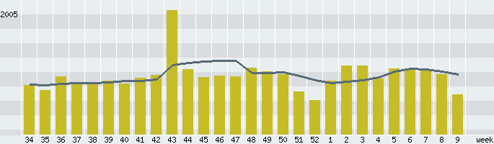

Membership services

As mentioned in the report present at the Evolution 2005 meetings, there is a crude mechanism where members of the Society can access the journal online if they are members of the Systematic Biology site. This is unsatisfactory as I’ve no desire to manage lists of users, and it is often hard to work out if somebody is a member simply from an email address. This issue is discussed further in the Editor’s report.

Publications Committee Report – Simon
22 June 2006, Publications Committee Report: The publications committee consists of Chris Simon (chair), Rod Page (Editor), David Cannatella (Past, Past President) and Vicki Funk/Dave Mindell (Treasurer). Pam Soltis last year appointed Dick Olmstead who agreed to serve on the committee to help find a new publisher. Paula Mabee will be asked to head the membership committee and has agreed to look over the RFP.

[From the Constitution: The Committee shall consist of at least five members including a Chairperson, the Editor, the most recent past-Editor, and the Treasurer. The Committee shall identify desirable policies for the Society’s publications, (minus the Editor) act for the Society in negotiating printing, publishing, and other contracts, and provide fiscal review of the Society’s publication management. The Committee shall also work with the publisher or printer to promote and increase membership. The Editor shall avoid contract negotiations with the publisher in order to maintain amiable relations between the current publisher and the Editor.]

New Publisher.

The last contract with Taylor and Francis was signed on the 20th May 2002 and covered Volume 52(2003) through 56 (2007). The previous contract was signed on the 21st of May 1997. The next contract will be signed on the 20th of May 2007 to cover Volumes 57 (2008) through 61 (2012). The search for the new Publisher will take place in 2006.

June 2005. C. Simon as head of the publications committee has had short informal conversations with several publishers: 1) Blackwell—publisher of Cladistics--at the last meeting, at their instigation and, 2) Oxford University Press—publisher of MBE—by email (discussing unfortunate restrictions on PDF reprints). Both publishers seem professional and appropriate for EEB journals; both are willing to experiment with open access or not. CS also spoke with Bill Martin, the editor of MBE during 2005 by email.

July 2005. C. Simon met with Bill Martin at the MBE meetings in Auckland. NZ. He is very pleased with OUP. Their first contract with OUP expires in December 2006 and they have decided to renew.

July and August 2007. Debbie Ciszek contacted the managing editors of other several OUP (Nucleic Acids Research, MBE) and Blackwell (J. Physiology, Cellular Microbiology) journals to ask about interactions with their publishers. All were very happy. OUP journals had no complaints, Blackwell journals only very minor complaints. Debbie’s reports are available from the committee on request.

SICB recently signed a contract with OUP, CS contacted them by email and they said that they were very happy with the contract.

9 November 2005. C. Simon met with Blackwell at their Boston Office: Notes follow.
1) Contract can be for Profit share, or Royalty.
2) Generally 50% share of surplus (profit) or percentage of subscriptions. Generally about the same revenue, but in profit share it’s more transparent.
3) Management fee. Five to ten dollars per member for handling subscriptions (not counting mailing). Journal access is sold to consortia in deals. Would be available in 3500 institutions world wide. Monthly reports on users and top users (ask Robin).
4) Blackwell works with JSTOR. Usage statistics looked at by librarians for renewal.
5) Libraries love Synergy/Blackwell.
6) See handouts including transition schedule.
Questionaires for the preparation of the “Request for Proposal are attached.”

We need to be able to access our membership list instantly if the publisher controls it. Burke charges $22,000 to handle membership and wants an additional $6,000 to handle membership sign-up on line. Plus $600 ballot on line.

10th November 05, C. Simon spoke with Allen Moore, the SSE person heading their search for a new Publisher. They are “leaning towards Blackwell” he thinks. Blackwell seems to want to help the Society.

13th December 05 Rod Page visited the book department of OUP and met with Ian Sherman from OUP. Ian's obviously keen for OUP to get Syst Biol, and Rod would be happy for this to happen, but Ian wasn't making a sales pitch was aware that it's not Rod’s decision to make). One thing that is nice to know is that Ian's been with OUP since 1998 which seems a lifetime in the publishing industry.

CS has read through the T&F contract and begun to prepare a list of costs and procedures for the RFP’s.

Taylor and Francis told Debbie Ciszek recently (March 06) that they suspect we are considering new publishers and they would like to meet with the Council at the next SSB meeting. CS and RO have set up a meeting with T&F (Corey Grey, Andrew Moyner) for Saturday evening.

CS discussed publishers with her university librarian and library bibliographer to the following questions:

1) Do you have any comments on how the UCONN library likes Synergy versus Highwire?

Librarian: Highwire is impressive; nearly 1000 journals for free (after 3 months- 1 year); division of Stanford libraries. She would choose Hirewire every time over Synergy (Blackwell)

Bibliographer: Prefers Highwire (Stanford); not-for-profit

2) Oxford University Press vs. Blackwell vs Taylor and Francis?

OUP is by far the most respected press for books. Journals may be equivalent among publishers. Think about BioOne.

3) Is Blackwell an "evil giant"? Not like Elsivier but does have a “big deal” journal policy that Libraries will not be able to afford in the future. Used to be lumped with Elsevier, Wiley, Kluer, but he thinks that has passed.

4) How much of an increase per year is OK. We may not have a lot of say with a commercial publisher in how much the subscription price goes up (I will put this in the contract; we do have control now). Increase only what you need to keep your journal viable. When packages are no longer viable, high priced journals will be dropped.

Next Editor

Rod Page began his term as editor elect on 1 January 2004, receiving all new submissions. He began his term as Editor on 1 January 2005. His term will expire on 31 December 2007 at midnight but the next editor elect will begin receiving new manuscripts on 1 January 2007. This schedule places the approval of the new editor at the June 2006 SSB council meeting. Thus the search for the next editor should start by June 2005 providing a year for the difficult task of finding just the right person. In addition, this will give the new Editor time to recruit an editorial board and make arrangements with his or her university for compensation (e.g. a research assistant for 4 years, agreement to allow 50% teaching buyout by SSB, office space, etc.) Some recommendations were made to Pam Soltis who followed up on them (I assume that she will report on this).

Miscellaneous

The only other activities of the publications committee are approval of routine postings of announcements to appear on the website and review of the new website material to find items missing or needing updates. Please notify CS if you have ideas for new items or updates to appear on the SSB site.

C. Simon has arranged for the printing of 72 Mugs (herp design) plus 72 additional mugs (mushroom design) by Museum Store Products (same company that printed the first 72 Mushroom designs). Taylor and Francis has agreed to sell them.

C. Simon has contacted T’s Plus of Groton Connecticut. CS spoke with SSE about selling them at registration and they agreed. Both mushroom and lizard designs are available in wide neck band and narrow neck band styles. Some designs are smaller due to printer error. We got a discount on those shirts. CS paid for all the shirts and mugs and so needs to be reimbursed.

We need more members; we owe. Our contract says, “The Society guarantees the Publisher a minimum Society membership of 1,300 full-rate plus student members per year; if the membership falls below this number, the Society agrees either to permit an increase in the per-member rate or to pay the Publisher directly the difference so as to bring the Publisher's revenue back to a minimum of $21 x 1,300 = $27,300/yr. “ According to the latest publisher’s report we have 1024 members; We are short 276 members. In addition, 290 of our members are students so we owe T&F the difference. Not sure where the $21 comes from. I would have thought that should be the full rate membership of $40 x 1,300. ??

Managing Editor Debbie Ciszek salary increase. Debbie has been working an average of 24 hours since January (or even earlier). She documented her hours during April through June. So when I renew her contract in December I would like to raise her salary from 20 hours per week to 24 hours per week equivalent. This is 60% time rather than 50% time. I propose that we pay her back pay for those extra hours during April, May and June.

Cracraft raises the issue of global access to the journal with free access to underdeveloped countries. BioOne allows such access. Will OUP and Blackwell?

Soltis describes process of negotiations with Jack Sullivan to become Editor Elect. Soltis moves that Sullivan be next Editor. Edwards seconds. Unanimous approval.

Ciszek’s annual salary is $45,427 x .5 = 22,713.50 with a proposal to increase to 60% time. Simon proposes to increase Ciszek’s time to a 60% rather than 50% appointment. Seconded by many. Unanimously approved.

Council of Scientific Society Presidents Report – Edwards/Soltis
Soltis describes CSSP and reviews goals and projects of Society. Dues are $795 per year. Soltis received feedback from Botanical Society for return on dues. They think it has been a good investment. Cracraft suggests that the actual costs will be more on the order of thousands of dollars after registration for meeting, travel to meeting etc. We already pay AIBS to lobby on behalf of SSB. Donoghue suggests we look into what other similar types of societies we already belong to and develop a strategic plan.

Edwards will follow up on Membership Committee and Appointments Committee.

O’Leary volunteers to represent SSB in the evolution/ID committee. She was appointed by Edwards. Edwards moves to approve general points in the Piliucci document and to further develop awareness of the issues on ID.

Edwards thanks council for help. Meeting adjourned at 6pm.

