These notes explain how to run the ‘Highlighting Important Stages in Evolution’ activity in class. They talk you through using the interactive Tree of Life, provide answers to the student questions and illustrate curriculum links. NB: You will need to have Flash 10 installed on your computer to perform these tasks.

Aims of activity: To encourage students to explore the Tree of Life interactive and video and to become familiar with the phylogenetic relationships among animals.

Learning objectives:
- To appreciate the thinking underpinning the classification of animals.
- To consider the strengths and limitations of this structure of the Tree of Life as a metaphor for the development and divergence of species.
- To appreciate key developments in animals’ evolutionary history and to understand the significance of these stages.
- To understand that the environment and conditions at various times in Earth’s history have favoured the selection of living things that has taken place.
- To be able to visualise the relationships between the phyla and important subgroupings of animals.

Guidance:
The Tree of Life activity should provide students with insight into the relationships between species of life on Earth, both today and the past. The activity provides a structure and an incentive for students to explore the Tree of Life interactive and video, which can be streamed and downloaded from www.wellcometreeoflife.org. You can watch the video by clicking on the ‘video’ link and explore the interactive via the ‘interactive’ link.
You can find a quick guide to using the interactive Tree of Life by clicking on the question mark icon in the interactive. This will show you how to get images, information and web links about the living things featured, as well as how to find common ancestors of any two living things you select. It explains how to change views of the interactive so you can see branches in proportion to length of time, relationships between branches, and links between different living things.
You can also switch back and forth between the interactive and the video.

It is suggested that teachers use the activity to discuss the mechanism of evolution with their students.

Materials: Interactive whiteboard for viewing Tree of Life video and exploring Tree of Life interactive; computers with fast access to the internet; student sheet (one per student).

Time: 100 minutes

- Show the Tree of Life video.
- Discuss the history of classification of living things, including the role of Linnaeus and the impact of knowledge derived from modern genetics.
- Given that evolution is a continuum of development, ask students to consider the challenges it poses in attempting to place individual species in coherent groups.
- Critically evaluate the Tree of Life as presented and make references to other ways of depicting the relationships between species.
- Using an interactive whiteboard, highlight in the interactive Tree of Live some of the major evolutionary developments that took place. Encourage students to see how the different configurations of the interactive can be used to help them work out what is happening at different junctures. Select one or two living things and click on the text, images, rotating video and web links.
- Ask students to use the interactive and other reference sources to work through the accompanying worksheet titled ‘Highlighting Important Stages in Evolution’.

ANSWERS TO QUESTIONS

- Which area of biology now offers the evidence that confirms what Darwin stated 150 years, namely, that all life is related? Genetics and molecular biology.
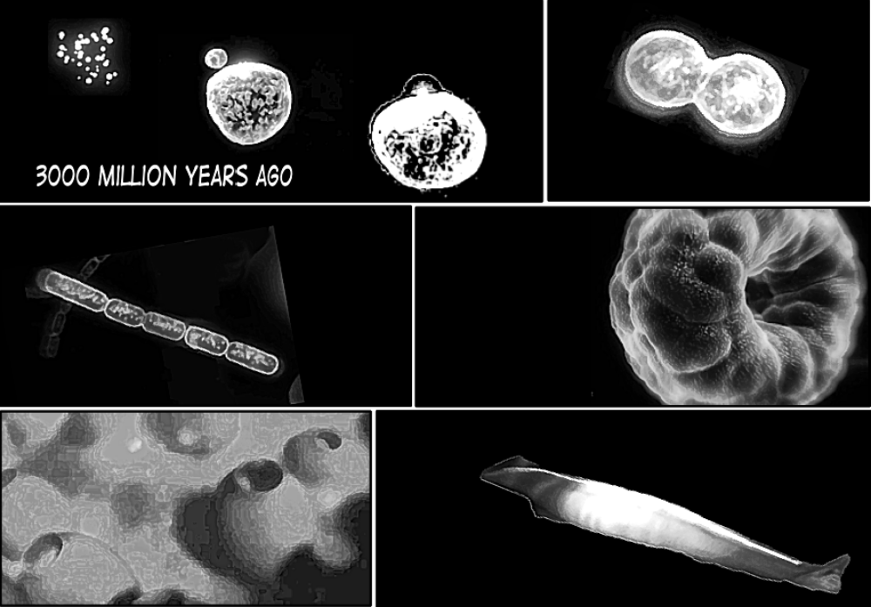
THE APPEARANCE OF THE EARLIEST ANIMALS
A
B
C
D
E
- (a) Identify which significant events in the early stages of life are depicted here in stages A–E.
A: Formation of earliest cells.
B: Cells reproducing by binary fission – cell splitting.
C: Filamentous algae formed from cells remaining attached.
D: Formation of hollow balls with an internal cavity. The first proper multi-celled living things.
E: development of bilateral bodies with a stiffened internal rod and sense organs
(b) Describe where on the Tree of Life interactive where you might expect to see these stages.

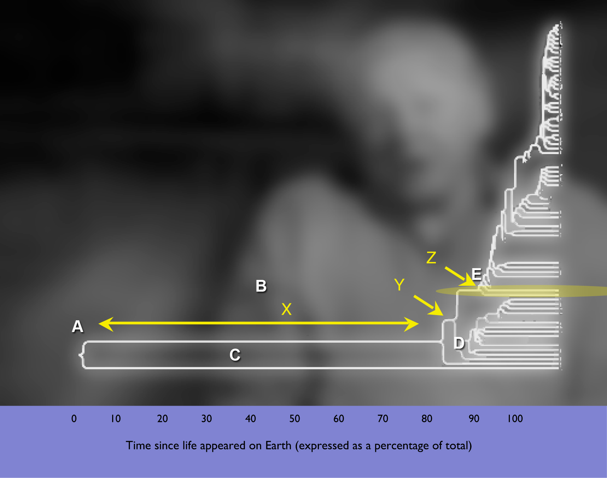
SIGNIFICANT STAGES IN THE EVOLUTION OF ANIMALS

- Draw an arrow on the tree of life to indicate at which point the earliest animals first appeared.

0 10 20 30 40 50 60 70 80 90 100

Time since life appeared on Earth (expressed as a percentage of total)

- Describe what life on Earth was like in the period of time shown as X on the diagram.
Mainly unicellular, or simple (not truly multicellular).
- One species appears to have been in existence since the very earliest times. Identify that species and describe how it features in the lives of modern mammals including humans.
Escherichia coli (E. coli) are bacteria found in huge numbers in almost everyone’s faeces (and those of other mammals as long as they are not hibernating – E. coli like to be warm), where they help break down the solid waste and promote the uptake of vitamin K and other important nutrients. These bacteria cause disease only if they escape from the gut and proliferate in the blood or elsewhere, or if those normally found in other species are eaten with contaminated food. Most other kinds of bacteria are not pathogens, but break down dead and dying plants and animals and fungi.
- The earliest multicellular animal phylum members are not considered to be direct ancestors of the more complex animals. Identify this phylum within the Tree of Life and state why this is so.
These are thought to be closely related to sponges, consisting of only a few types of cells, some unique to the phylum; they do not have true nerve, digestion or blood systems. For these reasons, they are not direct ancestors of the more complex animals.

- What is the significance of the characteristic shared by the group of animals that emerge at the point Y? Consider the relationship between this evolutionary development, the medium in which animals lived and the selection pressure favouring the characteristic.
This group of animals is called Bilateria. They possess bilateral symmetrical bodies that almost certainly evolved to provide a more streamlined body profile for faster and more efficient movement through water – the medium in which they first evolved. With the exception of the group known as the Echinoderms, most animals developing after this stage display bilateral symmetry. This stage of evolutionary development led to other significant evolutionary steps forward, including the emergence of a body plan based around three layers (triploblasty), the formation of a digestive tract with true mouth and anus and, ultimately, the migration of sense organs to the anterior (front) of the animal, and the formation of a distinct head.
- One of the simplest members of this group does not possess a gut. It also has developed a symbiotic relationship with types of algae, which attach to it. Name this animal and suggest why this symbiotic relationship may have developed.
Acoel is a very primitive bilaterally symmetrical animal that does not have a gut cavity (the name means ‘without cavity’) Some members of this group have developed this symbiotic relationship with algae, since without specialised cells and with only cilia to bring about movement, they are limited in their mobility but are also able to derive sufficient energy from this symbiotic relationship with algae.
  - SEGMENTED INVERTEBRATES
- Velvet worms are descendants of some of the earliest forms of segmented animal. The appearance of animals with segmented bodies is considered a major development in the evolution of the animal kingdom. How did the appearance of repeating segments offer a significant evolutionary advantage for animals that evolved this body structure?
The early segmented animals would have had an advantage over competitors in that their movement was better coordinated and probably faster too. Velvet worms are adapted to squeeze into small spaces and exploit these locations for food.
- Insects are the most diverse animals on Earth and belong to the phylum Arthropoda. Identify the earliest insect shown on the diagram and carefully circle the insect sub-classes shown. As it is the only class of invertebrate capable of flight, comment on the contribution made to insect success in possessing (i) a chitin exoskeleton, (ii) striated muscle tissue and (iii) highly developed sense organs.
The giant dragonfly is the earliest insect identified on the Tree of Life. The chitin exoskeleton could be moulded into many different shapes including structures associated with flight (wings etc). The striated or voluntary muscle was an evolutionary step forward in that it was able to contract and recover quickly, enabling the quick movement essential for flight. Highly developed sense organs enabled insects to detect quickly the changing events in their surrounding environment, especially important when flying.
- Some of the early insects were much larger than they are today. One suggested reason for their greater size is that the atmospheric oxygen concentration was much higher at that time. Explain the significance of this hypothesis.
The insect system of gas exchange is effective but largely relies on diffusion of oxygen into the body of the insect. The rate of diffusion is limited by the partial pressure (or concentration) of oxygen in the atmosphere. During the Triassic period, there was a reduction in atmospheric oxygen concentration, which may have caused the giant insects and other large invertebrates to die out.
  - ANIMALS WITH BACKBONES
- The earliest vertebrates appeared at the point indicated by Z on the diagram. Vertebrates have an articulating backbone or spinal column.
- How might having an articulating backbone made up of vertebrae provide a competitive advantage?
Increased animals’ repertoire of movement. Articulating structure presented greater strength so that animals could become terrestrial AND grow large.
- Vertebrata is a sub-phylum of the phylum Chordata. The shaded region on the diagram highlights the members of the chordate phylum that are not vertebrates. Find out both what all members of Chordata share in common, and why members of this branch are not considered vertebrates.
They all possess a notochord – a rigid rod-like structure at some developmental stage (though in vertebrates it develops further into the vertebral column), a hollow dorsal nerve cord, pharyngeal slits and a post-anal tail. The invertebrate chordates either have a notochord during their larval stage only, or the flexible rod remains for the duration of their adult life.
- The ancient pikaia, modern lamprey and hagfish show some unusual features that make them difficult to place into classification groups. Assigning some animals to taxonomic groups can be challenging for scientists. From our understanding of the principles of evolution by natural selection, why might we expect this type of problem to arise in trying to place living things into groups?
Classifying living things is artificial. Nature does not recognise the boundaries that we place around each group, which is one reason why scientists are constantly redefining taxonomic groups. Those living things on the borderline of evolutionary developments support the notion of evolution by natural selection being a continuum, but it is difficult to place them in a distinct group, since they often share characteristics of two groups.
- Acanthostega was one of the earliest tetrapods to walk on land. Scientists believe that no living animal is descended from it. From this you should be able to locate Acanthostega in the Tree of Life and use the information provided to indicate why scientists have reached these conclusions.
Fossils of Acanthostega show that it had eight webbed digits on each limb, whereas no living tetrapods (amphibia, reptiles, birds and mammals) share this limb plan.
- Locate Dimetrodon on the interactive (hint: Dimetrodon was a reptile that exhibited some of the characteristics of a mammal). Dimetrodon was a prehistoric animal that had a recognisable bony sail formed from projections formed from projections in its vertebrae and contained numerous blood vessels. How did Dimetrodon benefit from having the sail structure on its back? Dimetrodon was a ferocious carnivore during the daytime, but was unlikely to have hunted at night. How can scientists be fairly certain that it did not lead a nocturnal existence?
The sail structure was used to trap the sun’s heat energy and warm up it body during the day. Such a mechanism would have enabled Dimetrodon to possess a faster metabolism than other animals. This is because the higher body temperature would have allowed it to catalyse reactions more quickly. As a hunter, it would have been able to move more quickly than both its prey and competitors. However, unlike true mammals, which maintain constant body temperature independently of the sun’s direct energy, Dimetrodon was reliant on external heat from the sun.

- Select two examples of species for each of the following: (i) amphibian, (ii) reptiles, (iii) birds, (iv) mammals (living or extinct species). For each, use a combination of the Tree of Life information and other sources to establish the following phylogenetic categories: kingdom, phylum, class, order, family, genus and species. Through clicking on one animal in the interactive and then another, you will see the point at which they diverged. State when your two species last had a common ancestor and write down the main differences between the pairs of animals that resulted in them being considered in different groups.

- Now use a similar principle to find out how long has it been since the following took place. You should present your estimate as a percentage of the time since life has existed on Earth:
        - The appearance of the earliest fish.
Approximately 17%. On the interactive this is the point labelled Z at which pterapis emerges. About 83% of the time that life has existed had already passed before the simplest fish appeared on the Earth.
        - The appearance of a hollow body cavity.
Approximately 20%. On the interactive we can estimate that a true hollow body cavity appeared somewhere between the emergence of acoel and velvet worms.
        - The emergence of the first mammal.
Approximately 8%, with the emergence of megazostrodon.

- FURTHER WORK

- Animals belong to a ‘domain’ of living things called eukaryotes. Find out the other three kingdoms that fall within this domain. What are the shared characteristics of eukaryotes? What are the other two domains of living things?
The other three kingdoms in Eukaryota are plants, fungi, protists. Shared characteristics are: possess membrane-bound structures or organelles such as ribosomes and vesicles; contain their genetic material within double-membraned nucleus; presence of mitochondria, the site of aerobic respiration. The other domains are archaea and bacteria – collectively called prokaryotes.
- Use reference sources to find out about ‘endosymbiont theory’. Discuss with your class the significance of this idea to the tree of life for animals.
This is the theory that chloroplasts and mitochondria evolved from certain types of bacteria that prokaryotic cells engulfed. These cells and the bacteria trapped inside them entered a symbiotic relationship, a close association between different types of organisms over an extended time. More specifically, the relationship was endosymbiotic, meaning that one of the organisms (the bacteria) lived within the other (the prokaryotic cells).

Curriculum links

ENGLAND
A level

AQA
Evolution has resulted in different species of organisms. They are classified into five kingdoms.

The concept of a species. Definition of species in terms of variation and potential for breeding.

The five-kingdom classification. Recognition that kingdoms are divided into phyla, classes, orders, families, genera and species.

The classification of living organisms into five kingdoms: Prokaryotae, Protoctista, Fungi, Plantae and Animalia. The distinguishing characteristics of each kingdom. This hierarchy should be illustrated with reference to the classification of familiar organisms. Candidates will not be expected to recall classification of individual organisms.

OCR
Learning outcomes
Candidates should be able to:
(a) describe the important features of the five kingdoms
(b) explain the meaning of the term species
(c) describe the classification of species into taxonomic groups (genus, family, order, class, phylum, kingdom), and appreciate the significance of the various concepts of the species
(d) explain the relationship between classification and phylogeny
(e) explain how natural selection may bring about evolution
(f) explain why variation is important in selection
(g) explain how all organisms can potentially overproduce
(h) explain, with examples, how environmental factors can act as stabilising or evolutionary forces of natural selection
(i) describe the processes which affect allele frequencies in populations (The Hardy-Weinberg principle is not required.)
(j) explain the role of isolating mechanisms in the evolution of new species
(k) outline, with examples, structural and physiological adaptations of organisms to their environment.

WJEC
All organisms are related through their evolutionary history.

(a) Biodiversity is the number of different organisms on the planet. Biodiversity varies spatially and over time.

(b) Biodiversity has been generated through natural selection and adaptation over millions of years. Adaptive radiation e.g. Darwin’s finches on the Galapagos.*

(c) Organisms are classified into groups based on their evolutionary relationships. Classification places organisms into discrete and hierarchical groups with other closely related species. The need for classification and its tentative nature. Characteristic features of kingdoms: Prokaryotae, Protoctista, Plantae, Fungi, Animalia.*

(d) Animal biodiversity is classified into over 20 major phyla and several minor ones with each phylum containing organisms based on a basic blueprint. Basic features of: Annelids, Arthropods, Chordates. Arthropods are subdivided into four groups (details not required). Some phyla contain many more species than others.*

(e) Physical features and biochemical methods can be used to assess the relatedness of organisms. DNA ‘genetic fingerprinting’ and enzyme studies show relatedness without the problem of morphological convergence.*

(f) All organisms are named according to the Binomial system. The species concept.

Suggested practical activities: Observation of examples from different groups.

Scotland
Fourth Level

Biodiversity and interdependence
I understand how animal and plant species depend on each other and how living things are adapted for survival. I can predict the impact of population growth and natural hazards on biodiversity.
SCN 4-01a

Body systems and cells
I can explain how biological actions which take place in response to external and internal changes work to maintain stable body conditions.
SCN 4-12a

Through investigation, I can explain how changes in learned behaviour due to internal and external stimuli are of benefit to the survival of species.
SCN 4-12b

Inheritance
Through investigation, I can compare and contrast how different organisms grow and develop.
SCN 4-14a

Through evaluation of a range of data, I can compare sexual and asexual reproduction and explain their importance for survival of species.
SCN 4-14b

I can use my understanding of how characteristics are inherited to solve simple genetic problems and relate this to my understanding of DNA, genes and chromosomes.
SCN 4-14c

Topical science
I can debate the moral and ethical issues associated with some controversial biological procedures.
SCN 4-13c

Northern Ireland
CCEA AS and A Level Biology

1.5 Cells
Describe the ultrastructure of eukaryotic and prokaryotic cells:
- prokaryotic cells (e.g. bacteria) as those without nuclei, mitochondria or endoplasmic reticulum and possessing naked, circular DNA, small ribosomes, possibly plasmids, and a cell wall
- eukaryotic cells as those with a membrane-bound nucleus, chromosomes (helical DNA with a histone protein coat), mitochondria, endoplasmic reticulum, ribosomes, Golgi apparatus, vesicles, lysosomes, microtubules.

Understand the structure and function of eukaryotic cell components.

Compare eukaryotic cell structure:
- plant cells as protoplasts bordered by an extracellular cellulose cell wall and possessing chloroplasts and vacuole(s); neighbouring cell walls adhered by a middle lamella (a sticky material composed of calcium pectate)
- fungal cells as protoplasm (often multinucleate) bounded by an extracellular wall of chitin
- animal cells as lacking chloroplasts and a cell wall and possessing centrioles.

1.7 Continuity of cells
Describe the process of meiosis and understand its significance in producing haploid cells and genetic variation.

2.2 The adaptation of organisms
Understand that organisms are adapted to their environment:
- adaptation as a combination of behavioural, physiological and morphological ways in which an organism meets a particular environmental challenge
- study of behavioural, physiological and morphological ways that organisms meet environmental challenges
- study of organisms in their habitat (e.g. rough and smooth periwinkles on a rocky shore) refer to xerophytic and hydrophytic adaptations.

Understand that ecological factors have an influence on the distribution of organisms.

Understand the role of selection in maintaining the adaptiveness of populations of organisms in their environment:
- fitness as those features which allow an organism to be adapted in its environment
- the role of selection in maintaining the fitness of a population of organisms
- those individuals with features best suited to their environment leave proportionally greater numbers of
- offspring
- this differential reproductive success maintains the fitness of a population
- natural selection does not create useful adaptations but rather edits genetically inheritable features in a
- population, increasing the frequency of some while decreasing the frequency of others over time
- stabilising selection in maintaining the constancy of features in a non-changing environment
- directional selection in bringing about a change in frequency of a feature in a changing environment,
- and accounting for the diversity of organisms.
2.3 Biodiversity
Understand that the biochemical basis of life is similar for all organisms:
- all living organisms contain the biochemicals carbohydrates, lipids, nucleic acids and proteins.

Understand that biodiversity involves variation among living organisms at all levels of biological organisation:
- genetic diversity as the diversity of genes within a species
- species diversity as the diversity among species in an ecosystem
- ecosystem diversity as the variety of ecosystems within the biosphere.

Understand the concept of the species:

- a species as a group of individuals of common ancestry that closely resemble each other, and are normally capable of interbreeding to produce fertile offspring.

Understand the other taxa within which species can be grouped:
- genus as a group of similar and closely related species
- family as a group of apparently related genera
- order as a group of apparently related genera
- class as a grouping of orders within a phylum
- phylum as a grouping of organisms constructed on a similar plan
- kingdom as the largest and most inclusive grouping.

Understand phylogenetic taxonomy as a means of classifying sets of species according to ancestral relationships:
- establishing relationships among organisms according to a number of measurable features including:
    - - morphology and anatomy (external and internal features)
    - - cell structure (prokaryote/eukaryote)
    - - biochemistry (comparisons of DNA, RNA and the amino acid sequences in proteins)
- closely related organisms possess a high degree of agreement in the molecular structure of DNA (base sequence), RNA (base sequence) and protein (amino acid sequence), while the molecules of organisms distantly related usually show a pattern of dissimilarity.

2.3 Biodiversity

Appreciate the five kingdom system of classification:
- The five kingdoms as;
    - - prokaryotae
    - - protoctista
    - - fungi
    - - plantae
    - - animalia.

Describe features of Prokaryotae:
- structure of prokaryotae cells
- reproduction by division
- example: a rod-shaped bacterium.

Describe features of Protoctista:
- eukaryotic
- unicellular or showing limited differentiation
- some are heterotrophs (e.g. Phylum Protozoa) while some are autotrophs (e.g. Phylum Chlorophyta).

Describe the features of Fungi:
- the Fungi as lysotrophs (decomposers)
- consist of hyphae with chitinous cell walls
- feeding by extracellular digestion
- example: a mould.

Describe the features of Plantae:
- the plants as autotrophs (producers)
- possessing chlorophyll in chloroplasts
- possessing a cellulose cell wall.

Describe the features of Animalia:
- the animals as heterotrophs
- they are capable of locomotion.

Materials designed and developed in partnership with Isinglass Consultancy Ltd.

