Watch the Tree of Life video (at www.wellcometreeoflife.org) and use reference sources such as the internet, text books or the library to answer
the questions below.

 | Questions | Answers
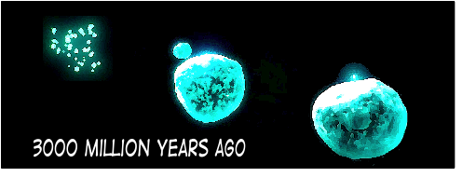 | What event took place that led to the development of the earliest living cells around 3000 million years ago?
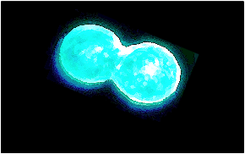 | How did the earliest cells reproduce?  Do any living things still reproduce in a similar way today?
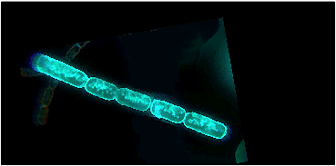 | How did algae come to be formed from cells?
 | Why is it helpful for this animal that lived on the sea floor to have sense organs at the front of its body?  How did the little projections from each segment of its body help this animal survive?
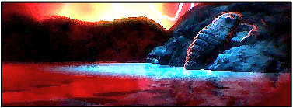 | When did animals with hard protective skins first climb out of the sea and walk on land?
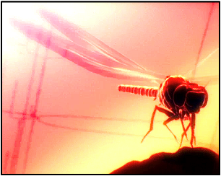 | This insect had a wingspan of nearly 1 metre. To grow that large and be able to fly, it must have been able to find a lot of food and not had many predators. Think about what may have happened to cause it to die out. Explain your ideas.
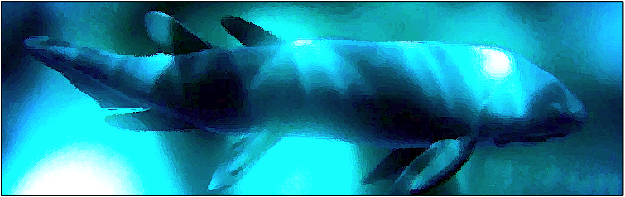 | Meanwhile, as insects were ruling the land the early fish were developing. What happened to their body structure that made them into the rulers of the seas? (3 things)
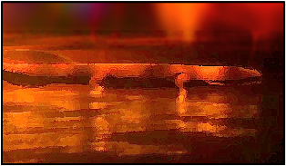 | One group moved from the sea to the land. Do you think this simply occurred one day or were they developing over time?  Why were these animals not truly land-living?
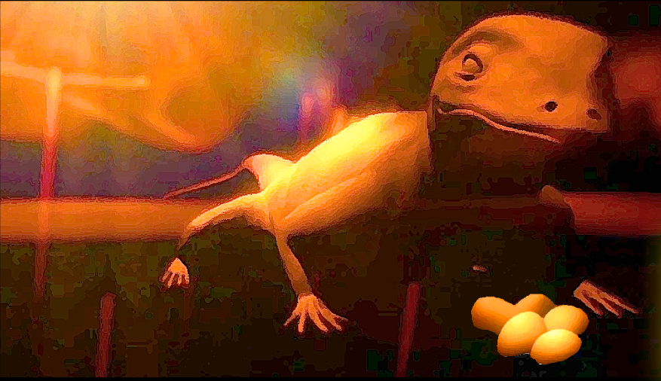 | These animals were the first terrestrial vertebrates (vertebrates are animals with a backbone). There are five groups of vertebrate – fish is one group. What are the other four groups? Give one example of an animal alive today from each group.
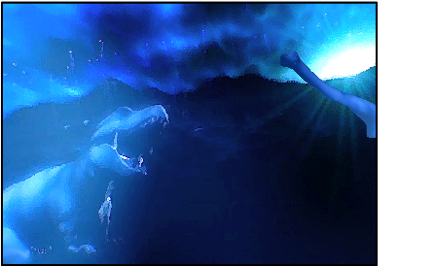 | The dinosaurs dominated the Earth for many years. Which group of vertebrates did they belong to?
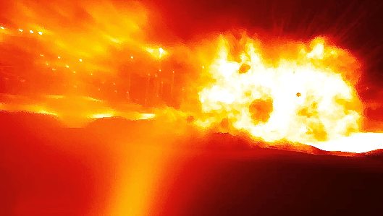 | What great disaster is thought to have happened about 65 million years ago that caused the dinosaurs to die out? Use the internet or a library to discover how this event could lead to the death of the largest animals that have ever walked the Earth.
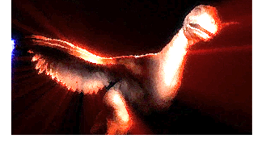 | The animal shown here is called Archaeopteryx. It died out a long time ago but a number of fossils have been found showing that it had sharp teeth, claws and feathers. What is special about this animal?
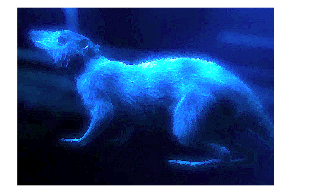 | Animals like this one existed at the time of the destruction of the dinosaurs, when they increased in number. They were the first mammals. What are the features that all mammals share?
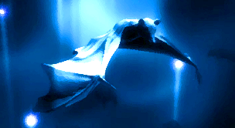 | Some mammals took to the air in a similar way to insects and birds. Is a bat more closely related to a bird or to a dolphin? Explain your answer.
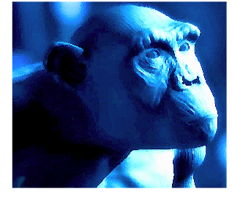 | Chimpanzees are mammals, and are our closest living relative. Would you expect the Tree of Life branches between chimpanzees and humans to have spread out very early on or more recently? Explain your answer.

Further questions

1. Working in small groups of 2–4 carry out some research into some other forms of life on Earth.

There are five kingdoms of living things – prokaryotes, protoctists, fungi, animals and plants. Use the internet or a reference library to find out the following:

a. Why are the living things in that kingdom grouped together?
b. What features do members of each kingdom share in common?
c. Examples of living things in the groups.

2. Present your work as a panel in a museum, titled ‘Five Kingdoms of Life’. Panels are used to explain ideas to visitors who are passing through an exhibition. To be effective, they should be clearly written with not too much detail. They should also be attractively designed.
Materials designed and developed in partnership with Isinglass Consultancy Ltd.

