Based around the Wellcome Trust’s animated fly-through of evolution on Earth:
www.wellcometreeoflife.org

Introduction

Charles Darwin proposed that all present-day species have arisen by change – what he called ‘descent with modification’. Darwin suggested that the history of living things could be shown as a ‘tree of life’ that emulates a real tree, with large branches giving rise to smaller branches which then ultimately further divide becoming twigs.

Darwin’s first known sketch
of a ‘tree of life’ (July 1837)
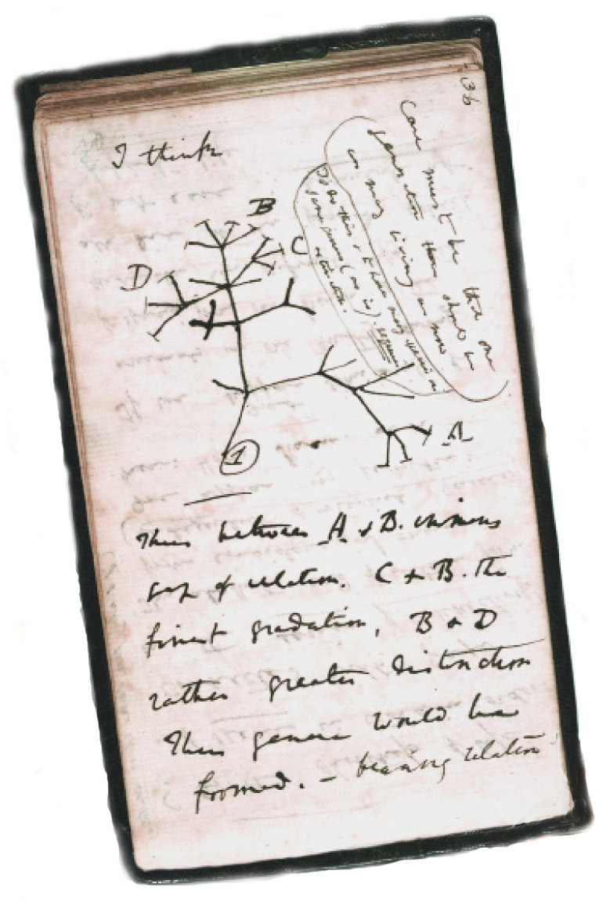
Today we accept that all life is related and that it has its origins in ancient forms. In the 150 years since Darwin published On the Origin of Species scientists have drawn and re-drawn phylogenetic trees (showing evolutionary relatedness among various groups of living things) to reflect our increasing knowledge and the emerging technology that has unearthed it (in some cases literally).

A species is a population or group of populations of similar living things that, for eukaryotes (including animals, fungi and plants) are able to interbreed and produce fertile offspring. This means that through mechanisms that Darwin described, there comes a point where a branch divides into two new species. Over time the new species will continue to evolve and may set up further branches – the formation of new species.

As part of its programme to mark the 200th anniversary of Charles Darwin’s birth, the UK biomedical research charity the Wellcome Trust has developed an animation of the evolution of animals and an interactive that explores the fascinating steps that have led to the formation of our modern natural world.

The following activities are based on this remarkable educational resource and will help you to appreciate the importance of Darwin’s ‘tree of life’ in helping to make sense of the origin of animal life on Earth.

Reproduced by kind permission of the Syndics of
Cambridge University Library

Activities

To carry out these activities you should navigate to the Wellcome Tree of Life website: www.wellcometreeoflife.org

- Click on ‘video’ to watch the short video introduction to the Tree of Life narrated by Sir David Attenborough.

- Then click on ‘interactive’ to explore the interactive Tree of Life.
You can find a quick guide to using the interactive by clicking on the question mark icon in the interactive. This will show you how to get images, information and web links about the living things featured, as well as how to find common ancestors of any two living things you select. It explains how to change views of the interactive so you can see branches in proportion to length of time, relationships between branches, and links between different living things.
You can also switch back and forth between the interactive and the video.

- You should now be ready to use the Tree of Life film and interactive to answer the questions below.
- Which area of biology now offers the evidence that confirms what Darwin stated 150 years, namely, that all life is related?
THE APPEARANCE OF THE EARLIEST ANIMALS

  - Identify which significant events in the early stages of life are depicted here in stages A–E.
  - Describe where on the Tree of Life interactive you might expect to see these stages.

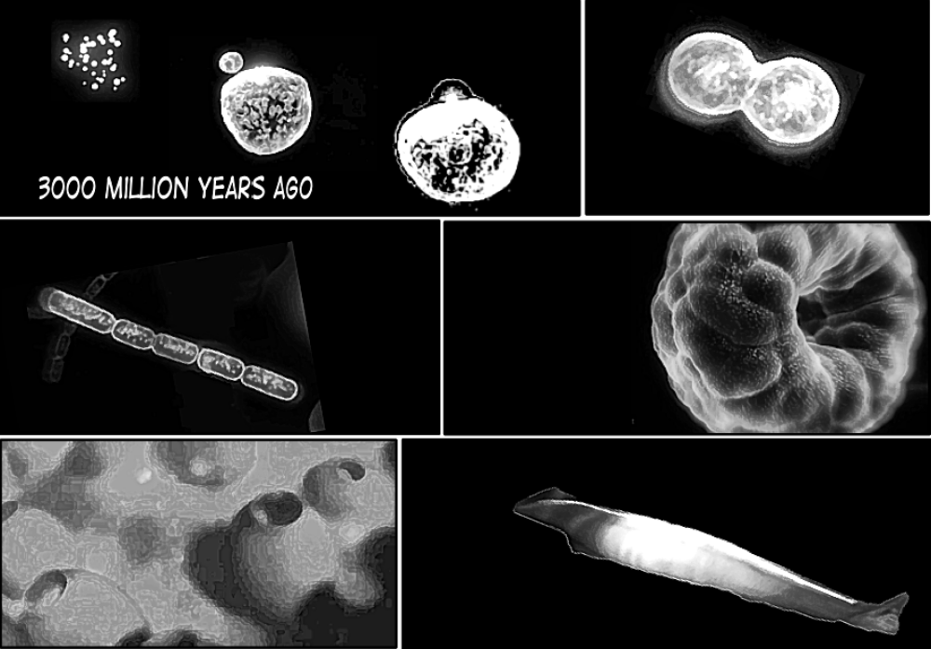
A
B
C
D
E
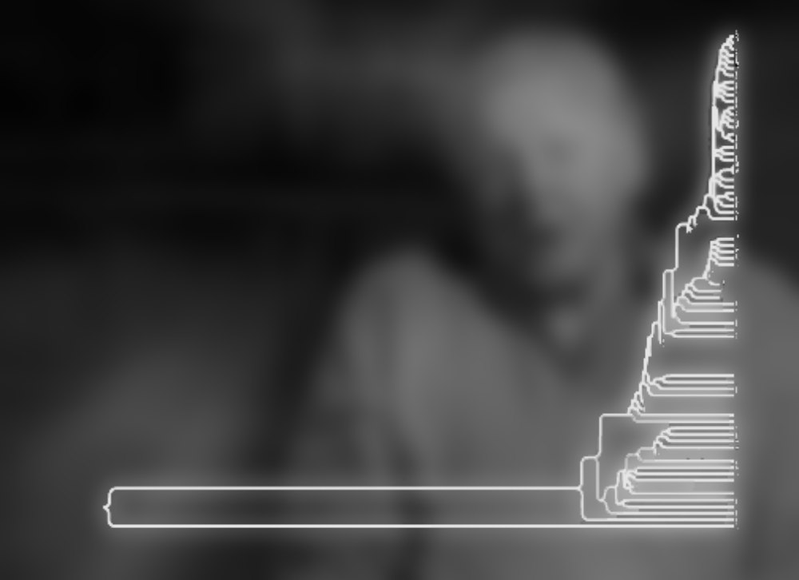
SIGNIFICANT STAGES IN THE EVOLUTION OF LIFE ON EARTH
X
0 10 20 30 40 50 60 70 80 90 100

Time since life appeared on Earth (expressed as a percentage of total)
Z
Y
  - Draw an arrow on the tree of life to indicate at which point the earliest animals first appeared.
  - Describe what the majority of life on Earth was like in the period of time shown as X on the diagram.
  - One species shown appears to have been in existence since the very earliest times. Identify that species and describe how it features in the lives of modern mammals, including humans.
  - The earliest multicellular animal phylum members are not considered to be direct ancestors of the more complex animals (phyla are the major taxonomic groups of animals and plants; they contain classes). Identify this phylum within the Tree of Life and state why this is so.
  - What is the significance of the characteristic shared by the group of animals that emerge at the point labeled Y? Consider the relationship between this evolutionary development, the medium in which animals lived and the selection pressure favouring the characteristic.
  - One of the simplest members of this group does not possess a gut. It also has developed a symbiotic relationship with types of algae, which attach to it. Name this animal and suggest why this symbiotic relationship may have developed.
SEGMENTED INVERTEBRATES
  - Velvet worms are descendants of some of the earliest forms of segmented animal. The appearance of animals with segmented bodies is considered a major development in the evolution of the animal kingdom. How did the appearance of repeating segments offer a significant evolutionary advantage for animals that evolved this body structure?
  - Insects are the most diverse animals on Earth and belong to the phylum Arthropoda. Identify the earliest insect shown on the diagram and carefully circle the insect sub-classes shown. As it is the only class of invertebrate capable of flight, comment on the contribution made to insect success in possessing (i) a chitin exoskeleton, (ii) striated voluntary muscle tissue and (iii) highly developed sense organs.
  - Some of the early insects were much larger than they are today. One suggested reason for their greater size is that the atmospheric oxygen concentration was much higher at that time. Explain the significance of this hypothesis.

  - ANIMALS WITH BACKBONES
  - The earliest vertebrates appeared at the point indicated by Z on the diagram. Vertebrates have an articulating backbone or spinal column.
              - How might having an articulating backbone made up of vertebrae provide a competitive advantage?
              - Vertebrata is a sub-phylum of the phylum Chordata. The shaded region on the diagram highlights the members of the chordate phylum that are not vertebrates. Find out both what all members of Chordata share in common, and why members of this branch are not considered vertebrates.
              - The ancient pikaia, modern lamprey and hagfish show some unusual features that make them difficult to place into classification groups. Assigning some animals to taxonomic groups can be challenging for scientists. From our understanding of the principles of evolution by natural selection, why might we expect this type of problem to arise in trying to place living things into groups?

- Acanthostega was one of the earliest tetrapods to walk on land. Scientists believe that no living animal is descended from it. From this you should be able to locate Acanthostega in the Tree of Life and use the information provided to indicate why scientists have reached these conclusions.
- Locate Dimetrodon on the interactive (hint: Dimetrodon was a reptile that exhibited some of the characteristics of a mammal). Dimetrodon was a prehistoric animal that had a recognisable bony sail formed from projections in its vertebrae, containing numerous blood vessels. How did Dimetrodon benefit from having the sail structure on its back? Dimetrodon was a ferocious carnivore during the daytime, but was unlikely to have hunted at night. How can scientists be fairly certain that it did not lead a nocturnal existence?

- Select two examples of species for each of the following: (i) amphibian, (ii) reptiles, (iii) birds, (iv) mammals (living or extinct species). For each, use a combination of the Tree of Life information and other sources to establish the following phylogenetic categories: kingdom, phylum, class, order, family, genus and species. Through clicking on one animal in the interactive and then another, you will see the point at which they diverged. State when your two species last had a common ancestor and write down the main differences between the pairs of animals that resulted in them being considered in different groups.
- Now use a similar principle to find out how long has it been since the following took place. You should present your estimate as a percentage of the time since life has existed on Earth:
        - The appearance of the earliest fish.
        - The appearance of a hollow body cavity.
        - The emergence of the first mammal.

- FURTHER WORK

- Animals belong to a ‘domain’ of living things called eukaryotes. Find out the other three kingdoms that fall within this domain. What are the shared characteristics of eukaryotes? What are the other two domains of living things?
Use reference sources to find out about ‘endosymbiont theory’. Discuss with your class the significance of this idea to the tree of life for animals.

Materials designed and developed in partnership with Isinglass Consultancy Ltd.

