Cyber Resilience Act Process Documentation

Author: Raymond Doetjes
Date: 28-05-2026
Table of Contents
Security Rating “Standard” 3
STRIDE Analysis 4

Security Rating “Standard”
As per the EU Cyber Resilience Act, the Merkle Logging Service is categorized under the Standard (default) category.

Justification:
- The software provides tamper-evident logging as a standalone library or gRPC service.
- It does not fall under the specific "Critical" categories defined in Annex III (e.g., identity management, browsers, or password managers).
- The software is developed exclusively in Go 1.26.x, utilizing a memory-safe language to eliminate common buffer overflow vulnerabilities.
- The dependency footprint is kept minimal to reduce the "transitive dependency" attack surface.

Phonax.com commits to providing security updates for the Merkle Logging Service for a minimum of 5 years from the date of release.

STRIDE Analysis
The tool exists out of an optional service: “merkle-server” that accepts a pre defined Remote Proecure Call (gRPC), for speed.

The merkle-server refuses to start without TLS certificates and that HMAC signing is a mandatory requirement for log consistency.
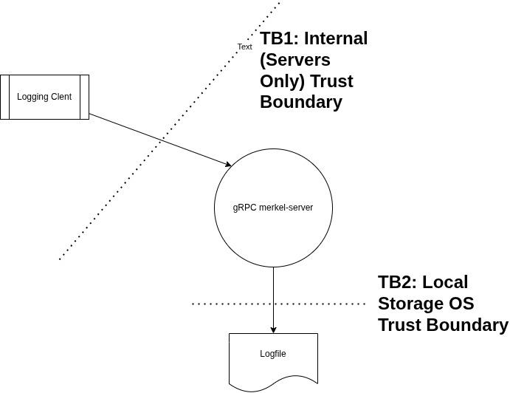

Table 1: TB1 → In-Transit (gRPC Service)
Threat | RISK | Mitigation
Spoofing | Unauthorized clients sending bogus log entries. | Authentication is enforced via TLS with Certificate Authority (CA) validation. Access can be further restricted via IP-allowlisting/firewalls.
Tampering | Man-in-the-Middle (MitM) attacks modifying packets | All communication is encrypted via TLS (v1.2+). HMAC-SHA256 signatures ensure the payload matches the expected hash.
Repudiation | Denial of log submission or origin. | Every log entry is chained to the previous entry's hash and signed with a unique HMAC key, creating an immutable cryptographic audit trail
Information Disclosure | Unauthorized reading of logs in transit. | TLS encryption prevents sniffing of log contents during ingestion.
Denial of Service | Socket exhaustion or resource overload. | The service is designed for containerized deployment (e.g., Kubernetes) allowing for horizontal scaling and resource limits (CPU/Memory).

Table 2: TB2: At-Rest (Log Storage & Library)
Threat | RISK | Mitigation
Spoofing | Local actor injecting messages into the log file. | Injecting messages requires recalculating the entire hash chain from the point of injection forward. This is detected by the `merkle-checker` tool  Access to log files is restricted via Operating System (OS) Level Permissions (ACLs) and strictly limited to privileged service accounts.
Tampering | Modifying existing log files on disk. | | The Merkle-tree hash chaining ensures that changing a single byte invalidates the chain. Unauthorized changes are flagged during verification.  Access to log files is restricted via Operating System (OS) Level Permissions (ACLs) and strictly limited to privileged service accounts.
Repudiation | Deleting logs to hide tracks. | While files can be deleted, the "gap" in the sequence numbers and the loss of the root hash chain provide proof of tampering.  Access to log files is restricted via Operating System (OS) Level Permissions (ACLs) and strictly limited to privileged service accounts.
Information Disclosure | Sensitive data leaked from log files. | Policy Requirement: End-users are instructed never to log PII/Secrets. If required, data must be encrypted before being passed to the library.  Access to log files is restricted via Operating System (OS) Level Permissions (ACLs) and strictly limited to privileged service accounts.
Denial of Service | Disk space exhaustion. | Startup rotation and monitoring of disk usage are required. The service should be deployed with log-rotation policies.

Vulnerability Management & SBOM Process
Automated SBOM Generation
The CI/CD pipeline (`ci.yml`) automatically generates a Software Bill of Materials (SBOM) in CycloneDX (JSON) format using `syft` on every commit and pull request. This provides full transparency into the project's dependency graph
Continuous Vulnerability Scanning
Vulnerabilities can be reported to security@phonax.com; we acknowledge receipts within 24 hours.
1. Submit-time Scanning: On every code push, `grype` analyzes the generated SBOM. The build is automatically blocked if any "High" or "Critical" vulnerabilities are detected.
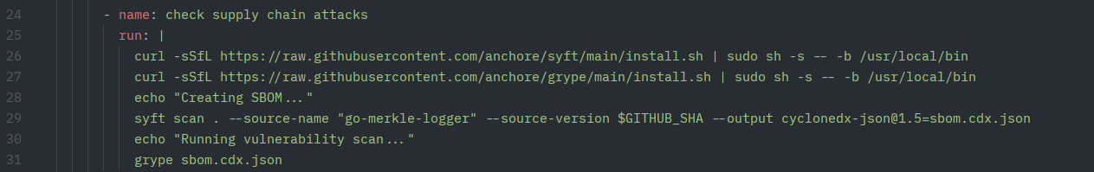Figure 1: CI push based scanning during development
2. Nightly Scanning: A scheduled GitHub Action runs every night at 00:00 UTC. This ensures that new vulnerabilities discovered in existing dependencies are caught even if no code changes are made.
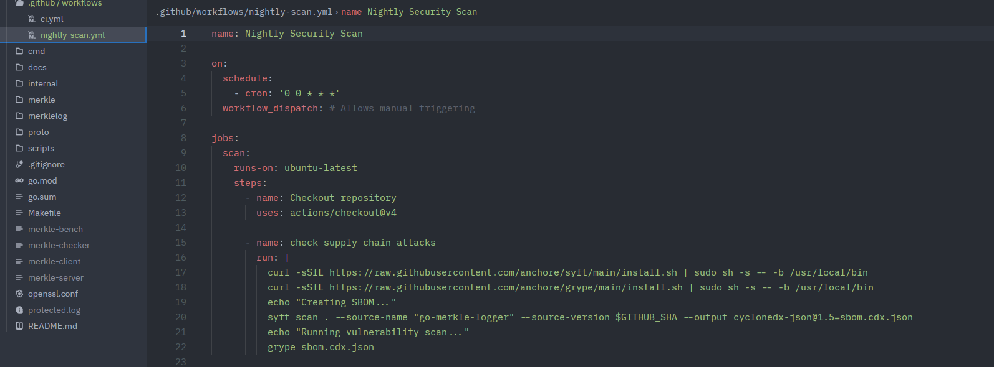Figure 2: Nightly SBOM supply chain attack diagnosis

Remediation process
- Update Policy: When a vulnerability is detected, developers use the `make update-sbom` target. This command automates `go get -u`, `go mod tidy`, and triggers a fresh scan.
- Timeline: Per our CRA compliance policy, "Critical" vulnerabilities must be triaged and addressed within 24 hours of detection by the nightly scan.
- Manual Overrides: Fixing supply chain issues is a manual verification process to ensure library updates do not introduce regressions.

Artifact Integrity & Provenance

To guarantee the integrity of our distributed software:

- Cryptographic Hashing: Every build generates `.tar.gz` archives for both the binaries and the corresponding SBOM.
- Registry Registration: Artifacts are uploaded to Artifactory with MD5, SHA1, and SHA256 checksums.
- Verification: Customers and automated systems can validate the downloaded artifact against the registered hashes to ensure the software has not been tampered with post-build.

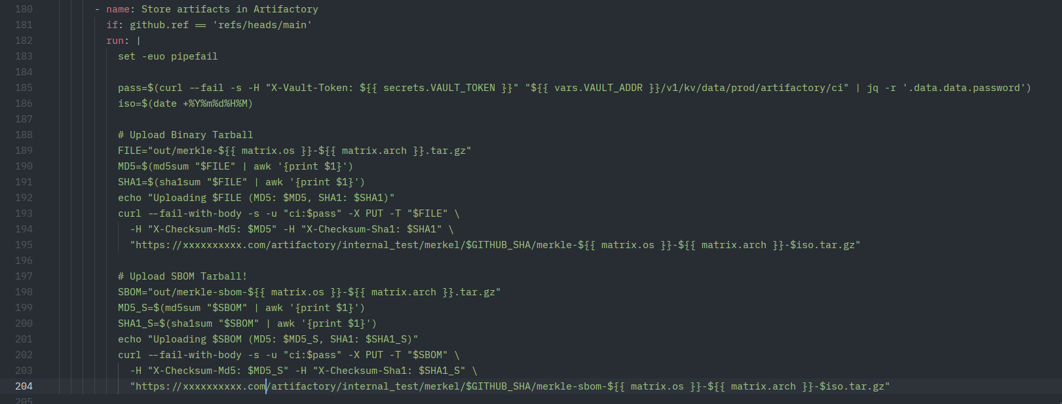Figure 3: Calculation and registration of MD5 and SHA1 checksum of software pacakge (artefect)
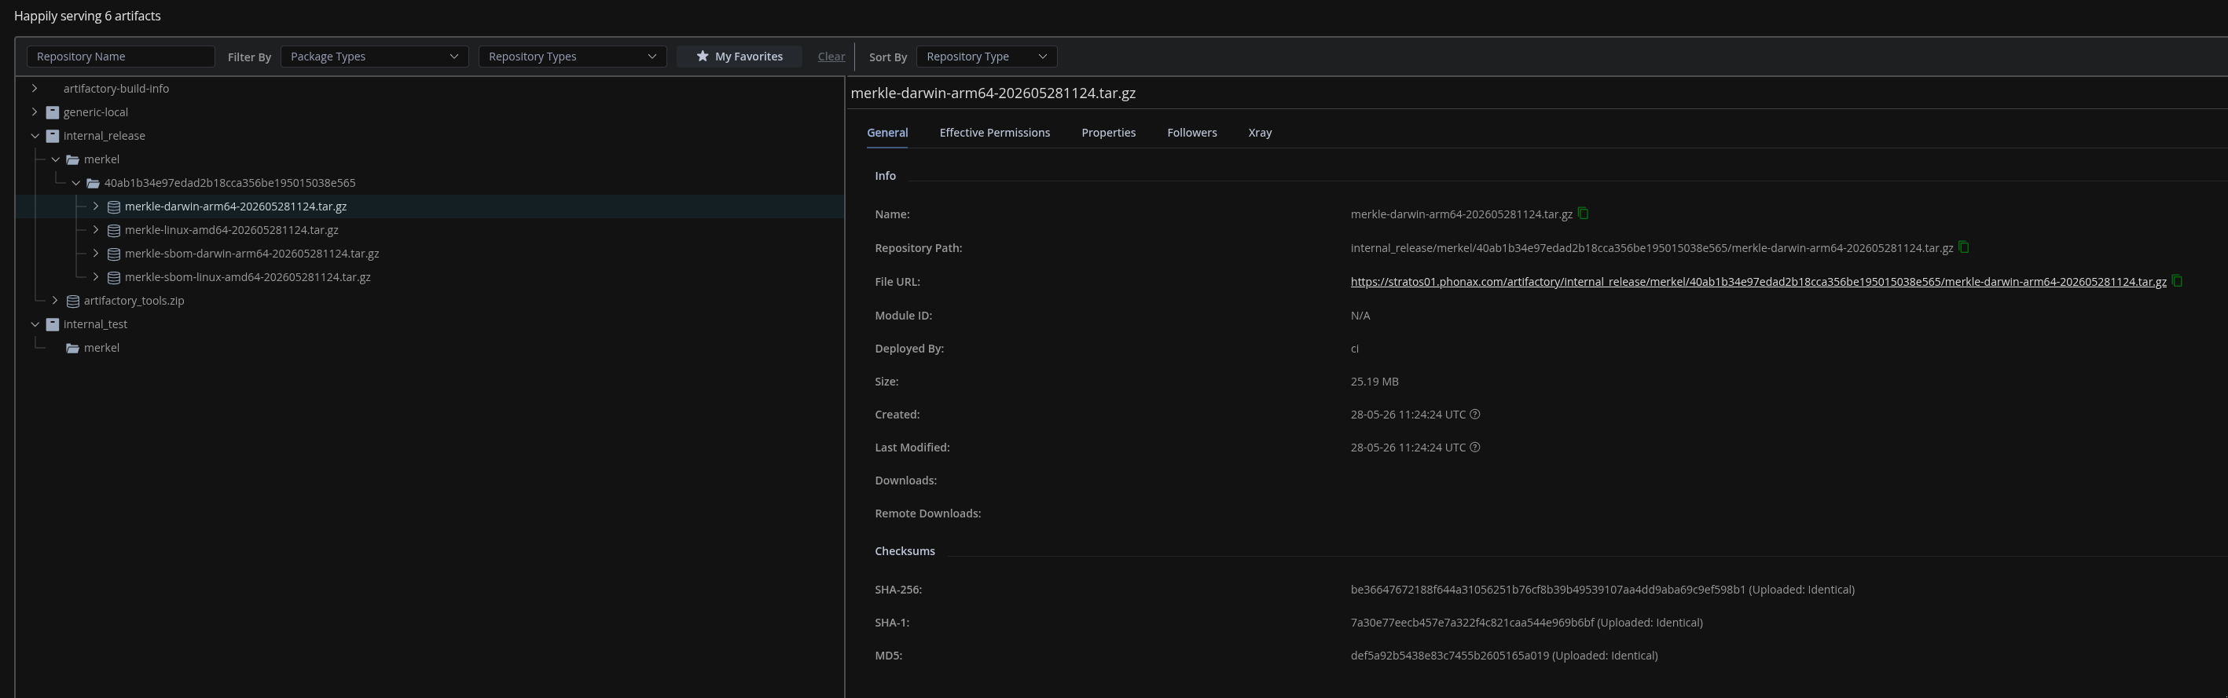Figure 4: Registration of MD5 and SHA1 of aretefact in artefact erpository

