How France Caught Up and Then Stopped
The case follows Lisa Stone as she tries to understand why Durabuild prospered during France's postwar boom and why growth eventually slowed. The Solow model gives her the answer. France started far below the United States in 1950, with GDP per capita at just 46 percent of the American level ($8,116 vs $17,712 in 2021 PPP dollars). France's capital per worker was roughly 42 percent of America's. Both countries had similar investment rates in the early years (around 23 percent of GDP), but because France started from such a low capital base, each dollar of new investment produced larger gains. This is convergence in action.
By 1980, France had closed the gap dramatically. GDP per capita reached 78 percent of the USA. Capital per worker actually exceeded America's. France's TFP, measured against the US as a benchmark, rose from 0.73 in 1960 to 1.14 by 1980, meaning French workers were briefly more productive than their American counterparts at the technology frontier. But then the slowdown came. By 2000, France's GDP per capita had fallen back to 68 percent of America's. Total Factor Productivity or TFP peaked and declined. The convergence story was over. Grandpa Frank's mistake was not recognizing that the high-growth phase was temporary, a natural consequence of capital deepening that had to slow as France approached its steady state.
Solow model predicts exactly what happened: rapid growth when far from steady state, deceleration as you approach it. The data confirms it.
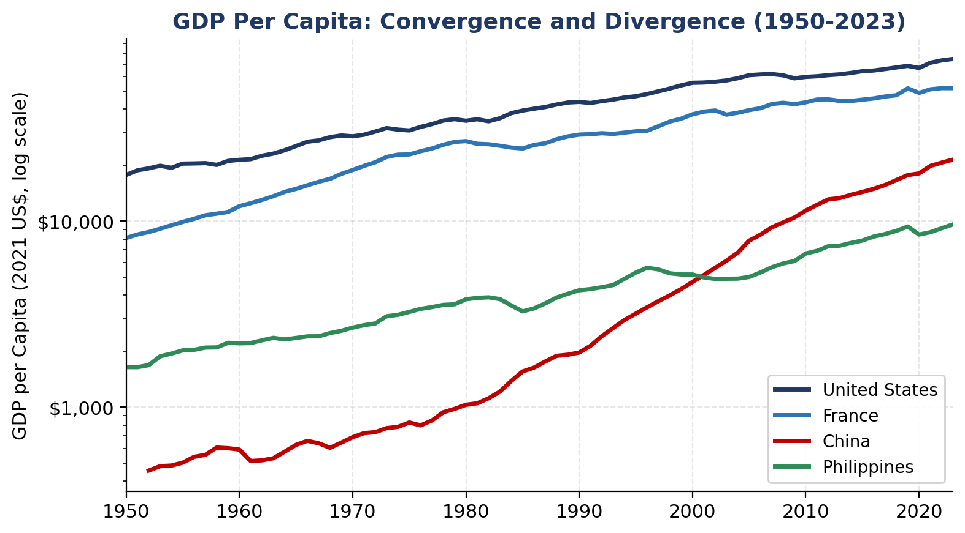
Figure 1: GDP per capita (log scale) for all four countries. France converges toward the USA, then stalls. China accelerates after 1980. The Philippines flatlines.

USA vs France: The Convergence and Slowdown
Indicator | 1950 | 1970 | 1980 | 2000 | 2023
GDP/cap FRA as % USA | 46% | 66% | 78% | 68% | 70%
K/Worker FRA as % USA | 42% | 78% | 106% | 79% | 145%
TFP FRA (USA=1) | n/a | 0.92 | 1.14 | 1.20 | 0.89
Invest/GDP (FRA) | 23% | 31% | 29% | 21% | 27%
Invest/GDP (USA) | 23% | 22% | 24% | 27% | 23%
Source: Penn World Table 10.01. GDP per capita at current PPPs (2021 US$). TFP indexed to USA=1.

China as the Next Convergence Story
Lisa walking along the Mississippi, wondering whether China would follow the same arc as France. The simulation answers this. China is doing exactly what France did, but at greater scale and with more extreme capital intensity. China's investment share has run at 35 to 43 percent of GDP for decades, far above anything France or the USA ever sustained. The result: China's capital stock grew from $773 billion in 1960 to $172 trillion by 2023. GDP per capita went from $591 to $21,428, moving from 3 percent of the US level to 29 percent.
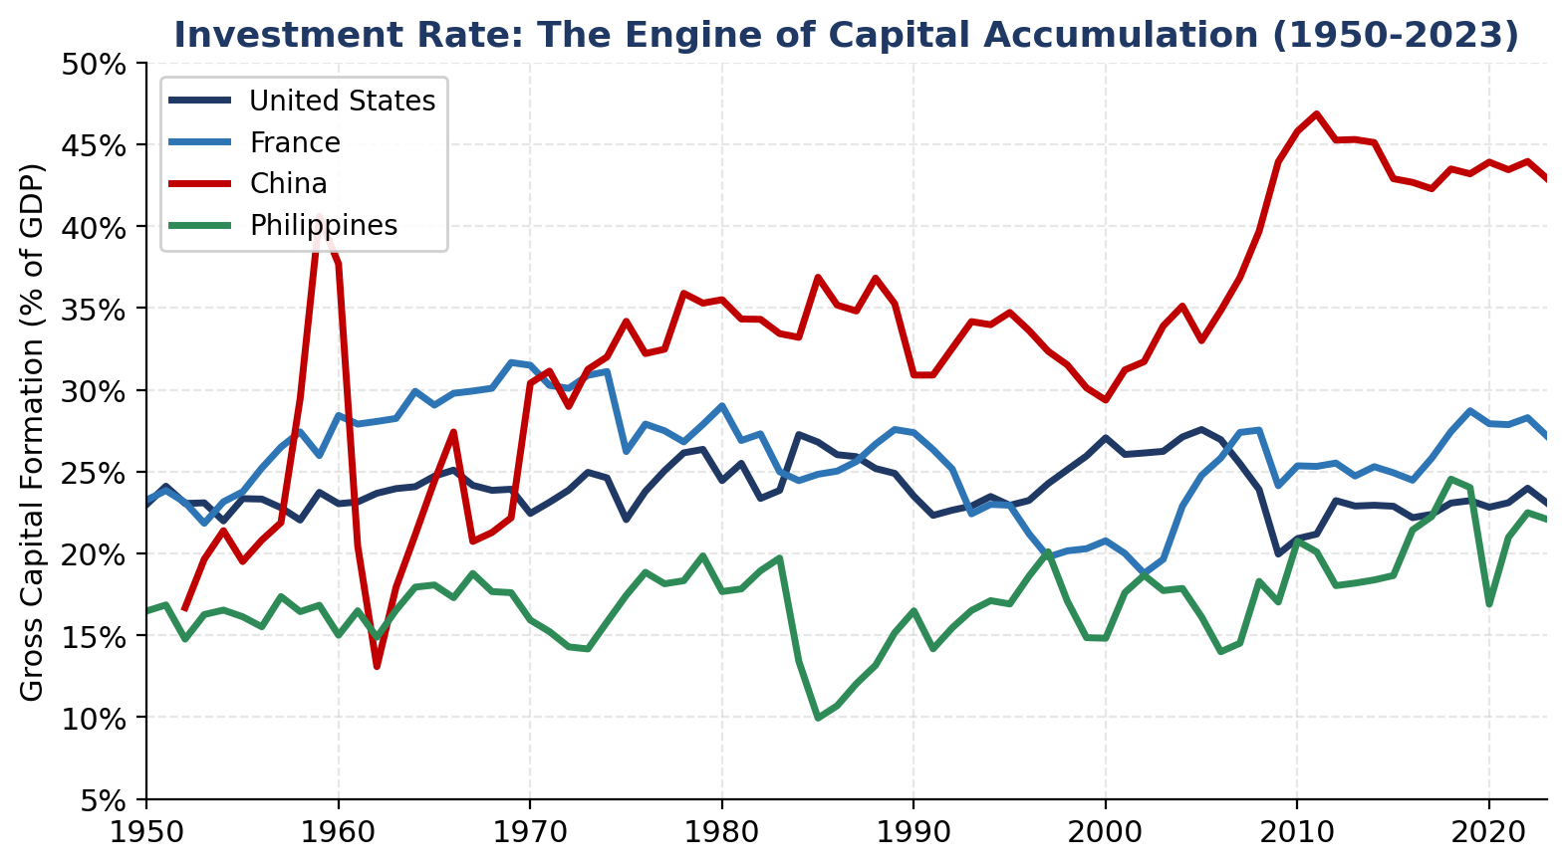
Figure 2: Investment as a share of GDP. China consistently runs at 2x the rate of the other three countries. The Philippines stays below 25% for most of the period.
But the Solow model also predicts what comes next. China's internal rate of return on capital has been falling steadily, from about 17 percent in 1970 to 7.4 percent by 2023. Diminishing returns are setting in. TFP relative to the USA sits at 0.47, meaning China is still far from the technology frontier. The question for is whether China can sustain growth through TFP improvements as capital deepening slows, or whether it will hit the same wall France did. The Grandpa Frank parallel writes itself: betting on China's high growth continuing indefinitely is the same mistake he made with France.

Why the Philippines Did Not Converge
This is where it diverges from cas. In 1960, the Philippines had a higher TFP than China (0.51 vs 0.24 relative to the USA) and a higher human capital index (1.50 vs 1.23). By any Solow prediction, the Philippines should have outgrown China. It did the opposite.
By 2023, China's TFP caught up to the Philippine level (0.47 vs 0.47). China's human capital nearly closed the gap (2.75 vs 2.96). GDP per capita tells the real story: China went from $591 to $21,428 while the Philippines went from $2,205 to $9,606. The Philippines started richer per person and ended poorer.
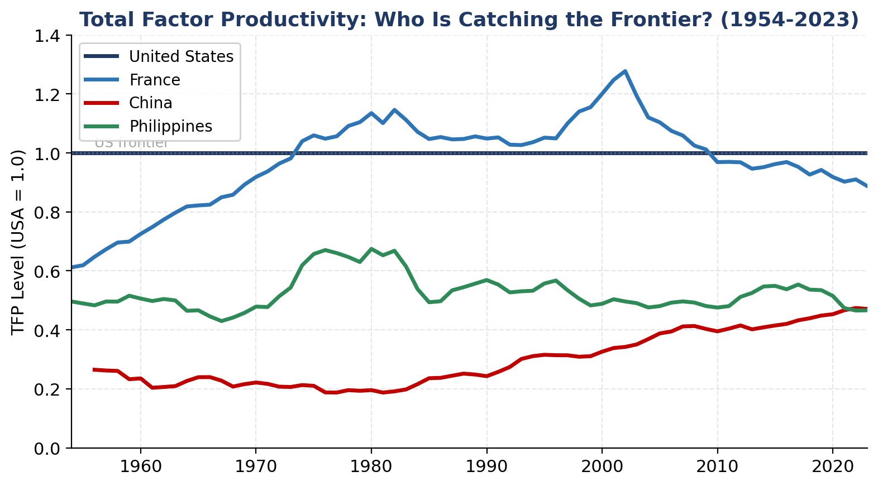
Figure 3: TFP levels relative to USA. France surpassed the US frontier before falling back. The Philippines and China converge to the same level by 2023, despite the Philippines starting far ahead.
The explanation is the savings rate. The Philippines never sustained investment above 24 percent of GDP. It averaged 15 to 18 percent for most of the postwar period. In Solow terms, its steady-state capital-to-labor ratio stayed low because the economy simply did not accumulate capital fast enough. Capital per worker in the Philippines reached $96,960 by 2023. China's hit $228,804. The USA stands at $482,411. The Philippines is not converging at the rate theory predicts because the core input to the Solow engine, the savings rate, has been structurally weak.

Four-Country Comparison: Key Solow Indicators
Indicator (2023) | USA | FRA | CHN | PHL | Insight
GDP per capita | $74,491 | $51,843 | $21,428 | $9,606 | PHL < CHN despite head start
TFP (USA=1) | 1.00 | 0.89 | 0.47 | 0.47 | PHL = CHN after 60 years
Human Capital | 3.83 | 3.31 | 2.75 | 2.96 | PHL still leads CHN
Investment/GDP | 23% | 27% | 43% | 22% | CHN 2x everyone else
K per Worker ($K) | $482K | $697K | $229K | $97K | PHL far from steady state
Return on Capital | 8.1% | 4.7% | 7.4% | 17.9% | PHL highest returns
Source: Penn World Table 10.01. All values for 2023. Capital per worker in thousands of 2021 US$ at current PPPs.

When Depreciation Catches Up
The Solow model's core insight is not just that growth happens. It is that growth stops. The production function is concave in capital: each additional unit produces less output than the one before. Meanwhile, depreciation is linear. It takes a fixed percentage of whatever capital stock you have. As you invest, new capital adds less and less output while depreciation keeps eating away at the existing stock at the same rate. Eventually the two forces balance. New investment exactly equals depreciation. That is the steady state. You are running just to stand still.
The PWT data lets us see exactly where each country sits on this curve. The gap between the return on capital and the depreciation rate tells you how far an economy is from its steady state. When the gap is wide, each dollar of investment earns well above what depreciation destroys. When the gap is narrow, the economy is near the crossover point.
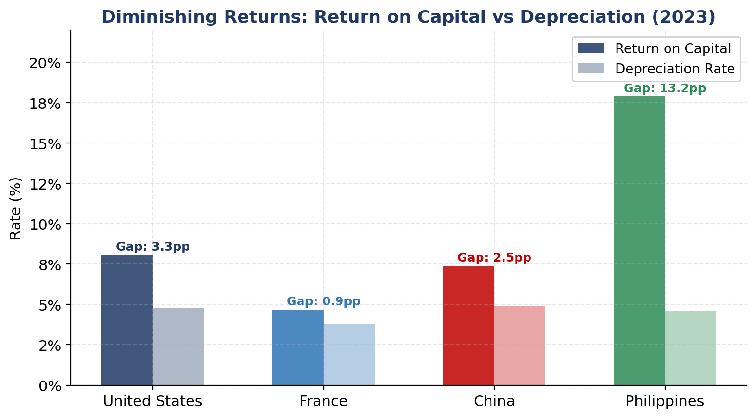
Figure 4: Return on capital vs depreciation rate (2023). France's gap has nearly closed at 0.9 percentage points. The Philippines has the widest gap at 13.2 points, meaning it is furthest from steady state.
France's gap is just 0.9 percentage points. Its return on capital (4.7%) barely exceeds depreciation (3.8%). France is essentially at its steady state. Every euro of new investment mostly replaces what wore out rather than expanding productive capacity. This is why France has more capital per worker than the USA ($697K vs $482K) but still produces less output per person. The extra capital earns almost nothing at the margin. This is diminishing returns fully realized.
China's gap is 2.5 percentage points (return 7.4%, depreciation 4.9%). Still positive, still growing, but narrowing. At its current investment rate of 43 percent, China is pouring capital in faster than any major economy in history. The Solow model says it does not matter how fast you pour. The concavity of the production function means depreciation will eventually match it. China's wall is approaching.
The Philippines has a 13.2 percentage point gap (return 17.9%, depreciation 4.6%). This is the widest gap of the four countries by far. Each peso of investment earns well above what depreciation destroys. In theory, this is exactly where you want to put capital. The marginal product is high, the steady state is far away, and the potential for growth is enormous. The problem, again, is that the economy is not generating enough savings to exploit the gap. The Philippines sits at the most favorable point on the diminishing returns curve but has the weakest mechanism to capitalize on it.
France has already hit the wall. China is approaching it. The Philippines has not even started the journey. Three countries at three different positions on the same curve, with the same model explaining all of them.

