USGA GHIN Calculator



# Synopsis

This project is meant to demonstrate competency in several web-design techniques, data types, and languages. It is a simple web-site that calculates a golf handicap based on the 20 most recent scores. It provides a form for entering a new score, and displays the 20 scores with the 10 used scores highlighted. The back-end database is implemented with a SQL server using MAMP. The scores database will contain a complete score history, and the most recent 20 entries are extracted to calculate the handicap. The courses file will contain a history of all courses entered. This will also remain small, unless I win the lottery and travel the world playing golf. The site demonstrates capability with html, Javascript, jquery, DOM, xmlHTTPRequest, and PHP.

# Annotated Display

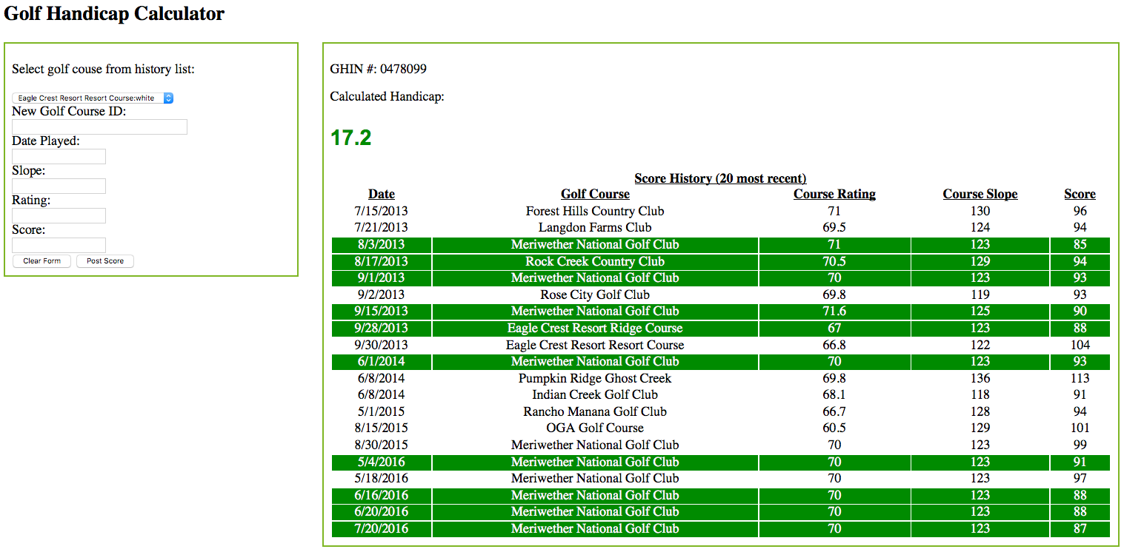

Simple interface. Form is populated with Javascript accessing the database by calling PHP scripts on the server side. The handicap is calculated and the scores table is populated with Javascript/PHP accessing the scores database table. The top ten scores are highlighted. When new score is posted, a new course name and tees played is added to the courses database table (Javascript/PHP) if required, and the new score is added to the scores database table (Javascript/PHP). The web page is updated dynamically with new scores in the table, and new courses in the form, and a new handicap index (GHIN), without requiring a page reload.