Home Credit Default Prediction

Executive Summary — Bayesian Network Model

Problem & Dataset. Home Credit Group serves unbanked and underbanked populations who lack conventional credit history. The business challenge is identifying loan applicants at high risk of default while minimising false refusals — a precision-recall tradeoff with direct financial and social consequences. The source data is drawn from the Home Credit Kaggle competition and consists of two application files plus four supplementary tables: bureau credit history, installment payment history, credit card balances, POS-cash loan balances, and prior application records. The application training file contains 307,511 historical loans with a known outcome (TARGET = 0 repaid, TARGET = 1 defaulted) and is the sole source of labeled data used for all model training and evaluation. The application_test.csv contains 48,744 applicants without a loan response, so it was eliminated from this study.
After joining all six source tables, 29 model-ready categorical features are derived per applicant. The 307,511 labeled rows are partitioned into three non-overlapping sets: a training set of 209,107 rows (oversampled to 259,503 to address the 8.5% minority-class imbalance), a calibration set of 36,902 rows used exclusively to fit the post-hoc probability calibrator, and a held-out test set of 61,503 rows used for all reported evaluation metrics.
- Algorithm models. Two Discrete Bayesian Networks were built using pgmpy. The Expert model uses a hand-crafted Directed Acyclic Graph encoding domain knowledge about causal risk relationships. The Auto model uses hill-climb search to learn DAG structure from data (max in-degree 3, 10,000 iterations). Both models use Bayesian parameter estimation with Dirichlet priors and Variable Elimination for inference. RandomOverSampler (minority class oversampled to 35% of majority) addresses the 8.5% default-class imbalance before training.
- Null analysis & imputation. A pre-fill null audit identified 20 MODEL_COLS variables carrying nulls before any defaults were applied. These were classified into two groups: structural nulls (~14% of rows with no bureau history, ~71% with no credit card) which are left as NaN and filled with conservative domain defaults (e.g. None, Short); and random nulls (EXT_SOURCE_1 at 54%, EXT_SOURCE_3 at 20%, DAYS_EMPLOYED at 18%) which are genuine data gaps suitable for imputation. KNN imputation (k=5) was applied to the three EXT_SOURCE columns using a focused feature set (DAYS_BIRTH, AMT_INCOME_TOTAL, AMT_CREDIT, EXT_SOURCE_1/2/3 cross-imputing). The imputer was fitted on training rows only to prevent data leakage. DAYS_EMPLOYED was filled with the training-set median for non-pensioner applicants; pensioner and unemployed NaN rows were left untouched. Imputation improved Auto recall by +0.04 but did not improve precision, which is governed by feature discriminative power rather than data completeness.
- Graph structure discovery & expert list. Initially, graph structure analysis was performed to identify the key independent variables and their structure. This full list performed poorly — each additional direct parent suppressed the predicted default probability, reducing recall progressively (as low as 0.14 in early experiments). These original candidate features were screened individually using Information Value (IV), followed by pairwise IV screening of 45 pairs to detect synergistic combinations. Systematically removing weak direct edges and retaining only AgeEducation (combined Age x EducationLevel, IV = 0.1523, the only pair with positive pairwise lift) produced the baseline Expert model with recall 0.45 and F1 0.26.
- Best performing model. Both models were evaluated on the 61,503-row held-out test set (4,965 defaults, 56,538 repaid). At threshold 0.12 both models achieve equivalent recall (0.45). The Auto model leads on precision and F1; the Expert model leads on calibration (ECE). At threshold 0.10 the Expert model reaches its peak recall of 0.525, correctly flagging 2,609 of 4,965 actual defaults in the held-out test set at a cost of 13,111 false alarms. The Auto model DAG — learned without domain constraints — independently routed demographic signals through intermediate nodes rather than directly to LoanOutcome.
Model | Threshold | TP | FP | Recall | Precision | F1 | ECE
Pre-imputation
Expert | 0.10 | 2,607 | 13,098 | 0.525 | 0.166 | 0.252 | 0.0009
Expert | 0.12 | 2,219 | 9,841 | 0.447 | 0.184 | 0.260 | 0.0009
Auto | 0.12 | 2,036 | 8,144 | 0.410 | 0.200 | 0.270 | 0.0057
Post-imputation
Expert | 0.10 | 2,607 | 13,098 | 0.525 | 0.166 | 0.252 | 0.0029
Expert | 0.12 | 2,234 | 10,177 | 0.450 | 0.180 | 0.260 | 0.0029
Auto | 0.12 | 2,234 | 9,524 | 0.450 | 0.190 | 0.270 | 0.0023
Table 1. Model performance on 61,503-row held-out test set (4,965 defaults). ECE = Expected Calibration Error; lower is better.
Pre-imputation at threshold 0.12, the Auto model catches more defaults than Expert (2,036 vs 2,219 TP) with a lower false-alarm burden (4.0 vs 4.4 FPs per TP). Imputation equalises recall — both models reach 2,234 TP at threshold 0.12 — but at a higher false-alarm cost: Expert rises to 4.6 FPs per TP (10,177 FP) and Auto to 4.3 FPs per TP (9,524 FP), as the calibrator must remap the shifted EXT_SOURCE distribution. Lowering the Expert threshold to 0.10 recovers an additional 373 defaults (2,607 TP) at a cost of 3,574 extra false alarms, raising the burden to 5.0 FPs per TP in both pre- and post-imputation runs. Which model is best for this business case is dependent on the cost of default and the resource cost to manually review a false positive. very low ECE.
- Calibration. Raw Bayesian Network probabilities are poorly calibrated by default due to the discrete CPT structure and oversampling. Isotonic regression calibration was fitted on the 36,902-row held-out calibration set (true class proportions preserved — not oversampled) and applied at inference time. Calibration reduced the Expert ECE from ~0.003 pre-calibration to 0.0009 after adding AgeEducation — a 74% reduction. Post-imputation ECE settled at 0.0029 for Expert and 0.0023 for Auto as the shifted EXT_SOURCE distribution required the calibrator to re-learn the probability mapping. Reliability diagrams are generated each run to monitor calibration quality visually.
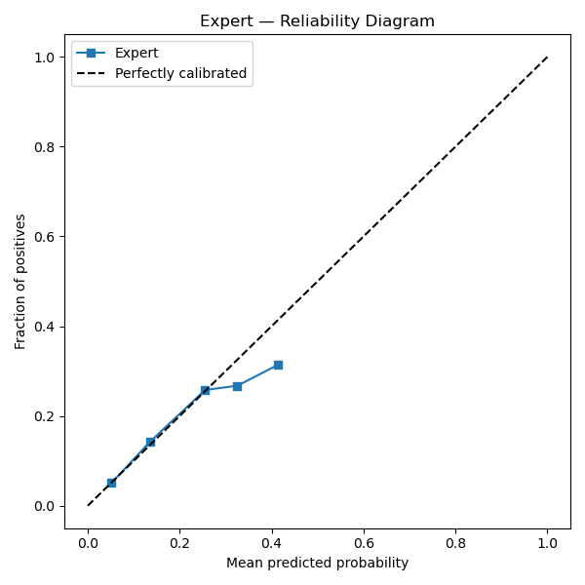  Expert Model — Reliability Diagram | 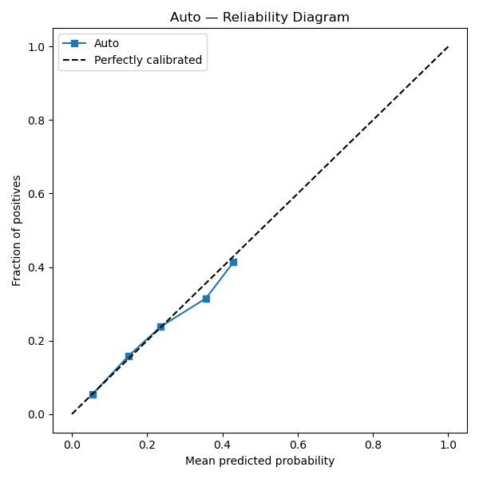  Auto Model — Reliability Diagram

Key Findings & Next Steps. The Expert model LoanOutcome node is structurally saturated by the three ExtSource risk signals — adding further direct parents consistently hurt recall in every test. The Auto model routes demographic signals (Age, EmploymentYears) through intermediate nodes rather than directly to LoanOutcome. KNN imputation improved Auto recall by +0.04 by replacing 54%-null EXT_SOURCE_1 'Unknown' states with scored risk bins; it did not improve precision, which is driven by feature discriminative power rather than data completeness. The most promising directions for further improvement are: (1) adding an OccupationType → LoanOutcome edge to the Expert DAG, where Laborers default at 10.3% vs Professionals at 6.1%; (2) sourcing higher-IV external signals; and (3) threshold optimization aligned to the business cost of a missed default vs a false refusal.

