**Raspberry Pi Notes**

**Started 2015-12-01**

**Sarir Khamsi**

# Introduction

These are some basic notes to help students get started with the Raspberry Pi 2 Model B (1 GB) development kit from Vilros.

## Kit contents

The kit contains

* Includes Raspberry Pi 2 Model B (1GB) and Enclosure Case (Clear)
* 200 Page Vilros Raspberry Pi User Guide
* Vilros 5MP Camera Module
* 8GB Micro SD Card pre-loaded with "NOOB" -- SD Card Adapter
* 5-Foot Micro USB Power Supply 2000 mA
* HDMI Cable
* Wireless Wifi Adapter
* Heatsink for Raspberry Pi - Set of 2 Heat Sinks
* Breadboard
* Jumper wires
* GPIO Ribbon Cable with Breakout board
* 10 Yellow LED's & 10 Red LED's
* 45PC 330ohm Resistors, 45PC 10K Resistors, 2X Big 12mm Button

### Vendor info

The vendor is at <http://www.vilros.com/>. The kits is at [this long link](http://www.vilros.com/raspberry-pi-2-model-b-1gb-ultimate-camera-kit-includes-200-page-user-guide-book-over-40-components-raspberry-pi-2-model-b-1gb-vilros-5mp-camera-module-wifi-dongle-8gb-kingston-micro-sd-card-adapter-case-power-supply-and-many-more.html) for US $95.

# Defaults

* Default username: pi
* Default password: raspberry
* Configure WiFi: wpa_gui

# Creating or adding new users

To add a new user to the system:

sudo useradd *newUser*

sudo adduser *newUser* audio # you need this or the toolbar fill flicker

# Initial setup

The program raspi-config (typing “sudo raspi-config”) sets up a lot of initial things. A couple things you will need or want to changes are

* Internationalization option: select en_US.UTF-8
* Timezone
* Enable the camera

## Screen shots

### Internationalization

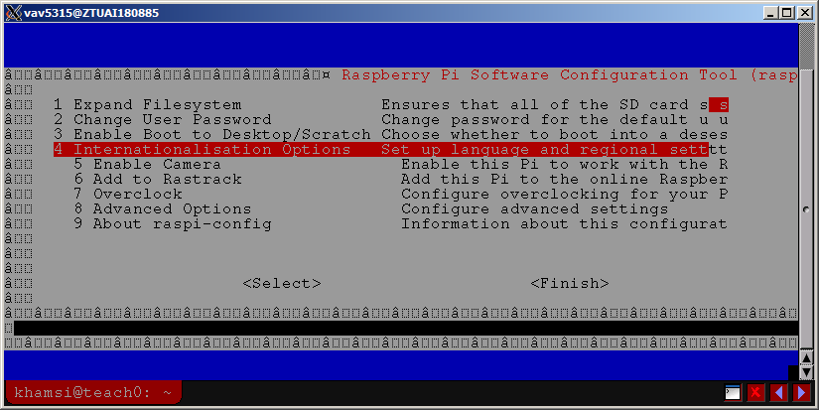

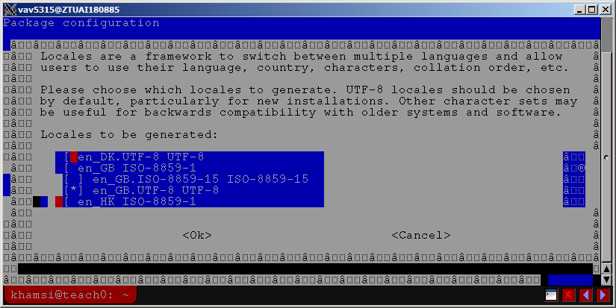

### Camera enable

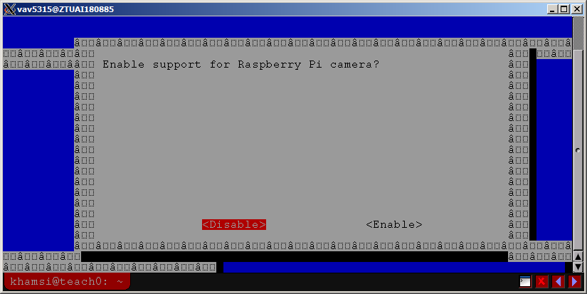

### Keyboard

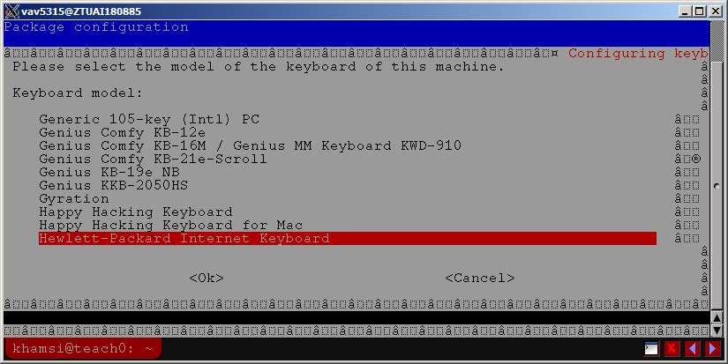

# Camera stuff

## Setup

## Running camera software

To start the camera, bring up a terminal and type:

sudo motion # ctrl-c to quit

To view the video, bring up a browser and use the URL: <http://localhost:8081>.

For control use the URL: <http://localhost:8080>.

# Customizations

The following tools and packages have been added to the instructor kit.

## Tools

* GNU Emacs
* xrdp (Remote Desktop Protocol)

sudo apt-get install Emacs xrdp

## Camera stuff

Run the following to install camera tools

sudo apt-get install -y libjpeg62 \

libjpeg62-dev \

libavformat53 \

libavformat-dev \

libavcodec53 \

libavcodec-dev \

libavutil51 \

libavutil-dev \

libc6-dev \

zlib1g-dev \

libmysqlclient-dev \

libpq5 \

libpq-dev

cd $HOME/Desktop

wget https://dropbox.com/s/xdfcxm5hu71s97d/motion-mmal.tar.gz

tar zxf motion-mmal.tar.gz

sudo mv motion /usr/bin/motion

sudo mv motion-mmalcam.conf /etc/motion.conf

sudo chown root:root /usr/bin/motion