**Bachelor Course Geophysics - SoSe 2022**

**Magnetics**

**Contact Information: Prof. P. Dietrich (0175 - 5873318)**

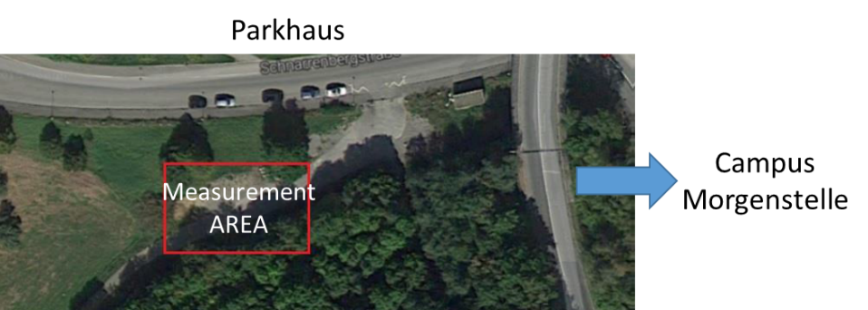

**Objective:** Locate a magnetic anomaly, a gas pipeline, buried beneath the surface near the Campus Morgenstelle (see map). The approximate location of the pipeline is known to be within a 20x20 m grid.

**You will need to give a clear explanation of where the pipeline is located. This includes geographic location relative to the surface, direction in which the pipe is laid, AND the approximate depth at which the pipe is buried.**

*Materials you need for the exercise*: Overhauser magnetometer, proton magnetometer, fluxgate magnetometer, 4 measuring tapes (>20 m), ranging poles (Fluchtstangen), prismatic square (Winkelprisma), compass, notebook or/and writing materials, clock, rain jacket, water.

**Measurements in the field:**

1) Set up a measurement grid.

2) Measure the total field with an Overhauser magnetometer

- 1m distance between measurements

- Sensor height 2m above ground

3) Measure the vertical gradient field with a Fluxgate magnetometer

- 1m distance between measurements

4) Measure the Earth magnetic field variation (base station record) with a proton magnetometer. This must be done every 5 minutes at a fixed point outside of the area that is influenced by the pipeline.

**Stay Organized!**

*You should organize your data in a table that includes: the x and y-coordinate of every measurement, and measured values from each magnetometer (in nT)). You should also include information about the field site such as weather conditions, obstacles that may influence the measurements or prevent them from being taken at exact locations, etc.*

**After measurements: Process the data to determine the location**

5) Process your measured Overhauser and Fluxgate data using an interpolation scheme of your choice (e.g. contouring by hand or use a software Matlab/Python/…). Plot appropriate contour maps (remove outliers before plotting the final results; for the Overhauser data subtract the value of the Earth magnetic field in order to obtain positive and negative anomalies).

**Writing your GROUP REPORT ---**

A) Introduction: Lay out the goal of this report (e.g., phrased as a question) and provide general context required for the reader to understand the following sections. Introduce the exercise task(s) and the study site, and include a figure of the survey area.

B) Methods: Explain the core geophysical principles, the instruments used, related uncertainties, and processing strategies. Outline the expectations (expected answers to the questions you are trying to solve) based on the geophysical theory and available site information.

C) Results: Exclusively summarize the findings of the survey including informative figures. Include:

1) Appropriate contour maps of the total field and gradient measurements. Make sure the figures are labeled and locate the pipeline on the maps.

2) Determine the maximum depth of the pipeline by plotting meaningful profiles (use the data from the contour maps), and explain how you get your result.

3) Plot the base station data versus time and discuss whether a correction for time variation is needed for the measured total field data.

*This section can be comparatively short as all interpretation is held back until the discussion section.

D) Discussions: Balance dierent scenarios that may explain your results. Contrast your results to your expectations outlined previously in the methods.

E) Conclusions: Reiterate the original motivation from the introduction and then provide take-away messages that are synthesized from the results and related discussions. This is often the most-read section, so highlight the most important points from your experiment.

**Submit as a zip archive including a pdf of your report and your data (e.g., as ASCII text file) on Ilias. Mention all group members and matrikelnumber on the report.**

**Submit your report the latest two weeks after the measurements**