Hardware Reconfiguration Scheme Based on the Digital TV Signal
Rodrigo R. de Oliveira, Lucas C. Cordeiro, Member, IEEE, Eddie B. de Lima Filho, and Vicente F. de Lucena Jr., Senior Member, IEEE

Abstract — This work presents a new hardware reconfiguration approach, which is capable of updating hardware modules, based on the digital TV (DTV) signal content. Such a scheme allows several synthesized hardware cores (bit-streams) to be signaled and simply broadcast, through an open DTV signal. Service information content, specifically designed for identifying and describing characteristics of the multiplexed hardware bit-streams, is added to the transmitted signal. The receiver framework, in turn, checks whether those characteristics correspond to the embedded reconfigurable devices (e.g., field programmable gate array - FPGA) and, if a match is found, it reassembles the related bit-streams and reconfigures the FPGA device. This approach can be used in several designs, regarding intelligent reconfigurable devices, and has the potential to minimize device costs and provide a better hardware reuse.

Index Terms — Digital TV, TV receivers, Programmable circuits, Programmable logic arrays.

INTRODUCTION
Embedded systems, as well as digital TV (DTV) receivers, are designed with no concern for technology advancements, regarding computational tasks performed by hardware, over time. Such systems typically have several functions performed with silicon hardware (application specific integrated circuit - ASIC), because they demand high computational complexity. One example of that is video decoding (e.g., advanced video coding – AVC or AVC/H.264 [1]), which is a demanding task normally performed by an ASIC silicon device.
Typically, when a new DTV network is deployed, ASIC devices are then used for developing new receivers, which provide all necessary decoding/processing techniques. However, if the associated standard is revised and other algorithms and/or protocols are adopted, the current infrastructure must be replaced, in order to provide advanced features. Such a problem is commonly known as hardware legacy and is closely related to the use of ASICs.
Recently, the international telecommunications union (ITU) introduced the high efficiency video coding (HEVC), also known as HEVC/H.265 [2], [3], as the next-generation video compression standard. Compared with its predecessor (AVC/H.264), it presents about twice the compression efficiency, without deteriorating the quality level of the encoded signal [4].
Given what was presented, one may notice that AVC/H.264-based systems are unable to incorporate the benefits of HEVC/H.265 immediately, due to hardware legacy. However, such flexibility could be achieved if the DTV receiver architecture was capable of performing demanding tasks through reconfigurable devices (e.g., field programmable gate array - FPGA), instead of ASICs.
Currently, the semiconductor industry and open core communities have boosted the use of FPGA. The latter even provide hardware-description source codes (e.g., VHSIC hardware description language - VHDL [5] and Verilog [6]), for a number of applications (e.g., crypto cores, DSP cores and encoder/decoder cores), which are available for downloading and using in project solutions [7].
Furthermore, current FPGA technologies are already a good option, when compared to ASICs, due to price equalization between them, which is provided by the amortization of non-recurring engineering (NRE) costs among customers, for each integrated circuit (IC) family [8], [9]. This reinforces the development of hardware architectures and critical tasks using reconfigurable devices, in embedded systems.
The growth in the adoption of FPGA solutions can already be seen in various segments of the consumer electronics industry [10], especially DTV, where such devices are used for implementing specific functions in corresponding receivers (e.g., timing control and output interfaces) [11].
The observations presented in the last paragraphs are the inspiration for the present work, which proposes a new approach for hardware update, by the DTV signal as transport infrastructure. In the context of a DTV system, the reconfiguration bit-stream can be regarded as regular data broadcast, along with the high definition television (HDTV) content of a television program, as shown in Fig. 1. A DTV system is composed of several subsystems, which include data preparation for transmission and complete signal reception, with subsequent content filtering. In the transport stream (TS) step, audio, video, and data, which include the FPGA bit-stream, are interleaved, engendering a multiplexed DTV stream flow [12]. Finally, in the transmission step, the resulting signal is then modulated and sent through a DTV channel. At the receiving side (see Fig. 1), each device in range detects and decodes the transmitted content. The result of this process is the complete extraction of the FPGA-core data stream, which is then reassembled in a persistent storage module. After this step, the FPGA module is reconfigured.

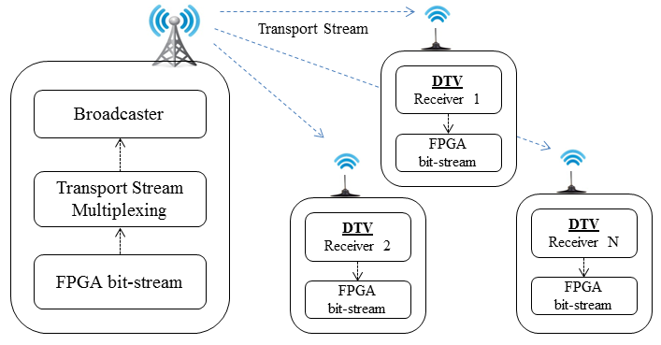
Fig. 1. The FPGA bit-stream broadcast, in a DTV environment.

This work deals with generic hardware update for DTV environments, where receivers do not need to leave the user premises. Indeed, designing reconfigurable hardware architectures can be an efficient way to improve the receiver lifespan, or even to create low cost receivers and embedded systems.
The presented scheme extends the use of DTV channels, introducing a way of transmitting synthesized hardware data. It can be employed in a wide range of future designs, regarding intelligent hardware architectures, and has the potential to boost the use of hardware reconfiguration in embedded solutions (e.g., DTV receivers), besides providing the opportunity to deeply exploit this scheme, in order to develop architectures to be reconfigured.
Hardware reconfiguration has already been used in a vast range of projects, but the solution presented here is an innovative way to perform this process. It is expected that the subject of this work, along with its related schema, can stimulate the scientific community to develop a wide range of environments, which rely on the hardware update technology.
The remaining of this work is organized as follows. Section II provides a summary regarding the related literature. Section III contains a brief explanation of DTV and data broadcasting. Next, section IV tackles reference receivers and basic concepts related to FPGA configuration schemes. Then, section V presents the complete hardware update approach, by detailing each step involved in this process. Finally, conclusions and future work are presented in section VI.

RELATED WORK
Recent studies, on similar topics, present some related work based on intelligent hardware architectures, with hardware reconfiguration, as the core technology for building more compact and efficient systems.
Indeed, architectures with hardware resource management present a new trend in embedded systems. In these approaches, pre-synthesized hardware unit functions are able to execute run-time reconfiguration of FPGA cores, according to the user’s interaction, such as described by Lin et al [13].
Intelligent embedded systems can make use of the partial dynamic hardware, for run-time reconfiguration. Such a feature, which is similar to a microprocessor multi-task system, allows a multiplex of distinct hardware modules to run at the same time. Thus, functional pre-synthesized hardware blocks, i.e., logical blocks, can be reconfigured or not, according to system needs [14]. In that case, the use of partial dynamic reconfiguration causes a considerable reduction in power consumption, besides a significant decrease in device costs.
The reconfigurable streaming architecture, presented by Hillenbrand et al [15], allows the inclusion procedure of signal processing pre-synthesized cores, into hardware description language (HDL) sources, to be run-time reconfigurable. In that case, the pre-synthesized cores minimize the synthesis process and allow the design of adaptive reconfigurable system architectures.
A complete multi-core reconfigurable platform, combining processors with some reconfigurable logic, can provide a rich and flexible environment for application programmers, as proposed by Serres et al [16].
The related works are based on pre-synthesized cores, which need to be present on their embedded file system. Those cores are used according to system demands, or even due to user interaction. However, the proposed approach is based on broadcast networks, through which pre-synthesized cores for updating several devices can be sent. Therefore, several core modules, from different manufacturers, can be delivered, at the same time, for a large amount of receivers.

HARDWARE-DATA BROADCAST THROUGH THE DIGITAL TV SIGNAL
The DTV TS consists of packets with audio, video, and data, which are 188 bytes in length. The packet is the basic TS data unit and is composed of a sync-byte field, whose value is 0x47, followed by three 1-bit fields (transport error indicator, payload unit start indicator, and transport priority) and an identification (13-bit), known as packet identifier (PID) [17], among others. The PID provides a means of differentiating the payload content of each transport unit (packet), in a TS; if a PID is allocated and reported to a receiver (through a table), this means that a given packet carries video, audio, or other data, according to what was informed. Thus, the proprietary broadcast content is identified by its respective PID values.
Fig. 2 shows a transport stream with different packets, which consist of video, audio, program association table (PAT), and hardware payload (PID 0x77). This transport stream slice shows that packets with the same PID, that is, carrying parts of the same information, are spaced over time. The receiver de-multiplexer then needs to filter a transport stream, using the corresponding PIDs, for accessing its payload content.
The DTV system is able to broadcast binary applications [17], which are interleaved with other HDTV contents (audio, video, and data). In order to inform that an application is being broadcast, the DTV standard uses the application information table (AIT) [18]. The AIT information is used, by the receiver resident system, for downloading all content related to the associated application.
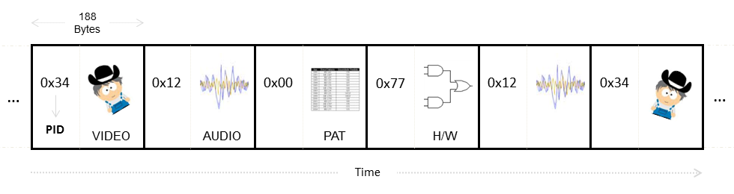
Fig. 2. Transport stream packet structure used to carry different data types, which includes hardware reconfiguration data.

The DTV telecommunication network allows the broadcast of several data types. Here, it is important to consider two main characteristics: the data format and the required synchronization, which are necessary for broadcasting some data types. The format may be classified into three categories, as follows: delimited data, un-delimited data, and datagrams following some protocol control. The delimited data can be divided into units of a defined size (e.g., files and objects); however, the un-delimited data are considered continuous bit-streams. Finally, datagrams correspond to data packets related to a communication protocol (e.g., IPv4 and IPv6).
Regarding synchronization, transmitted data are divided into synchronous, synchronized, and asynchronous [19]. The synchronous data have synchronization requirements with other data in the same stream, which is known as intra-media synchronization. Synchronized data are those that must be presented at predetermined time instances and in synchronism with elements of other media (e.g., closed caption), which is called inter-media synchronization. Finally, the asynchronous data, in turn, have no temporal synchronization requirements.
The data format characteristics and the required data synchronization are important to consider, when choosing the best way for data broadcasting.

Data Broadcasting Mechanisms
An important feature of DTV standards is the data broadcasting capability. The broadcast data are normally used to describe and identify the HDTV broadcasted content. For instance, the European DTV standard, known as digital video broadcasting (DVB), offers four data transport mechanisms: data piping, data streaming, multiprotocol encapsulation (MPE), and Carousels [20], [21]. Data piping is the simplest mechanism, which consists of inserting raw data directly into the TS packet payload area. Data streaming is more complex, when compared to the data piping method. The data streaming approach can arrange data using private sections or packetized elementary stream (PES) packets. Private sections are split into 4084 bytes of payload, plus 8 bytes of header and 4 bytes of cyclic redundancy check (CRC), which amounts to 4096 bytes. Some advantages regarding private sections are the contiguity control, given by the section number field and the error detection control, which is obtained via redundant information (e.g., CRC_32) [22]. Reimers describe the data streaming method by PES packets [23]. MPE uses the logical link control sub-network access protocol (LLC/SNAP) encapsulation, which allows for using any network protocol. Particularly, MPE allows for using unicast (i.e., datagram sent to a single receiver) and multicast (i.e., datagram sent to receiver sets). Carousels are techniques used to repeatedly deliver data in a continuous cycle [24], [25], as defined by the digital storage media command and control (DSM-CC) standard [26], which is adopted by both digital audio video council (DAVIC) and DVB. DSM-CC specifies two types of carousels: data and object carousels. The latter extends the data carousel by specifying a file system directory structure (e.g., media files, applications, image files, and directories). Section V-A addresses the presented broadcasting methods, by evaluating the core data characteristics and the most suitable method to implement hardware reconfiguration schemes.

DTV RECEIVER ARCHITECTURES AND FPGA RECONFIGURATION SCHEMES
DTV receivers (e.g., Set-top Boxes) are used to demodulate and decode the HDTV broadcast signal, in such a way that the transmitted TS, carrying audio, video, and data packets (see section III) is recovered. Normally, DTV standards specify reference receiver architectures, in order to suggest design implementations to manufacturers [27]. In fact, commercially available receivers normally present similar composition and provide a set of device drivers with exemplary applications. These data are taken as a reference to access and manipulate hardware devices.
Fig. 3 shows the basic components present in receiver architectures. The air interface (e.g., front-end, also called demodulator) device is responsible for demodulating any available DTV signal, in the receiver range. It recovers the TS stream flow output by the multiplexer device, which was sent at the transmitter end. The DEMUX component uses the front-end (air interface) output (a transport stream flow), splits packets related to a given PID identifier (see section III), and outputs them in continuous separate flows. Later on, those flows are forwarded to their respective decoders (e.g., H.264 video decoder), which in turn decode the content (e.g., audio or video packets), in a continuous decoding process. The other flows, present in the transport stream, are split by DEMUX, according to a given PID provided by the resident application (e.g., filter software parser) control.

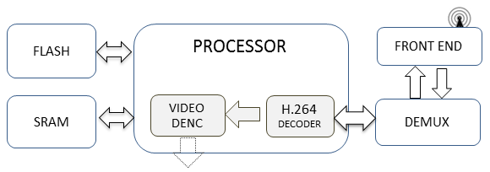
Fig. 3. Receiver architecture composed of air interface (Front End), demultiplexer, H.264 decoder, and memories.

FPGA Standalone Reconfiguration Schemes
The standard process of hardware development begins with a design entry (e.g., hardware schematics or HDL) [28]. Then, a HDL is used for developing hardware specifications to configure a FPGAs or a complex programmable logic device (CPLD). The most well-known HDLs are VHDL and Verilog. In the final step of the design flow, a bit-stream file (e.g., raw binary file – RBF) is generated, which is then used to reconfigure the FPGA device. Typically, it is done by an electronic design automation (EDA) tool, which is also provided by the FPGA manufacturer [28]. Thus, it is possible to validate the final design behavior before delivering the bit-stream.
Although the FPGA reconfiguration is done by a tool, typically provided by the manufacturer, one may also develop a standalone reconfiguration scheme. In general, standalone schemes employ two modes (e.g., master or slave modes) to reconfigure the FPGA, using a bit-stream (pre-synthesized binary code). In master mode, an FPGA is typically used to control the reconfiguration process; however, in slave mode, the FPGA configuration is controlled by an external device (e.g., microcontroller, CPLD, or another FPGA). Additionally, the standard IEEE 1149.1 [29], known as joint test action group (JTAG), is another mode commonly used by FPGA manufacturers. Normally, FPGA manufacturers provide a JTAG cable along with a programming tool, which is used to reconfigure their FPGA development boards. These cables are available to work with different communication interfaces, such as USB, Parallel/Serial port, or Ethernet, and are an attractive way to construct a host/target communication interface. This interface is commonly adopted by several embedded systems and has already been largely tested and validated. The JTAG has basically 4 control signals: test data input (TDI), test data output (TDO), test mode select (TMS), and test clock (TCK), which are used to configure the device through a test access port (TAP) controller [29].
The literature also presents standalone open-source JTAG libraries [30], [31] that enable a variety of JTAG-based manufacturer communication cables. Those libraries can use the serial vector format (SVF) [32], to configure several FPGA models. The SVF file, which describes actions over JTAG interfaces, is a standard used for exchanging descriptions of high-level IEEE 1149.1 (JTAG) bus operations [32]. The standalone program can parse and play the SVF file, thus reconfiguring the FPGA.
SVF files can be obtained from other formats, through a converting tool or even an FPGA manufacturer tool. Indeed, most FPGA manufacturers commonly provide this file, which is used as a standard format to reconfigure devices.
In order to create a host/target physical connection, the reference DTV receiver was used as host device, and a commercial FPGA board as target device. The USB-manufacturer programmer cable, based on the JTAG program mode, is used to connect both sides, as seen in Fig. 4.
The standalone FPGA programmer system was based on an open-source JTAG reference code, which was adapted to fit the DTV receiver (i.e., the module responsible for reconfiguring the FPGA). In order to do that, some third-party libraries were integrated to the receiving system, so that the open-source code could work properly. Thus, the resident application (reconfiguration module) is able to control the FPGA-board read and write (R/W) operations.

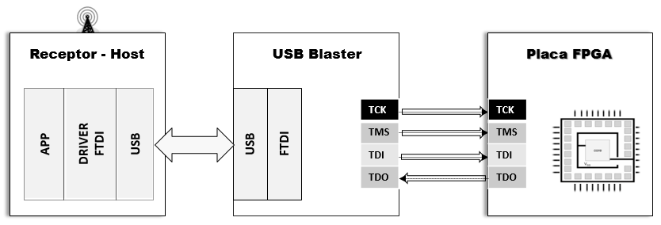
Fig. 4. The DTV Receiver (host) connected to a reference FPGA board (target), through a USB/JTAG programmer cable.

THE HARDWARE RECONFIGURATION SCHEME BASED ON THE DTV SIGNAL
The entire hardware reconfiguration scheme can be split into three distinct steps. The first consists of preparing data to be broadcast. In particular, that means encapsulating the synthesized FPGA bit-stream into a transport stream. Here, it is assumed that the bit-stream is already synthetized, tested, and validated for the same FPGA model used by the receiver. The second step involves filtering, remounting, checksum validation, and persistence. Finally, the final step uses the downloaded bit-stream to reconfigure the receiver FPGA module. All mentioned steps, which results in the complete reconfiguration process of the FPGA device compose the proposed scheme. The following sections discuss each procedure step, in detail.

Hardware Data Multiplexing in Transport Streams
From the point of view of the DTV signal, the FPGA bit-stream is seen as regular data. This way, such content needs to be signaled (i.e., a PID to identify the content flow and description information, using a new data table), in order to notify the receiver about its existence, in the broadcast signal.
In order to add information regarding that, one must follow the DTV standard rules. First, it is necessary to choose the most suitable method for transporting reconfiguration bit-streams, by taking into account their main characteristics (see section III-A). Ultimately, hardware cores are binary data, which contain hardware descriptions for configuring FPGA devices. This way, the hardware data stream is regarded as delimited. Moreover, it does not have temporal requirements and can be considered asynchronous data.
Beyond what was tackled, other criteria for choosing the most suitable data broadcast method were taken into consideration: support for error detection and capability to perform broadcast. TABLE I compares the data piping, data streaming and carousel techniques, in order to check the most suitable method for this task. MPE was not considered here, due to its dependence on a network protocol (see section III-A). Considering what is shown in TABLE I, the most appropriate data broadcasting method, for transporting hardware reconfiguration data, is data streaming using private sections.
TABLE I
Comparison Regarding Data Broadcasting Methods
Requirements |  | Data  Piping | Data Streaming |  | Carousel
 |  | Data  Piping | Private Section | PES | Carousel
Support to error detection |  | - | OK | OK | -
Support to broadcast |  | OK | OK | OK | OK
Support unbounded  Data | Synchronous | - | - | OK | -
Support unbounded  Data | Asynchronous | OK | OK | - | -
Support unbounded  Data | Synchronized | - | - | OK | -
Support bounded  Data | Synchronous | - | - | - | -
Support bounded  Data | Asynchronous | - | OK | - | OK
Support bounded  Data | Synchronized | - | - | - | OK
“OK” means appropriate method and “-” means no support or not appropriate.

Thus, the hardware bit-stream is divided into sections of 4092 bytes in length, as illustrated in Fig. 5, according to the data streaming rules. The identification of the private section content is given by table_id, which is an 8-bit field of the private section table. The section_number field presents the sequential number of a section, which is used to keep the correct order for data remounting. It is worth noticing that sections can arrive out of order and, therefore, the resident receiver system needs to implement a mechanism to maintain the correct section order.

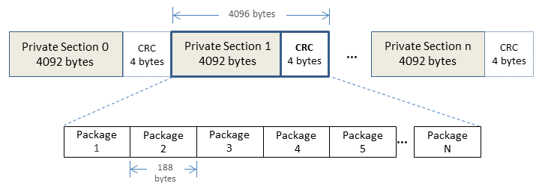
Fig. 5. The FPGA synthesis stream, divided into sequenced private sections of variable size, which are then organized into TS packets.

The last_section_number field indicates the total number of sections used for carrying the synthetized hardware content. The private_data_byte field is a variable size one, which is used to carry the FPGA bit-stream.
For this work, the section_syntax_indicator field was set to ‘1’, in order to enable the CRC_32 checksum field of the private section syntax. This redundant information enables the receiver to detect errors, via a checksum algorithm.
In order to signal the FPGA bit-stream content, the proposed scheme follows a syntax similar to the one used by AIT. In summary, it must provide a FPGA bit-stream description and an access point, in such a way that the receiver is able to download and remount FPGA core data. The new table, named update information table (UIT), follows the AIT syntax. Its role is to provide detailed information about characteristics of the transmitted FPGA core. This is crucial information used by the receiver, in order to decide if the transmitted content can be used or not. The FPGA core information, borne by the new table, is then used by the receiving device, in order to filter the hardware bit-stream.
Other information, about the transmitted hardware core, must also be included and broadcast, along with hardware contents, such as a description of the hardware upgrade module (e.g. decoder, multiplexer, cypher, etc.), FPGA manufacturer name, family, device part number (which was used to synthesize the core), size of the synthesized core, in bytes, PID and TID for section filtering, etc. The mentioned data need to be added to the TS, in order to provide all necessary information related to the new content. TABLE II shows the complete UIT structure, whose mnemonics are define in the MPEG-2 systems standard [17].

TABLE II
The Update Information Table - UIT
Data Structure | Bit Rate  (No. of bits) | Mnemonic | Value
update_information_table() {
table_id | 8 | uimsbf | 0x91
section_syntax_indicator | 1 | bslbf
hw_core_flag | 1 | bslbf
Reserved | 2 | bslbf
section_lenght | 12 | uimsbf
fpga_core_number | 16 | uimsbf
Reserved | 2 | bslbf
version_number | 5 | uimsbf
current_next_indicator | 1 | bslbf
section_number | 8 | uimsbf
last_section_number | 8 | uimsbf
reserved_future_use | 4 | uimsbf
update_loop_lenght | 12 | uimsbf
for (i=0; i<N; i++) {
descriptor()
}
reserved_future_use | 4 | bslbf
update_loop_length | 12 | uimsbf
for (i=0; i<N; i++) {
update_hw_identifier()
reserved_future_use | 8 | uimsbf
reserved_future_use | 4 | bslbf
descriptors_loop_length | 12 | uimsbf
for(i=0; i<N; i++) {
descriptor()
}
}
CRC_32 | 32 | rpchof
}

Program map table (PMT) sections provide the access point to the newly created UIT table, in a similar way as already done for AIT. UIT gives access to the hw_core_flag field, which is used to signal the existence of hardware content. If this field is set to ‘0x1’, this means that there is hardware content in the DTV signal; otherwise, ‘0x0’ indicates that no hardware content is being broadcast.
The fpga_core_number field identifies the number of hardware cores being currently broadcast. The other necessary data are provided by update_hw_identifier(), which is a specific descriptor regarding transmitted hardware modules, similar to application_identifier(), used in AIT. The update_hw_identifier() portion presents a list of available hardware cores, whose size was reported by fpga_core_number. The syntax of update_hw_identifier() is shown in TABLE III.

TABLE III
The update_hw_identifier Field Syntax
Data Structure | Bit Rate  (No. of bits) | Mnemonic | Value
update_hw_identifier () {
fpga_core_size | 32 | bslbf
fpga_core_version | 16 | bslbf
fpga_core_module_name()
fpga_core_device_info()
fpga_section_identifier()
}

The fpga_core_size filed is 32 bits in length, informs the core size, and is used by the receiver application, in order to check if the whole bit-stream content was reassembled. The fpga_core_version field identifies the core update version number and is used during the reassembling process, in order to check if the receiver was already updated. The following three fields are descriptors, which bear information about each transmitted core. In addition, there is a list of access points (PID and TID), which are used for filtering private sections carrying hardware-reconfiguration content (see TABLE VI).
TABLE IV presents the syntax of the fpga_core_module_name() descriptor, which is identified by a descriptor_tag set to ‘0x01’.

TABLE IV
The FPGA_core_module_name Descriptor Syntax
Data Structure | Bit Rate  (No. of bits) | Mnemonic | Value
fpga_core_module_name() {
descriptor_tag | 8 | uimsbf | 0x01
descriptor_lenght | 8 | uimsbf
for(i=0; i<N; i++){
reserved_future_use | 24 | bslbf
descriptor_core_length | 8 | uimsbf
for(i=0; i<N; i++) {
fpga_core_module_name | 8 | uimsbf
}
}
}

The descriptor_length field identifies the size of the content located inside the loop. The next field, that is, descriptor_core_length, identifies the size of the fpga_core_module_name information, which is composed by 32 characters, where each one is coded with 8 bits. Such a field is used to inform the hardware module name (e.g. decoders, multiplexer, cypher, etc.) available for reconfiguration. The next descriptor is named fpga_core_device_info() and is shown in TABLE V. This descriptor is identified by a descriptor_tag set to ‘0x03’. Its descriptor_length field presents the size of the fpga_info string field, where each character is also coded with 8 bits. This field informs the name of the FPGA manufacturer, followed by the FPGA family and, lastly, the part number of the FPGA device, for which the core was synthesized. Such values are arranged into the fpga_info character string field, separated by spaces (‘0x32’): “fpga-manufacturer-name fpga-family-name fpga-part-number”. This information is used, by the receiver, to identify the FPGA device information in the broadcast content.

TABLE V
The FPGA_core_device_info Descriptor Syntax
Data Structure | Bit Rate  (No. of bits) | Mnemonic | Value
fpga_core_device_info() {
descriptor_tag | 8 | uimsbf | 0x03
descriptor_length | 8 | uimsbf
for(i=0; i<N; i++){
fpga_info | 8 | uimsbf
}
}

The last descriptor is the fpga_section_identifier(), shown in TABLE VI. This descriptor is identified by a descriptor_tag set to ‘0x05’. The next field, that is, descriptor_length, contains the loop content size, in bytes. The remount_core_pck_pid field informs the PID used to locate packets with the desired hardware content. Besides, it is used, in association with the remount_core_sec_tid field (which informs the section table ID (TID)), for accessing private sections with core content. The remount_priority field informs the remount priority order for each group of 256 sections, represented by its own PID and TID. Such an approach is used if the hardware bit-stream needs more than 256*4080 bytes; otherwise, only one group is enough, that is, it is set to ‘0x00’. For the next group represented by other PIDs and TIDs, this value is incremented by 1 and so on.
The receiver system uses the presented information to check the characteristics of the broadcast hardware core and, if a match is found, to guide the execution of hardware updates.

TABLE VI
The FPGA_section_identifier Descriptor Syntax
Data Structure | Bit Rate  (No. of bits) | Mnemonic | Value
fpga_section_identifier() {
descriptor_tag | 8 | uimsbf | 0x05
descriptor_lenght | 8 | uimsbf
for(i=0; i<N; i++){
remount_core_pck_pid | 32 | bslbf
remount_core_sec_tid | 16 | bslbf
remount_priority | 8 | uimsbf
}
}

Core Data Filtering
The DTV-receiver resident system is configured to filter the transmitted content, in order to find some hardware reconfiguration bit-stream (core). The system will look for UIT and parse it, beginning with the hw_core_flag field. If it is set to ‘0x0’, the system simply ignores the current UIT; otherwise (‘0x1’), there is a signaled hardware bit-stream content and the system then parses the remaining UIT content (e.g., fpga_core_size, fpga_core_version, fpga_core_module _name, etc.), in order to retrieve the corresponding table fields, which describe the characteristics of the broadcast bit-stream (hardware core). Finally, such values are compared with the suitable FPGA, as shown in Fig. 6. The characteristics of the suitable FPGA device can be stored in a simple text file, which is made available at the receiver file system, as done here.

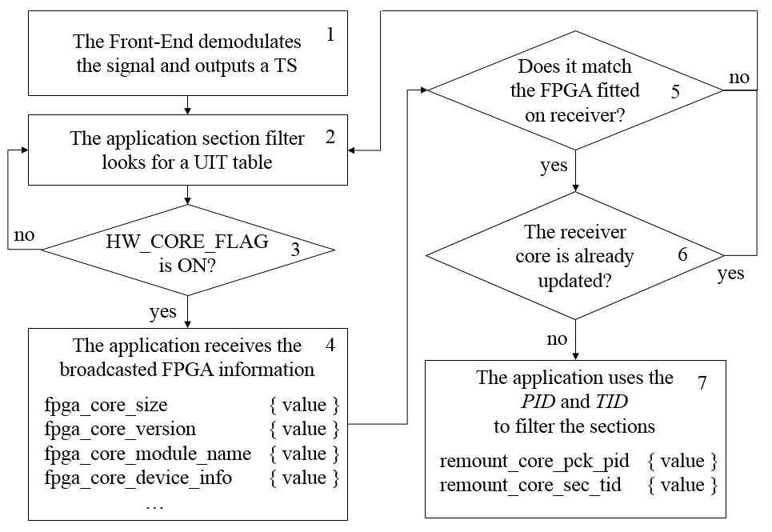
Fig. 6. Steps to check the UIT content and find a broadcast core hardware suitable for the receiver, in order to retrieve the correct PID for filtering.

If some of these fields do not match the receiver hardware characteristics, the system then interrupts the reconfiguration process. Indeed, it may happen, given that content may have been sent to another kind of receiver, with different FPGA devices. On the other hand, if this content fits the receiver hardware architecture, then the system continues the filtering procedure and parses the remount_core_pck_pid and remount_core_sec_tid fields. Those values are used as an access point for extracting the transmitted reconfiguration bit-stream (for programming section-filter modules), directly from private sections, as depicted in Fig. 7. When a private section is retrieved, its CRC is checked, for validation purposes (see section III-A). If the section is not corrupted, the system stores the section payload, according to the section order provided by the section_number field.
The system keeps this iterative process until the last section is received, in order to conclude the reassembling process. However, the procedure completion depends on the validation of the entire private section payload. If a section is not validated (e.g., corrupted), the reconfiguration process discards that and the search for a valid section content continues. Given that sections may be randomly retrieved, the receiving system is responsible for ensuring correct order.
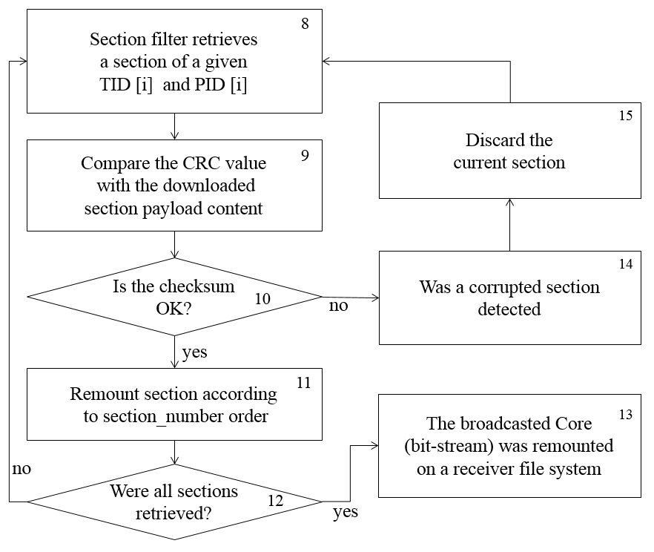
Fig. 7. Steps involved in the process of obtaining the broadcast hardware core stream, which includes verification of each private section, downloading and content reassembling.

The Target Device Reconfiguration
The FPGA reconfiguration is the last step of the entire proposed scheme. The main idea is to exercise the complete chain, that is, from the beginning of the process (core multiplexing) to its end (FPGA reconfiguration). At this point, the receiver has already checked if the core characteristics fit the FPGA model (see section V-B), used at the receiver, and has finished the system core reassembling (obtained broadcasted SVF file). Now, in this step, the remounted hardware core stream reaches a receiver reconfigurable target device, through a JTAG mode, as presented in section IV-A.

Reconfiguration-Process Test Results
As Proof of Concept (PoC), some HDL source code examples were synthesized, which aim at exciting the entire scheme. Fourth VHDL/Verilog source code examples are used, which are synthesized for a reference FPGA (Altera Stratix, EP1S10F780C6) and then tested and validated, by means of an EDA tool.
The validation is based on typical examples, in order to check if the FPGA is configured properly and the scheme works in a DTV system. The first pre-synthetized example converted to an SVF file (see section-III) is a simple binary-coded decimal (BCD) light emitting diode (LED) counter (Ex01.svf). The second one is a BCD to 7-Seg decoder (Ex02.svf). The third is an example in which a text message is written on a 16x2 liquid crystal display (LCD) device (Ex03.svf). Finally, the fourth and last one is a 7 segments counter (Ex04.svf).
Each core is multiplexed into its respective TS, according to the schema described in this work (see section IV-A). The result of this process consists of fourth transport stream files, carrying and signaling each respective bit-stream. The TS example files are generated according to the integrated services digital broadcasting terrestrial (ISDB-T) standard [33], which is similar to terrestrial DVB. For this process, an MPEG2 transport stream data generator and a packet manipulator tool are used. The bit rate used to multiplex each transport stream is 1.57 Mbps.
The first experiments were performed to establish the better section repetition rate to be used at the scheme. For this, 8 transport streams, carrying and signaling Ex01.svf hardware core, were generated. Thus, for the first example, the repetition rate used was 500ms of repetition rate. For the next, was used 750ms, 1000ms, 1250ms, 1500ms, 1750ms and 2000ms successively (Table VII).

TABLE VII
Results Obtained With The Proposed Reconfiguration Scheme
TS_{NAME} | Private section repetition rate | RMT
Ex01_500ms.ts | 500 ms | 29,20 s
Ex01_750ms.ts | 750 ms | 17.76 s
Ex01_1000ms.ts | 1000 ms | 9.87 s
Ex01_1250ms.ts | 1250 ms | 12.70 s
Ex01_1500ms.ts | 1500 ms | 13.60 s
Ex01_1750ms.ts | 1750 ms | 14,26 s
Ex01_2000ms.ts | 2000 ms | 14,84 s

According with Table VII, the results using rate of 500ms (Ex01_500ms.ts), presented the lowest performance for remounting process using private sections. Using this rate, there is a greater discard of sections by the remounting system when compared with lower rates. The discard happens, when the remounting system captures a smaller number of sections, in each repetition cycle. In the 750ms repetition rate (Ex01_750ms.ts) there was an improvement in the remounting performance reducing discard of sections when compared with a 500ms repetition rate. However, the rates between 1000ms and 1500ms, had the best average performance during remounting hardware core. The above rates this range have similar values, but already present a tendency to increase the remounting time.
The other experiments were based in a private section bit-rate of 1000ms; the UIT bit-rate is also 1000ms. In order to perform the TS broadcasting task, a USB 2.0-based multi-standard modulator is used.
Some results are generated for validating the correct operation of the entire scheme. The metrics evaluated here (intend to give an idea of the obtained performance) are the remounting time (RMT), that is, the time during the download of the reconfiguration data, and the reconfiguration time (RCT), which is the time period employed to parse the related SVF file and reconfigure the target FPGA. The latter will take place only if a RMT process has occurred. The RMT is the sum of the checksum verification time necessary to check all sections, plus the download time for all sections (remounting). The RCT time is the total time needed to reconfigure the FPGA device, using the implemented JTAG host/target mode. The SVF based frequency for all examples was 1.00E+07 HZ. TABLE VIII shows the obtained results, when broadcasting and reception tests are performed using this reconfiguration scheme. The pre-synthetized core file name is represented by the HW_{NAME} table column. Column CR_{SIZE} shows the pre-synthetized core size, followed by the TS_{NAME,} which is the generated transport stream file name. Finally, the RMT and RCT fields show the average remounting time and average reconfiguration time, respectively.
TABLE VIII
Results Obtained With The Proposed Reconfiguration Scheme
HW_{NAME} | CR_{SIZE} | TS_{NAME} | RMT | RCT
Ex01.svf | 900.845 bytes | Ex01.ts | 9.87 s | 20.36 s
Ex02.svf | 900.945 bytes | Ex02.ts | 10.89 s | 20.34 s
Ex03.svf | 900.923 bytes | Ex03.ts | 9.95 s | 20.29 s
Ex04.svf | 900.951 bytes | Ex04.ts | 10.25 s | 20.26 s

Performed experiments showed that pre-synthesized cores could be signaled, multiplexed, and broadcast with other DTV contents. The achieved RMT time, in each experiment, is satisfactory, considering that the scheme's task was performed in concurrency with other DTV tasks (e.g., application retrieval, table filtering, electronic program guide construction, etc.). The RCT is also satisfactory, considering that the employed reference receiver presents low processing power. Indeed, the SVF parser took most of the elapsed time. The reconfiguration JTAG mode is generic and ideal for this PoC, but can be improved if FPGA devices are integrated into the receiver board.
The RMT associated to Ex02.svf was larger than what was obtained with the other example files, due to the way this particular reconfiguration bit-stream is organized into sections. Although all test files present the same size, the resulting RMT depends on some factors, such as reading start point related to private sections, signal strength, and corrupted private sections. Regarding final users, those periods are not perceived, given that associated tasks are performed in parallel with other receiver tasks. However, if the reconfigured FPGA device is being used (e.g. for media decoding), a momentary service interruption may be noticed.
The reconfiguration scheme through the DTV signal presented here can be regarded as an innovative approach, when compared to those found in the literature on reconfigurable architectures. The main idea of the proposed methodology relies on the delivering way for pre-synthesized hardware cores.
Related studies in the literature use pre-synthesized cores for run-time reconfiguration and present some similarities with the proposed scheme. The main difference is that the former needs to maintain a number of previously stored cores; then, the resident system decides when to use each one. The proposed approach, however, can broadcast the desired core to a huge number of devices, which are then automatically reconfigured. In addition, this scheme could send pre-synthetized cores of several manufacturers, and each device would be responsible for accepting or rejecting such content.
Another feature is that the broadcaster can send the hardware update data cyclically, during a period of time, which provides an opportunity for all devices, in the range of the DTV signal, to perform hardware reconfiguration. Thus, in DTV networks, where receivers are based on the replacement of hardware modules, the new technology advances and enhancements could be immediately incorporated, leading to a flexible DTV environment.

Conclusion
This work presented a new approach for hardware reconfiguration, which is intended to be used in DTV environments. The proposed scheme allows the receiver to be automatically reconfigured, providing the idea to create new receiver architectures. Additionally, the receiver design architecture could be focused on hardware upgrade, in numerous ways.
The results obtained with the pre-synthetized core experiments show that the system is able to reconfigure distinct core modules, in a DTV system. The experiments also show that this reconfiguration scheme can work in parallel with other DTV tasks. Indeed, the obtained remounting time is satisfactory for an embedded system with low processing power, and the reconfiguration time can be improved if, the FPGA is integrated on the receiver board.
Critical tasks normally performed by an ASIC device, such as H.264 video decoding and crypto tasks, could be designed in FPGA, based on the present scheme. It would enable the incorporation of technological advances, such as new video compression schemes, which would create a flexible DTV network. Furthermore, other devices that use transport streams could also make use of the proposed scheme, in order to design intelligent architectures and flexible low-cost devices.
References
- M. Yoshida, M. Takahashi, H. Mizosoe, T. Nakamura, and Y. Yatabe, “Highly Efficient H.264/AVC Codec Technology for High Definition Consumer Applications,” in Proc. IEEE International Conference on Consumer Electronics, Las Vegas, USA, pp. 1-2, Jan. 2008.
- G. J. Sullivan, J. R. Ohm, W. J. Han, and T. Wiegand, “Overview of the High Efficiency Video Coding (HEVC) Standard,” IEEE Trans. Circuits Syst. Video Technol., vol. 22, no. 12, pp. 1649-1668, Dec. 2012.
- F. Bossen, B. Bross, K. Sühring, and D. Flynn, “HEVC complexity and implementation analysis,” IEEE Trans. Circuits Syst. Video Technol., vol. 22, no. 12, pp. 1685–1696, Dec. 2012.
- H. Koumaras, M. Kourtis, and D. Martakus, “Benchmarking the encoding efficiency of H.265/HEVC and H.264/AVC,” in Proc. Future Network and Mobile Summit, Berlin, Germany, pp. 1-7, Jul. 2012.
- “IEEE Standard VHDL Language Reference Manual”, IEEE Std 1076-2008, Jan. 2009.
- “IEEE Standard for Verilog Hardware Description Language”, IEEE Std 1364-2005, Apr. 2006.
- S. Z. Ahmed, G. Sassatelli, L. Torres, and L. Rougel, "Survey of new trends in industry for programmable hardware: FPGAs, MPPAs, MPSoCs, structured ASICs, eFPGAs and new wave of innovation in FPGAs," in Proc. International Conference on Field Programmable Logic and Applications, Milano, Italy, pp. 291-297, Sep. 2010.
- B. K. Reddy, S. Sabbavarapu, and A. Acharyya, "A new VLSI IC design automation methodology with reduced NRE costs and time-to-market using the NPN class Representation and functional symmetry," in Proc. IEEE International Symposium on Circuits and Systems, Melbourne, Australia, pp. 177-180, Jun. 2014.
- P. H. W. Leong, "Recent Trends in FPGA Architectures and Applications," in Proc. IEEE International Symposium on Electronic Design, Test and Applications, Hong Kong, SAR, China, pp. 137-141, Jan. 2008.
- E. Monmasson and M. N. Cirstea, "FPGA design methodology for industrial control systems - A review," IEEE Trans. Ind. Electron., vol. 54, no. 4, pp. 1824-1842, Aug. 2007.
- A. H. Salman, T. Adiono, W. A. Cahyadi, Y. Kurniawan, "SOC design and FPGA implementation of Digital TV receiver," in Proc. International Conference on Telecommunication Systems, Services, and Applications, Bali, Indonesia, pp. 125-129, Oct. 2012.
- “Digital Terrestrial Television, Video coding, audio coding and multiplexing Part 3: Signal multiplexing systems”, ABNT NBR 15602-3, Nov. 2007.
- C.-T. Lin, S.-J. Horng, and Y.-L. Huang, “Hardware Resource Manager for Reconfiguration System,” in Proc. International Symposium on Biometrics and Security Technologies, Taipei, Taiwan, pp. 59-65, Mar. 2012.
- J. Eachanobe, I. Del Campo, R. Finker, and k. Basterretxea, “Dynamic Partial Reconfiguration in Embedded Systems for Intelligent Environments,” in Proc. IEEE International Conference on Intelligent Environments, Guanajuato, Mexico, pp. 26-29, Jun. 2012.
- D. Hillenbrand, C. Brugger, J. Tao, S. Yang, and M. Balzer, “RIVER: Reconfigurable Pre-Synthesized-Streaming Architecture for Signal Processing on FPGAs,” in Proc. Parallel and Distributed Processing Symposium Workshops and PhD Forum, Shanghai, China, pp. 397-400, May 2012.
- O. Serres, V. K. Narayana, and T. El-Ghazawi, “An Architecture for Reconfigurable Multi-core Explorations,” in Proc. International Conference on Reconfigurable Computing and FPGAs, Cancun, Mexico, pp.105-110, Dec. 2011.
- “Information Technology – Generic Coding of Moving Pictures and Associated Audio Information: Systems”, ISO/IEC 13818-1, Dec. 2000.
- “Digital Terrestrial Television, Data Coding and Transmission Specification for Digital Broadcasting Part 3: Data Transmission Specification”, ABNT NBR 15606-3, Mar. 2012.
- M. S. Park, Y. J. Lee, J. H. Choi, and J. S. Choi, “The design and implementation of data server for data broadcast service,” in Proc. International Conference on Electronics, Circuits and Systems, Sharjah, United Arab Emirates, vol. 3, pp. 1176-1179, Dec. 2003.
- E. P. J. Tozer, Broadcast Engineer’s Reference Book, Focal Press: Burlington, USA, 2004, pp. 352-355.
- W. Fischer, Digital Video and Audio Broadcasting Technology: A Practical Engineering Guide, Springer Verlag: Berlin, Germany, 2010, pp. 457-465.
- G. Castagnoly, S. Brauer and M. Herrmann, "Optimization of cyclic redundancy-check codes with 24 and 32 parity bits", IEEE Trans. Commun., vol. 41, no. 6, pp.883 -892, Jun 1993.
- U. Reimers, DVB - The Family of International Standards for Digital Video Broadcasting, 2nd ed., Springer Verlag: Berlin, Germany, 2005, pp. 287-288.
- “Digital Video Broadcasting (DVB): Specification for Data Broadcasting”, ETSI EN 301 192 – V1.5.1, Nov. 2009.
- “Digital Video Broadcasting (DVB); Implementation guidelines for Data Broadcasting”, ETSI TR 101 202 – V1.2.1, Jan. 2003.
- R. J. Crinon, "The DSM-CC Object Carousel for Broadcast Data Services," in Proc. IEEE International Conference on Consumer Electronics, Rosemont, USA, pp. 246-247, Jun. 1997.
- “Digital Terrestrial Television – Receivers”, ABNT NBR 15604, Nov. 2007.
- E. Stavinov, 100 Power Tips For FPGA Designers, CreateSpace Independent Publishing Platform: Charleston, USA, 2011, pp. 171-200.
- “IEEE Standard for Test Access Port and Boundary-Scan Architecture”, IEEE Std. 1149.1, 2013.
- M. Strubel, “Implementing JTAG debugging solutions for custom hardware,” in Proc. Embedded World 2012, Nuremberg, Germany, pp. 1-17, Feb. 2012.
- R. Dominic, “Design and Implementation of an On-Chip Debug Solution for Embedded Target Systems based on the ARM7 and ARM9 Family,” Ph.D. thesis, University of Applied Sciences Augsburg, Augsburg, Germany, 2005.
- K. P. Parker, The Boundary-Scan Handbook Third Edition, Kluwer Academic Publishers: Massachusetts, USA, 2003, pp. 10-60.
- “Transmission System for Digital Terrestrial Television Broadcasting”, ARIB Standard STD-B31, Nov. 2005.

biographies

R. R. de Oliveira received the B. Sc. degree in Computer Science from Universidade de Cruz Alta (UNICRUZ), Cruz Alta, Rio Grande do Sul, Brazil, in 1999 and the M.Sc. in Informatics in 2004 from Universidade Federal do Amazonas (UFAM). He is currently a Ph.D. candidate at Universidade Federal do Amazonas. His research interests include development of application to Digital TV devices, DTV technology, middleware, hardware reconfiguration and the development of embedded systems.
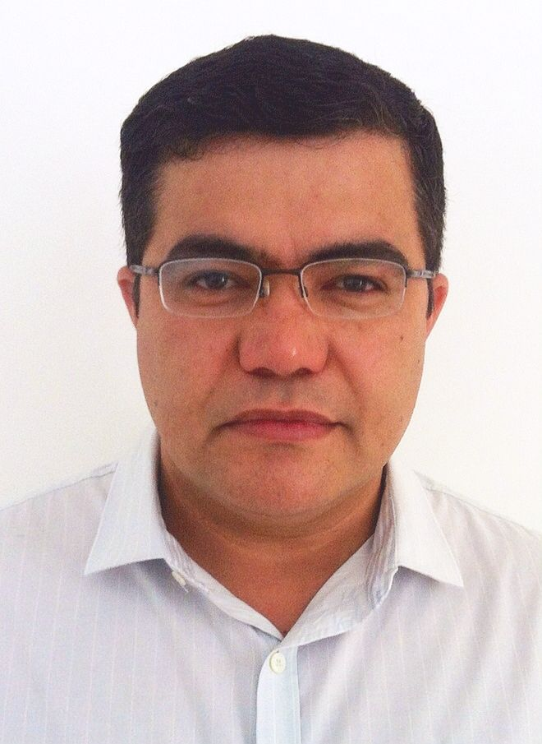

L. C. Cordeiro (M’13) received a Ph.D. in computer science from the University of Southampton in 2011. Since 2011, he has been an adjunct professor in the Electronics and Computing Department at Universidade Federal do Amazonas (UFAM). His work focuses on software verification, bounded and unbounded model checking, satisfiability module theories, and embedded systems.
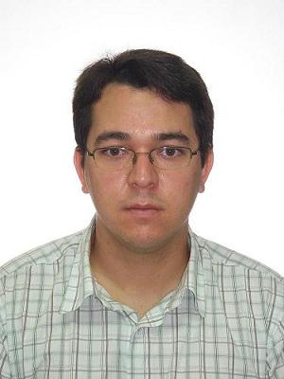

E. B. de Lima Filho received the B. Sc. degree in Electrical Engineering from Universidade Federal do Amazonas (UFAM), Manaus, AM, Brazil, in 1999, and the M. Sc. and D. Sc. degrees in Electrical Engineering from Universidade Federal do Rio de Janeiro (COPPE/UFRJ), Rio de Janeiro, RJ, Brazil, in 2004 and 2008, respectively. Since 2007, he has been with the Science, Technology and Innovation Center for the Industrial Pole of Manaus (CT-PIM), Manaus, AM, Brazil, working with digital TV, middleware and embedded systems. His research interests include digital signal processing, channel/source coding, video/image processing, and cognitive radio.
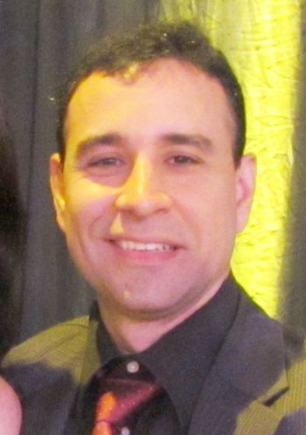

V. F. de Lucena Jr. (S’91-M’94-SM’14) received his Ph.D. (Dr.-Ing) in 2002 from the University of Stuttgart in Germany. Since 1990, he has been a Faculty Member with the Engineering College at the Universidade Federal do Amazonas (UFAM) in Manaus - Brazil. He is also with the Electronics and Information Technology R&D Center CETELI, a research group that works with software engineering and consumer electronics. His research interests include automation systems, new software engineering approaches, and the development of embedded systems.
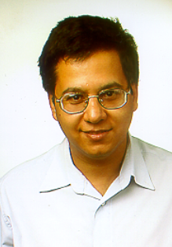

This work was supported by FAPEAM, CAPES and CNPq. R. R. de Oliveira is with PPGI and CETELI at UFAM, Manaus, Amazonas, Brazil (e-mail: rodrigo@dcc.ufam.edu.br). L. C. Cordeiro is with PPGEE and CETELI at UFAM, Manaus, Amazonas, Brazil (e-mail: lucascordeiro@ufam.edu.br). E. B. de Lima Filho is with Science, Technology and Innovation Center for the Industrial Pole of Manaus – CT-PIM and PPGEE at UFAM, Manaus, Amazonas, Brazil, (e-mail: eddie@ctpim.org.br). V. F. de Lucena Jr. is with PPGEE, PPGI, and CETELI at UFAM, Manaus, Amazonas, Brazil (e-mail: vicente@ufam.edu.br).

