ScrivQiq Instructions

# Introduction

A lot of people love the Scrivener writing tool. It’s great for organizing many writing tasks, but its citation support is rudimentary. On the other hand, Qiqqa is an excellent document and citation manager, but is only works with Microsoft word.

Last year, a discussion arose on Qiqqa’s user forum bemoaning the lack of integration between Scrivener and Qiqqa. There are people who want to write in Scrivener, but still want to use Qiqqa to manage references.

One forum member, Chris Kent, posted a description of his workaround (summarized here, see the end of this document for the full text):

1. develop the initial doc in Scrivener using all the useful features for writers
2. maintain the references in Qiqqa using all the goodies this software provides to the researcher
3. when I need to add a reference in my Scrivener document mark it as a reference using special characters so I can later find them in Word e.g. rather than the correct (visual) format of (Smith and Jones, 2010)
4. When I think I've completed my document I then compile and export to Word and work on it there leaving the original text in Scrivener. I then have to replace all the references marked as < > manually with their correct Qiqqa links which does take a while.
5. finish and polish the document in Word and keep dreaming of the days when this issue will be resolved.

While this works, he noted that step 4 was very time consuming and made the conversion from Scrivener to Word and essentially one time event.

He suggested that this is an “opportunity for a third party to offer an integration solution”. The solution would have two things:

1. A “facility to look into the Qiqqa database and copy the Qiqqa document key into the [Scrivener] document”.
2. A way to compile the Scrivener document into Word format “which would include the relevant Qiqqa codes which makes all the magic happen when we click ‘Reformat Document’ in Qiqqa.”

# SquivQiq Description

SquivQiq adds two buttons to Microsoft Word to add the functionality Chris wrote about :

1. A button to cut a Qiqqa “citation cluster” from a Word document onto the Windows clipboard as text suitable for pasting into an “inspector footnote” in Scrivener
2. A button to turn the footnotes in a compiled Scrivener -> Word document back into citation clusters ready to format with Qiqqa.

# Installing SquivQiq.bas

You should already have downloaded SquivQiq.bas to you computer from the Github website that hosts these instructions (<https://github.com/rdsteed/ScrivQiq>).

Open Word to a blank document and perform the following steps:

1. Type Alt-F11 to open the Visual Basic screen. In the upper left hand corner of the screen you should see the word “Normal”:  
   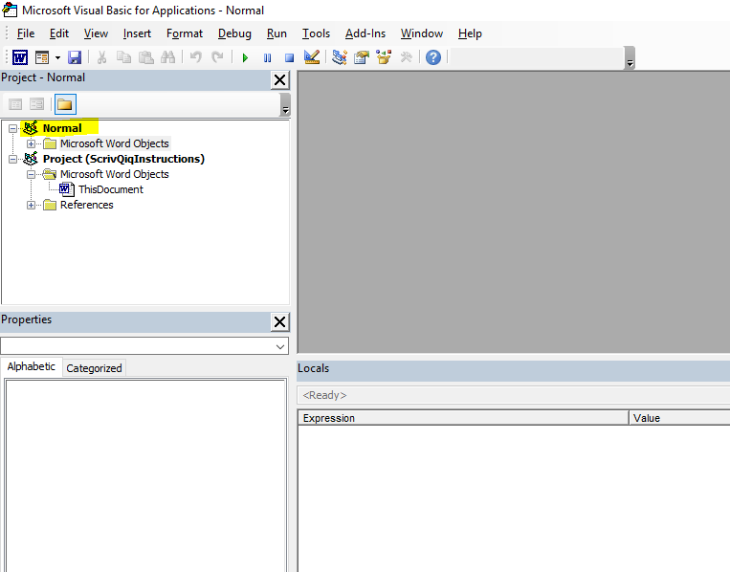
2. Right Click on “Normal” for a drop down list. You should see the option to “Import File…”:  
   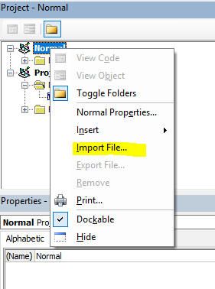
3. Select “Import File…” and select the copy of ScrivQiq.bas that you downloaded. Once you do this, the macros have been added to your copy of Word.

# Add buttons to Quick Access Toolbar

For easy access to the macros, I recommend creating buttons in the Quick Access Toolbar

To assign a macro to a custom button on the Quick Access toolbar, follow these steps:

1. Click the Customize Quick Access Toolbar button at the end of the Quick Access toolbar and then click More Commands on its drop-down menu.  
   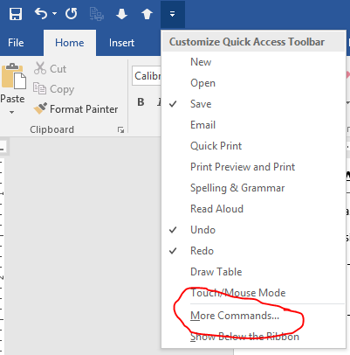  
   Excel opens the Excel Options dialog box with the Quick Access Toolbar tab selected.
2. Click Macros in the Choose Commands From drop-down list box.  
   Excel lists the names of all the macros created in the current workbook in the Choose Commands From list box. If you don’t see the macros you added in the last section, something went wrong, and you should try again.
3. Click the name of the first macro to add (Normal.ScrivQiq. CutCluster) to a custom button on the Quick Access toolbar in the Choose Commands From list box and then click the Add button.  
   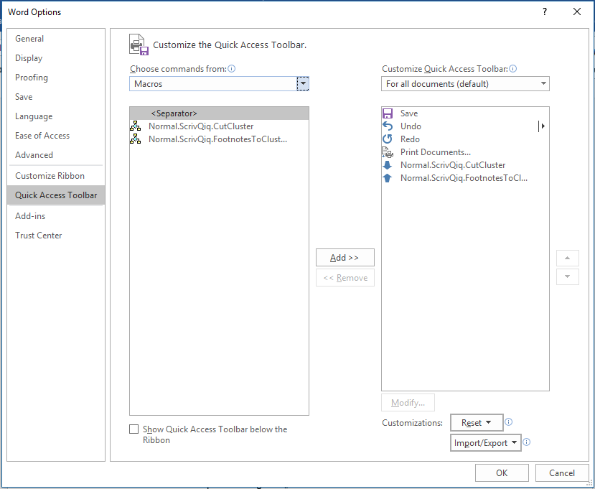  
   Repeat for the second macro to add (Normal.ScrivQiq.FootnotesToClusters)
4. Click OK to close the Options dialog box.

# Adding a Citation Cluster to Scrivener

As you are writing in Scrivener, you should have Qiqqa running as well as a copy of Word opened to a blank document.

When you come to a point in Scrivener where you want to a citation cluster, open up an inspector footnote at that point.

Switch to the blank copy of Word and create the citation cluster as the only thing in the Word document.

Click on the “CutCluster” button in the Quick Access Toolbar. (The citation cluster should disappear as it is cut to the clipboard).

Return to Scrivener and paste into the open inspector footnote.

# Create the Word Document with Citations

In Scrivener, compile the document to a Word document. In the footnotes/comments section of the compile dialog box, all boxes under Footnotes should be unchecked and the Export to RTF dropdown should be set to “Footnotes”.

Open the compiled Word file. You’ll see all of your citation cluster codes in footnotes.

Click on the “FootnotesToClusters” button in the Quick Access Toolbar. All of the footnotes will disappear and the citations will all appear as “From Scrivener”.

Use Qiqqa InCite to “Add Bibliograph Section”

Click on “Reformat Document” (the magic wand) in Qiqqa InCite to generate all inline citations and the Bibliography in your format of choice.

# Chris Kent’s Qiqqa Forum Post

Hi Lisa

No I have not had any response from Qiqqa but I live in hope. My Uni uses EndNote and I have tried using it with Scrivener but to say it was clumsy and user unfriendly is an understatement. IMHO EndNote is not a patch on Qiqqa and when it comes to developing large docs Word is not a patch on Scrivener.

The only workaround I have come up with is reflected by my current workflow:

1. develop the initial doc in Scrivener using all the useful features for writers
2. maintain the references in Qiqqa using all the goodies this software provides to the researcher
3. when I need to add a reference in my Scrivener document mark it as a reference using special characters so I can later find them in Word e.g. rather than the correct (visual) format of (Smith and Jones, 2010)
4. When I think I've completed my document I then compile and export to Word and work on it there leaving the original text in Scrivener. I then have to replace all the references marked as < > manually with their correct Qiqqa links which does take a while.
5. finish and polish the document in Word and keep dreaming of the days when this issue will be resolved.

This is the exactly what I did for my 15K word Masters dissertation and Yes! it does take some time and effort to manage. Once you’ve done these changes you are then committed to Word – which is the issue. For larger projects like the 100K+ word book I have just completed it was a bigger challenge but fortunately it does not have too many references. But for my 90K+ PhD thesis and writing academic papers with lots of references I anticipate this will be a MAJOR challenge especially as time is a major constraint!

To be fair to the authors I think we need to remember what each software package was originally designed for and who their target market is:

1. Qiqqa was designed to help researchers manage their personal libraries and streamline and manage their research process.
2. Scrivener was written to help authors manage a writing project to produce a very large document.
3. Word was developed to serve the wider community who wanted a powerful feature rich general purpose word processing package for all kind of documents, big and small.

As a PhD student I have specific document development needs and the combination of Qiqqa and Scrivener is my perfect solution. However, with the lack of integration between Qiqqa and Scrivener I either have to introduce Word into the mix and use the workaround I've described above to complete the latter stages of my document development, or do everything with a combination of Qiqqa and Word because of Qiqqa’s natural integration with Word.

The question it comes down to is this: 'Which is the right tool for the job?' and when the answer is 'a combination of all of the above' it comes down to the economics of providing that integrated solution - which is, I guess, where we are at.

This does provide an opportunity for a third party to offer an integration solution and if anyone out there would like to take up this challenge then I'm sure the Qiqqa / Scrivener community will supportive, delighted, and hungry to give it a go. As a former software developer myself here's how I see how a 'plug-in' might work:

If Scrivener had the facility to look into the Qiqqa database and copy the Qiqqa document key into the document e.g. "and now I want to talk about this idea from these guys blah blah blah" that would at least capture the document reference as we write. This would effectively be the Scrivener equivalent of ‘Cite whilst you write’.

It also means we can carry on developing our documents knowing we have captured the right references in the right places and keeps us in Scrivener for as long as possible – which is the important part!

When we have completed our Scrivener document we could export it from Scrivener into Word in the usual way via ‘Compile’ and all references like would need to be converted to their usual Qiqqa format required in Word e.g. [ jones2013strategic ] which would include the relevant Qiqqa codes which makes all the magic happen when we click ‘Reformat Document’ in Qiqqa.

We just need to reformat the document to get everything in the correct format – which is what the natural Qiqqa / Word integration does well.

When we want to further refine our work – which will inevitably happen as writing is an iterative process – we go back to Scrivener and carry on working there. When we are happy with the changes having included more Qiqqa references and perhaps deleted others, we re-compile, shift back over to Word, reformat our document with Qiqqa and “Hey Presto” job done! This would alleviate all the manual reformatting we currently have to do via my current work around.

If there are any developers out here who would like to take up this challenge I’d certainly be very interested in talking to them, and if there are any other members of the Scrivener / Qiqqa community who would like to join the discussion or share their own Ideas I’d love to hear from you.

This is a topic I will be writing more about on my blog in the coming months (see www.chriskentmsc.com) and if there is enough interest perhaps we could encourage a third party to provide the integration we so desperately want.

Hope that helps.

Best wishes

Chris