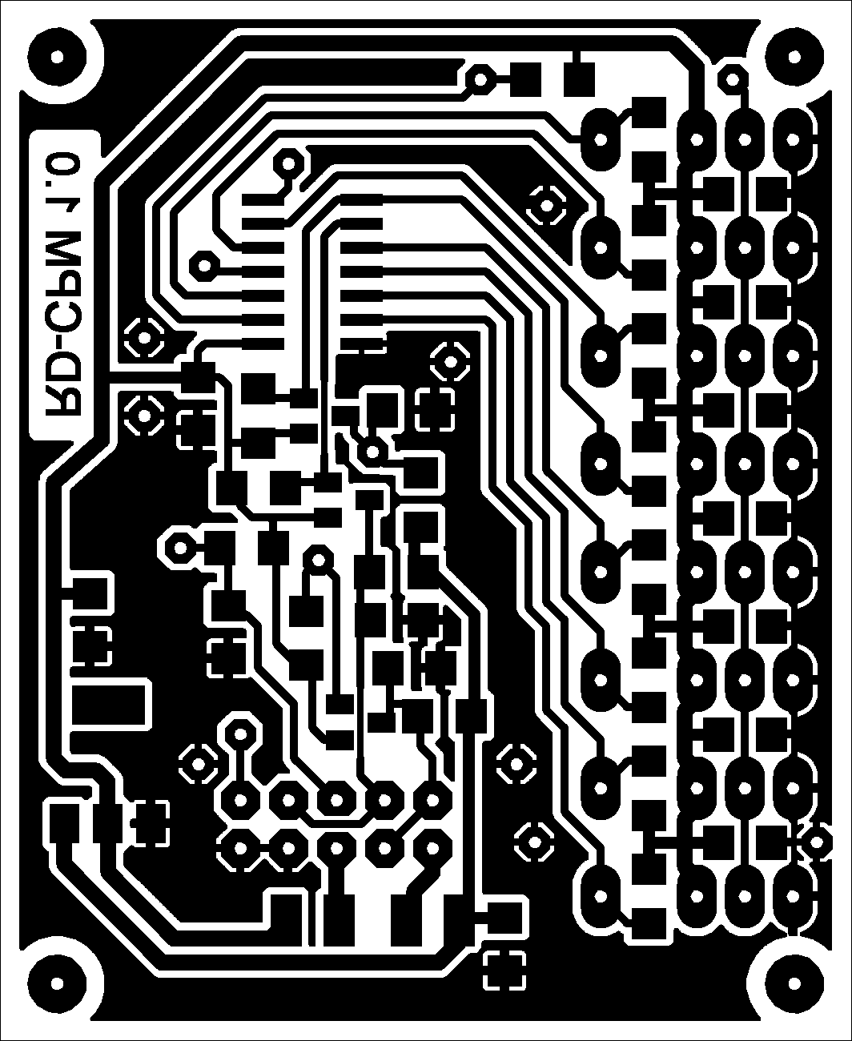

45 x 55 mm 45 x55 mm

45 x 55 mm 45 x55 mm

45 x 55 mm 45 x55 mm

