Use Case Name: Shipping Forecast for North Slope for Barrow-Prudhoe Bay
Point of Contact Name: Ruth Duerr

Use Case Name
Give a short descriptive name for the use case to serve as a unique identifier. Consider goal-driven use case name.

When can a ship get from the U.S. west coast through the Bering Strait to the North Slope of Alaska – Barrow-Prudhoe Bay?

Goal
The goal briefly describes what the user intends to achieve with this use case.

To provide seasonal ‘outlooks’ and forecasts for opening week dates for non-ice-strengthened vessel operations through the Bering Strait with destination of the North Slope of Alaska with the result of probabilistic range of days for safe passage along with duration of applicability (e.g. week plus or minus, duration). Provide these seasonal outlooks initially 3 months in advance. Generate and maintain forecasts of when sea ice conditions affect safe ship passage 1-2 (up to 7) days in advance.

Summary
Give a summary of the use case to capture the essence of the use case (no longer than a page). It provides a quick overview and includes the goal and principal actor.

The North American Ice Service, which is a joint cooperation among the International Ice Patrol, the Canadian Ice Service and the U.S. National Ice Center, are responsible for developing seasonal, monthly, weekly and daily forecasts of sea ice navigability in Arctic waters in support of ship navigation and other marine activities (including mitigation of the need for search and rescue activities). There is a need to resupply communities on the North Slope and service commercial activities (e.g. mineral exploration and extraction) using a variety of vessels (boats, ships, barges). These needs can currently only be met during safe ice conditions in the Bering Strait and Barrow-Prudhoe Bay. Since the usual period that shipping is possible is ~ 2 months, having an accurate first passage time is important to a variety of stakeholders.

The U.S. uses two categories ice-free and ice partial concentrations (?) for classifying conditions. Canada uses three categories ice partial concentrations, open water, and ice-free. NAIS and other operational ice centers make multi-timescale predictions of when in the spring various areas will be open for relatively safe ship passage. Partial concentrations are in 10th’s of percent intervals and reported on charts for each ice category/type (e.g. first year). IIP provides limits of all known floating land ice aka icebergs (LAKI). Icebergs are of terrigineous origin?

What are the important parameters? The ice edge is defined LAKSI. Ice strength – thickness and temperature, snow cover. Melting and drift of sea ice (seasonal and perennial). Presence of glacial ice. Characteristics of vessel and purpose of passage. Need to identify ice types. Different observations are used to identify different ice types with additional factors such as observing conditions, and past experience (analyst, and previous days). Meteorological conditions (winds, radiative flux). Provide limits of all known sea ice (LAKSI), nowcasts (24-48hrs, eventually 7 day forecast) in the region.

To answer this question one needs information on the initial conditions such as near real time NSIDC passive microwave data and improved data for partial concentrations from passive uwave, to include mwave e.g. sar, with better resolution over the season. These are derived from vis/ir and SAR data plus local conditions from in situ measurements, records of past conditions, and a seasonal weather forecast. Then you need a statistical model and regional sea ice forecast model integrated forward to create a seasonal prediction. The output is operational sea ice charts.

At present this is very manually intense process. There are some opportunities for improving the rate and effectiveness of analyst operations for more robust into forecast models.

New data – Global Hawk UAV opportunity.

Actors
List actors, people or things outside the system that either acts on the system (primary actors) or is acted on by the system (secondary actors). Primary actors are ones that invoke the use case and benefit from the result. Identify sensors, models, portals and relevant data resources. Identify the primary actor and briefly describe role.

Data providers:
- See Data Resource Table for data needed for model inputs (NIC has a list of datasets)
- Additional data for model validation

NIC forecaster – Mr/Ms Y
NIC analyst – Mr/Ms Z
NIC outlook modeler - Dr. Todd Arbetter (NIC)
NIC regional analyst – one or more NIC analyst/ forecaster - regional chart creator
NIC senior analyst - coordinates and participates in validation
NIC data acquisition - IT team, data inputs, runs codes for GIS environment, reformat data, puts products out - Semeon Sertsu (IT head)
NIC scientist - reviews new potential streams – Lt. Cmdr Mike Vancas
NIC senior scientist – mr. Sean Helfrich – interpretation duties, works with outlook modeler
NIC chief scientist – Pablo

General public – any user via web means
MASIE ice charts (up to weekly) – public and shipping, but also ancillary data for analyst use

Preconditions
Here we state any assumptions about the state of the system that must be met for the trigger (below) to initiate the use case. Any assumptions about other systems can also be stated here, for example, weather conditions. List all preconditions.

Late spring
Initial meeting between Ice Centers before the outlook development can begin
Data are available for the current season as well as previous years
Have competent NIC outlook modeler

Triggers
Here we describe in detail the event or events that brings about the execution of this use case. Triggers can be external, temporal, or internal. They can be single events or when a set of conditions are met, List all triggers and relationships.

Ongoing yearly activity of ice centers by NAIS, regularly scheduled
Request from U.S. government for specified purpose
In response to an emergency (e.g. search)
Time of year ~ June for coming season

Basic Flow
Often referred to as the primary scenario or course of events. In the basic flow we describe the flow that would be followed if the use case where to follow its main plot from start to end. Error states or alternate states that might be highlighted are not included here. This gives any browser of the document a quick view of how the system will work. Here the flow can be documented as a list, a conversation or as a story.(as much as required)

- Ingest data for ice chart creation
- Data is interpreted by regional analysts to create chart (interpretations vary)
- Senior integrating analyst reviews/adjusts charts for consistency in time/space
- Ingest into models the available initial condition/forcing data (includes the ice charts)
- Run the models
- Interpret results, issue forecast
- Validate the forecast
- Update every 15 days

Alternate Flow
Here we give any alternate flows that might occur. May include flows that involve error conditions. Or flows that fall outside of the basic flow.

- Adding a new data source to the ice chart process
- Updating the ice chart process when a data source becomes permanently unavailable
- Use regional climate model instead of a statistical model
- Unusual weather driven shift in the ice that affects forecasts to point an alert is given
- Ice berg warning needed (if it Thule) - this actually is the role of the International Ice Patrol (US Coast Guard in US)
- Ship flounders in thick ice. Shipping company sues.

Post Conditions
Here we give any conditions that will be true of the state of the system after the use case has been completed.

Reports posted to the web site.

Activity Diagram
Here a diagram is given to show the flow of events that surrounds the use case. It might be that text is a more useful way of describing the use case. However often a picture speaks a 1000 words.

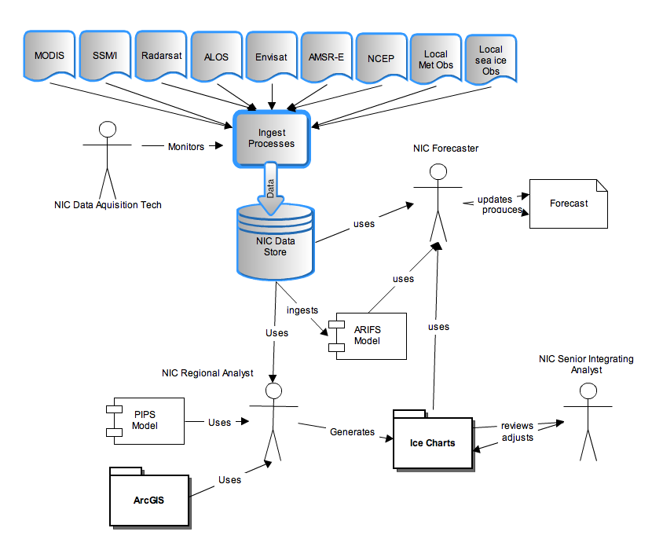

Notes
There is always some piece of information that is required that has no other place to go. This is the place for that information.

While much of the data could come from NSIDC, due to timeliness needs and established relationships usually a bent pipe approach is taken to acquire the data. Also, human interpretation is a very large part of the process.

Resources
In order to support the capabilities described in this Use Case, a set of resources must be available and/or configured. These resources include data and services, and the systems that offer them. This section will call out examples of these resources.

Data:
Data | Type | Characteristics | Description | Owner | Source System
(dataset name) | Remote,  In situ,  Etc. | e.g. – no cloud cover | Short description of the dataset, possibly including rationale of the usage characteristics | USGS, ESA, etc. | Name of the system which supports discovery and access
Near-Real-Time DMSP SSM/I-SSMIS | Remote
MODIS |  |  | don’t really know what they get and how |  | bent pipe
NCEP reanalyses
Radarsat II | SAR | limited coverage | NIC has a contract; but the data are not publicly freely available at this point
ALOS | SAR | limited coverage |  | Japan | ASF
Envisat | SAR | limited coverage |  | Europe | ASF
AMSR-E | Remote Sensing |  | 89 GHz imagery, may use the sea ice products | NASA | Lance
Local met obs |  |  | from weather towers
Local Observatories | Acoustic sensors, profiler, mass balance buoy, SIMB buoy | Ocean heat content, presence of ice and how much (mass balance) and fraction melted (bottom melt rates) | Gives rate of change of ice based on in-situ measurements | Beaufort Gyre Obs, Nth Pole EO
MASIE
Sea ice forecast document | Report | Multi-region outlook (pdf) | Full report | NIC | Web. www.natice.noaa.gov
Local sea ice obs | GPS, GTS, air temperature and pressure | Location and movement of ice, temperature and pressure | Buoys on ice, local and movement, seasonal ice buoys deployed from a range of means | NIC | NIC

Modeling Services
Model | Owner | Description | Consumes | Frequency | Source System
(model name) | Organization that offers the model | Short description of the model | List of data consumed | How often the model runs | Name of the system which offers access to the model
PIPS Model | Navy | Very short term models | Used in chart creation - developed and maintained at Stennis; but run at FNMOC | Run daily | FNMOC
ARIFS? |  | statistical seasonal sea ice model |  | Run bi-weekly

Event Notification Services
Event | Owner | Description | Subscription | Source System
(Event name) | Organization that offers the event | Short description of the event | List of subscriptions (and owners) | Name of the system which offers this event
Iceberg notification |  | If we were doing Thule this would be an issue
Extreme weather events |  | Large anomalies in predicted sea ice due to things like wind shifts that bring ice in

Application Services
Application | Owner | Description | Source System
(Application name) | Organization that offers the Application | Short description of the application portal | Name of the system which offers access to this resource

Tools Used
Resource | Owner | Description | Availability | Source System
Name | Organization that owns/ manages resource | Short description of the resource | How often the resource is available | Name of system which provides resource
ARCGiS |  |  | always

