Use Case Name: Parameterization factors for Spectral Albedo of Arctic Sea Ice
Point of Contact Name: Siri Jodha Singh Khalsa

Use Case Name
Give a short descriptive name for the use case to serve as a unique identifier. Consider goal-driven use case name.
Improved parameterization of factors affecting the spectral albedo of the Arctic Ocean.

Goal
The goal briefly describes what the user intends to achieve with this use case.

The Arctic sea ice cover is changing due to decreases in thickness (add others), change in snow cover (others), increase in the length of the melt season, new importance of seasonal ice, and increased importance of events such as rain on snow, snow ice formation. These changes depend on ice type (perennial versus seasonal) and factors such as surface type, area and amount of snowfall. The goal here is to develop an improved parameterization of the factors that affect surface visible and near-IR band albedo for the Arctic Ocean, so that global climate models can more accurately account for these changes.

Summary
Give a summary of the use case to capture the essence of the use case (no longer than a page). It provides a quick overview and includes the goal and principal actor.
CESM (CICE), uses a multi-scattering function calculation that takes into account specified characteristics via direct modeling and/ or parameterization of melt ponds, snow, ice, surface scattering of the fixed thickness of the scattering layer (two-stream delta Eddington model), open water, all bundled as an albedo which varies on between 1 and 1/10 degree spatial and ~ 1 hour time scales. Alpha (lambda) = A_p(x,t) x Alpha_p (lambda) + A_s(x,t) x Alpha_s (lambda) + A_i(x,t) x Alpha_i (lambda). A_p is the best candidate for improvement (but all these factors on the right side of the equation are eligible for improvement). Lambda is wavelength (including bands), x is grid cell, t is time. A_x is area fraction (sum of A_x = 1). Alpha is spectral albedo. Total albedo is the integration of Alpha (lambda) over wavelength. Alpha_x are the albedos for p = ponds, s=snow, i=ice.

Primary focus is ‘p’ = Melt Ponds. Secondary focus is ‘s’ = snow properties.

Variables and parameters (terms used differently by modelers and field researchers) to consider include, 1) melt pond characteristics (properties of melt pond ice - areal fraction, depth, ‘bubbliness’ air (size and volume) of ice below the melt pond surface, porosity, evolution), 2) snow properties (grain size, depth, water content), 3) near surface ice properties (density, salinity, overall thickness) and ice topography (area - size, shape of surface morphology), 4) open water area and fraction (e.g. polynyas, leads, cracks, other openings in the ice) = 1 - fraction of open sea ice, 5) sea ice biomass, 6) aerosol and dust depositions, 7) sediments, 8) timing of the onset of melting and freezing and snow accumulation.

Important factors are - ice thickness, change in snow cover, length of the melt season, new importance of seasonal ice, rain on snow, and snow ice formation.

For example, melt progresses differently in seasonal and perennial ice. New ice (e.g. frazil ice, grease, nilas) and young (congelated sheet or pancake ice, first year) tend to form earlier and cover a wider area.

Field observations are needed to better characterize albedo as a function of melt pond conditions, especially during the melt season. An observation strategy must be developed, executed and the data analyzed and published. A modeler then uses these published, validated results to develop an improved parameterization suitable for incorporation into a global climate model (GCM).

Actors
List actors, people or things outside the system that either acts on the system (primary actors) or is acted on by the system (secondary actors). Primary actors are ones that invoke the use case and benefit from the result. Identify sensors, models, portals and relevant data resources. Identify the primary actor and briefly describe role.

Data providers – see Data Resource (all extras, unknowns, has beens)
In-situ Researcher – Don (played by younger Harrison Ford)
Remote sensing Researcher – Walt M (Brad Pitt)
Laboratory researcher – Bonnie Light (Liv Tyler)
Process modeler – Chris P (Justin Bieber)
Sea Ice modeler – Marika (Jodi Foster, younger), Elizabeth @ LANL
Software engineer for CICE model development – Fred (played by Fred)

Preconditions
Here we state any assumptions about the state of the system that must be met for the trigger (below) to initiate the use case. Any assumptions about other systems can also be stated here, for example, weather conditions. List all preconditions.

Availability of model, data, researchers, modelers, software engineer, and new observations (i.e. lab, in-situ, satellite)

Triggers
Here we describe in detail the event or events that brings about the execution of this use case. Triggers can be external, temporal, or internal. They can be single events or when a set of conditions are met, List all triggers and relationships.

Opportunity for adding improvements to model
Biases in sea ice model simulation
Identification of new factors or their understanding for albedo in CICE
New funding or research program becomes available

Basic Flow
Often referred to as the primary scenario or course of events. In the basic flow we describe the flow that would be followed if the use case where to follow its main plot from start to end. Error states or alternate states that might be highlighted are not included here. This gives any browser of the document a quick view of how the system will work. Here the flow can be documented as a list, a conversation or as a story.(as much as required)

- In-situ researcher collects and reviews existing data (albedo measurements, sea ice extent, concentration, age, thickness)
- In-situ researcher investigates optimal sampling strategy based on accessibility, location of first year and multi-year ice, ice thickness adequate for safe operating, and where areas with good melt pond evolution are likely to be.
- Lab researcher carries out experiments for salinity and temperature properties of melt ponds, remote sensing researcher analyzes images for XX
- In-situ researcher plans and carries out campaign to collect in-situ data
- Researcher analyzes field and remote sensing data to elucidate the relationship between melt ponds and albedo at various spatial scales
- Publish results
- Sea ice modelers collaborates with in-situ researcher on characterization of spectral albedo as a function of melt pond conditions based on analyzed results
- Modeler develops new parametrization for model
- Software engineer codes the parameterization for the model
- New albedo model incorporated into GCM
- Modeler runs and validates model
- Modeler intercompares with other models
- Publish new model

Alternate Flow
Here we give any alternate flows that might occur. May include flows that involve error conditions. Or flows that fall outside of the basic flow.

- Validation of model fails. New analysis has to be performed

Post Conditions
Here we give any conditions that will be true of the state of the system after the use case has been completed.

Activity Diagram
Here a diagram is given to show the flow of events that surrounds the use case. It might be that text is a more useful way of describing the use case. However often a picture speaks a 1000 words.

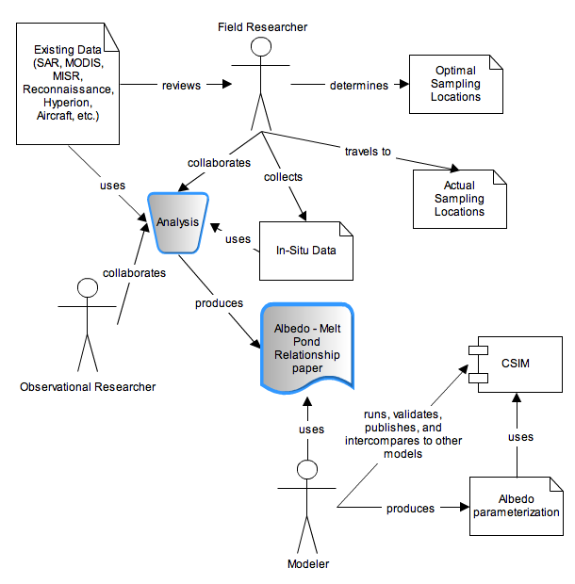

Notes
There is always some piece of information that is required that has no other place to go. This is the place for that information.

Resources
In order to support the capabilities described in this Use Case, a set of resources must be available and/or configured. These resources include data and services, and the systems that offer them. This section will call out examples of these resources.

Data:
Data | Type | Characteristics | Description | Owner | Source System
(dataset name) | Remote,  In situ,  Etc. | e.g. – no cloud cover | Short description of the dataset, possibly including rationale of the usage characteristics | USGS, ESA, etc. | Name of the system which supports discovery and access
MODIS | Remote | True solar color, reflectance (MOD09) with no cloud cover | MODIS visible imagery | NASA | ECHO
MISR | Remote | IDENTIFY what PRODUCT - no cloud cover, suitable spatial resolution | FILL IN | NASA | ECHO
NTM Reconnaissance satellite data | Remote-sensing imagery | Optical, broad band visible of the surface arctic region, some coverage of SHEBA data set, criteria for image selection - no cloud cover | Over four ocean sites. High resolution. Source of known Melt Pond distribution. Complementary to SHEBA field program (in-situ) with area and time overlap covering the same subject of melt pond characteristics | DOD, declassified now public domain | NSIDC
UAV | Remote | Programmed coverage, laser altimeter, ice thickness and topography
Hyperion | Remote | Direct measure or hyper spectral characteristics of melt ponds, 30m res. - no cloud cover | FILL IN | NASA | LP-DAAC
Airborne – manned, unmanned or aerial photography | remote | Area fraction of ponds, leads and ice and distributions.  Irregular sample data unless coordinated with the campaign | FILL IN | TBD | TBD
Field camp data | In situ | SHEBA – determine the surface heat budget of arctic ocean – top of atmos, thru snow, ice and into ocean. More melt ponds – time series, albedos, evolution (size, depth), surface obs, aerial, ice salinity, ice temperature | Sea ice stole the show… | NSF, NASA, NOAA, lots | NSIDC held much of the SHEBA data but now appears to be at NCAR/EOL (was originally JOSS)
Field campaign data | In situ | AIDJEX, HOTRAX, Dave Barber’s, IPY stuff
Arctic Melt Pond Statistics | Remote | Derived from NTM, with imagery, color coded maps, no cloud cover |  | NOAA | NSIDC
Sea Ice Melt Pond Data | Spectrometer | Albedo depth and XXX (Ruth to fill in) |  | David Barber’s stuff  NOAA | NSIDC
Lab measurements | Details of melt water drainage through the ice | Porosity and dependence on temp and salinity | Effects of adding fresh water to the system | Black hats | CRREL
IABP data | In-situ | Webcam to look at Nth Pole melt ponds

Modeling Services
Model | Owner | Description | Consumes | Frequency | Source System
(model name) | Organization that offers the model | Short description of the model | List of data consumed | How often the model runs | Name of the system which offers access to the model
CESM | NCAR | Coupled GCM for testing and validation
CICE | LANL | GCM - sea ice component of CESM

Event Notification Services
Event | Owner | Description | Subscription | Source System
(Event name) | Organization that offers the event | Short description of the event | List of subscriptions (and owners) | Name of the system which offers this event

Application Services
Application | Owner | Description | Source System
(Application name) | Organization that offers the Application | Short description of the application portal | Name of the system which offers access to this resource

Other resources
Resource | Owner | Description | Availability | Source System
(sensor name) | Organization that owns/ manages resource | Short description of the resource | How often the resource is available | Name of system which provides resource

