**Introduction**

As per mention in Assignment this is Ecommerce project for Medicare website for online purchase of medicines. The complete MEAN Stack has been used to build the project. Frontend is in AngularJS and Backend is consist of NodeJS, ExpressJS, MongoDB. The data is stored on local machine of MongoDB.

In this there are two types of users. Admin and Normal users. Admin have all access to add component, remove component, update component, and delete component. Users have access to create account, add the product to cart and to place the order.

There are two separate links for admin and user login. Those are

1. <http://Localhost:4200/auth/signin> for admin
2. <http://Localhost:4200/> for user

**Git Account :**

The link of my git account is

<https://github.com/rdwebushi>

**URL of project Link :**

The link of AngularApp is given below

[**https://github.com/rdwebushi/Capstone/tree/master/MedicalStore**](https://github.com/rdwebushi/Capstone/tree/master/MedicalStore)

**Project Details:**

As per mention in Assignment this is Ecommerce project for Medicare website for online purchase of medicines. The complete MEAN Stack has been used to build the project. Frontend is in AngularJS and Backend is consist of NodeJS, ExpressJS, MongoDB. The data is stored on local machine of MongoDB.

In this there are two types of users. Admin and Normal users. Admin have all access to add component, remove component, update component, and delete component. Users have access to create account, add the product to cart and to place the order.

**MVC Architecture:**

The following was the flow of project.

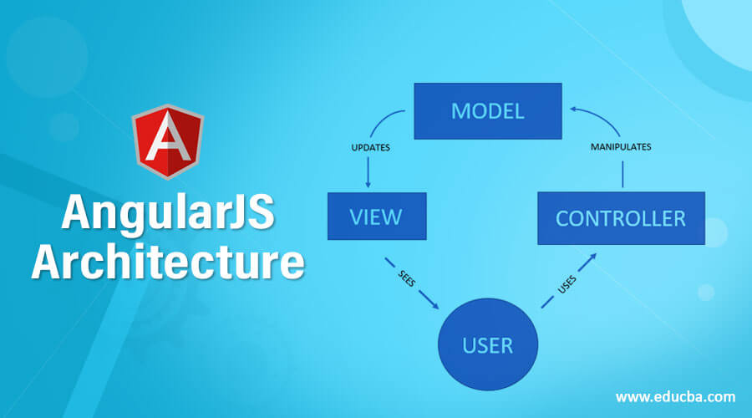

The MVC model is used in project that helps to connect all technologies. MVC : Model View and Controller : MVC is one of the type of architecture which help to develop the web application using any language.

**Model layer**

This layer provide the details about schema and model.

**Schema** :

We will create the Schema using mongoose reference and inside a schema provide the all property name with their data types. With the help of schema we will create the model and provide the collection name. we have to export this model.

**Controller layer**

It import the model class. An do the operation on collections base upon the request receive from router and provide the acknowledgement. Operation are : insert, delete, update and retrieve.

**Router layer** :

Router is use to router your request base upon the path. In router layer we will take the decision which controller method we have to call base upon the request. Router layer provide the features of all http methods. Like Get, Post, Put and delete.

**Main application**

We will load all required modules. Creating the reference of express js, adding middleware, connect the database, run the application in specific port number and then map the main path of the application.

**CORS : Cross Origin Resource Sharing**

In backend technologies develop in any language they have to enable cors policy to connect it with frontend technologies. Node JS provide external module ie cors. So we have installed this module and added as middleware module in express js.

**AngularJS:**

The frontend part is in angular application. In this application I have created services, components and classes. With which the data has been channelized in frontend side from backend. The services carries the url linking using HTTPClient module and connects it with backend. There are four services used mainly for user, product, cart and order purpose.

These services used to call from respective components to perform CRUD operations. In this as mention above there are two type of users. Admin and user. The admin have tasks to manage user and products. He can create, delete, update and search the users and products. The users can only do operations such as register themselves on site, signIn in site and add the products to cart.

All these operations conducted inn frontend.

**NodeJS:**

Node is the base of the project. It is used in backend with express and MongoDB module. Backend connects MongoDB database to project. All to perform CRUD operations.

**MongoDB:**

Created database for user and product to store the data In databases we can store the data in semi structure format. MonoDB is a type of No SQL database which is use to store the data in document format. Mongo DB is schema less database. We can store the data using document concept. Front end side : Angular or React JS know how to consume JSON Database. Node JS or Java or Python or Php or Asp.net if they are REST API then known how to consume and produce the JSON data.

**Future Scope**

With adding new features like Payment getaway and other this website can be helpful to various people.