**Automated ticket issuing system for Bangladesh Railway**

**A Software Development Project Management Plan**

**Prepared By**

**Chakraborty , Uchchhwash (15-28458-1)**

**Rahman , A.T.M Ashfiqur (15-28517-1)**

**Huque , Kazi Ahmedul (15-28875-1)**

**Under the supervision of**

**S.M. Abdur Rouf Bhuiyan**



**AMERICAN INTERNATIONAL UNIVERSITY - BANGLADESH**

**August 17 , 2017**

# Acknowledgement

This Project was instructed and supervised by respected teacher S.M. Abdur Rouf Bhuiyan. The duration of this project is from 4th July 2017 to 17th August 2017.

# Review

|  |  |  |
| --- | --- | --- |
| **Version** | **Date** | **Description** |
| 1.0.0 | 20th July 2017 | The initial version of starting this project. |
| 1.0.1 | 17th August 2017 | This is the final version. Some problems were solved regarding documentation. |

Table of Contents

1.Introduction 4

2.Process Model 4

2.1 Choosing a Perfect Model 4

2.2 Why this Model 5

2.3 Software Life Cycle Flowchart………………………………………………………………………6

3. Quality Gates for Each Phase of Software Development 7

4. List of Tasks 7

5. Estimation for each task 8

6.Scheduling the Task8…………………………………………………………………………………………8

7. List Of Milestone………………………………………………………………………………………………9

8. Staffing Plan 10

9. Monitoring And Controlling Mechanism 12

10. Risk Management 13

11. List of Deliverables: 14

12. Defect Tracking Process 15

13. Metrics 16

14. Postmortem 17

# 1.Introduction

This is the documentation of the software development project management for Automated Ticket Issuing System for Bangladesh Railway. This Software Project Management Plan will explain details about the software development lifecycle which our group will take in order to complete the desired software product . This document will cover detailed information about the management plan used to this project . The intended audience for this document is the designers and the IT department people. It specifies the technical and managerial approaches to develop the software product. All technical and managerial activities required to turn over the deliverables to the Bangladesh Railway are Included .This includes scheduling , identification of tasks and factors that may impact the project and planning.

# 2.Process Model

## 2.1 Choosing a Perfect Model

RAD model is Rapid Application Development model .It is a type of Incremental model .In RAD the Components are developed in parallel Manner. It is a faster software development process. The term has recently become a marketing buzzword that generically describes application that can be designed and developed within 60-90 days. It was intended to describe a process of development that involves application prototyping.

## 

## 2.2 Why this Model

* To limit a project’s exposure to the forces of change.
* To prevent runaway schedules.
* To prevent cost overruns.
* To converge early toward a design acceptable to the customer and feasible for the developers.
* To save development time , possibly at the expense of the economy or product quality.
* In certain situations , a usable 80% solution can be produced in 20% of the time that would have been required to produce a total solution.
* We have got well-defined requirement from the client to build this software . So , we easily planned the project and progress for the RAD Model.

**2.3 Software Life Cycle Flow Chart**

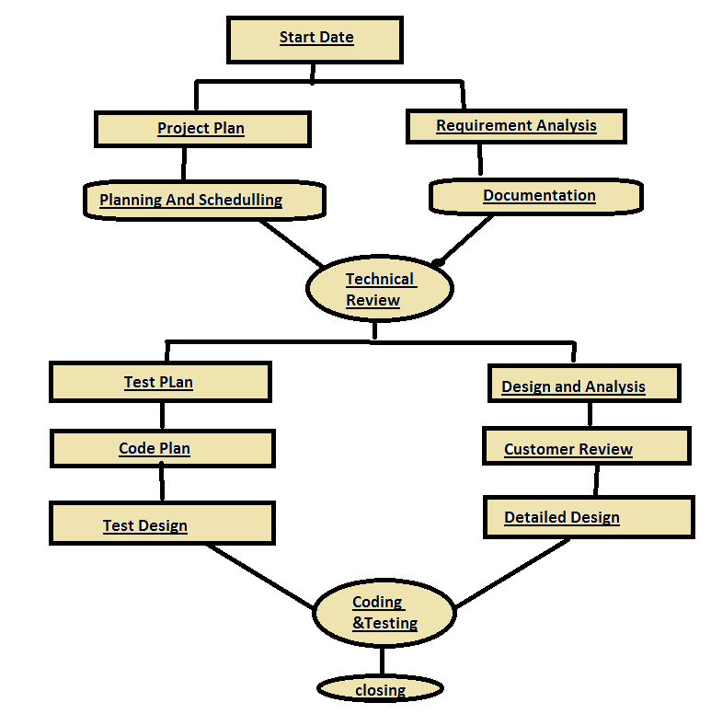

# 3. Quality Gates for Each Phase of Software Development

|  |  |
| --- | --- |
| **Work Product** | **Quality Assurance Technique** |
| Specification | Formal Technical Review |
| Development Plans | Formal Technical Review |
| Designing | Inspection done by experts |
| Analysis | Inspection done by experts |
| Project Planning | Formal Technical Review |
| Implementation | Coding and Reviewing |
| Testing | Test Coverage Management |

# 4. List of Tasks

|  |  |
| --- | --- |
| **Number** | **Task** |
| **1** | **Requires Elicitation.**  **.** |
| **2** | **Analysis** |
| **3** | **Designing** |
| **4** | **Implementation & Unit Testing.** |
| **5** | **System Integration & System Testing.** |
| **6** | **Internal Project review(Functional prototype).** |
| **7** | **Project Acceptance By Bangladesh Railway** |

# 5. Estimation for each task

|  |  |  |
| --- | --- | --- |
| **Task of Phase** | **Days** | **Hours** |
| **Requirements Elicitation** | 12 | 96 |
| **Project Planning** | 13 | 104 |
| **Requirements Analysis** | 10 | 80 |
| **System Design** | 17 | 136 |
| **Object Design** | 12 | 96 |
| **Implementation & Unit Testing** | 14 | 112 |
| **System Integration & system testing** | 12 | 96 |

**Note:** Each engineer works for 8 hours a day and 5 days a week. Total project duration is 90 working days excluding National holidays.

# 6. Scheduling the Tasks

|  |  |  |
| --- | --- | --- |
| **Start Date** | **Project Phase** | **End Date** |
| October 2nd | Require Elicitation | October 17th |
| October 18th | Project Planning | November 6th |
| November 7th | Requirement Analysis | November 21st |
| November 22nd | System Design | December 13th |
| December 14th | Object Design | January 1st |
| January 2nd | Implementation & unit | January 21st |
| January 22nd | System Integration | January 30th |
| January 31st | System Testing | February 5th |

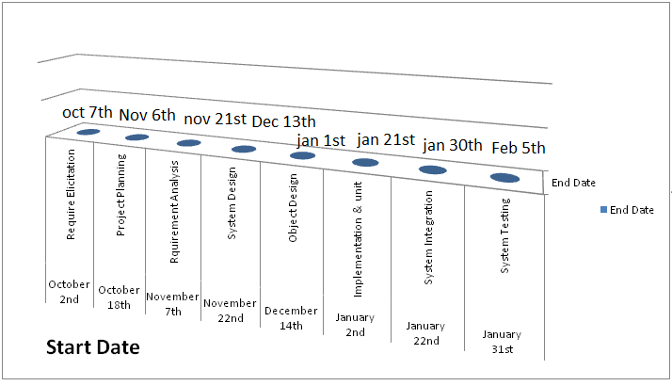

**Note:** Some weekends are included in the time frame which is not counted as working days . We assume that only 85% time of an engineer per day will be used to develop software. Other 15% will be spending by reading emails , attending meetings , process improvement activities etc.

**7. List Of Milestone**

|  |  |
| --- | --- |
| **Date** | **Project Milestones** |
| **September 27** | **Project Presentation by Bangladesh Railway** |
| **October 2 - October 6** | **Analysis Review** |
| **November 5** | **Project Review with Bangladesh Railway** |
| **December 25** | **Object Design Review** |
| **January 2** | **Demo Software** |
| **January 12** | **Internal Project Review (functional prototype)** |
| **February 5** | **Project Acceptance by Bangladesh Railway** |

# 8. Staffing Plan

The purpose staffing plan is to make certain the project has sufficient staff with the right skills and experience to ensure a successful project completion . The following is a detailed breakdown of the roles required to execute the project. It includes the project role , the project responsibility of the role number of staff required fulfilling the role and the duration the staff resource will be needed on the project.

|  |  |  |  |  |  |
| --- | --- | --- | --- | --- | --- |
| **Role** | **Name** | **Est. Working Hours** | **Key Project Phase** | **Number of Staff** | **Hourly Rate** |
| **Project Manager** | Shahriar Tushar | 110 | All | 01 | 105 |
| **Requirements Analyst (Lead)** | Faiyaz Islam | 30 | Requirements | 01 | 85 |
| **Requirement Analyst** | 1.Istian Revee  2.Ali Ahmed  3.Rifat Khan | 20  15  20 | Requirements | 03 | 80 |
| **Software**  **Engineer**  **(Lead)** | 1.Abir Hossain  2.Shihab Ahmed | 25  25 | System Allocation & Design | 02 | 88 |
| **Software Engineer** | 1.Salman Ahmed  2.Shams Ahmed | 35  48 | System Allocation | 02 | 65 |
| **Programmer**  **(Lead)** | Samiul Shovon | 22 | Implementation | 01 | 125 |
| **Programmer** | 1.Showmik Das  1.Niloy Sharma | 34  38 | Implementation | 02 | 100 |
| **Verification Engineer** | 1.Partho Deb  2.Bishal Das | 32  34 | Requirements , design , Implementation | 02 | 50 |
| **Software Designer** | Saikat Das | 65 | Design | 01 | 155 |
| **Quality Analyst** | Nirjhor Sinha | 30 | All(but Most work on Front-end) | 01 | 190 |
| **Database Engineer** | Imran Ahmed | 25 | Design , Implementation , Installation | 01 | 80 |
| **Configuration Manager** | Adib Ahmed | 25 | All(But most work up-front During definition) | 01 | 55 |
| **Technical Writer** | Noushin Jannat | 24 | Documentation | 01 | 85 |
| **Installation Specialist** | Bonodeep Singho | 24 | Installation | 01 | 100 |

**Note:** Most staff will be required to attend weekly project status meetings, for which the dates are yet to be determined. All staff identified as “Leads” will be required to attend the meetings. Staffs who are in a group underneath a “Lead” will not be required to attend, while staff who have a “Lead” role, or who have no subordinate “Lead” will be required to attend.

# 

# 9. Monitoring And Controlling Mechanism

Monitoring of progress is done by the Project Manager using the following means:

* Weekly Project Meetings will take place at the lead project manager’s room.
* Meetings are held Tuesday at 11 am and inform each other of the progress made on the various tasks. New tasks are assigned by the Project Manger during this meetings . Before project group meetings , the Project Manager will read the minutes of relevant previous meetings and compose an agenda for the meeting. Team members can propose additional agenda points before or during the meeting.
* These meetings are scheduled once in a week. During these meetings , the Project Manager and Quality Assurance Manager meet with the Senior Management. The following things need to be , done before a progress meeting:

1.A progress report of the last reporting period is written by the Project Manager;

2.The Project Manager and Quality assurance Manager read the minutes of the previous meeting.

Tracking the risk is very important . Quality assurance , configuration management , documentation and training are the project support function for monitoring and controlling.

A hard copy version of the progress repost is delivered to the senior Management.

# 

# 10. Risk Management

|  |  |
| --- | --- |
| **Description** | **Probability** |
| **Communication collapse:** There is a chance to break in Communication between the team members or sponsors. If this happen , it could potentially lead to falling behind. If it happen then we will try hard to reach that teammate .If they become unreachable for a time being . We will redistribute the works . | **25%** |
| **Hardware Incapacity:** There is a chance that the company server could fall before, during or after deployment of our software . If this happen then no solution will come , it means this project will unable to deliver to the sponsor .All necessary recovery steps will be taken as soon as possible | **30%** |
| **Defect at modeling /planning:** If any defect found during the project in our planning or modeling then the project will demand more time to complete. | **15%** |
| **Political crisis :** In case of hartal or any political issue our workers will work in the weekends to recover the lost time. | **50%** |

# 

# 11. List of Deliverables:

Software Project Management Plan defining the technical and managerial processes necessary for the development and delivery of the system.

* Agreement between Bangladesh Railway and developers , representing a contract between the Bangladesh Railway and the developers of what is going to be delivered.
* Analysis Document describing the functional and global requirements of the system of 4 models. The use case model , the object model , the functional model and the dynamic model/
* System Design describing design goals , the high level decomposition of the system , concurrency identification , hardware/software control implantation and boundary conditions , the document forms the basis of the object design.
* Object design is composed of two documents. The first document is an updated RAD. The code related data will be in the form of Java output from the code from each team.
* Test Manual documentation is the principles of operation. The delivery consists of a presentation of the system. Bangladesh Railway expects the acceptance test to be successfully demonstrated on February 5.

**12. Defect Tracking Process**

**There can be taken some precautionary measurements to track defect .Those measurements are stated below:**

* Breakdown the whole execution procedure into several parts and scrutinize each part circumspectly to track down defects.
* While coding phase starts , always check that the implementation is actually being based upon on requirements.
* Requirements illustrated by the Bangladesh Railway stakeholders should be maintained and updated on a regular basis.
* There should be satisfactory amount of interaction between the coder and the project manager to ensure the quality of the system.
* The project manager has to be communicative towards the stake holders of the Bangladesh Railway.

# 

# 13. Metrics

|  |  |  |
| --- | --- | --- |
| **Schedule** | **Milestones** | **MS Project** |
| **Staff Usage** | Graph of person hrs used per month both projected and actual | MS Excel |
| **Expenditures** | Graph of total expenditures over time both projected and actual | MS Excel |
| **No of Requirements** | Graph of total requirements identified per module overtime. | MS Excel |
| **No of Requirements Defects** | Graph of number of defects identified per module overtime. | MS Excel |
| **No of Objects** | Graph of number of objects identified over time. | MS Excel |
| **Coding Progress** | Number of objects coded. | MS Excel |
| **Coding Size** | Lines of code measured daily. |  |
| **Test Progress** | Unit test causes passed overtime. | MS Excel |
| **Defect Tracking** | Numbers of code defects. |  |
| **Test Progress** | Number of integration test passed overtime. | MS Excel |
| **Defect Tracking** | Number of code defects test passed overtime. | MS Excel |

# 

# 14. Postmortem

The overall project plan follows the model , a modified RAD model. 3 prototypes have to be delivered : A graphical user interface , a functional prototype and a system integration prototype. Analysis is started before Project Planning is finished . System Design is followed by Object Design . We hope that we will be to complete this project successfully without any major interruption. On closing of the project we want to complete a final review with Bangladesh Railway and Celebrate the outcome of the project.