**‘FoodBank’(Online Food Review System)**

**Version 1.0**

**A Software Requirements Engineering project submitted**

**By**

**Under the supervision of**

**SYED ISHTEAQUE AHMED**

**Assistant Professor**

**Department of Computer Science**

**Faculty of Science & Information Technology**

**American International University – Bangladesh Spring 16-17**

Software Requirements Specification

For

**FoodBank**  
Online Food Review System

|  |  |
| --- | --- |
|  | **Version 1.0** |
|  | Prepared By |
| **Chakraborty,Uchchhwash** | **(15-28458-1)** |
| **Susmoy, Bhattacharjee** | **(15-28966-1)** |
| **Rahman Md. Zahid** | **(15-28982-1)** |
| **Amit Kumar Paul** | **(13-24733-2)** |
| **Imam Hasan Faruque Ridoy** | **(13-24726-2)** |
|  |  |

**AMERICAN INTERNATIONAL UNIVERSITY - BANGLADESH**

**May 09, 2017**

**Table of Contents**

|  |  |  |  |
| --- | --- | --- | --- |
| **Table of Contents .........................................................................................................................................................** | | | **3** |
| **1.** | **Introduction .....................................................................................................................................................** | | **5** |
|  | 1.1 | Purpose ................................................................................................................................................................ | 5 |
|  | 1.2 | Document Conventions ....................................................................................................................................... | 5 |
|  | 1.3 | Intended Audience and Reading Suggestions ..................................................................................................... | 5 |
|  | 1.4 | Project Scope ...................................................................................................................................................... | 6 |
| **2.** | **Overall Description .........................................................................................................................................** | | **6** |
|  | 2.1 | Product Perspective ............................................................................................................................................ | 6 |
|  | 2.2 | Product Features ................................................................................................................................................. | 7 |
|  | 2.3 | User Classes and Characteristics ....................................................................................................................... | 7 |
|  | 2.4 | Operating Environment ...................................................................................................................................... | 8 |
|  | 2.5 | Design and Implementation Constraints ........................................................................................................ | 9 |
|  | 2.6 | User Documentation ........................................................................................................................................ | 10 |
|  | 2.7 | Assumptions and Dependencies ....................................................................................................................... | 10 |
| **3.** | **System Design ..................................................................................................................................................** | | **11** |
|  | 3.1 | User Scenario .................................................................................................................................................... | 11 |
|  | 3.2 | UML................................................................................................................................................................. | 14 |
|  | 3.3 | Data Dictionary ............................................................................................................................................... | 18 |
|  | 3.4 | User Interface Design ...................................................................................................................................... | 19 |
| **4.** | **System Features ............................................................................................................................................** | | **24** |
|  | 4.1 | Sign Up ........................................................................................................................................................... | 24 |
|  | 4.2 | Login .............................................................................................................................................................. | 24 |
|  | 4.3 | Request Password ............................................................................................................................................ | 24 |
|  | 4.4 | Set Information ............................................................................................................................................... | 24 |
|  | 4.5 | Search Method Selection ................................................................................................................................ | 25 |
|  | 4.6 | Modify Search ................................................................................................................................................. | 25 |
|  | 4.7 | Show Search History………………………………………………………………………………………… | 25 |
|  | 4.8 | Show Reviews.................................................................................................................................................... | 25 |
|  | 4.9 | Live Support .................................................................................................................................................... | 25 |
|  | 4.10 | Select Search Locations……………………………………………………………………………………… | 26 |
|  | 4.11 | Assign Own Food Review………….................................................................................................................. | 26 |
|  | 4.12 | Rate Review….................................................................................................................................................. | 26 |
|  | 4.13 Modifying Account Information ........................................................................................................................... | | 26 |
|  | 4.14 | View Restaurant Information .......................................................................................................................... | 27 |
|  | 4.15 | Remove Account ........................................................................................................................................... | 27 |
|  | 4.16 | Uploading Pictures Of Foods .......................................................................................................................... | 27 |
|  | 4.17 | Share Reviews.................................................................................................................................................... | 27 |
|  | 4.18 | Comment In reviews ......................................................................................................................................... | 27 |
|  | 4.19 | One Tap Best Food Search............................................................................................................................... | 28 |
|  | 4.20 | Sort By Price..................................................................................................................................................... | 28 |
|  | 4.21 Sort By Rating ....................................................................................................................................................... | | 28 |
|  | 4.22 | Advertise Foods From Restaurants................................................................................................................... | 28 |
|  | 4.23 | Report Review ................................................................................................................................................. | 28 |
|  | 4.24 | Sign Out…………………………………………………………………………………………………….... | 29 |
|  | **5.** | **External Internal Requirements………………………………………………………………...29** |  |
| 29 | 5.1 | User Interface……………………………………………………………………………………...29 |  |
|  | 5.2 | Software Interface…………………………………………………………………………………30 |  |
|  | 5.3 | Hardware Interface………………………………………………………………………………...30 |  |
|  | 5.4 | Communications Interface……………………………………………………………………...…30 |  |
|  | **6. Nonfunctional Requirements………………………………………………………………………….30** | |  |
|  | 6.1 | Performance Requirements ...........................................................................................................................30 |  |
|  | 6.2 | Safety Requirements.......................................................................................................................................31 |  |
|  | 6.3 | Security Requirements ...................................................................................................................................31 |  |

**7.Acknowledgement.………………………………………………………………………….31**

**8.References……………………………………………………...……………………………31**

**1. Introduction**

This section gives a scope description and overview of everything included in this SRS document. Also the purpose for this document is described and a list of abbreviation and definitions is provided.

**1.1Purpose**

The purpose of this document is to give a detailed description of the requirements for the “Foodbank” software. It will illustrate the purpose and complete declaration for the development of system.

It will also explain system constraints, interface and interactions with other external applications.

This document is primarily intended to be proposed to a customer for its approval and a reference for developing the first version of the system for the development team.

**1.2 Document Conventions**

This document follows MLA Format. Bold-faced text has been used to emphasize section and sub-section headings. Highlighting is to point out words in the glossary and italicized text is used to label and recognize diagrams.

**1.3 Intended Audience and Reading Suggestions**

The intended audience for this document is the project sponsor, business analyst, the development team and the team advisor. Throughout the rest of this document the project will be broken up into sections.

The second section provides the perspective of the project in detailed terms and a description of the product features. User classes and their characteristics are also specified. Also listed all the working operating environments as well as all the constraints are identified.

Third section provides different user scenarios with a description of the different system interfaces. Necessary analysis models, UMLs and interface workflow are represented as well.

Fourth section described all the product features that can be performed by using the application. In the end all the non-functional requirements will be described which includes performance, security as well as some other quality attributes.

**1.4 Project Scope**

The “Foodbank” is a GPS-based mobile application which helps people to find the restaurants based on the specification like dish, price and user’s current position. The application should be free to download from either a mobile phone application store or similar services.

Restaurant owners can provide their restaurant information using the web-portal. This information will displayed to the user on the basis of foodies(user's) reviews and points. An administrator also uses the web-portal in order to administer the system and keep the information accurate. The administrator can, for instance, verify restaurant owners and manage user information.

Furthermore, the software needs both Internet and GPS connection to fetch and display results. All system information is maintained in a database, which is located on a web-server. The software also interacts with the GPS-Navigator software which is required to be an already installed application on the user’s mobile phone. By using the GPS-Navigator, users can view top desired restaurants on a map and be navigated to them.

**2. Overall Description**

This section will give an overview of the whole system. The system will be explained in its context to show how the system interacts with other systems and introduce the basic functionality of it. It will also describe what type of stakeholders that will use the system and what functionality is available for each type. At last, the constraints and assumptions for the system will be presented

**2.1 Product Perspective**

This system will consist of two parts: one mobile application and one web portal. The mobile application will be used to provide locations of best restaurants for a specific food and view information about them. The web portal will be used for managing the information about the restaurants and the system as a whole.

The mobile application will need to communicate to a GPS application within the mobile phone, which in turn communicates with a physical GPS device to find the location of the user. The GPS will provide the mobile application with locations of both the user and the restaurants and the distance between them, but it will also provide maps and the functionality to display the application’s data on the map. The functionality provided by the GPS will be embedded into the application in order for the user to be able to use the functions in the application in a seamlessly manner.

Since this is a data-centric product it will need somewhere to store the data. For that, a database will be used. Both the mobile application and web portal will communicate with the database, however in slightly different ways. The mobile application will only use the database to get data while the web portal will also add and modify data. All of the database communication will go over the Internet.

**2.2 Product Features**

With the mobile application, the users will be able to search for desired dishes. The result will be based on the criteria the user inputs. There are several search criteria and it will be possible for the administrator of the system to manage the options for those criteria that have that.

The result of the search will be viewed either in a list view, depending on what criteria included in the search. The list view will have one list for top restaurant reviews on the search criteria and show a small part of the restaurant information so the user can identify the restaurant.

The map view will show each restaurant location as a pin on the map as well as the user’s own location. In both views the users will be able to either select a restaurant as target destination or get information how to get there, or view the information of a specific restaurant.

The web portal will provide functionality to manage the system and the restaurant information. It will also provide information about the system, for example show when there is a new update.

**2.3 User Characteristics**

There are three types of users that interact with the system users of the mobile application, restaurant owners and administrators. Each of these three types of users has different use of the system so each of them has their own requirements.

The mobile application users can only use the application to find top restaurants based on ratings and reviews that were given by users and foodies. This means that the user have to be able to search for desired dishes, choose a restaurant from that search outcome and then navigate to it. In order for the users to get a relevant search result there are multiple criteria the users can specify and all results matches all of those.

The restaurant owners will not only use the mobile application but also the web portal. There they will manage the information about their restaurant, for example a description of the restaurant, contact information and their menu.

The administrators interact with the web portal. They are managing the overall system so there is no incorrect information within it. The administrator can manage the information for each restaurant as well as the options for both the mobile application users and the restaurant owners.

**2.4 Operating Environment**

This system’s application will be available on Android and iOS. But user’s will be able to visit the website to get the service as well. User’s can visit from their laptop , desktop or any internet connected devices.

Latest every version of Android and iOS can use this application’s mobile version. For better and efficient use and support we are omitting the older versions of both of this two operating systems.

**For Android:**

**Applicable Operating System - Version**

Jelly Bean - 4.1-4.3.1

Kitkat - 4.4-4.4.4

Lollipop - 5.0-5.1.1

Marshmallow - 6.0-6.0.1

Nougat - 7.0-7.1

**For iOS:**

**Applicable Operating System - Version**

iOS9 - 9.3.5

iOS10 - 10.2.1

**For Windows:**

Any Kind of Internet Browser (Chrome , Internet Explorer , Firefox )

**2.5 Design and Implementation Constraints**

The mobile application is constrained by the system interface to the GPS navigation system within the mobile phone. Since there are multiple system and multiple GPS manufacturers, the interface will most likely not be the same for every one of them. Also, there may be a difference between what navigation features each of them provide.

**CO-1:**Only the verified users will be able to use the application to comment or post a food review .Account must be verified after sign up.

**CO-2:** This Application will be available only for Android and later on IOS. Any android phone supporting at leastJelly Bean will be able to run the application.

**CO-3:**The mobile application is constrained by the system interface to the GPS navigation system within the mobile phone. Since there are multiple system and multiple GPS manufacturers, the interface will most likely not be the same for every one of them. Also, there may be a difference between what navigation features each of them provide.

**CO-4:** The internet connection is also a constraint for the application. Since the application fetches data from the database over the internet, it is crucial that there is an internet connection for the application to function.

**CO-5:** The database system of this application will be based on MySQL Database.

**CO-6:** Both the web portal and the mobile application will be constrained by the capacity of the database. Since the database is shared between both application it may be forced to queue incoming requests and therefore increase the time it takes to fetch data.

**CO-7:** This application will only available in English language.

**CO-8:** Application itself will ensure the total security of user data.

**CO-9:** To avoid problems with overloading the operating system the application is only allowed to use 20 megabytes of memory while running the application. The maximum amount of hard drive space is also 20 megabytes.

**CO-10:** Development of the application will have to maintain the java documentation standards and conventions for Android.

Both the web portal and the mobile application will be constrained by the capacity of the database. Since the database is shared between both application it may be forced to queue incoming requests and therefore increase the time it takes to fetch data.

**2.6 User Documentation**

**UD-1:** The system shall provide an online hierarchical and cross-linked help system in HTML that describes and illustrates all system functions.

**UD-2**: The system shall provide a user manual and a video that how it will work.

**UD-3:** The first time a new user accesses the system and on user demand the system shall provide a demo of the application, to allow users easily get into the application.

**UD-4:** There will be option to send any complain, report or suggestion about user experience for improving the application.

**UD-5:** The system shall provide a help desk called ‘FoodBank’ SUPPORT' which will be available 24/7.

**2.7 Assumptions and Dependencies**

**AS-1:** This application will be available to user 24/7.

**AS-2:** The application will be more user friendly to fulfill user expectations.

**AS-3:** Users will get the best user experiences by using the application.

**AS-4:** Business could be possible by advertisement of restaurant owners.

**DE-1:** Sign up of a user will depend on e-mail and mobile number verification process.

**DE-2:**Resturant owner’s sign up will depend on the verification process o the administration.

**DE-3:** As the application is online based it will be connected to database for checking the restaurant information’s , food reviews , comments , ratings and location information as well as user profile.

**DE-4:** Mobiles which we will use to run the application must have the specification to run the program well.

**DE-3:** Advertiser’s payment can be done with bankcheque , bKash .

**3. System Design**

All the user stories, UML along with data dictionary will be shown and described in this section. UML contains use case diagrams, class diagrams, activity diagrams and entity relationship diagrams.

**3.1 User Scenario**

For this application service all the user stories based on three major user characteristics are given:

|  |  |  |  |
| --- | --- | --- | --- |
| **SL.** | **Sample Use Case** | **Actor** | **Corresponding user stories** |
| **1.** | **Sign Up** | **Restaurant Owner/Food Reviewer** | **As a restaurant owner/food reviewer , I want to sign up so that I can use the application.** |
| **2.** | **Login** | **Restaurant Owner/Food Reviewer** | **As a restaurant owner/food reviewer , I want to login so that I can use the application whenever I want.** |
| **3.** | **Request for password** | **Restaurant Owner/Food Reviewer** | **As a restaurant owner/ food reviewer, I want to request for my password if I forget it so that I can use the application again.** |
| **4.** | **Set Information** | **Restaurant Owner/Food Reviewer** | **As a restaurant Owner or a food reviewer I want to set the information about myself including my favorite foods and so that other users will know about them.** |
| **5.** | **Search Method Selection** | **Food Reviewer** | **As a food reviewer I can search in many ways about foods. By food category search , by location search etc.** |
| **6.** | **Modify search** | **Food Reviewer** | **As a food reviewer I can modify the search and can also filter the search results.** |
| **7.** | **Show Search History** | **Food Reviewer** | **As a food reviewer , I can see their search history to find previous searches.** |
| **8.** | **Show Reviews** | **Food Reviewer** | **As a food reviewer ,I can see reviews of other’s post and can also react to them .** |
| **9.** | **Live Support** | **Restaurant Owner/Food Reviewer** | **As a restaurant Owner or a food reviewer ,I can contact the live support 24/7.** |
| **10.** | **Select Search Locations** | **Food Reviewer** | **As a food reviewer , I can choose a specific location to search on that specific area for any desired food or restaurants.** |
| **11.** | **Assign Own Food Review** | **Food Reviewer** | **As a food reviewer I can give a review of any food from my account.** |
| **12.** | **Rate Review** | **Food Reviewer** | **As a food reviewer I can rate reviews of other reviewers or can rate my own review on scale of 10.** |
| **13.** | **Modifying Account**  **Information** | **Restaurant Owner/Food Reviewer** | **As a restaurant Owner or a food reviewer I can make changes to my contact information or address information by verifying my mail or mobile number.** |
| **14.** | **View Restaurant Information** | **Restaurant Owner/Food Reviewer** | **As a restaurant Owner or a food reviewer I can see information of other restaurants and other reviewers review about the restaurant.** |
| **15.** | **Remove Account** | **Restaurant Owner/Food Reviewer** | **As a food reviewer I can remove my account . but have to verify a code from mobile number.**  **As a restaurant owner I can remove my account but have to do it by contacting FoodBank’s Admin.** |
| **16.** | **Uploading Picture of Foods** | **Food Reviewer** | **As a food reviewer I can upload pictures of my foods when I give a review.** |
| **17.** | **Share Reviews** | **Food Reviewer** | **As a food reviewer I can share a review of other reviewer.** |
| **18.** | **Comment In Reviews** | **Food Reviewer** | **As a food reviewer I can make comments in other reviewer’s review or can comment in own review.** |
| **19.** | **One Tap Best food Search** | **Food Reviewer** | **As a food reviewer there is a option for one tap search .One tap search will find the best foods around the current location.** |
| **20.** | **Sort By Price** | **Food Reviewer** | **As a food reviewer I can search and click sort by price to find the food with lowest or highest price.** |
| **21.** | **Sort by Rating** | **Food Reviewer** | **As a food reviewer I can search and click sort by rating to find the food with lowest or highest rating.** |
| **22.** | **Advertise Foods by Restaurant owners** | **Restaurant Owner** | **As a restaurant owner I can put my advertise to their website or application by paying FoodBank.** |
| **23.** | **Report Review** | **Food Reviewer** | **As a food reviewer I can report against any reviewers review if it abusive or violation to anyone.** |
| **24.** | **Sign Out** | **Food Reviewer/Restaurant Owner** | **As a restaurant Owner or a food reviewer I can sign out if the application.** |

**3.2UML**

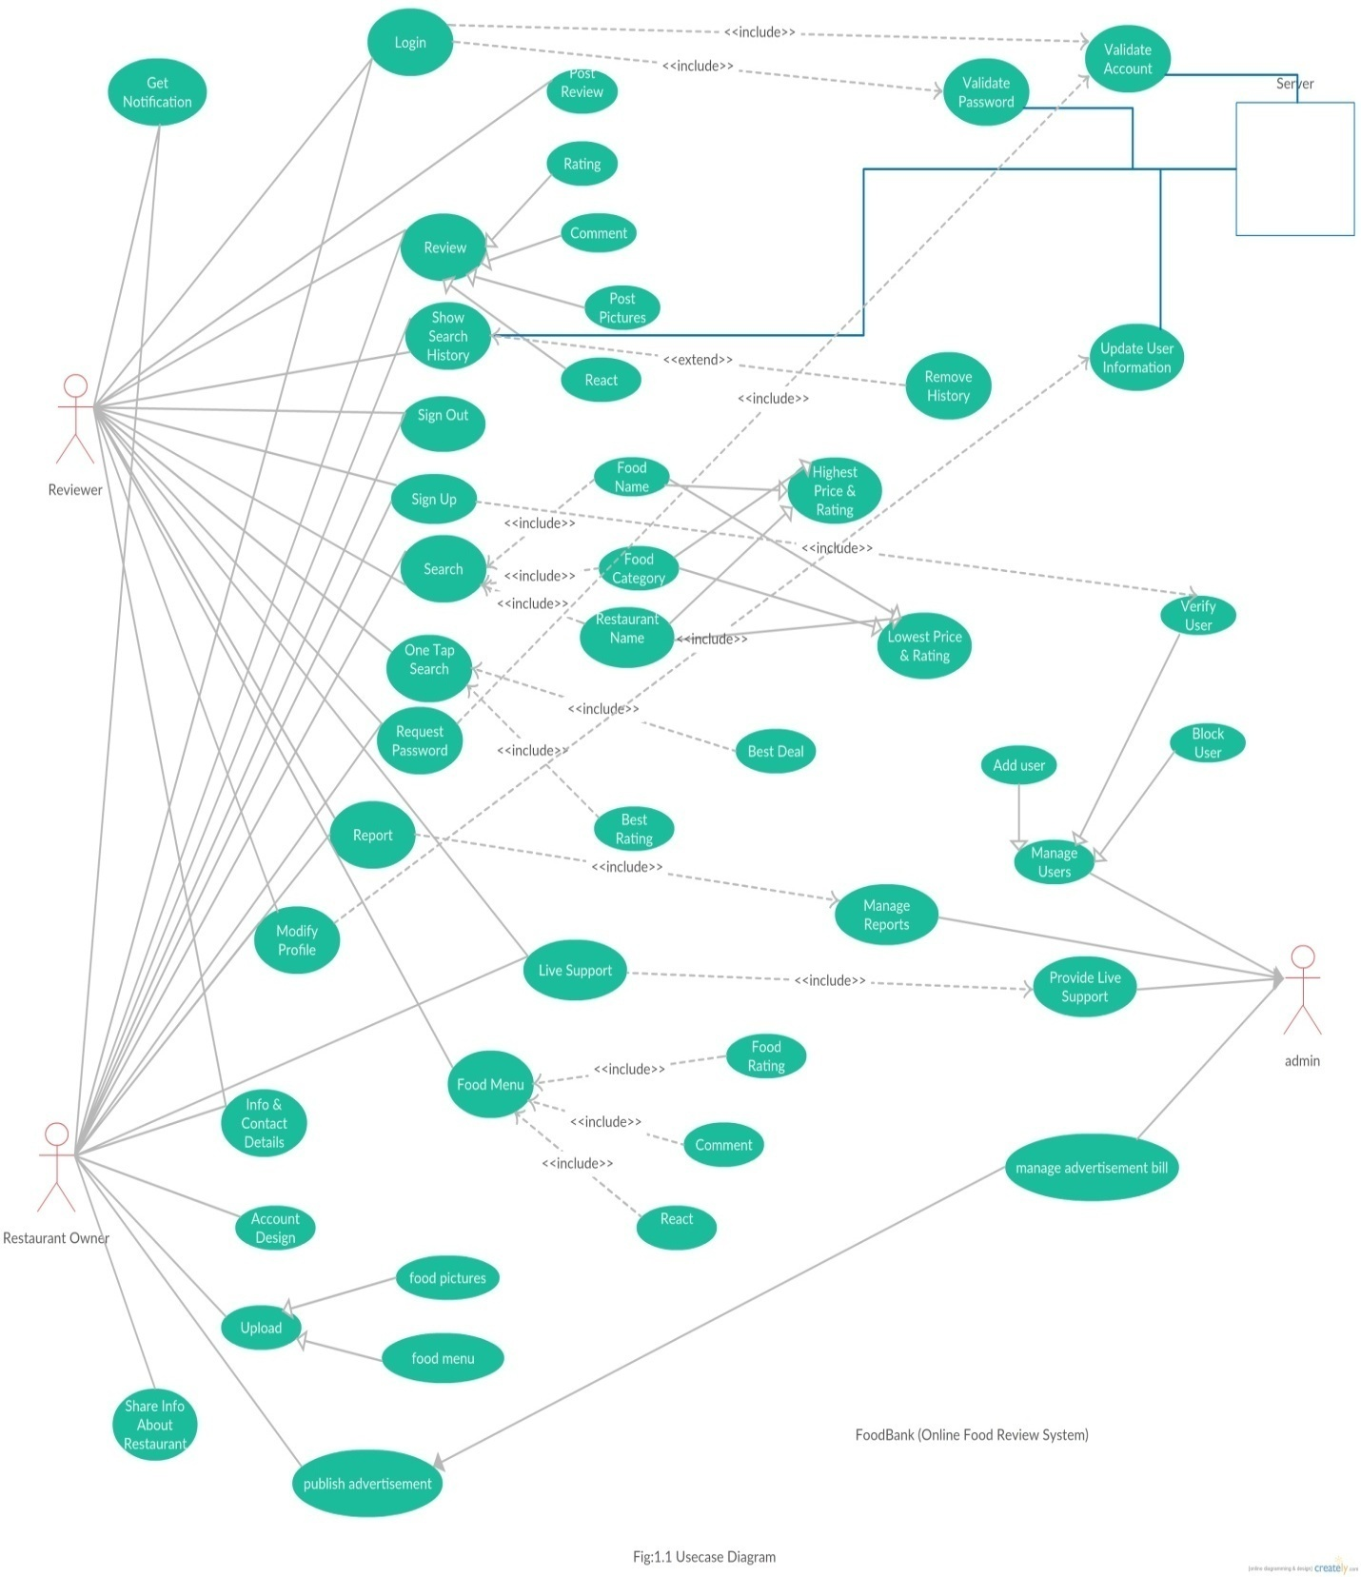

**Figure 1.1 – ‘FoodBank System [Use Case Diagram]**

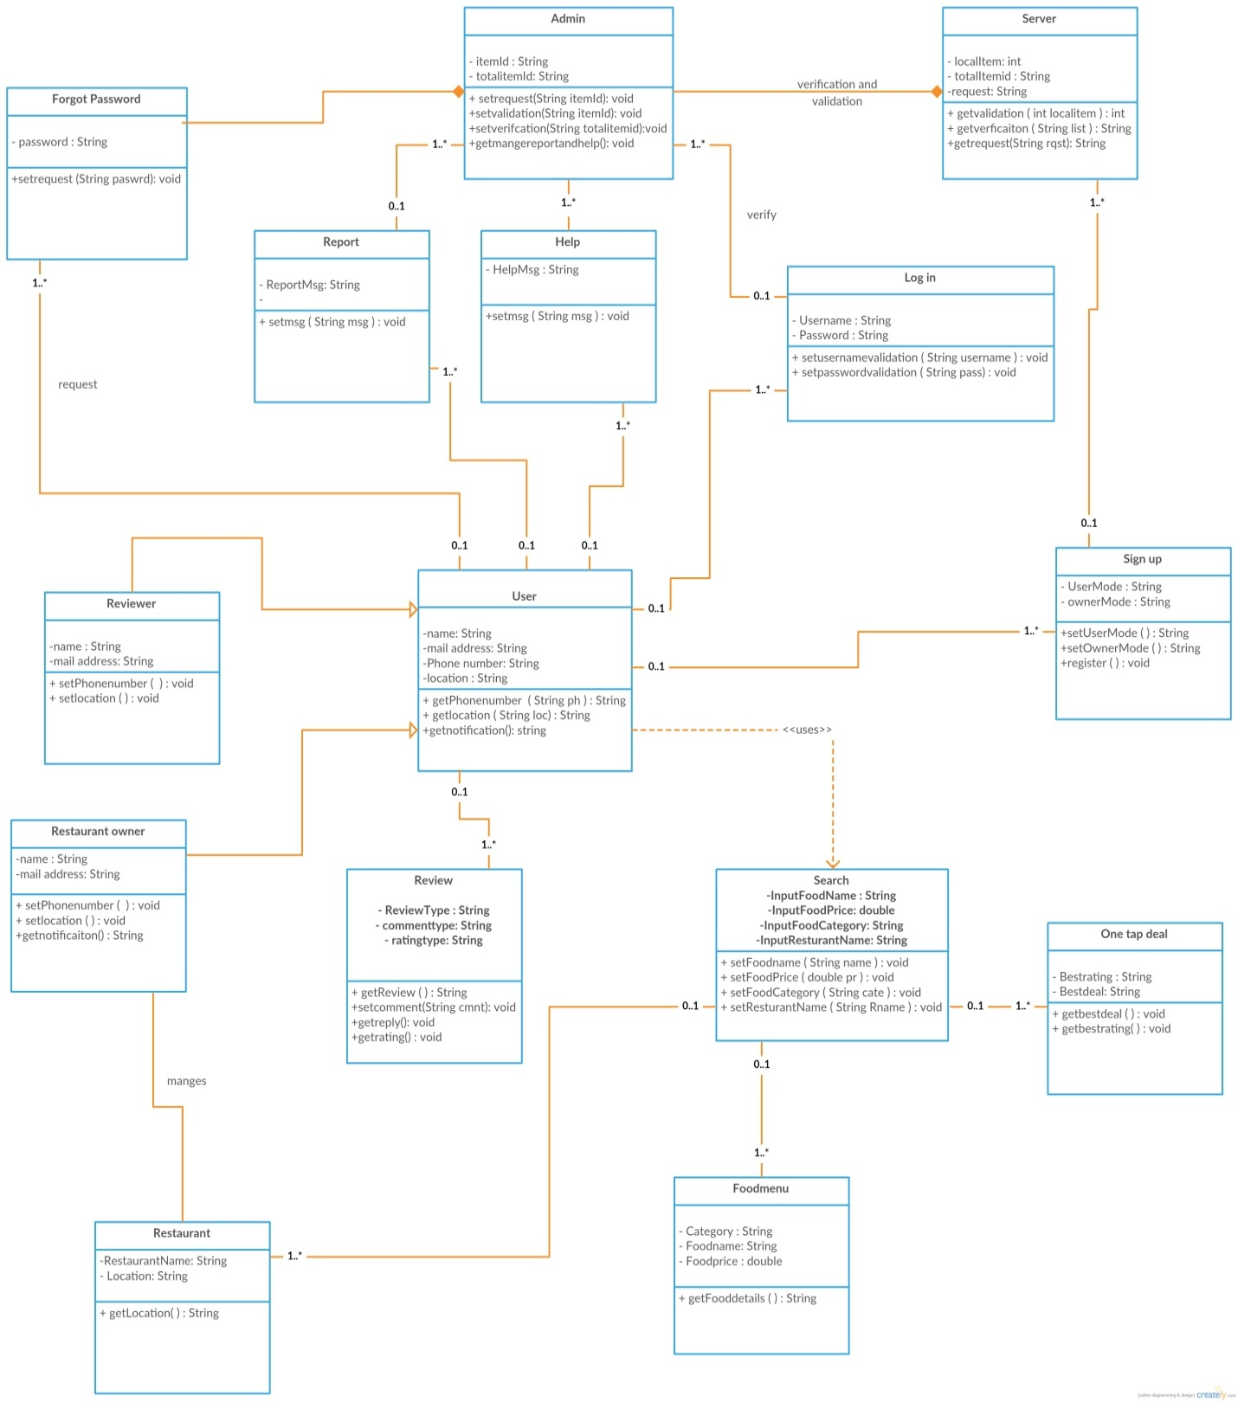

**Figure 1.2 – ‘FoodBank System [Class Diagram]**

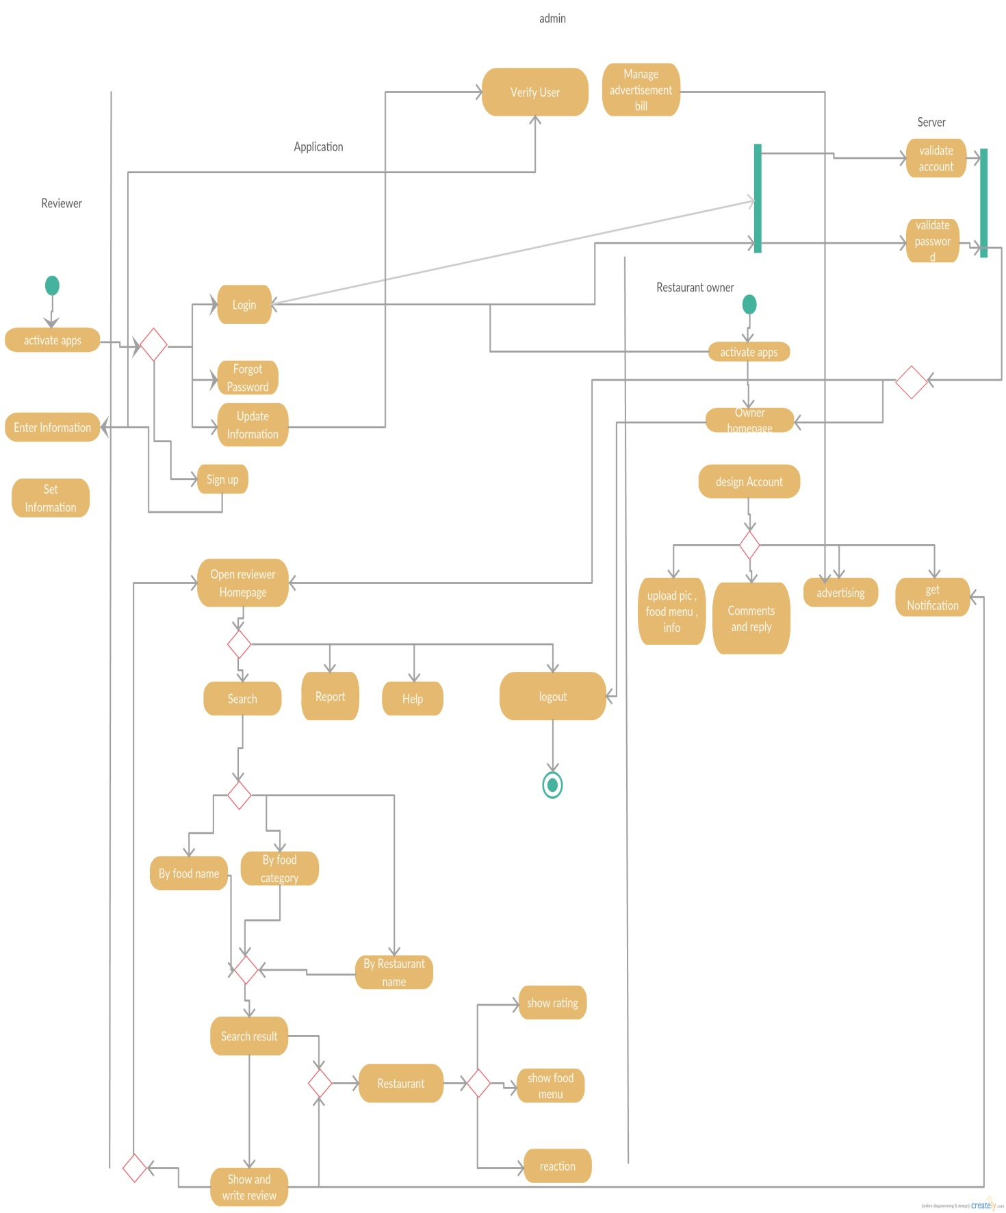

**Figure 1.3 – ‘FoodBank System [Activity Diagram]**

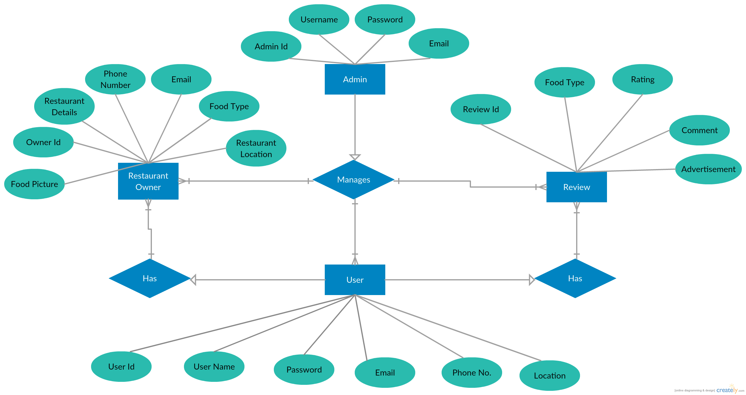

**Figure 1.4 – ‘FoodBank System [ER Diagram]**

**3.3 Data Dictionary**

Data Dictionary will describe the contents, format and structure of a database and the relationship between its elements, used to control access to and manipulation of the database. Data dictionary of the ER diagram is given below:

|  |  |  |  |  |
| --- | --- | --- | --- | --- |
| **Entity** | **Attribute** | **Type/Size** | **Validation** | **Key** |
| User | User_Id | **Number(7)** | 100000-999999 | Primary |
| User | User_Name | **Text(30)** | Required |  |
| User | Password | **Number(20)** | Required |  |
| User | Email | **Text(30)** | Required |  |
| User | Phone_No | **Number(15)** | 1-999999999999 |  |
| User | Location | **Text(30)** | Required |  |
| Restaurant Owner | Owner_Id | **Number(7)** | 100000-999999 | Primary |
| Restaurant Owner | Owner_Email | **Text(30)** | Required |  |
| Restaurant Owner | Owner_Phone_No | **Number(15)** | 1-999999999999 |  |
| Restaurant Owner | Restaurant Details | **Text(500)** | Required |  |
| Restaurant Owner | Restaurant Location | **Text(50)** | Required |  |
| Restaurant Owner | Food_Type | **Text(30)** | Required |  |
| Restaurant Owner | Food_Picture | **Image** |  |  |
| Admin | Admin_Id | **Number(7)** | 100000-999999 | Primary |
| Admin | Admin_Username | **Text(30)** | Required |  |
| Admin | Admin_Password | **Text(30)** | Required |  |
| Admin | Admin_Email | **Text(30)** | Required |  |
| Review | Review_Id | **Number(10)** | 1-9999999999 | Primary |
| Review | Food_Type | **Text(30)** | Required |  |
| Review | Rating | **Float** | 0.1-10.00 |  |
| Review | Comment | **Text(100)** | Required |  |
| Review | Advertisement | **Image** |  |  |

**3.4 User Interface Design  
  
  
 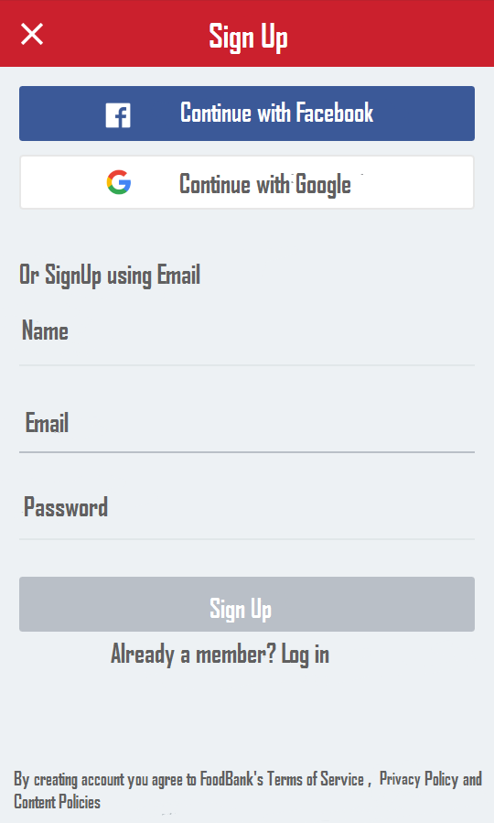**

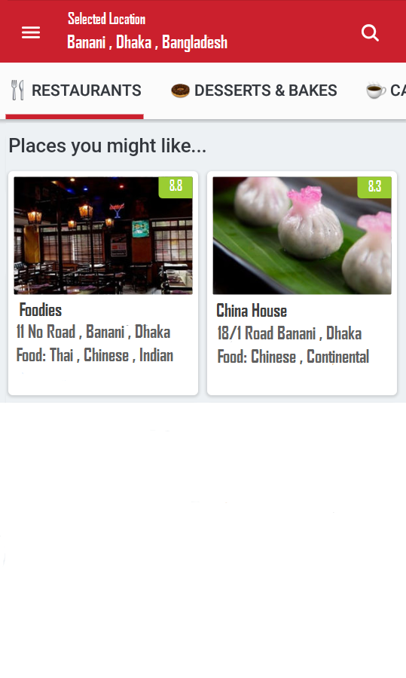 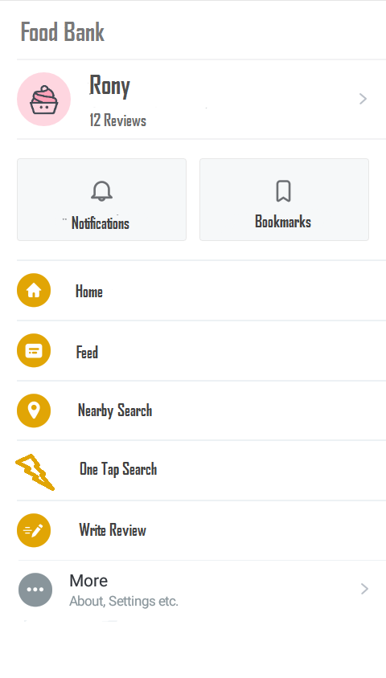

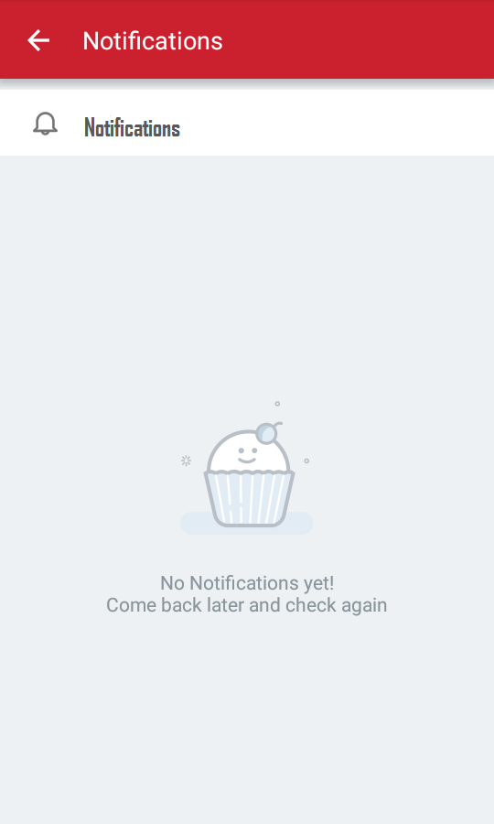 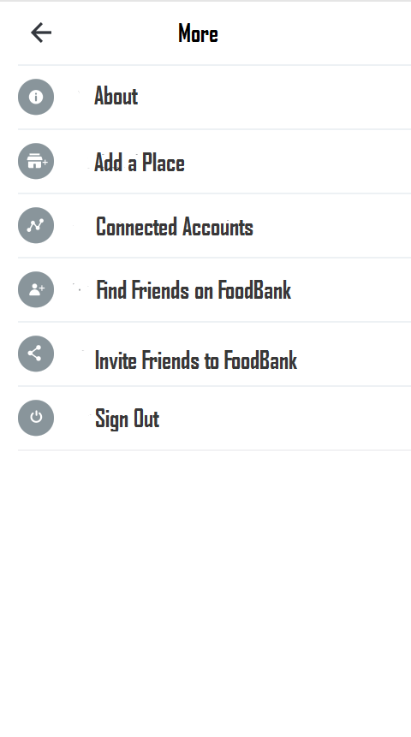

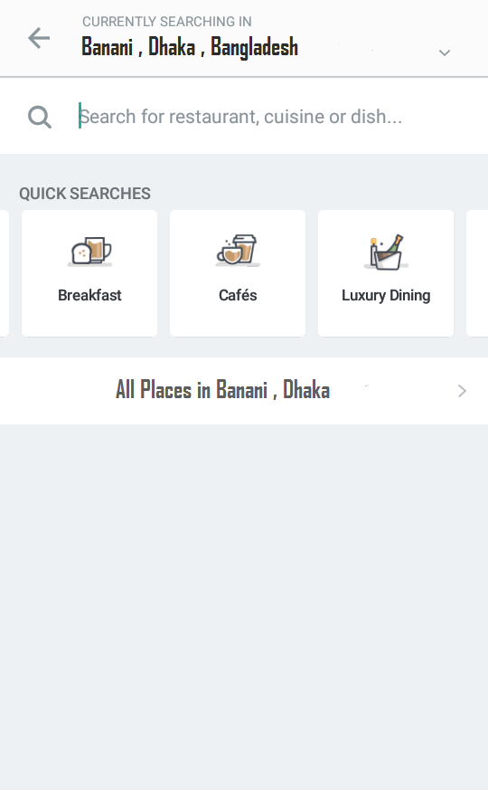 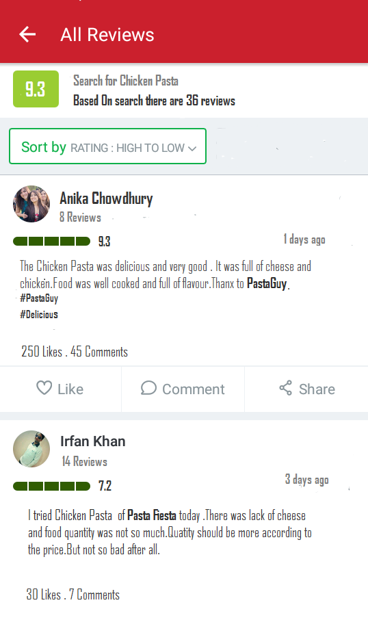

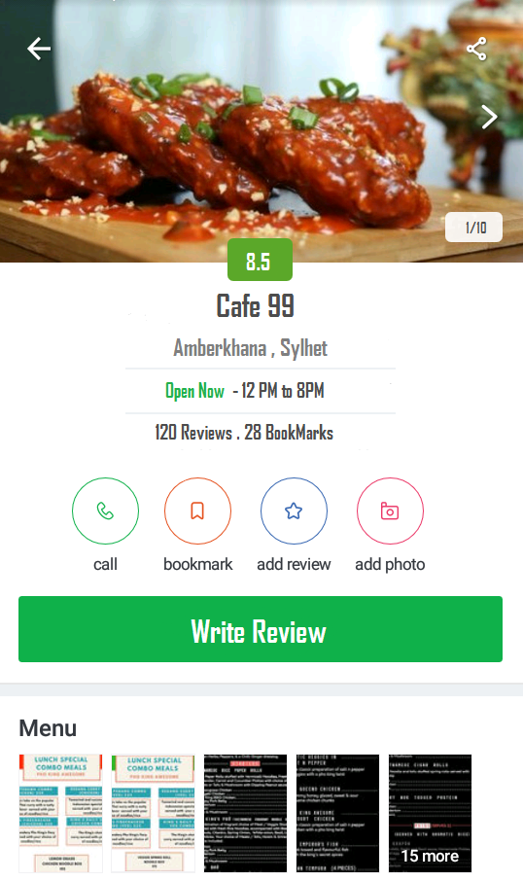 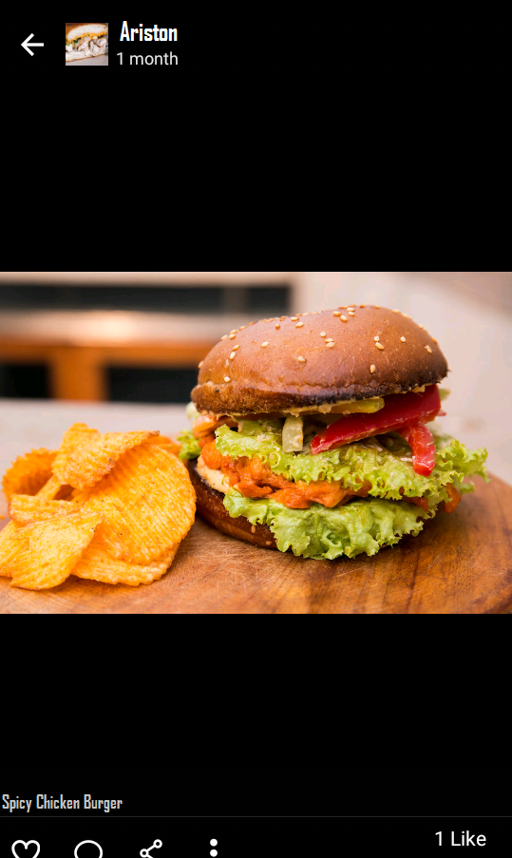

**4. System Features**

This section will give an overview of every features in this system. All the functionalities and every single details will be considered here.

**4.1 Sign Up**

Description: A user need to sign up in the software to get all the facilities. So the user must give user name, email and password to create account.

Priority: High

Functional Requirements: System shall create a new account.

**4.2 Login**

Description: Given that a user is registered he/she can login or get access to the server using email and password or directly using Facebook, Google plus.

Priority: High

Functional Requirements: System shall allow the user to use the account.

**4.3 Request Password**

Description: If a user forgets his/her password then the user will be able to request for a new password.

Priority: High

Functional Requirements: System shall send a PIN number for verification to access the user to their account.

**4.4 Set Information**

Description: Users have to set their important information about themselves including phone numbers , emails.

Priority: High

Functional Requirements: System shall store all the important user data in order to give information to the profile.

**4.5 Search Method Selection**

Description: Users can set the method of search. They just have to set how they want the search to be executed.

Priority: High

Functional Requirements: System will search according to users choice and return the results.

**4.6 Modify Search**

Description: Users will be able to modify their search whenever they want like if they want to filter their search by price , rating they can do it too.

Priority: Medium

Functional Requirements: System shall update the information if users wants to modify the search.

**4.7 Show Search History**

Description: Users will be able to see their search history and their visited ports.

Priority: Medium

Functional Requirements: System shall show the history of user’s search activities**.**

**4.8 Show Reviews**

Description: Users will be able to see the reviews of other’s post and can also react to them.

Priority: Medium

Functional Requirements: System shall show reviews of users.

**4.9 Live Support**

Description: Users can have live support whenever they want as it will be available most of the time.

Priority: High

Functional Requirements: System shall provide live support so that users will find help if they are facing any problems if they have any harass issues.

**4.10 Select Search Location**

Description: Users can search from their current location or can select a certain location to see the best foods and reviews around the location.

Priority: High

Functional Requirements: System shall display all the reviews and foods of selected locations whenever user search from a certain location .

**4.11 Assign Own Food Review**

Description: Users can give a review of any food from any restaurants.

Priority: High

Functional Requirements: System shall assign the review of users to the database. And after assigning it will be visible to others.

**4.12 Rate Review**

Description: Users can rate reviews of other reviewers on a scale of 10

Priority: Medium

Functional Requirements: System shall display the reviews and their ratings.

**4.13 Modifying Account Information**

Description: Users or Restaurant owners can make changers to their information or address or contact number.

Priority: Medium

Functional Requirements: System shall update the information when user makes a information change request.

**4.14 View Restaurant Information**

Description: Users shall able to see restaurant information provided by restaurant owner.

Priority: High

Functional Requirements: System shall display all the information provided by restaurant owner.

**4.15 Remove Account**

Description: Users or restaurant owner can cancel their account anytime .

Priority: Medium

Functional Requirements: System shall remove the account from the system database but a phone verification will be required.

**4.16 Uploading Pictures of Foods**

Description: Users can end the parking time by a touch to the phone.

Priority: high

Functional Requirements: System shall stop the payment calculation and display the amount that they have to charge.

**4.17 Share Reviews**

Description: Users can be able to share other’s reviews.

Priority: Low

Functional Requirements: System shall share other reviewer’s review.

**4.18 Comment in reviews**

Description: Users can make comments in other reviewers review.

Priority: Low

Functional Requirements: System shall allow the comments in other reviewer’s review.

**4.19 One Tap Best Food Search**

Description: Users can tap the one tap best food search button to find the best food around with lowest price ,highest price , highest rating ,lowest rating.

Priority: Medium

Functional Requirements: System shall take the the current location and find the best food around.

**4.20 Sort By Price**

Description: Users will be able to find the foods by sorting their price.

Priority: Medium

Functional Requirements: System shall sort the foods by price and return the results to users.

**4.21 Sort By Rating**

Description: Users will be able to find the foods by sorting their rating.

Priority: Medium

Functional Requirements: System shall sort the foods by rating and return the results to users.

**4.22 Advertise Foods by restaurant owners**

Description: Restaurant owners can put their advertisements on the ‘Foodbank’.

Priority: High

Functional Requirements: System will show the restaurant advertisements on the site.

**4.23 Report Review**

Description: Users can report anyone’s review if it is abusive to others.

Priority: Medium

Functional Requirements: System shall put reports to admins and they will verify and take preliminary actions.

**4.24 Sign Out**

Description: Users and restaurant owners will be able to sign out from the system.

Priority: Medium

Functional Requirements: System shall let the user to sign out.

**5. External Interface Requirements**

**5.1 User Interface**

Food Hubweb based system has simple user interface, in line with the resents redesign of this application, with the home screen offering large swappable images of nearby restaurants that lead to their respective listings, in addition to options to browse restaurants and search for them by entering keywords for name, location, cuisine or dish and price.

The Browse Restaurants option takes you to a menu that offers mood-based recommendations. So, you can select if you're looking to get reasonable food price. Selecting the location is the next step, following which, the app offers a list of restaurants that match the criteria.

There's a separate screen for location based restaurants search through which you can sort restaurants based on the distance from your current location. You can apply additional filters such as ratings, whether the restaurant is open at the time of the search, cuisine, budget and other aspects.

There's also a 'Featured Content' section that offers lists such as top 10 restaurants, foodie leader board (for regular users), and featured reviews, among other content. Users can also post pictures for restaurants they've visited in case they just want to post picture reviews. Pictures can be posted through the restaurant's listing page or through a section within the app that allows users to upload reviews and pictures of restaurants.

Users can also add restaurants to their Wish list or mark them as ‘better' and favorite’s from their respective listings page.

This application provides information such as scanned menus, mapped coordinates, pictures, ratings, contact details and user reviews for restaurants across a number of locations in Bangladesh.

**5.2 Software Interface**

The mobile application communicates with the GPS application in order to get geographical information about where the user is located and the visual representation of it, and with the database in order to get the information about the restaurants which serves the best dishes implying on searched one . The communication between the database and the web portal consists of operation concerning both reading and modifying the data, while the communication between the database and the mobile application consists of only reading operations.

**5.3 Hardware Interface**

Since neither the mobile application nor the web portal have any designated hardware, it does not have any direct hardware interfaces. The physical GPS is managed by the GPS application in the mobile phone and the hardware connection to the database server is managed by the underlying operating system on the mobile phone and the web server.

**5.4 Communications Interface**

The communication between the different parts of the system is important since they depend on each other. However, in what way the communication is achieved is not important for the system and is therefore handled by the underlying operating systems for both the mobile application and the web portal.

**6. Nonfunctional Requirements**

Here all the other non-functional requirements performance, safety and security will be discussed. Also a short software quality description will be attached in the end.

**6.1 Performance Requirements**

**Pe-1:** The system and server of the application will be able to maintain 50 thousand users(reviewers) and 2000 thousands restaurant owners after the launch of the application.

**Pe-2:** Responses to queries shall take no longer then 5-6 seconds on backend.

**Pe-3:** The system will display the loading status of activity during action performed by the user.

**Pe-4:** Pages of the application shall be well designed and will maintain efficiency.

**Pe-5:** Primary Performance requirement of the application is speed of the Internet network of Mobile Phone or WiFi or broadband connection speed on desktop or laptop.

**Pe-6:** Application may get a bit slow if server is under heavy load and many actions are performed by multiple users at the same time.

**6.2 Safety Requirements**

Basically there are less safety requirements needed for this application except to create any fake id and not to disturb or harass any unknown person by abusive comments on their reviews otherwise actions might be taken according to the policy and regulations of the application. As user provide their mobile numbers, then the system will provide high security to that account. It will not be easy to hack others or do unauthorized events .

**6.3 Security Requirements**

1.All information's of a user data shall be encrypted and saved.

2.User will have to log in to application or website to perform any activity.

3.User will get the custom privacy experience.

4.Log in from multiple devices will be possible but verification must be completed individually in each device.

**7. Acknowledgements**

Firstly we want to thank our course SYED ISHTEAQUE AHMED sir for his huge support for our project. The total guidance of him lead us to a very successful project.

**8. References**

**1.** [**https://www.yelp.com/sf**](https://www.yelp.com/sf)

**2.** [**http://eat24.com/**](http://eat24.com/)

**3.** [**https://www.opentable.com/start/home**](https://www.opentable.com/start/home)

**4.http://www.gayot.com/**

**5.https://www.zagat.com/**

**Business Rule**

|  |  |  |  |  |
| --- | --- | --- | --- | --- |
| ID | Rule definition | Type of rules | Static or  Dynamic | Source |
| BR-1 | For every restaurant’s top selected foods system shall provide unique numbers to be not mixed up during data retrieve | Constraint | Static | FoodBank |
| BR-2 | All images of the desired dishes must include alternative text to meet accessibility requirements | Constraint | Static | FoodBank |
| BR-3 | Website may not contain any HTML tags or attributes that are deprecated according to the HTML5 standard | Constraint | Static | Government rule |
| BR-4 | If a customer search for a dish, then at the end of the search result system shall display dishes that similar to search one | Action enablers | Dynamic | FoodBank |
| BR-5 | Every dish has a price which display along with the search | Fact | Static | FoodBank |
| BR-6 | If there any bad reviews over a restaurant food or service then warning given to the restaurant owner | Inference | Dynamic | FoodBank |
| BR-7 | Result must be shown according to search one | Constraint | Dynamic | FoodBank |
| BR-8 | If any reviewers uses abusive comments on comment box, then his/her account shall be blocked | Inference | Dynamic | FoodBank |
| BR-9 | From Ratings and reviews dish quality will be measured | Action enablers | Static | FoodBank |
| BR-10 | Restaurant owner shall pay for their new dishes advertisements | Constraint | Dynamic | FoodBank |