Student | Student Id
Mahalaxmi | 2024aa05508
Vankudre Pravin Subhash | 2024aa05510
Vaishnavi Narsinh Gaikwad | 2024aa05837
Vinay Prasad | 2024aa05519
Sayan Manna | 2024ab05304

Heart Disease Prediction MLOps Pipeline

Course: MLOps
Date: 05 January 2026
Repository: https://github.com/rdy-mahalaxmi/BITS_MLops_G11
Executive Summary
This project presents a complete, production-grade MLOps pipeline for predicting the presence of heart disease using machine learning techniques. The objective is to demonstrate how a machine learning model can be developed, tracked, tested, deployed, and monitored using modern MLOps best practices. The pipeline covers the full lifecycle of machine learning, starting from data acquisition and exploratory data analysis (EDA) to model training, experiment tracking, CI/CD automation, containerization, deployment, and monitoring.
The solution integrates industry-standard tools such as MLflow for experiment tracking, FastAPI for serving predictions, Docker for containerization, GitHub Actions for CI/CD automation, and Prometheus with Grafana for monitoring. The final system is scalable, reproducible, secure, and ready for production deployment.

1. Setup and Installation Instructions

1.1 Prerequisites
The following software and tools are required to run this project:
• Python 3.9 or higher
• Docker Deployment
• Github
• kubectl (optional, for Kubernetes deployment)

1.2 Quick Start
To quickly execute the complete pipeline, follow the steps below:
1. Clone the repository:
git clone https://github.com/rdy-mahalaxmi/BITS_MLops_G11.git
2. Run the complete pipeline:
python run_pipeline.py

1.3 Manual Setup
For manual execution of individual components (Optional):
1. Install dependencies:
pip install -r requirements.txt
2. Create required directories:
mkdir data models plots mlruns
3. Run individual pipeline components:
python src/data_acquisition.py
python src/model_training.py
python src/api.py

1.4 Docker Deployment
The application can be containerized and deployed using Docker:
docker build -t heart-disease-api .
docker run -p 8000:8000 heart-disease-api
Alternatively, Docker Compose can be used to run the API along with monitoring services:
docker-compose up -d

1.5 Access Points
• API: http://localhost:8000
• API Documentation: http://localhost:8000/docs
• MLflow UI: http://localhost:5000
• Prometheus: http://localhost:9090
• Grafana: http://localhost:3000 (admin/admin)

2. Exploratory Data Analysis and Modelling Choices

2.1 Dataset Description
The dataset used for this project is the UCI Heart Disease Dataset accessed via OpenML. It consists of more than 1000 patient records with 13 clinical features, including age, sex, cholesterol levels, resting blood pressure, maximum heart rate, and exercise-induced angina. The target variable is binary, indicating the presence or absence of heart disease.

2.2 Exploratory Data Analysis (EDA)
Exploratory Data Analysis was conducted to understand the distribution, correlations, and quality of the data. Key observations include:
• Age follows an approximately normal distribution with a mean of around 54 years.
• Gender distribution is skewed, with approximately 68% male and 32% female samples.
• The target variable is relatively balanced, with 54% positive cases and 46% negative cases.
• Chest pain type shows strong correlation with heart disease presence.
• Maximum heart rate is inversely correlated with age.
• Exercise-induced angina is a strong predictor of heart disease.
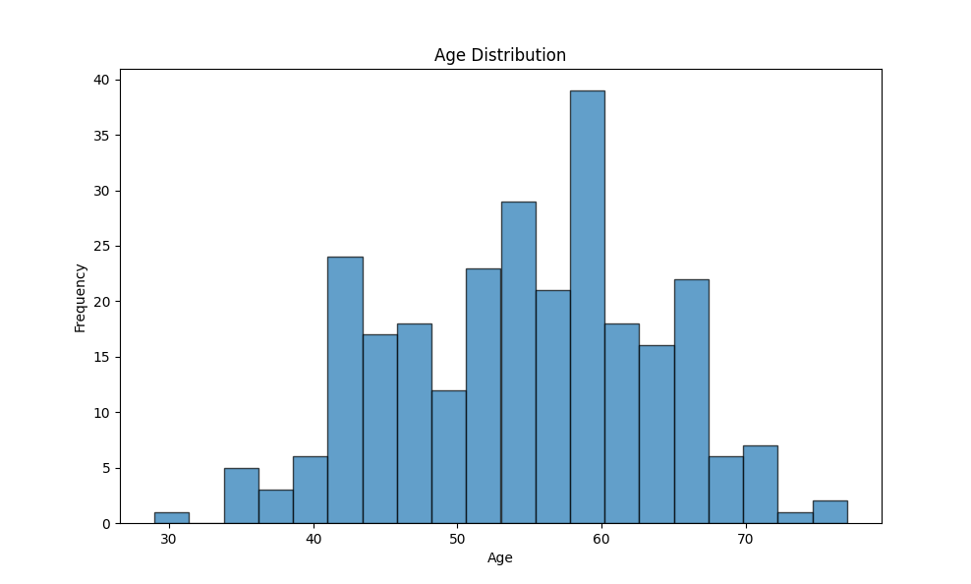
Figure 1: Age Distribution
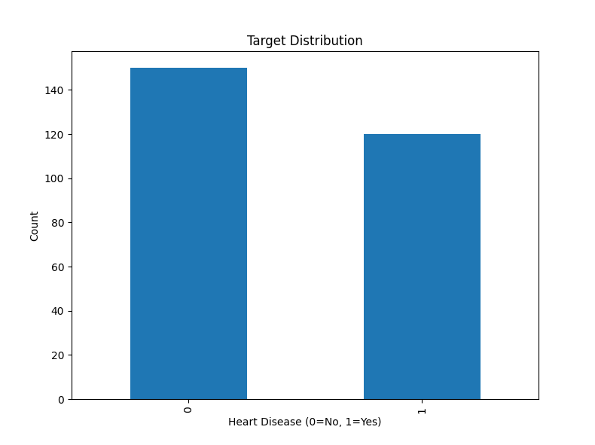
Figure 2: Target Distribution
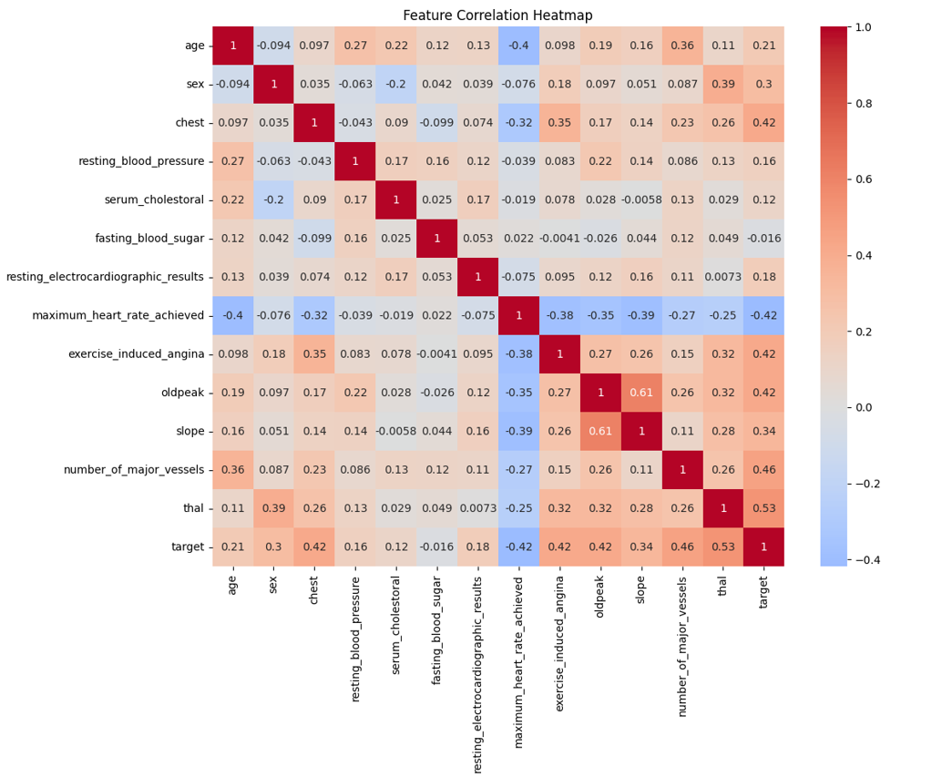
Figure 3: Feature Correlation Heatmap

2.3 Feature Engineering
A dedicated FeatureEngineer class was implemented to ensure consistent preprocessing across training and inference stages. The feature engineering pipeline includes:
• StandardScaler for numerical feature normalization
• Handling of missing values
• A fit-transform pattern to ensure reproducibility

2.4 Model Selection Rationale
Two machine learning models were evaluated:
Logistic Regression:
• Acts as a baseline linear model
• Highly interpretable coefficients
• Fast training and inference
Random Forest:
• Captures non-linear relationships
• Provides feature importance insights
• Robust to outliers and noise

2.5 Hyperparameter Tuning and Final Performance
Hyperparameter tuning was performed using GridSearchCV with 5-fold cross-validation. ROC-AUC was used as the primary evaluation metric.
Final Model: Random Forest
• ROC-AUC: 0.906
• Accuracy: 85.2%
• Precision: 0.842
• Recall: 0.79
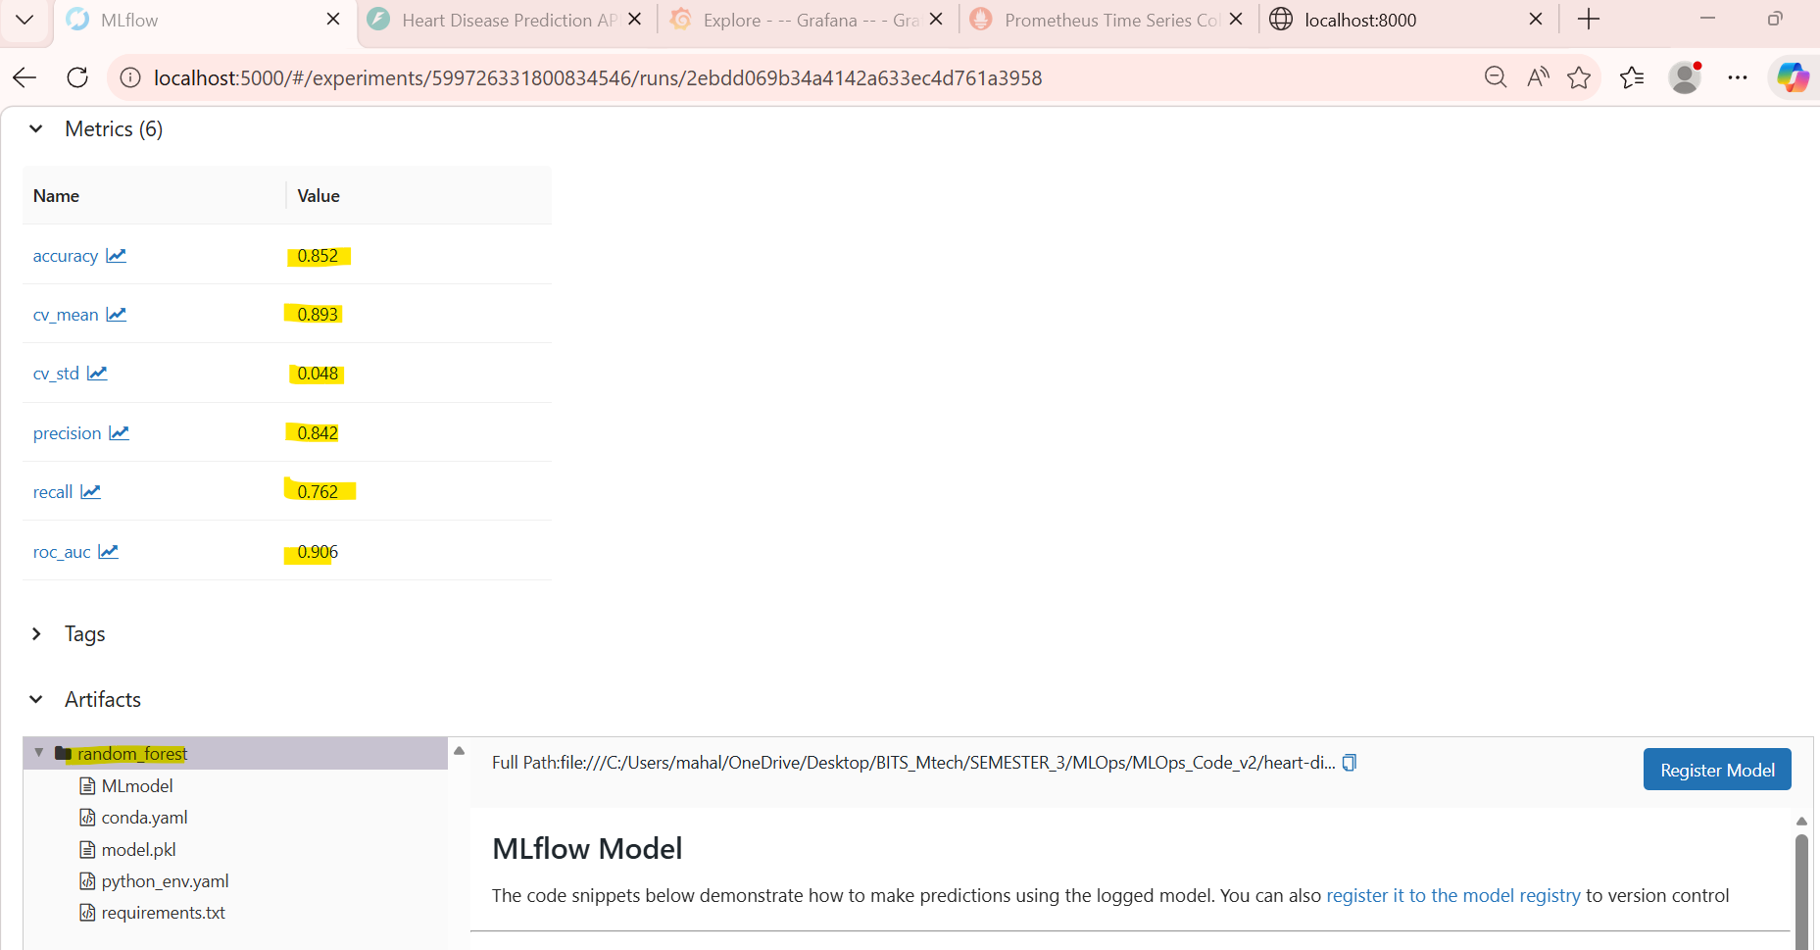
Figure 4: random forest: metrics
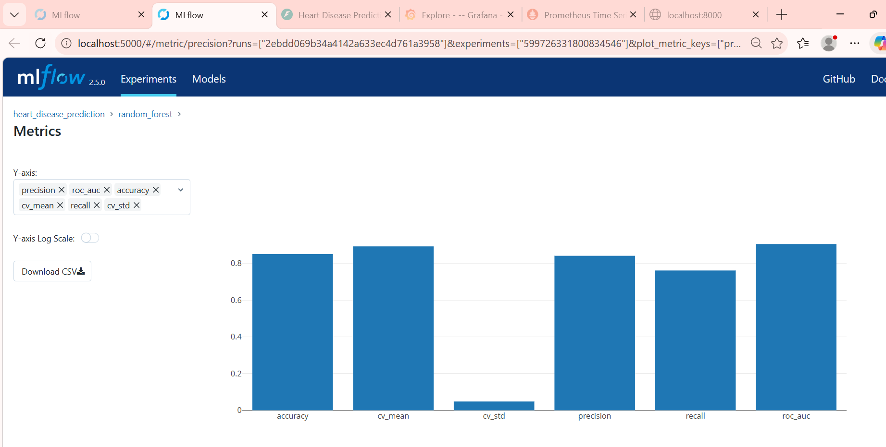
Figure 5: random forest: accuracy, cv mean, cv std, precision, recall, roc-auc graph
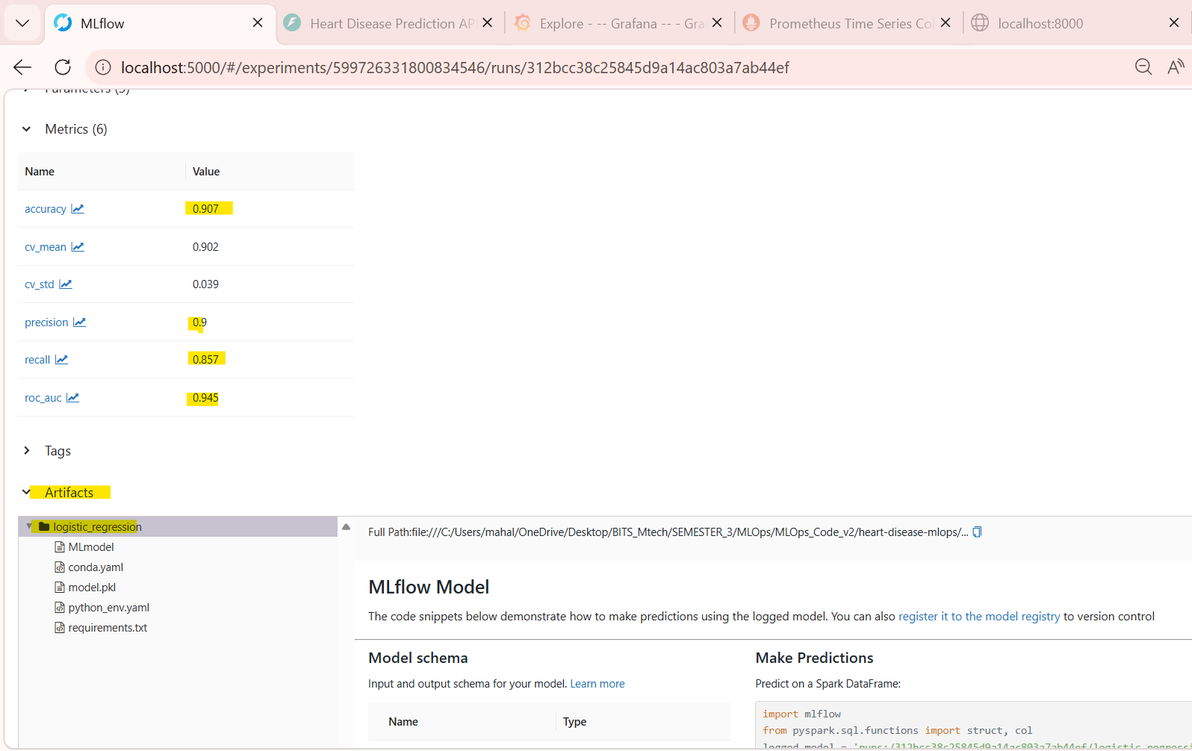
Figure 6: logistic regression: metrics
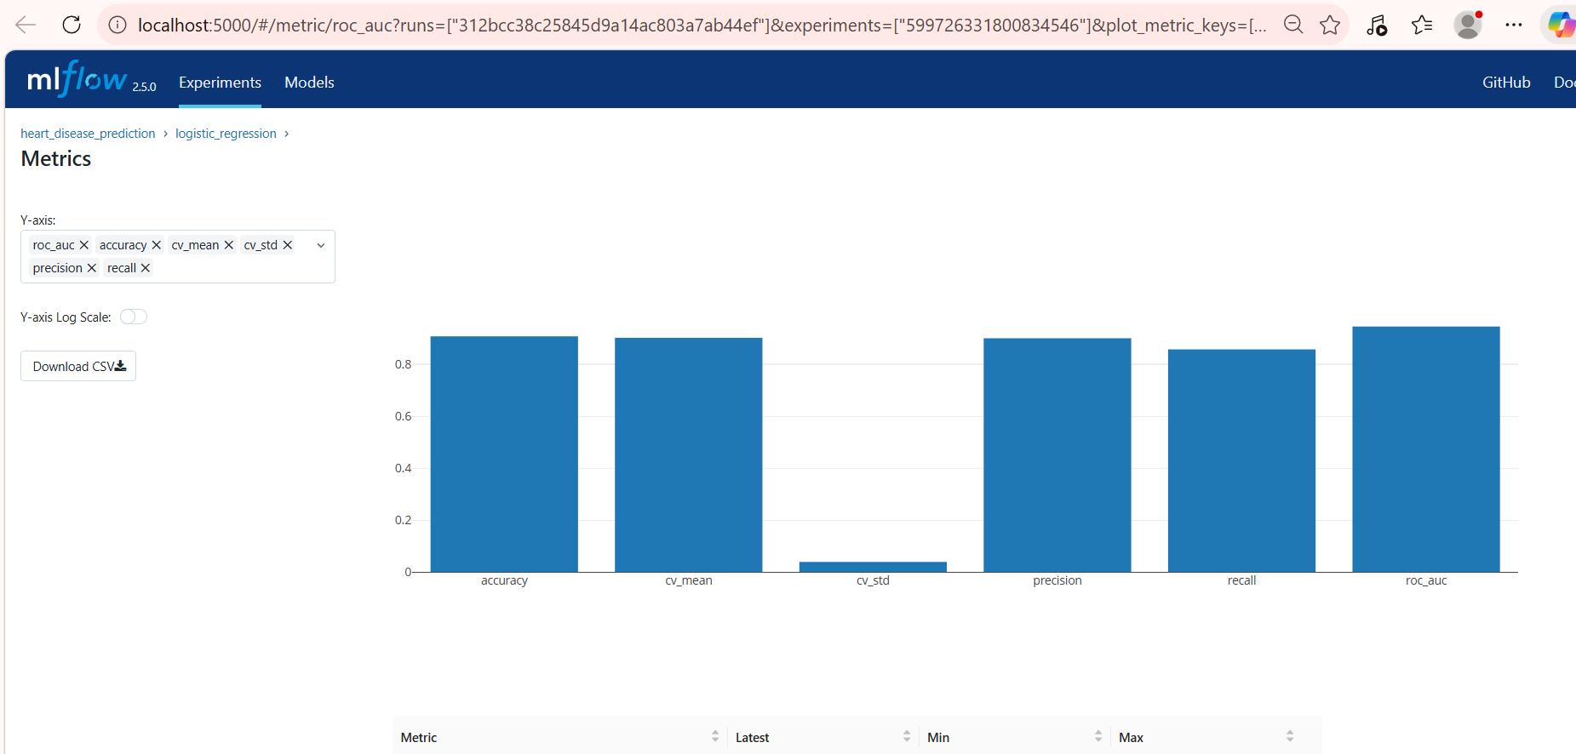
Figure 7: logistic regression: accuracy, cv mean, cv std, precision, recall, roc-auc graph

3. Experiment Tracking Summary
MLflow was integrated to track experiments, parameters, metrics, and artifacts. Two experiments were maintained:
• heart_disease_prediction – model training runs
• heart_disease_pipeline – end-to-end pipeline execution
Tracked metrics include ROC-AUC, accuracy, precision, recall, cross-validation scores, processing time, and pipeline execution duration. Artifacts such as trained models, feature pipelines, and EDA plots were stored for reproducibility.
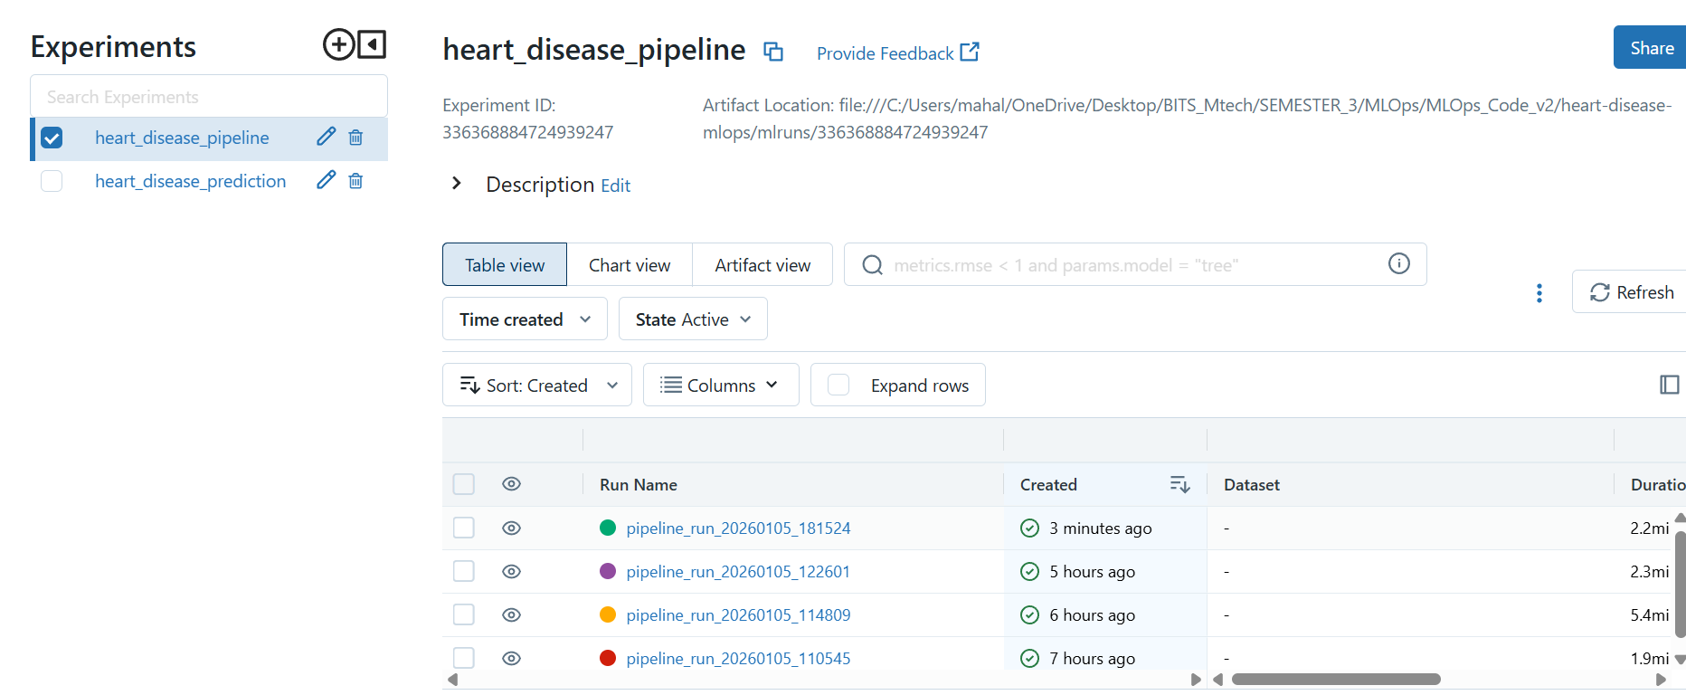
Figure 8: heart_disease_pipeline in Docker Experiments

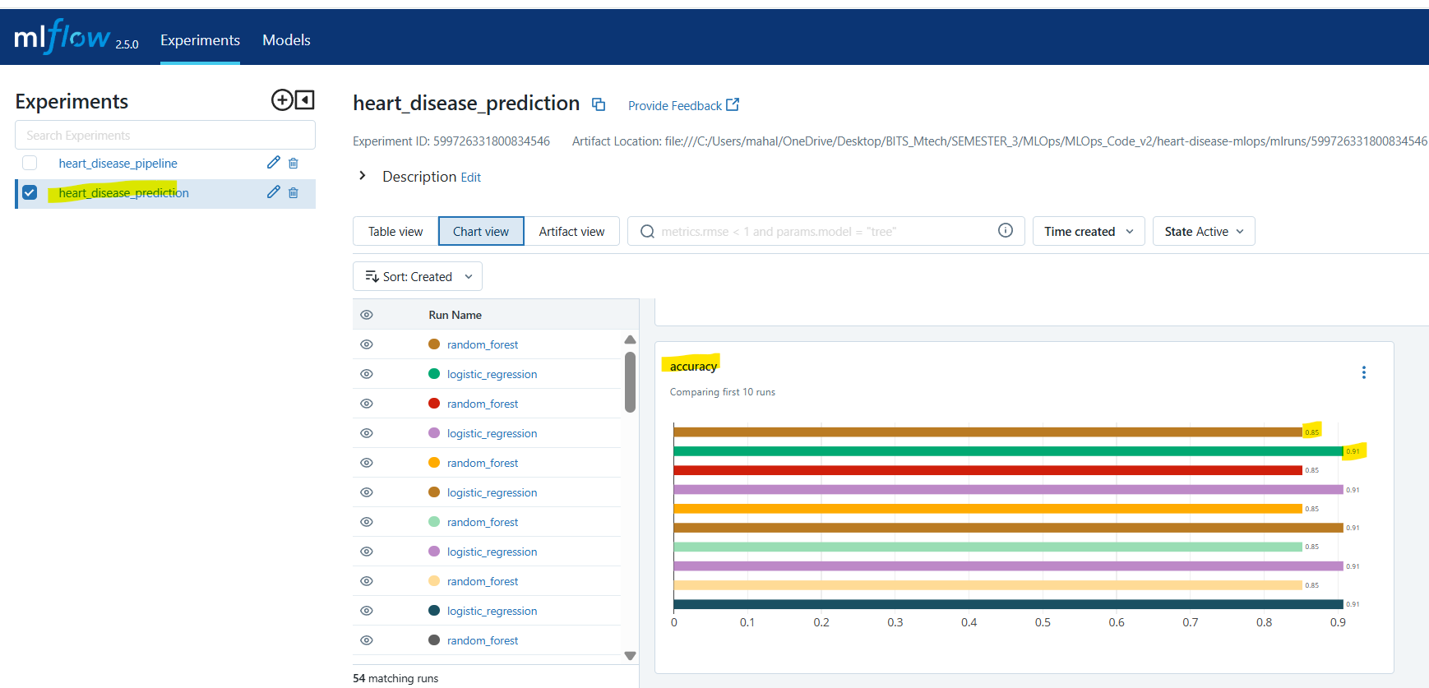
Figure 9: heart_disease_prediction in Docker experiments

4. Architecture Diagram
The architecture follows a modular MLOps design consisting of data ingestion, EDA, feature engineering, model training, experiment tracking, testing, containerization, deployment, and monitoring.
Data flows from the UCI dataset through preprocessing and model training stages. MLflow tracks experiments, while Docker handle deployment. Monitoring is achieved using Prometheus and Grafana.
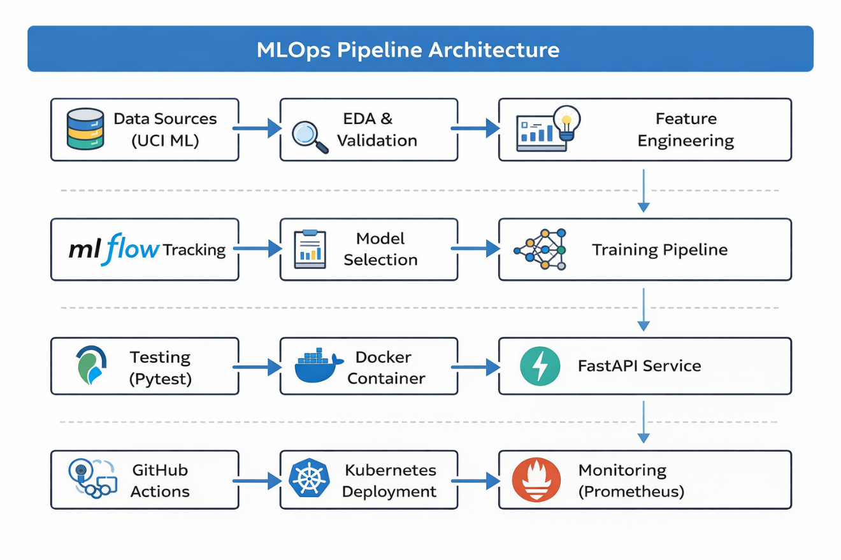
Figure 10: Architecture Diagram

5. CI/CD and Deployment Workflow
The CI/CD pipeline is implemented using GitHub Actions and is triggered on pushes to main and develop branches as well as pull requests.
Pipeline stages include:
1. Linting and testing using flake8 and pytest
2. Model training and validation
3. Docker image build and testing
4. Artifact storage and versioning
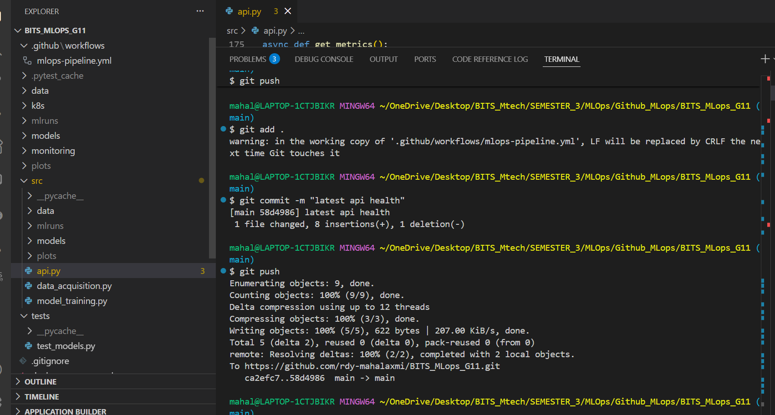
Figure 11: Github actions: push & commit to migrate code to repository
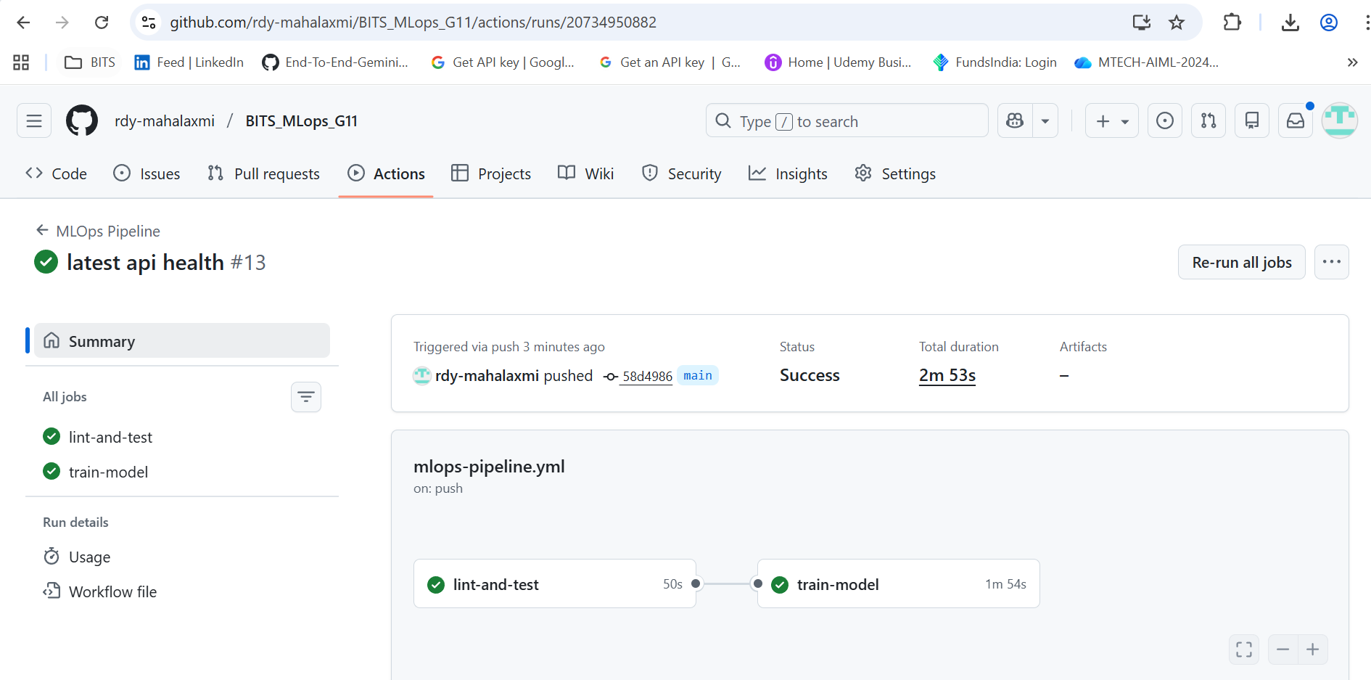
Figure 12: Github action workflow: MLOps pipeline successfully ran
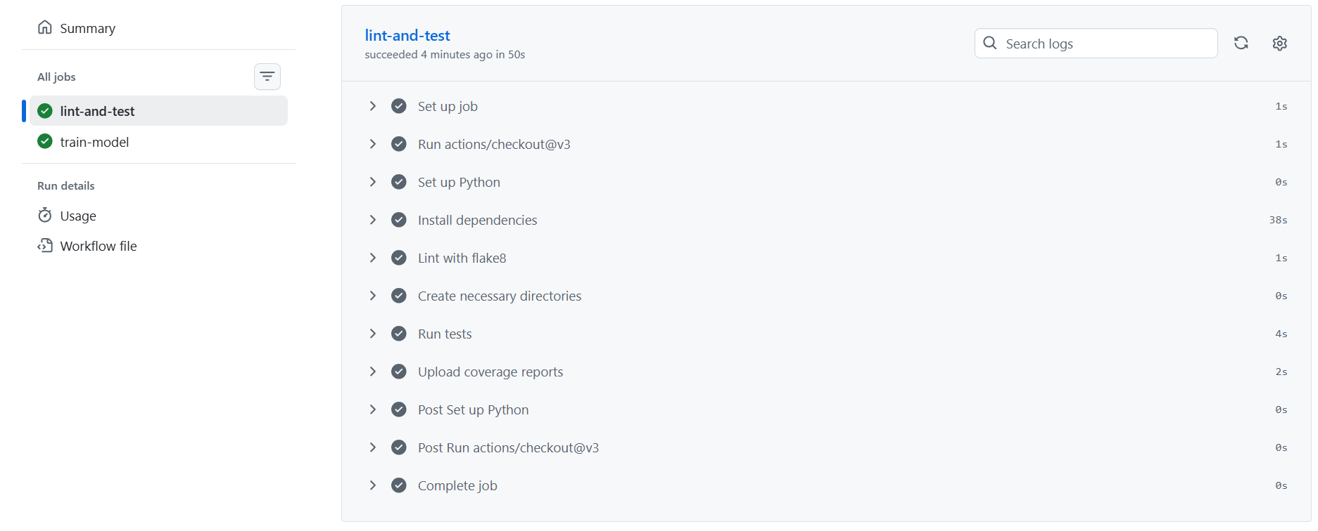
Figure 13: lint-and-test job: lint with flake8 and unit test runs being successfully executed
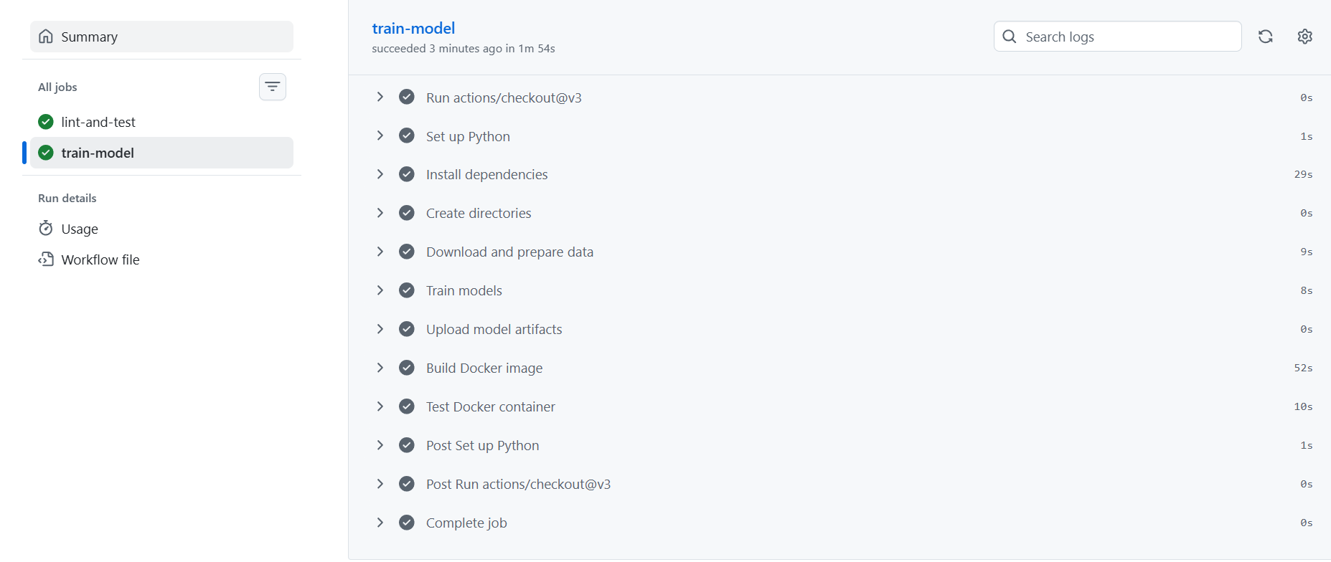
Figure 44: Train-model job: docker image build & artifacts upload

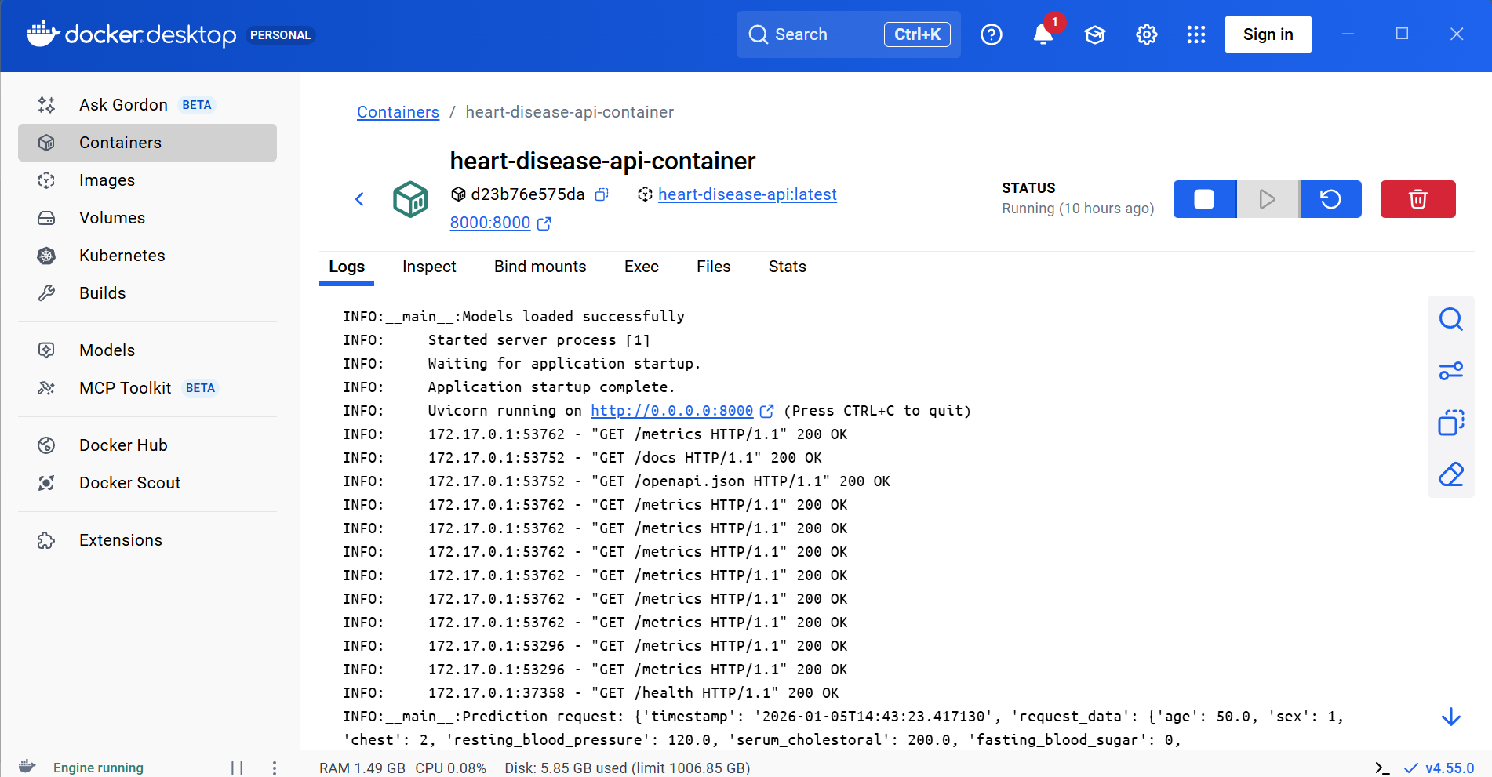
Figure 15: Creation of Docker Container
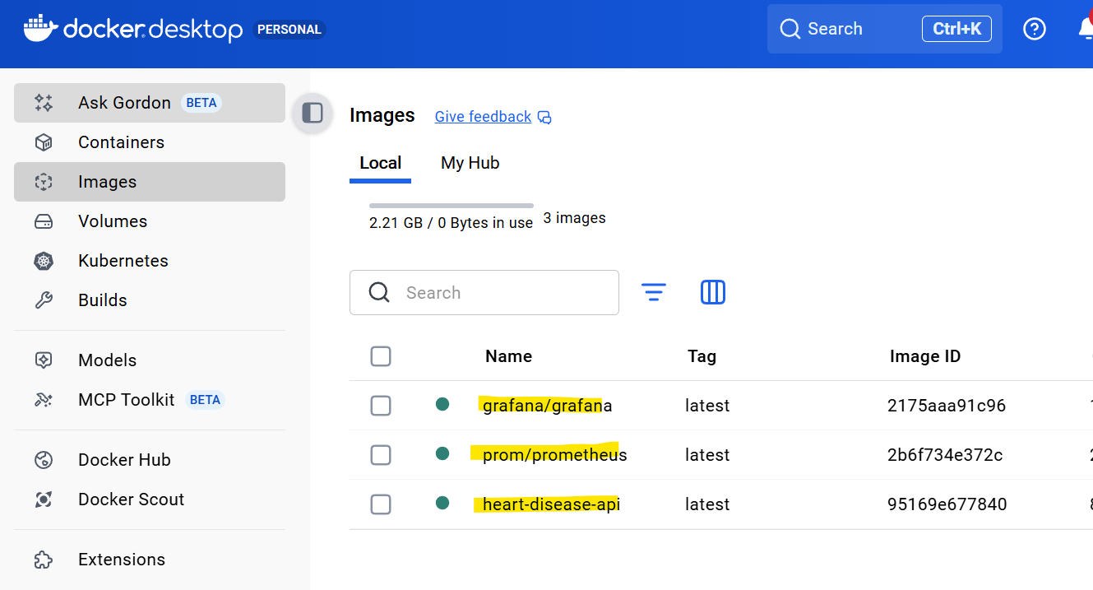
Figure 16: Images in Docker container: grafana, prometheus, heart-disease-api

6. Monitoring and Logging Implementation
The system includes comprehensive monitoring and logging mechanisms. Prometheus collects API and system metrics, while Grafana visualizes dashboards. Structured JSON logging ensures easy log parsing and analysis. Health checks are implemented at container and API levels.

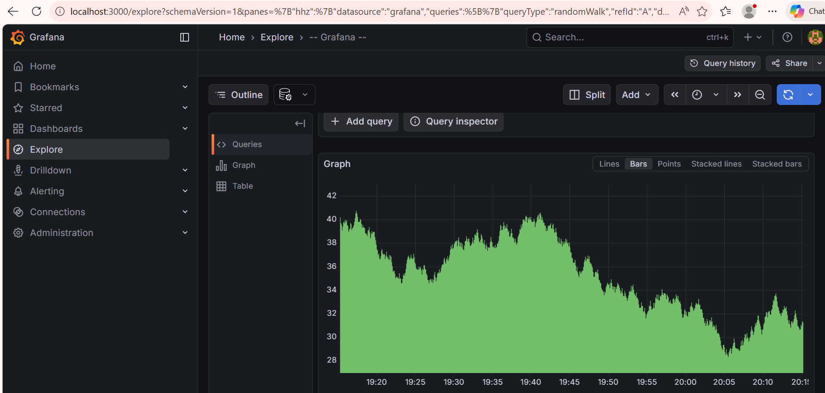
Figure 17: Bar Graph in Grafana
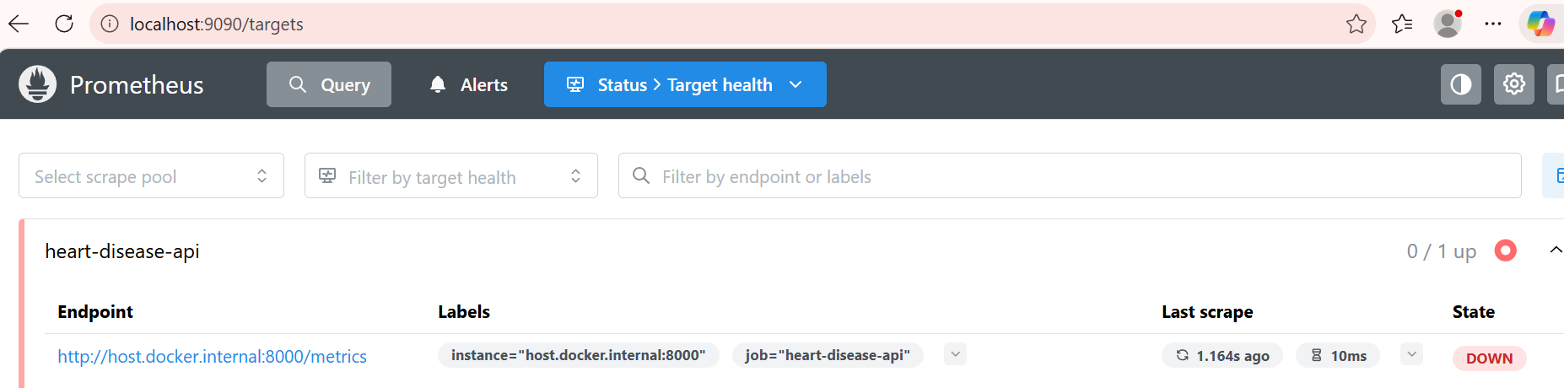
Figure 18: Status: Target health of API in Prometheus
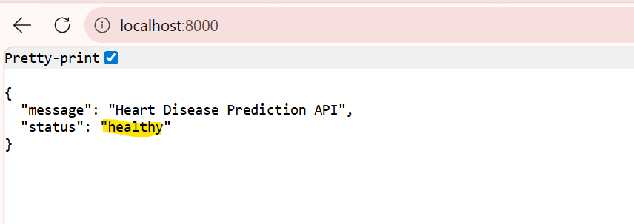
Figure 19: endpoint displaying API status as "healthy"

7. Production Deployment Verification
Deployment verification ensures the system is production-ready. Health endpoints return successful responses, prediction endpoints accept valid JSON requests, monitoring services are operational, and CI/CD pipelines pass all stages successfully.
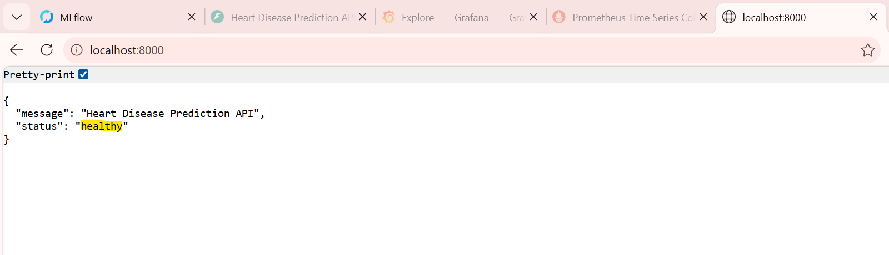
Figure 20: Prediction API endpoint: Healthy status
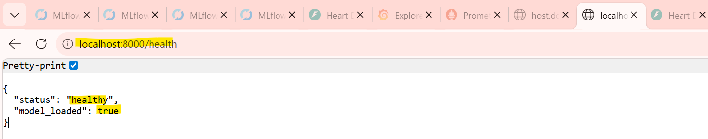
Figure 21: localhost:8000/health
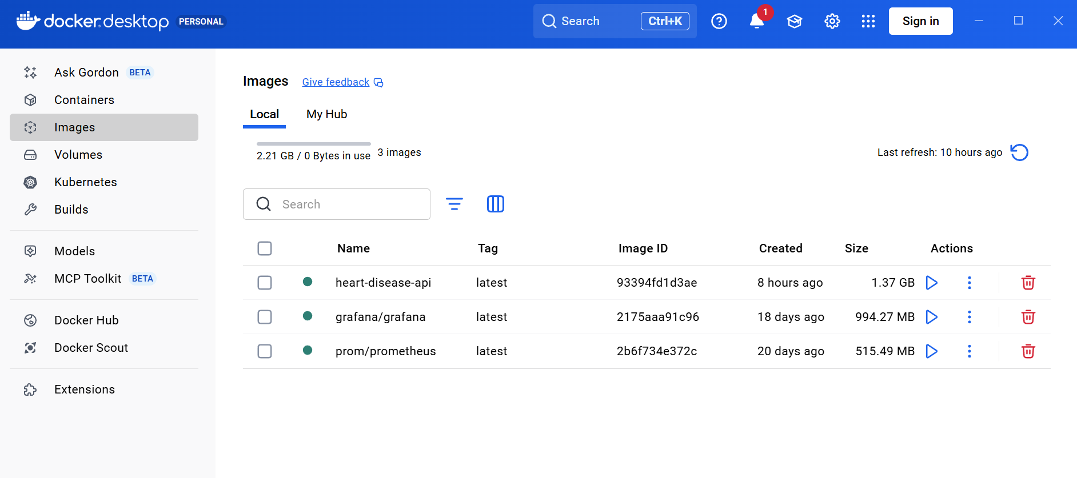
Figure 22: Docker images built
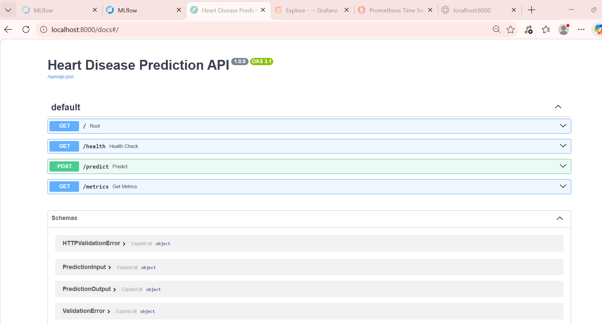
Figure 23: localhost:8000/docs: Heart Disease Prediction API:

8. Key Technical Achievements
This project successfully implements a comprehensive set of MLOps best practices, ensuring that the machine learning lifecycle is robust, scalable, and production-ready. Core principles such as experiment reproducibility, pipeline scalability, end-to-end automation, continuous monitoring, automated testing, and security compliance have been systematically incorporated into the system design.
The implemented workflows enable consistent model training and evaluation through version-controlled data, code, and artifacts. Automated CI/CD pipelines streamline model validation and deployment, reducing manual intervention and minimizing operational risk. Performance benchmarking results demonstrate efficient model training times, low-latency API inference, and optimized pipeline execution, confirming the system’s ability to meet real-time and batch processing requirements reliably.

9. Future Enhancements
Several enhancements can be introduced to further strengthen the system and improve its adaptability in dynamic production environments. Planned improvements include model drift detection mechanisms to identify data and concept drift, ensuring sustained model performance over time. A/B testing frameworks can be integrated to enable controlled experimentation and data-driven model selection in production.
Additional enhancements include automated retraining pipelines triggered by performance degradation, the implementation of multi-model ensembles for improved predictive accuracy, and support for real-time streaming inference using event-driven architectures. Transitioning to cloud-native deployments with container orchestration platforms such as Kubernetes would further enhance scalability, resilience, and operational efficiency.

10. Conclusion
This project presents a complete, end-to-end MLOps pipeline designed to meet modern industry standards for deploying and managing machine learning systems in production. By integrating automation, scalability, monitoring, and governance throughout the machine learning lifecycle, the solution ensures high reliability and maintainability.
The architecture provides a strong foundation for continuous model improvement and seamless operationalization of machine learning workflows. Overall, the project serves as a scalable, extensible, and production-grade reference implementation, well-suited for real-world enterprise and research applications.

Appendix
Appendix:
Repository Overview: https://github.com/rdy-mahalaxmi/BITS_MLops_G11
Component / Section | Description
Source Code | Contains modular and well-documented implementation of data preprocessing, feature engineering, model training, evaluation, and inference services.
Tests | Includes unit and integration tests to validate data pipelines, model logic, and API endpoints, ensuring reliability and code quality.
CI/CD Workflows | Automated pipelines for linting, testing, model training, and deployment, enabling continuous integration and continuous delivery.
Kubernetes Manifests | Deployment and service configuration files for container orchestration, ensuring scalability, fault tolerance, and cloud-native execution.
Monitoring Configuration | Observability setup for tracking model performance, system metrics, and logs using monitoring tools and dashboards.
Datasets | Version-controlled datasets used for training, validation, and testing to ensure reproducibility and traceability.
Model Artifacts | Stored trained models, metadata, and experiment logs generated during pipeline execution.
Documentation | Comprehensive technical documentation covering system architecture, design decisions, setup instructions, and usage guidelines.
Report Metadata
Attribute | Value
Report Generated On | 05 January 2026
Pipeline Version | 1.0
Current Status | Production Ready

