CheckerBoard Data Model Concept

Runnan Dong

Rdyz6

Feb 10th

Layout:

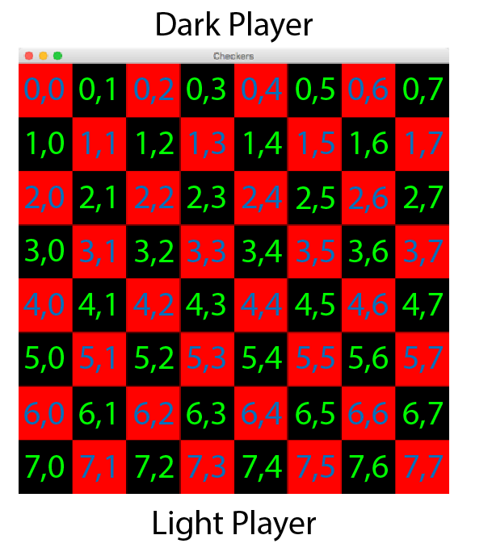

On the upside is dark player. Dark chesses are set on row which smaller than 3(row < 3). If (row + 1) is odd, the chess will be placed on odd column(col); else, the chess will be placed on even col. About light side, which set on row larger than 4(row > 4). If (row + 1) is odd, the chess will be placed on odd column(col); else, the chess will be placed on even col.

Dark Side Move rules:

1. Before becoming a king, a legal row move from current position should be +1, and a legal col Move can be +1 or -1(row + 1, col +/- 1).
2. When row value equal to (NUM_ROW -1), a legal row move should only be -1; When row value equal to 0, a legal row move should only be +1.
3. When col value equal to (NUM_COL -1), a legal col move should only be -1; When col value equal to 0, a legal col move should only be +1.

Dark Side Jump rules:

1. Before becoming king, assume the position of a dark chess is (x,y), a Jump only allowed when a light chess exists on (x+1,y +/- 1). If another chess exits on (x+2, y +/- 2), the jump is not allowed. After becoming king, a legal jump is allowed when a light chess exists on (x +/- 1, x+/- 1), and If another chess exits on (x +/- 2, y +/- 2), the jump is not allowed.
2. Double jump is allowed if first condition true.

Light Side Move rules:

1. Before becoming a king, a legal row move from current position should be -1, and a legal col Move can be +1 or -1(row + 1, col +/- 1).

2. When row value equal to (NUM_ROW -1), a legal row move should only be -1; When row value equal to 0, a legal row move should only be +1.

3. When col value equal to (NUM_COL -1), a legal col move should only be -1; When col value equal to 0, a legal col move should only be +1.

Light Side Jump rules:

1. Before becoming king, assume the position of a light chess is (x,y), a Jump only allowed when a dark chess exists on (x-1,y +/- 1). If another chess exits on (x-2, y +/- 2), the jump is not allowed. After becoming king, a legal jump is allowed when a light chess exists on (x +/- 1, x+/- 1), and If another chess exits on (x +/- 2, y +/- 2), the jump is not allowed.
2. Double jump is allowed if first condition true.

Kings’ rule

1. Dark side become king when row = NUM_ROW - 1; Light side become king when row = 0.
2. After becoming a king, a legal row move from current position can be +1/-1, and a legal col Move can be +1 or -1 (row +/- 1, col +/- 1).

Win or Lost rule.

1. Light side must go first.
2. Win happened when one side lost all chesses.
3. Lost happened when no legal moves or jumps.
4. A draw happened when drawCounter reaches to 40. drawCounter counts when all chess become king.

Data model field list:

currentPlayer:Player

lightPlayer: Player

drakPlayer:Player

drawCounter:int

currentPositionX:int

currentPositionY:int

jump[]: jump

move[]: move

darkSide[]:Chip

lightSide[]:Chip

Data Model method list:

setPlayer(Player)

getPlayer():Player

setDarkPlayer(Player)

getDarkPlayer():Player

setLightPlayer(Player)

getLightPlayer():Player

jumpList()

getJumpList: jump[]

jumpCheck():Boolean

moveList()

getMoveList:move[]

moveCheck():Boolean

setDrawCounter(int)

getDrawCounter():int

setTurnCounter(int)

getTurnCounter():int

setCurrentPositionX(Position)

setCurrentPositionY(Position)

getPositionX():Position

getPositionY():Position

getState(PositionX,PositionY,Chip)

getState(): chip[][]