PIZZA SALES DASHBOARD
SQL Query Reference · Power BI Validation Document
This document contains all SQL queries written against the (pizza_sales) table to validate KPIs and chart outputs in the Power BI dashboard. Each query is grouped by dashboard section.
A. KPI METRICS
A1. Total Revenue
SELECT SUM(total_price) AS Total_Revenue
FROM pizza_sales;
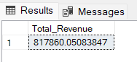
A2. Average Order Value
SELECT (SUM(total_price) / COUNT(DISTINCT order_id)) AS Avg_Order_Value
FROM pizza_sales;
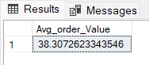
A3. Total Pizzas Sold
SELECT SUM(quantity) AS Total_Pizza_Sold
FROM pizza_sales;
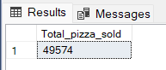
A4. Total Orders
SELECT COUNT(DISTINCT order_id) AS Total_Orders
FROM pizza_sales;
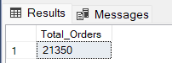
A5. Average Pizzas Per Order
SELECT CAST(CAST(SUM(quantity) AS DECIMAL(10,2)) /
CAST(COUNT(DISTINCT order_id) AS DECIMAL(10,2)) AS DECIMAL(10,2))
AS Avg_Pizzas_Per_Order
FROM pizza_sales;
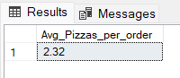
B–C. TREND ANALYSIS
Time-series queries used to populate trend charts showing order volume by day and month.
B. Daily Trend for Total Orders
SELECT DATENAME(DW, order_date) AS order_day,
COUNT(DISTINCT order_id) AS total_orders
FROM pizza_sales
GROUP BY DATENAME(DW, order_date);
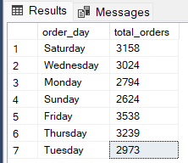
C. Monthly Trend for Orders
SELECT DATENAME(MONTH, order_date) AS Month_Name,
COUNT(DISTINCT order_id) AS Total_Orders
FROM pizza_sales
GROUP BY DATENAME(MONTH, order_date);

D–F. SALES MIX & CATEGORY BREAKDOWN
Percentage and quantity breakdowns by pizza category and size: used for pie/donut charts.
D. % of Sales by Pizza Category
SELECT pizza_category,
CAST(SUM(total_price) AS DECIMAL(10,2)) AS total_revenue,
CAST(SUM(total_price) * 100 /
(SELECT SUM(total_price) FROM pizza_sales) AS DECIMAL(10,2)) AS PCT
FROM pizza_sales
GROUP BY pizza_category;
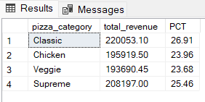
E. % of Sales by Pizza Size
SELECT pizza_size,
CAST(SUM(total_price) AS DECIMAL(10,2)) AS total_revenue,
CAST(SUM(total_price) * 100 /
(SELECT SUM(total_price) FROM pizza_sales) AS DECIMAL(10,2)) AS PCT
FROM pizza_sales
GROUP BY pizza_size
ORDER BY pizza_size;
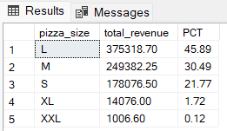
F. Total Pizzas Sold by Pizza Category
Example shown filtered to February (MONTH = 2). Remove or adjust the WHERE clause for other periods.
SELECT pizza_category,
SUM(quantity) AS Total_Quantity_Sold
FROM pizza_sales
WHERE MONTH(order_date) = 2
GROUP BY pizza_category
ORDER BY Total_Quantity_Sold DESC;
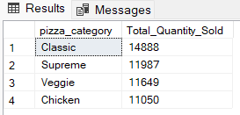
G–L. BEST & WORST SELLERS
Top 5 and Bottom 5 pizza rankings across three dimensions: Revenue, Quantity, and Order Count.
By Revenue
G. Top 5 Pizzas by Revenue
SELECT TOP 5 pizza_name,
SUM(total_price) AS Total_Revenue
FROM pizza_sales
GROUP BY pizza_name
ORDER BY Total_Revenue DESC;
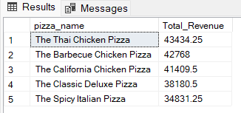
H. Bottom 5 Pizzas by Revenue
SELECT TOP 5 pizza_name,
SUM(total_price) AS Total_Revenue
FROM pizza_sales
GROUP BY pizza_name
ORDER BY Total_Revenue ASC;
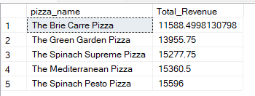
By Quantity Sold
I. Top 5 Pizzas by Quantity
SELECT TOP 5 pizza_name,
SUM(quantity) AS Total_Pizza_Sold
FROM pizza_sales
GROUP BY pizza_name
ORDER BY Total_Pizza_Sold DESC;
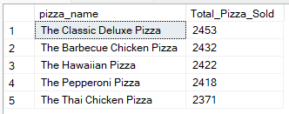
J. Bottom 5 Pizzas by Quantity
SELECT TOP 5 pizza_name,
SUM(quantity) AS Total_Pizza_Sold
FROM pizza_sales
GROUP BY pizza_name
ORDER BY Total_Pizza_Sold ASC;
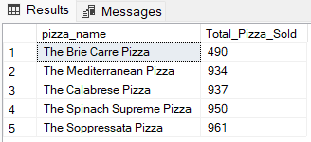
By Total Orders
K. Top 5 Pizzas by Total Orders
SELECT TOP 5 pizza_name,
COUNT(DISTINCT order_id) AS Total_Orders
FROM pizza_sales
GROUP BY pizza_name
ORDER BY Total_Orders DESC;
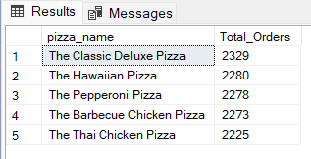
L. Bottom 5 Pizzas by Total Orders
SELECT TOP 5 pizza_name,
COUNT(DISTINCT order_id) AS Total_Orders
FROM pizza_sales
GROUP BY pizza_name
ORDER BY Total_Orders ASC;
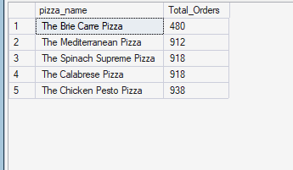
💡 Filter Tip
Apply (pizza_category) or (pizza_size) filters to any query using a WHERE clause:
-- Example: filter Bottom 5 by Orders to the 'Classic' category
SELECT TOP 5 pizza_name,
COUNT(DISTINCT order_id) AS Total_Orders
FROM pizza_sales
WHERE pizza_category = 'Classic'
GROUP BY pizza_name
ORDER BY Total_Orders ASC;

