LAB 3 – Sri Yogesh Dorbala - 0029086240

1. Throughput increases with the increase in block size. There is no definite block size for which the speed is optimal. As observed from the graph, throughput keeps on increasing with block size. Below readings are taken by calculating an average of 8-10 operations on each block size (hence the random peaks at some stages).

|  |  |  |
| --- | --- | --- |
| Block Size | Throughput(Mbps) | Completion Time (micro secs) |
| 500 | 3572 | 6490 |
| 1000 | 5634 | 4115 |
| 1500 | 7156 | 3240 |
| 2000 | 8266 | 2805 |
| 3000 | 9168 | 2529 |
| 4000 | 13249 | 1750 |
| 5000 | 10973 | 2113 |
| 6000 | 17011 | 1363 |
| 7000 | 11982 | 1935 |
| 8000 | 16986 | 1365 |

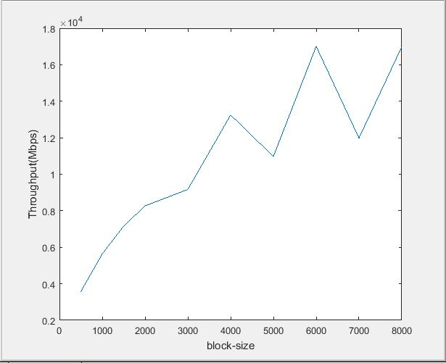

The above results may vary at different times as there are many other minute factors involved in network speeds. Though there are a few fluctuations here and there, it is almost certain that throughput value keeps on increasing with increase in block size.

1. Throughput observed at both the sender and the receiver are the same

|  |  |  |
| --- | --- | --- |
| Packet-Spacing(micro-sec) | Sender(Throughput-Mbps) | Receiver(Throughput-Mbps) |
| 50 | 74.892 | 74.856 |
| 10 | 117.245 | 117.235 |
| 5 | 132.38 | 132.256 |
| 1 | 144.345 | 144.015 |
| 0.5 | 145.471 | 145.239 |
| 0.1 | 145.823 | 145.536 |

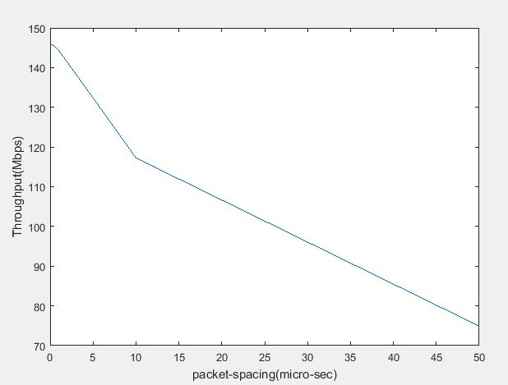

As packet spacing is reduced from 50 to 0.1 micro seconds throughput value increases from 74 to 145 Mbps as shown both from the graph and the table. This is expected because when the time spacing between two consecutive packets decrease, the completion time decreases and therefore the throughput increases.

|  |  |
| --- | --- |
| Payload-Size | Sender(Throughput-Mbps) |
| 50 | 7.456 |
| 500 | 74.563 |
| 1000 | 150.239 |
| 2000 | 298.481 |
| 4000 | 588.439 |
| 8000 | 952.231 |

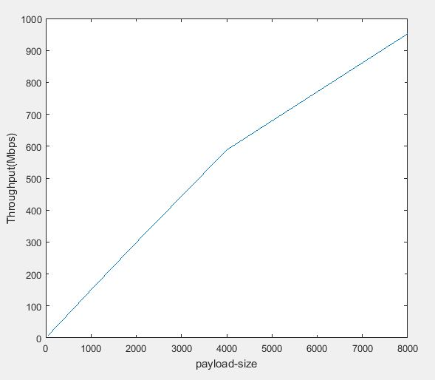

As the payload size increases, more number of bits are carried per transaction. This makes the time taken to complete the file transfer to reduce. This drop in completion time results in a better throughput yield.

1. After capturing the packets, the *pcap* file generated can be viewed in a friendly manner by using Wireshark. One of the 10 packets that got captured is shown below after expanding in Wireshark utility.

An Ethernet frame has in order: 6-octet destination MAC address (which from the pic below is b6:c5:d2:04:6e:61), 6-octet source MAC address(f6:53:ee:71:fc:c5) followed by a 2-byte field which in the pic shown below is ‘*08 00’* which is used to denote IPv4 type.

This *type* value right after source and destination MAC addresses helps in distinguishing the type of Ethernet frame at hand. If the value of the type is less than 1500 then it represents ‘IEEE 802.3’, else it represents ‘DIX’ (the 2-bit value in IEEE 802.3 is length field which stores the length of the payload. Since the payload length for an Ethernet frame cannot be greater than 1500, the 2-bit value after source and destination MAC addresses in IEEE 802.3 cannot be greater than 1500). As the value here is hex ‘*08 00’* which represents type IPv4(which is greater than 1500), the Ethernet frame is of type DIX here.

The first 4 bits of the IP packet header in this example after ‘08 00’ is ‘01 00’ denoted by 4. This informs us that the version of the IP is 4.

From the below division, we can get to the start of the UDP packet header. The first 4 bytes specify the source port (‘d4 3c’: 54332) and the destination port (‘c3 5c’: 50012). Once the UDP packet header is parsed we are left with payload information which in the below case are all represented by blocks of 4’s (which is the hex for ‘D’) having a length of 1000 as shown below.

Wireshark utility helped discern the information about the different headers involved in the packet.

