ASSIGNMENT 8

Name: Vansh Singh

Roll No: 2101CS79

Contents:

1. Program Flow
2. Codes
3. Working of Program (Screenshots)

1. Program Flow:

homepage.html

* insert.php
* homepage2.html > welcome.php
* update.php > updateredirect.php > updatefname.php

> updatelname.php

> updatepassword.php

* delete.php > deleteexec.php > deleteperm.php

2. Codes:

homepage.html ->

<!DOCTYPE html>

<html lang="en">

<head>

    <meta charset="UTF-8">

    <meta http-equiv="X-UA-Compatible" content="IE=edge">

    <meta name="viewport" content="width=device-width, initial-scale=1.0">

    <title>Welcome to User Registration</title>

    <link rel="stylesheet" href="style.css">

</head>

<body>

    <div class="container">

        <h2> Welcome to User Registration Portal</h2>

        <form action="insert.php" method="post">

            <input type="text" name="fname" id="fname" placeholder="Enter your First Name" required>

            <input type="text" name="lname" id="lname" placeholder="Enter your Last Name" required>

            <input type="email" name="email" id="email" placeholder="Enter your E-mail" required>

            <input type="password" name="password" id="password" placeholder="Enter your Password" minlength="8" required>

            <input type="password" name="cpassword" id="cpassword" placeholder="Confirm Password" required>

            <button type="submit" class="btn">Submit</button><br>

            <a href="homepage2.html">Login</a>

            <p>Already Registered? Click <a href="update.php"> here </a> to update your details</p>

            <p>Done all shenanigans? Click <a href="delete.php"> here </a> to delete your details</p>

        </form>

    </div>

    <script src="index.js"></script>

</body>

</html>

style.css for homepage.html ->

*{  background-color: rgb(157,136,175);

    margin: 0px;

    padding: 0px;

    box-sizing: border-box;

}

.container{

    max width: 80%;

    background-color: rgb(157,136,175);

    padding: 34px;

    margin: auto;

}

.container h2{

    text-align: center;

}

input{

    border: 2px solid black;

    border-radius: 6px;

    outline: none;

    font-size: 12px;

    width: 80%;

    margin: 11px auto;

    padding: 7px;

}

form{

    display: flex;

    align-items: center;

    justify-content: center;

    flex-direction: column;

}

.btn{

    color: white;

    background: purple;

    padding: 8px 12px;

    font-size: 16px;

    border: 2px solid white;

    border-radius: 14px;

    cursor: pointer;

}

insert.php ->

<?php

    $con = mysqli_connect("localhost","root","pppv@123","assign1");

    if(!$con)die("connection to database failed due to" . mysqli_connect_error());

    $name1 = $_POST['fname'];

    $name2 = $_POST['lname'];

    $email1 = $_POST['email'];

    $password1 =  $_POST['password'];

    $password2 = $_POST['cpassword'];

    if($password1 == $password2){

        $sql = "INSERT INTO `users` (`fname`,`lname`,`email`,`password`) values ('$name1','$name2','$email1','$password1');";

        if($con->query($sql)==true)echo "Successfully Inserted";

        else echo "ERROR: $sql <br> $con->error";

    }

    else echo "Passwords do not match. Enter again";

    $con->close();

?>

homepage2.html ->

<!DOCTYPE html>

<html>

  <head>

    <title>Welcome to Sign In</title>

    <style>

      body {

        font-family: Arial, sans-serif;

        text-align: center;

      }

      h1 {

        color: #4CAF50;

      }

      label {

        display: inline-block;

        width: 80px;

        text-align: left;

      }

      input[type=email], input[type=password] {

        width: 250px;

        padding: 10px;

        border: 1px solid #ccc;

        border-radius: 4px;

        box-sizing: border-box;

        margin-bottom: 20px;

      }

      input[type=submit] {

        background-color: #4CAF50;

        color: white;

        padding: 10px 20px;

        border: none;

        border-radius: 4px;

        cursor: pointer;

      }

    </style>

  </head>

  <body>

    <h1>Welcome to Sign in</h1>

    <form action="welcome.php" method="post">

      <label for="email">Email:</label>

      <input type="email" id="email" name="email" required><br><br>

      <label for="password">Password:</label>

      <input type="password" id="password" name="password" required><br><br>

      <input type="submit" value="Login">

    </form>

  </body>

</html>

welcome.php ->

<?php

            $con = mysqli_connect("localhost","root","pppv@123","assign1");

            if(!$con)die("connection to database failed due to" . mysqli_connect_error());

            $emaill1 = $_POST['email'];

            $passwordd1 =  $_POST['password'];

            $sq1 = "select * from users where email = '$emaill1';";

            $result = mysqli_query($con,$sq1);

            $data = array();

            if (mysqli_num_rows($result) > 0) {

            while ($row = mysqli_fetch_assoc($result)) {

                $data[] = $row;

            }

            }

            $found = "";

            $firstname = "";

            $lastname = "";

            foreach($data as $row){

                $found = $row['password'];

                $firstname = $row['fname'];

                $lastname = $row['lname'];

                break;

            }

            if($found == ""){

                echo "No such email ID found";

            }

            else{

                if($found==$passwordd1){

                    echo "Welcome ".$firstname." ".$lastname." with email id- ".$emaill1;

                    die();

                }

                else{

                    echo "Wrong Password entered";

                }

            }

            $con->close();

?>

update.php ->

<!DOCTYPE html>

<html>

  <head>

    <title>Welcome to Sign In</title>

    <style>

      body {

        font-family: Arial, sans-serif;

        text-align: center;

      }

      h1 {

        color: #4CAF50;

      }

      label {

        display: inline-block;

        width: 80px;

        text-align: left;

      }

      input[type=email], input[type=password] {

        width: 250px;

        padding: 10px;

        border: 1px solid #ccc;

        border-radius: 4px;

        box-sizing: border-box;

        margin-bottom: 20px;

      }

      input[type=submit] {

        background-color: #4CAF50;

        color: white;

        padding: 10px 20px;

        border: none;

        border-radius: 4px;

        cursor: pointer;

      }

    </style>

  </head>

  <body>

    <h1>Welcome to Update Page</h1>

    <form action="updateredirect.php" method="post">

      <label for="email">Email:</label>

      <input type="email" id="email" name="email" required><br><br>

      <label for="password">Password:</label>

      <input type="password" id="password" name="password" required><br><br>

      <button type="submit" value="Login">Submit</button>

    </form>

  </body>

</html>

updateredirect.php ->

<?php

            $con = mysqli_connect("localhost","root","pppv@123","assign1");

            if(!$con)die("connection to database failed due to" . mysqli_connect_error());

            $emaill1 = $_POST['email'];

            $passwordd1 =  $_POST['password'];

            $sq1 = "select * from users where email = '$emaill1';";

            $result = mysqli_query($con,$sq1);

            $data = array();

            if (mysqli_num_rows($result) > 0) {

            while ($row = mysqli_fetch_assoc($result)) {

                $data[] = $row;

            }

            }

            $found = "";

            $firstname = "";

            $lastname = "";

            foreach($data as $row){

                $found = $row['password'];

                $firstname = $row['fname'];

                $lastname = $row['lname'];

                break;

            }

            if($found == ""){

                echo "No such email ID found";

                die();

            }

            else{

                if($found==$passwordd1){

                    //login done

                    session_start();

                    $_SESSION['mail']=$emaill1;

                }

                else{

                    echo "Wrong Password entered";

                    die();

                }

            }

            $con->close();

?>

<!DOCTYPE html>

<html lang="en">

<head>

    <meta charset="UTF-8">

    <meta http-equiv="X-UA-Compatible" content="IE=edge">

    <meta name="viewport" content="width=device-width, initial-scale=1.0">

    <title>Document</title>

</head>

<body>

    <?php

    echo "Welcome ".$firstname." ".$lastname." with email id- ".$emaill1;

    ?>

        <form action="updatefname.php" method="post">

            <input type="text" name="ffname" id="ffname" placeholder="Enter your new First Name" required>

            <button type="submit" name = "fnameup" class="btn">Update first name</button><br>

        </form>

        <form action="updatelname.php" method="post">

            <input type="text" name="llname" id="llname" placeholder="Enter your new Last Name" required>

            <button type="submit" class="btn">Update Last Name</button><br>

        </form>

        <form action="updatepassword.php" method="post">

            <input type="password" name="passwordd" id="passwordd" placeholder="Enter your new Password" required>

            <input type="password" name="cpasswordd" id="cpasswordd" placeholder="Confirm Password" required>

            <button type="submit" class="btn">Update Password</button><br>

        </form>

</body>

</html>

updatelname.php ->

<?php       session_start();

            $emai = $_SESSION['mail'];

            $con = mysqli_connect("localhost","root","pppv@123","assign1");

            if(!$con)die("connection to database failed due to".mysqli_connect_error());

            $lastname = $_POST['llname'];

            $sql = "update `users` set `lname` = '$lastname' where `email`='$emai' ;";

            if($con->query($sql)==true)echo "Successfully updated";

            else echo "ERROR: $sql <br> $con->error";

            $con->close();

?>

updatefname.php

<?php       session_start();

            $emai = $_SESSION['mail'];

            $con = mysqli_connect("localhost","root","pppv@123","assign1");

            if(!$con)die("connection to database failed due to".mysqli_connect_error());

            $firstname = $_POST['ffname'];

            $sql = "update `users` set `fname` = '$firstname' where `email`='$emai' ;";

            if($con->query($sql)==true)echo "Successfully updated";

            else echo "ERROR: $sql <br> $con->error";

            $con->close();

?>

updatepassword.php ->

<?php       session_start();

            $emai = $_SESSION['mail'];

            $con = mysqli_connect("localhost","root","pppv@123","assign1");

            $pass1=$_POST['passwordd'];

            $pass2=$_POST['cpasswordd'];

            if(!$con)die("connection to database failed due to".mysqli_connect_error());

            if($pass1 == $pass2){

                $sql = "update `users` set `password` = '$pass1' where `email`='$emai' ;";

                if($con->query($sql)==true)echo "Successfully updated";

                else echo "ERROR: $sql <br> $con->error";

            }

            else{

                echo "Wrong: password and confirm password don't match";

            }

            $con->close();

?>

delete.php ->

<!DOCTYPE html>

<html>

  <head>

    <title>Delete Account</title>

    <style>

      body {

        font-family: Arial, sans-serif;

        text-align: center;

      }

      h1 {

        color: #4CAF50;

      }

      label {

        display: inline-block;

        width: 80px;

        text-align: left;

      }

      input[type=email], input[type=password] {

        width: 250px;

        padding: 10px;

        border: 1px solid #ccc;

        border-radius: 4px;

        box-sizing: border-box;

        margin-bottom: 20px;

      }

      input[type=submit] {

        background-color: #4CAF50;

        color: white;

        padding: 10px 20px;

        border: none;

        border-radius: 4px;

        cursor: pointer;

      }

    </style>

  </head>

  <body>

    <h1>Delete Account</h1>

    <form action="deleteexec.php" method="post">

      <label for="email">Email:</label>

      <input type="email" id="email" name="email" required><br><br>

      <label for="password">Password:</label>

      <input type="password" id="password" name="password" required><br><br>

      <input type="submit" value="Login">

    </form>

  </body>

</html>

deleteexec.php

<?php

            $con = mysqli_connect("localhost","root","pppv@123","assign1");

            if(!$con)die("connection to database failed due to" . mysqli_connect_error());

            $emaill1 = $_POST['email'];

            $passwordd1 =  $_POST['password'];

            $sq1 = "select `password` from `users` where `email` = '$emaill1';";

            $result = mysqli_query($con,$sq1);

            $data = array();

            if (mysqli_num_rows($result) > 0) {

            while ($row = mysqli_fetch_assoc($result)) {

                $data[] = $row;

            }

            }

            $found = "";

            foreach($data as $row){

                $found = $row['password'];

                break;

            }

            if($found == ""){

                echo "No such email ID found";

                die();

            }

            else{

                if($found==$passwordd1){

                    session_start();

                    $_SESSION['mail'] = $emaill1;

                }

                else{

                    echo "Wrong Password entered";

                    die();

                }

            }

            $con->close();

?>

<!DOCTYPE html>

<html lang="en">

<head>

    <script type="text/javascript">

        var baseUrl="http://localhost/backend";

        function ConfirmDelete(){

            if(confirm("Delete Account")){

                location.href = baseUrl + '/deleteperm.php'

            }

        }

    </script>

    <meta charset="UTF-8">

    <meta http-equiv="X-UA-Compatible" content="IE=edge">

    <meta name="viewport" content="width=device-width, initial-scale=1.0">

    <title>Document</title>

</head>

<body>

    <button type="submit" onclick="ConfirmDelete()"> Delete Account Permanently </button>

</body>

</html>

deleteperm.php ->

<?php

            $con = mysqli_connect("localhost","root","pppv@123","assign1");

            session_start();

            $emai = $_SESSION['mail'];

            if(!$con)die("connection to database failed due to".mysqli_connect_error());

            $sql = "DELETE FROM `users` where `email` = '$emai';";

            if($con->query($sql)==true)echo "Deletion Successful";

            else echo "ERROR: $sql <br> $con->error";

            $con->close();

?>

3. WORKING OF PROGRAM (SCREENSHOTS) :

backend is the name of the folder where we have stored all the files related to this assignment

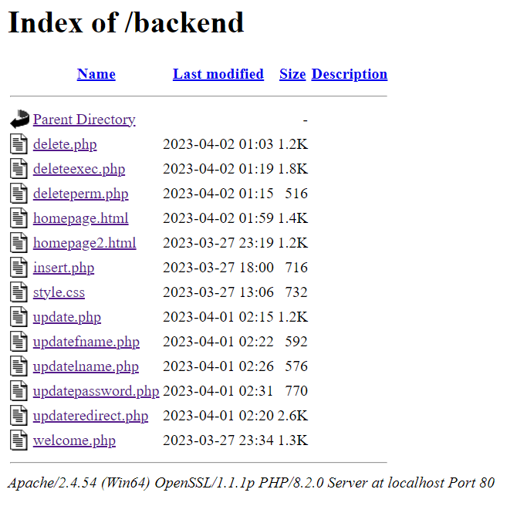

**homepage.html with style.css**

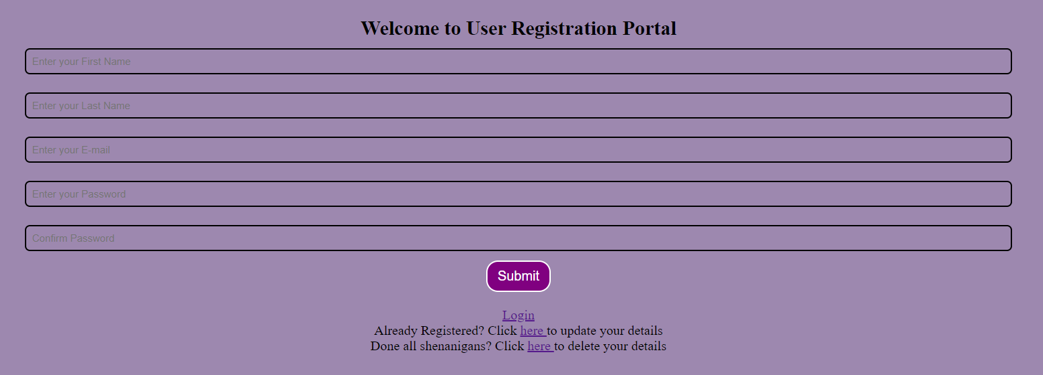

initial state of mysql

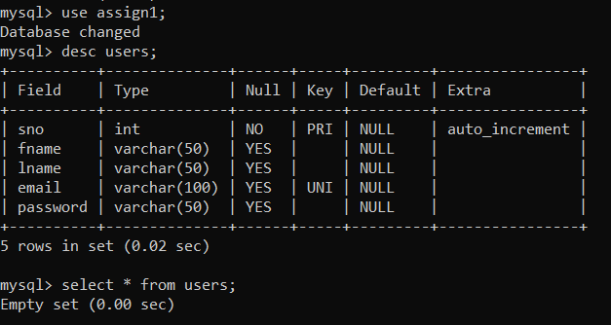

some required fields of homepage.html

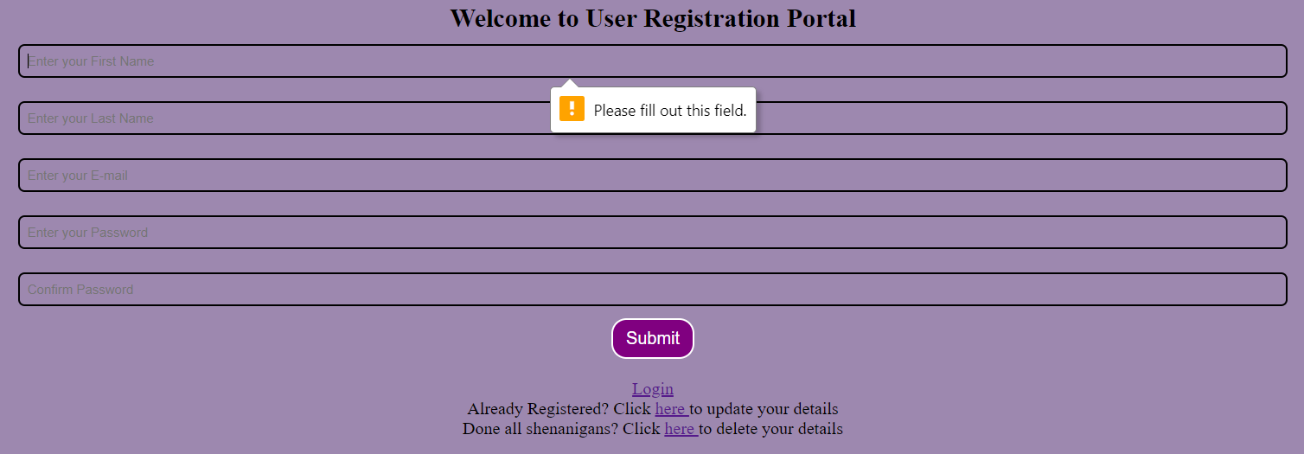

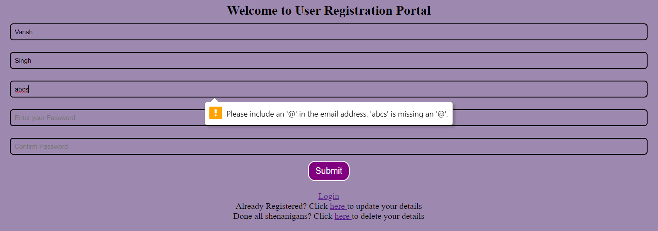 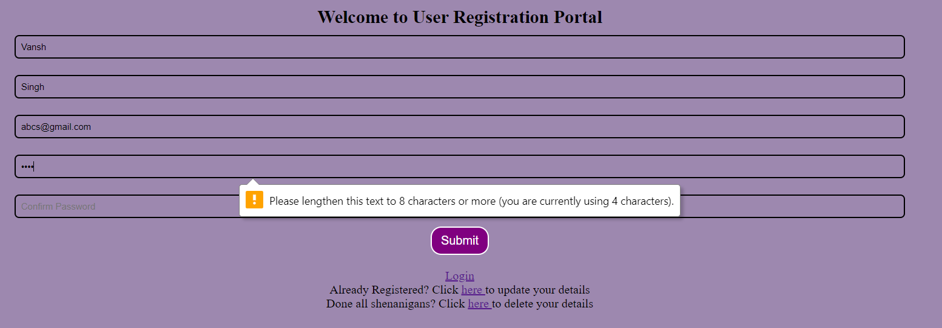

Using passwords that don’t match and clicking submit button

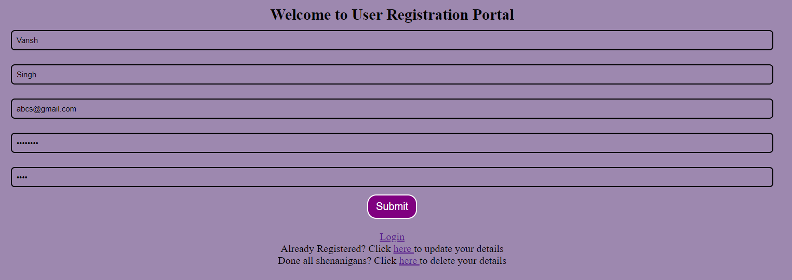

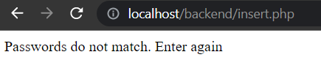

After successfully putting same password in confirm password:



Corresponding MySQL table users after this:

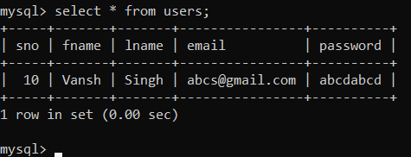

**SIGN IN PAGE (homepage2.html)**

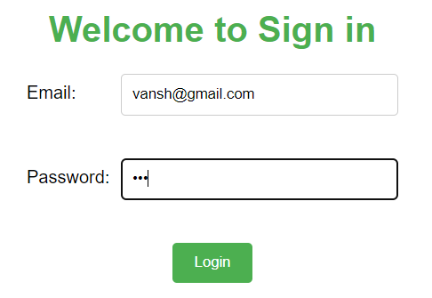

Trying a email that doesn’t exist



Trying wrong password on an email that exists

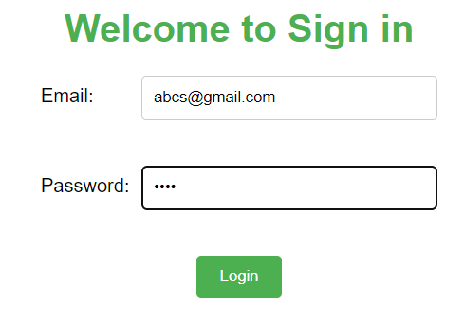



Trying correct password and mail

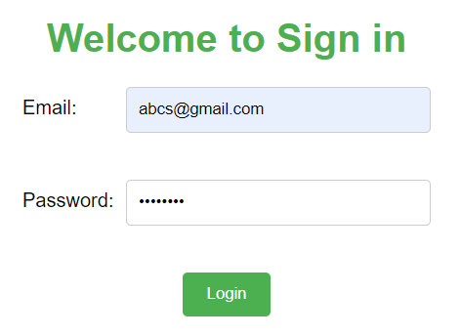



**Update Page (update.php):**

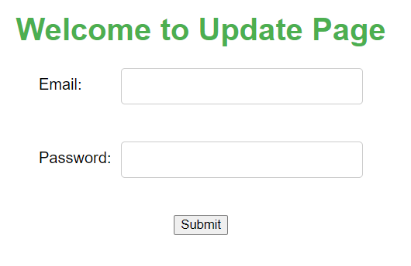

Using unknown mail and password:

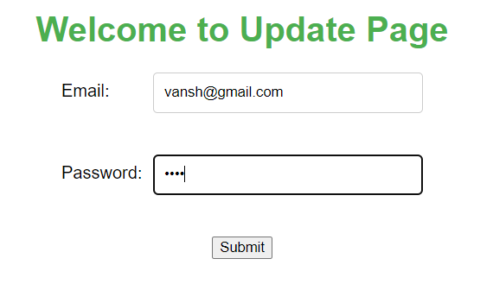

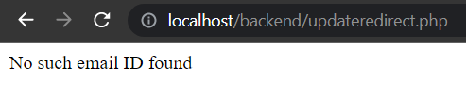

Using known mail but wrong password

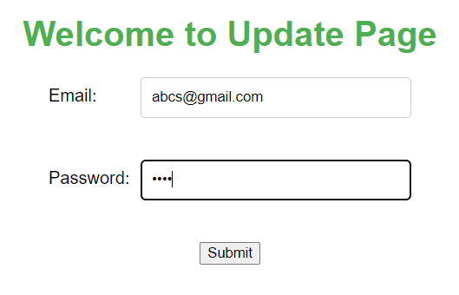



Using Correct mail and password

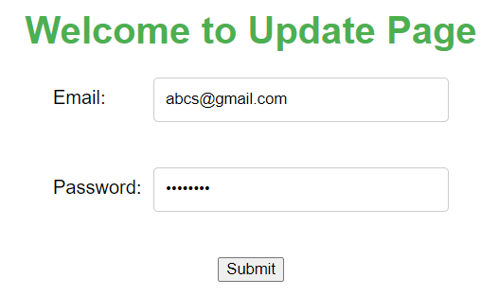

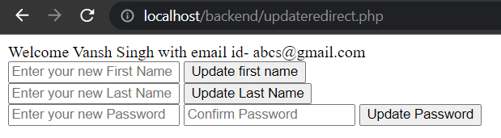

Updating first name

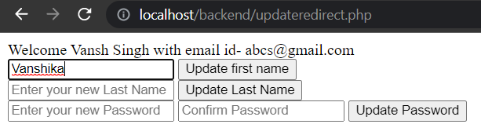



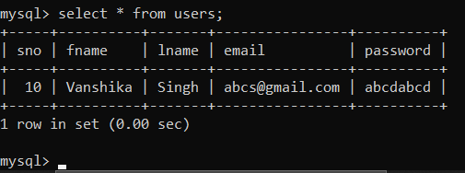

Updating last name

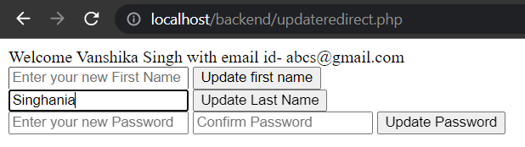



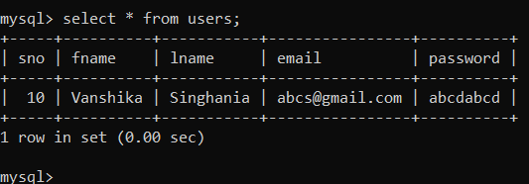’

Updating Password

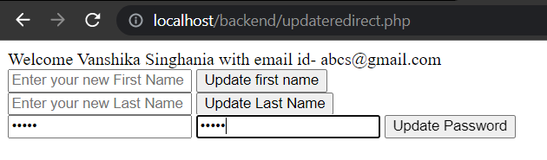



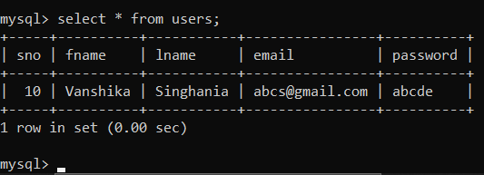

**DELETION (delete.php)**

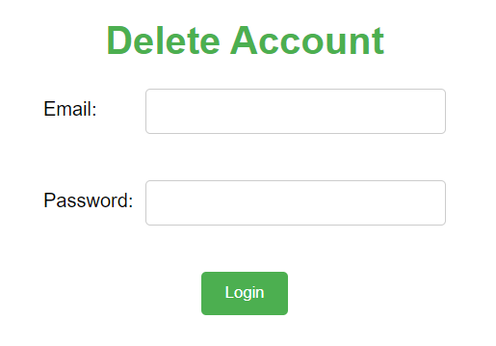

Using wrong mail and password

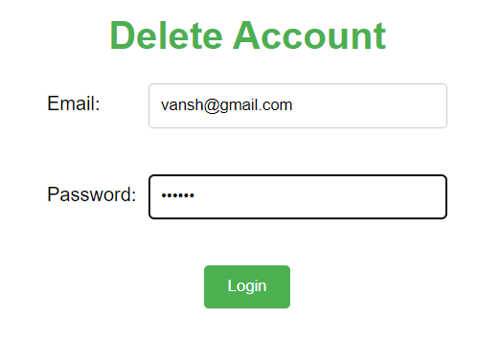



Using correct mail but wrong password

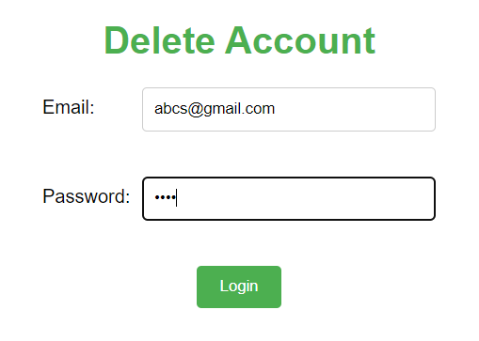



Using correct mail and password

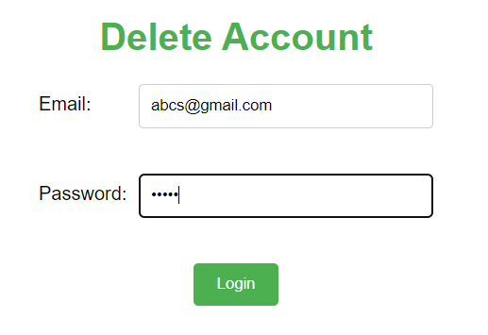

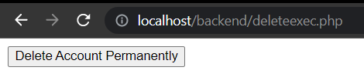

After clicking this option we get a popup using javascript:

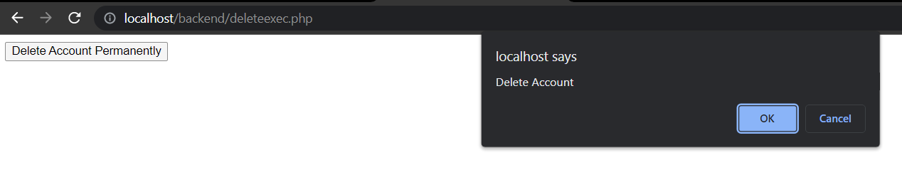

Clicking on cancel, we return to the same state:



Clicking on OK:



The account gets deleted and and it gets reflected in the mysql as well

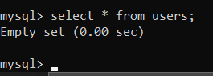

**THANK YOU FOR YOUR TIME**

**^_^**