# Introduction

## Objectives

## Innovation

## Structure

# Requirements

Runtime Node Requirements

**The effort to introduce new capabilities in the runtime should be reasonable** : Estimate effort needed to introduce the following features: - missing WebRTC features eg Identity - Protocol on the fly mechanism - Policy engine - Hyperty Registry - others?**The Runtime must be secured** : *to be done: Identity attacks to be secured against*

It should be possible to deploy in secured elements like SIM cards or embedded SIM (Nuno: not yet entirely sure that this can be done.)

**Security goals:**

G1 - to protect the confidentiality and integrity of the state of hyperty instances. G2 - to protect the integrity of the code of hyperty instances. G3 - to enforce the security policies attached to hyperty code.

**Possible attack vectors:**

*Malicious hyperty code:* E.g., by exploiting a bug in the hyperty runtime (HR), a malicious hyperty manages to escape from its sandboxed environment and escalates its privileges to gain access to a victim hyperty instance. The attacker can then read or modify sensitive data (break G1), modify the code (break G2), or modify the security policy (break G3) of the victim.

*Compromised browser:* E.g., the local user logs in to the computer, and attaches a debugger to the browser’s process. This gives the user full access to the browser’s state, including the HR’s. Therefore all G1, G2, and G3 can be violated. A similar attack can be performed by malware that subverts the browser’s security mechanisms and allows for an attacker to control the HR.

*Compromised operating system:* E.g., a kernel rootkit subverts the kernel, and gains access to the entire memory state of the browser process in which the victim hyperty instance is running. Just like in the previous cases, all G1, G2, G3 can be violated. Jail-breaking the kernel can bring similar consequences.

*Compromised hardware:* E.g., an attacker manages to gain physical access to the host computer and has the capability to extract secrets directly from the RAM memory or by probing the system bus. This attack can violate the security goals G1, G2, and G3.

**The Runtime must have a good performance** : **The Runtime should support Web Messaging Notifications** : http://dev.w3.org/html5/postmsg/**The Runtime should support Web Socket** : http://www.w3.org/TR/websockets/ **The runtime must support standard Javascript (ECMAScript)** : http://www.ecma-international.org/ecma-262/5.1/ **The Runtime should support W3C WebRTC APIs** : http://www.w3.org/TR/mediacapture-streams/

http://www.w3.org/TR/webrtc/ **The Runtime should be deployable in the most used Devices and Operating Systems** : Including: * Android (Smartphone and Tablet) * iOS (Smartphone and Tablet) * Raspberry PI * Linux VM * Windows VM ##Messaging Node Requirements##

**Messaging Node with carrier grade deployment features** : * Resilience (operate under load, failures, and attacks) * Security (DoS and DDoS protection) * Service assurance management**The Messaging Node MUST offer DoS and DDoS Protection** : The MN MUST provide protection against Denial of Service (DoS) and Distributed Denial of Service Attacks (DDoS)**It should be possible to support Protocol on-the-fly** : In order to support Node to Node between different implementations and protocols without having the need to standardise Node-2-node protocol.

This should imply the support of Javascript **Messaging Transport Protocols** : It should be possible to support several protocols including:

* WebSockets
* HTTP Streaming
* HTTP Long-Polling
* REST**Message Caching**  : It must be possible to cache submitted messages Store and forward ??(FFS)**Messaging Node logging** : It should be possible to remotely log message routing events.**Message delivery reliability** : Delivery errors must be returned to clients**Messaging Node deployments with carrier grade scalability** : million of messages / sec ??

volume of traffic: to be elaborated**Messaging Node should be tolerant to unstable connections**  : Used Messaging addresses and Messaging Sessions should not change when connections are lost for a short period of time or when client IP address changes eg due to access network handover (eg wifi to LTE). Sessions should be resumed with minimal impact on the client.

Example: https://github.com/primus/primus

To be improved according to comments**Events about clients connection / disconnection from Messaging Node** : It should be possible to get events with information about Messaging Node clients connection and disconnection.

Such feature is useful for connection status purposes.**Messaging Node must support very low message delivery latency** : **Messaging Node must be deployable in the most used Virtual Machines** : **Messaging Node should require minimal computing resources** : In order to be deployable in constrained computing environments eg residential /enterprise gateways.**Messaging Node must support external authentication and Authorisation** : Messaging Node must be able to use an external Authentication Service

Messaging Node must be able to use an external Authorisation Service for the following features: * send/publish a Message * receive a Message * subscribe / register handlers to be notified about published messages

**Messaging Node must support multiple messaging functionalities** :

Network QoS Requirements

**QoS component should assure collaboration between network and application layer actors** : There should be a collaboration between network operators (Network or Internet Service providers) and communication service providers, e.g. 3rd party communication service providers, since network operators do not have the control over the whole environment.**QoS component should provide a single contact point for troubleshooting issues** : A single contact point should be assured for troubleshooting issues, i.e. to verify the appropriate level of the quality and make eventual improvements.**QoS component should enable isolating and valorizing performance improvements** : Segments that contribute to improvement of quality should be identified. The improvements should be valorized and quantified, e.g. for monetization reasons. **QoS component should leverage IP paths diversity** : The are different possible connection paths, i.e. paths offering best-effort services or managed paths with a certain Service Level agreement. These different possibilities should be considered. **QoS component should impact different network types and segments** : Should impact mobile, wireline, wifi access networks, but also interconnection. **QoS component should be compatible with evolution of different standards and terminals** : **QoS component should be compatible with deployed network technologies** : Eventual improvements should be in line with current technologies. It should not be neccessary to make big changes to existing network deployments, but current technologies should be modified or improved. **QoS component should be compatible with application layer technologies e.g. WebRTC** : **QoS component should exploit partially SLA and partially best-effor network segments** : The communication service path can consist of parts provided by different actors. As not all of these actors may be willing to provide quality of service, the communication path may consist of segments with Service Level Agreement or with best effort quality. As a result there is not necessarily end-to-end path, but the quality may vary.**QoS component should take into account participating and non-participating actors** : Network QoS should take into account a fact that in the communication path there can be participating and non-participating actors, i.e. not all actors will support providing network QoS so it will not always be possible to offer end-to-end quality.**QoS component should have global reach** : Network QoS should be provided on a global scale

Service Framework Requirements

**Framework must be agnostic of the Messaging Node used** : **The Service Framework MUST avoid any JS conflict** : The hyperty has to be self contained, if we add a framework as angular (for example) we may have conflict if an existing angular is already in the site (or another framework - I have some experience for instance on Jquery conflict with Prototype ... )

Do we need a framework as angular as we will not have any graphical user interface in the hyperty framework ?**Service Framework MUST be Modular in nature** : Development of modules on the Framework should be loosely coupled, self contained and re-usable by other libraries/modules **The Service Framework MUST be open source** : No proprietary solution as the project itself demands all components be open source.**Service Framework should be Supported in all Devices and Operating Systems featuring Hyperty Runtime** : See devices and operating systems defined at #1 **Service Framework MUST be light weight and fast** : The service framework size is important as latency plays an important role and we don't want heavy frameworks that adds overhead to the overall performance in executing the hyperties **Service Framework SHOULD support Model-View-Controller design pattern** : Model-View-Controller approach: enables easier maintainability and clarity

*View:* The view presents data to users through format & layout. The view is rendered by the model *Model:* The model handles data & business logic. It also allows for clear separation between the presentation (View) and application logic *Controller:* Receives user requests and calls back to the model to select a proper view. Uses HTTP GET or POST request to manage the data

# State of the Art

## Security in Runtime

In this document, we present an overview about the security in runtime component of the project. In first place, we will define the security goals we want to achieve. Then, possible attacks against those goals are explained. Finally, we present the state of the art on how current systems solve the referred problems, splitting the security runtimes in two distinct areas:

* Web Browsers
* Secure elements

In the Web Browsers section, we will present security mechanisms for JavaScript code protection in fully-featured environments (the web browsers themselves), while in the Secure Elements section, the state of the art on code security runtimes for systems featuring less functionality and computation capabilities but requiring tighter security requirements during its operation.

**Security goals:** The following points consist in specific security goals that the hyperty instances must achieve.

G1 - to protect the confidentiality and integrity of the state of hyperty instances. G2 - to protect the integrity of the code of hyperty instances. G3 - to enforce the security policies attached to hyperty code.

**Possible attack vectors:** Multiple attack types can be performed against the hyperty instances, at multiple levels (software, OS, hardware). We now present and detail the most well-known attack vectors occuring at each level.

*Malicious hyperty code:* E.g., by exploiting a bug in the hyperty runtime (HR), a malicious hyperty manages to escape from its sandboxed environment and escalates its privileges to gain access to a victim hyperty instance. The attacker can then read or modify sensitive data (break G1), modify the code (break G2), or modify the security policy (break G3) of the victim.

*Compromised browser:* E.g., the local user logs in to the computer, and attaches a debugger to the browser’s process. This gives the user full access to the browser’s state, including the HR’s. Therefore all G1, G2, and G3 can be violated. A similar attack can be performed by malware that subverts the browser’s security mechanisms and allows for an attacker to control the HR.

*Compromised operating system:* E.g., a kernel rootkit subverts the kernel, and gains access to the entire memory state of the browser process in which the victim hyperty instance is running. Just like in the previous cases, all G1, G2, G3 can be violated. Jail-breaking the kernel can bring similar consequences.

*Compromised hardware:* E.g., an attacker manages to gain physical access to the host computer and has the capability to extract secrets directly from the RAM memory or by probing the system bus. This attack can violate the security goals G1, G2, and G3.

### Web Browsers

#### Monolithic vs Modular Architectures:

Traditionally, commercial and open-source web browsers employed a monolithic architecture. This means that both user’s and web application’s data are combined into a single security domain, which brings serious performance/usability and security issues. On the performance/usability side, if a web application crashes during its execution, the whole web browser can be affected, harming the user experience. On the security side, if an attacker exploits an unpatched vulnerability in the browser while a user is using it, he may gain access to the whole user space, being able to execute code on behalf of that user and access its private sensitive information, like credentials.

Nowadays, web browsers evolved into modular architectures, in order to achieve privilege separation and overcome monolithic architectures’ flaws. This way, browser developers came up with multiple different architectures to achieve this separation between what is user’s property (credentials, preferences) and what is “web’s” property (applications’ code). Multiple techniques were employed in these architectures to achieve this separation:

* **Sandboxing:** In computer security, a sandbox is a security mechanism which allows untrusted programs to run within a trusted environment, without affecting its trustiness. This is usually done by restricting the resources (disk, memory, network) the untrusted software can access. An example is creating scratch memory and disk spaces where it can read/write and limiting the network capabilities it can use, in order to prevent the host environment from getting damaged. This is what Chromium browser [1] applies to separate the user and the web side in a modular architecture. It features two modules:
* A **browser kernel module** which acts on behalf of the user and is responsible for implementing the tab-based windowing system of the browser, storing user’s data as its preferences, bookmarks, credentials and cookies and also working as a middleware between the native operating system window manager and every instance of the second browser module, the rendering engine.
* The **rendering engine** provides the web application behaviour. It interprets and executes web content, serving calls to the DOM API. It is the unique browser part in contact with the untrsuted web content. Apart from that, it is also responsible for enforcing the same-origin policy between the user and a website he’s visiting.

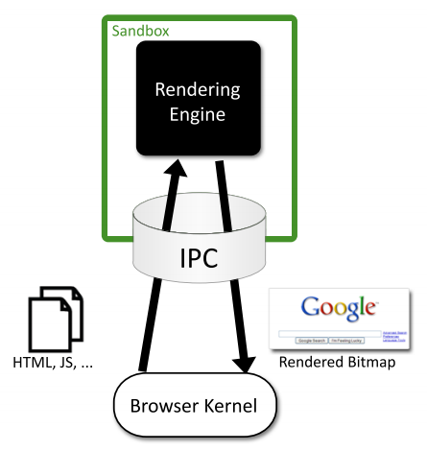

Figure 2: Chromium sandbox scheme

#### Browser Extensions Security:

Browser extensions provide useful additional functionality to web browsers, such as facilitating the access to a website’s content or even as almost standalone applications running on the browser environment. However, these extensions often introduce serious security issues into both user’s browser and websites, because most of the times they’re written by well-meaning developers who are not security experts. Extensions can read and alter users’ bookmarks and preferences, websites’ content and perform requests over the network, many times on behalf of the browser user. Browser extensions are mostly written in JavaScript and HTML, and since JavaScript provides methods for converting a string to code (e.g. eval), an extension may be dangerous if misused. Typically, benign extensions face two types of attackers:

* **Network attackers:** Targeting end-users who connect to insecure networks (public Wi-Fi hotspots), these attacks consist in reading and altering HTTP traffic, in order to detect if an extension adds an HTTP Script - JavaScript file loaded over HTTP - to itself, and altering the code in such case.
* **Web attackers:** A malicious website can launch a XSS attack on an extension if the extension treats the website as trusted, possibly stealing the browser’s userdata, like credentials. This way, it can scale up to attack multiple websites within the same entry point.

According to [2], Google Chrome and its extension platform apply three mechanisms to prevent these vulnerabilities: * **Privilege Separation:** Every Chrome extension has two types of components which run in separate processes: zero or more content scripts and zero or one core extension. Content scripts read and modify websites as needed. The core extension implements functionality not directly involving websites, like browser UI jobs or long-running background tasks. These two types of components communicate by sending structured clones over a trused channel. Each website that an extension communicates with, receives its own isolated instance of a content script, making content scripts highly bound to attacks. However, only the core extension is able to communicate with the Chrome extension’s API, reducing the risk that a content script is able to access the user data space. The architecture scheme of a Google Chrome extension is on Fig. 3. * **Isolated Words:** This mechanism ensures that content scripts and websites have separate JavaScript heaps and DOM objects. Consequently, content scripts never exchange pointers with websites, protecting them against web attackers. * **Permissions:** Extension developers have to specify the desired permissions in kind of a manifest file that is packaged with the extension. For example, the bookmarks permission is needed for the extension to be able to read and alter the user’s bookmarks. Only core extension can use permissions to invoke browser API methods, while content scripts are limited to interacting with the core extension and the website it is running on. This way, an extension is limited to the permissions its developer requested, so an attacker is not able to request new permissions for a compromised extension in runtime.

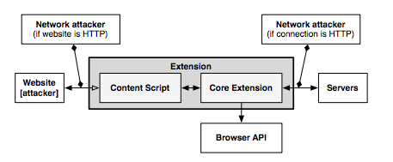

Figure 3: The architecture of a Google Chrome extension

#### XSS Detection Techniques:

Cross-Site Scripting attacks are getting more common on the web, since they allow an attacker to get control of a user’s browser and execute malicious code (usually JavaScript/HTML) within the trusted context of a web application. This can result in the attacker being able to access any sensitive information associated to the application (cookies, session IDs, etc.). The study of XSS attacks can be split into two distinct categories, according to [3]:

* **Persistent/Stored attacks:** Occurs when a malicious user registers itself into a web application and posts a malicious JavaScript to the application, which, by its turn, save it into the application’s data repository, persistently. After that, if another user fetches the content uploaded by the malicious one onto his browser, and since this code is coming out of the trusted context of the web application, the user’s browser will allow the script to access any possibly sensitive resource it is willing to, overcoming this way the security imposed by the same-origin policy. Apart from stealing the user’s information, XSS attacks can also be used to redirect users to a malicious website which can then perform other distinct attacks within its context. A persistent XSS attack scheme is presented on Fig. 4.

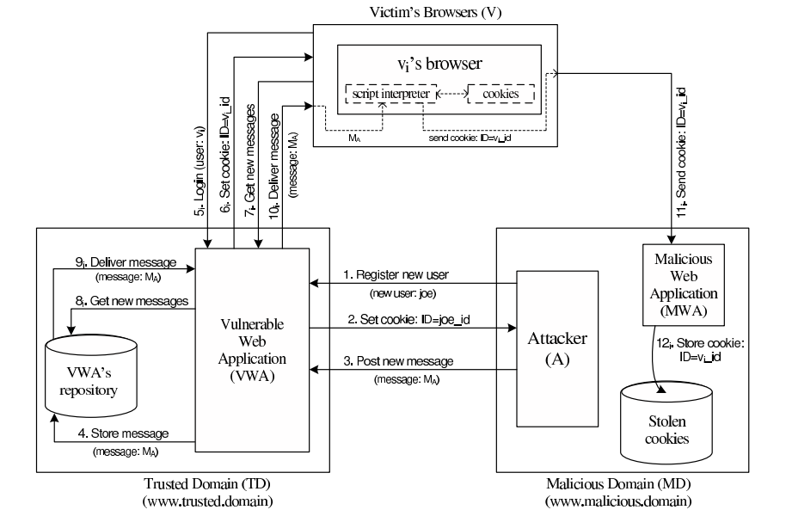

Figure 4: Scheme of a persistent XSS attack

* **Non-persistent/Reflected attacks:** Unlike the first type, reflected attacks do not persistently store malicious code in the web application data space. Instead of that, the content is automatically reflected back to the user through a third-party mechanism. For example, by using a spoofed email, an attacker can make a user click on a link containing malicious code, which will finally be interpreted by the user’s browser, but within the trusted context fo the web application. This type of XSS attacks is often combined with other techniques as phishing, and is the most common type of XSS attacks in web applications. Figure 5 shows a scheme of the architecture of a non-persistent XSS attack.

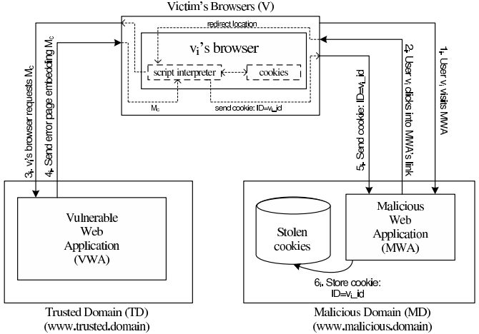

Figure 5: Scheme of a non-persistent XSS attack

#### XSS (and other types) prevention techniques:

* **Analysis and Filtering of the Exchanged Information:**

This technique consists in defining a list of characters or tags which users are allowed to exchange with the web application, in the form of text inputs, uploaded files, etc. Then, a filtering process simply rejects everything that is not part of the list. Other approach, reported in [4], is having a proxy-server at the web application’s site in order to filter both incoming and outcoming requests. This filtering takes into account a set of rules defined by the application developers. Although, a simple use of regular expressions is able to evade both the referred methods and proxy-servers can rapidly become a performance bottleneck on the application deployment. Authors of [5] also suggested placing a proxy-server on the server-side of the application, but in order to differentiate trusted and untrusted traffic, driving each type to separate channels. This partitioning process uses Information Flow Control techniques to taint information and track it thenceforward. On other point of view, approaches seen in [6,7] propose the content filtering to happen at the client-side. On the one hand, authors of [6] try to achieve the prevention of XSS attacks by blacklisting links embedded within the web application’s pages, making them unavailable for the client. However, the authors say this approach can only detect basic XSS attacks based on the violation of same-origin policy. On the other hand, authors of [7] present another client-proxy solution that is intended to detect malicious requests reflected from the attacker to the victim (non-persistent XSS attacks). If such a request is detected, the malicious characters are re-encoded by the proxy, trying to avoid the success of the attack.

* **Security Enforcement on the Web Browser Runtime:**

There are also other strategies which try to avoid the need for intermediate elements like proxy-servers by proposing startegies to enforce the runtime context of the web browser. In [8], authors propose an auditing system for the JavaScript interpreter of the Mozilla Firefox browser, which detects misuses on JS operations and take counter-measures to avoid violations on browser’s security. Other approach is also followed by [9], which presents the use of dynamic taint tracking on JavaScript code, in order to detect whether browser’s sensitive resources are going to be transferred to an untrusted third-party. In such case, the user is warned and can decide whether he allows or denies the transfer. Finally, the approach followed by [10] propose a policy-based management where a list of actions is embedded into the documents exchanged between the browser and the server. These actions help the browser to decide whether or not a script should be executed. Although, a lack of semantics in the policy-language and the restrictiveness of the approach due to the sandboxing-like mechanism are some of the drawbacks.

### Secure Elements

#### Java Card: Internet Computing on a Smart Card

In secure computing, a smart card is a typical card with a built-in computer chip. Until a few years ago, it was only used to produce credit and debit cards, whose information can only be accessed when in possession of the card itself and a PIN code. Due to the short information on how to communicate and program them, until a few years ago this useful technology wasn’t being used on computer security in general.

* **Hardware:**

This single-chip computer is an off-the-shelf **8-bit microcontroller** with added tamper-safe features. While most 8-bit microcontrollers can support at least **64 KBytes** of 8-bit memory, popular smart cards contain 4 to 20 Kbytes of memory, due to size constraints. The memory space of a smart card is divided into RAM, EEPROM and ROM. RAM is used to store temporary values when a program is running, while EEPROM is used to store sensitive data as an encryption key or the account holder info on credit cards. Finally, ROM is used to store the basic programs that run on the smart card. The single-chip computer is embedded in a plastic chip carrier, and both of them hold several tamper-resistant and tamper-detection features.

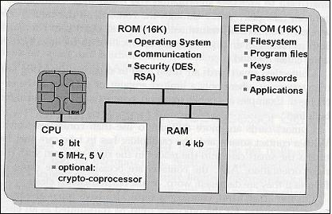

Figure 6: Java Smart Card scheme [11]

* **Software**

The paucity of 8-bit assembly language courses, books and software tools led engineers to break the smart card application bottleneck by building a Java virtual machine with its runtime support into a 12-Kbyte smart card. **Java** was the obvious answer for three reasons: * Java brings smart card programming into the mainstream of software development * Java “safe programming” security model based on a runtime interpreter is a nontrivial side benefit, due to its processor independence. A Java card can be deployed on multiple smart card models. * Java interpreters were tested to the limit, holes had been found, and fixed

With this in mind, engineers concluded that Java could preserve the required security in the smart card operation, while allowed a more friendly and well-known programming approach. However, available memory was an issue when deploying such heavy language runtime like Java. Features like garbage collection and exceptions handling were not included in Java Card because of that.

* **Internet Computing with Java Smart Card**

Java Cards combine smart card’s identity-verification features with the Java “sandbox”, guaranteeing that only allowed applications run on the card and that applications are protected from each other.

#### Cloud of Secure Elements

Cloud of Secure Elements (CoSE) [12] is an emerging concept whose goal is to provide trusted computing resources to mobile and cloud applications. To reach that, it relies on an infrastructure composed by multiple secure microcontrollers, named Secure Elements.

CoSE, in a WEB-like paradigm, are meant to support Uniform Resource Identifiers (URIs) for users to locate the different secure elements and use their embedded resources. These resources usually target two service types: Near Field Communication (NFC) facilities for mobile applications and trusted cryptogrtaphic features for cloud applications.

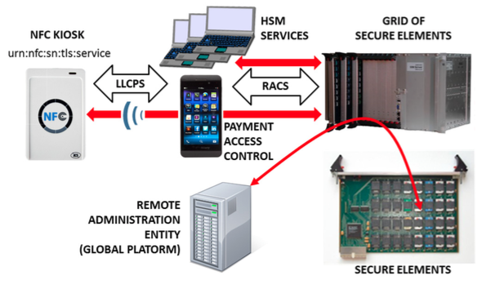

Figure 7: CoSE architecture

* **Architecture**

A Cloud of Secure Elements has the following components, as Fig. 7 shows:

* NFC kiosks, typically deliver payment facilities
* Users with NFC-enabled devices or terminals needing trusted cryptographic resources
* Grid of Secure Elements (GoSE)
* Secure elements, with resources identifiable by URI
* Remote administration entities, performing management operations over applications and secure elements
* **Grid of Secure Elements (GoSE)**

A grid of secure elements is an Internet server hosting multiple secure elements. Each element may be plugged in through USB readers, hardware sockets or electronic boards. Communication may be achieved with RACS protocol (works over IP/TCP/TLS stack) and performs both the association between elements and unique identifiers and data exchange with secure elements.

* **Malicious Code on Java Cards: Attacks and Countermeasures**

Despite all the advantages on using Java language in smart cards, such as the absence of low-level memory vulnerabilities, Java Cards still have an open door for attacks through malicious code. This attack entry is possible because an on-card bytecode verifier (BCV) is optional on Java Cards, and those who don't feature it, are more open to malicious code that might damage other applets running on the system or even the platform itself.

#### **Defenses against malicious code**

Here we present the different mechanisms for protection against malicious code actions present in Java Cards.

##### **Bytecode verification**

Bytecode verification of Java code guarantees type safety, and thus, memory safety. On normal Java platform, bytecode verification occurs at load time. Although, since Java Cards do not support dynamic class loading, this verification must occur at the time an applet is installed to the card. However, most Java Cards do not feature an on-card BCV and rely on a digital signature of a third party who is trusted to have performed bytecode verification off-card.

##### **Applet firewall**

The applet firewall is an additional defense mechanism present in Java Cards. The firewall performs runtime checks to prevent applets from accessing and/or altering data of other applets (concretely, in a different security context). For every object within an applet, the firewall records its context, and for any field or method accessed this context is checked. Only the Java Card Runtime Environment (JCRE) has unlimited permission, since it executes in root-mode, on a UNIX terminology.

#### **Getting malicious code on cards**

##### **CAP file manipulation**

This is the easiest way of introducing ill-typed code on a Java Card. This can be achieved by editing a CAP (Converted APplet) file to introduce a type flaw in the bytecode and install it to the card. Although, this will only work for cards without an on-card BCV and with unsigned CAP files. In example, by changing a baload (byte load) opcode onto a saload (short load) one, will make the platform treat a byte array as a short array, and can potentially lead to accessing other applet's memory space.

##### **Abusing Shareable Interface Objects**

The shareable mechanism of Java Card can be used to create type confusion between applets without any direct editing on CAP files. Shareable interfaces allow direct communication between security contexts. Using this to create type confusion is pretty simple: Let two applets communicate through a shareable interface, but compile and generate CAP files for both applets using different definitions of the shareable interface, which is possible because the applets are compiled and loaded separately. This way we can achieve an attack like the CAP file manipulation but without ever touching the CAP file directly.

##### **Abusing the transaction mechanism**

The Java Card transaction mechanism is probably the tricliest aspect of the Java Card platform. It allows multiple byte-code instructions to be turned into an atomic operation, offering a roll-back mechanism in case the operation is aborted, either through card tear or calling an API method. Buggy implementations of the transaction mechanism in some cards tend to make it not behave as expected. When object references are spread around the code, by assignments to instance fields and local variables, it becomes difficult for the mechanism to keep track of all the references that should be nulled out. The root cause of the problem is that stack-allocated variables, such as short[] localArray are not subject to roll-back in the event of a programatically transaction abort (through API method call).

#### **Dynamic countermeasures**

Now we present some dynamic runtime checks implemented by some VMs in order to prevent ill-typed code to damage the Java Card platform. These were verified by [13], by performing tests on multiple Java Card models of multiple manufacturers against the referred vulnerabilities.

* Runtime type checking
* Object (array) bounds checking
* Physical (byte size) bounds checking
* Firewall checks
* Integrity checks in memory

### **Automated Analysis of Security-Critical JavaScript APIs**

Current web applications usually rely on JavaScript in order to offer additional features like maps, widgets or social media content. Although, since these additions may manipulate a page Document Object Model (DOM), steal cookies or navigate on the page, untrusted third-party JavaScript may pose security threats to the hosting page.

A widely-used approach is to combine a language-based sandbox to restrict the capabilities of untrusted JavaScript with an API offered by the trusted code part to the untrusted one. This API encapsulates all security-critical resources and guarantees they are only accessed in a safe way.

Given this, the authors of [14] proposed ENCAP, a tool that verifies API confinement, analyzing the isolation level it can offer to the critical objects it is intended to protect. ENCAP relies on a context-insensitive and flow-insensitive static analysis method. It analyses the API implementation and generates a conservative Datalog model of all API methods. Also, they propose SESlight, an ECMA JavaScript-subset language which only allows a strict (syntactically and semantically verified) subset of the whole language to be used.

## Standards

The reTHINK project describes a framework that provides solutions to manage real time communication capabilities. To implement this framework the project team tried to use the most suitable existing standards which provides compability which existing technoligies. Using consolidated and widely used standards also make the development more efficient since Open Source libraries can be used in the developments. Addtionally to well-known standards, the project team has also tried to find emerging standards which can be adapted for ReTHINK requirements. In those cases, a tradeoff analysis has been made to determine if the choice of a not consolidated standard is optimal in terms of cost of use due to the lack of existing libraries and projects which use them.

The IETF has been creating and promoting the Internet standards since 1986. The IETF is organized in a large number of Working Groups (WG) which works on specific areas. For ReTHINK project, the team has focused on standards delivered by several WG (namely Rtcweb, TRAM, HTTP/2 and Network). The Rtcweb WG has defined a set of RFCs (many of them are still drafts) which are used in WebRTC, it defines how WebRTC works on the wire. Many of the used protocols already existed but many of them were created ad-hoc to meet WebRTC requirements. Other RFCs are informational and hes been released to gather the WG knowledge in a formal way. The TRAM (TURN Revised and Modernized) working group is carrying out a modernization of the protocols used to transport real-time media over Internet which is the final function of ReTHINK framework.

HTTP/2 is the new version of HTTP/1.1 which has been used in the web for the last 16 years. It provides a new low level design to optimize current Web applications keeping the semmantic of HTTP/1.1 which is still valid. HTTP/1.1 has been historically transported over TCP, however to take advantage of all the new features of HTTP/2 a new transport protocol build over UDP has been designed: QUIC. HTTP/2 draft is based on SPDY but it includes new features and will soon become a definitive RFC. The draft belongs to the HTTP WG. QUIC was developed by Google but it has been recently become an IETF Draft taking over the last changes in the protocol until close the defintiive RFC. HTTP/2 over QUIC has been considered as an alternative for messaging in the ReTHINK framework as it is optimized to be used over wireless connection and minimizes the delay in every communication.

The IETF is in charge of standarizes all the protocols on the wire in Internet. In turn, the W3C (WWW Consortium) is the main international standards organization for the World Wide Web. It standarizes how the browser behave (e.g. WebRTC 1.0 API exposed by the browsers) and and the lenguages (e.g. HTML and Javascript) which can be executed by a standar browser. It is main role is to promote and homogenize the evolution of the Web. During the state of the Art research work we focused on the standards susceptible of being used by any element within the ReTHINK framework.

The WebRTC 1.0 API has been standarized by the W3C is the way in which a Javascript application interacts with the browser to establish real-time sessions with other WebRTC endpoints. A comprehensive knowledge of this API was necessary to make design decissions and to define the architecture and the data model of the framework.

A Community group has been created within the W3C to promote an alternative WebRTC API called ORTC (Object Real-Time Communications) which gives more control to the WebRTC developer making easier to implement some scenarios. There are still not implementations of ORTC in production-ready browser, however the features introduced by this standard which is likely to become the base of the WebRTC 2.0 API have been considered during the design phase.

Another relevant W3C API is the Push API which allows a push service to send "push messages" to a webapp regardless of whether the webapp is currently active on the user agent. This is specially usefull for webapps running on mobile devices where the webapp may need to receive a notification while the browser is not in foreground.

The use of another feature supported by browser called Service Workers has been already evaluated to be used to implement different parts of the Runtime environment. Despite the fact that this specification is still a Working Draft of the W3C it is already supported by the most important browsers. However, this is feature is not supported by server side Javascript-based runtime environment, it only can be used when the Runtime is executed by a browser.

There is another interesting W3C Draft called "Application Lifecycle and Events" which extends the Service Workers with APIs for managing the lifecycle of an application and associated events. This Draft allows web developers to create applications that manage the application lifecycle and react to system events e.g. email or VoIP application. However, this Draft has been not been adopted by many vendors so far.

In this section the standars released by the Open Mobile Alliance (OMA) were also reviewed. The OMA is a Mobile Operator driven industry forum for the definition of interoperable mobile service enablers. OMA defines APIs to offer functionalities and resources of Operator networks to developers. Amongst the API and protocols standarized by the OMA the team decided to reviewed those which are relevant for the project such as the Authorization Framework for Network APIs, the RESTful Network API for WebRTC Signaling, Quality of Service API and Notification Channel. The LWM2M/COAT protocol which was designed to be supported by constrained devices has also been considered as a suitable alternative to interact with the Registry and Discovery services.

Finally, a recent standar called Smart Device Template (SDT) and released by the HGI (Home Gateway Iniative) has been reviewed. It provides a framework to create a consistent representation of Smart Home devices. This makes easier the integration of new devices in Home Gateway or in the cloud being specially interesting to implement M2M within the ReTHINK framework.

## Runtime

A very comprehensive analysis and evaluation of existing web runtime solutions was performed.

In order to evaluate the possibility to modify native implementations of WebRTC engines, Ericsson OpenWebRTC and Google WebRTC.org solutions were considered. OpenWebRTC is a promising modular WebRTC implementation based on popular GStreamer multimedia framework open source solution. Unfortunately, OpenWebRTC is not much supported by Ericsson lacking required documentation to let it be adapted to fulfil reTHINK new requirements. Google WebRTC.org solution is the reference implementation of WebRTC specification providing all APIs defined in the standards. However, the effort required to change it to fulfill reTHINK requirements is estimated to be very high. On the other hand, having an extended version of an existing WebRTC implementation would require the user to install a new reTHINK Browser. For all the above reasons, it was decided to re-use existing native implementations of WebRTC engines without modifications.

Javascript engine solutions were evaluated to analyse the possibility to adapt them in order to fulfill reTHINK runtime requirements, notably in terms of security (sandboxing). The V8 JavaScript Engine is an open source JavaScript engine developed by Google for the Google Chrome web browser. It has since seen use in many other solutions and it is considered the most powerful Javascript engine in terms of features and performance. It has mechanisms to facilitate its extension with new features but lacks required mechanisms for sandbox creation. One evaluated alternative, is to use nodejs that runs on top of V8 as well as having nodejs inside Docker taking advantage of its management and security features. Both solutions fulfill reTHINK security requirements and will be considered for reTHINK runtime implementations that are not based on browsers.

Firefox OS is a good candidate to implement reTHINK runtime in mobile devices supporting this Operating Systems. It natively suports JavaScript and HTML APIs 5 (including WebRTC) as programming language, and a robust privilege model to communicate directly with cellphone hardware, and application marketplace.

Three WebRTC based Media Server solutions were evaluated. Jitsi Videobridge supports Selective Forwarding Unit (SFU) for multiuser video communication and it is based on XMPP architecture. Kurento, supports MCU/SFU Star topologies and a modular architecture to implement media processing services. Janus Gateway is a flexible and modular WebRTC gateway that can be used to deploy a full-fledged WebRTC gateway on a cloud provider or just a small nettop/box to handle a specific use case, looking at applications as pluggable modules that a client can connect to through this gateway. These solutions, are good candidates to support server side Hyperties providing media related services.

## Messaging

*To make a summary of* [*contributions about messaging SOTA*](../sota/messaging) *including an evaluation on how to be taken into account in reTHINK and how. The full contributions will be provided in annex*

## Service Frameworks

*To make a summary of* [*contributions about Service Framework SOTA*](../sota/web-frameworks) *including an evaluation on how to be taken into account in reTHINK and how. The full contributions will be provided in annex*

An analysis of existing JavaScript frameworks based on the reTHINK service framework requirements was carried out on some of the popularly used frameworks today. These frameworks all endeavor to facilitate the development of web applications utilizing the Model-View-Control design pattern. For the reTHINK project however, focus was on the data model management and routing capabilities of these frameworks.

Even though Angular JS is the most popular framework, which provides great two way data-binding allowing for synchronization of data, and has a large community base, it was not considered a suitable applicant for this project due to its complex directives API and inflexibility on configuring (i.e. it offers no configuration possibilities after the Bootstrap procedure). Another reason is that Angular is more suitable for Single Page Apps (SPA) unlike a dynamic environment like the reTHINK runtime where multiple applications can be downloaded and executed concurrently.

Another framework analyzed was Backbone.JS which also did not fit into the reTHINK service framework requirements due to the lack of a modular structure. Backbone lacks a controller concept and views and Models are relatively tightly coupled, resulting to tightly coupled modules which are not desirable for the reTHINK project.

StapesJS another framework analyzed offered a lightweight less complex framework especially suitable of mobile platforms. However it in itself offers very little APIs and demands combination with other libraries such as JQuery, React and Rivets.

MeteorJS and Polymer on the other hand are good applicants. While MeteorJS offers rapid prototyping and produces cross-platform code for mobile and fixed platforms, Polymer offers a lightweight shim that uses a new faster data-binding system which significantly reduces code size for modern browsers.

Polymer provides special features for registering JavaScript elements, lifecycle callbacks, property observation and data-binding, which are all functionalities to enhance the architecture of the Hyperty Runtime environment. MeteorJS offers the distinct advantage to be used both for all devices and operating systems featuring the Hyperty Runtime and with less complexity with respect to other frameworks. However it has very strong dependency to the back end server being NodeJS. What this means for the reTHINK project is it will fit in perfectly, if the tool of choice for the Messaging Node where NodeJS. This is compatible with the other components as NodeJS is one of the tools considered for the reTHINK Messaging Node.

To summarize, the main objective of service framework is to provide an SDK which developers can utilize to facilitate the development of Hyperties. The SDK is envisioned to provide high level APIs on top of the Runtime APIs for managing especially the data models. It will also provide basic templates for different Hyperty Types which developer can use or extend in developing more advanced merged-up Hyperties.

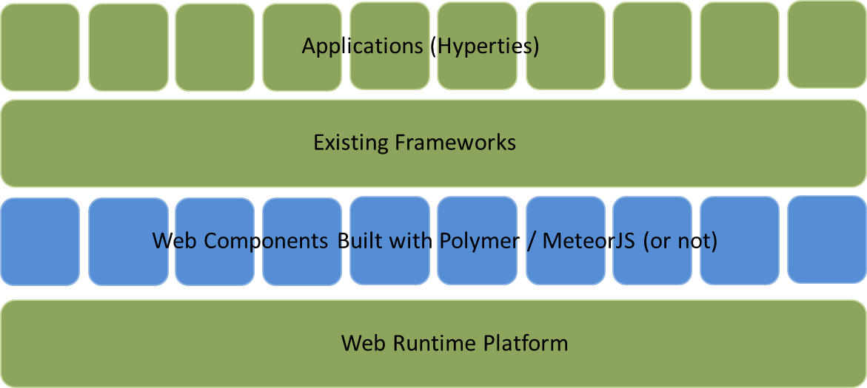

Figure 8: Service framework middle layer

The existing web platform (runtime) is the basis of all applicatiion development. With the middle layer of web components offering a new set of bulding blocks to choose from, a new ecosystem is formed on top of which other frameworks and applications exist. From the analyzed existing JavaScript Frameworks, MeteorJS and Polymer offer a good stepping stone to extend and be used within the reTHINK project.

## Projects

The WONDER project has enlightened some foundations paths to be followed in a post-IMS era dominated by Web technologies that reTHINK is currently exploiting. Notably, the novel Signalling On-the-fly (SigOfly) concept was conceived and successfully demonstrated to enable seamless interoperability between different WebRTC service domains. reTHINK Protocol On-the-fly concept extends WONDER, the Signalling On-the-fly concept to any other service domain where needed protocol stacks can be executed in a Web Runtime.

The WONDER Library used to validate SigOfly concept can be used in reTHINK as a good starting point to design and implement reTHINK runtime APIs and reTHINK Javascript framework.

## Products

### ApiRTC

#### What is ApiRTC?

ApiRTC is the communication platform developped by Apizee. This includes a communication platform and a client JavaScript library that can be used by developpers to developped their own applications without having to consider the technical aspects of communication. Complete version of ApiRTC with tutorials is described on www.apirtc.com

#### Features Overview

ApiRTC Entreprise edition includes following features :

**Session :**

Connexion : long polling , webSocket; HTTP, HTTPS; Presence : group connection and subscription; Custom User Data sharing ; Browsers type and version detection

**IMClient :**

Instant Messaging : 1 to 1, Group

**WebRTC Client :**

* Voice Calls, Voice and Video Calls
* Audio, video mute
* ScreenSharing
* TakeSnapshot
* Support of IE and Safari for audio and video calls through a plugin
* Network disconnection detection
* Network traversal management for media flows
* DataChannel
* Calls recording
* Connection to IMS, RCS, SIP Architecture
* Conference calls

**Data Client :**

Custom data sending and reception

**Compatibility :**

Window, linux, OSx, Android devices through WebRTC compatible browsers Plugin for Android and iOS application development

#### Architecture Overview

ApiRTC solution use different components on server and client side.

**Messaging Node :**

On server side, main used components are NodeJs and Redis :

NodeJs : https://nodejs.org/ - Description is available : http://en.wikipedia.org/wiki/Node.js

NodeJs is a Javascript engine that can be enhanced through diffrent existing modules for connections, log, ...

Redis : http://redis.io/ - Description is available : http://en.wikipedia.org/wiki/Redis

Redis is a NoSQL database that is really interesting for real time data and that provide a publish/subscribe that can be used to establish communication between several nodeJs process.

**Runtime / Framework :**

ApiRTC use a javascript library on client side to provide teh developers APIs that enables teh developpesr to use platform feature.

#### Architecture

ApiRTC actual architecture is presented on following diagram :

Components such as NodeJs, Redis or socket.io are used. ApiRTC uses JSON over WebSocket to manage signalling between clients and server.

#### APIs

ApiRTC provides API for developers : complete set of APIs is describe on http://apirtc.com/api-docs/

APIS are decomposed with main following classes : * ApiRTCSession

manage user connection to the platform (presence) * ApiRTCWebRTCClient : manage WebRTC feature : call, dataChannel ... * ApiRTCIMClient : manage Instant messaging feature * ApiRTCDataClient: : manage data sending feature * ApiRTCWhiteBoardClient : manage Whiteboard feature

#### Requirements Analysis

Analysis regarding WP3 Messaging node requirements :

**Messaging Node with carrier grade deployment features :** NodeJs and Redis enables to buld a resiliante and scalable architecture

**The Messaging Node MUST offer DoS and DDoS Protection :** User authentication, message rate limitation are example of feature taht may be implemented to fulfill this requirement

**It should be possible to support Protocol on-the-fly :**

ProtOFly connector can be developped. JS connector can be develop on top of NodeJs to enable protofly on server side. This connector will be for example reusable to connect an external CSP, Kurento Media Server, or the Identity manager

**Messaging Transport Protocols:**

Socket.io enables the usage of different transport protocol to establish connection between user and server. (Long polling, WebSocket ...)

**Messaging Node logging :**

Several logging modules are available : log4js, winston, bunyan ... Logs can be dispalyed in console, store in file with log rotate, send to a network entity ...

**Message delivery reliability :** Socket.io enables message acknowledgement

**Messaging Node deployments with carrier grade scalability :**

Using Redis cluster mode : it is possible to use Redis Cluster with PUB/SUB mechanism : several NodeJs entities can be connected through the redis cluster : this can enable load balancing, redundancy

**Messaging Node should be tolerant to unstable connections :**

Socket.io can manage reconnection with different configurable parameters (timeout, retries ...) reconnection whether to reconnect automatically (true)

reconnectionDelay how long to wait before attempting a new reconnection (1000) reconnectionDelayMax maximum amount of time to wait between reconnections (5000). Each attempt increases the reconnection by the amount specified by reconnectionDelay. timeout connection timeout before a connect_error and connect_timeout events are emitted (20000)

**Events about clients connection / disconnection from Messaging Node :**

Using socket.io different events are fired on connection status : connect. Fired upon connecting. error. Fired upon a connection error disconnect. Fired upon a disconnection. reconnect. Fired upon a successful reconnection. reconnect_attempt. Fired upon an attempt to reconnect. reconnecting. Fired upon an attempt to reconnect. reconnect_error. Fired upon a reconnection attempt error. reconnect_failed. Fired when couldn’t reconnect within reconnectionAttempts

**Messaging Node must support very low message delivery latency :**

**Messaging Node must be deployable in the most used Virtual Machines :** NodeJs is available on Linux, windows, mac and can be deployed on small virtual machine or devices

**Messaging Node should require minimal computing resources :** Messaging nodes components can be isntalled in only one VM

**Messaging Node must support external authentication and Authorisation :** Module like Passport : http://passportjs.org/ enables to use external authentication like facebook, twitter, google .. (We will have to check if passport can be used as it seems to require Express which may not be relevant in rethink case)

**Messaging Node must support multiple messaging functionalities :** Several routing can be performed with socket.io. Send message to only one dest, broadcast message to several users

#### Integration in Rethink

ApiRTC can be used in a nodejs based Messaging Node.

Integration of ApiRTC in Rethink can be done by adding differents connectors depending of needs : - Identity Management : connector to Identity server - QoS Management : connector to QoS server - Other Web communication platform : connector to communication platform using ProtOFly - VoIP Platform : Connector to WebRTC GW - Connector to Media Servers

A Redis Cluster with Pub/Sub mechanism can be used to manage communications between connectors

For Rethink, Apizee propose the usage of apiRTC, for instance to simulate an external CSP connection.

### State of the art of current WebRTC solutions of Quobis

#### What is Sippo?

Sippo is the name of a WebRTC product family authored by Quobis which includes the following products: - Sippo WebRTC Application Controller: the server which provides the services. - Sippo WebRTC Apps: reference web applications which leverage the main features provided why the WAC. Two examples: - Sippo WebCollaborator: Reference enterprise WebRTC softphone - Sippo Click To Call: Reference customer contact WebRTC softphone

#### What is a “WebRTC Application Controller”?

Sippo WebRTC Application Controller (WAC, in short) is a solution that allows to deploy WebRTC applications fully-interconnected with existing services (AAA, OSS, BSS, etc.) and legacy VoIP or UC systems.

Sippo WAC supports a number of business cases, through its APIs, ranging from a simple click-to-dial button to advanced scenarios like RCS-based services, integration with existing Web Portals (including Facebook, Twitter or GMail), Banking, Health, Logistics, call centers/CRMs, UC, etc.

Sippo is standards compliant and has been designed and developed by engineers who participate in WebRTC standardization forums like W3C, IETF, 3GPP, SIPForum and GSMA. Thanks to its abstraction layer, Sippo can include new signaling modules rapidly or even use different signaling protocols within the same application (e.g. one signaling protocol for audio/video, another for IM/presence, etc.).

Sippo WAC is the right tool to develop, adapt or deploy any WebRTC tool in a SDN, in the case of telcos, or corporate architecture, with the security that it is going to be interoperable with the existing services and WebRTC gateways. In addition it provides features to manage user provisioning, store call detail records and provides contextual information

Sippo has been developed by Quobis and it's distributed worldwide through a network of first-class partners and UC vendors.

#### Reference architecture

Sippo WAC is a network component which sits on the edge of the network, in close collaboration with the WebRTC gateway. The following picture describes how the WAC fits into a service provider or enterprise voice network:

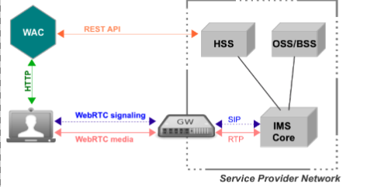

Figure 9: Sippo WAC reference architecture

The following network elements are the basic ones to understand the reference architecture (from right to left):

* Service Provider Network: this block represents the existing UC platform owned by the enterprise (where we might find a corporate PBX) or service provider (where we might find an IMS core or a Class 4/5 softswitch). In the latter case we will also find OSS/BSS systems and other identity management platforms that interact with Sippo in some way.
* Third-party WebRTC gateway: in some cases where the UC core does not support WebRTC traffic, there is a need for a WebRTC gateway which takes care of the translation of both the signaling and media plane. Signaling can be standard based (like SIPoWS) or a vendor-specific signaling protocol. The WebRTC gateway can be a standalone network element or it can be a functionality embedded into an existing network element like a SBC or an application server. Sippo excels in interoperability with leading gateway vendors thanks to its award-winning abstraction layer, please consult your sales manager for a complete list of supported vendors.
* WebRTC Application Controller (WAC): this is the network element where the WebRTC applications are deployed and managed. Applications are downloaded to the browser from the WAC vía HTTP, while the actual media and signaling traffic goes to the customer network through the WebRTC gateway. Sippo runs on a dedicated server which can be installed at the customer premises or in the cloud.
* Web browsers: the WebRTC applications are downloaded into the web browser after the user has been authenticated. From the point of view of the end-user, this is the only application that he/she will need to use. Sippo applications needs to have HTTP connectivity with the WAC and with the WebRTC gateway.

In a real deployment there are a number of additional network elements involved such a Session Border Controller, firewalls, STUN/TURN servers, SIP routers, etc… which will interact in some way with the WebRTC services and applications.

#### Understanding the role of a WebRTC Application Controller

The term “WebRTC Application Controller” has been coined by Quobis after our experience deploying WebRTC projects in large service providers all around the world. In a real setup, there are a number of features that are not meant to be provided by the service provider network, the WebRTC gateway or the browser (for example, authentication, identity management or security).

Sippo brings to the market a rich set of features which speeds up the deployment of WebRTC into existing networks, as for example:

* Multi signaling mechanisms
* SIP over WebSockets (RFC 7118)
* JSON-based APIs
* REST-based APIs
* Identity Management
* User provisioning
* Security Control
* Policy Control
* Statistics and logging
* Address book synchronization
* Browser abstraction layer

Besides those features, Sippo provides sippo.js, a ORCA.js (http://www.orcajs.org) compatible API for application developers hiding all the complexities of WebRTC signaling and media, hence enabling applications to be developed once and run in different devices, browsers and network environments.

Along with Sippo, Quobis has developed a number of WebRTC applications for specific verticals such as the Sippo Web Collaborator, Sippo Click to Call or Sippo GMail Toolbar.

#### Sippo interfaces and API’s

Sippo offers a set of different API’s and service interfaces that are summarised in the picture below:

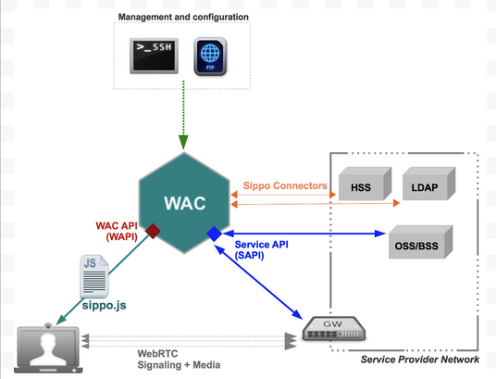

Figure 10: Sippo interfaces and APIs

##### Sippo.js API

Sippo.js is a Javascript API that is downloaded to the user’s browsers, thus containing all the signaling stacks and WebRTC media API calls. Sippo applications are built on top of this sippo.js API and it can also be used by third-party developers to code their own client applications.

Sippo.js API supports a complete set of signaling stacks, including both standards-based (like SIPoWS, authored by Quobis at RFC7118) and vendor-specific ones. That means that the applications built on top of the Sippo.js API are capable of communicating with different gateways from different vendors without changing the code. That’s one of the benefit of using Sippo.js API as it hides the complexity of the underlying signaling plane and provides a single and simple-to-use javascript API to the applications.

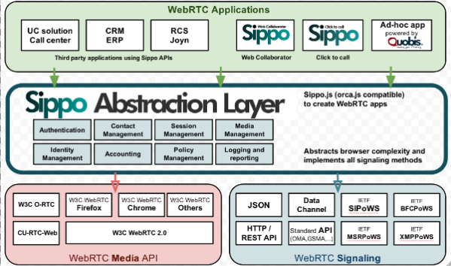

Figure 11: Sippo.js abstraction layer

##### Sippo Service API (SAPI)

Sippo Service API (SAPI) is a REST API which allows to connect Sippo WAC to different elements from the operator’s core and access network. This API can play both client-role and server-role to integrate the Sippo WAC and the WebRTC applications into the core.

SAPI is used in server-role between the WebRTC gateway and the WAC. It can be used for Identity Management (IdM) checks as part of the authentication process and check the permission set of the subscriber. When a some requests reach the WebRTC Gateway from a WebRTC Application, the gateway in turn verify the identity of the subscriber using the WebRTC application by sending an IdM request to the WAC through the SAPI.

##### Sippo connectors

Some of the Sippo features requires to connect to external services or to behave as a server to third party platforms. Some of those features are exposed to the sippo.js API while others are internal to the Sippo core.

Sippo connectors available so far in this version are:

* LDAP connector: Sippo can synchronize with an external LDAP server to retrieve contact lists, phone numbers and related information.
* Vendor-specific connectors: Sippo provides specific connectors for some features provided by the gateway vendors. The details of each connector is described in the joint application notes issued by Quobis and each vendor, please contact your sales representative for more information. The configuration of these connector is described in annex documents to this guide.

##### Sippo WebRTC API (WAPI)

This is an internal API offered by the Sippo WAC to the client applications, and it’s not intended to be used by third parties. This API basically interchanges messages between the application and the WAC using WebSockets (JSONoWS) or HTTP.

#### Sippo internals: services and backends

This explains some basic concepts of the Sippo architecture, in order to understand how to properly configure the controller and all the services provided and also how the different sippo.js API calls are interpreted and managed from the WAC depending on the configuration.

There are two key concepts to understand the internal architecture of Sippo: services and backends. A service is a functionality provided by the WAC, whereas a backend is a implementation of a specific service. In other words, we can say that a services is “what” to do and the backend is “how” to do it.

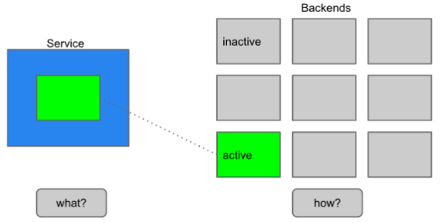

Figure 12: Sippo services and backends

There are thirty-three available services at Sippo WAC that are listed alphabetically in the table below. Some of those services have a 1-to-1 implementation at sippo.js API calls while others are internals and not exposed to the end user, but are explained here for completeness.

#### 1.7. Sippo WebRTC applications

Services providers and enterprises can deploy their own WebRTC applications using Sippo WAC, developed by using the existing Sippo Javascript API sippo.js (which includes the Sippo Abstraction Layer) and also making use of all the Sippo services like authentication, contacts, etc…

Every Sippo application needs to run connected to a Sippo WAC, as some of the features are not implemented on the browser but on the WAC.At the current Sippo version, both the applications and the sippo.js libreries must be hosted and donwloaded from the WAC. This is mandatory on this current version. Please note that, in this scenario, some cross-domain issues may arise. Please contact Quobis system engineering department for more information on this topic.

Communication between the WebRTC applications running on the browser and the Sippo WAC is done by using the WAPI interface, which dispatches the incoming messages to the corresponding services, as shown in the picture below:

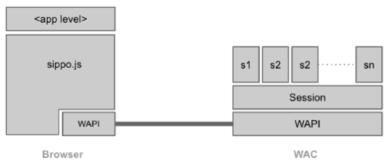

Figure 13: Sippo WebRTC applications stack

#### Potential integration with Wonder proposal

##### About signaling-on-the-fly

The WONDER Javascript Framework was designed and implemented to address the lack of a standard WebRTC signalling protocol by implementing the novel Signalling On-the-Fly concept, enabling seamless interoperability between different WebRTC Service Provider domains.

The WONDER library assumes there won’t be a standard WebRTC signaling protocol to give developers the freedom to select (or invent) the protocol that better suits WebRTC Application needs and, at the same time, standardization tasks effort are minimized, shortening innovation to market timing. This means, the message server and associated protocol stack can be selected, loaded and instantiated during runtime. Such characteristic enables signaling protocols selected per WebRTC Conversation to ensure full Signaling interoperability among peers using Triangle based Network topologies. Such mechanism we call Signalling on-the-fly.

##### Signaling-on-the-fly versus multi-signaling support

The Sippo WebRTC Application Controller tries to hide the complexity on vendors thanks to the support of different signaling stacks. This means that while a web client is making a request to the WAC to have access to a WebRTC application, the WAC adapts the JS code of the application to the type of gateway to use the signaling protocol that the gateway is supporting.

The Sippo WAC has a mechanism to deal with different gateways (including those from different vendors) in an active way, so high availability and scalability can be achieved with no need to use a load balancer for the gateways. It’s important to mention that he Sippo WAC does not manage real time traffic as this goes from the browser to the other browser (or to the gateway in case of interconnection with legacy networks).

In order to leverage the result and proposals of Wonder around signaling on the fly we can explore the possibility to move to the application (and browser) the complexity of selection the signaling for the call (now the abstraction layer is part of the WAC, as described in section 1.5) or try to adapt the Sippo WAC to manage the rehydration of signaling of the clients during a call or session.

The WAPI, as the API that interchanges messages between the application and the WAC using WebSockets (JSONoWS) or HTTP, can play an active role in both options to manage this approach.

#### Requirements Analysis

Sippo.js provides a high level abstraction layer which allow to build WebRTC applications in an easy and quick way. Sippo.js supports many signaling protocols for WebRTC and can be used with WebRTC gateways from many vendors. This is possible thanks to it implements a static-flavor of the protocol-of-the-fly approach used in reTHINK project. This was identitified in the early stages of WebRTC as a need to deal with the signaling diversity in the WebRTC arena. Sippo.js can be adapted to be an intermediate layer between the hyperty and the web application hidding all the innecesary complexity to te developer. This will also allow that all the applications already build over Sippo.js can be used in reTHINK reducing considerably the integration costs.

# Hyperty Runtime Specification

## Runtime Architecture

The main Hyperty runtime architecture is presented in fig. (**???**). It is comprised by different types of components that, for security reasons, are executed in isolated sandboxes. Thus, components downloaded from a specific Service Provider (e.g. Service Provider 1 from fig. (**???**)) are executed in sandboxes that are different from the sandboxes used to execute components downloaded from another service provider (e.g. Service Provider 2 from fig. (**???**)). In addition, for the same Service Provider, and also for security reasons, protocol stubs and Hyperties are isolated from each other and executed in different sandboxes. Communication between components running in different sandboxes are only possible through messages exchanged through a message bus functionality provided by the Core Sandbox. In general, in the Core Sandbox, all required functionalities to support the deployment, execution and maintenance of components downloaded from service providers, are executed. Core components are, ideally, natively part of the device runtime. However, to support existing platforms including Browsers and Mobile Operating Systems, to minimise the need to install new applications, the existing device native runtime functionalities (e.g. Javascript engine) are distinguished from the hyperty core runtime functionalities. In such situations, the Hyperty Core Runtime components are downloaded from the Hyperty Runtime Service Provider and are executed in an isolated core sandbox.

Figure (**???**) High Level Runtime Architecture with trusted Hyperties

Figure (**???**) High Level Runtime Architecture with trusted Hyperties

In figure (**???**), the Application and the Hyperty Instances it consumes, are downloaded from the same Service Provider, and they trust each other, i.e. they are executed in the same sandbox. In figure (**???**), it is depicted the Runtime Architectyre where the Application and the Hyperty Instances it consumes, don't trust each other, for example, they are downloaded from different service providers. In such situation, Hyperties and the Application are isolated from each other and are executed in different sandboxes.

Figure (**???**) High Level Runtime Architecture with untrusted Hyperties

Figure (**???**) High Level Runtime Architecture with untrusted Hyperties

According to [ongoing discussions](https://github.com/reTHINK-project/core-framework/issues/41): * one sandbox for the ASP providing the Application * one sandbox per Hyperty Service Provider Domain that includes the Router/Policy Engine and associated protoStub * the ProtoStub is used to communicate with Service Provider backend services. * Hyperty instances communicates with Msg bus through Router/Policy Engine which may also act as a kind of firewall * according to recommendations provided in the [runtime security analysis](securityanalysis.md), protoStubs and Router/Policy Engines execute isolated in independent sandboxes. * to prevent cross origin attacks / spy, access to Message BUS may be subject to authorisation * Different Points of Policy Enforcement: * Policies enforced at Hyperty Sender Domain Router for outgoing messages * Policies enforced to control the access to message Bus * Policies enforced at Hyperty Receiver Domain Router for incoming messages

The different types of policies to be applied on these different points, namely in the Message BUS, requires further research to avoid performance overhead and potential conflicts. Initial thoughts: Message BUS PEP would enforce general access control policies that are agnostic of sender and target domains, or specific to the domain managing the device runtime (Core Runtime Provider). The access control to CRUD operations on standardised data objects like the Communication Data Object (eg only the owner of an active communication may apply delete or update operations on it) is a good candidate.

Below, it is depicted a functional architecture of the Runtime:

*Provide first a higher level architecture without showing detailed components. Distinguish internal APIs from external Interfaces which should be identified according to names defined in D2.2.*

High Level Runtime Architecture with unstruted Hyperties

High Level Runtime Architecture with unstruted Hyperties

### Service Provider Sandboxes

According to Browser Sandbox model, each Service Provider Sandboxes executes components downloaded from the same Service Povider domain including Hyperties, protocol stubs used to connect and communicate with Service Provider Domain and PEP enabled Connector.

Functionalities to support Hyperty Communication through data object synchronisation are provided by the Syncer component based on Object.observer API. Details are discussed [here](https://github.com/reTHINK-project/architecture/blob/master/docs/datamodel/data-synch/readme.md).

#### Application

#### Hyperty

#### Policy Enforcer

Handles communication between Hyperties and the local Message Bus, enforcing when needed valid Policies on this communicayion (e.g. authorisation policies) according to Service Provider domain policies. It also enforces access control policies to synchronised object (Object Monitor functionalities as proposed [here](https://github.com/reTHINK-project/architecture/issues/52)).

#### Protocol Stub

Protocol Stack to be used to communicate with Service Provider Backend Servers (including Messaging Server or other functionalities like IdM) according to Protocol on the Fly and codec on the fly concept.

Protocol stubs are reachable through the Message BUS. In this way it is ensured that all messages received and sent goes through the message bus where policies can be enforced and additional data can be added or changed including message addresses and identity tokens.

### Core Runtime

Complete Hyperty Runtime Architecture

Complete Hyperty Runtime Architecture

#### Policy Decision Point and Message BUS authorisation

It provides Policy decision functionalities for the Service Provider Router sandbox according to Policies downloaded and stored locally when associated Hyperties are deployed. The possibility to consult Policies stored remotely should also be investigated. It also provides authorisation / access control to the Message BUS.

#### Message BUS

Supports local message communication between Hyperty Instances in a loosely coupled manner. Access to message BUS is subject to authorisation to prevent cross origin attacks / spy from malicious Hyperties.

See [postaljs](https://github.com/postaljs/postal.js)

#### Registry

Local Runtime Hyperty registry where Hyperty local addresses are registered and discoverable by other local Hyperties. The Runtime Registry should ensure synchronisation with Remote Domain Registry (to be provided by WP4)

#### Identities Containers

Contains Tokens that associates Hyperties with Users, it also provides Identity assertions. Something similar to [WebRTC IdP Proxy](http://w3c.github.io/webrtc-pc/#identity) but not limited to WebRTC.

When registered, Hyperties are associated with an Identity by the Registry / Identities container. Then all, messages sent by the Hyperty will be signed with a token according to the Identity associated to the Hyperty.

#### Runtime User Agent

Manages Core Sandbox components including its deployment and update from Core Runtime Provider. It also handles Device bootstrap and the deployment of Hyperties and Protocol Stubs in the Runtime. It includes a Catalogue Protocol Stub to interface with any reTHINK Service Provider Catalogue service to query and download required Catalogue Data Objects, according to [Catalogue Service interface design][interface-catalogue](https://github.com/reTHINK-project/architecture/blob/master/docs/interface-design/Interface-Design.md#73-catalogue-interface).

#### QoS User Agent

Manages network QoS in the runtime. Not limited to WebRTC. Relationship with LHCB?

*to be discussed in Aveiro*

### Native Runtime

Functionalities that are natively provided by the runtime.

#### WebRTC Media Engine

Provides the support for Stream communication between Hyperties according to WebRTC Standards.

## Security analysis of the Hyperty Runtime

### Introduction

This document presents the security analysis of the Hyperty Runtime architecture [[1]](https://github.com/reTHINK-project/core-framework/blob/master/docs/specs/runtime/runtime-architecture.md).

The Hyperty Runtime depends on a trusted computing base (TCB) that consists of several components: the Native Runtime, the Core Sandbox, and the underlying JavaScript engine, Operating System, and hardware. If the Native Runtime is compromised, so it will be the support for WebRTC stream communication between hyperties. Subverting the Core Sandbox components may result in (1) incorrect decision and enforcement of policies by the PDP, (2) failure in routing messages through the Message Bus, (3) flawed registration and discovery of Hyperty and protoStubs by the Registry, and (4) incorrect maintenance of identities by the Identities Container. Subverting the JavaScript Engine such as V8 can undermine the correctness and security of JavaScript code, which includes both some the components of the Hyperty Runtime written in JavaScript (i.e., PDP, Message Bus, Registry, Identities Container, and WebRTC engine) and the client code hosted by the Hyperty runtime, namely Hyperty Instances, ProtoStubs, Service Provider Policy Enforcers (SPPEs), and Applications. Since the JavaScript Engine depends on Operating System and hardware, compromising these components may interfere with the correct operation of the JavaScript engine and overlying components.

Next, we analyze the security properties of our system assuming that the trusted computing base is intact. Then, we assess the security vulnerabilities of the Hyperty Runtime when deployed on platforms featuring specific software and hardware configuration. In particular, we explore three platform configurations: *browser*, *standalone*, and *constrained*. We analyze each target platform under its specific threat model.

### Mitigated threats assuming an intact TCB

When the TCB is intact, our architecture ensures the correct isolation of client JavaScript code (i.e., Hyperties, ProtoStubs, SPPEs, and Applications). Isolation is enforced both between different client code instances and between client code instances and the environment (e.g., external applications, or OS resources). The Hyperty Runtime enforces access control decisions based on policy rules attached to Hyperty code. Such policies can regulate different aspects of a Hyperty’s behavior: access to local resources (e.g., cookies, files, network, etc), routing, charging, and privacy restrictions. The system also ensures the authenticity of client code and the identity of the involved entities.

In the basic threat model, we assume that an attacker can server arbitrary client code to the Hyperty Runtime. The attacker can impersonate a legitimate service provider and serve malicious ProtoStub, Hyperty, or SPPE code. When instantiated on the Hyperty Runtime, this code can attempt to execute JavaScript instructions in order to access private data held: by other client code (including applications’), by the Hyperty Runtime TCB, or by the surrounding environment (e.g., the JavaScript Engine, or the Operating System). Malicious code may also aim to tamper with some of the Hyperty Runtime components. For example, malicious code may try to tamper with Hyperty policies or with the policy enforcement engine in order to escalate privileges. Finally, malicious code may launch denial of service attacks (e.g., by executing CPU intensive code). Below in this document, we expand on this threat model to consider potential vulnerabilities of our system when deployed on different environments. Next, we describe how our system defends against several classes of potential attacks.

#### T1: Unauthorized access by client code

The basic mechanism of our architecture to prevent unauthorized access by client code is sandboxing. Each Hyperty instance running in the system runs in its own sandbox. A sandbox defines a security perimeter for the Hyperty instance, preventing it from reading or writing the memory (or other resources) allocated to other Hyperty instances or by other components in the surrounding environment. An independent sandbox hosts the ProtoStub instance required by local Hyperty instances to communicate with external services. This sandbox will prevent potentially malicious ProtoSub code from unauthorized access to resources. To communicate outside the sandboxes, the runtime provides well defined interfaces: the Syncer, which is used by the Hyperty instance to communicate with the SPPE, and an API to communicate with the Message Bus. The SPPE and the PEE are responsible for enforcing the policy associated with the Hyperty instance.

Note that, in our architecture, sandboxing is also used to secure the components of the Hyperty Runtime that are implemented in JavaScript, namely the components allocated in the Core Sandbox. The JavaScript engine implements both the client code sandboxes and the Core Sandbox.

#### T2: Policy subversion

Every Hyperty instance is constrained by a policy. A policy defines a set of rules, which can be of several types: access control rules, routing rules, charging usage rules, and privacy rules. Altogether, the policy's rules are responsible for regulating, supervising, or restricting the operations that a Hyperty can perform, e.g., prevent access to a local file, enforce a predefined network route, or define the usage costs of a service. To prevent a malicious Hyperty instance (or ProtoSub) from subverting the policy rules and escalate its privileges, the policy decision components and the policy repository are protected from the Hyperty instance by the Core Sandbox. As a result, policy integrity and enforcement are safe from malicious client code.

#### T3: Threats to client code authenticity

The authenticity of client code -- Hyperty, ProtoStub, or SPPE -- can be compromised if at least one of two events has occurred without being detected before the code is loaded and instantiated into a sandbox: an attacker has modified the original code bytes (e.g., by embedding malware into a Hyperty code), or (ii) has modified the code identity or the manufacturer identity. To prevent such attacks, client code must be digitally signed by its manufacturer. By checking these signatures before instantiating the Hyperty, ProtoStub, or SPPE code on the sandboxes and assuming that the cryptographic primitives are correctly implemented, the Hyperty Runtime can guarantee the integrity and identity of the code.

#### T4: Denial of service attacks

A malicious Hyperty instance, ProtoStub, or SPEE implementation can launch denial of service attacks by holding to specific resources, e.g., hogging the CPU by sitting on an infinite loop, or flooding the network with bogus messages. The JavaScript engine featuring the Hyperty Runtime prevents such attacks by placing a limit to the maximum utilization of a given service by a client code instance, for example by bounding the CPU cycles that a Hyperty instance is allowed to execute uninterrupted.

### Vulnerability assessment of the Hyperty Runtime

The Hyperty Runtime can effectively thwart the threats described in the previous section so long as the system's TCB remains intact. However, when deployed on a specific platform, the Hyperty Runtime may become vulnerable to some environment-specific security risks. In this section, we study the potential vulnerabilities of the TCB when deployed on three different platforms: browser, standalone application, and constrained devices. But first, we describe our methodology to ensure a uniform vulnerability assessment of the system across platforms.

#### Methodology

Our basic methodology is based on a *vulnerability matrix*. A vulnerability matrix indicates representative practical attacks that can be carried out against the TCB on a given platform as a mean to compromising the security of the Hyperty Runtime. An attack is successful by achieving one or more goals described in the section above: permit unauthorized access by client code (T1), subvert Hyperty policies (T2), compromise the authenticity of client code (T3), and launch denial of service attacks (T4). We classify the attacks to the TCB along two dimensions: (i) the layer of the computer stack where the attack is directed to (e.g., the operating system), and (ii) the difficulty level of the attack based on the technical skills and resources required by the adversary.

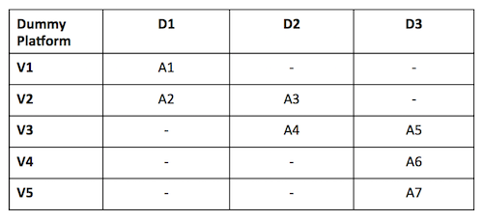

Figure 18: Vulnerability matrix for a dummy platform

The figure above provides an example of a vulnerability matrix for a dummy platform. The content of each cell describes examples of attacks that can be launched to the TCB, e.g., "A1: inspection of JavaScript code through the browser", "A7: probing the system bus". Columns represent the difficulty level and rows the attack layer (both of them will be explained below). Intuitively, the vulnerability matrix allow us to grasp how exposed the TCB is to attacks: the lower the difficulty degree of the attacks is the more vulnerable the Hyperty Runtime will be when deployed on a particular target platform. Next, we describe the classification for attack layers and difficulty levels:

**Attack layers.** Attack layers can be classified in five types, ordered top-down, from the highest to the lowest layer of the computer stack, as shown in the figure below:

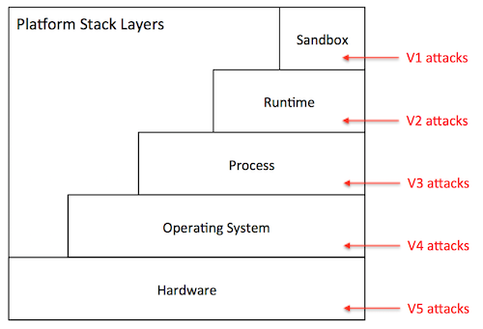

Figure 19: Stack

* *Sandbox level (L1)*: The attacker has direct access to the sandbox environment, hence to the code and execution state of Hyperty instances. For example, on a browser platform, users typically have access to the JavaScript of a given page. This means that a malicious user can leverage that mechanism to tamper with the JavaScript code of local Hyperty instances.
* *Runtime level (L2)*: The attacker has direct access to the code or execution state of the Hyperty Runtime. Depending on the specific exploit, he can mount attacks that disable defenses against the attacks described in the previous section. On the browser, for example, a L2 attack can be achieved by installing a malicious browser extension that bypasses the policy enforcement mechanism of the Hyperty Runtime.
* *Process level (L3)*: The attacker has access to the execution state of the process where the Hyperty Runtime is hosted. Just like the L2 attacks, this type of attack can result in catastrophic consequences. Examples of attacks performed at the process level include attaching a debugger to the Hyperty Runtime process and inspect its internal data structures, or dumping its memory state to disk by reading from /dev/mem.
* *Operating system level (L4)*: The adversary has access to the execution state of the operating system, and therefore to the execution state of the Hyperty Runtime. Similarly to L2 and L3, L4 attacks can be catastrophic. An attack performed at this layer, for example, installs a rootkit to mainain a log of all operations performed by local Hyperty instances.
* *Hardware level (L5)*: The adversary has physical access to the hardware of the platform and can launch simple attacks that do not involve tampering with the circuitry. Attacks in this category include, removal or inspection of the hard disk, probing the system bus in order to extract secrets from volatile memory, etc. An attack at this level may also include tampering with the silicon chips, perform side-channel attacks, etc. Such attacks require a high-level of expertise and committed resources. In theory, attacks performed at this level can reveal the entirety of the system state, including the operating system's. In practice, however, such attacks are more directed towards the extractions of specific secrets when L3 attacks or above are not possible.

**Difficulty level.** The difficulty level of an attack depends on several factors: the privileges owned by the adversary (e.g., user or superuser), the skills that are required (e.g., know how to run a debugger or tamper with silicon), and the necessary resources to carry out the attack (e.g., specific software exploits, memory probes, etc.). Based on these factors, we define three difficulty levels for a given attack:

* *Easy (D1)*: The attack is easy to perform. The tools that are necessary to launch the attack are accessible, well documented, and simple to handle. Some examples of D0 attacks include: (i) on a browser platform, a malicious user leverages the browser interface to modify Hyperty code, (ii) on a constrained device, the device owner abuses superuser privileges to disable the policy enforcement mechanisms of the Hyperty Runtime.
* *Medium (D2)*: The attack requires considerable skills and / or resources. It can be launched by mastering the tools presently available in the system (e.g., tools provided by the operating system, debuggers) or by installing new ones that can be found on the Internet (including malware or exploits). The attacker has limited skills or resources to discover new vulnerabilities or to develop exploits autonomously. Examples of such attacks include, attaching debuggers to extract in-memory secrets from the Hyperty Runtime, patch the Hyperty Runtime using exploit code published on the Web, etc.
* *Hard (D3)*: The attack is very sophisticated. To mount the attack, the attacker must be able to develop its own exploit code, find new vulnerabilities in the system, and / or launch software hardware attacks. For example, finding bugs in a device driver’s code and write software exploits. The attacks performed at the deep hardware level are also considered hard to execute.

When drawing a vulnerability matrix, we define *attacker profiles*, which define sets of possible attacks that characterize possible attack agents in that particular platform. For example, for the browser platform, we define three profiles: regular user, advanced user, and power user. The regular user captures an average web user, which is able to launch attacks like "inspection of JavaScript code through the browser", but not "probing the system bus". We now present our vulnerability assessment for each of the target platforms.

#### Browser platform

The primary platform targeted by reTHINK is the browser. Browsers can be highly heterogeneous; we may be talking about desktops, laptops, or mobile devices featuring many different configurations with respect to: hardware architecture, operating system in use, installed software, and specific browser version and extensions. In spite of this diversity, a Hyperty-enabled browser will tend to follow the general architecture represented in the figure below.

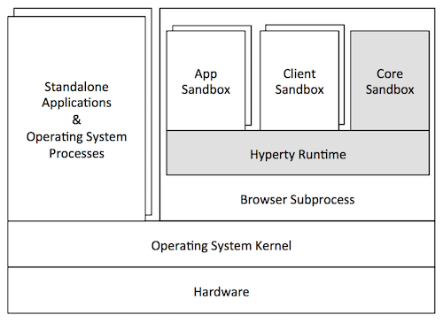

Figure 20: Browser

In this architecture, the Hyperty Runtime represented by the shaded components of the Figure is deployed on an independent browser process. This process is in fact a "subprocess" of the browser that implements a sandboxing mechanism of its own (as in the Chrome browser). This mechanism is responsible for isolating the Hyperty Runtime from the browser's rendering engine. The JavaScript engine is responsible for the secure execution of JavaScript code inside individual sandboxes: (1) the Core Sandbox of the Hyperty Runtime, (2) service provider sandboxes for hosting Hyperty instances, ProtoStubs and SPPEs, and (3) application sandboxes for executing guest applications. As expected, the Hyperty Runtime process depends on the operating system, which in turn depends on the underlying hardware setup. Browser processes run side-by-side with other standalone application processes and operating system services.

From the security point of view, the threats to the TCB of the Hyperty Runtime are mainly caused by an adversarial user. To better characterize these threats, we define three attacker profiles and draw the vulnerability matrix as follows:

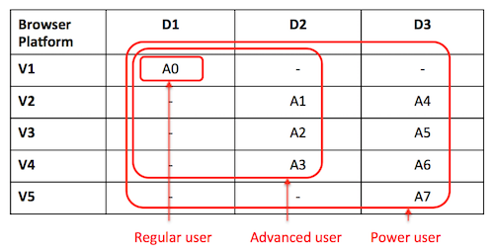

Figure 21: Security Browser

* *Regular user*: This attacker profile captures the class of users with an average proficiency level in computing, but are willing to subvert the security properties of the system's TCB. The user's privileges allow for limited operations, such as: launch the browser, and run Hyperty-based applications. A regular user is expected to mount the following attacks:
* *A0*: Access and modify client JavaScript code through the browser interface.
* *Advanced user*: This profile captures users with superuser privileges and some degree of skills and knowledge of the system. The user is aware of existing tools and techniques that can be leveraged to hack into the system's components, has access to exploits available on the Internet, and can handle auxiliary tools (e.g., debuggers, Unix advanced commands, etc.). The user can assemble and disassemble the basic hardware components of the system (e.g., plugging in / out the hard disk). For mobile devices, the user can root or jailbreak the platform by following instructions. Thus, considering this set of skills, in addition to A0, an advanced user can perform several other attacks at different stack layers such as these:
* *A1*: Compromise the runtime by installing a malicious browser extension.
* *A2*: Dump the memory contents of the process to disk.
* *A3*: Install a rootkit on the operating system that keeps track of Hyperty instances' communication.
* *Power user*: This profile corresponds to highly skilled users, who have deep knowledge of the system and can launch sophisticated attacks. A user is able to investigate unknown vulnerabilities in the software (including in the Hyperty Runtime or in the OS) and develop specific software exploits. Moreover, the user has enough resources and tools to launch hardware attacks that involve tampering with silicon. A power user is able to mount not only the attacks described previously, but more sophisticated attacks on various layers of the stack:
* *A4*: Find and exploit a bug in the Hyperty Runtime.
* *A5*: Attach a debugger to the browser’s subprocess and inspect / modify its memory.
* *A6*: Build a device driver to continuously monitor the execution of Hyperty Instances.
* *A7*: Probe the system bus and extract private key material of Hyperty Instances.

**Vulnerability assessment:** As illustrated by the vulnerability matrix, the browser platform is vulnerable to a range of attacks. Some of these attacks can be mounted by regular users with relative ease. In addition, there are several ways for advanced users to successfully compromise the TCB by exploiting the system at different stack layers. As a result, we recommend that browser platforms are avoided for hosting client code which the local user has incentives to subvert. Examples of such code include: Hyperty instances restricted by specific usage charging policies, ProtoStubs that encode proprietary communication protocols, or Applications that access copyrighted digital data.

#### Standalone platform

A variant of the browser platform is to deploy the Hyperty Runtime as a standalone application, for example to execute as mobile apps on mobile devices as smartphones or tablets. The Hyperty Runtime can also be packaged as a classical standalone application for desktop platforms running Linux or Windows. To allow for the development and maintenance of such applications, reTHINK will provide an SDK that will include APIs and platform specific libraries for adapting the Hyperty Runtime to the underlying operating system platform.

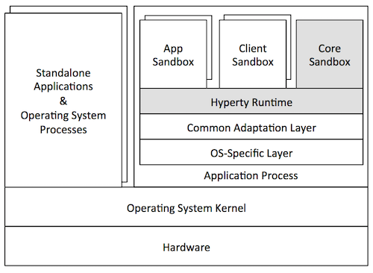

Figure 22: Application platform

The figure above illustrates a general standalone platform tailored for Android mobile devices. Just like in the browser platform, the Hyperty Runtime is wrapped around a host process. The host process is responsible for (1) mediating the system calls issued by the Hyperty Runtime to the operating system and (2) providing a user interface to the Hyperty Runtime and client JavaScript applications (and hyperties). In addition to the Hyperty Runtime, the host process application consists of: a platform-independent adaptation layer, and platform-specific libraries, e.g., for IO, storage, and memory management. In the example of the figure, the platform-specific libraries correspond to the Android API framework.

From the security point of view, standalone and browser platforms are quite similar; for that reason we adopt the same attacker profiles (regular user, advanced user, and power user). The main difference between architectures is twofold. First, the host application will prevent direct introspection of the JavaScript code running inside Hyperty Runtime sandboxes. As a result, the application architecture is able to mitigate simple attacks to the browser (A0 in the browser’s vulnerability matrix), raising the bar for regular users. Second, the host application will not support software extensions. This restriction prevents some advanced attacks to the runtime based on installation of malicious extension code, and to the browser process (see attacks A1 and A2, respectively, in the browser's vulnerability matrix). Next, we present the vulnerability matrix of the standalone platform and provide alternative attack examples.

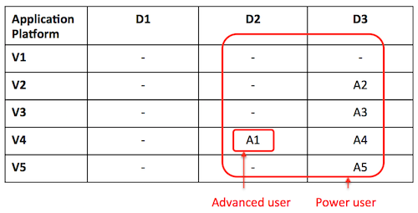

Figure 23: Security Application platform

* *Advanced user*: An advanced user can compromise the entire system by launching attacks at the OS level:
* *A1*: Root the device and instrument the operating system in order to introspect Hyperty instances' sandboxes.
* *Power user*: A power user can mount more sophisticated attacks on various layers of the stack:
* *A2*: Find and exploit a bug in the Hyperty Runtime.
* *A3*: Find a bug in the host application code and exploit it.
* *A4*: Monitor the execution of Hyperty Instances by rooting the device.
* *A5*: Hack the device hardware to extract sensitive Hyperty data from memory.

**Vulnerability assessment:** As highlighted by the vulnerability matrix, an Android-based standalone platform is more robust to attacks than the browser platform. This is mainly due to the fact the application architecture allows us to close security holes in the browser architecture that can hardly be thwarted without modifying the browser. Nevertheless, it is still possible to for an advanced user to compromise the system by rooting the device; the need to root the device will likely deter the regular users. Nevertheless, we recommend prudence in deploying client code that the local user has high incentives to subvert.

#### Constrained platform

reTHINK also targets constrained platforms, namely Raspberry Pi devices. Such devices adopt an internal architecture very similar to the standalone platform: they can run Linux or even Android operating systems. Essentially, their main differences take place at the implementation level. Therefore, our security analysis of the standalone platform applies for both cases.

## Runtime APIs

*Should we use Typescript interfaces to define Runtime APIs?*

### Runtime UA

Register Hyperty deployed by the App that is passed as input parameter. To be used when App and Hyperties are from the same domain otherwise the RuntimeUA will raise an exception and the App has to use the loadHyperty(..) function.

registerHyperty( Object hypertyInstance, URL.HypertyCatalogueURL descriptor )

Deploy Hiperty from Catalogue URL

loadHyperty( URL.URL )

Deploy Stub from Catalogue URL or domain url

loadStub( URL.URL )

Used to check for updates about components handled in the Catalogue including protocol stubs and Hyperties. *check relationship with lifecycle management provided by Service Workers*

checkForUpdate(CatalogueURL)  
  
discoverHiperty(applId, OSname, capability_list)   
accomodate interoperability in H2H and proto on the fly for newly discovered devices in M2M

### Registry

To register a new Hyperty in the runtime which returns the HypertyURL allocated to the new Hyperty.

HypertyURL registerHyperty( postMessage, HypertyCatalogueURL descriptor)

To unregister a previously registered Hyperty

unregisterHyperty( HypertyURL url )

To register a new Protocol Stub in the runtime including as input parameters the function to postMessage, the DomainURL that is connected with the stub, which returns the RuntimeURL allocated to the new ProtocolStub.

HypertyRuntimeURL registerStub( postMessage, DomainURL )

To unregister a previously registered protocol stub

unregisterStub( HypertyRuntimeURL )

To register a new Policy Enforcer in the runtime including as input parameters the function to postMessage, the HypertyURL associated with the PEP, which returns the RuntimeURL allocated to the new Policy Enforcer component.

HypertyRuntimeURL registerPEP( postMessage, HypertyURL hyperty )

To unregister a previously registered protocol stub

unregisterPEP( HypertyRuntimeURL )

To receive status events from components registered in the Registry

onEvent( Message.Message event )

To discover protocol stubs available in the runtime for a certain domain. If available, it returns the runtime url for the protocol stub that connects to the requested domain. Required by the runtime BUS to route messages to remote servers or peers (*do we need something similar for Hyperties?*).

RuntimeURL discoverProtostub( DomainURL url)

To discover sandboxes available in the runtime for a certain domain. Required by the runtime UA to avoid more than one sandbox for the same domain.

RuntimeSandbox getSandbox( DomainURL url )

To verify if source is valid and to resolve target runtime url address if needed (eg protostub runtime url in case the message is to be dispatched to a remote endpoint ).

Message.Message resolve( Message.Message message )

### Message BUS

To send messages with optional call back. This function is accessible outside the Core runtime.

postMessage( Message.Message message , callback)

To add "listener" functions to be called when routing messages published on a certain "resource" or send to a certain url. This function is only accessible by internal Core Components.

addListener( listener, URL.URL url )

To add an interceptor Policy Enforcer which "listener" function is called when routing messages published on "interceptedURL" or send to the "interceptedURL". To avoid infinite cycles messages originated with from "pepURL" are not intercepted. This function is only accessible by internal Core Components.

addPEP( listener, URL.URL pepURL, URL.URL interceptedURL)

### Hyperty

To initialise the Hyperty instance including as input parameters its allocated Hyperty url, the runtime BUS postMessage function to be invoked to send messages and required configuration retrieved from Hyperty descriptor.

init( HypertyURL url, postMessage, ProtoStubDescriptor.ConfigurationDataList configuration )  
  
  
report(message)

### Policy Enforcer

To initialise the Policy Enforcer including as input parameters its allocated component runtime url, the runtime BUS postMessage function to be invoked to send messages and the url of the Hyperty associated to the Policy Enforcer (it will forward received and processed messages to this address).

init( URL.RuntimeURL pepURL, bus.postMessage , HypertyURL hyperty)

To set postMessage() function to be used by the Policy Enforcer to send messages usually the "MessageBUS".

setSender( postMessage )

To set postMessage() function to be used by the Policy Enforcer to receive messages usually the Hyperty or a Syncher. In case the resouce parameter is provided this postMessage() is only valid for messages containing the same resource url.

setReceiver( postMessage, resource )

To receive messages from the message BUS

postMessage(message)

### protoStub

To initialise the protocol stub including as input parameters its allocated component runtime url, the runtime BUS postMessage function to be invoked on messages received by the protocol stub and required configuration retrieved from protocolStub descriptor.

init( URL.RuntimeURL runtimeProtoSubURL, bus.postMessage, ProtoStubDescriptor.ConfigurationDataList configuration )  
  
connect( )  
  
  
disconnect( )  
postMessage(message)  
addListener( onMessage )

### Syncher

*should we distinguish between Reporter and Observer syncher?*

To set postMessage() function to be used by the Syncher to send messages usually a "Policy Enforcer" but it could also be the MessageBUS.

setSender( postMessage )

Hyperty instance uses this function to provide the object to be changed by the (observer) syncher according to messages received. The Hyperty instance has previsouly used the *Object.observe* javascript api to set as an observer of this object

Promise <SyncObject> createAsObserver( receivedMessage )

To create a new object and ask another Hyperty instance to observe it. A Create Message will be generated and sent by the Syncher. Promise is used to handle Response messages to this object.

Promise <SyncObject> createAsReporter( resourceURL, schemaURL, toURL, dataObject?)

By default the events triggered by changes performed on this object by the Resporter Hyperty will trigger the synchronisation process. Otherwise the Hyperty instance should invoke a separate function, *addAttribute()*, *updateAttribute()*, *deleteAttribute()* defined below and afterwards invoke the *synch()* function to trigger the synchronisation process.

To add an attribute to object without triggering the synchronisation process:

addAttribute(resourceURL, attributeName, attributeValue)

To update an attribute without triggering the synchronisation process:

updateAttribute(resourceURL, attributeName, attributeValue)

To delete an attribute without triggering the synchronisation process:

deleteAttribute(objectId, attributeName)

To delete an Object:

delete(objectId)

To trigger the synchronisation process:

Promise synch(objectId)

To receive messages from other Hyperties that will be reported to the Hyperty:

postMessage(message)

### HypertySandbox

postMessage(Message.Message message)

### Identities Container

Functions to deal with assertions compliant with [WebRTC RTCIdentityProvider](http://w3c.github.io/webrtc-pc/#identity-provider-interaction)

IdAssertion generateAssertion( contents, origin, usernameHint )  
validateAssertion( assertion, origin )

### LHCB

getCurrentConnectivityStatistics()  
sendConnectivityStatisticsToBroker()

## Runtime Main Procedures

### Runtime Basic Procedures

#### Deploy runtime

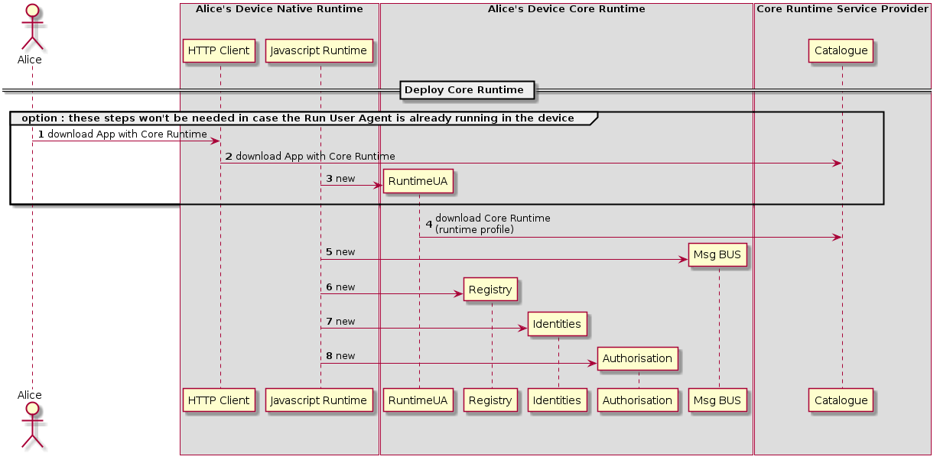

Figure 24: Deploy Core Runtime Components in the Native Runtime

In case the device does not support the Hyperty Core Runtime components eg an existing browser like Chrome or a Network Node.js Server, they have to be deployed in the Device.

**Notes from 6th July H2H Comm Work Session:**

Runtime Core components should be as much as possible independent on the Runtime type. They should be deployed once and executed at the background. The next time the runtime is started there should be no need to download the core runtime again unless there is a new version. Runtime core components should be singletons (?) shared by different Apps and Hyperty instances. In order to support these characteristics for the Browser, Runtime Core components should be implemented with Web/Service Workers (FFS).

The Core Runtime is provided by a specific Service Provider that handles a central repository or catalog of the needed Core Runtime components.

This process may be triggered by the deployment of an Hyperty or Protocol Stub using some existing libraries like require.js. Such possibility has to be validated with experimentations.

#### Deploy Protocol Stub

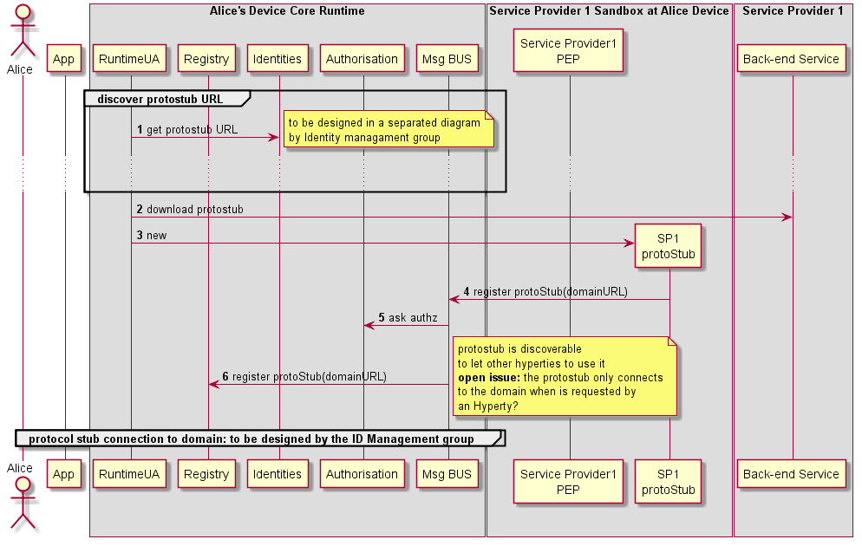

Figure 25: Deploy Protocol Stub

Steps 1-2 : The protocol stub deployment may be triggered by the deployment of an Hyperty or by some attempt from a local Hyperty to communicate with a remote Hyperty running in the domain served by the protocol Stub. In this case the Runtime Registry would take the initiative to start the protocol stub deploy (FFS). Such trigger may take advantage of some existing libraries like require.js (to be validated with experimentations). The Runtime UA only downloads and deploys requested protocol stub after checking in the Registry that there is no protocol stub available in the runtime.

Steps 3 - 4 : the Runtime UA is able to derive the URL to download the protocol stub from the domain url, since it is a well known URI defined in the reTHINK Architecture Interfaces. The Runtime UA uses the protocol stub well known URI to download and instantiate it in the runtime.

Steps 5 - 7 : the new protocol stub is registered in the Runtime Registry, which allocates and return the runtime address (RuntimeURL) for the new runtime component. In addition, the runtime Registry requests the runtime BUS to add its listener to receive events about the protocol stub status.

Steps 8 - 11 : the Runtime UA retrieves required configuration data for the new protocol stub and initialises it. The protostub adds a listener to the runtime BUS to receive messages from the runtime.

Protocol stubs are connected by using credentials handled by the Core Runtime Identities Container which are detailed in the [domain login use case](../identity-management/domain-login.md).

Steps 12 - 13 : protocol stub publishes its status (including events about when it is connected or disconnected) in its resource status. Components registered on the protocol stub status resources, like the Registry, are notified about the new protocol status.

Message to publish Protocol Stub Status

"id" : "1"  
"type" : "UPDATE",  
"from" : "hyperty-runtime://sp1/protostub/123",  
"resource" : "hyperty-runtime://sp1/protostub/123/status",  
  
"body" : { "value" : "LIVE" }

#### Deploy Hyperty

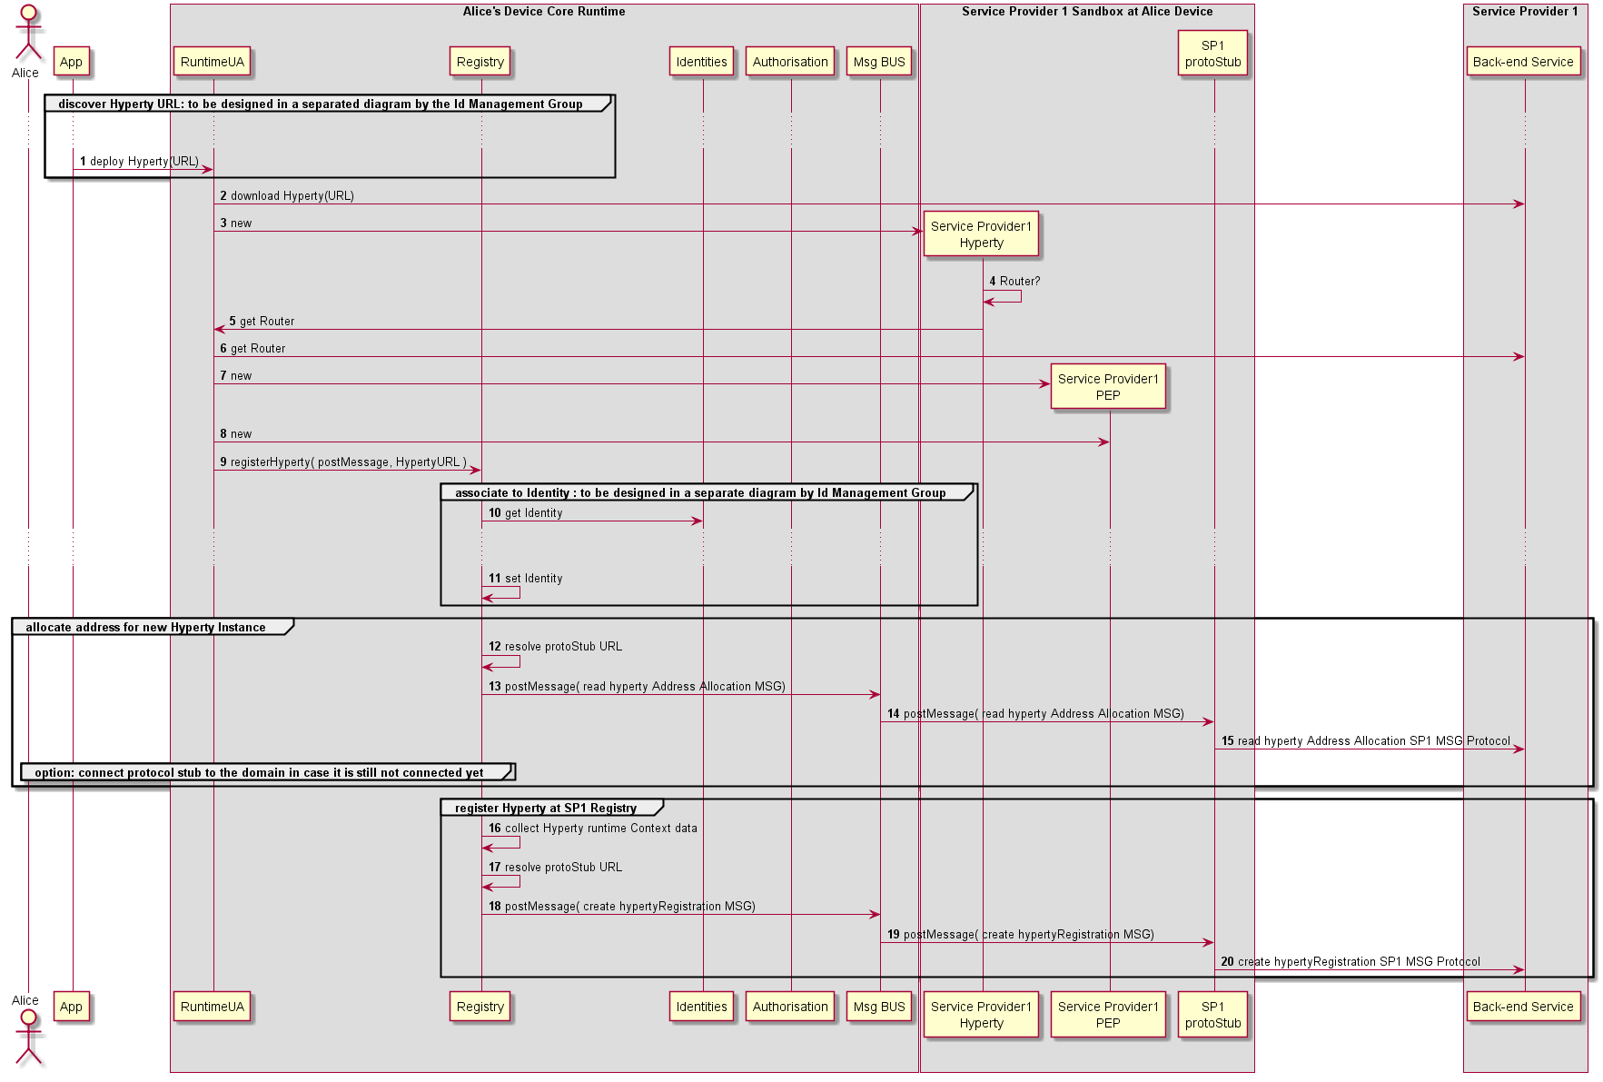

Figure 26: Deploy Hyperty

According to the sandboxing runtime architecture, Hyperties and App domains will have an impact on the procedures to be used to deploy the Hyperty. Nevertheless, the trigger of Hyperty deployment may take advantage of some existing libraries like require.js.

** Hyperty and App from the same domain **

Steps 1 - 4: In this situation, the App and the Hyperty are running in the same isolated sandbox which is different from the Hyperty Core Runtime Sandbox. This means the download and instantiation of the Hyperty has first to be performed by the Application. Then the App asks the Runtime UA to register and activate the new Hyperty in the runtime.

** Hyperty and App from different domains **

Steps 7 - 8: In this situation, the App and the Hyperty are running in different and isolated sandboxes. In this case the Hyperty sandbox is managed by the runtime UA which means the runtime UA can download and instante the Hyperty. The runtime UA should avoid the creation of new sandboxes in case there is already a sandbox for the same domain

Steps 9 - 10 : the [Hyperty is registered](register-hyperty.md).

Steps 11: the runtime UA checks in the Hyperty Descriptor if a Policy Enforcer is required

** Alt1 : Hyperty PEP deployment is required **

Steps 12 - 13 : the runtime UA downloads and instantiates the Hyperty PEP in a isolated sandbox.

Steps 14 - 15 : the Runtime UA register in the runtime Registry the new PEP for the new deployed Hyperty and the Registry returns PEP Runtime component URL

Steps 16 - 17 : the runtime UA activates the Hyperty PEP which adds its intercepting listener to the runtime BUS to receive messages targeting the Hyperty URL.

** Alt2 : Hyperty PEP deployment is not required **

Steps 18 - 19 : the runtime UA activates the Hyperty instance which adds its listener to the runtime BUS to receive messages targeting the Hyperty URL.

#### Message Routing in Message BUS

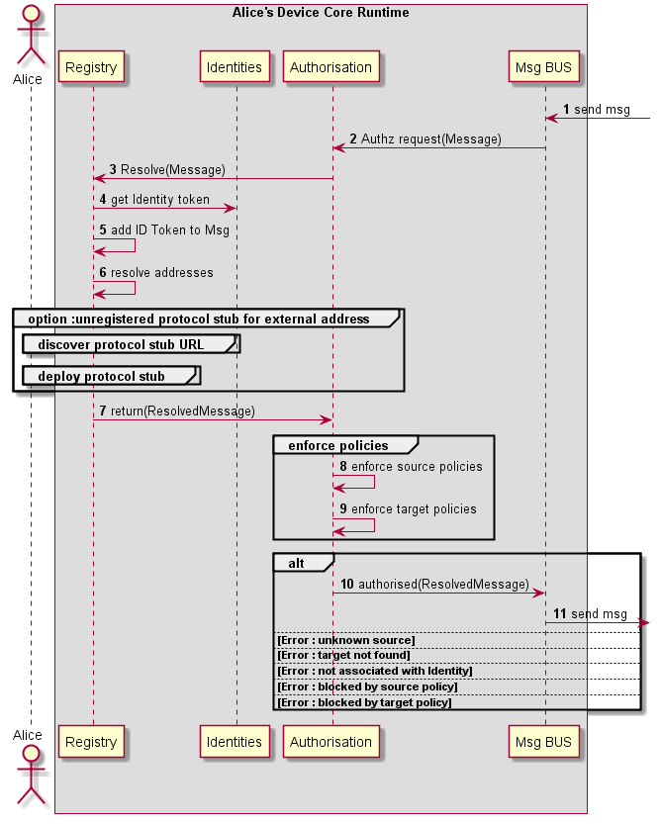

Figure 27: Message Routing in Message BUS

#### Intra-domain Local Communication

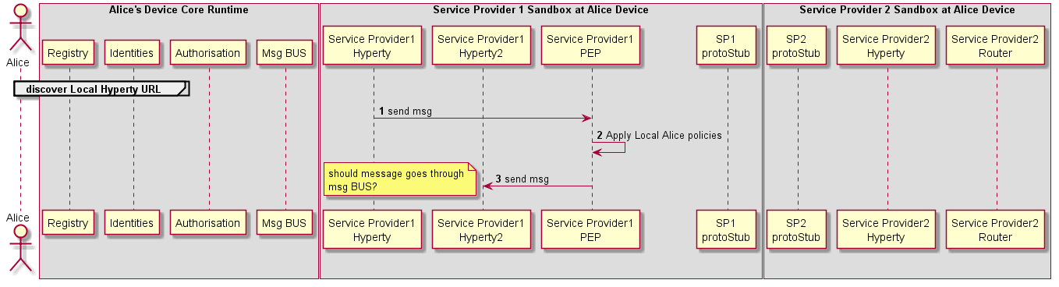

Figure 28: Intra-domain Local Communication

#### Intra-domain Remote Communication



Figure 29: Intra-domain Remote Communication

#### Inter-domain Local Communication

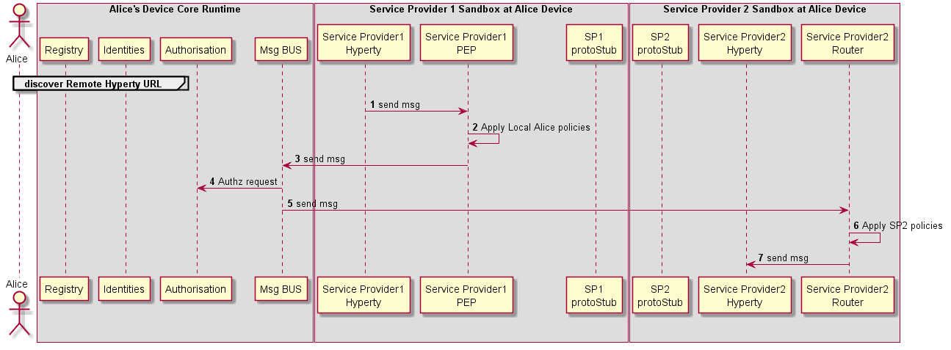

Figure 30: Inter-domain Local Communication

#### Inter-domain Remote Communication

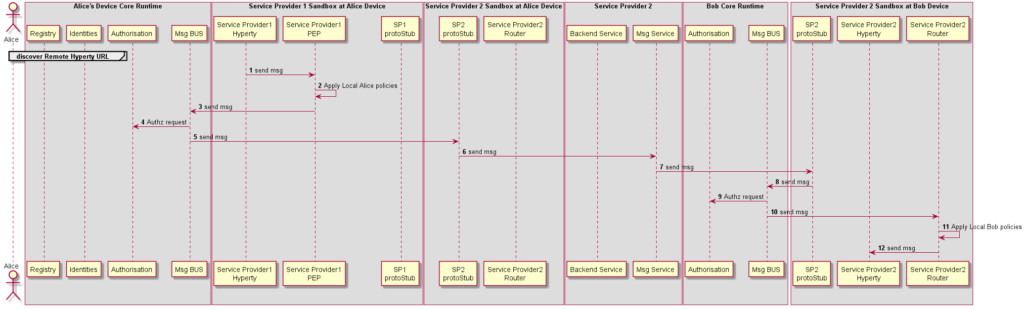

Figure 31: Inter-domain Remote Communication

### Runtime Identity Management Procedures

#### User Registration

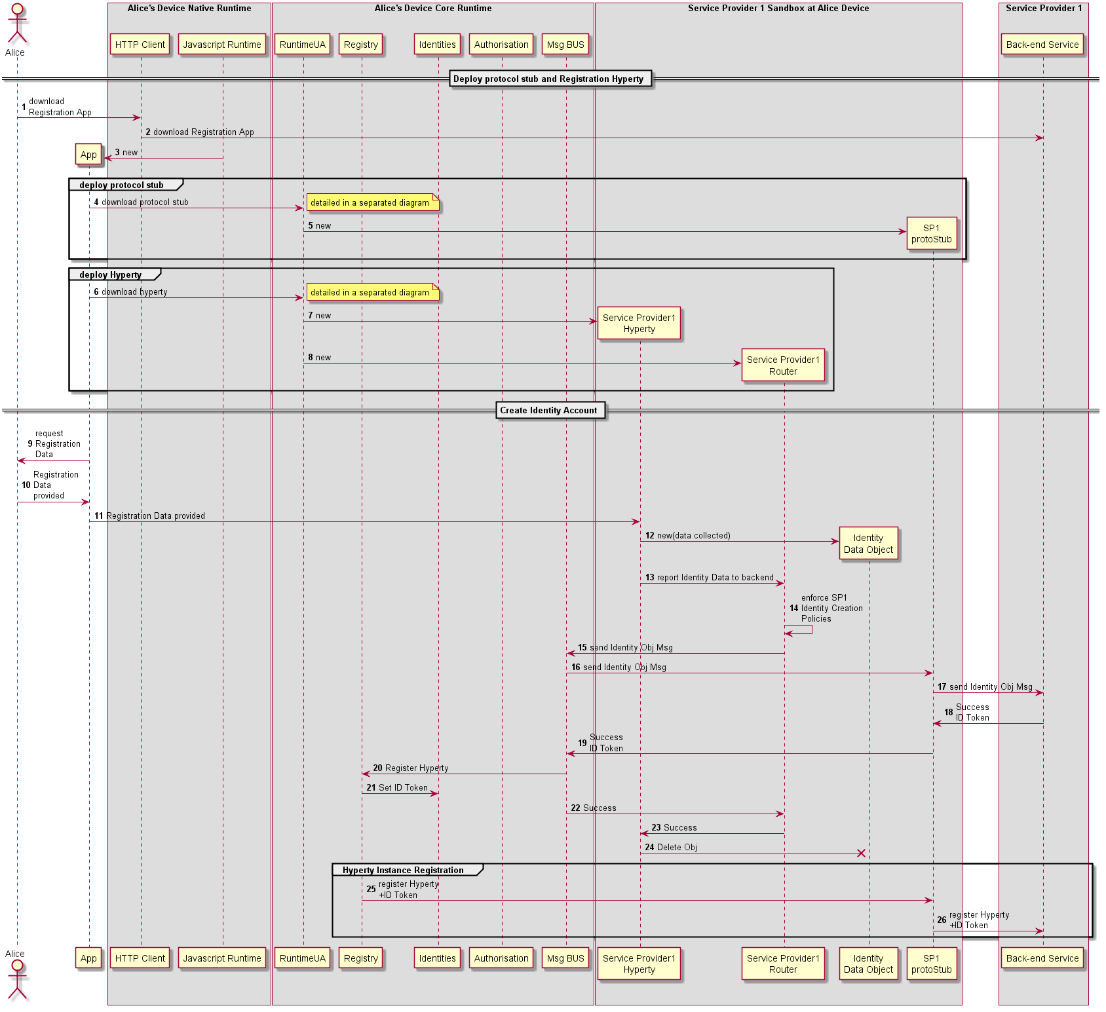

Figure 32: User registration

In this use case, it is considered there is a single protocol stub to interact with all back-end services including Identity Management. Another option is to have different protocol stubs to interact with different back-end services including authentication, authorisation and messaging services.

#### Discovery

The picture shows Discovery of a Hyperty. The first picture is about the preparation or "How comes the HYperty URL into the Discovery service?". The second pictury is about "How to find this information?" and "How to use it?".

##### Prepare Discovery

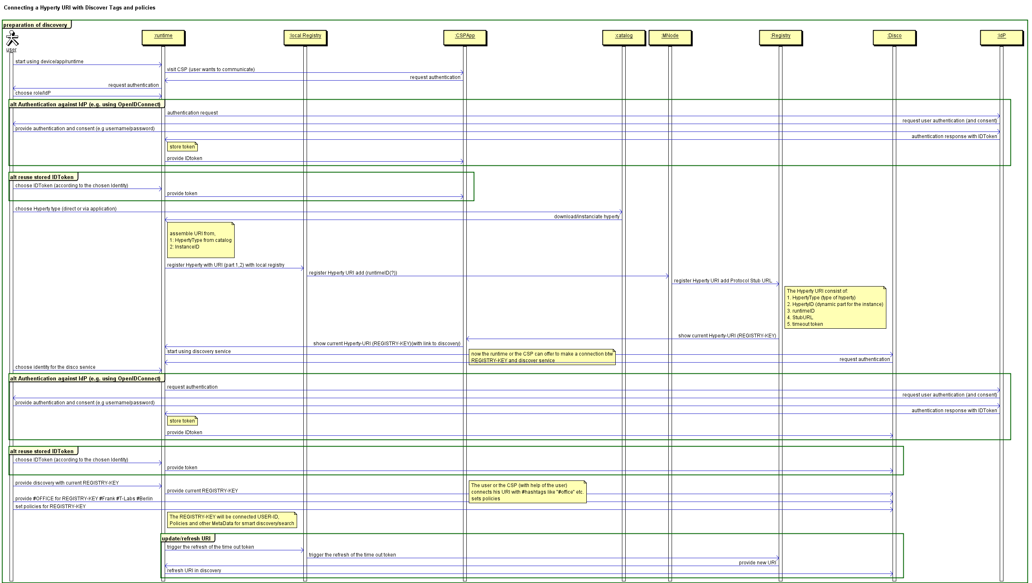

Figure 33: Prepare Discovery

##### Use Discovery

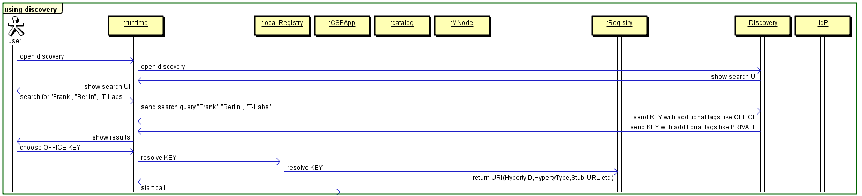

Figure 34: Use Discovery

#### Domain Login

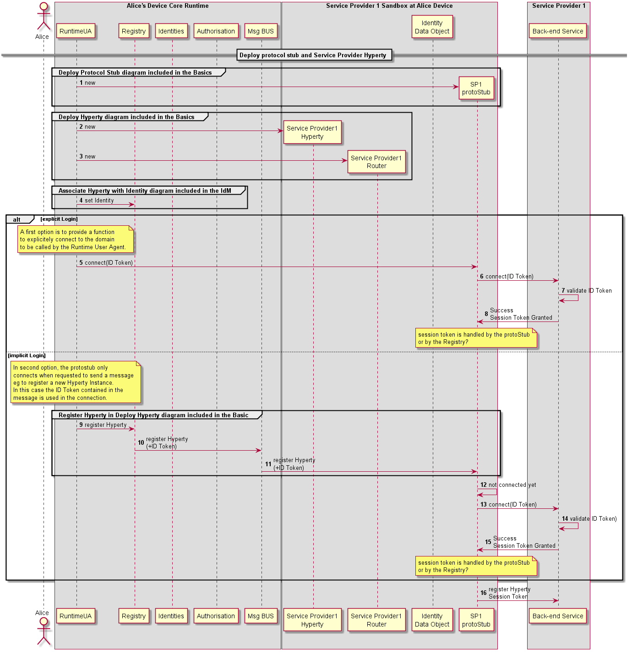

Figure 35: Domain Login

In this use case, it is considered there is a single protocol stub to interact with all back-end services including Identity Management. Another option is to have different protocol stubs to interact with different back-end services including authentication, authorisation and messaging services.

#### Associate User Identity to Hyperty Instance

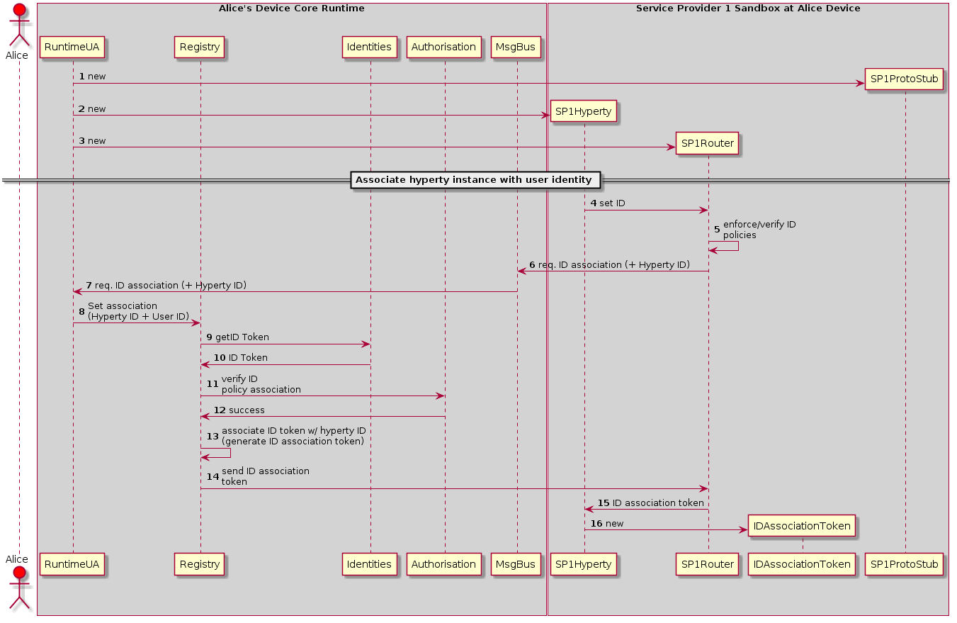

Figure 36: Associate User Identity to Hyperty Instance

This sequence details the steps needed to associate the user identity to a given Hyperty instance.

*1*- Create ProtoSutb1 sandbox.

*2*- Create Hyperty 1 instance for Service Provider 1.

*3*- Create SP1 router and the respective PEP connector.

*4*- The application using Hyperty 1, triggers a request to set the Identity to be associated to this Hyperty instance. This request is sent to the SP1 router to be touted to the RunTime UA

*5*- Optimally the SP1 router checks the policies of the application itself in regard to the internal identity rule/policies. note that, this verification is internal and not related with the verification performed by the Core Runtime.

*6*- SP1Router send the request (if authorized by the Application internal rules) to associate a identity to the Hyperty 1 instance. This request is sent to the Core Runtime Message Bus. This request includes the Identification Token of Hyperty 1.

*7*- The MsgBus sends the Hyperty-user association to the RunTime UserAgent.

*8*- The RunTime UserAgent 'selects' the user identity to be used (eventually by asking Alice which used ID to use) and sends it to the Registry.

*9*- The registry sends a request to the Identities Engine.

*10*- The Identities Engine replies with the identity token (ID Token) for the selected user. This step assumes that a identity Token has already exists for the requested user. If it does not, a [Domain Login](domain-login.md) must be performed.

*11*- The Registry sends a request to the Authorization/Policy engine to verify if the User Identity association request by the Hyperty Instance is authorized by the existing Policies.

*12*- If the association is allowed a success message is replied to the registry. If not a reject message is replied (not depicted in the figure).

*13*- The Register Engine generates an Association Token. This Association Token will allow the Hyperty instance to use the requested ID Token.

*14*- The created ID Association Token is sent to the SP1 router.

*15*- The router forwards the ID Association Token to the Hyperty instance (how requested it).

*16*- Hyperty 1 created a new ID Association Token object.

Note: This association protocol is assuming that the request for the ID association is triggered by the Application/Hyperty instance. The Second option is for the association action to be triggered by the User Agent (RuntimeUA). In this case steps 4 to 7 need to be changed.

Question: Which option should be provided? If both, which should be the default one?

#### User identity assertion

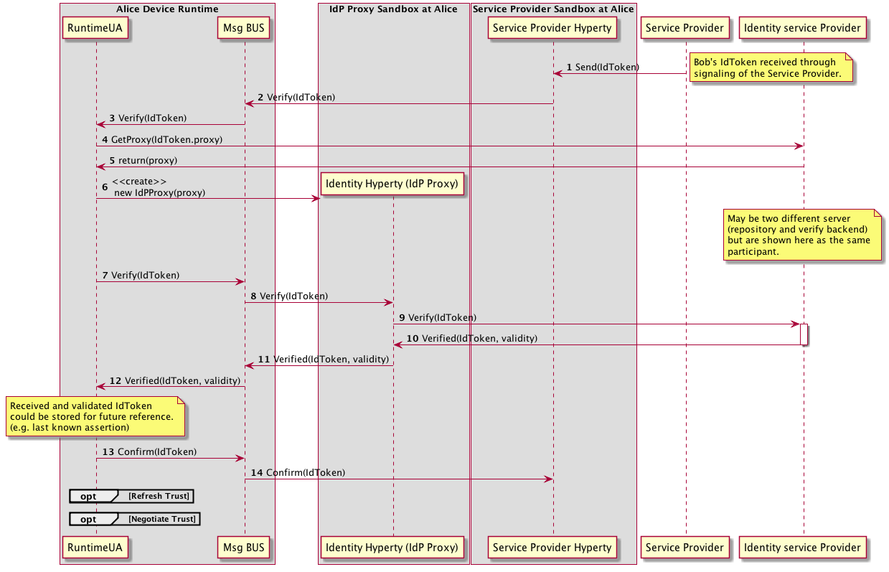

Figure 37: User identity assertion sequence diagram

In this sequence, Alice Hyperty receives an Identity Assertion from its signaling/backend service. Before prompting the user with the asserted identity (e.g. an incoming call notification) it must be verified. The hyperty thus uses the Verification API to ask the runtime to verify the received assertion. Communication with the Runtime is done through the Msg bus.

Upon receiving the verification request, the runtimeUA instantiate an IdP Proxy from a URL. This URL is given in the IdToken. Alternatively the IdP Proxy may already have been instantiated. Once instantiated, the RuntimeUA uses it to verify the IdToken. Communication with the IdP Proxy is also done through the Msg bus.

If the IdToken is validated, the RuntimeUA confirms the validity to the Hyperty.

### Main Runtime Procedures for H2H Communication

#### H2H Intradomain Communication - Alice invites Bob

This MSC diagrams shows the most relevant steps to support the initial invitation of Alice to Bob.

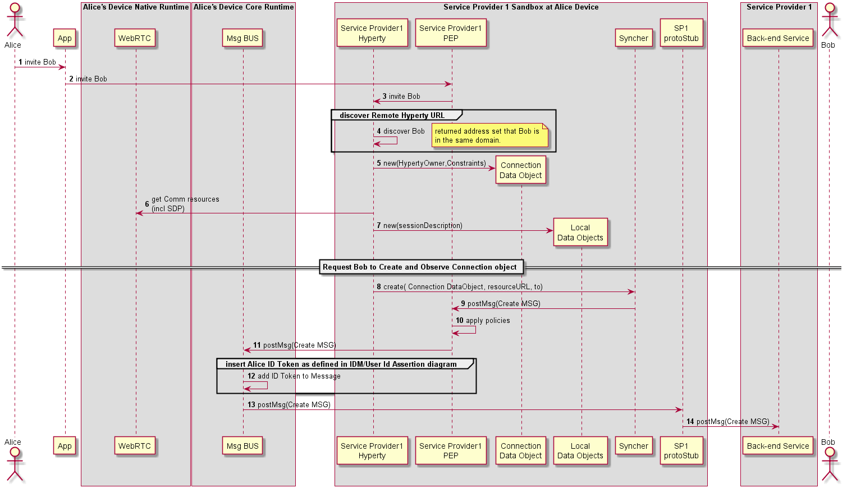

Figure 38: Alice invites Bob for a communication

(Steps 1 - 4) : Alice decides to invite Bob for a communication. The discovery of Bob's Hyperty Instance URL is described here(../identity-management/discovery.md).

(Steps 5 - 7) : the Hyperty Instance creates the Connection, the LocalConnectionDescription and the LocalIceCandidates data objects as defined [here](https://github.com/reTHINK-project/architecture/blob/master/docs/datamodel/communication/readme.md#connection).

(Steps 8 - 9) : the Hyperty Instance requests the Syncher to ask Bob to create and observe these objects. Syncher generates CREATE messages for each object and puts it in the Body in JSON format. For simplification purposes we assume the CREATE msg contains the Connection object plus local SDP and local IceCandidates:

[**Create Message**](https://github.com/reTHINK-project/architecture/tree/master/docs/datamodel/message#createmessagebody)

"id" : "1"  
"type" : "CREATE",  
"from" : "hyperty-instance://sp1/alicehy123",  
"to" : "hyperty-instance://sp1/bobhy123",  
"contextId" : "qwertyuiopasdfghjkl",  
"body" : { "resource" : "comm://sp1/alice/123456", "value" : "<json object with connection, sdp and ice candidates>"}

(Steps 10) : Alice's PEP applies local policies if required including outgoing communication request access control

(Steps 11) : Alice ID Token assertion is added to the message (see [here](../identity-management/user-identity-assertion.md) for more details).

(Steps 12 - 14) : the message is routed through Alice Message BUS reaching Service Provider Back-end Messaginge Service.

#### H2H Intradomain Communication - Bob receives invitation

This MSC diagrams shows how Bob receives invitation from Bob.

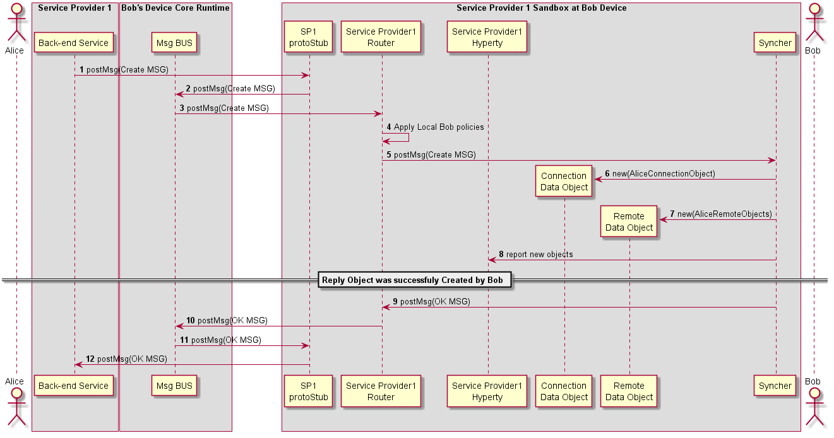

Figure 39: Bob receives invitation

(Steps 1 - 4) : Service Provider Back-end Messaginge Service routes the message to Bob's Message BUS, asserts Alice's identity and forwards the message to Bobs Router reaching Bob's PEP component

(Step 4) : Bob's PEP applies local policies if required including incoming communication request access control

(Steps 5 - 8) : the message is forwarded to Bob's Syncher which creates the requested new objects and reports to Bob's Hyperty Instance the new created objects.

(Steps 9 - 14) : As soon as the new Objects were created by Bob's syncher, it responds back to Alice to confirm the objects were created with a [Response Message](https://github.com/reTHINK-project/architecture/tree/master/docs/datamodel/message#responsemessagebody). In (Step 12) Bobs ID-Token is added to the Message:

"id" : "1"  
"type" : "RESPONSE",  
"from" : "hyperty-instance://sp1/bobhy123",  
"to" : "hyperty-instance://sp1/alicehy123",  
"contextId" : "qwertyuiopasdfghjkl",  
"body" : { "code" : "200" , "description" : "ok"}

#### H2H Intradomain Communication - Invitation Acknowledgement

This MSC diagrams shows how Alice is aknowledged that Bob received the invitation

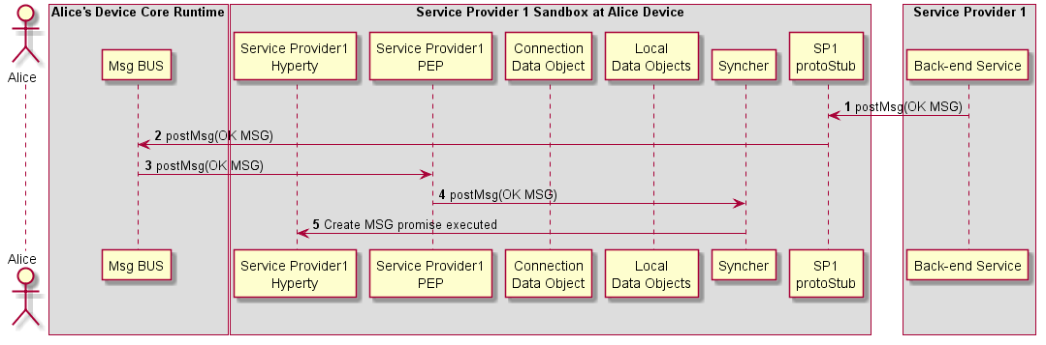

Figure 40: Aknowledged that Bob received the invitation

(Step 1 - 3) : Service Provider Back-end Messaginge Service routes the OK Message to Bob's Message BUS which forwards it to its PEP

(Step 4) : Bob's PEP applies local policies if required

(Steps 5 - 6) : the message is forwarded to Alice's Syncher which updates the Data Object and reports the change to Alice's Hyperty Instance

#### Incoming call is notified to Bob's application and Alice is updated

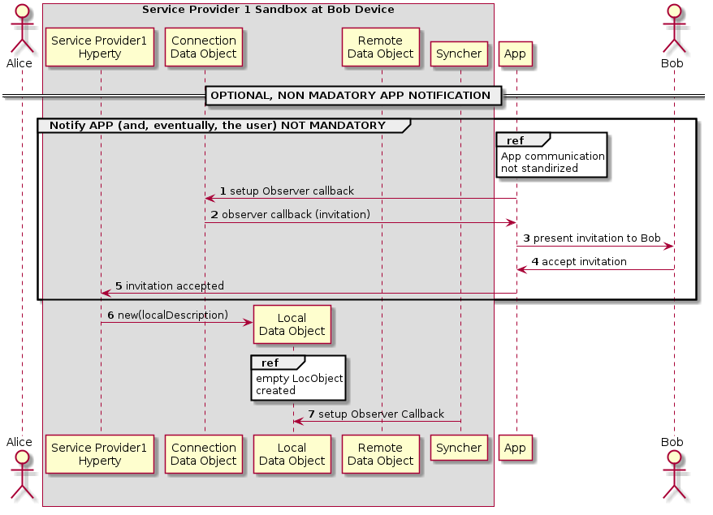

Figure 41: notification update

(step 1) The Application which interacts with the human user setups a callback in to be notified when the Connection data Object is modified.

(step 2) When a Data Connection Object receives any modification request from another Hyperty, the callback setup in the step before is called. The App is aware of the incoming invitation to establish a media session.

(step 3) The App can show this invitation to the human user in some way through a human interface. (step 4) In such a case the human typically will accept the communication. (step 5) The App accepts the invitation through the API exposed by the the Service Provider Hyperty. In order to start the media session a Local Data Object is created (step 10) where the data related to the local parameters of the media session is going to be established.

(step 6) The Syncher element from the Hyperty setups an Observer callback in the Local Data Object which will be called when the Local Data Object changes. (step 7) The observer reports that there is a communication in progress to the Syncher.

#### Bob starts WebRTC API

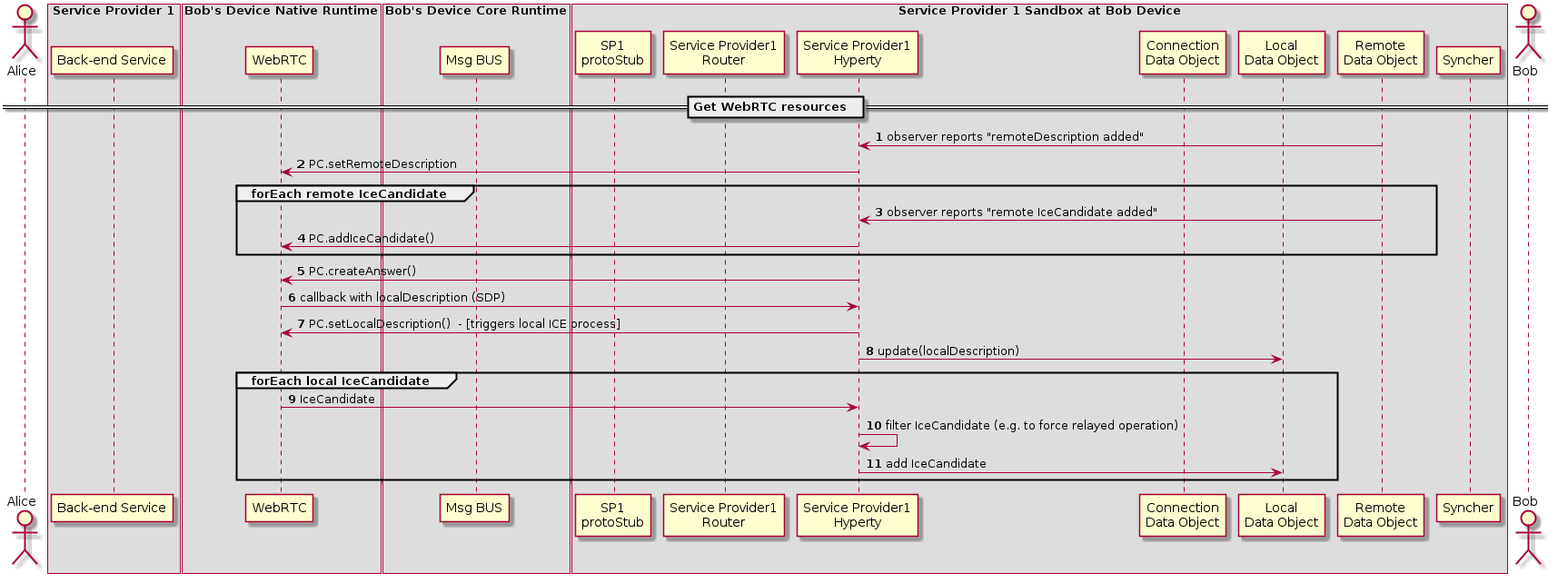

Figure 42: Bob gatheres WebRTC resources

(Step 1) The Hyperty is notified about the added remoteDescription object.

(Step 2) The Hyperty calls the WebRTC API from the browser including the remote parameters from the Remote Data Object. The same happens when a new Ice Candidate is updated in the Remote Data Object (step 3 and Step 4).

While remote Ice Candidate are added (step 3 and Step 4 may take place several times as Trickle Ice is supported) the Hyperty calls the Peer Connection method to create an SDP answer (step 5) to be sent to it with all the parameters used to establish the media session between Alice and Bob but the Ice Candidates which will be received asynchronously later. When the SDP with the local description is ready a callback is called and the SDP is sent to the Hyperty (step 6).

(Step 7) The Hyperty calls the Peer setLocalDesciption API method from the WebRTC API exposed by the browser so that the browser is aware of the media parameters which are going to be used to establish the media session with Alice. At this point the gathering process of local Ice Candidates starts.

(Step 8) The Hyperty updates the Local Data Object with the parameters from the localDescription.

(Step 9) As a result of the started ICE process local connectivity candidate will be reported from the WebRTC engine to the Hyperty. For each reported localCandidate the Hyperty can optionally perform a filter operation (Step 10), e.g. to filter out non-relay candidates to force TURN based operation, and reports the remaining candidates to the Local Data Object (Step 11)

#### Synchronization of Alice's Data Object

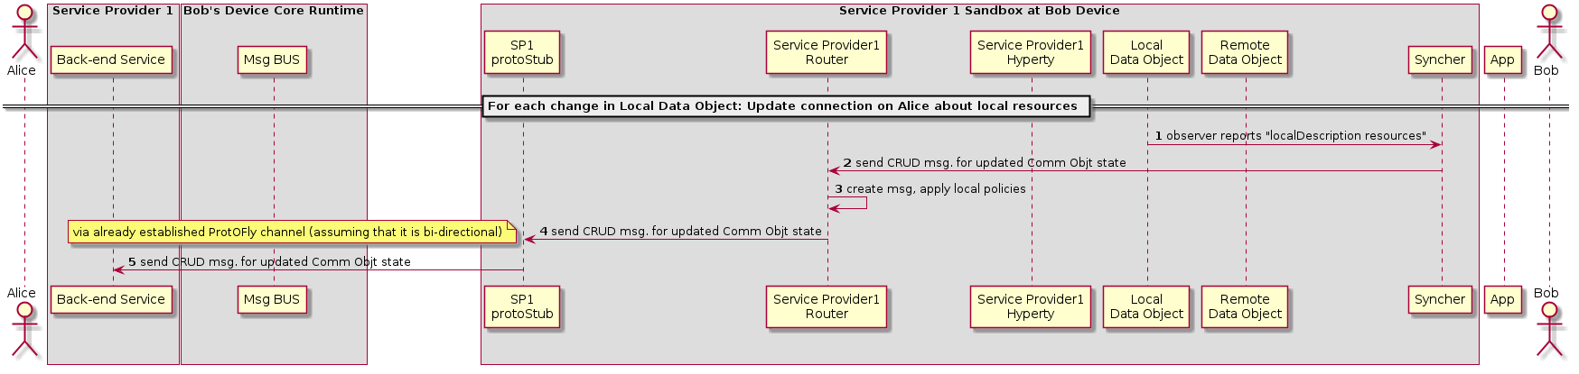

Figure 43: Synchronization of Alice's Data object

1. Synchronization of Alice's Data object (Step 1) The local Data object reports that there have been changes in the connection parameters and the Syncher sends a CRUD message through the Policy Enforcer to Update the Remote Data Object at Alice's Hyperty (Step 2).

(Step 3) the Policy Enforcer checks if the message is compliant with the local policies and the message is sent to the ProtoStub (Step 4) to be in turn sent to the Service Provider 1 Back-End (Step 5)

### Runtime Main Procedures for M2M Communication

The overview of the M2M End-User runtime components and their interaction with the Management Services and Network Services is presented in the diagram below. 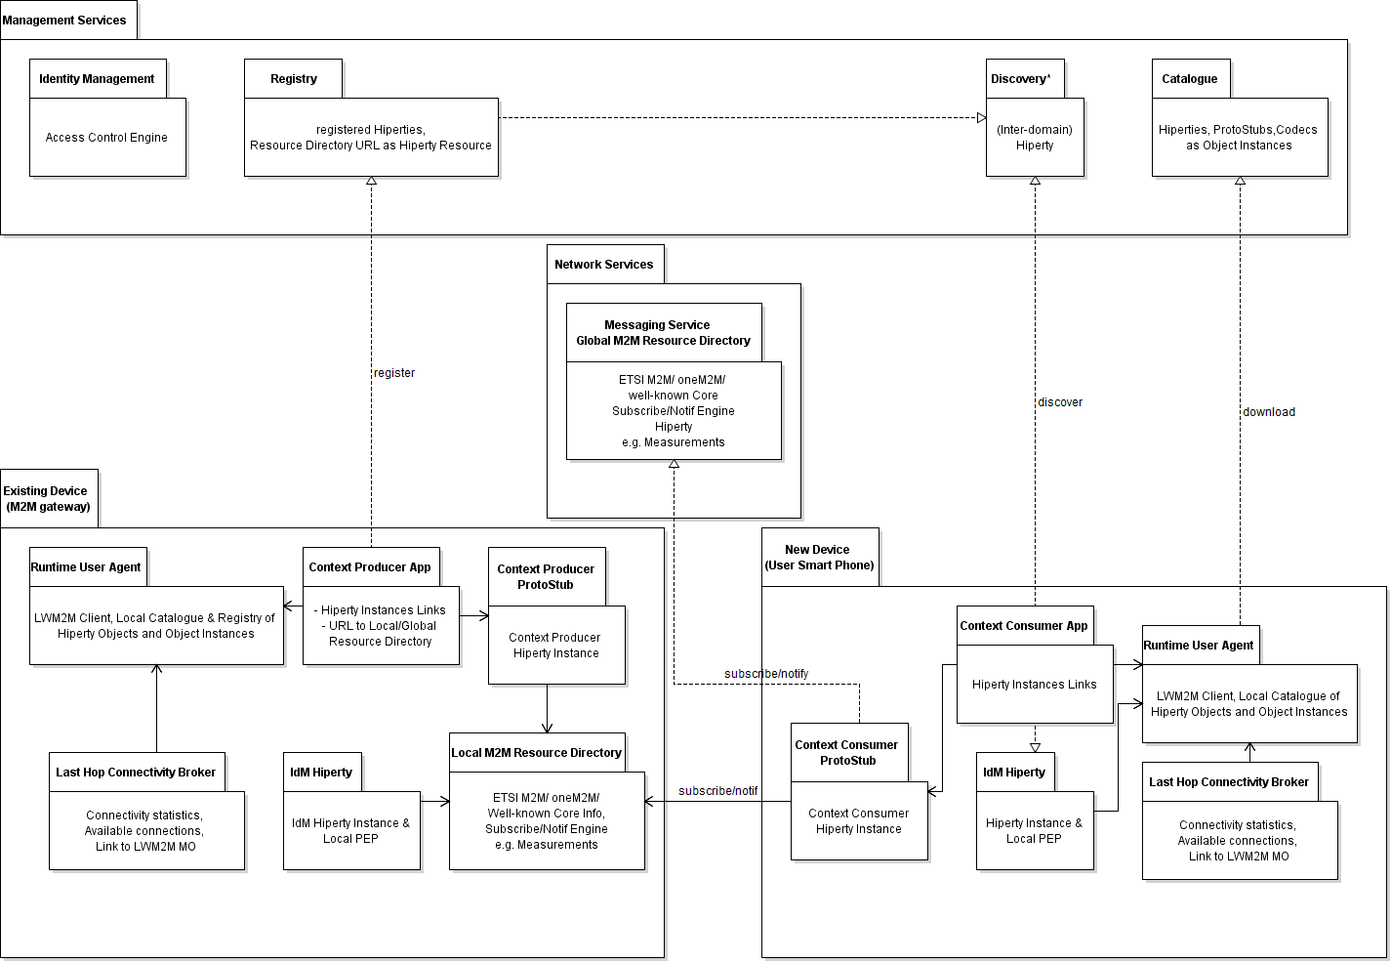

#### M2M Device Bootstrap

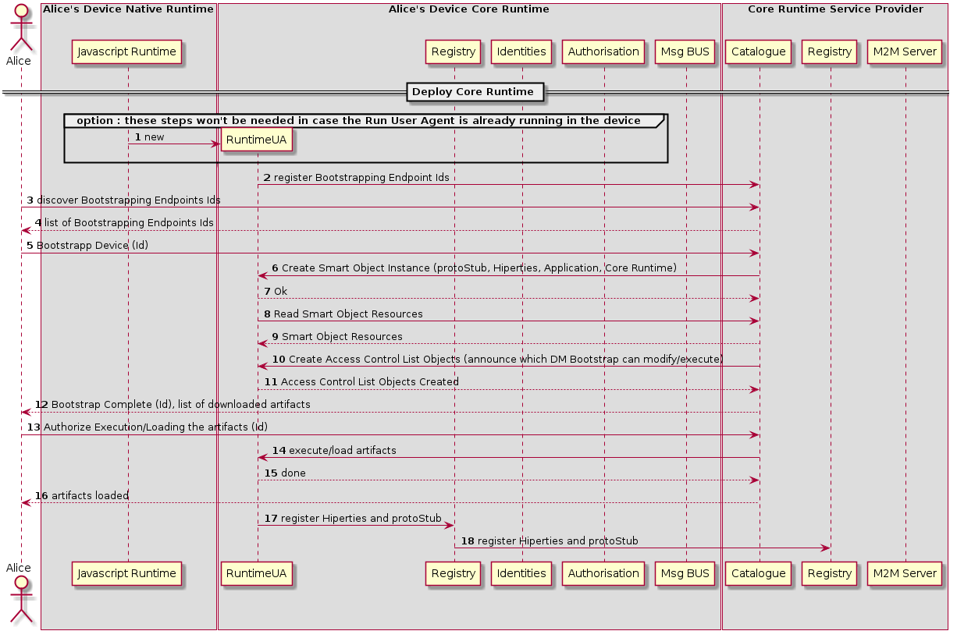

Diagram

*Data flows description missing*

#### M2M Intra Communication : Context Discovery

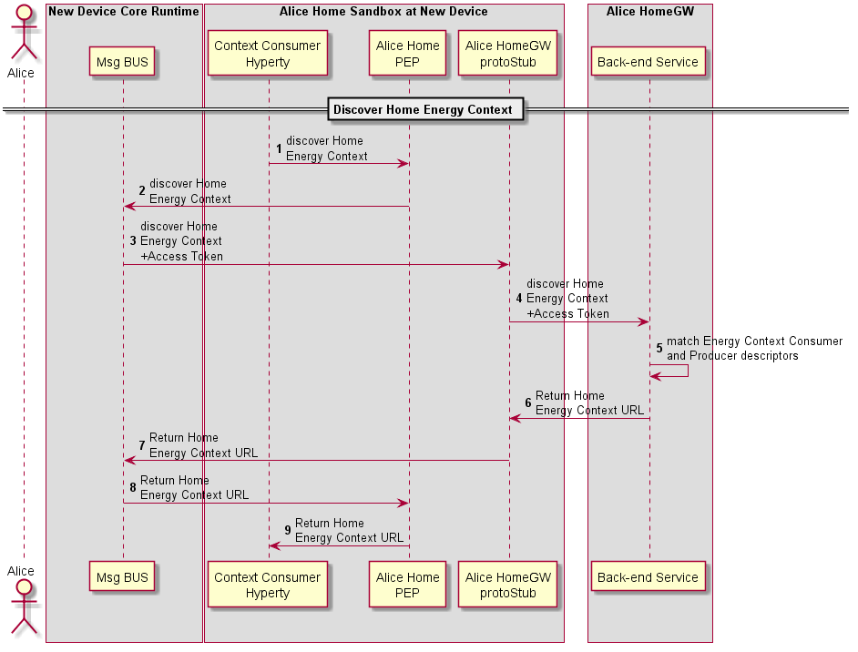

Context Discovery in M2M Intradomain Communication

[**Previous: Device Bootstrap, Authentication Registration**](m2m-bootstrap-auth-registration.md)

Steps 1 - 4: The Energy Context Consumer Hyperty requests to Discover the Home Energy Context through the Gateway Protocol Stub.

**READ Message**

"id" : "1"  
"type" : "READ",  
"from" : "hyperty-instance://alice.home/washmachinehy123",  
"to" : "alice.home",  
"body" : { "resource" : "alice.home/registry/context",   
 "criteria" : {"tag" : "energy"},  
 "projection" : {"url" : 1} }

Steps 5: The Residential Gateway finds the Energy Context Provider (HEMS) instance in its registry. It performs a match between its descriptor and the Energy Context Consumer (Wash Machine) descriptor to verify that both are compliant.

Steps 6 - 9: The Home Energy Context URL is returned to the Energy Context Consumer Hyperty.

**RESPONSE to READ Message**

"id" : "1"  
"type" : "RESPONSE",  
"from" : "alice.home",  
"to" : "hyperty-instance://alice.home/washmachinehy123",  
"body" : { "code" : "200" , "description" : "ok",  
 "value" : {"url" : "ctxt://alice.home/energy"}}

#### M2M Intra Communication : PUB-SUB Communication

[**Previous: Context Discovery**](m2m-intra-comm-3-discovery.md)

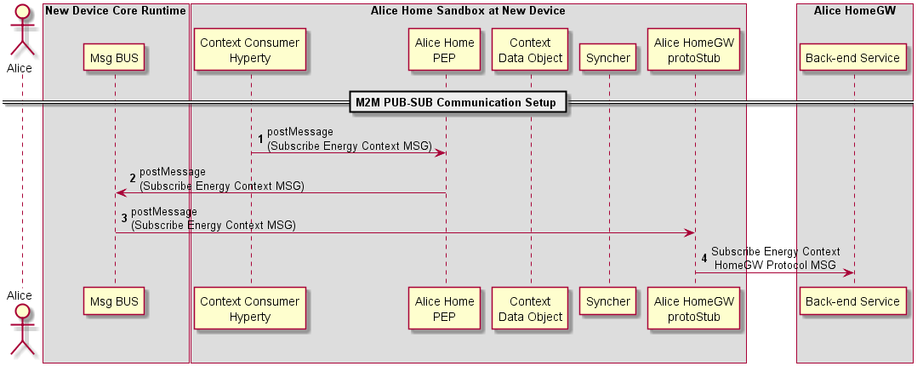

Context Discovery in M2M Intradomain Communication

Steps 1 - 4: The Energy Context Consumer Hyperty requests to Subscribe the Home Energy Context through the Gateway Protocol Stub.

**SUBSCRIBE Message**

"id" : "1"  
"type" : "SUBSCRIBE",  
"from" : "hyperty-instance://alice.home/washmachinehy123",  
"to" : "alice.home",  
"body" : { "resource" : "ctxt://alice.home/energy" }

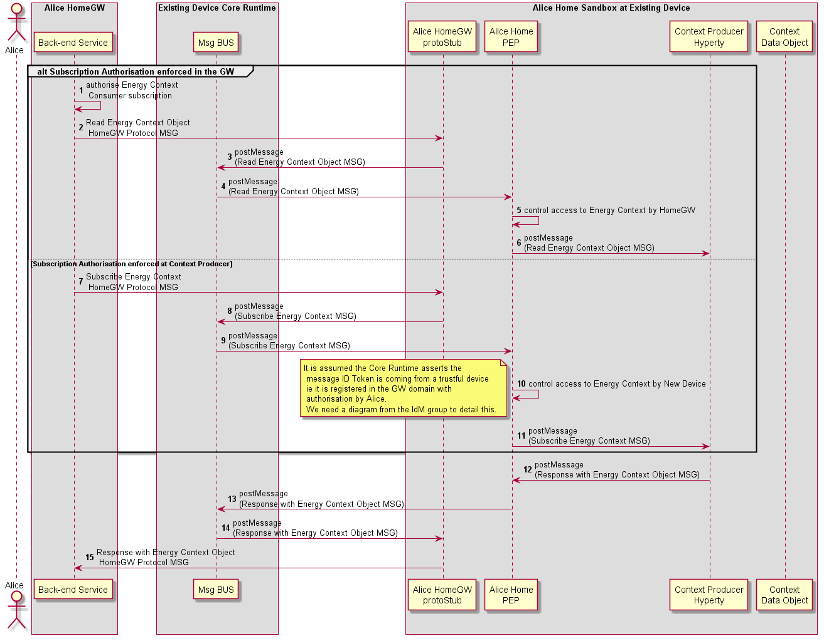

Context Discovery in M2M Intradomain Communication

Two options to handle with Subscription Auhtorisation:

**Option 1: Authorisation enforced in the GW**

Steps 1 : The Residential Gateway uses local policies to authorise the subscription request.

Steps 2 - 6: The Residential GW requests the Device holding the Context to retrieve the most updated Energy Context Data object. Through a READ message.

**READ Message**

"id" : "1"  
"type" : "READ",  
"from" : "alice.home",  
"to" : "hyperty-instance://alice.home/hemshy123",  
"body" : { "resource" : "ctxt://alice.home/energy" }

**Option 2: Authorisation enforced in the Device**

Steps 7 - 11 : The subscription request is forwarded to existing device Policy Enforcer which applies local policies to give permission to forward the message to the Producer Hyperty. It is assumed the Core Runtime asserts the message ID Token is coming from a trustful device ie it is registered in the GW domain with authorisation by Alice. (to be detailed in a separated IdM related diagram). *question:* should the Policy Enforcer respond with the Context Data Object without interacting with the Hyperty instance but only with the object?

Steps 12 - 15: The Hyperty responds with the most updated Context Data object.

**RESPONSE to READ or SUBSCRIBE Message**

"id" : "1"  
"type" : "RESPONSE",  
"from" : "hyperty-instance://alice.home/hemshy123",  
"to" : "hyperty-instance://alice.home/washmachinehy123", // for subscribe message response  
"to" : "alice.home", // for read message response  
"body" : { "code" : "200" , "description" : "ok",  
 "value" : { <Energy Context Data Object>}}

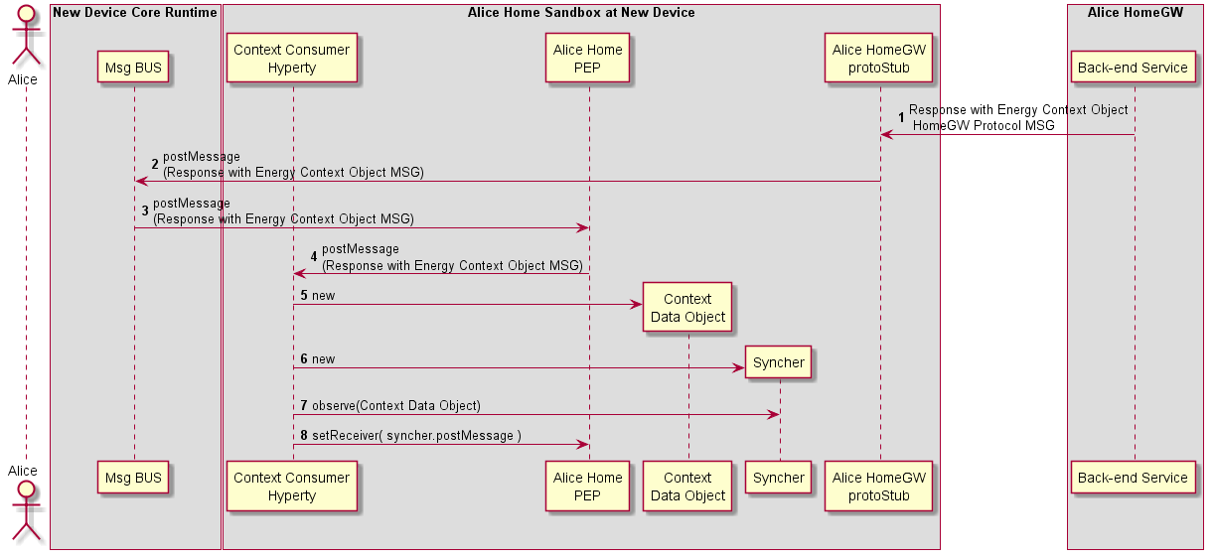

Context Discovery in M2M Intradomain Communication

Steps 1 - 4: The Subscription Response with Energy Context Data Object reachs the Consumer Hyperty.

Steps 5 - 8: Context Consumer Hyperty instantiates the received Energy Context Data Object and sets as an observer of it. Then, instantiates an Observer Syncher to observe it.

## Runtime Implementation Considerations

### Browser Runtime Implementation

## General design considerations

The Runtime implementation at browsers plays a central role in reTHINK project. Browsers are almost always present in devices aimed to be used by human beings so using its runtime to execute any application will ensure that it will be correctly interpreted and executed. However, browser's runtime has many security constraints the developer must deal with in order to get a functional web application.

The design of the browser runtime implementation for reTHINK project has been directed by security and functional requirements along as well as the security limitations imposed by the browser.

* A Service Worker is used to manage the cache of Runtime Core Components
* Hyperties and Protocol Stubs are implemented inside Web Workers
* Runtime Core components, Hyperties and Protocol Stub are executed inside an iFrame loaded from reTHINK runtime provider domain
* Web Workers are only able to interact each other with self.postMessage(..) which is caught by window.addEventListener('message', handleSizingResponse, false); implemented by the Runtime MsgBUS Core Component
* The same Service Worker may also be used to manage the cache of Hyperties and protostubs
* Since it is not possible to use webrtc APIs inside a web worker, there will be a "reTHINK WebRTC" component inside the iFrame but outside the web worker, that is in charge of interacting with the WebRTC API on behalf of Hyperties running inside Web Workers, through messages exchanged between Hyperties and the "reTHINK WebRTC". There will be a "HypertyWebRTCAgent" that will expose standard WebRTC APIs to be used by the Hyperty. In this way the Hyperty is not aware that it is not interacting directly with the native WebRTC API. It should be analysed whether communication between "reTHINK WebRTC" and "HypertyWebRTCAgent" will be supported by the Message BUS or by something else.
* Since the Hyperty API to be consumed by the Application can't be directly used by the App (cos it is inside a Web Worker) there will a kind of RPC communication through messages exchanged between the HypertyAPIStub component running on the App side and an API Skeleton running on Hyperty side. It should be analysed whether communication between these components will be supported by the Message BUS or by something else.
* in addition, and since it is not possible to pass WebRTC Media and Data Streams handled inside the iFrame towards the Application that is outside the iFrame, a local loop peerconnection is established between the "reTHINK WebRTC" and the "HypertyAPIStub" running on Application side. See more details below.

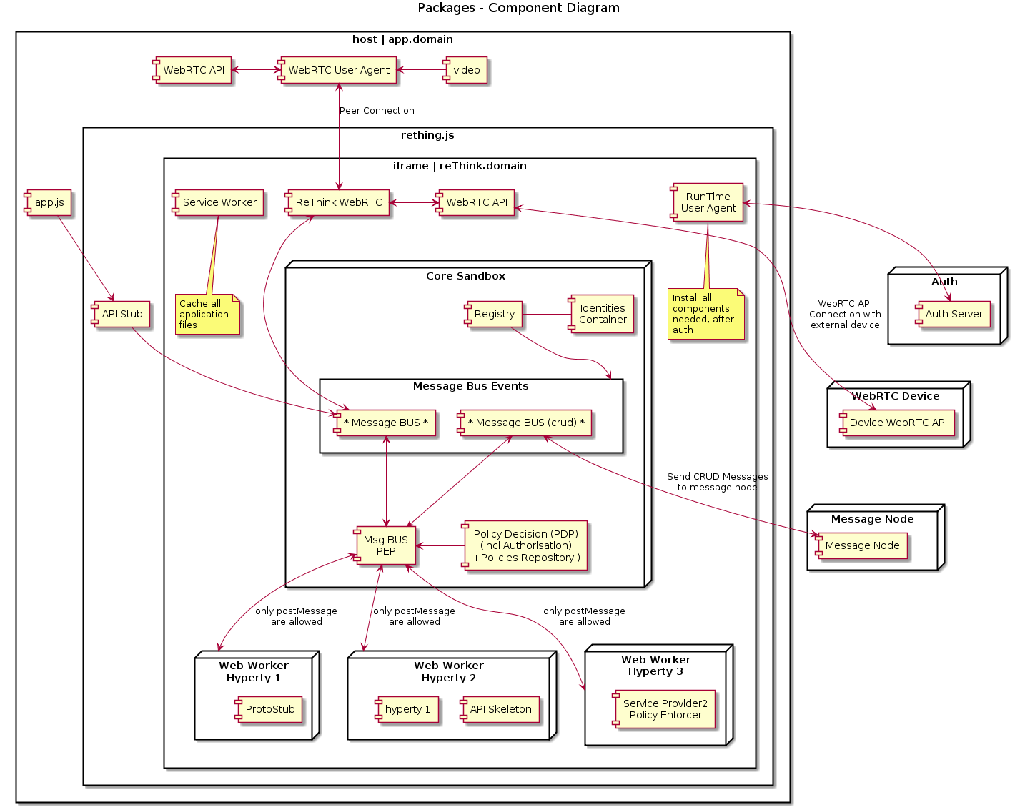

#### Runtime Architecture with IFrame

After some investigation we find away to send stream from app client to iframe with our domain. We use peer connection to send media stream.

**how it works** The peer getUserMedia from app client and make a call to peer inside the rethink iframe, and this answer with null stream (we send stream one way), after this, peer can send the stream through peer connection to another client.

We need to do an experimentation code to make an complete validation for this architecture.

### Considerations about the implementation of Runtime for standalone applications

A couple of tools have emerged to build native apps using standard web technologies. Among them: - crosswalk - cordova / phonegap / ionic

#### Crosswalk

Crosswalk is a runtime for mobile and desktop web applications. It enables to deploy standard web application for various devices (Android/IOS/Linux). It is based on Chrome and Blink for rendering.

By using the Crosswalk Project, an application developer can:

* Use all the features available in modern web browsers: HTML5, CSS3, JavaScript.
* Access the latest recommended and emerging web standards.
* Use experimental APIs not available in mainstream web browsers.
* Control the upgrade cycle of an application by distributing it with its own runtime.
* Add custom extensions to an application, to leverage platform features not exposed by Crosswalk or the standardized web platform.
* Crosswalk supports WebRTC applications so it makes possible to send and receive real-time flows from Android and iOS devices.

#### Crosswalk Architecture

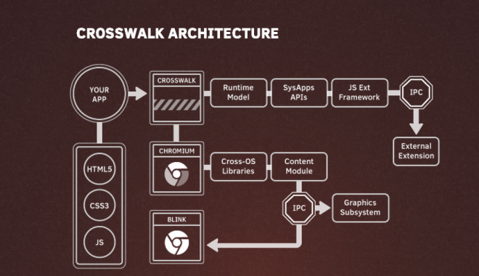

crosswalk

Crosswalk supports an efficient way of creating your own Web APIs as extensions by writing native Java code. This way the user can expose new platform and device APIs as they need them. New Api could be available in crosswalk before they get standardized at the W3C level.

#### cordova /Ionic / phonegap

Apache Cordova is a library used to create native mobile applications using Web technologies. The application is created using HTML, CSS and JavaScript and compiled for each specific platform using the platform native tools. Cordova provides a standard set of JavaScript APIs to access device features on all supported platforms. Additional features can be provided through the development of plugins

#### Cordova functionnal schema

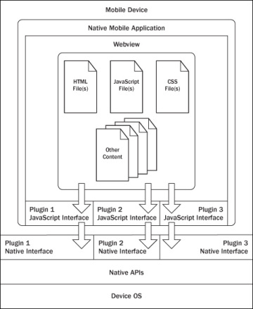

cordova

The application itself is implemented as a web page, by default a local file named index.html, that references whatever CSS, JavaScript, images, media files, or other resources are necessary for it to run. The app executes as a WebView within the native application wrapper, which you distribute to app stores.

At its core, Cordova offers a simple but powerful API to call Javascript functions that map to native code or plugins. This means you can transfer any kind of data from native land into web land. Cordova can do almost a native app can do, it just needs the right plugins that send the right data to your web code

#### Cordova plugins

A Cordova plugin bridges a bit of functionality between the WebView powering a Cordova application and the native platform the Cordova application is running on. Plugins are composed of a single JavaScript interface used across all platforms, and native implementations following platform-specific Plugin interfaces that the JavaScript will call into. It should be noted that all of the core Cordova APIs are implemented using this exact architecture. Cordova has a high quality plugin API, we just need more great plugins that expose data from the native layer, not just hard coded features or UIs. While the default plugins are very simple and easy to use, they don’t scale well when you want to build something really custom

#### Some plugin examples

##### iosRTC

iosrtc is a wrapper around Google’s WebRTC library and simply provides PeerConnection, getMediaDevices and getUserMedia APIs , without any limitations or artificial constraints.

##### phoneRTC

phoneRTC : https://github.com/alongubkin/phonertc

##### Crosswalk-based Cordova Android

Crosswalk-based Cordova Android is derived from Cordova Android and uses Crosswalk as the HTML5 runtime. It is an Android application library that allows for Cordova-based projects to be built for the Android Platform. It is aimed at replacing default Android Webview with Crosswalk Webview, bringing all new functionalities of Chrome.

This solution has been succesfully used by companies part of the reTHINK project to develop WebRTC hybrid applications so it is a suitable candidate to be used to implement standalone reTHINK applications for Android.

#### Cordova vs PhoneGap

Cordova is the community powered version of PhoneGap, which is Adobe’s productized version and ecosystem on top of Cordova.

#### Cordova vs Ionic

Ionic uses and extends Cordova

#### Webview

The WebView class is an extension of Android's View class that allows you to display web pages as a part of your activity layout. It does not include any features of a fully developed web browser, such as navigation controls or an address bar. All that WebView does, by default, is show a web page. This allows to leverage features provided by the browser engine in any App without adding extra libraries.

Since Android 4.4 (KitKat), the WebView component is based on the Chromium open source project. WebViews now include an updated version of the V8 JavaScript engine and support for modern web standards previously missing in old WebViews. New Webviews also share the same rendering engine as Chrome for Android, so rendering should be much more consistent between the WebView and Chrome.

In Android 5.0 (Lollipop), the WebView has moved to an APK so it can be updated seperately to the Android platform.

##### Webview WebRTC support

From WebView v36 WebRTC is supported so it makes easier to add WebRTC capabilities to any native. Webview 36.0.0.0 is still a developer preview version so it can not be used in official Apps currently but it is expected to become soon the stable release..

##### Crosswalk vs Webview

The size of the apps is lower compared to Crosswalk applications which must include all the libraries to implement the browser functionality. The WebView can be updated separately from the rest of the application. This can be an advantage as it will allows to fix any kind of issue and support new features, but it may cause issues if the App using it is not updated to fix any possible incompability.

One of the obvious drawbacks is that Webview is not available in iOS.

#### OpenWebRTC

OpenWebRTC is an open sourced project from Ericsson Research : https://github.com/EricssonResearch/openwebrtc

A flexible, mobile-first, cross-platform WebRTC client framework based on GStreamer. OpenWebRTC currently supports iOS, Android, Mac OS X and Linux.

### Selected solutions for the implementation:

#### Solutions that have already been tested :

##### Android :

Crosswalk : integrate chromium in the application with different possible integration : - Crosswalk embedded in the application - Crosswalk cordova plugin

Crosswalk usage should ensure us a compatibility with what is done for browser runtime as it embed Chromium

##### iOS :

iOSRTC, cordova plugin : https://github.com/eface2face/cordova-plugin-iosrtc

Usage of Cordova will enables us to reuse the components that will be developped on the browser runtime.

##### Android & iOS :

Crosswalk and iosRTC can be embeded in the same application code to support both platform.

Hybrid solution will be selected for the project as it enable to use JavaScript for the runtime

#### Solution to be tested during the implementation :

* Usage of Webviews will be interesting as it should facilitate the integration of WebRTC API.
* openWebRTC can also be insteresting as it should enable the possibility to build complete native and hybrid application.

### Runtime implementation in Constrained Devices

NodeJs is considered one of the options for implementing the Runtime API for platforms like Raspberry PI and [Beagle Board](http://beagleboard.org/bone):

### NodeJs Installation

For installing NodeJs on Raspberry Pi, 2 steps are required: download the debian package and then install it (http://weworkweplay.com/play/raspberry-pi-nodejs/)

wget http://node-arm.herokuapp.com/node_latest_armhf.deb   
sudo dpkg -i node_latest_armhf.deb

For installing NodeJs on BeagleBoard (http://beagleboard.org/Support/BoneScript) one can compile it from scratch (http://www.armhf.com/node-js-for-the-beaglebone-black/) or install it in a similar way as for Raspberry using one of the versions from the download page: http://www.armhf.com/download/

### Design

The goal of the design is to use stable NodeJs open-source or business friendly modules that provide functionality for the components that are part of the architecture of the Runtime.

One of the key functional requirements is security of the Runtime. Thus multiple sandboxes to separate code is present in the Runtime architecture as a security by design feature. There are 3 types of sandboxes to be used: Core Sandbox, Service Provider Sandbox and Hyperty Sandbox (http://gf3.github.io/sandbox/).

The message component of the Runtime implementation constitues one of the main components. There are many message buses implemented as NodeJs modules. The one selected for evaluation is Capriza, https://github.com/capriza/node-busmq, having as key functionality: scalability and guaranteed order of messages.

For the Runtime UA a module implementing the protocol LWM2M is already available for NodeJs (https://github.com/telefonicaid/lwm2m-node-lib).

### Code Snippets (maybe they should be directly added as code on the github)

For creating several sandboxes the following code can be used:

#### Also potentially relevant:

http://samsung.github.io/iotjs/

also see: https://github.com/reTHINK-project/core-framework/blob/master/docs/specs/runtime/implementation/standalone-runtime.md

# Message Node Specification

## Messaging Node Architecture

Below, it is depicted a functional architecture of the Messaging Node:

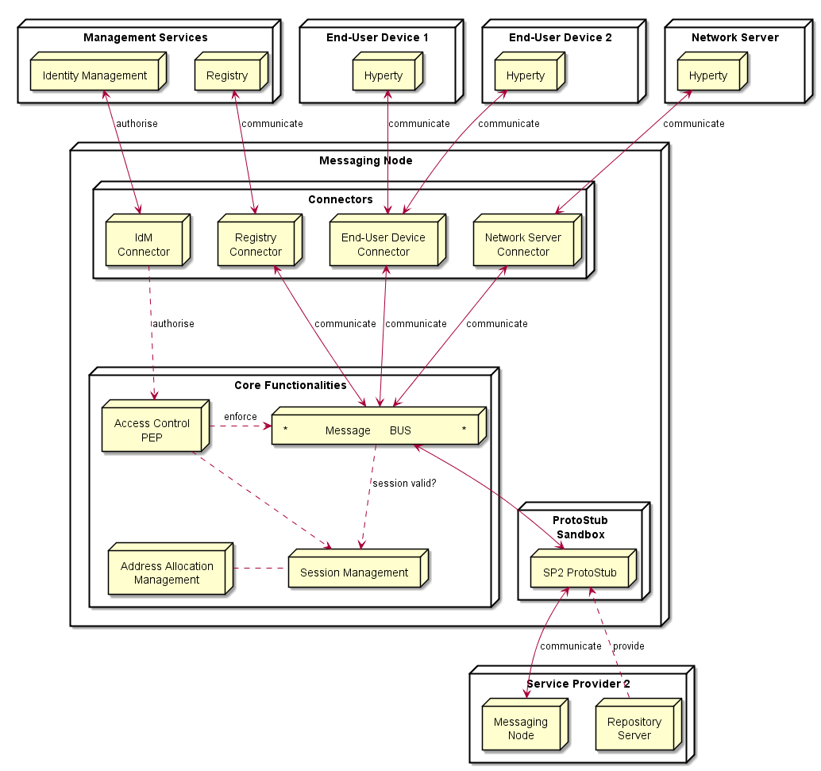

Messaging Node Architecture

The Messaging Node is comprised by three main types of functionalities:

The Core Functionalities, Connectors and Protocol Stubs.

### Core Functionalities

#### Message BUS

Routes messages to internal Messaging Node components and external elements by using Connectors or Protocol Stubs. It supports different communication patterns including publish/subscribe communication.

#### Access Control

Message Routing including pub/sub Subscriptions are subject to Access Control in cooperation with authentication and authorisation provided by Identity Management functionalities.

#### Session Management

Session Management functionalities are used to control messaging connections to service provider back-end services. For example, when user turns-on the device and connects to its domain, providing credentials as required by Identity Management functionalities. In general, each message should contain a valid token that was generated when the used connected to the Messaging Node. It also manages the registry of protocol stubs and connectors supported by the Messaging Nodes to support the routing of messages to these components.

#### Address Allocation Management

Manages allocation of messaging addresses to Hyperty Instances in cooperation with Session Management when users connect to the domain.

It also manages the allocation of messaging addresses to foreign Hyperty Instances i.e. Hyperty Instances that are provided from external domains but that use the protofly concept to interact with Hyperty Instances served by this Messaging Node.

### Protocol Stub

In special situations eg when the download of external software (protocol stubs) into end-user devices is not allowed, it should be possible to have interoperability between Messaging Nodes from different domains by using the protofly concept.

Thus, a Protocol Stack to be used to communicate with another Messaging Node can be deployed.

### Connectors

Connectors implements protocol stacks used to interoperate with external elements from the domains, including:

* IdM Connector to interact with remote Identity Management functionalities
* Registry Connector to interact with remote Registry functionalities
* End-User Device Connector to interact with Hyperty Instances running in the end-user device
* Network Server Connector to interact with Hyperty Instances running in a Network Server

## Vertx Specification

*For each* [*functional block*](msg-node-architecture.md) *identify existing vertx components that can be reused and extended If extensions are neede they should be specificied by designing apis to be implemented*

### Core Functionalities

* Main objective of core func. is to authorize, filter and process messages. Messages are JSON objects that should have 2 blocks, HEADER and BODY, and are processed from different components of core. Inbound messages should be processed in a Pipeline. The sequence is "Session Management" -> "Access Control" -> "Message BUS"
* Pipeline components will implement a simple interface that we can reuse from io.vertx.core.Handler<E> replacing E with a PipelineContext object. Using the vertx Handler has the advantage to be compatible with io.vertx.ext.web.Router, that can be a replacement for the Pipeline.
* Outbound messages should be processed in a Pub/Sub system. If message BODY block are for CRUD operations, there should be a Pub/Sub protocol for object/model subscriptions, where should this be processed? The address scheme of the vertx EventBus is not enough for this functionality. We need to control the Pub/Sub functionality better than what vertx give to us with the address scheme! Hyperties need to subscribe to objects/collections not just addresses.

#### Pipeline

By now, additional components are identified (Pipeline, PipelineContext). This is similar to vertx Router but without the URL addressing scheme. The io.vertx.ext.web.Router class could be a possible candidate for Pipeline functionalities, however the Router is hard coded to work with HTTP protocols, and there is no need for static configurations of routing schemes. I would advise to implement a simple Pipeline system instead of using the Router, less dependencies and better decoupled from the protocol.

#### Session Management

Connection (WebSocket, SockJS) events/messages for OPEN and CLOSE should be intercepted by this component. A session instance is linked to a connection resource (WebSocket, SockJS) if authorized. Every message header is intercepted, session token is verified and if exist, a "user" or other identification URL is replaced in HEADER. The JSON object is forwarded to "Access Control" component.

#### Address Allocation Management

This is not a Pipeline component (it doesn't process messages), but it's used by the "Session Management" to allocate Hyperty identification URL's that will be linked to a Session when the Hyperty is connected. This will be used to translate Hyperty an URL address into the correspondent Connector Resource.

#### Access Control

This component is able to analyze HEADER (identification URL from "Session Management") and BODY blocks and decide if the message should be forwarded to the "Message Bus" or denied. There is a possibility to add a rule engine in this step, but it's not specified for now, what kind of rule engine.

#### Message BUS

Main objective of the MB is to process the BODY block, that contains information of the protocol, CRUD operation or other defined information. Vertx EventBus can be used directly for the Message Bus component. Important headers of the original JSON (like the identification URL) must be forwarded to io.vertx.core.eventbus.Message.headers() map.

### Protocol Stub Sandbox

### Connectors

#### End User Device Connector

The aim of this Connector is to enable interaction with Hyperty instances running in the end-user device. This component will need to interact somehow with the Protocol Stub sandbox to achieve this, since the communication protocol will not be standardized. It will need to implement a simple protocol for sending and receiving requests. In itself it is not responsible for processing communication requests, that is left to the protocol stack. It merely forwards messages to and from the Hyperty instance.

#### Network Server Connector

The aim of this Connector is to enable interaction with Hyperty instances running in a network server. This component will need to interact somehow with the Protocol Stub sandbox to achieve this, since the communication protocol will not be standardized. It will need to implement a simple protocol for sending and receiving requests. In itself it is not responsible for processing communication requests, that is left to the protocol stack. It merely forwards messages to and from the Network server.

#### Registry Connector

The Registry provides an interface for registration and deregistration of Hyperty instances, as well as for keeping the published information up to date. For each Hyperty instance, the Registry stores data (hyperty location, type, description, start-time, presence information of user) that enables other applications to contact it. The implementation of the Registry service is thought to be basically a distributed database. It will provide service interfaces for CRUD operations to allow users to retrieve data for a given GraphID, publish (i.e. create, update, and delete) their own information on the ring. To verify authenticity and integrity of the published data, digital signatures will be applied. The Connector will exposed the available interfaces of the Registry Services to users of managing Hyperty instances. This will have to be implemented as a standalone application with an adapter interface to the Event Bus for encoding and decoding messages and deployed as a fat executable jar which contain all the dependencies it needs to run on vertx.

#### IdM Connector

This Connector is to provide functionalities for interacting with the remote Identity Management Functionailities. It is unclear if this should be for authentication purpose, or simply for CRUD operations. In WP4 there is also discussion on an Identity Module.

*As hyperties need to be linked to an end-user identity when downloaded and instantiated on a device, an Identity Module should be present on the device. This module at minimum should act as an identity selector for the user and as a secure local repository for identity tokens provided by IdPs*

If this is the case, then it is unclear to me what the connector on the Messaging Node should do. However, if the connector is thought to provide authentication and authorisation, Vert.x offers Auth APIs (Common, JDBC, JWT and Shiro) JWT auth sounds interesting as it uses JSON web tokens.

Another interesting library is the authentication and discorvery is [vertx-pac4j] (https://github.com/pac4j/vertx-pac4j). This vertx module provides multiple authenication mechanisms (OAuh, CAS, HTTP, OpenID, SAML2.0 and OpenIDConnect) for different IdPs. However, it is based on vertx.2. So if it suits the requirements, we will need to adapt to vertx.3.

## NodeJs based Messaging Node Specification

For each [functional block](msg-node-architecture.md) the WP3 team has identified existing nodeJs modules which can be either reused or extended.

### Core Functionalities

This section attempts to match the functional blocks of the Message Node architecture to features and functional blocks of the nodeJs and Redis architecture.

#### Message BUS

The message bus can be implemented with Redis. http://redis.io

Redis is an open source (BSD licensed), in-memory data structure store, used as database, cache and message broker. It supports data structures such as strings, hashes, lists, sets, sorted sets with range queries, bitmaps, hyperloglogs and geospatial indexes with radius queries. Redis has built-in replication, Lua scripting, LRU eviction, transactions and different levels of on-disk persistence, and provides high availability via Redis Sentinel and automatic partitioning with Redis Cluster.

##### Usage of Redis with NodeJs

Redis integrate a PUB/SUB mechanism : http://redis.io/topics/pubsub

SUBSCRIBE, UNSUBSCRIBE and PUBLISH implement the Publish/Subscribe messaging paradigm where (citing Wikipedia) senders (publishers) are not programmed to send their messages to specific receivers (subscribers). Rather, published messages are characterized into channels, without knowledge of what (if any) subscribers there may be. Subscribers express interest in one or more channels, and only receive messages that are of interest, without knowledge of what (if any) publishers there are. This decoupling of publishers and subscribers can allow for greater scalability and a more dynamic network topology.

Redis can be used to add scalability/redundancy to the messaging node as the different components of the architecture can easily be splitted on different servers. This Pub/Sub mechanism is simple to use and It can also facilitate the development and the integration of new connectors

Communication between NodeJs and Redis can be managed by a NodesJs Redis client module : https://github.com/NodeRedis/node_redis

Redis instance can be a single instance or a Redis cluster.

#### Access Control

User connection to NodeJs connectors can be authentified on the NodeJs module. Socket.io integrate a way to authenticate incoming request, authenication component will have to be develop on NodeJs connectors.

This component is able to analyze HEADER (identification URL from "Session Management") and DATA blocks and decide if the message should be forwarded to the "Message Bus" or denied.

PassportJs, which is an intesreting middleware, that could enable us to add third party authentication should be used : http://passportjs.org/

An authentication can also be done between NodeJs and Redis.

#### Session Management

For a complete session management on NodeJs, it will be interesting to use express which is a Web framework for NodeJs : http://expressjs.com/

#### Address Allocation Management

This component will have to be developped on a NodeJs server

#### Protocol Stub & Connectors

Connectors will be NodeJs process to be developped.

Goal will be to mutualize connectors by using the protoStub/protoFly mechanism : this will add flexibility to connect other GWs, CSP ...

##### IdM Connector

This Connector is to provide functionalities for interacting with the remote Identity Management Functionailities. Node.js can easily interact with OAuth servers in order to authenticate and authorize users.

It this is for authentication purpose the authentication agqinst the IdP has to be done at the begining. If the CRUD operations have to be authorized on a per identity basis (e.g. user A, correctly authenticated, is only allowed to do 'RU' over a Data Objet) we should get

##### Registry Connector

The Registry provides an interface for registration and deregistration of Hyperty instances, as well as for keeping the published information up to date. For each Hyperty instance, the Registry stores data (hyperty location, type, description, start-time, presence information of user) that enables other applications to contact it. The implementation of the Registry service is thought to be basically a distributed database. It will provide service interfaces for CRUD operations to allow users to retrieve data for a given GraphID, publish (i.e. create, update, and delete) their own information on the ring. To verify authenticity and integrity of the published data, digital signatures will be applied. The Connector will exposed the available interfaces of the Registry Services to users of managing Hyperty instances.

##### End-User Device Connector

Communication between Users and NodeJs can be managed by socket.io Socket.io is a popular Node.js library to handle connections at application level. It can use Websocket and it falls back to HTTP automatically if WS connectivity is not possible.

##### Network Server Connector

The aim of this Connector is to enable interaction with Hyperty instances running in a network server. This component will need to interact somehow with the Protocol Stub sandbox to achieve this, since the communication protocol will not be standardized. It will need to implement a simple protocol for sending and receiving requests. In itself it is not responsible for processing communication requests, that is left to the protocol stack. It merely forwards messages to and from the Network server.

##### Node Sandbox framework

[Node-sandbox](https://www.npmjs.com/package/node-sandbox) allows to run untrusted code outside of the main node process. The code can be interfaced with code running in the sandbox via RPC (or any library that works over the node Stream API).

### NodeJs implementation architecture

**Architecture : NodeJs and Redis :**

Here is decription of the architecure with Redis :

**Architecture : Integration in ReThink :**

Following architecture shows the target integration with the different components of the ReThink projet :

**Architecture : Integration in ReThink with Actors:**

Following architecture shows the actors in the architecture to unsderstand the decomposition of work to be done and the interaction with other partners :

## Matrix.org based Messaging Node Specification

This section matches the requirements for the functional blocks of the Message Node architecture to features and functional blocks of the matrix.org architecture. Functional gaps are identified and proposals for extensions to the standard Matrix.org Homeserver are made in order to fill these gaps.

### Protocol Stub and Connectors

Protocol Stubs and Connectors are means to make a Messaging Node interoperable with foreign signalling protocols.

A protocol stub is the core entity of the Protocol-on-the-fly concept. It is a downloadable piece of JavaScript code that is executed in the client's runtime and performs the required adaptations on the messaging protocol. In a Protocol-on-the-fly based communication relation there is always one side in the client role (i.e. the side that downloads the stub) and the other side in the server role (the side that the stub connects to).

A Messaging node has to support both operation modes in order to provide full bi-directional interoperability.

#### Matrix as Protocol-on-the-fly client

The most appropriate feature that Matrix provides for this purpose is the concept of "Application Services". An Application Service is an implementation of a special service function that can be attached to a Homeserver (HS). Based on certain patterns, messages are filtered and forwarded to the Application Service that performs application specific tasks. This concept is quite comparable to Application Servers in the IP Multimedia Subsystem (IMS) framework. It can, for example, be used for aggregation and accounting purposes, but also for the implementation of "breakout" communication to other types of messaging infrastructures it is well suited.

A special dedicated Application Service is proposed that will implement a Protocol-on-the-fly client engine to allow the "breakout" to different signalling domains that provide a Protocol-on-the-fly stub. Such an Application Service will be a very flexible mechanism for interdomain collaboration.

#### Matrix as Protocol-on-the-fly server

In order to support the server role in the Protocol-on-the-fly architecture, a specialized Matrix protocol stub needs to be implemented that connects to a Homeserver. Since the Matrix Homeserver has a well-documented API and the Matrix message format allows the transport of arbitrary payload, this implementation should be straight forward. The implementation can make use of the SDK's that are available for Matrix client developers. These SDK's encapsulate a lot of the internal complexity for REST based communication.

#### Connectors in Matrix

Connectors also play the role of protocol adapters, which makes them comparable to protocol stubs. The difference is that they are not downloaded to the Messaging Node clients. Instead they are executed in the scope of the Messaging Node itself. Such Connectors are intended to connect with different "legacy" clients that don't support the Protocol-on-the-fly concept.

Also for the implementation of such connectors the concept of Application Services seems well suited. The matrix.org developer community has implemented this as a proof of concept that connects the Matrix ecosystem with the Internet Relay Chat (IRC) world. Messages that contain a specially prefixed address are filtered out, converted to IRC messages, forwarded to the corresponding IRC client and vice versa. This can be used as pattern for the implementation of additional adapters.

### Core Functionalities

#### Message Bus

The Message Bus is responsible for the routing of messages to internal Messaging Node components and external elements by using Connectors or Protocol Stubs. This routing shall support different communication patterns including publish/subscribe communication.

These main routing requirements are fulfilled out-of-the-box by standard matrix features. In order to route messages to internal Messaging Node components it will be required to provide such components with virtual identifiers that can be used internally to address them.

#### Access Control

The main task of the access control is to enforce manageable policies to the forwarding of individual messages. For example, a single type of message shall be blocked if a special combination of sender and/or receiver matches.

Matrix.org requires registration/subscription and login of users in order to exchange any messages with other users. These authentication and authorisation methods however always apply to a complete user- and communication session, that means to ALL messages that are exchanged in a session scope. This concept does not provide an access control on a "per message" base.

The matrix developer community already discusses the integration of a "policy service", but so far this integration in not yet specified.

In order to achieve a "per message"-policy enforcement without deeper changes in the matrix core, we propose the introduction of a message proxy as first step of the message flow. This proxy has the task to check the messages and to apply the policies. It would forward messages according to the policies and should reject the rest. A potential bypassing of this proxy must be avoided by appropriate network configurations.

The design of this message proxy component should be closely coordinated with the MessagingStub that is used to connect to this Matrix based Messaging Node, because the proxy will be the first contact point for the stub.

The following figure gives an overview of the intended architecture of the Matrix based Messaging Node.

Matrix Messaging Node Architecture

Matrix Messaging Node Architecture

#### Session Management

The requirements regarding session management as described in the Messaging Node architecture can be separated in three aspects which are handled in the following sub-chapters: * User session control, * Communication session control, and * Stub and connector management.

##### User session control

In order to use matrix based messaging users have to be registered/subscribed with a matrix HomeServer. Matrix provides an API for the subscription of new users with their HomeServers. This API can be used to provision accounts also programmatically, when required.

In order to establish a communication session with other peers, users have to pass a login sequence. During this sequence an access token is generated which is valid for this login session. This access token must be present in all sub-sequent requests during this user session. No mandatory authentication methods are specified. This is left as implementation specific for the particular HomeServers. The specification lists following standard methods:

* m.login.password,
* m.login.recaptcha,
* m.login.oauth2,
* m.login.email.identity, and
* m.login.dummy.

The HomeServer Client API provides means to request the supported methods before login.

##### Communication session control

Communication sessions between two or more users require a valid user session. Communication sessions are always based on "rooms". Each room is identified by a unique room-id. Messages are sent to room-ids and not to individual users. Users must explicitly create or join rooms in order to send and receive messages. Some rooms might be open - others may require an invitation by the creator of the room. Rooms are persistent, i.e. they exist also if not all room members are currently logged in. The message history is maintained by the Matrix HomeServers and can be requested by clients.

##### Stub and connector management

Matrix.org provides powerful means to connect, federate, and synchronise Matrix HomeServers from different domains. The resolution of the peer HomeServers connectivity is done via DNS. The message exchange between them is secured by encryption mechanisms.

However - for the interoperability with non-Matrix infrastructures there is no "golden" way. The selected and most appropriate approach is via Application Services, as described before.

The "Stub and connector management" function is responsible for the management of the Application Services that implement the Protocol-on-the-fly clients and the connectors.

#### Address Allocation Management

In order to be addressable each hyperty instance should be treated as an individual client of the Messaging Node that registers with an own identity and needs a login before it can exchange messages. The Messaging Node allocates the identity of a hyperty during the registration/subscription process. The allocated identity serves then as a messaging address for domain internal communication.

External Hyperties from foreign domains (that might use different communication protocols and identifiers) will need an address representation in the Matrix domain that is compatible with the local addressing scheme. The Messaging Node is responsible for the creation and assignment of such transient addresses for domain external entities.

Since we have identified Application Services as the most appropriate way of connecting to other signalling domains, also the management of such virtual transient addresses is in the responsibility of the corresponding Application Service. Each Application Service itself has to maintain an own namespace of virtual users and must be able to operate (send/receive) "on behalf" of such a virtual user.

# Conclusions

# References

[1] - [Barth, A.; Jackson, C.; Reis, C. and Team, Google Chrome. 2008. The Security Architecture of the Chromium Browser.](http://seclab.stanford.edu/websec/chromium/chromium-security-architecture.pdf)

[2] - [Nicholas Carlini, Adrienne Porter Felt, and David Wagner. 2012. An evaluation of the Google Chrome extension security architecture. In Proceedings of the 21st USENIX conference on Security symposium (Security'12). USENIX Association, Berkeley, CA, USA.](http://nicholas.carlini.com/papers/2012_usenix_chromeextensions.pdf)

[3] - [Garcia-Alfaro, J. and Navarro-Arribas, G. 2007. A Survey on Detection Techniques to Prevent Cross-Site Scripting Attacks on Current Web Applications., in Javier Lopez & Bernhard M. Hämmerli, ed., 'CRITIS' , Springer, , pp. 287-298 .](http://eprints.uoc.edu/research/bitstream/10363/605/1/JGA01.pdf)

[4] - [Scott, D. and Sharp, R. Abstracting application-level web security. 11th Internation Conference on the World Wide Web, pp. 396–407, 2002.](http://rich.recoil.org/publications/websec.pdf)

[5] - [Pietraszeck, T. and Vanden-Berghe, C. Defending against injection attacks through context-sensitive string evaluation. Recent Advances in Intrusion Detection (RAID 2005), pp.124– 145, 2005.](http://tadek.pietraszek.org/publications/pietraszek05_defending.pdf)

[6] - [Kirda, E., Kruegel, C., Vigna, G., and Jovanovic, N. Noxes: A client-side solution for mitigating cross-site scripting attacks. 21st ACM Symposium on Applied Computing, 2006.](https://iseclab.org/papers/noxes.pdf)

[7] - [Ismail, O., Etoh, M., Kadobayashi, Y., and Yamaguchi, S. A Proposal and Implementation of Automatic Detection/Collection System for Cross-Site Scripting Vulnerability. 18th Int. Conf. on Advanced Information Networking and Applications (AINA 2004), 2004.](http://ieeexplore.ieee.org/xpl/freeabs_all.jsp?arnumber=1283902&abstractAccess=no&userType=instima)

[8] - [Hallaraker, O. and Vigna, G. Detecting Malicious JavaScript Code in Mozilla. 10th IEEE International Conference on Engineering of Complex Computer Systems (ICECCS’05), pp.85–94, 2005.](http://www.cs.ucsb.edu/~vigna/publications/2005_hallaraker_vigna_ICECCS05.pdf)

[9] - [Jovanovic, N., Kruegel, C., and Kirda, E. Precise alias analysis for static detection of web application vulnerabilities. 2006 Workshop on Programming Languages and Analysis for Security, pp. 27–36, USA, 2006.](https://iseclab.org/papers/pixy2.pdf)

[10] - [Jim, T., Swamy, N., Hicks M. Defeating Script Injection Attacks with Browser-Enforced Embedded Policies. International World Wide Web Conferencem, WWW 2007, May 2007.](http://www2007.org/papers/paper595.pdf)

[11] - [Uwe Hansmann, Martin S. Nicklous, Frank Seliger, and Thomas Schaeck. 1999. Smart Card Application Development Using Java (1st ed.). Springer-Verlag New York, Inc., Secaucus, NJ, USA.](http://dl.acm.org/citation.cfm?id=555354)

[12] - [Pascal Urien. Cloud of Secure Elements Perspectives for Mobile and Cloud Applications Security. IEEE Conference on Communications and Network Security 2013 - Poster Session](http://ieeexplore.ieee.org/stamp/stamp.jsp?tp=&arnumber=6682733)

[13] - [Wojciech Mostowski and Erik Poll. 2008. Malicious Code on Java Card Smartcards: Attacks and Countermeasures. In Proceedings of the 8th IFIP WG 8.8/11.2 international conference on Smart Card Research and Advanced Applications (CARDIS '08), Gilles Grimaud and François-Xavier Standaert (Eds.). Springer-Verlag, Berlin, Heidelberg, 1-16. DOI=10.1007/978-3-540-85893-5_1 http://dx.doi.org/10.1007/978-3-540-85893-5_1](http://www.cs.ru.nl/E.Poll/papers/cardis08.pdf)

[14] - [Ankur Taly, Úlfar Erlingsson, John C. Mitchell, Mark S. Miller, and Jasvir Nagra. 2011. Automated Analysis of Security-Critical JavaScript APIs. In Proceedings of the 2011 IEEE Symposium on Security and Privacy (SP '11). IEEE Computer Society, Washington, DC, USA, 363-378. DOI=10.1109/SP.2011.39 http://dx.doi.org/10.1109/SP.2011.39](http://www-cs-students.stanford.edu/~ataly/Papers/sp11.pdf)

1. Chromium sandbox scheme
2. The architecture of a Google Chrome extension
3. Scheme of a persistent XSS attack
4. Scheme of a non-persistent XSS attack
5. Java Smart Card scheme
6. CoSE architecture
7. Service framework middle layer
8. Sippo WAC reference architecture
9. Sippo interfaces and APIs
10. Sippo.js abstraction layer
11. Sippo services and backends
12. Sippo WebRTC applications stack
13. Runtime High Level Architecture
14. Runtime High Level Architecture with Unstrusted Hyperties
15. Runtime High Level Architecture with Policy Enforcer
16. Runtime Architecture
17. Vulnerability matrix for a dummy platform
18. Stack
19. Browser
20. Security Browser
21. Application platform
22. Security Application platform
23. Deploy Core Runtime Components in the Native Runtime
24. Deploy Protocol Stub
25. Deploy Hyperty
26. Message Routing in Message BUS
27. Intra-domain Local Communication
28. Intra-domain Remote Communication
29. Inter-domain Local Communication
30. Inter-domain Remote Communication
31. User registration
32. Prepare Discovery
33. Use Discovery
34. Domain Login
35. Associate User Identity to Hyperty Instance
36. User identity assertion sequence diagram
37. Alice invites Bob for a communication
38. Bob receives invitation
39. Aknowledged that Bob received the invitation
40. notification update
41. Bob gatheres WebRTC resources
42. Synchronization of Alice's Data object
43. Alice invites Bob for a communication
44. Alice invites Bob for a communication
45. Runtime Main Procedures for M2M Communication
46. M2M Device Bootstrap
47. Communication 4 pub sub 1
48. Communication 4 pub sub 2
49. Communication 4 pub sub 3
50. Runtime browser implementation
51. Crosswalk Architecture
52. Cordova functionnal schema
53. Cordova functionnal schema
54. Messaging Node Architecture