# Specification

This chapter provides an update of the detailed specification of the Hyperty Runtime, the Message Node and Messages used for the main procedures, taking into account changes performed during the implementation activities.

## Runtime Architecture

The main Hyperty Runtime architecture is comprised by different types of components that, for security reasons, are executed in isolated sandboxes. Thus, components downloaded from a specific Service Provider (e.g. Service Provider 1) are executed in sandboxes that are different from the sandboxes used to execute components downloaded from another service provider (e.g. Service Provider 2). In addition, for the same Service Provider, and also for security reasons, protocol stubs and Hyperties are isolated from each other and executed in different sandboxes. Communication between components running in different sandboxes is only possible through messages exchanged through a Message Bus functionality provided by the Core Sandbox. On the other hand, the Protocol Stub provides the bridge for the Hyperty Runtime to communicate with associated Service Provider. For example, in Figure below, protostub1 is the only way that Hyperty instances have to communicate with Service Provider 1. In general, in the Core Sandbox, all required functionalities to support the deployment, execution and maintenance of components downloaded from service providers, are executed. Core components are, ideally, natively part of the device runtime. However, to support existing platforms including Browsers and Mobile Operating Systems, to minimise the need to install new applications, the existing device native runtime functionalities (e.g. JavaScript engine) are distinguished from the Hyperty Core Runtime functionalities. In such situations, the Hyperty Core Runtime components are downloaded from the Hyperty Runtime Service Provider and are executed in an isolated core sandbox.



High Level Runtime Architecture with trusted Hyperties

The Application and the Hyperty can be delivered by the same Service Provider or by different Service Providers, i.e. Hyperty is delivered by an (Hyperty) Service Provider and the Application is delivered by an Application Service Provider. These two different situations impacts the level of trust between the Application and the Hyperty, that should be handled by the Hyperty Runtime accordingly.

In Figure above, the Application and the Hyperty Instances it consumes, are downloaded from the same Service Provider. Thus, it is assumed they trust each other and that they can be executed in the same sandbox with no impact on how the Application consumes the Hyperty Application API. In Figure below, it is depicted the Runtime Architecture where the Application and the Hyperty Instances it consumes, don't trust each other, for example, they are downloaded from different service providers. In such situation, Hyperties and the Application are isolated from each other and they are executed in different sandboxes. In this case, the Hyperty Application API is no longer local and the application is only able to reach the Hyperty Instance through the Message BUS. It is desirable to abstract the Application developer from these situations and to let the Application developer call the Hyperty Application API as if they are always local. This implies that the Core Runtime and the Sandbox implementation, is able to support a Remote Procedure Call (RPC) communication when the Application and the Hyperty Instance are in different sandboxes.

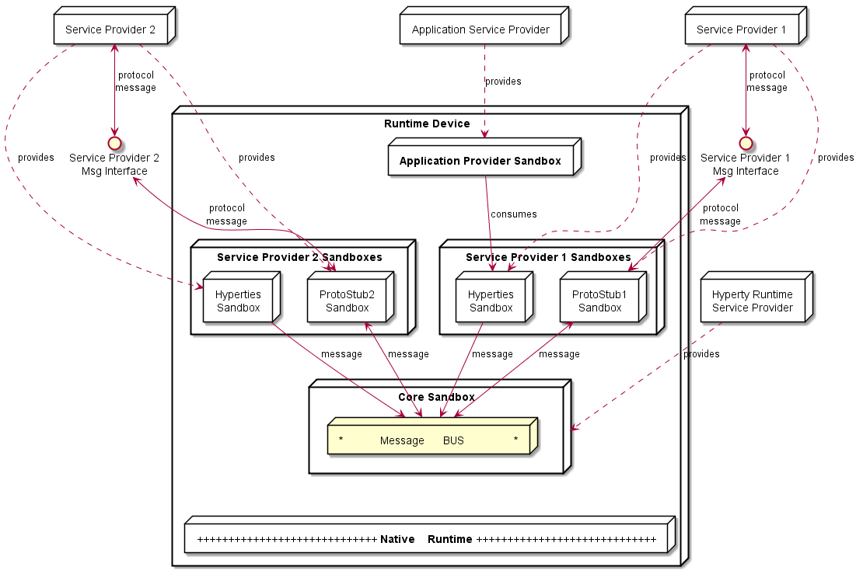

High Level Runtime Architecture with untrusted Hyperties

As described below, to prevent cross origin attacks / spy, access to Core Runtime Message BUS is subject to authorisation, by using standardised policies downloaded from each involved Service Provider. In addition, the Hyperty Runtime Architecture also supports Hyperty Interceptors executed in a dedicated sandbox (see Figure below) enabling the enforcement of proprietary policies.

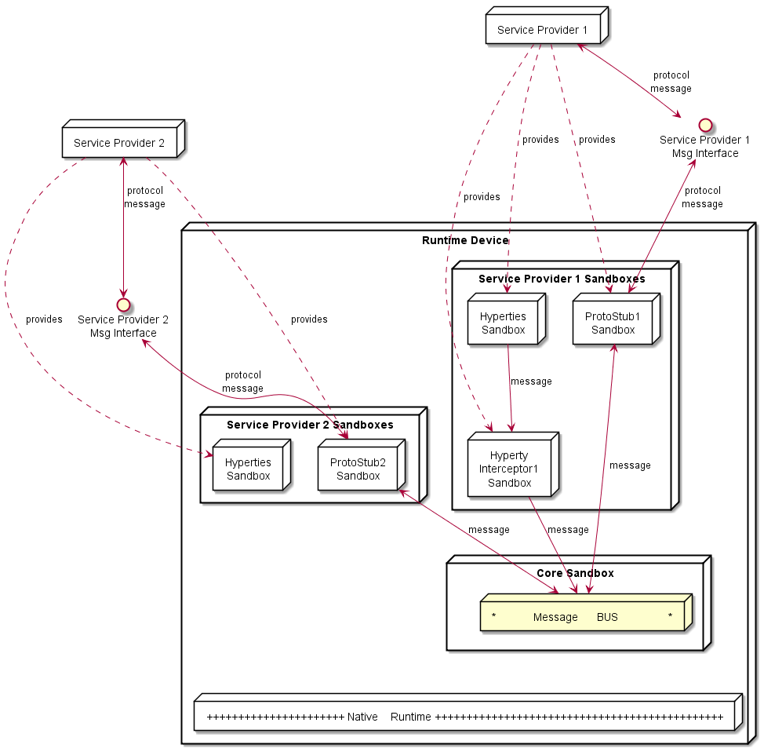

High Level Runtime Architecture with domain specific Policy Enforcer

In addition, Core Policy Engine should enforce general access control policies that are agnostic of sender and target domains, or specific to the domain managing the device runtime (Core Runtime Provider). The policies used to control the access to [Hyperty Data Objects](https://github.com/reTHINK-project/dev-service-framework/blob/master/docs/manuals/p2p-data-sync.md) (see below) , are a good example of such policies.

Some more details are provided in the following sections.

### Service Provider Sandboxes

#### Hyperty

As [previously defined, Hyperties](https://github.com/reTHINK-project/dev-service-framework/blob/master/docs/manuals/hyperty.md) cooperate each other via P2P Synchronisation of Hyperty JSON Data Objects supported by the novel [Reporter - Observer communication pattern](https://github.com/reTHINK-project/dev-service-framework/blob/master/docs/manuals/p2p-data-sync.md) and on top of the [Hyperty Messaging Framework](https://github.com/reTHINK-project/dev-service-framework/blob/develop/docs/manuals/hyperty-messaging-framework.md).

#### Hyperty Interceptor

Hyperty Interceptor complements the Core Policy Engine functionality enabling the enforcement of proprietary or closed Policies in the Hyperty Runtime for a specific Hyperty instance.

#### Protocol Stub

The Protocol Stub implements a protocol stack to be used to communicate with the Service Provider's backend servers (including Messaging Server or other functionalities like IdM) according to [Protocol on the Fly](https://github.com/reTHINK-project/dev-service-framework/blob/develop/docs/manuals/hyperty-messaging-framework.md#protocol-on-the-fly-protofly-and-protostubs) concept.

Protocol stubs are only reachable through the Message BUS. In this way it is ensured that all messages received and sent goes through the message bus where policies can be enforced and additional data can be added or changed including identity tokens.

### Core Runtime

The Core Runtime components are depicted in Figure below.

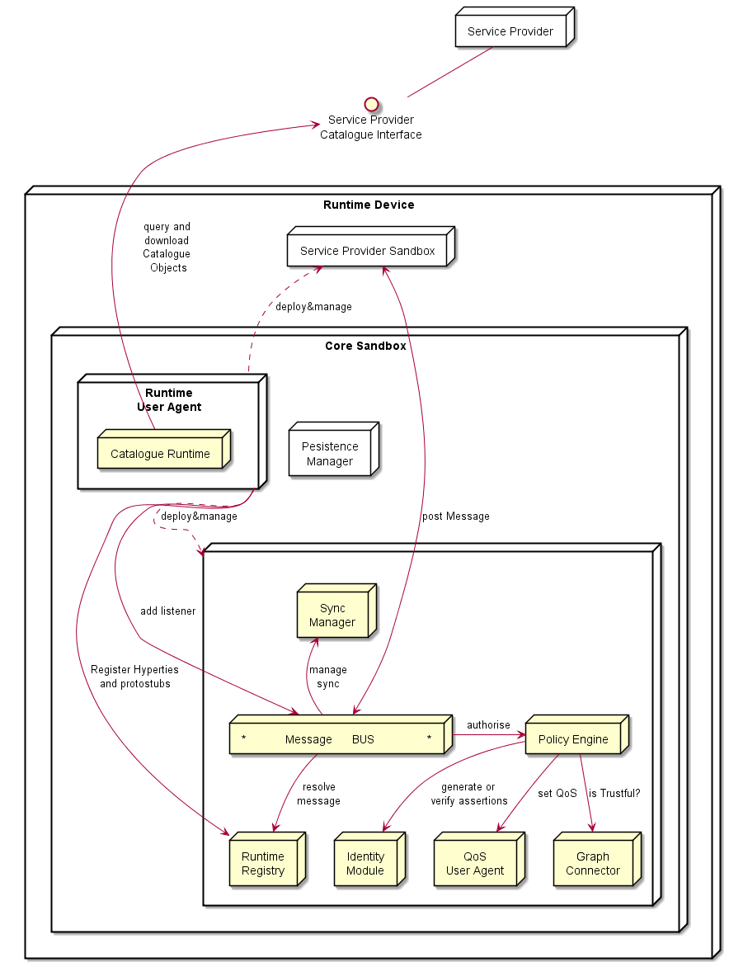

Runtime Core Architecture

Runtime Core components should be as much as possible independent on the Runtime type. They should be deployed once and executed at the background. The next time the runtime is started there should be no need to download the core runtime again unless there is a new version. Runtime core components instances should be shared by different Apps and Hyperty instances.

The Core Runtime is provided by a specific Service Provider (the Core Runtime Service Provider) that handles a Catalogue service to with Runtime Descriptors and a Registry service to handle the registration of Runtime instances.

#### Message BUS

The Message Bus Supports local message communication in a loosely coupled manner between Service Provider sandboxes including Hyperty Instances, Protocol Stubs and Policy Enforcers. Messages are routed to listeners previously added by the Runtime User Agent, to valid Runtime URL addresses handled by the Runtime Registry functionality.

Access to Message Bus is subject to authorisation to prevent cross origin attacks / spy from malicious downloaded code including Hyperties, Protocol Stubs or Policy Enforcers.

#### Core Policy Engine

The Core Policy Engine provides Policy decision and Policy Enforcement functionalities for incoming and outgoing messages from / to Service Provider sandboxes, according to Policies downloaded and stored locally when associated Hyperties are deployed by the Runtime User Agent. It also provides authorisation / access control to the Message BUS.

The verification or generation of identity assertions, to get valid Access tokens, are two examples of actions ruled by policies.

#### Runtime Registry

The Runtime Registry handles the registration of all available runtime components including Core components, Service Provider Sandboxes and each component executing in each sandbox like Hyperty Instances, Protocol Stubs, Hyperty Inteceptors and Applications.

The Runtime Registry handles the allocation of Runtime URL addresses for all these components and manages its status.

In addition, the Runtime Registry ensures synchronisation with Back-end Service Provider's Domain Registry.

The Runtime Registry must have listeners to receive messages at:

hyperty-runtime://<runtime-instance-identifier>/registry

#### Identity Module

The Runtime Identity Module manages ID and Access Tokens required to trustfully manage Hyperty Instances communication including trustful association between Hyperty Instances with Users. In addition, it also supports the generation and validation of Identity assertions. Identity module is an extension of [WebRTC Identity](http://w3c.github.io/WebRTC-pc/#identity) and interacts with Identity Providers via IDP Proxy protostubs.

Messages routed by Message Bus should be signed with a token according to the Identity associated to it and managed by the Identity Module.

The Runtime Identity Module must have listeners to receive messages at:

hyperty-runtime://<runtime-instance-identifier>/idm

#### Runtime User Agent

The Runtime User Agent, manages Core Sandbox components including its download, deployment and update from Core Runtime Provider. It also handles Device bootstrap and the deployment and update of Service Provider sandboxes including Hyperties, Protocol Stubs and Policy Enforcers, via the Runtime Catalogue.

#### Runtime Catalogue

The Runtime Catalogue manages the descriptors of deployable components and Hyperty Data Object schemas that are downloaded from the Service Provider Catalogue via the [Catalogue Service interface](https://github.com/reTHINK-project/architecture/blob/master/docs/interface-design/Interface-Design.md#73-catalogue-interface). The Runtime Catalogue ensures synchronisation with Back-end Catalogue servers.

The Runtime Catalogue must have listeners to receive messages at:

hyperty-runtime://<runtime-instance-identifier>/catalogue

#### Persistence Manager

The Persistence Manager provides data storage functionalities (write and read) to Core Runtime Components including Runtime Catalogue, Runtime Registry, Policy Engine and Graph Connector.

#### Sync Manager

The Sync Manager is in charge of handling authorisation requests to create Sync Data Objects and subscription requests to Sync Data Objects. As soon as authorisation is granted the Sync Manager handles all required MessageBUS listeners in order to setup the Data Sync Stream routing path among Hyperties. The Sync Manager must have listeners to receive messages at:

hyperty-runtime://<runtime-instance-identifier>/sm

#### QoS User Agent

The QoS User Agent Manages network QoS in the runtime. This component requires further investigations which will be reported later.

#### Graph Connector

The Graph Connector is a local address book maintaining a list of trustful communication users. This functionality is further detailed in deliverable D4.2.

The Graph Connector must have listeners to receive messages at:

hyperty-runtime://<runtime-instance-identifier>/graph

### Native Runtime

The Native Runtime provides Functionalities that are natively provided by the runtime, e.g. JavaScript engine or WebRTC Media Engine to support for Stream communication between Hyperties according to WebRTC Standards when available.

## Security analysis of the Hyperty Runtime

### Introduction

This section presents the security analysis of the [Hyperty Runtime architecture](https://github.com/reTHINK-project/core-framework/blob/master/docs/specs/runtime/runtime-architecture.md).

The Hyperty Runtime depends on a trusted computing base (TCB) that consists of several components: the Core Sandbox, the Native Runtime, and underlying Operating System and hardware. Subverting the Core Sandbox components may result in (1) incorrect decision and enforcement of policies by the PDP, (2) failure in routing messages through the Message Bus, (3) flawed registration and discovery of Hyperty and ProtoStubs by the Registry, and (4) incorrect maintenance of identities by the Identities Container. If the Native Runtime is compromised, so it will be the support for WebRTC stream communication between Hyperties. Since the Native Runtime implements the JavaScript engine (e.g., V8 [21]), tampering with the Native Runtime will undermine the execution of components implemented in JavaScript code, namely the components of the Core Sandbox (i.e., Policy Engine, Message Bus, Registry, Identities Container, and WebRTC engine) and client code instances (i.e., Hyperty Instances, ProtoStubs, Service Provider Policy Enforcers (SPPEs), and Applications). Lastly, compromising the Operating System or the hardware may result in incorrect behaviour of any of their overlying components, in particular the Native Runtime.

Next, we analyse the security properties of our system assuming that the trusted computing base is intact. Then, we assess the security vulnerabilities of the Hyperty Runtime when deployed on platforms featuring specific software and hardware configuration. In particular, we explore three platform configurations: *browser*, *standalone*, and *M2M standalone application*. We analyze each target platform under its specific threat model.

### Mitigated threats assuming an intact TCB

When the TCB is intact, our architecture ensures the correct isolation of client JavaScript code (i.e., Hyperties, ProtoStubs, SPPEs, and Applications). Isolation is enforced both between different client code instances and between client code instances and the environment (e.g., external applications, or OS resources). The Hyperty Runtime enforces access control decisions based on policy rules attached to Hyperty code. Such policies can regulate different aspects of the behaviour of a Hyperty: access to local resources (e.g., cookies, files, network, etc), routing, charging, and privacy restrictions. The system also ensures the authenticity of client code and the identity of the involved entities.

In the basic threat model, we assume that an attacker can serve arbitrary client code to the Hyperty Runtime. The attacker can impersonate a legitimate service provider and deliver malicious ProtoStub, Hyperty, or SPPE code. When instantiated on the Hyperty Runtime, this code may attempt to execute JavaScript instructions in order to access private data held (1) by other client code (including applications’), (2) by the Hyperty Runtime TCB, or (3) by the surrounding environment (e.g., the JavaScript Engine, or the Operating System). Malicious code may also aim to tamper with security-critical components, such as Hyperty policies or the policy enforcement engine, in order to escalate privileges. Finally, malicious code may launch denial of service attacks (e.g., by executing CPU intensive code). Below in this document, we expand on this threat model to consider potential vulnerabilities of our system when deployed on different environments. Next, we describe how our system defends against several classes of potential attacks.

#### T1: Unauthorized access by client code

The basic mechanism of our architecture to prevent unauthorized access by client code is sandboxing. Each Hyperty instance running in the system runs in its own sandbox. A sandbox defines a security perimeter for the Hyperty instance, preventing it from reading or writing the memory (or other resources) allocated to other Hyperty instances or by other components in the surrounding environment. An independent sandbox hosts the ProtoStub instance required by local Hyperty instances to communicate with external services. This sandbox will prevent potentially malicious ProtoSub code from unauthorized access to resources. To communicate outside the sandboxes, the runtime provides well defined interfaces: the Syncher, which is used by the Hyperty instance to communicate with the SPPE, and an API to communicate with the Message Bus. The SPPE and the PEE are responsible for enforcing the policy associated with the Hyperty instance.

The origin of the client code is validated. An origin is a combination of URI scheme, hostname, and port number. The origin can be asserted using certificates (e.g. using TLS) thus we only allow client code from secure origin.

Client code is subject to Same Origin Policy for direct interactions between client code instances. However, this can be relaxed using Cross Origin Resource Sharing (CORS) policy declarations. Pieces of client code from different origins can still communicate without CORS using the Message Bus API. Message exchange must be identified by the origin of senders and recipients. Subscription to messaging channels (where multiple client codes could publish messages) must be subject to authorization.

Note that, in our architecture, sandboxing is also used to secure the components of the Hyperty Runtime that are implemented in JavaScript, namely the components allocated in the Core Sandbox. The JavaScript engine implements both the client code sandboxes and the Core Sandbox.

#### T2: Policy subversion

Every Hyperty instance is constrained by a policy. A policy defines a set of rules, which can be of several types: access control rules, routing rules, charging usage rules, and privacy rules. Altogether, policy's rules are responsible for regulating, supervising, or restricting the operations that a Hyperty can perform, e.g., prevent access to a local file, enforce a predefined network route, or define the usage costs of a service. To prevent a malicious Hyperty instance (or ProtoSub) from subverting policy rules and escalate its privileges, the policy decision components and the policy repository are protected from the Hyperty instance by the Core Sandbox. As a result, policy integrity and enforcement are safe from malicious client code.

#### T3: Threats to client code authenticity

The authenticity of client code -- Application, Hyperty, ProtoStub, or SPPE -- can be compromised if at least one of two events has occurred without being detected before the code is loaded and instantiated into a sandbox: an attacker has modified the original code bytes (e.g., by embedding malware into a Hyperty code), or (ii) has modified the code identity. To prevent such attacks, client code's origin must be digitally signed and transmitted over a secure channel. Additionally the client code may be signed by its manufacturer. By checking these signatures before instantiating the Hyperty, ProtoStub, or SPPE code on the sandboxes and assuming that the cryptographic primitives are correctly implemented, the Hyperty Runtime can guarantee the integrity and identity of the code.

#### T4: Denial of service attacks

A malicious Hyperty instance, ProtoStub, or SPEE implementation can launch denial of service attacks by holding to specific resources, e.g., hogging the CPU by sitting on an infinite loop, or flooding the network with bogus messages. The JavaScript engine featuring the Hyperty Runtime prevents such attacks by placing a limit to the maximum utilization of a given service by a client code instance, for example by bounding the CPU cycles that a Hyperty instance is allowed to execute uninterrupted.

### Vulnerability assessment of the Hyperty Runtime

The Hyperty Runtime can effectively thwart the threats described in the previous section so long as the system's TCB remains intact. However, when deployed on a specific platform, the Hyperty Runtime may become vulnerable to some environment-specific security risks. In this section, we study the potential vulnerabilities of the TCB when deployed on three different platforms. But first, we describe our methodology to ensure a uniform vulnerability assessment of our system across platforms.

#### Methodology

Our basic methodology is based on a *vulnerability matrix*. A vulnerability matrix indicates representative practical attacks that can be carried out against the TCB on a given platform as a mean to compromising the security of the Hyperty Runtime. An attack is successful by achieving one or more goals described in the section above: permit unauthorized access by client code (T1), subvert Hyperty policies (T2), compromise the authenticity of client code (T3), and launch denial of service attacks (T4). We classify the attacks to the TCB along two dimensions: (1) the layer of the computer stack where the attack is directed to (e.g., the operating system), and (2) the difficulty level of the attack based on the technical skills and resources required by the adversary.

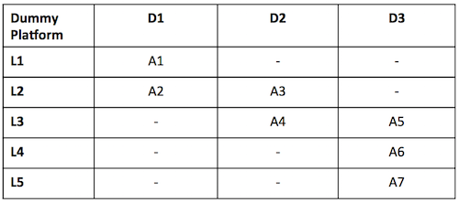

Figure (**???**): Vulnerability matrix for a dummy platform

The figure above provides an example of a vulnerability matrix for a dummy platform. The content of each cell describes examples of attacks that can be launched to the TCB, e.g., "A1: inspection of JavaScript code through the browser", "A7: probing the system bus". Columns represent the difficulty level and rows the attack layer (both of them will be explained below). Intuitively, the vulnerability matrix allow us to grasp how exposed the TCB is to attacks: the lower the difficulty degree of the attacks is the more vulnerable the Hyperty Runtime will be when deployed on a particular target platform. Next, we describe the classification for attack layers and difficulty levels:

**Attack layers.** Attack layers can be classified in five types, ordered top-down, from the highest to the lowest layer of the computer stack, as shown in the figure below:

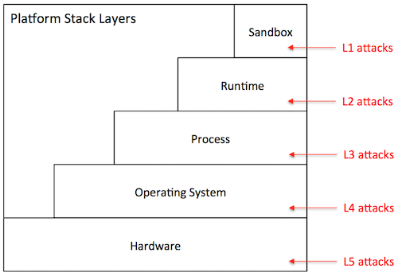

Figure (**???**): Stack

* *Sandbox level (L1)*: The attacker has direct access to the sandbox environment, hence to the code and execution state of Hyperty instances. For example, on a browser platform, users typically have access to the JavaScript of a given page. This means that a malicious user can leverage that mechanism to tamper with the JavaScript code of local Hyperty instances.
* *Runtime level (L2)*: The attacker has direct access to the code or execution state of the Hyperty Runtime. Depending on the specific exploit, he can mount attacks that disable defences against the attacks described in the previous section. On the browser, for example, a L2 attack can be achieved by installing a malicious browser extension that bypasses the policy enforcement mechanism of the Hyperty Runtime.
* *Process level (L3)*: The attacker has access to the execution state of the process where the Hyperty Runtime is hosted. Just like the L2 attacks, this type of attack can result in catastrophic consequences. Examples of attacks performed at the process level include attaching a debugger to the Hyperty Runtime process and inspect its internal data structures, or dumping its memory state to disk by reading from /dev/mem.
* *Operating system level (L4)*: The adversary has access to the execution state of the operating system, and therefore to the execution state of the Hyperty Runtime. Similarly to L2 and L3, L4 attacks can be catastrophic. An attack performed at this layer, for example, installs a rootkit to maintain a log of all operations performed by local Hyperty instances.
* *Hardware level (L5)*: The adversary has physical access to the hardware of the platform and can launch simple attacks that do not involve tampering with the circuitry. Attacks in this category include, removal or inspection of the hard disk, probing the system bus in order to extract secrets from volatile memory, etc. An attack at this level may also include tampering with the silicon chips, perform side-channel attacks, etc. Such attacks require a high-level of expertise and committed resources. In theory, attacks performed at this level can reveal the entirety of the system state, including the operating systems. In practice, however, such attacks are more directed towards the extractions of specific secrets when L3 attacks or above are not possible.

**Difficulty level.** The difficulty level of an attack depends on several factors: the privileges owned by the adversary (e.g., user or superuser), the skills that are required (e.g., know how to run a debugger or tamper with silicon), and the necessary resources to carry out the attack (e.g., specific software exploits, memory probes, etc.). Based on these factors, we define three difficulty levels for a given attack:

* *Easy (D1)*: The attack is easy to perform. The tools that are necessary to launch the attack are accessible, well documented, and simple to handle. Some examples of D0 attacks include: (i) on a browser platform, a malicious user leverages the browser interface to modify Hyperty code, (ii) on a constrained device, the device owner abuses superuser privileges to disable the policy enforcement mechanisms of the Hyperty Runtime.
* *Medium (D2)*: The attack requires considerable skills and / or resources. It can be launched by mastering the tools presently available in the system (e.g., tools provided by the operating system, debuggers) or by installing new ones that can be found on the Internet (including malware or exploits). The attacker has limited skills or resources to discover new vulnerabilities or to develop exploits autonomously. Examples of such attacks include, attaching debuggers to extract in-memory secrets from the Hyperty Runtime, patch the Hyperty Runtime using exploit code published on the Web, etc.
* *Hard (D3)*: The attack is very sophisticated. To mount the attack, the attacker must be able to develop its own exploit code, find new vulnerabilities in the system, and / or launch software hardware attacks. For example, finding bugs in a device driver’s code and write software exploits. The attacks performed at the deep hardware level are also considered hard to execute.

When drawing a vulnerability matrix, we define *attacker profiles*, which define sets of possible attacks that characterize possible attack agents in that particular platform. For example, for the browser platform, we define three profiles: regular user, advanced user, and power user. The regular user captures an average web user, which is able to launch attacks like "inspection of JavaScript code through the browser", but not "probing the system bus". We now present our vulnerability assessment for each of the target platforms.

#### Browser platform

The primary platform targeted by reTHINK is the browser. Browsers can be highly heterogeneous; we may be talking about desktops, laptops, or mobile devices featuring many different configurations with respect to: hardware architecture, operating system in use, installed software, and specific browser version and extensions. In spite of this diversity, a Hyperty-enabled browser will tend to follow the general architecture represented in the figure below.

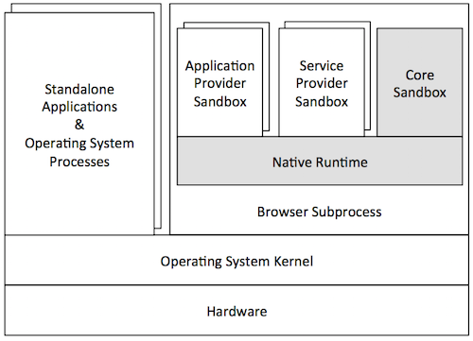

Figure (**???**): Browser

In this architecture, the Hyperty Runtime (represented by the shaded components of the Figure) is deployed on an independent browser process. This process is in fact a "subprocess" of the browser that implements a sandboxing mechanism of its own (as in the Chrome browser). This mechanism is responsible for isolating the Hyperty Runtime from the browser's rendering engine. The JavaScript engine is responsible for the secure execution of JavaScript code inside individual sandboxes: (1) the Core Sandbox of the Hyperty Runtime, (2) service provider sandboxes for hosting Hyperty instances, ProtoStubs and SPPEs, and (3) application provider sandboxes for executing guest applications. As expected, the Hyperty Runtime process depends on the operating system, which in turn depends on the underlying hardware setup. Browser processes run side-by-side with other standalone application processes and operating system services.

From the security point of view, the threats to the TCB of the Hyperty Runtime are mainly caused by an adversarial user. To better characterize these threats, we define three attacker profiles and draw the vulnerability matrix as follows:

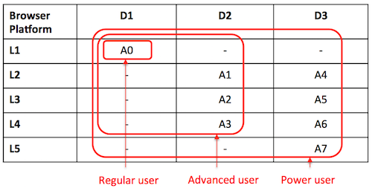

Figure (**???**): Security Browser

* *Regular user*: This attacker profile captures the class of users with an average proficiency level in computing, but are willing to subvert the security properties of the system's TCB. The user's privileges allow for limited operations, such as: launch the browser, and run Hyperty-based applications. A regular user is expected to mount the following attacks:
  + *A0*: Access and modify client JavaScript code through the browser interface.
* *Advanced user*: This profile captures users with superuser privileges and some degree of skills and knowledge of the system. The user is aware of existing tools and techniques that can be leveraged to hack into the system's components, has access to exploits available on the Internet, and can handle auxiliary tools (e.g., debuggers, Unix advanced commands, etc.). The user can assemble and disassemble the basic hardware components of the system (e.g., plugging in / out the hard disk). For mobile devices, the user can root or jailbreak the platform by following instructions. Thus, considering this set of skills, in addition to A0, an advanced user can perform several other attacks at different stack layers such as these:
  + *A1*: Compromise the runtime by installing a malicious browser extension.
  + *A2*: Dump the memory contents of the process to disk.
  + *A3*: Install a rootkit on the operating system that keeps track of Hyperty instances' communication.
* *Power user*: This profile corresponds to highly skilled users, who have deep knowledge of the system and can launch sophisticated attacks. A user is able to investigate unknown vulnerabilities in the software (including in the Hyperty Runtime or in the OS) and develop specific software exploits. Moreover, the user has enough resources and tools to launch hardware attacks that involve tampering with silicon. A power user is able to mount not only the attacks described previously, but more sophisticated attacks on various layers of the stack:
  + *A4*: Find and exploit a bug in the Hyperty Runtime.
  + *A5*: Attach a debugger to the browser’s subprocess and inspect / modify its memory.
  + *A6*: Build a device driver to continuously monitor the execution of Hyperty Instances.
  + *A7*: Probe the system bus and extract private key material of Hyperty Instances.

**Vulnerability assessment:** As illustrated by the vulnerability matrix, the browser platform is vulnerable to a range of attacks. Some of these attacks can be mounted by regular users with relative ease. In addition, there are several ways for advanced users to successfully compromise the TCB by exploiting the system at different stack layers. As a result, we recommend that browser platforms are avoided for hosting client code which the local user has incentives to subvert. Examples of such code include: Hyperty instances restricted by specific usage charging policies, ProtoStubs that encode proprietary communication protocols, or Applications that access copyrighted digital data.

**Phase 1 implementation:** In the phase 1 implementation, we use native mechanisms provided by the browser API to ensure that the required sandboxing properties are satisfied. The core runtime components execute inside an iFrame. The iFrame implements the core sandbox by isolating the code of the core runtime from the main window in which the application javascript code is executed. This isolation mechanism prevents applications from having direct access to the memory address space of the core runtime. Communication between application and core runtime is possible only through a single and well defined entrypoint which allows them to exchange messages: method postMessage(). Hyperties and protoStub execute as independent Web Workers. Web Workers effectively isolate their internal states from each other and from the core runtime. The postMessage() method constitutes the only communication bridge between the these components. Based on this analysis, we conclude that the phase 1 implementation prototype satisfies the security properties that were specified for the browser runtime architecture.

#### Standalone platform

A variant of the browser platform is to deploy the Hyperty Runtime as a standalone application, for example to be executed as a mobile app on mobile devices such as smartphones or tablets. The Hyperty Runtime can also be packaged as a classical standalone application for desktop platforms running Linux or Windows. To allow for the development and maintenance of such applications, reTHINK will provide an SDK that will include APIs and platform specific libraries for adapting the Hyperty Runtime to the underlying operating system platform.

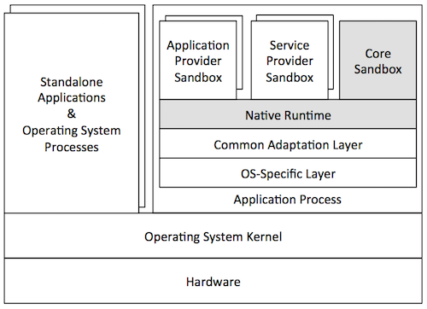

Figure (**???**): Application platform

The figure above illustrates a general standalone platform tailored for Android mobile devices. Just like in the browser platform, the Hyperty Runtime is wrapped around a host process. The host process is responsible for (1) mediating the system calls issued by the Hyperty Runtime to the operating system and (2) providing a user interface to the Hyperty Runtime and client JavaScript applications (and Hyperties). In addition to the Hyperty Runtime, the host process application consists of: a platform-independent adaptation layer, and platform-specific libraries, e.g., for IO, storage, and memory management. In the example of the figure, the platform-specific libraries correspond to the Android API framework.

From the security point of view, standalone and browser platforms are quite similar; for that reason we adopt the same attacker profiles (regular user, advanced user, and power user). The main difference between architectures is twofold. First, the host application will prevent direct introspection of the JavaScript code running inside Hyperty Runtime sandboxes. As a result, the application architecture is able to mitigate simple attacks to the browser (A0 in the browser’s vulnerability matrix), raising the bar for regular users. Second, the host application will not support software extensions. This restriction prevents some advanced attacks to the runtime based on installation of malicious extension code, and to the browser process (see attacks A1 and A2, respectively, in the browser's vulnerability matrix). Next, we present the vulnerability matrix of the standalone platform and provide alternative attack examples.

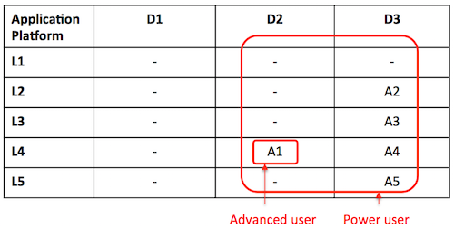

Figure (**???**): Security Application platform

* *Advanced user*: An advanced user can compromise the entire system by launching attacks at the OS level:
  + *A1*: Root the device and instrument the operating system in order to introspect Hyperty instances' sandboxes.
* *Power user*: A power user can mount more sophisticated attacks on various layers of the stack:
  + *A2*: Find and exploit a bug in the Hyperty Runtime.
  + *A3*: Find a bug in the host application code and exploit it.
  + *A4*: Monitor the execution of Hyperty Instances by rooting the device.
  + *A5*: Hack the device hardware to extract sensitive Hyperty data from memory.

**Vulnerability assessment:** As highlighted by the vulnerability matrix, an Android-based standalone platform is more robust to attacks than the browser platform. This is mainly due to the fact the application architecture allows us to close security holes in the browser architecture that can hardly be thwarted without modifying the browser. Nevertheless, it is still possible to for an advanced user to compromise the system by rooting the device; the need to root the device will likely deter the regular users. Nevertheless, we recommend prudence in deploying client code that the local user has high incentives to subvert.

**Phase 1 implementation:** In the phase 1 implementation, we use Crosswalk to support standalone applications. Crosswalk is an HTML application runtime that allows us to execute the hyperty runtime as native mobile applications in Android and iOS devices without the need to install a full-blown browser. Mobile applications only need to be bundled with both Crosswalk webviews and the hyperty runtime code. Since a Crosswalk webview implements a Chromium-based runtime, it can seamlessly execute the hyperty runtime code that was implemented for the browser platform. Therefore, since we reuse the code of the browser phase 1 implementation, we can conclude that standalone applications will inherit similar security properties from browser applications.

#### M2M standalone platform

reTHINK also targets M2M communication use cases. For this reason, a standalone platform is necessary to run the Hyperty Runtime and guest client code. The targeted devices consist of Raspberry Pi and Beagle Boards. Such devices adopt an internal architecture very similar to the standalone platform: they can run Linux or even Android operating systems. We envision that these devices will run Linux-based operating systems. Essentially, the main difference between M2M and vanilla standalone application platform takes place at the implementation level. Therefore, our security analysis of the standalone platform is applicable to both instances. As Node.js was chosen as Native Runtime for the reTHINK M2M standalone application platform, attacks like server side injection caused by eval function are well known and there are best practices to avoid and protect the software components against such attacks. A valuable source of information that will be taken into account during the implementation is located at [[108](https://nodesecurity.io/resources)].

## Messaging Node Architecture

The Messaging Node functional architecture is presented in the figure below and it comprises three main types of functionalities including the Core Functionalities, Connectors and Protocol Stubs.

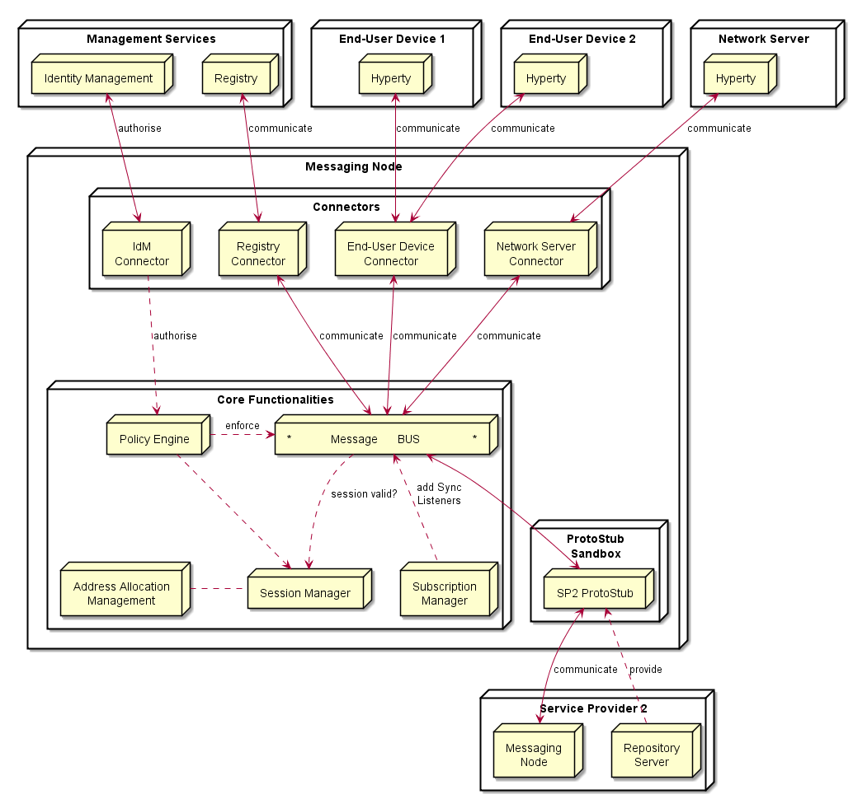

Figure (**???**): Messaging Node Architecture

### Core Functionalities

#### Message BUS

The Message BUS routes messages to internal Messaging Node components and external elements by using Connectors or Protocol Stubs. It supports different communication patterns including publish/subscribe and Request/response communication.

#### Policy Engine

The Policy Engine provides Policy decision and Policy Enforcement functionalities at Domain level for incoming and outgoing messages in cooperation with authentication and authorisation provided by Identity Management functionalities. It also provides authorisation / access control to the Message BUS.

#### Session Management

Session Management functionalities are used to control messaging connections to service provider back-end services. For example, when user turns-on the device and connects to its domain, providing credentials as required by Identity Management functionalities. In general, each message should contain a valid token that is generated when the client connects to the Messaging Node. It also manages the registry of protocol stubs and connectors supported by the Messaging Nodes to support the routing of messages to these components.

#### Address Allocation Management

The Address Allocation Management functionality handles the allocation of URL addresses to Hyperty Instances and Hyperty Data Objects in cooperation with Session Management when users connect to the domain.

It also manages the allocation of messaging addresses to foreign Hyperty Instances i.e. Hyperty Instances that are provided from external domains but that use the protofly concept to interact with Hyperty Instances served by this Messaging Node. For example, if the Messaging Node is implemented by core IMS or a simple SIP Proxy/SIP Registry, it is required the management of a pool of SIP addresses to be allocated to clients that have no account in the IMS HSS or in the SIP registry.

Address Allocation Management functionality must have listeners to receive messages for the following addresses:

domain://msg-node.<sp-domain>/hyperty-address-allocation  
domain://msg-node.<sp-domain>/object-address-allocation

### Subscription Manager

The Message Node Subscription Manager is in charge of handling Subscription and Unsubscription requests from Runtime Sync Managers in order to manage the Data Sync Stream routing path in the Message Node.

The Subscription Manager functionality must have listeners to receive messages for the following addresses:

domain://msg-node.<sp-domain>/sm

### Protocol Stub

In special situations e.g. when the download of external software (protocol stubs) into end-user devices is not allowed, it should be possible to have interoperability between Messaging Nodes from different domains, by using the protofly concept.

Thus, a Protocol Stack to be used to communicate with another Messaging Node can be deployed.

It should be noted that protocol stubs can also be used to implement a Messaging Node connector, in case it does not exist.

### Connectors

Connectors implements protocol stacks used to interoperate with external elements from the domains. Connectors can be supported by using protocol on-the-fly concept, giving more flexibility for the integration of the Messaging Node in the Service Provider infra-structure.

#### Registry Connector

Registry Connector to interact with remote Registry functionalities. It must have listeners to receive messages for the following addresses:

domain://registry.<sp-domain>

#### IdM Connector

IdM Connector interacts with remote Identity Management functionalities. It must have listeners to receive messages for the following addresses:

domain://idm.<sp-domain>

#### End-User Device Connector

End-User Device Connector to interact with Hyperty Instances running in the end-user device

#### Network Server Connector

Network Server Connector to interact with Hyperty Instances running in a Network Server

## Messages Specification

### Address Allocation Messages

The following Messages used to manage URL address allocation are specified in this doc. Where,

* <type> can be "hyperty" or "object"
* number" : <integer> is the number of addresses to be allocated
* <scheme> defines the URL scheme to be used in the address allocation and depends on requested address allocation <type> :
  + hyperty for "hyperty" address types
  + connection, comm or ctxt are valid for "object" type addresses
* "allocationKey" : <key> a key to be used in a address block deallocation request. Any string is valid but it is suggested to use something associated with the Runtime Instance URL e.g. hyperty-runtime://<sp-domain>/<runtime-instance-identifier>

#### Address allocation request

**Message requesting address allocation**

Message sent by the Hyperty Runtime Registry function to Message Node Address Allocation function.

"id" : "<1>"  
"type" : "CREATE",  
"from" : "hyperty-runtime://<sp-domain>/<runtime-instance-identifier>/registry/allocation",  
"to" : "domain://msg-node.<sp-domain>/<type>-address-allocation",  
"body" : { "value" : {"number" : <integer> , "scheme" : <scheme>, "allocationKey" : "<key>"} }

**Response Message returning the requested addresses allocation**

Message sent by the Message Node Address Allocation function to Hyperty Runtime Registry function.

"id" : "<1>"  
"type" : "RESPONSE",  
"from" : "domain://msg-node.<sp-domain>/<type>-address-allocation",  
"to" : "hyperty-runtime://sp1/runalice/registry/allocation",  
"body" : { "code": 200, "value" : {"allocated": ["<scheme>://<sp-domain>/<identifier>", ...]} }

#### Address deallocation request for one block of addresses

**Message to request address deallocation for one block of addresses**

Message sent by the Hyperty Runtime Registry function to Message Node Address Allocation function.

"id" : "<3>"  
"type" : "DELETE",  
"from" : "hyperty-runtime://<sp-domain>/<runtime-instance-identifier>/registry/allocation",  
"to" : "domain://msg-node.<sp-domain>/<type>-address-allocation",  
"body" : { "resource" : "<key>" }

**Response to Message requesting address deallocation for one specific set of addresses**

Message sent by the Message Node Address Allocation function to Hyperty Runtime Registry function.

"id" : "3"  
"type" : "RESPONSE",  
"from" : "domain://msg-node.<sp-domain>/<type>-address-allocation",  
"to" : "hyperty-runtime://sp1/runalice/registry/allocation",  
"body" : { "code": 200 }

#### Address deallocation request for one or more addresses

**Message to request address deallocation for one or more addresses**

Message sent by the Hyperty Runtime Registry function to Message Node Address Allocation function.

"id" : "<2>"  
"type" : "DELETE",  
"from" : "hyperty-runtime://<sp-domain>/<runtime-instance-identifier>/registry/allocation",  
"to" : "domain://msg-node.<sp-domain>/<type>-address-allocation",  
"body" : { "childrenResources" : {"["<scheme>://<sp-domain>/<identifier>", ...]} }

**Response to Message requesting address deallocation for one specific set of addresses**

Message sent by the Message Node Address Allocation function to Hyperty Runtime Registry function.

"id" : "2"  
"type" : "RESPONSE",  
"from" : "domain://msg-node.<sp-domain>/<type>-address-allocation",  
"to" : "hyperty-runtime://sp1/runalice/registry/allocation",  
"body" : { "code": 200 }

### Registration Messages

This doc specifies Messages to be used to manage registrations in the Domain Registry, where,

* <RegistryDataObject> is a JSON object compliant with [RegistryDataObject data model](https://github.com/reTHINK-project/dev-service-framework/tree/master/docs/datamodel/hyperty-registry).
* <userURL> is the a user address compliant with [UserURL data model](https://github.com/reTHINK-project/dev-service-framework/blob/master/docs/datamodel/address/readme.md#user-url-type). Example: user://example.com/bob
* <DiscoveredHypertyInstance> is a JSON object compliant with [HypertyInstance data model](https://github.com/reTHINK-project/dev-service-framework/tree/develop/docs/datamodel/hyperty-registry#hyperty-instance).
* <DiscoveredDataObjectInstance> is a JSON object compliant with [HypertyDataObjectInstance data model](https://github.com/reTHINK-project/dev-service-framework/tree/develop/docs/datamodel/hyperty-registry#hyperty-instance).

#### Registration request

Message sent by the Hyperty Runtime Registry function to Registry Domain server (Connector or Protostub).

"id" : "1"  
"type" : "CREATE",  
"from" : "hyperty-runtime://<sp-domain>/<runtime-instance-identifier>/registry",  
"to" : "domain://registry.<sp-domain>",  
"body" : { "value" : <RegistryDataObject> }

Message sent by the Registry Domain server (Connector or Protostub) to Hyperty Runtime Registry function.

"id" : "<1>"  
"type" : "RESPONSE",  
"from" : "domain://registry.<sp-domain>",  
"to" : "hyperty-runtime://<sp-domain>/<runtime-instance-identifier>/registry",  
"body" : { "code": 200 }

#### Unregistration request

Message sent by the Hyperty Runtime Registry function to Registry Domain server (Connector or Protostub).

"id" : "4"  
"type" : "DELETE",  
"from" : "hyperty-runtime://<sp-domain>/<runtime-instance-identifier>/registry",  
"to" : "domain://registry.<sp-domain>",  
"body" : { "value" : <RegistryDataObject> }

Message sent by the Registry Domain server (Connector or Protostub) to Hyperty Runtime Registry function.

"id" : "<4>"  
"type" : "RESPONSE",  
"from" : "domain://registry.<sp-domain>",  
"to" : "hyperty-runtime://<sp-domain>/<runtime-instance-identifier>/registry",  
"body" : { "code": 200 }

#### Hyperty Instance Query per User

Message sent by an Hyperty Instance to Registry Domain server (Connector or Protostub).

"id" : "2",  
"type" : "READ",  
"from" : "hyperty://<sp-domain>/<hyperty-instance-identifier>",  
"to" : "domain://registry.<sp1>"  
"body" : { "resource" : "/hyperty-instance/user/<userURL>" }

**Response Message returning the discovered Hyperty Instances**

Message sent by Registry Domain server (Connector or Protostub) to an Hyperty Instance.

"id" : "2"  
"type" : "RESPONSE",  
"from" : "domain://registry.<sp-domain>",  
"to" : "hyperty://<sp-domain>/<hyperty-instance-identifier>",  
"body" : { "code": 200, "value" : ["<discoveredHypertyInstance>"] }

#### Data Object Query per User

Message sent by an Hyperty Instance to Registry Domain server (Connector or Protostub).

"id" : "3",  
"type" : "READ",  
"from" : "hyperty://<sp-domain>/<hyperty-instance-identifier>",  
"to" : "domain://registry.<sp-domain>"  
"body" : { "resource" : "/hyperty-data-object-instance/<scheme>/owner/<userURL>" }

**Response Message returning the discovered Hyperty Data Object Instances**

Message sent by Registry Domain server (Connector or Protostub) to an Hyperty Instance.

"id" : "3"  
"type" : "RESPONSE",  
"from" : "domain://registry.<sp-domain>",  
"to" : "hyperty://<sp-domain>/<hyperty-instance-identifier>",  
"body" : { "code": 200, "value" : ["<DiscoveredDataObjectInstance>"] }

### Hyperty Data Object Synchronisation Messages

This doc specifies Messages that are used to manage Hyperty Data Object Synchronisation, including:

* Synchronisation Management Messages by Syncher Reporter
* Synchronisation Management by Syncher Observer
* Synchronisation management by Sync Manager Reporter
* Synchronisation management by Sync Manager Observer
* Synchronisation Management by Message Node
* Synchronisation Messages among Synchers

where,

* <ObjectURL> is any valid [Data Object URL](https://github.com/reTHINK-project/dev-service-framework/blob/master/docs/datamodel/address/readme.md) including CommunicationURL, ConnectionURL and ContextURL. Example: "comm://example.com/<alice>/123456"
* <json object> is the Data Object instance itself
* <ChildDataObject> is a Child Data Object instance itself

#### Synchronisation Management by Syncher Reporter

##### Hyperty Data Object Creation

Message sent by the Reporter Syncher Hyperty to Reporter Runtime Sync Manager.

"id" : "1"  
"type" : "CREATE",  
"from" : "hyperty://<sp-domain>/<hyperty-instance-identifier>",  
"to" : "hyperty-runtime://<sp-domain>/<hyperty-runtime-instance-identifier>/sm",  
"body" : { "resource" : "<ObjectURL>", "authorise" : [{"HypertyURL"}], "value" : "<json object> , "schema" : "hyperty-catalogue://<sp-domain>/dataObjectSchema/<schema-identifier>" }

**note:** "resource" is present in the body in case the ObjectURL is already known by the reporter eg in a Reporter delegation procedure.

###### Response

Reporter Runtime Sync Manager Response Message sent to the Reporter Syncher Hyperty to confirm Object Data creation.

"id" : "1"  
"type" : "RESPONSE",  
"from" : "hyperty-runtime://<sp-domain>/<hyperty-runtime-instance-identifier>/sm",  
"to" : "hyperty://<sp-domain>/<hyperty-instance-identifier>",  
"body" : { "code" : "200", "value" : "{ "resource" : "<ObjectURL>", "childrenResources" : [{"<resource-children-name>"}] } }

Reporter Runtime Sync Manager forwards to the Reporter Syncher Hyperty, Response Messages sent by invited Observer Hyperties.

"id" : "1"  
"type" : "RESPONSE",  
"from" : "hyperty-runtime://<sp-domain>/<hyperty-runtime-instance-identifier>/sm",  
"to" : "hyperty://<sp-domain>/<hyperty-instance-identifier>",  
"body" : { "code" : "1XX\2XX" , "source" : "hyperty://<sp-domain>/<hyperty-observer-instance-identifier>" }

##### Delete Data Object requested by Reporter

Message sent by Object Reporter Hyperty to Reporter Runtime Sync Manager.

"id" : "6"  
"type" : "DELETE",  
"from" : "hyperty://<sp-domain>/<hyperty-instance-identifier>",  
"to" : "hyperty-runtime://<sp-domain>/<hyperty-runtime-instance-identifier>/sm",  
"body" : { "resource" : "<ObjectURL>" }

###### Response

Response Message sent back by Reporter Runtime Sync Manager to Object Reporter Hyperty.

"id" : "6"  
"type" : "RESPONSE",  
"from" : "hyperty-runtime://<sp-domain>/<hyperty-runtime-instance-identifier>/sm",  
"to" : "hyperty://<sp-domain>/<hyperty-instance-identifier>",  
"body" : { "code" : "200" }

#### Synchronisation Management by Syncher Observer

##### Hyperty request to be an Observer

Message sent by Observer (candidate) Hyperty Instance to the Observer Runtime Sync Manager.

"id" : "1"  
"type" : "SUBSCRIBE",  
"from" : "hyperty://<observer-sp-domain>/<hyperty-observer-instance-identifier>",  
"to" : "hyperty-runtime://<observer-sp-domain>/<hyperty-observer-runtime-instance-identifier>/sm",  
"body" : { "resource" : "<ObjectURL>" , "childrenResources" : [{"<resource-children-name>"}], "schema" : "hyperty-catalogue://<sp-domain>/dataObjectSchema/<schema-identifier>" }

###### Response

200OK Response Message sent back by Observer Runtime Sync Manager to Observer Hyperty Instance containing in the body the most updated version of Data Object.

"id" : "1"  
"type" : "RESPONSE",  
"from" : "hyperty-runtime://<observer-sp-domain>/<hyperty-observer-runtime-instance-identifier>/sm",  
"to" : "hyperty://<observer-sp-domain>/<hyperty-observer-instance-identifier>",  
"body" : { "code" : "2XX", "value" : "<data object>" }

##### Data Object Unsubscription request by Observer Hyperty

Message sent by Object Observer Hyperty to Runtime Observer Sync Manager .

"id" : "7"  
"type" : "UNSUBSCRIBE",  
"from" : "hyperty://<observer-sp-domain>/<hyperty-observer-instance-identifier>",  
"to" : "hyperty-runtime://<observer-sp-domain>/<hyperty-observer-runtime-instance-identifier>/sm",  
"body" : { "resource" : "<ObjectURL>" , "childrenResources" : [{"<resource-children-name>"}]}

###### Unsubscription Response

Response Message sent back by Runtime Observer Sync Manager to Object Observer Hyperty.

"id" : "7"  
"type" : "RESPONSE",  
"from" : "hyperty-runtime://<observer-sp-domain>/<hyperty-observer-runtime-instance-identifier>/sm",  
"to" : "hyperty://<observer-sp-domain>/<hyperty-observer-instance-identifier>",  
"body" : { "code" : "2XX" }

Response to Object Delete sent by Runtime Reporter

#### Synchronisation management by Sync Manager Reporter

##### Observer Invitation

Message sent by the Reporter Runtime Sync Manager to invited Observer Hyperty Instance.

"id" : "1"  
"type" : "CREATE",  
"from" : "hyperty-runtime://<sp-domain>/<hyperty-runtime-instance-identifier>/sm",  
"to" : "hyperty://<sp-domain>/<hyperty-observer-instance-identifier>",  
"body" : { "resource" : "<ObjectURL>", "childrenResources" : [{"<resource-children-name>"}] , "value" : "<json object > , "schema" : "hyperty-catalogue://<sp-domain>/dataObjectSchema/<schema-identifier>" }

###### Response

Response Message sent back by invited Hyperty Instance to the Reporter Runtime Sync Manager.

"id" : "1"  
"type" : "RESPONSE",  
"from" : "hyperty://<observer-sp-domain>/<hyperty-observer-instance-identifier>",  
"to" : "hyperty-runtime://<sp-domain>/<hyperty-runtime-instance-identifier>/sm",  
"body" : { "code" : "1XX\2XX" }

##### All Observers are requested to delete Data Object

Message sent by Reporter Runtime Sync Manager to Object Changes Handler.

"id" : "6"  
"type" : "DELETE",  
"from" : "<ObjectURL>/subscription",  
"to" : "<ObjectURL>/changes"

###### Response to Object Delete

Message sent by Observer Runtime Sync Manager to Object Subscription Handler, on behalf of Observer Hyperty.

"id" : "6"  
"type" : "RESPONSE",  
"from" : "<ObjectURL>/changes",  
"to" : "<ObjectURL>/subscription",  
"body" : { "code" : "2XX", "source" : "hyperty-runtime://<observer-sp-domain>/<hyperty-observer-runtime-instance-identifier>" }

#### Synchronisation management by Sync Manager Observer

##### Observer Subscription request sent to Data Object Subscription Handler

Message sent by Observer Runtime Sync Manager to Data Object Subscription Handler.

"id" : "2"  
"type" : "SUBSCRIBE",  
"from" : "hyperty-runtime://<observer-sp-domain>/<hyperty-observer-runtime-instance-identifier>/sm",  
"to" : "<ObjectURL>/subscription",  
"body" : { "subscriber" : "hyperty://<observer-sp-domain>/<hyperty-observer-instance-identifier>" }

###### Response

200OK Response Message sent back by Data Object Subscription Handler to Observer Runtime Sync Manager containing in the body the most updated version of Data Object.

"id" : "2"  
"type" : "RESPONSE",  
"from" : "<ObjectURL>/subscription",  
"to" : "hyperty-runtime://<observer-sp-domain>/<hyperty-observer-runtime-instance-identifier>/sm",  
"body" : { "code" : "2XX", "value" : "<data object>" }

##### Observer Unsubscription request sent to Data Object Subscription Handler

Message sent by Observer Runtime Sync Manager to Data Object Subscription Handler.

"id" : "8"  
"type" : "UNSUBSCRIBE",  
"from" : "hyperty-runtime://<observer-sp-domain>/<hyperty-observer-runtime-instance-identifier>/sm",  
"to" : "<ObjectURL>/subscription",  
"body" : { "subscriber" : "hyperty://<observer-sp-domain>/<hyperty-observer-instance-identifier>", "childrenResources" : [{"<resource-children-name>"}] }

###### Response

200OK Response Message sent back by Data Object Subscription Handler to Observer Runtime Sync Manager.

"id" : "8"  
"type" : "RESPONSE",  
"from" : "<ObjectURL>/subscription",  
"to" : "hyperty-runtime://<observer-sp-domain>/<hyperty-observer-runtime-instance-identifier>/sm",  
"body" : { "code" : "2XX" }

#### Synchronisation Management by Message Node

##### Data Sync Routing Path setup request at Observer Message Node

Message sent by Observer Runtime Sync Manager to Message Node to request the setup of the Data Sync Routing Path.

"id" : "1"  
"type" : "SUBSCRIBE",  
"from" : "hyperty-runtime://<observer-sp-domain>/<hyperty-observer-runtime-instance-identifier>/sm",  
"to" : "domain://msg-node.<observer-sp-domain>/sm",  
"body" : { "resource" : "<ObjectURL>" , "childrenResources" : [{"<resource-children-name>"}], "schema" : "hyperty-catalogue://<sp-domain>/dataObjectSchema/<schema-identifier>"}

###### Response

200OK Response Message sent back by Message Node to Observer Runtime Sync Manager.

"id" : "1"  
"type" : "RESPONSE",  
"from" : "domain://msg-node.<observer-sp-domain>/sm",  
"to" : "hyperty-runtime://<observer-sp-domain>/<hyperty-observer-runtime-instance-identifier>/sm",  
"body" : { "code" : "2XX" }

##### Request to remove Data Sync Routing Path at Observer Message Node

Message sent by Observer Runtime Sync Manager to Message Node to request the removal of the Data Sync Routing Path.

"id" : "9"  
"type" : "UNSUBSCRIBE",  
"from" : "hyperty-runtime://<observer-sp-domain>/<hyperty-observer-runtime-instance-identifier>/sm",  
"to" : "domain://msg-node.<observer-sp-domain>/sm",  
"body" : { "resource" : "<ObjectURL>" , "childrenResources" : [{"<resource-children-name>"}] }

###### Response

200OK Response Message sent back by Message Node to Observer Runtime Sync Manager.

"id" : "9"  
"type" : "RESPONSE",  
"from" : "domain://msg-node.<observer-sp-domain>/sm",  
"to" : "hyperty-runtime://<observer-sp-domain>/<hyperty-observer-runtime-instance-identifier>/sm",  
"body" : { "code" : "2XX" }

#### Synchronisation Messages among Synchers

##### Data Object Update

Message sent by Object Reporter Hyperty to Data Object Changes Handler.

"id" : "3"  
"type" : "UPDATE",  
"from" : "<ObjectURL>",  
"to" : "<ObjectURL>/changes",  
"body" : { "value" : "changed value" }

##### Creation of Data Object child

Message sent by Child Object Reporter Hyperty to Data Object Parent Children Handler.

"id" : "4"  
"type" : "CREATE",  
"from" : "hyperty://<sp-domain>/<hyperty-child-reporter-identifier>",  
"to" : "<ObjectURL>/children/<resource-children-name>",  
"body" : { "resource" : "hyperty://<sp-domain>/<hyperty-child-reporter-identifier>#<1>", "value" : "{ "<ChildDataObject>" } }

###### Response

(Optional) Response Message from Child Object Observer Hyperty to Child Object Reporter Hyperty.

"id" : "4"  
"type" : "RESPONSE",  
"from" : "<ObjectURL>/children/<resource-children-name>",  
"to" : "hyperty://<sp-domain>/<hyperty-child-reporter-identifier>",  
"body" : { "code" : "2XX" , "source" : "hyperty://<sp-domain>/<hyperty-child-observer-identifier>" }

##### Update of Data Object Child

Message sent by Child Object Reporter Hyperty to Data Object Parent Children Handler.

"id" : "5"  
"type" : "UPDATE",  
"from" : "hyperty://<sp-domain>/<hyperty-child-reporter-identifier>",  
"to" : "<ObjectURL>/children/<resource-children-name>",  
"body" : { "resource" : "hyperty://<sp-domain>/<hyperty-child-reporter-identifier>#<1>", "value" : "{ "<UpdatedChildDataObject>" } }

##### Delete of Data Object Child

Message sent by Child Object Reporter Hyperty to Data Object Parent Children Handler.

"id" : "5"  
"type" : "DELETE",  
"from" : "hyperty://<sp-domain>/<hyperty-child-reporter-identifier>",  
"to" : "<ObjectURL>/children/<resource-children-name>",  
"body" : { "resource" : "hyperty://<sp-domain>/<hyperty-child-reporter-identifier>#<1>" }