## Protocol on-the-fly (protofly) and Protostubs

Protocol on-the-fly leverages the code on-demand support by Web runtimes (eg Javascript), to dynamically select, load and instantiate the most appropriate protocol stack during run-time. Such characteristic enables protocols to be selected at run-time and not at design time, enabling protocol interoperability among distributed services, promoting loosely coupled service architectures, optimising resources spent by avoiding the need to have Protocol Gateways in service's middleware as well as minimising standardisation efforts. The implementation of the protocol stack, e.g. in a javascript file, that is dynamically loaded from the Service Provider and instantiated at run-time is called **Protostub:**. For security reasons, Protostubs are executed in isolated sandboxes and are only reachable through the Runtime MessageBUS and the Protostub Sandbox MiniBUS.

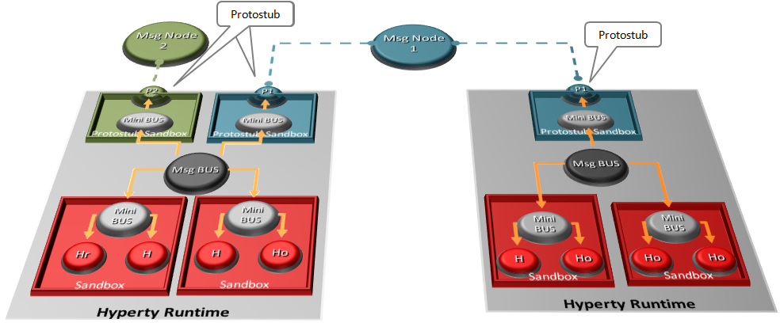

Protocol on-the-fly and Protostubs