## Hyperty development evaluation survey

### Survey purpose.

The purpose of this sruvey was to evaluate the evolution of the feedback perceived from developers when developing hyperties to check the evolution of the project and compare with the resuts obtained from phase 1.

### List of questions included in the survey

1. Is the documentation clear and easy to find and understand?
2. Which parts of the reTHINK did you need to understand better to develop the hyperty?
3. Do you identify any part which would require a better documentation?
4. Do you understand how the syncher API works?
5. Do you find the reporter-observer pattern used for data exchange between hyperties helpful?
6. Do you understand the role of the Message Node?
7. Do you understand the role of the Registry domain? 8.Do you understand the role of the Catalogue node?
8. Is the provision of the Catalogue node easy?
9. Do you find the hyperty developer toolkit useful?
10. Is the documentation of the developer toolkit complete and easy to follow?
11. Is there any unclear or missing point the hyperty developer toolkit documentation?
12. Did you manage to implement all the features of your application for phase 2?
13. If you answered "No" to the previous question, please let us know what features you tried to implement and was not possible.
14. Did you manage to debug your application easily during the development?
15. Is clearly defined the border between Application and hyperty code?
16. Did you find any limitation of the Identity Management features provided by the Runtime?

### Is the documentation clear and easy to find and understand?

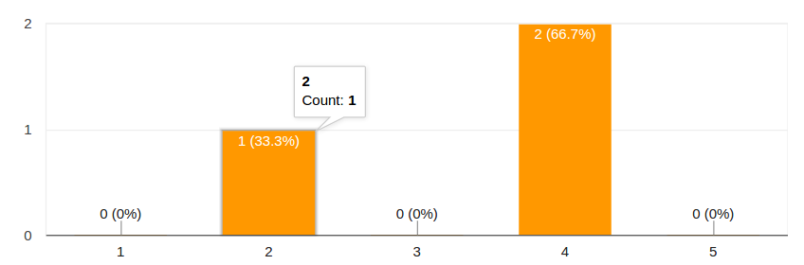

Answers for question 1

A light improvements has been registered from phase1 survey.

### Which parts of the reTHINK did you need to understand better to develop the hyperty?

The syncher was mentioned by all the participants in the survey. Other aspects mentioned are Message Bus, Discovery and Identity Management.

### Do you identify any part which would require a better documentation?

Syncher is also identied as the topic that would require more detailed and interactive documentation. Also the dataObjectReporter and Observer were mentioned.

### Do you understand how the syncher API works?

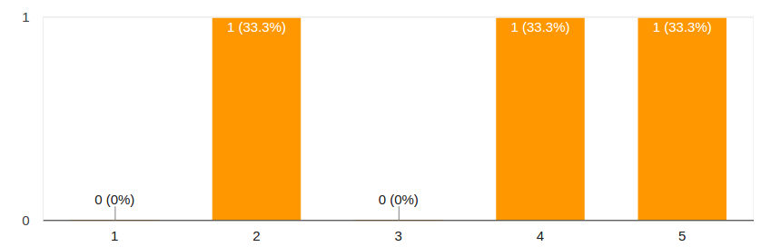

Answers for question 4

### Do you find the reporter-observer pattern used for data exchange between hyperties helpful?

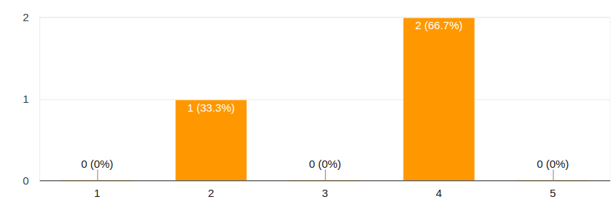

Answers for question 5

### Do you understand the role of the Message Node?

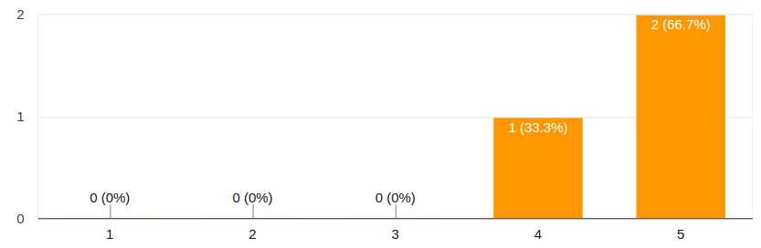

Answers for question 6

### Do you understand the role of the Registry domain?

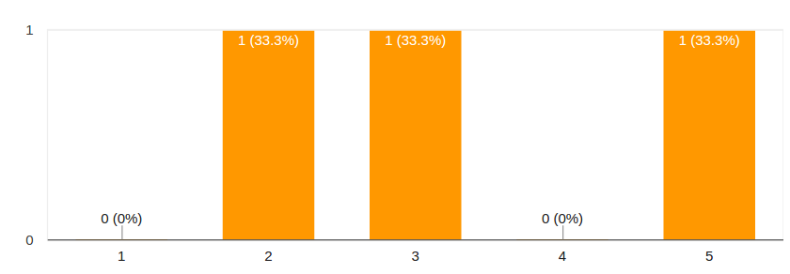

Answers for question 7

### Do you understand the role of the Catalogue node?

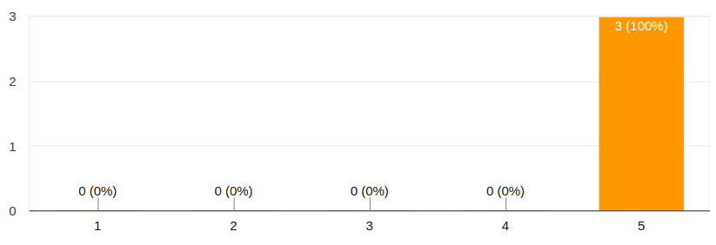

Answers for question 8

### Is the provision of the Catalogue node easy?

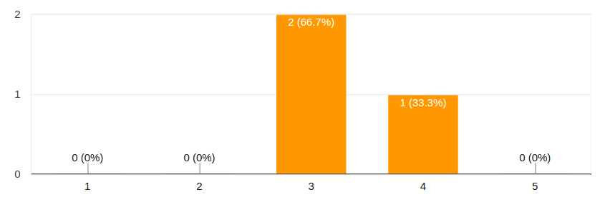

Answers for question 9

The provison of the Catalogue is found easier now by participants in the survey.

### Do you find the hyperty developer toolkit useful?

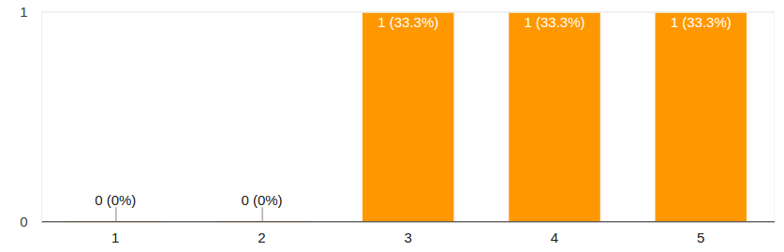

Answers for question 10

### Is the documentation of the developer toolkit complete and easy to follow?

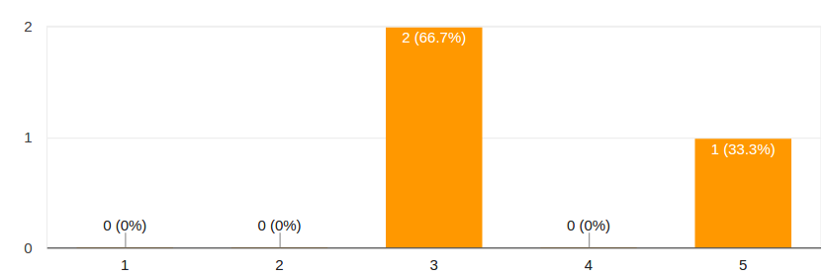

Answers for question 11

### Is there any unclear or missing point the hyperty developer toolkit documentation?

It was answered that the development of ProtoStubs and IdProxies was not correctly documented.

### Did you manage to implement all the features of your application for phase 2?

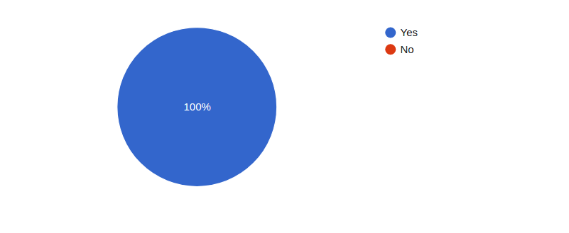

Answers for question 13

### If you answered "No" to the previous question, please let us know what features you tried to implement and was not possible.

No answers received for this point.

### Did you manage to debug your application easily during the development?

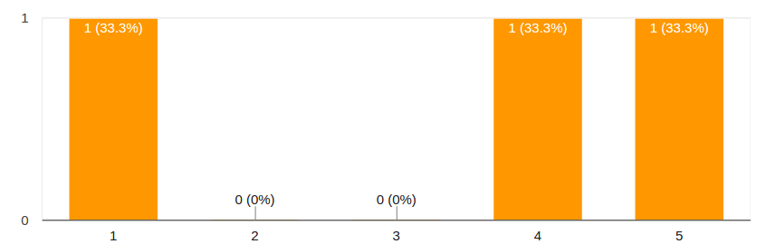

Answers for question 15

The results are better than the obtained for phase 1. However this is a point which should be addressed in the future to make development easier.

### Is clearly defined the border between Application and hyperty code?

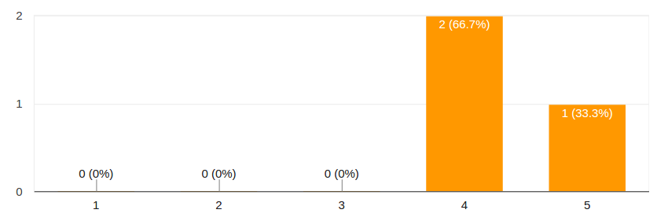

Answers for question 16

### Did you find any limitation of the Identity Management features provided by the Runtime?

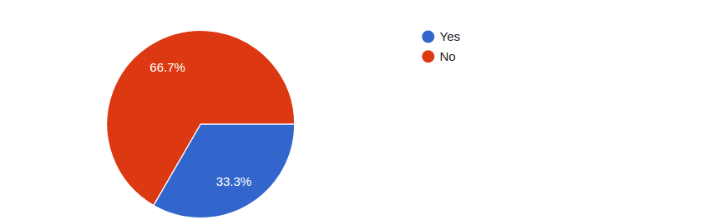

Answers for question 17

The limitation found was a more complete information about the registered user