## Application development evaluation survey

### Survey purpose.

The purpose of this survey was to evaluate the evolution of the feedback perceived from application developers using the ReTHINK framework to check the evolution of the project and compare with the results obtained from phase 1.

### List of questions included in the survey

1. Do you now understand the reTHINK overall concept?
2. What feature/s of reTHINK framework does looks more promising to you?
3. Is the documentation clear and easy to understand?
4. Did you deploy your own reTHINK development environment or you use an existing one?
5. If you deployed your own development environment, how easy was it?
6. What hyperties does your application use?
7. Were the used hyperties well documented?
8. Did you manage to implement all the features of your application for phase 2?
9. If you answered "No" to the previous question, please let us know what features you tried to implement and was not possible.
10. Did you manage to debug your application easily during the development?
11. What would you like to improve/add in order to be able to debug ReTHINKs apps more easily?
12. Does the identity meet the requirements of your application?
13. Is clearly defined the border between Application and hyperty code?

### Do you now understand the reTHINK overall concept?

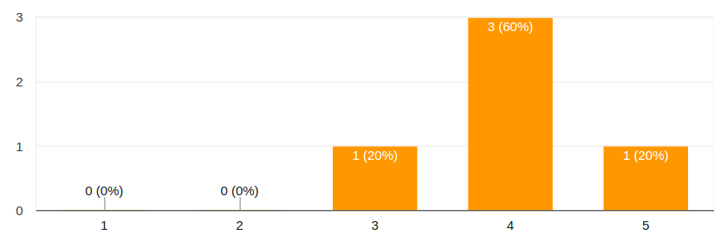

Answers for question 1

### What feature/s of reTHINK framework does looks more promising to you?

### Is the documentation clear and easy to understand?

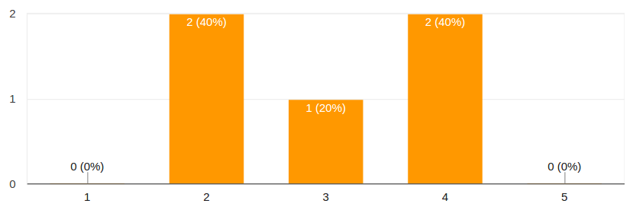

Answers for question 3

### Did you deploy your own reTHINK development environment or you use an existing one?

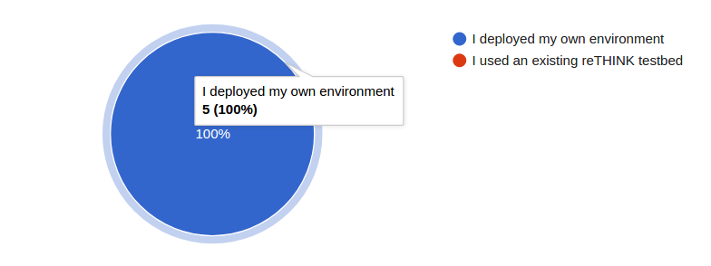

Answers for question 4

### If you deployed your own development environment, how easy was it?

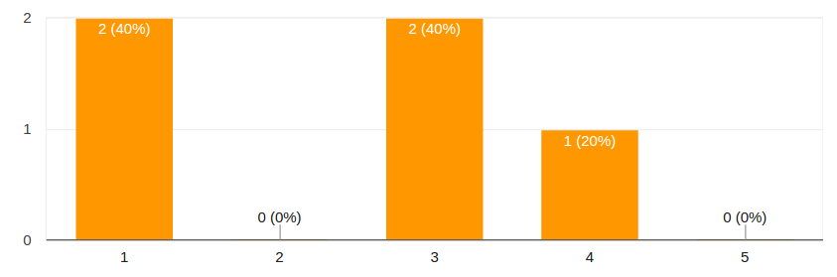

Answers for question 5

### What hyperties does your application use?

### Were the used hyperties well documented?

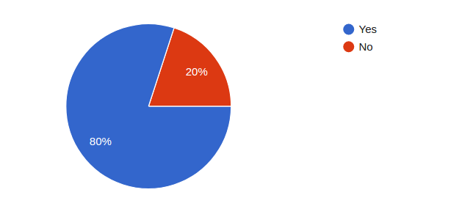

Answers for question 7

### Did you manage to implement all the features of your application for phase 2?

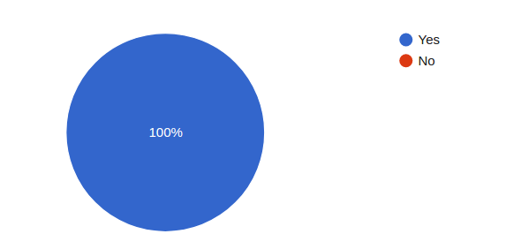

Answers for question 8

### If you answered "No" to the previous question, please let us know what features you tried to implement and was not possible.

### Did you manage to debug your application easily during the development?

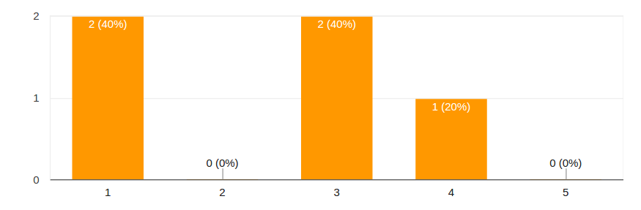

Answers for question 10

### What would you like to improve/add in order to be able to debug ReTHINKs apps more easily?

### Does the identity meet the requirements of your application?

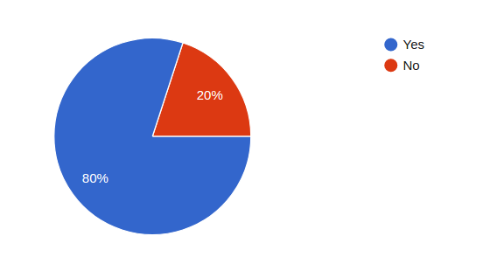

Answers for question 12

### Is clearly defined the border between Application and hyperty code?

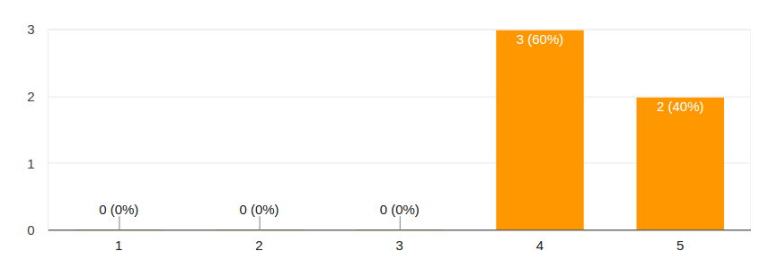

Answers for question 13